Dasatinib loaded nanostructured lipid carriers for effective treatment of corneal neovascularization

Qingqing Liª, Xianwei Yangª, Peipei Zhang^{b}, Fei Moª, Peiru Siª, Ximeng Kangª, Menghan Wangª, Jiye Zhang^{a*}

Affiliations:
ª School of Pharmacy, Health Science Center, Xi’an Jiaotong University, Xi’an, 710061, P. R. China
^{b} Health Science Center, Xi’an Jiaotong University, Xi’an, 710061, P. R. China
* Co-corresponding author

Address correspondence to:

Jiye Zhang
School of Pharmacy, Health Science Center, Xi’an Jiaotong University
No. 76 Yanta Westroad
Xi’an, 710061, P. R. China
Fax: +86-29-82657833
Tel: +86-29-82657833
E-mail address: zjy2011@mail.xjtu.edu.cn

S1. Preparation of oligochitosan-NLC
275 mg of the lipid phase (5 mg dasatinib, 112 mg glycerin monosterate, 69 mg Miglyol 812 N and 89 mg Solutol®HS 15) and 10 mL of the aqueous phase (3 mg/mL Gelucire 44/14 and 3 mg/mL soy lecithin) was heated in a water bath of 75°C. Next, the aqueous phase was dropwise added into the lipid phase under magnetic stirring. 5 min later, the mixed solution was homogenized for 15 min before being rapidly cooled in an ice bath. After string for 10 min in the ice bath, 1 mL of the resulted solution was dropwise added into 1 mL oligochitosan solution (10 mg/mL) at room temperature. Half an hour later, the sample was centrifuged for 5 min at 15000 rpm followed by being filtered by a 0.22 µm filter to remove the unencapsulated drug. Blank and coumarin 6-loaded NLC (coumarin 6-NLC) were prepared in the same manner.
S2. Cytotoxicity assay
The cytotoxicity of dasatinib-loaded NLC (dasa-NLC) was evaluated by an MTT assay. HUVEC cells were seeded into a 96-well plate with a density of 30000 cells/well. After incubation for 24 hours, the cell culture medium was replaced by free dasatinib or dasa-NLC at different concentrations. 24 hours later, an MTT assay was conducted to determine the cell viability relative to the control (no drug treatment).
S3. Corneal distribution study
The corneal distribution study of drug loaded NLC was carried out by investigating the influence of NLC encapsulation on the distribution of coumarin 6 in the cornea. In this study, one drop of coumarin 6 loaded NLC (coumarin 6-NLC 10 μl) was instilled into the right eyes of mice. The mice were euthanized at predetermined time points and the right eyes were immediately enucleated. After being embedded in the OCT, the eyes were frozen at −80°C. Sagittal sections (5 µm) were dissected by a cryostat microtome (Lecia, Germany) and the fluorescent images of the cornea sections were captured by a fluorescence microscopes (Nikon DS-Ri2).

Table S1. Stability observation of NLC and oligochitosan-NLC.
 | Soy lecithin  (mg) | Oligochitosan  (mg/ml) | Size  (nm) | Zeta potential (mV) | Day 1 | Day 2 | Day 3 | Day 7
1 | 0 | 0 | 17.8±0.15 | -7.52±0.24 | Clear | Precipitate | - | -
2 | 20 | 0 | 74.18±0.34 | -23.67±-0.81 | Clear | Clear | Precipitate | -
3 | 30 | 0 | 80.14±1.95 | -28.0±-1.75 | Clear | Clear | Clear | Clear
4 | 30 | 10 | 90.23±1.32 | 18.2±0.83 | Clear | Clear | Clear | Clear

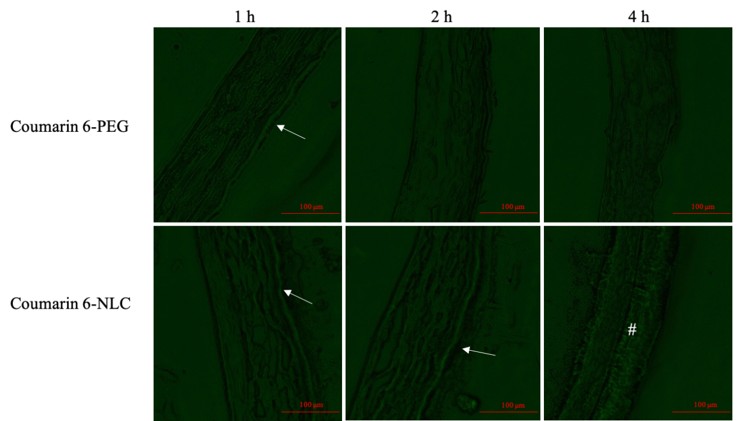

Fig. S1 Fluorescent images of the cornea at different times after the administration of coumarin 6-PEG solution or coumarin 6-NLC. Arrow: corneal epithelium, #: stroma.

Fig. S2 Cytotoxicity of dasa-NLC.

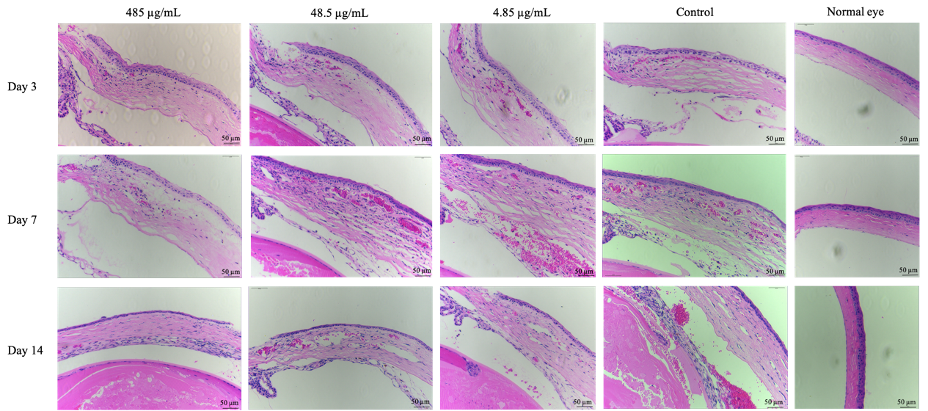
Fig. S3 H&E staining of the peripheral cornea from different groups at different time.

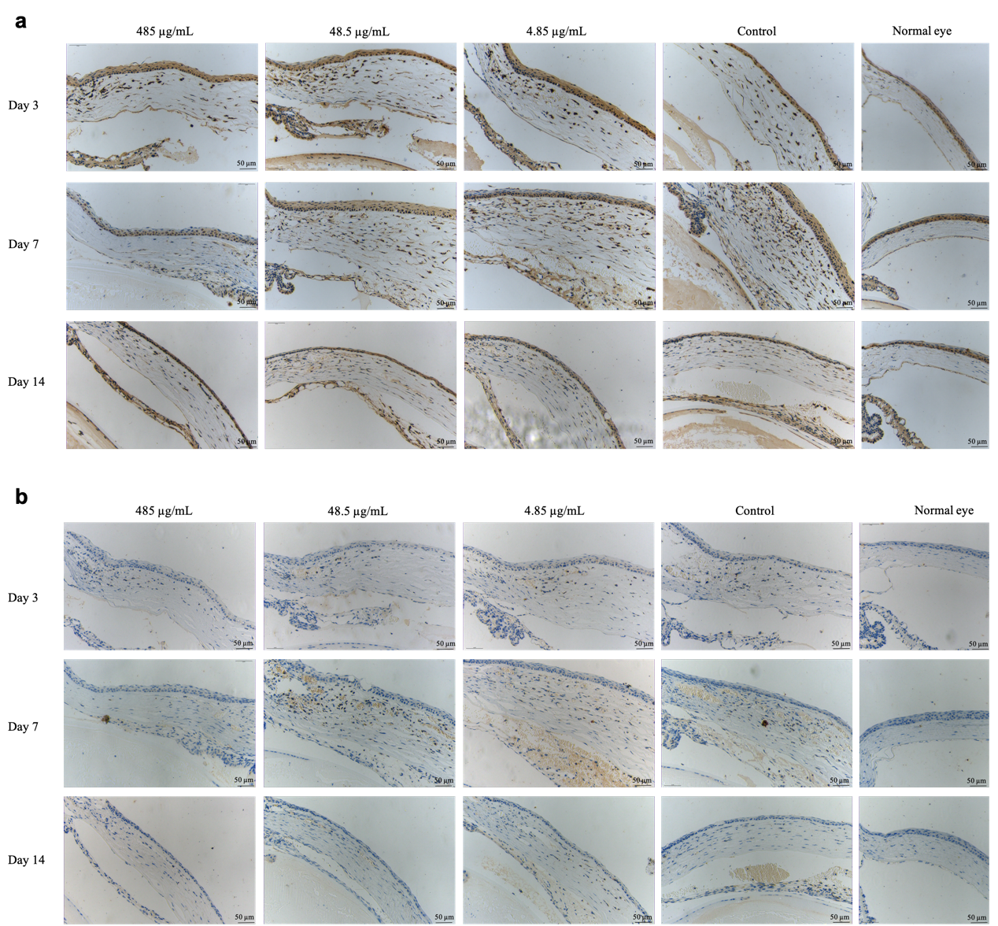
Fig. S4 Immunohistochemistry staining of Src (a) and pSrc (b) in the peripheral cornea with different treatments at different time.

