Supplementary Tabs.
Taxon | No. | L | HF (A) | HF (LPCh) | W | NPCh | HCh (A-LPCh) | Angle(°)
M. boeckhi (Stürzenbaum, 1876) | KGP-PO-0001 | 42 |  | 19 | 14 | 7-8 | 4-5 | 11-12
M. boeckhi (Stürzenbaum, 1876) | T.829 | 63 | 33 | 49 | 43* | 7 | 7.6-9 | 11-12
M. boeckhi (Stürzenbaum, 1876) | T.3593 | 50 | 14 | 24 | 18.7 | 10 | 4-5.4 | 11-12
M. boeckhi (Stürzenbaum, 1876) | T.3206 | 69 |  | 49 | 37.3 | 4 | 12-30** | 11-12
M. boeckhi (Stürzenbaum, 1876) | T.3137 | 69 | 45 | 58 | 46* | 4 | 11.5-12 | 11-12*
M. boeckhi (Stürzenbaum, 1876) | T.81 | 39 | 21 | 30 |  | 4 | 3-25**

Tab.1. Specimens of M. boeckhi with measured parameters. L – length of preserved part of the phragmocone; HF (A) – height of the phragmocone at the apical part of preserved phragmocone; HF (LPCh) - height of the phragmocone at the last preserved chamber. W – maximum width of the phragmocone; NPCh – number of preserved chambers; HCh (A-LPCh) – height of chambers, from apical part to the last preserved chamber. All measured data are in (mm), angle in degrees. *estimated; ** height of the preserved „body chamber“.

No. | Lithology | %SOM | %C_{total} | TOC
TO 7 | Dark organodetritic limestone | 0.006 | 11.45 | 0.05
TO 8 | Dark organodetritic limestone | 0.005 | 11.50 | 0.05
TO 9 | Dark organodetritic limestone | 0.004 | 11.49 | 0.05

Tab. 2. SOM = soluble organic matter; TOC = total organic carbon

Supplementary figs/movies

Supplementary Fig/movie 1A.
Micro-CT visualisation (movie) of longitudinal sections of specimen Breviconoteuthis aff. breviconus documenting character of the septa and their attachment to the wall of the phragmocone.
Permanent link: https://web.natur.cuni.cz/ugp/palaeobiology/Bervicono1
(not active yet)
Supplementary Fig/movie 1B.
The 3D micro-CT visualisation (movie) of the specimen Breviconoteuthis aff. breviconus from locality Podhradie.
Permanent link: https://web.natur.cuni.cz/ugp/palaeobiology/Bervicono2
(not active yet)

Fig.2
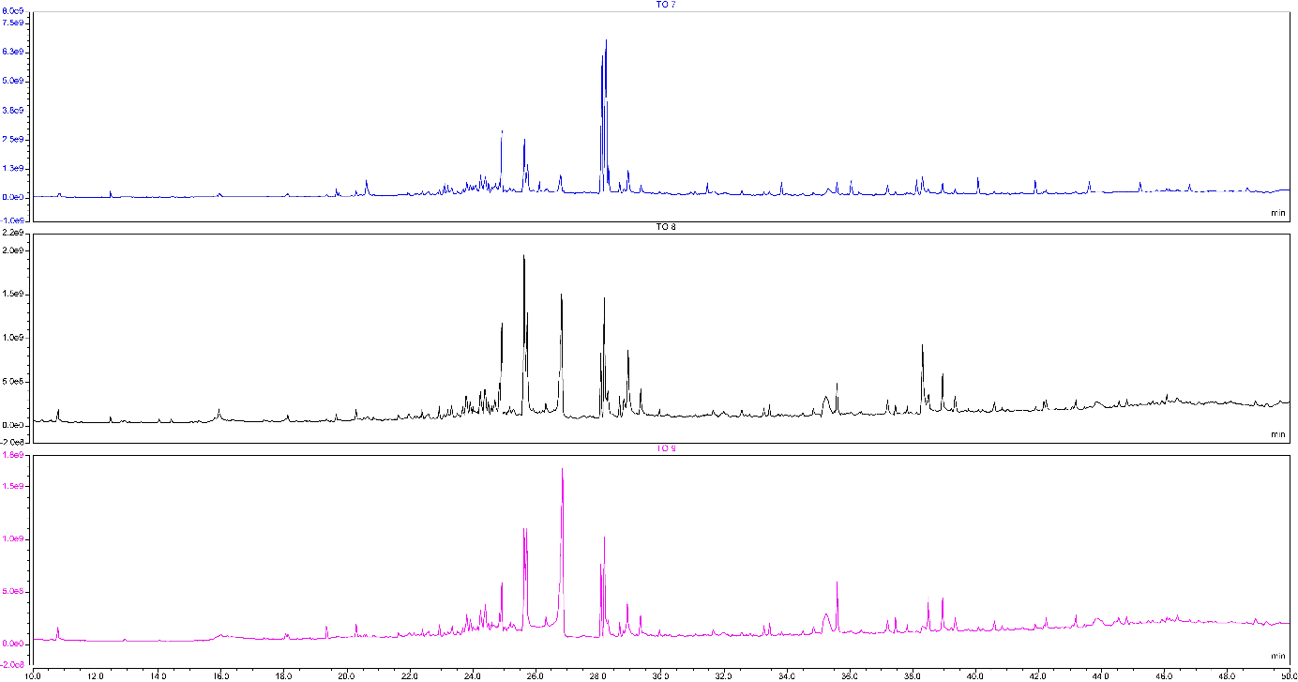

Supplementary Fig. 2. Total ion chromatograms. All peaks represent an organic compound and the peak area corresponds to the concentration of the compound. As it is well seen, all three chromatograms from three Beds (1-3, samples TO 7-9) are almost identical indicating a very similar content of organic matter produced by algae.

