Impact of covariate model building methods on their clinical relevance evaluation in population pharmacokinetic analyses: comparison of the full model, stepwise covariate model (SCM) and SCM+ approaches
Morgane Philipp^{@,1,2}, Simon Buatois³, Sylvie Retout^{2,3}, France Mentré¹

@ morgane.philipp@inserm.fr or morgane.philipp@roche.com, 01 57 27 74 43
¹ Université Paris Cité, INSERM, IAME, UMR 1137, Paris, France
² Institut Roche, Boulogne-Billancourt, France
³ Roche Pharma Research and Early Development, Pharmaceutical Sciences, Roche Innovation Center Basel, Switzerland

ORCID:
Morgane Philipp: https://orcid.org/0000-0001-9827-316X
Simon Buatois: https://orcid.org/0000-0002-1472-5366
Sylvie Retout: https://orcid.org/0000-0003-4867-8438
France Mentré: https://orcid.org/0000-0002-7045-1275

SUPPLEMENTARY FILES

Supplementary File 1

Table S1.1 Characteristics of the clinical studies used for the population PK model development of Retout et al. (2020) [28]

 | Phase III study HAVEN 1 | Phase III study HAVEN 2 | Phase III study HAVEN 3 | Phase III study HAVEN 4 | Phase I/II study
Patients type | Adult and adolescent people with hemophilia A (age ≥ 12 years) with FVIII inhibitors | Pediatric people with hemophilia A  (age < 12 years  or 12–17 years  and < 40 kg) with  FVIII inhibitors | Adult and adolescent people with hemophilia A (age ≥ 12 years) without  FVIII inhibitors | People with  hemophilia A  with or without FVIII  inhibitors | People with  hemophilia A with or without FVIII inhibitors
Number of patients | 112 | 63 | Arm A & D: 99  Arm B & C: 49 | Run-in part: 7  Expansion part: 41 | Cohort 1: 6  Cohort 2: 6  Cohort 3: 6
Subcutaneous dosing regimen | 3 mg/kg every week for  4 weeks followed by  1.5 mg/kg every week | 3 mg/kg every week for  4 weeks followed by  1.5 mg/kg every week | Arm A & D:  3 mg/kg every week for 4 weeks followed by 1.5 mg/kg every week  Arm B & C:  3 mg/kg every week  for 4 weeks followed by 3 mg/kg every 2 weeks | Run-in part:  6 mg/kg every 4 weeks  Expansion part:  3 mg/kg every week for 4 weeks  followed by 6 mg/kg every 4 weeks | Cohort 1:  1 mg/kg followed by 0.3 mg/kg every week  Cohort 2:  3 mg/kg followed by 1 mg/kg every week  Cohort 3:  3 mg/kg every week
Number of PK samples per patient (median [min–max]) | 14 [4–17] | 12 [7–17] | Arm A & D:  11 [6–14]  Arm B & C:  11 [1–14] | Run-in part:  25 [25–26]  Expansion part:  8 [7–9] | Cohort 1:  65 [64–71]  Cohort 2:  58 [21–62]  Cohort 3:  52 [30–61]

Table S1.2 Summary of the covariates distribution of the 389 patients included in the emicizumab population PK database used by Retout et al. (2020) [28]

Continuous covariate |  | Median [min–max]
Age (years) |  | 30.0 [1.22 - 77.00]
Body weight (kg) |  | 69.1 [9.50–156]
Albumin (g/L) |  | 45.0 [33.0–56.6]
Aspartate aminotransferase (U/L) |  | 23.0 [11.0–91.0]
Bilirubin (μmol/L) |  | 10.5 [0.33–46.0]
Categorical covariate | Category | N [%]
Status | Non-inhibitor (REF) | 195 [50%]
Status | FVII inhibitor | 192 [50%]
Race | White/Caucasian (REF) | 242 [63%]
Race | Black | 31 [8%]
Race | Asian, including Japanese | 89 [23%]
Race | Other or unknown | 25 [6%]

Fig. S1.1 Simulated individual emicizumab concentration of the dataset n°1 with the base model (left) and of the dataset n°1 with the covariate model (right); the different colors highlight the 5 clinical studies

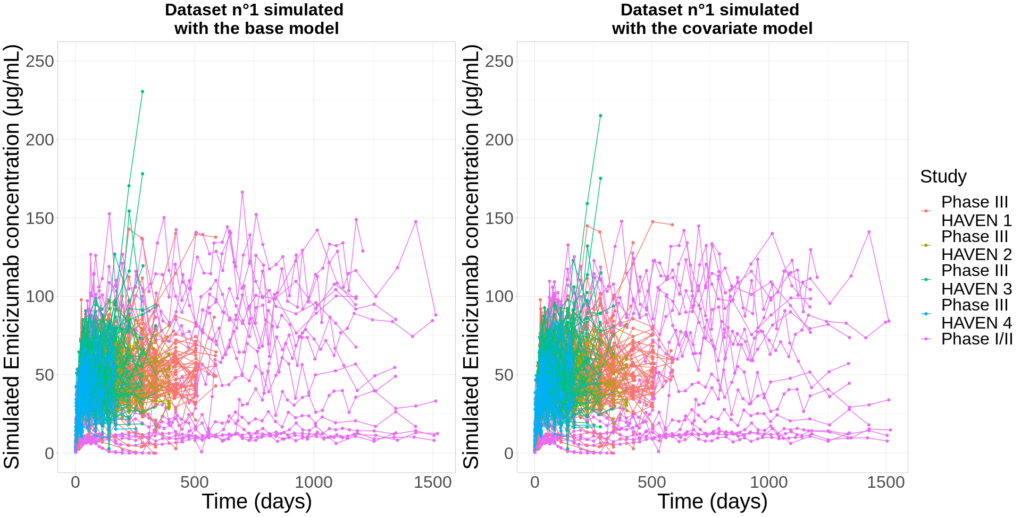

Fig. S1.2 Covariates correlation matrix; body weight (BW), age (AGE), albumin (ALB), aspartate aminotransferase (AST), total bilirubin (BILI), patient status (STAT), race (RACE)

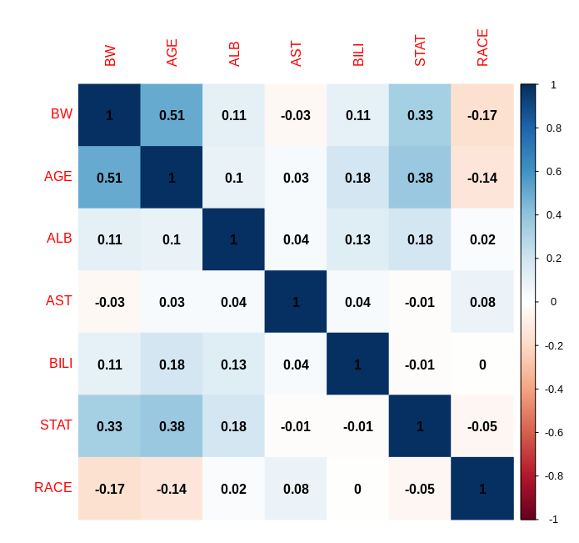
Table S1.3 Single decisions based on the conclusions made on 2 or more covariate ratios; the 5 possible decisions about the covariate clinical relevance are the following: relevant (R), non-relevant significant (NRS), non-relevant non-significant (NRNS), insufficient information significant (IIS), insufficient information non-significant (IINS)

Case | Decision
R & … & {R|NRS|NRNS|IIS|IINS} & … | R
NRS & … & {NRS|NRNS} & … | NRS
NRNS & … & NRNS & … | NRNS
IIS & … & {NRS|NRNS|IIS|IINS} & … | IIS
IINS & … & {NRS|NRNS|IINS} & … | IINS

Supplementary File 2

Fig. S2.1 Boxplots of REE (left) and EE (right) of estimated covariate parameters under the base (top) and covariate (bottom) model; the 5th, 25th, 50th, 75th and 95th percentiles are displayed on the boxplot

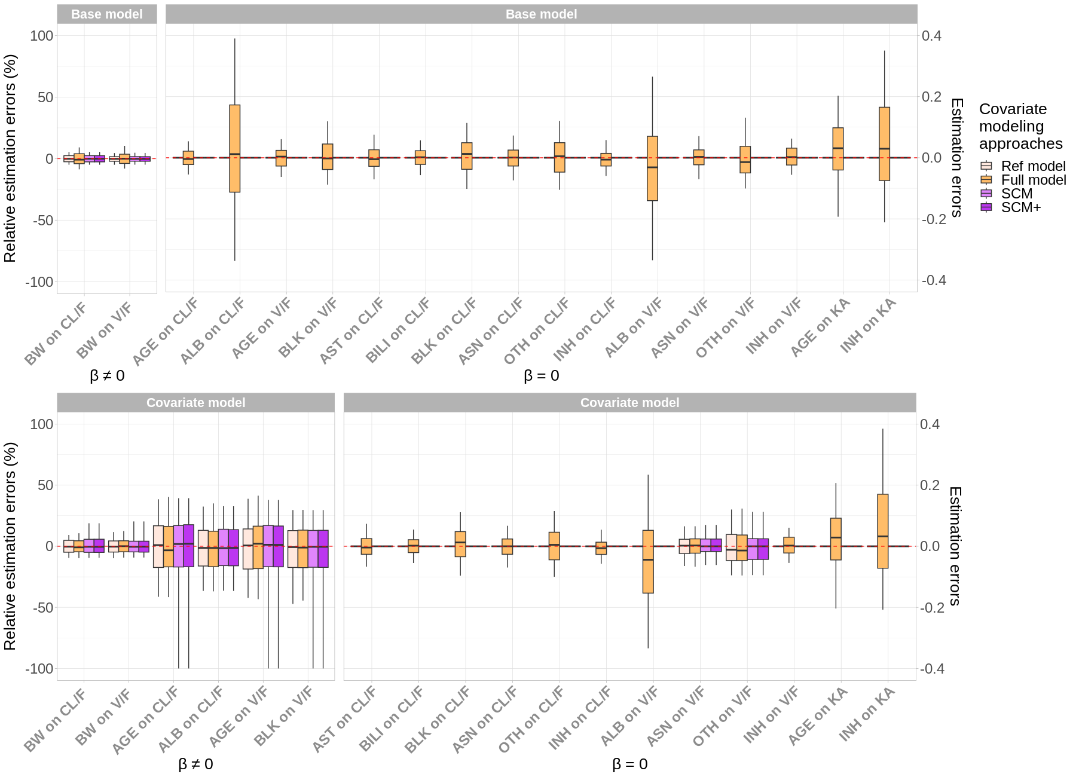
Fig. S2.2 Boxplots of RSE (left) and SE (right) of estimated covariate parameters under the base (top) and covariate (bottom) model; red points indicate the empirical RSE and SE values; the 5th, 25th, 50th, 75th and 95th percentiles are displayed on the boxplot

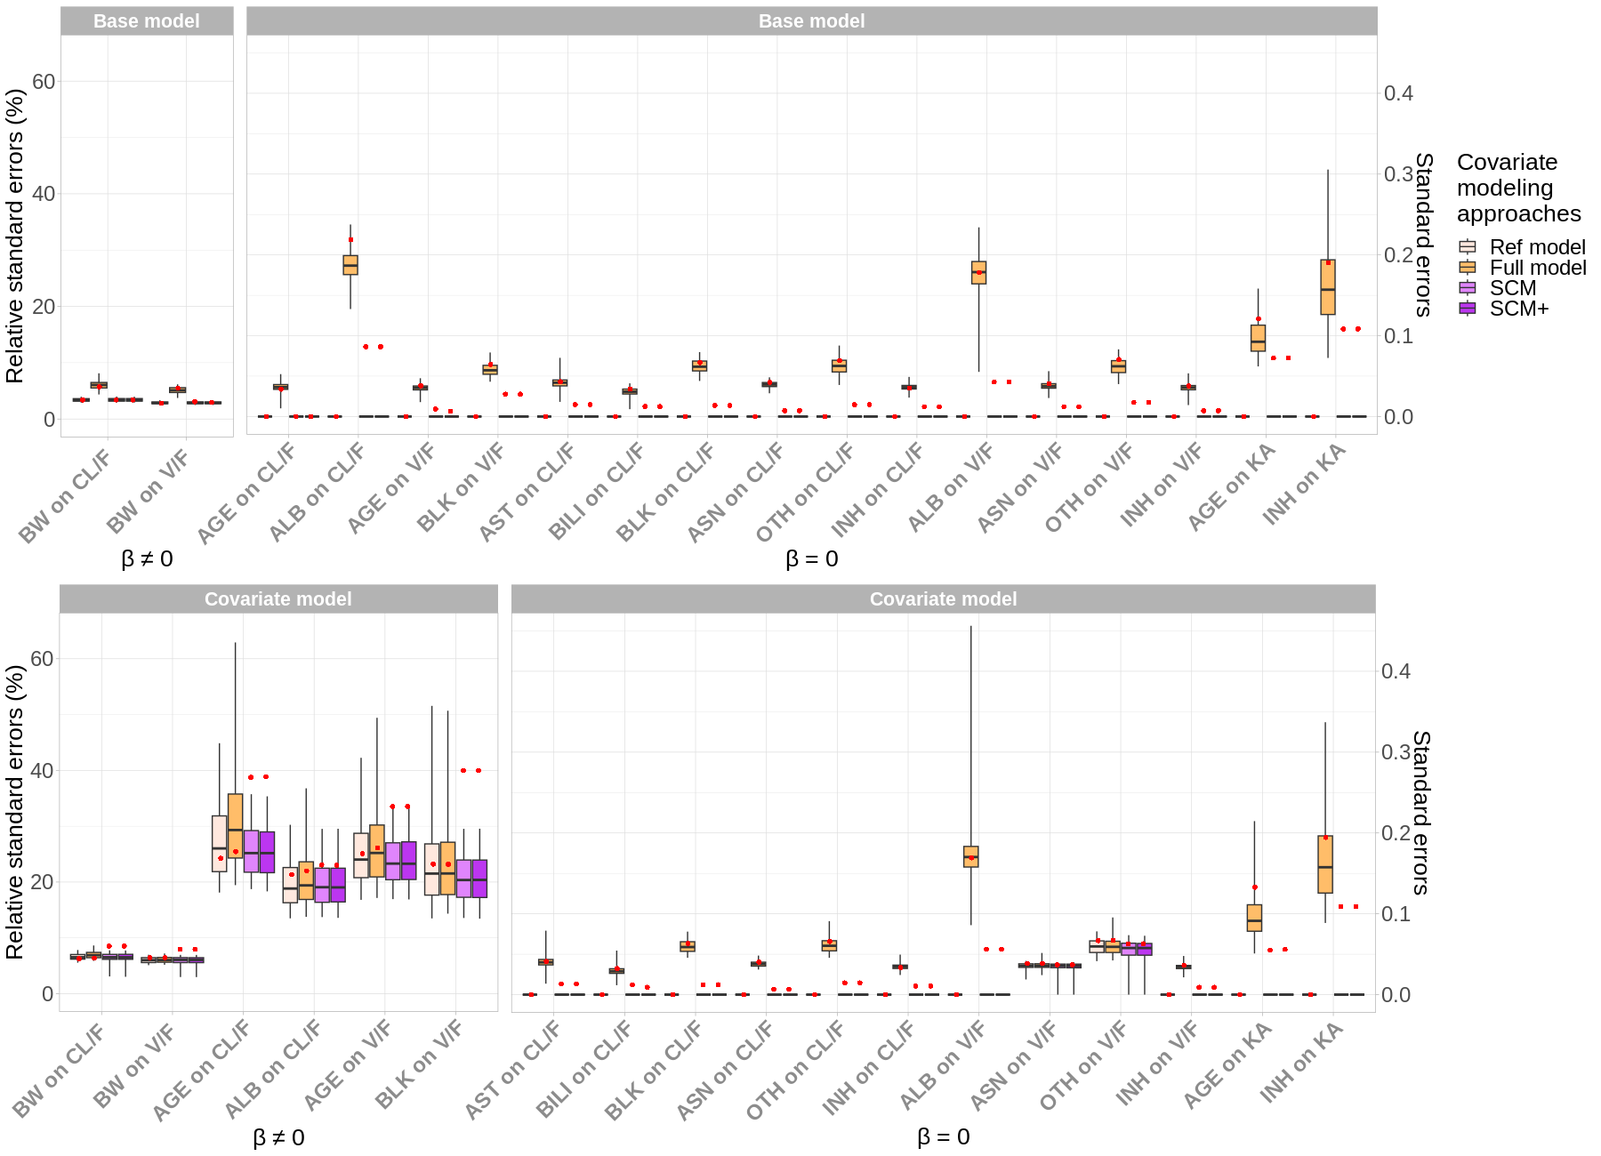

Supplementary File 3

Fig. S3.1 Boxplots of REE of P90 ratios of continuous covariates for simulated covariates were $β≠0$ (left) and $β=0$ (right) under the base (top) and covariate (bottom) model; the 5th, 25th, 50th, 75th and 95th percentiles are displayed on the boxplot

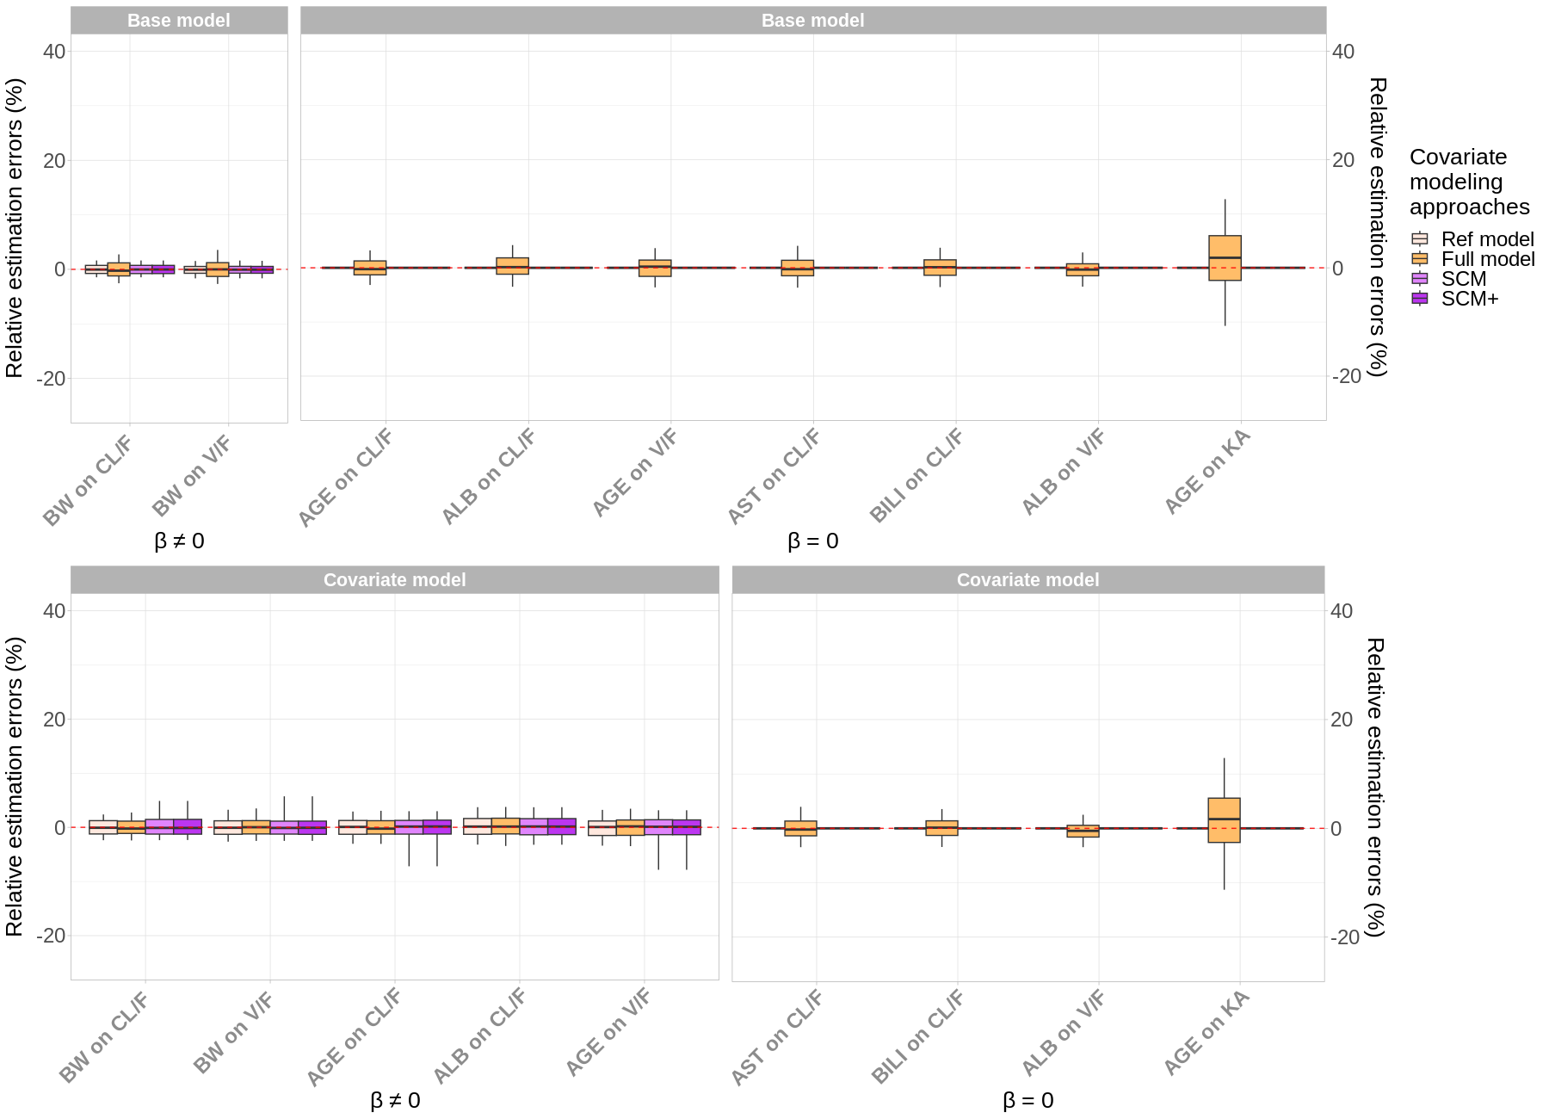
Fig. S3.2 RRMSE of P90 ratios of continuous covariates for simulated covariates were $β≠0$ (left) and $β=0$ (right) under the base (top) and covariate (bottom) model

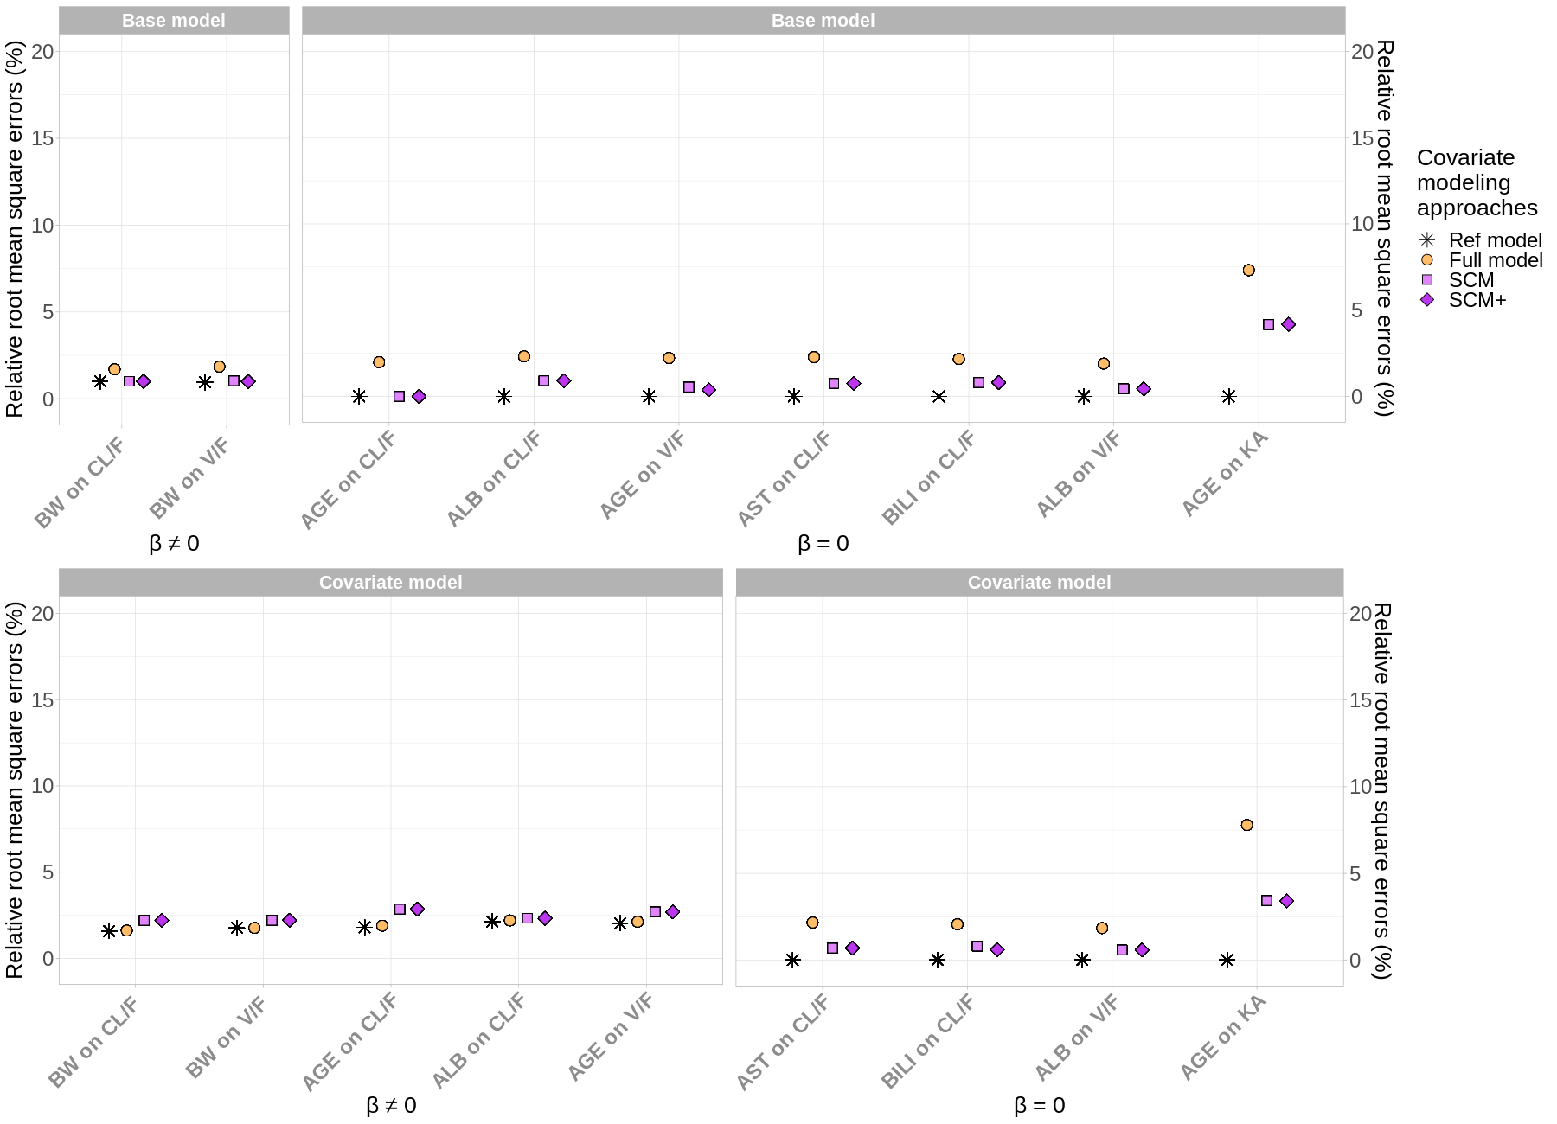
Fig. S3.3 Coverage rates of P90 ratios of continuous covariates for simulated covariates were $β≠0$ (left) and $β=0$ (right) under the base (top) and covariate (bottom) model; the target range of [0.850, 0.938] is shaded in gray and the value of 0.900 is indicated by a dashed line

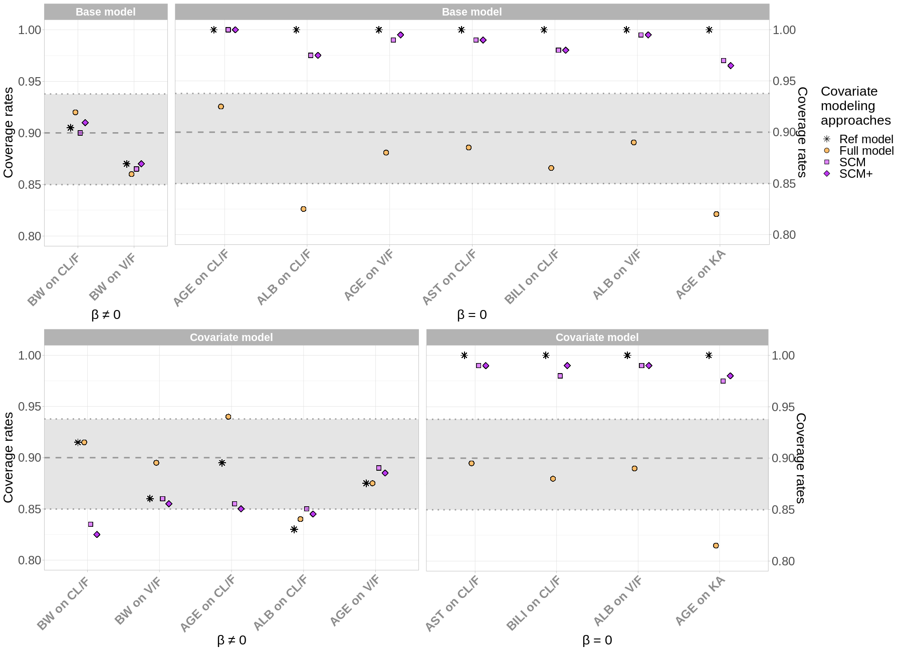

Supplementary File 4

Table S4.1 Parameter estimates (SE, RSE%) obtained with the reference model (left), the full model (middle left), SCM (middle right) and SCM+ (right) by fitting the simulated dataset n°1 with the base model;
* indicates that SE and RSE were computed for the corresponding variance

Parameters (units) | Ref model | Full model | SCM | SCM+
$μ_{CL/F}$ (L/day) | 0.291 (0.005, 2%) | 0.291 (0.008, 3%) | 0.291 (0.005, 2%) | 0.291 (0.005, 2%)
$μ_{V/F}$ (L) | 11.275 (0.188, 2%) | 11.253 (0.295, 3%) | 11.294 (0.187, 2%) | 11.294 (0.187, 2%)
$μ_{KA}$ (1/day) | 0.465 (0.040, 9%) | 0.478 (0.072, 15%) | 0.496 (0.048, 10%) | 0.496 (0.048, 10%)
$$β_{CL/F,BW}$$ | 0.996 (0.030, 3%) | 0.921 (0.052, 6%) | 0.986 (0.030, 3%) | 0.984 (0.030, 3%)
$$β_{V/F,BW}$$ | 1.041 (0.029, 3%) | 1.052 (0.056, 5%) | 1.064 (0.030, 3%) | 1.064 (0.030, 3%)
$$β_{CL/F,AGE}$$ | / | 0.055 (0.033, 61%) | / | /
$$β_{CL/F,ALB}$$ | / | 0.126 (0.163, 129%) | / | /
$$β_{V/F,AGE}$$ | / | 0.023 (0.038, 163%) | / | /
$$β_{V/F,BLK}$$ | / | -0.052 (0.055, 105%) | / | /
$$β_{V/F,ASN}$$ | / | -0.089 (0.035, 39%) | / | /
$$β_{V/F,OTH}$$ | / | -0.039 (0.070, 181%) | / | /
$$β_{CL/F,AST}$$ | / | -0.043 (0.042, 98%) | / | /
$$β_{CL/F,BILI}$$ | / | -0.015 (0.030, 194%) | / | /
$$β_{CL/F,BLK}$$ | / | 0.001 (0.012, 2313%) | / | /
$$β_{CL/F,ASN}$$ | / | -0.062 (0.038, 62%) | / | /
$$β_{CL/F,OTH}$$ | / | 0.016 (0.057, 366%) | / | /
$$β_{CL/F,INH}$$ | / | 0.037 (0.037, 101%) | / | /
$$β_{V/F,ALB}$$ | / | -0.059 (0.161, 271%) | / | /
$$β_{V/F,INH}$$ | / | 0.072 (0.040, 55%) | / | /
$$β_{KA,AGE}$$ | / | 0.230 (0.082, 36%) | 0.223 (0.079, 35%) | 0.225 (0.079, 35%)
$$β_{KA,INH}$$ | / | 0.057 (0.190, 335%) | / | /
$$ω_{CL/F}$$ | 0.290 (0.007*, 8%*) | 0.287 (0.007*, 8%*) | 0.290 (0.007*, 8%*) | 0.290 (0.007*, 8%*)
$$ω_{V/F}$$ | 0.285 (0.007*, 8%*) | 0.280 (0.007*, 9%*) | 0.285 (0.007*, 8%*) | 0.285 (0.007*, 8%*)
$$ω_{KA}$$ | 0.651 (0.060*, 14%*) | 0.637 (0.066*,16%*) | 0.641 (0.062*, 15%*) | 0.641 (0.062*,15%)
$a$- fixed (μg/mL) | 0.025 (/, /) | 0.025 (/, /) | 0.025 (/, /) | 0.025 (/, /)
$$b$$ | 0.147 (0.002, 1%) | 0.147 (0.002, 1%) | 0.147 (0.002, 1%) | 0.147 (0.002, 1%)

Table S4.2 Parameter estimates (SE, RSE%) obtained with the reference model (left), the full model (middle left), SCM (middle right) and SCM+ (right) by fitting the simulated dataset n°1 with the covariate model;
* indicates that SE and RSE were computed for the corresponding variance

Parameters (units) | Ref model | Full model | SCM | SCM+
$μ_{CL/F}$ (L/day) | 0.293 (0.005, 2%) | 0.293 (0.007, 3%) | 0.292 (0.005, 2%) | 0.293 (0.005, 2%)
$μ_{V/F}$ (L) | 11.796 (0.226, 2%) | 11.476 (0.287, 3%) | 11.817 (0.225, 2%) | 11.797 (0.225, 2%)
$μ_{KA}$ (1/day) | 0.471 (0.038, 8%) | 0.481 (0.072, 15%) | 0.500 (0.047, 9%) | 0.471 (0.038, 8%)
$$β_{CL/F,BW}$$ | 0.810 (0.047, 6%) | 0.788 (0.049, 6%) | 0.810 (0.047, 6%) | 0.807 (0.047, 6%)
$$β_{V/F,BW}$$ | 0.841 (0.055, 7%) | 0.857 (0.055, 6%) | 0.846 (0.055, 6%) | 0.840 (0.055, 6%)
$$β_{CL/F,AGE}$$ | 0.161 (0.029, 18%) | 0.177 (0.031, 18%) | 0.153 (0.029, 19%) | 0.165 (0.029, 18%)
$$β_{CL/F,ALB}$$ | -0.907 (0.152, 17%) | -0.846 (0.158, 19%) | -0.907 (0.152, 17%) | -0.909 (0.152, 17%)
$$β_{V/F,AGE}$$ | 0.132 (0.035, 26%) | 0.160 (0.037, 23%) | 0.144 (0.035, 24%) | 0.134 (0.035, 26%)
$$β_{V/F,BLK}$$ | -0.240 (0.041, 17%) | -0.245 (0.041, 17%) | -0.239 (0.041, 17%) | -0.240 (0.041, 17%)
$$β_{V/F,ASN}$$ | -0.085 (0.033, 39%) | -0.084 (0.033, 40%) | -0.086 (0.033, 39%) | -0.086 (0.033, 38%)
$$β_{V/F,OTH}$$ | -0.040 (0.067, 166%) | -0.037 (0.066, 179%) | -0.040 (0.067, 166%) | -0.040 (0.067, 168%)
$$β_{CL/F,AST}$$ | / | -0.040 (0.039, 98%) | / | /
$$β_{CL/F,BILI}$$ | / | -0.014 (0.027, 194%) | / | /
$$β_{CL/F,BLK}$$ | / | 0.001 (0.011, 24906%) | / | /
$$β_{CL/F,ASN}$$ | / | -0.059 (0.036, 62%) | / | /
$$β_{CL/F,OTH}$$ | / | 0.016 (0.056, 359%) | / | /
$$β_{CL/F,INH}$$ | / | 0.033 (0.034, 104%) | / | /
$$β_{V/F,ALB}$$ | / | -0.078 (0.171, 218%) | / | /
$$β_{V/F,INH}$$ | / | 0.070 (0.037, 53%) | / | /
$$β_{KA,AGE}$$ | / | 0.229 (0.081, 35%) | 0.214 (0.079, 37%) | /
$$β_{KA,INH}$$ | / | 0.066 (0.190, 288%) | / | /
$$ω_{CL/F}$$ | 0.275 (0.006*, 8%*) | 0.273 (0.006*, 8%*) | 0.275 (0.006*, 8%*) | 0.275 (0.006*, 8%*)
$$ω_{V/F}$$ | 0.267 (0.006*, 9%*) | 0.266 (0.006*, 9%*) | 0.268 (0.006*, 8%*) | 0.267 (0.006*, 9%*)
$$ω_{KA}$$ | 0.648 (0.061*,15%*) | 0.631 (0.069*, 17%*) | 0.636 (0.063*, 16%*) | 0.648 (0.061*, 15%*)
$a$ - fixed (μg/mL) | 0.025 (/, /) | 0.025 (/, /) | 0.025 (/, /) | 0.025 (/, /)
$$b$$ | 0.147 (0.166, 1%) | 0.147 (0.167, 1%) | 0.147 (0.166, 1%) | 0.147 (0.166, 1%)

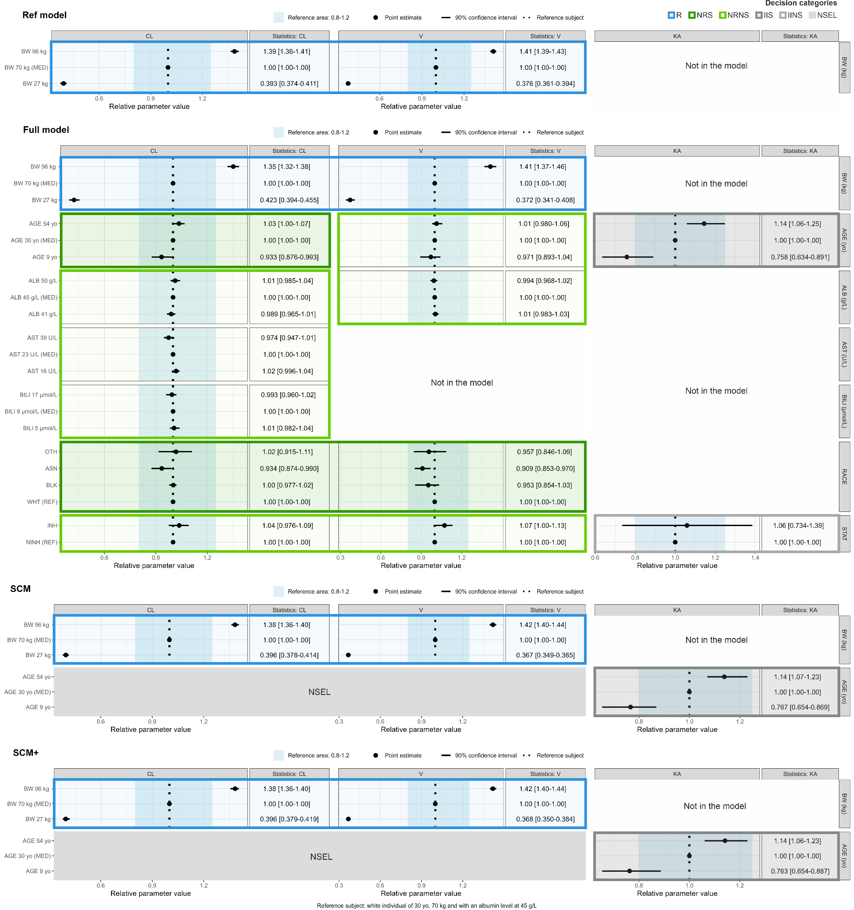
Fig. S4.1 Forest plots obtained with the reference model (up), the full model (middle up), SCM (middle bottom) and SCM+ (bottom) by fitting the simulated dataset n°1 with the base model

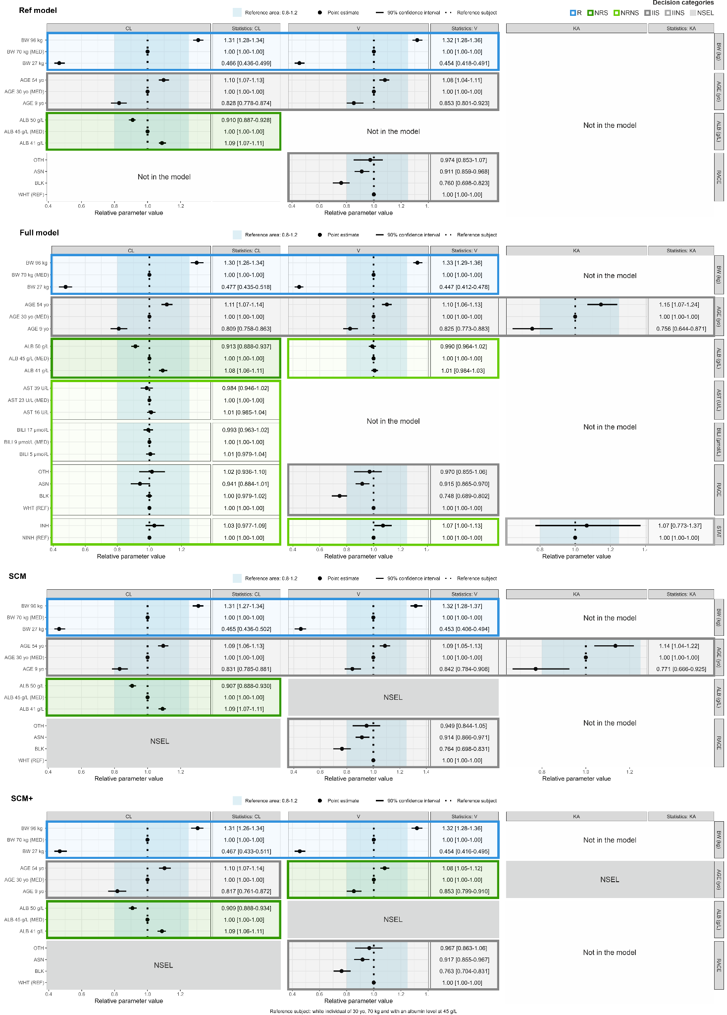
Fig. S4.2 Forest plots obtained with the reference model (up), the full model (middle up), SCM (middle bottom) and SCM+ (bottom) by fitting the simulated dataset n°1 with the covariate model

Supplementary File 5

Table S5.1 Computational efficiency parameters obtained with the full model, SCM, SCM+ for the dataset n°1 simulated with the base and covariate models

 | Base model |  |  | Covariate model
 | Full model | SCM | SCM+ | Full model | SCM | SCM+
Total runtime (hours) | 1.1 | 4.9 | 1.4 | 0.9 | 18.3 | 3.9
Number of NONMEM runs | 6 | 53 | 51 | 6 | 105 | 81
Number of covariate-parameter relationships put aside from the set of investigated covariate-parameter relationships | / | / | 1 | / | / | 2
Number of objective function evaluations | 13 804 | 24 526 | 23 371 | 12 757 | 119 750 | 67 100

Table S5.2 Number of NONMEM runs executed with the full model, SCM and SCM+ across the 200 simulated dataset under the base and the covariate models

 | Base model |  |  | Covariate model
 | Full model | SCM | SCM+ | Full model | SCM | SCM+
Number of NONMEM runs  Median (min - max) | 6 | 53  (41 - 83) | 43  (37 - 75) | 6 | 83  (74 - 120) | 69  (52 - 98)
Number of covariate-parameter relationships put aside from the set of investigated covariate-parameter relationships  Median (min-max) | / | / | 2  (0 - 4) | / | / | 3  (1 - 5)

