Supplementary Table 1: Associations of periodontitis and mixed metal/metalloid by WQS positive model and negative model
Models | OR | 95%CI | P
Positive | 1.51 | 1.38, 1.66 | <0.001
Nagetive | 0.84 | 0.76, 0.93 | <0.001
The WQS model was adjusted for sex, age, race/ethnicity, education, body mass index, smoking status, drinking alcohol status, diabetes, hypertension and hyperlipidemia.

Supplementary Table 2: Associations of periodontitis and neutrophils.
Category |  | OR | 95%CI | P
Neutrophils | Q1 | Reference
 | Q2 | 1.17 | 0.98, 1.40 | 0.084
 | Q3 | 1.43 | 1.19, 1.73 | <0.001
 | Q4 | 1.72 | 1.42, 2.08 | <0.001
The multivariate logistic model was adjusted for sex, age, race/ethnicity, education, body mass index, smoking status, drinking alcohol status, diabetes, hypertension and hyperlipidemia.

Supplementary Table 3: The indirect effect and direct effect of periodontitis and metal/metalloid by mediation analysis.
Mediators | Indirect effect |  |  | Direct effect |  | Proportion  Mediated(%)
Mediators | Conefficient(95%CIs) | P |  | Conefficient(95%CIs) | P | Proportion  Mediated(%)
Cadmium | 0.0142(0.0097,0.0194) | <0.001 |  | 0.1247(0.1014,0.1512) | <0.001 | 11.3%
Lead | 0.0012(0.0001,0.0029) | 0.106 |  | 0.0217(0.0124,0.0375) | <0.001 | 5.5%
Mercury | -0.0011(-0.0018,-0.0005) | 0.001 |  | -0.0075(-0.0129,-0.0023) | 0.006 | 14.6%
Manganese | -0.0003(-0.0009,-0.0004) | 0.338 |  | 0.0010(-0.0024,0.0044) | 0.582 | 30%
Selenium | -0.0001(-0.0001,0.0000) | 0.072 |  | -0.0006(-0.0011,-0.0002) | 0.010 | 16.7%

The mediation analysis was adjusted for sex, age, education, body mass index.

Supplementary Figure 1: The forest plot of distributing the association of periodontitis and single metal/metalloid in Model 1.
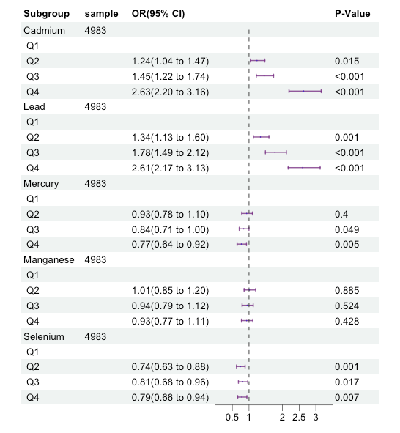

Model1 was adjusted for sex, age, race/ethnicity, education.

Supplementary Figure 2: The forest plot of distributing the association of periodontitis and single metal/metalloid in Model2.
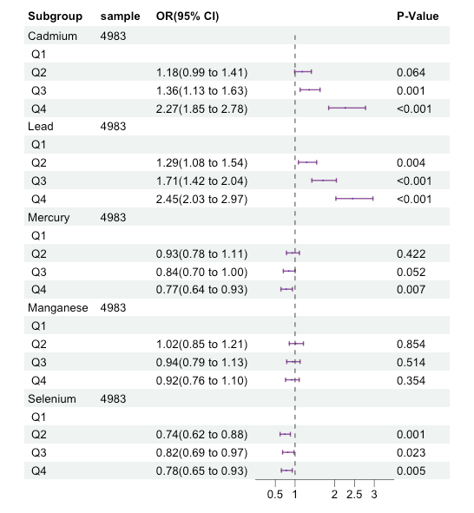

Model2 was adjusted by sex, age, race/ethnicity, education, body mass index, smoking status, drinking alcohol status.

Supplementary Figure 3: The forest plot of distributing the association of periodontitis and single metal/metalloid in Model3.
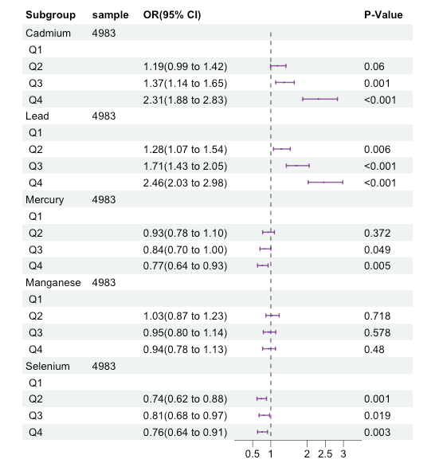

Model3 was adjusted by sex, age, race/ethnicity, education, body mass index, smoking status, drinking alcohol status, diabetes, hypertension and hyperlipidemia.

Supplementary Figure 4: The forest plot of distributing the association of periodontitis and joint metal/metalloid.
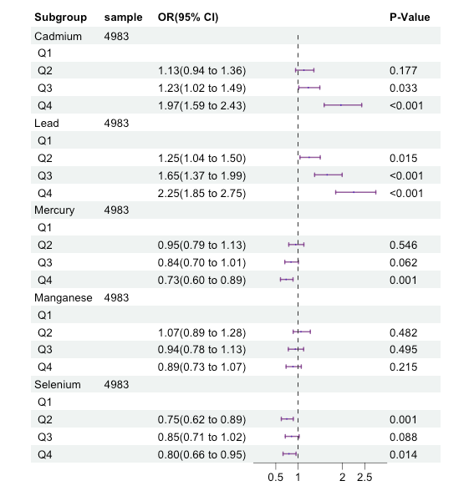
The multivariate logistic model was adjusted for sex, age, race/ethnicity, education, body mass index, smoking status, drinking alcohol status, diabetes, hypertension and hyperlipidemia.

Supplementary Figure 5: Correlation Matrix of five metals.
