Table 1 Optimization of Time and Temperature with Tf₂NH for 1a
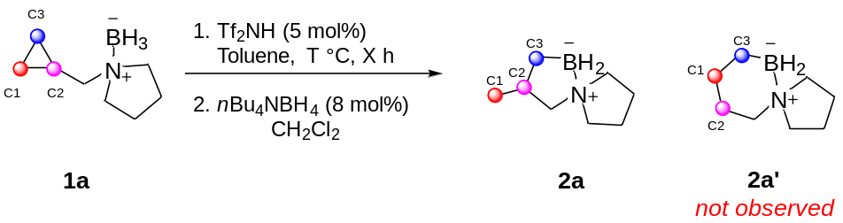
Entry | Temperature  (°C) | Tf₂NH  (mol%) | Time (h) | 2a  Yield (%)
1 | rt | 5 | 16 | No  conversion
2 | 80 | 5 | 60 | 25
3 | 100 | 5 | 4 | 15
4 | 100 | 5 | 16 | 47
5 | 125 | 5 | 1 | 20
6 | 125 | 5 | 3 | 69
7 | 125 | 5 | 4.5 | 99
8 | 125 | 100 | 1 | 99

Table 2 Reaction scope of the formal cyclopropane hydroboration reaction
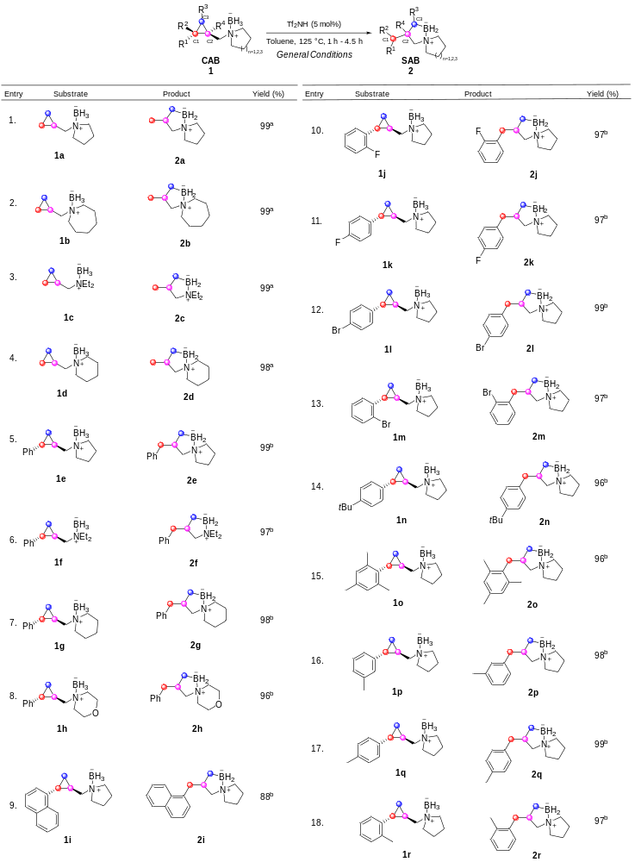

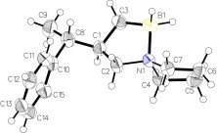
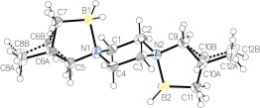
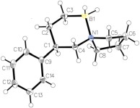
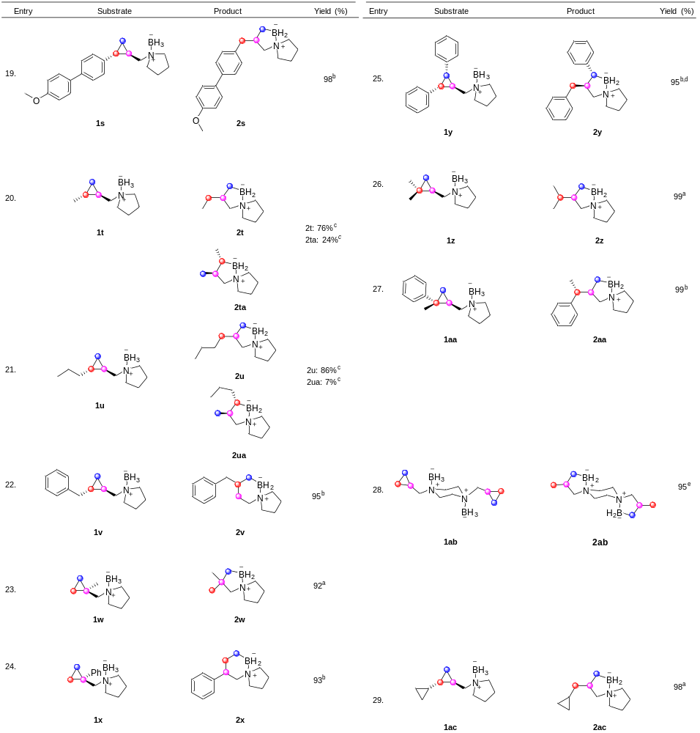

Conditions: ªReaction time: 4.5 h. ^{b}Reaction time: 1.5 h. ^{c}Reaction time: 1 h, Tf₂NH: 50 mol% ^{d}T = 150 °C. ^{e}Reaction time: 2 h, Tf₂NH: 2 equivalents.

