Supporting Information
Cyclopropanes to Spirocyclic Amine-Boranes: Merging Metal Free C‒H Bond Activation and C‒C Bond Cleavage

Saher H. Siddiqui and André B. Charette*

Centre in Green Chemistry and Catalysis, Center for Continuous Flow Synthesis, Department of Chemistry, Université de Montréal, 1375, av. Thérèse Lavoie-Roux, Montréal, Québec H2V 0B3, Canada
andre.charette@umontreal.ca

Table of Contents

Experimental Section 3
General Methods 3
Optimization of Reaction Conditions 5
Synthesis and Characterization of Compounds 9
Synthesis of Cyclopropane Amine-Boranes (CABs) 9
Synthesis of Cyclopropyl Methanols ‒ General Procedure A 9
Synthesis of Cyclopropyl Carboxylic Acids ‒ General Procedure B 10
Synthesis of Cyclopropane Amine‒Boranes – General Procedure C 11
Synthesis of Spirocyclic Amine-Boranes (SABs) ‒ General Procedure D 44
Post-Functionalization 75
Synthesis to SAB-F₂ Analogues 75
Derivatization to Boronic Acid and Boronic Esters 79
Suzuki-Miyaura Cross-Coupling 83
Chan-Lam Cross-Coupling 86
Oxidation of C‒B bond 87
Regioselectivity in the Transformation of CABs to SABs 88
Mechanistic Studies Using Deuterium Experiments 89
Variable Temperature NMR Experiment 91
Single-Crystal XRD Structures of CABs and SABs 92
1-((2-(p-Tolyl)cyclopropyl)methyl)pyrrolidine borane (1q): 92
3-(4-Methylbenzyl)-5-aza-1-boraspiro[4.4]nonane (2q): 93
9-Phenyl-5-aza-6-boraspiro[4.5]decane (2x): 94
1-(((1S,2S)-2-Methyl-2-phenylcyclopropyl)methyl)pyrrolidine borane (1aa): 95
3-((S)-1-Phenylethyl)-5-aza-1-boraspiro[4.4]nonane (2aa): 97
1,4-Bis(cyclopropylmethyl)piperazine borane (1ab): 98
3,11-Dimethyl-5,8-diaza-1,9-diboradispiro[4.2.4]tetradecane (2ab): 99
References 100

Experimental Section

General Methods
Unless otherwise stated, all glassware was oven dried and/or was flame-dried prior to use. All reactions were set up and carried out under an argon atmosphere. Anhydrous solvents were obtained either by filtration through drying columns on a GlassContour system (Irvine, CA) (benzene, acetonitrile, and THF) or by distillation over calcium hydride (triethylamine, pyridine and dichloromethane) or sodium (THF). Methanol, glacial acetic acid, formic acid, and benzoic acid were used as is from commercial bottles. Unless otherwise noted, all solutions are aq. solutions. Analytical thin-layer chromatography (TLC) was performed on precoated, glass-backed silica gel (Merck 60 F254). Visualization of the developed chromatogram was performed by UV absorbance (254 nm), UV fluorescence (350 nm) or by staining with aq. potassium permanganate (KMnO₄), p-Anisaldehyde, or ninhydrin. Flash column chromatography was performed using silica gel (pore size 60 Å, 230-400 mesh particle size, 40-63 μm particle size) in glass columns for the separation of products. Melting points were obtained on a Buchi melting point B-540 apparatus and are uncorrected. Specific rotations, [α]_{D} values, were calculated from optical rotations measured at 25 °C in MeOH at the specified concentrations (c in g/100 ml) using a 0.5-dm cell length (l) on a Perkin-Elmer Polarimeter 241 at 589 nm, using the general formula: [α]²⁵_{D}= (100 × α)/(l × c). Nuclear magnetic resonance spectra (¹H NMR, ¹³C NMR) were recorded on Bruker AV400, AV500, and AV700 MHz spectrometers and ¹¹B and ¹⁹F NMR spectra were recorded on AV400 and AV500. The corresponding chemical shifts for ¹H NMR and ¹³C NMR spectra are reported in parts per million relative to the chemical shift of tetramethylsilane and recorded in CDCl₃, using the residual CHCl₃ as a reference (¹H: δ 7.26 ppm, ¹³C: δ 77.2 ppm), (CD₃)₂CO using the residual solvent as a reference (¹H: δ 2.09 ppm, ¹³C: δ 205.9 ppm) and (CD₃)₂SO using the residual solvent as a reference (¹H: δ 2.54 ppm, ¹³C: δ 40.5 ppm). All ¹³C NMR spectra were obtained with complete proton decoupling. Data is reported as follows: chemical shift, multiplicity (s = singlet, d = doublet, t = triplet, q = quartet, qn = quintet, sx = sextet, h = heptet, m = multiplet and br = broad), coupling constant in Hz and integration. Infrared spectra were taken on a Bruker Vertex Series FTIR (neat) and are reported in reciprocal centimeters (cm⁻¹). High resolution mass spectra (HRMS) were performed on an LC-MSD instrument from Agilent technologies 1200 series in positive electrospray ionization (ESI Pos) and atmospheric-pressure chemical ionization (APCI). Analytical SFC were performed by the Centre de Spectroscopie de Masse de l'Université de Montréal. SFC data are reported as follows: (column type, eluent, flow rate, pressure: retention time (tr)).
Reagents used: All organic extracts were dried over sodium sulfate, filtered, and concentrated under vacuum. Diethylzinc was purchased neat from AkzoNobel and used without further purification. Bis(trifluoromethanesulfonamide), thionyl chloride, pyrrolidine, BH₃-DMS were purchased from Sigma-Aldrich and were used without further purification. Unless specified, all reagents for Suzuki cross-coupling reactions were used without further purification and palladium catalysts were handled in the glovebox. All reagents used were purified using standardized protocols.

Optimization of Reaction Conditions
General Procedure for the Optimization of Activating Reagent, Time, and Temperature
Cyclopropane 1a was added to a microwave reaction vial (volume size: 2‒5 mL) and placed under positive argon pressure. The activating agent (5 mol%) was added followed by the addition of the solvent (0.4 M). The microwave vial was sealed with a microwave vial cap and heated at the temperatures described below (see Table S1 and S2). Once the reaction time was complete, the reaction mixture was quenched by adding solid (nBu₄)NBH₄ (8 mol%) under argon atmosphere. The mixture was then diluted with CH₂Cl₂ and filtered over a short pad of silica. The silica pad was washed twice with CH₂Cl₂, and the filtrate was concentrated under reduced pressure. The residue was analyzed by NMR spectroscopy to determine the formation of 2a.

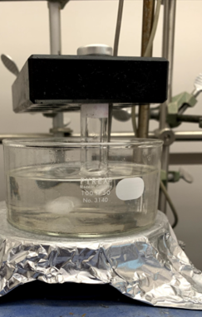
Table S1: Screening of Activating Reagent
Entry | Activating Reagent | pKa (MeCN) | Result
1 | None | N/A | SM
2 | Tf₂NH | 0.3 | 2a  (99% conversion)
3 | 4-Nitrobenzenesulfonamide | 24.9 | SM
4 | TfOH | 0.7 | SM
5 | Acetic Acid | 23.5 | SM
6 | Formic acid | 21.5 | SM
7 | Benzoic acid | 20.5 | SM

Table S2: Optimization of Time and Temperature Using Tf₂NH
Entry | Temperature  (°C) | Tf₂NH  (mol%) | Time (h) | 2a  Yield (%)
1 | rt | 5 | 16 | No  conversion
2 | 80 | 5 | 60 | 25
3 | 100 | 5 | 4 | 15
4 | 100 | 5 | 16 | 47
5 | 125 | 5 | 1 | 20
6 | 125 | 5 | 3 | 69
7 | 125 | 5 | 4.5 | 99
8 | 125 | 100 | 1 | 99ª

ªThe reaction was quenched with one equivalent of nBu₄NBH₄

Effect of Substituent
A relationship between the nature of substituents and the reaction time was observed. CABs substituted with aromatic substituents underwent ring-opening faster than those with aliphatic or no substituents. For entries 1 and 2, the reactions did not go to completion and starting material was present in the crude ¹H NMR spectrum.
Table S3: Effect of Substituent
Entry | R | Yield (%)
1 | Pr | 15
2 | H | 20
3 | Ph | 99
4 | p-Fluorobenzene | 99

Summary of Optimization Results
The reaction was optimized to provide 2a in quantitative yield at 125 °C in 4.5 h using Tf₂NH (5 mol%) as the activating agent and toluene as the solvent (Table S2). During optimization, it was found that heating the reaction mixture to 160 °C for 16 h provided the 5‒5 spirocyclic amine‒borane motif resulting from the cleavage of C2‒C3 distal carbon bond. The ring-opened product was evident by a characteristic doublet at 1.07 ppm in the ¹H NMR spectrum and additional NMR correlation studies confirmed the formation of SAB 2a. The ¹³C NMR spectrum consisted of a broad signal at 21.9 ppm, indicating the formation of a C‒B bond. In addition, a well-resolved triplet was observed in the ¹¹B NMR spectrum at ‒3.6 ppm which supported the presence of a tetracoordinate boron bearing two hydrogen atoms, further confirming the formation of SAB 2a. During the optimization, it was also established that the reaction did not proceed to form 2a at room temperature in the presence of Tf₂NH or while heating in the absence of Tf₂NH. No ring-opened product was observed when Tf₂NH was replaced by other activating agents (Table S1). When the temperature was lowered to 100 °C and the reaction time was increased to 16 h (Table S2, entry 7) the yield of 2a decreased to 47% conversion while only 15% yield was obtained after 4 h at 100 °C (Table S2, entry 8). A maximum of 25% conversion to 2a was obtained when the reaction was run for 60 h at 80 °C (Table S2, entry 9). Generally, an increase in temperature and reaction time provided a linear correlation with respect to conversion. A stoichiometric amount of Tf₂NH led to the formation of 2a in quantitative yield in 1 h at 125 °C.

Synthesis and Characterization of Compounds

Synthesis of Cyclopropane Amine-Boranes (CABs)

Synthesis of Cyclopropyl Methanols ‒ General Procedure A
Cyclopropanemethanol analogues were synthesized according to literature procedures.¹ To a flame-dried round bottom flask under was added CH₂Cl₂ (30 mL) and DME (1 equiv) under argon atmosphere followed by the addition of Et₂Zn (1 equiv). The reaction mixture was cooled to ‒12 °C and diiodomethane (1 equiv) was added dropwise over a period of 5 min while maintaining the internal temperature between ‒12 °C to – 8 °C. The reaction mixture was stirred for 10 min and a solution of the corresponding allylic alcohol (7 mmol) in CH₂Cl₂ (6 mL) was added over a period of 5 min while maintaining an internal temperature of ‒5 °C. The mixture was warmed to room temperature and stirred for 12 h under positive argon pressure. The reaction mixture was quenched with a dropwise addition of aq. NH₄Cl (3 mL) and the mixture was transferred to a separatory funnel. The organic layer was separated, and the aqueous layer was extracted with EtOAc (3 x 25 mL). The combined organic layers were dried over anhydrous Na₂SO₄, filtered, and concentrated under reduced pressure. The residue was purified by silica gel chromatography (1:4 EtOAc/hexanes) to provide the corresponding cyclopropylmethanols in 50% ‒ 85% yield.
Synthesis of Allylic Alcohols: (Wittig Reaction) A mixture of the corresponding aldehyde (~10 mmol) and (carbethoxymethylene)triphenylphosphorane (2 equiv) in toluene (0.1 M) was refluxed for 16 h. The solvent was removed under reduced pressure and the residue was purified by silica gel chromatography (1:4 EtOAc/hexanes) to provide the corresponding ester. The product was added to a flame dried round bottom flask and diluted with toluene (22 mL). The mixture was cooled to 0 °C and DIBAL‒H (1.0 M in hexanes, 2 equiv) was added to the flask. The reaction mixture was stirred at 0 °C for 2 h. After the reaction time was complete, the reaction mixture was quenched with a dropwise addition of 1 N HCl (10 mL). The mixture was then diluted with H₂O (10 mL) and EtOAc (20 mL) and transferred into a separatory funnel. The organic layer was separated, and the aqueous layer was extracted with EtOAc (3 x 20 mL). The combined organic layers were dried over anhydrous Na₂SO₄, filtered, and concentrated under reduced pressure. The residue was purified by silica gel chromatography (1:4 EtOAc/hexanes) to provide the pure corresponding allylic alcohol.

Synthesis of Cyclopropyl Carboxylic Acids ‒ General Procedure B
Periodic acid (2 equiv) and CrO₃ (1 mol%) were added to a flame-dried flask containing MeCN (0.2 M). The reaction mixture was allowed to stir for 10 min at room temperature. The flask was cooled to 0 °C and a solution of the cyclopropanemethanol (1 equiv) (prepared according to General Procedure A) in MeCN (1.5 M) was added dropwise to the flask while stirring vigorously. Once the addition was complete the mixture was stirred for 10 min, following which the solvent was removed under reduced pressure. The solid residue was dissolved in H₂O (~3 mL/mmol) and EtOAc was added to the flask (1:1 EtOAc:H₂O) and stirred for 10 seconds. The mixture was transferred into a separatory funnel and the aqueous layer was extracted with EtOAc (3x) and separated. The combined organic layers were washed with H₂O (~3 mL/mmol), dried over anhydrous Na₂SO₄, filtered, and concentrated under reduced pressure to provide a residue in the form of a pale orange oil or solid depending on the substrate. The residue was used as is for the next step without further purification.

Synthesis of Cyclopropane Amine‒Boranes – General Procedure C
1-(Cyclopropylmethyl)pyrrolidine borane: Scaled to ~14 g (1a)
Cyclopropanecarboxylic acid (12.0 g, 120 mmol) was added to a 250 mL flame-dried round bottom flask followed by the addition of CH₂Cl₂ (100 mL). The flask was cooled to –10 °C followed by the addition of SOCl2 (26.1 mL, 360 mmol) in one portion and reaction mixture was refluxed for 2 h to form the acyl chloride. After 2 h, the excess SOCl2 and CH₂Cl₂ was distilled off and the residue was dissolved in CH₂Cl₂ (40 mL). A solution of pyrrolidine (32.9 mL, 401 mmol) in CH₂Cl₂ (15 mL) was prepared in a second 250 mL flame-dried round bottom and placed in an ice bath. The solution of the acyl chloride was added dropwise into the flask at 0 °C over a period of 10 min (exothermic!). The ice bath was removed, and the reaction mixture was stirred at room temperature for 20 min. The reaction mixture was transferred into a 500 mL separatory funnel and 150 mL 10% aq. NaOH solution was added. The organic layer was separated, and the aqueous layer was extracted with CH2Cl2 (2 x 100 mL). The combined organic layers were dried over anhydrous Na₂SO₄, filtered, and concentrated under reduced pressure to provide the corresponding amide as a viscous oil. The oil was then added to a flame-dried 250 mL round bottom flask containing anhydrous THF (110 mL). The solution was cooled to 0 °C followed by the dropwise addition of BH3•SMe2 (21.5 mL, 227 mmol, 1.7 equiv) over 10 min. (exothermic!). After the exothermic reaction ceased (~30 sec), the reaction mixture was refluxed for 2 h. The reaction mixture was then cooled and poured slowly over a short pad of silica gel to decompose any residual BH3•SMe2. The pad of silica gel was eluted with CH2Cl2 (3 x 5 mL) and the filtrate was concentrated under reduced pressure. The residue was purified by column chromatography (1:9 EtOAc:Hexanes, R_{f}: 0.4) to provide CAB 1a as a clear oil in 75% yield (13.8 g, 136 mmol).
¹H NMR (500 MHz, CDCl₃) δ 3.26 ‒ 3.15 (m, 2H, H_{5,8}), 2.95 ‒ 2.87 (m, 2H, H_{5,8}), 2.69 (d, J = 6.7 Hz, 2H, H₄), 2.21 – 2.11 (m, 2H, H_{6,7}), 1.95 (br, 1H, BH₉), 1.91 – 1.80 (m, 2H, H_{6,7}), 1.77 (br, 1H, BH₉), 1.58 (br, 1H, BH₉), 1.41 – 1.28 (m, 1H, H₂), 0.68 – 0.58 (m, 2H, H_{1,3}), 0.22 – 0.14 (m, 2H, H_{1,3}).
¹³C NMR (126 MHz, CDCl₃) δ 67.7, 60.5 (2C), 23.0 (2C), 6.9, 4.4 (2C).

¹¹B NMR δ –11.7 ppm.

IR (film) ν_{max}: 2996, 2368, 2275, 1458, 1166, 1026, 935, 830 cm⁻¹.

HRMS (ESI, m/z): calculated for [M + Na]⁺ C₈H₁₈BN requires m/z 162.1424, found m/z 162.1431.

1-(Cyclopropylmethyl)azepane borane (1b)
Cyclopropanecarboxylic acid (300 mg, 2.9 mmol) was converted to CAB 1b using general procedure C modified with azepane (647 µL, 5.7 mmol). Purification by column chromatography (1:9 EtOAc:Hexanes, R_{f}: 0.4) provided CAB 1b in 71% yield (340 mg, 2.0 mmol).
¹H NMR (400 MHz, CDCl₃) δ 3.10 (dd, J = 13.6, 8.4 Hz, 2H, H_{5,10}), 2.99 (dd, J = 13.7, 8.8 Hz, 2H, H_{5,10}), 2.63 (d, J = 6.7 Hz, 2H, H₄), 2.06 – 1.77 (m, 2H, H_{6,9}), 1.68 – 1.45 (m, 8H, H_{6,9} H_{7,8}, H₁₁), 1.45 – 1.28 (m, 2H, H_{2,} H₁₁), 0.72 – 0.56 (m, 2H, H_{1,3}), 0.21 ‒ 0.15 (m, 2H, H_{1,3}).

¹³C NMR (101 MHz, CDCl₃) δ 68.5, 60.6 (2C), 29.5 (2C), 22.7 (2C), 6.4, 4.7 (2C).

¹¹B NMR δ ‒10.9 ppm.

IR (film) ν_{max} 2962, 2857, 2364, 2322, 2277, 1342, 1165, 1048, 1014, 880 cm ⁻¹.

HRMS (ESI, m/z): calculated for [M ‒ 2H]⁺ C₁₀H₂₀BN requires m/z 166.1762, found m/z 166.1760.

N-(Cyclopropylmethyl)-N-ethylethanamine borane (1c)
Cyclopropanecarboxylic acid (103 mg, 1.2 mmol) was converted to CAB 1c using general procedure C modified with diethylamine (247 μL, 2.4 mmol). Purification by column chromatography (1:9 EtOAc:Hexanes, R_{f}: 0.4) provided CAB 1c in 87% yield (147 mg, 1.0 mmol).

¹H NMR (500 MHz, CDCl₃) δ 3.00 – 2.81 (m, 4H, H_{5,7}), 2.62 (d, J = 6.7 Hz, 2H, H₄), 1.73 (br, 1H, H₉), 1.42 (br, 1H, H₉), 1.30 (br, 1H, H₉), 1.21 (t, J = 7.3 Hz, 6H, H_{6,8}), 1.19 – 1.11 (m, 1H, H₂), 0.70 – 0.54 (m, 2H, H_{1,3}), 0.25 ‒ 0.20 (m, 2H, H_{1,3}).

¹³C NMR (126 MHz, CDCl₃) δ 63.0, 53.2 (2C), 9.1 (2C), 5.48, 4.5 (2C).

¹¹B NMR δ ‒13.1 ppm.

IR (film) ν_{max}: 3081, 3001, 2980, 2380, 2326, 2278, 1468, 1388, 1168, 1021, 828 cm⁻¹.

HRMS (ESI, m/z): calculated for [M ‒ 2H]⁺ C₈H₁₈BN requires m/z 140.1605, found m/z 140.1605.

1-(Cyclopropylmethyl)piperidine borane (1d)
Cyclopropanecarbonyl chloride (1.7 g, 16.1 mmol) was converted to CAB 1d using general procedure C modified with piperidine (4.7 mL, 47.5 mmol). Purification by column chromatography (1:9 EtOAc:Hexanes, R_{f}: 0.4) provided CAB 1d in 76% yield (1.9 g, 12.2 mmol).

¹H NMR (400 MHz, CDCl₃) δ 3.01 ‒ 2.94 (m, 2H, H_{5,9}), 2.88 – 2.71 (m, 2H, H_{5,9}), 2.63 (d, J = 6.7 Hz, 2H, H₄), 2.01 ‒ 1.90 (m, 2H, H_{6,8}), 1.74 (br, 1H, H₁₀), 1.62 – 1.45 (m, 4H, H_{6,8,} H_{7,} H₁₀), 1.44 – 1.28 (m, 3H, H_{2,} H_{7,} H₁₀), 0.68 – 0.50 (m, 2H, H_{1,3}), 0.18 – 0.14 (m, 2H, H_{1,3}).

¹³C NMR (101 MHz, CDCl₃) δ 68.6, 58.1 (2C), 23.0, 20.7 (2C), 5.5, 4.4 (2C).

¹¹B NMR δ ‒12.1 ppm.

IR (film) ν_{max}: 2954, 2863, 2365, 2274, 1449, 1172, 1088, 1038 cm ⁻¹.

HRMS (ESI, m/z): calculated for [M ‒ 2H]⁺ C₉H₁₈BN requires m/z 152.1605, found m/z 152.1601.

*CABs 1e-1h were synthesized from 2-phenylcyclopropane-1-carbonyl chloride according to general procedure C (modified with respective amines)*

1-((2-Phenylcyclopropyl)methyl)pyrrolidine borane (1e)
CAB 1e was prepared according to general procedure C starting from commercially available 2-phenylcyclopropane-1-carbonyl chloride (200 mg, 1.1 mmol) and pyrrolidine (269 µL, 3.3 mmol). Purification by column chromatography (1:9 EtOAc:Hexanes, R_{f}: 0.4) provided CAB 1e as a white solid in 86% yield (205 mg, 1.0 mmol).

¹H NMR (500 MHz, CDCl₃) δ 7.27 (t, J = 7.5 Hz, 2H, ArH), 7.20 (tt, J = 7.4, 1.3 Hz, 1H, ArH), 7.12 (dd, J = 8.8, 0.9 Hz, 2H, ArH), 3.31 – 3.13 (m, 2H, H_{5,8}), 2.98 (dd, 1H, J = 12.9, 6.3 Hz, 1H, H₄), 2.92 – 2.82 (m, 2H, H_{5,8}), 2.78 (dd, J = 12.8, 7.2 Hz, 1H, H₄), 2.25 ‒ 2.18 (m, 2H, H_{6,7}), 1.96 – 1.82 (m, 3H, H_{6,7,} H₉), 1.82 – 1.76 (m, 1H, H₁), 1.76 – 1.68 (m, 1H, H₂), 1.58 (br, 1H, H₉), 1.50 – 1.36 (br, 1H, H₉), 1.08 (dt, J = 8.6, 5.3 Hz, 1H, H₃), 0.93 – 0.84 (dt, J = 8.8, 5.3 Hz 1H, H₃).

¹³C NMR (126 MHz, CDCl₃) δ 141.6, 128.6 (2C), 126.1, 126.0 (2C), 67.1, 60.9, 60.5, 23.3, 22.9 (2C), 18.6, 14.8.

¹¹B NMR δ ‒11.6 ppm.

IR (film) ν_{max}: 2367, 2273, 1603, 1497, 1458, 1164, 1095, 756, 697 cm⁻¹.

HRMS (ESI, m/z): calculated for [M + Na]⁺ C₁₄H₂₂BN requires m/z 238.1738, found m/z 238.1730.

mp 44‒46 °C.

N-Ethyl-N-((2-phenylcyclopropyl)methyl)ethanamine borane (1f)
CAB 1f was prepared according to general procedure C starting from commercially available 2-phenylcyclopropane-1-carbonyl chloride (200 mg, 1.1 mmol) and Et₂NH (338 µL, 3.3 mmol). Purification by column chromatography (1:9 EtOAc:Hexanes, R_{f}: 0.4) provided CAB 1f as a clear oil in 86% yield (207 mg, 1.0 mmol).

¹H NMR (500 MHz, CDCl₃) δ 7.30 – 7.24 (m, 2H, ArH), 7.21 (tt, J = 7.3, 1.3 Hz, 1H, ArH), 7.11 – 7.05 (m, 2H, ArH), 2.95 – 2.83 (m, 5H, H_{5,8}, H₄), 2.72 (dd, J = 13.5, 7.4 Hz, 1H, H₄), 1.83 – 1.75 (m, 1H, H₁), 1.53 – 1.45 (m, 1H, H₂), 1.88 − 1.39 (br, 3H, H₉), 1.23 (td, J = 7.3, 4.9 Hz, 6H, H_{6,7}), 1.08 (dt, J = 8.7, 5.3 Hz, 1H₃), 0.89 (dt, J = 8.9, 5.5 Hz, 1H₃).

¹³C NMR (126 MHz, CDCl₃) δ 141.7, 128.6 9 (2C), 126.1, 125.9 (2C), 62.7, 53.4, 53.1, 23.3, 17.4, 14.7, 9.1 (2C).

¹¹B NMR δ ‒12.9 ppm.

IR (film) ν_{max}: 2379, 2328, 2278, 1603, 1461, 1389, 1167, 1029, 758, 697 cm⁻¹;

HRMS (ESI, m/z): calculated for [M + Na]⁺ C₁₄H₂₄BN requires m/z 240.1894, found m/z 240.1896.
1-((2-Phenylcyclopropyl)methyl)piperidine borane (1g)
CAB 1g was prepared according to general procedure C starting from commercially available 2-phenylcyclopropane-1-carbonyl chloride (338 mg, 1.9 mmol) and piperidine (545 µL, 5.5 mmol). Purification by column chromatography (1:9 EtOAc:Hexanes, R_{f}: 0.4) provided CAB 1g as a clear oil in 87% yield (370 mg, 1.6 mmol).

¹H NMR (500 MHz, CDCl₃) δ 7.30 – 7.22 (m, 2H, ArH), 7.20 (tt, J = 7.3, 1.2 Hz 1H, ArH), 7.13 ‒ 7.10 (m, 2H, ArH), 3.08 – 2.95 (m, 2H, H_{5,9}), 2.91 (dd, J = 12.9, 5.7 Hz, 1H, H₄), 2.85 (dd, J = 13.3, 7.8 Hz, 2H, H_{5,9}), 2.79 (dd, J = 13.0, 6.8 Hz, 1H, H₄), 1.97 – 1.89 (m, 2H, H_{6,8}), 1.83 – 1.70 (m, 3H, H₂, H_{6,8}), 1.65 – 1.53 (m, 4H, H_{7,} 3H₁₀), 1.53 – 1.40 (m, 2H, H₁, H₇), 1.08 (dt, J = 8.5, 5.3 Hz, 1H, H₃), 0.89 (dt, J = 8.8, 5.5 Hz, 1H, H₃).

¹³C NMR (126 MHz, CDCl₃) δ 141.6, 128.5 (2C), 126.03, 126.0 (2C), 65.9, 58.6, 58.0, 23.3, 23.0, 20.9, 20.8, 17.3, 14.8.

¹¹B NMR δ ‒11.9 ppm.
IR (film) ν_{max}: 2954, 2939, 2861, 2361, 2341, 1457, 1173, 757 cm⁻¹.
HRMS (ESI, m/z): calculated for [M + Na]⁺ C₁₅H₂₄BN requires m/z 252.1894, found m/z 252.1902.

4-((2-Phenylcyclopropyl)methyl)morpholine borane (1h)
CAB 1h was prepared according to general procedure C starting from commercially available 2-phenylcyclopropane-1-carbonyl chloride (250 mg, 1.4 mmol) and morpholine (351 µL, 4.0 mmol). Purification by column chromatography (1:9 EtOAc:Hexanes, R_{f}: 0.4) provided CAB 1h as a clear oil in 84% yield (270 mg, 1.2 mmol).

¹H NMR (500 MHz, CDCl₃) δ 7.32 ‒ 7.28 (m, 2H, ArH), 7.21 (tt, J = 7.4, 1.2 Hz, 1H, ArH), 7.15 – 7.07 (m, 2H, ArH), 4.39 – 4.18 (m, 2H, H_{5,8}), 3.73 (dq, J = 6.1, 2.8 Hz, 2H, H_{5,8}), 3.13 – 2.96 (m, 3H, H₄, H_{6,7}), 2.94 ‒ 2.87 (m, 2H, H_{6,7}), 2.84 (dd, J =13.5, 7.4 Hz, 1H, H₄) 1.97 (br, 1H, H₉), 1.87 – 1.72 (m, 3H, H₁, H₂, 1H₉), 1.64 (br, 1H, H₉), 1.15 (dt, J = 8.6, 5.4 Hz, 1H, H₃), 0.94 (dt, J = 8.8, 5.5 Hz, 1H, H₃).

¹³C NMR (126 MHz, CDCl₃) δ 141.2, 128.7 (2C), 126.2, 126.0 (2C), 70.4, 62.2, 62.1, 57.8, 57.4, 23.5, 16.6, 15.0.
¹¹B NMR δ ‒13.3 ppm.
IR (film) ν_{max}: 2954, 2939, 2861, 2361, 2341, 1457, 1173, 757 cm⁻¹.

HRMS (ESI, m/z): calculated for [M + Na]⁺ C₁₄H₂₂BNO requires m/z 254.1687, found m/z 254.1678.

1-((2-(Naphthalen-1-yl)cyclopropyl)methyl)pyrrolidine borane (1i)
2-(Naphthalen-1-yl)cyclopropane-1-carboxylic acid (332 mg, 1.6 mmol) was converted to CAB 1i according to general procedure C. Purification by column chromatography (1:9 EtOAc:Hexanes, R_{f}: 0.4) provided CAB 1i as a white solid in 56% yield (274 mg, 1.0 mmol).

¹H NMR (500 MHz, CDCl₃) δ 7.78 (d, J = 8.6 Hz, 1H, ArH), 7.76 (d, J = 8.8 Hz, 2H, ArH), 7.55 (s, 1H, ArH), 7.49 – 7.37 (m, 2H, ArH), 7.21 (dd, J = 8.5, 1.6 Hz, 1H, ArH), 3.32 – 3.15 (m, 2H, H_{5,8}), 3.02 (dd, J = 12.8, 6.0 Hz, 1H, H₄), 2.95 ‒ 2.86 (m, 2H, H_{5,8}), 2.82 (dd, J = 12.8, 7.4 Hz, 1H, H₄), 2.23 – 2.13 (m, 2H, H_{6,7}), 2.00 – 1.92 (m, 1H, H₁), 1.91 – 1.79 (m, 4H, H_{6,7}, H_{2,} H₉), 1.65 (br, 2H, H₉), 1.20 (dt, J = 8.7, 5.3 Hz, 1H, H₃), 0.97 (dt, J = 8.9, 5.5 Hz, 1H, H₃).

¹³C NMR (126 MHz, CDCl₃) δ 139.1, 133.6, 132.2, 128.3, 127.7, 127.5, 126.3, 125.3, 124.7, 124.2, 67.1, 61.0, 60.5, 23.6, 23.0, 22.96, 18.6, 14.8.
¹¹B NMR δ ‒11.6 ppm.

IR (film) ν_{max}: 2980, 2925, 2850, 2359, 2338, 2274, 2177, 1631, 1599, 1457, 1170, 1094 cm⁻¹
HRMS (ESI, m/z): calculated for [M + Na]⁺ C₁₈H₂₄BN requires m/z 288.18940, found m/z 288.18941.

mp 116‒117 °C.

1-((2-(2-Fluorophenyl)cyclopropyl)methyl)pyrrolidine borane (1j)
2-(2-Fluorophenyl)cyclopropane-1-carboxylic acid (1.13 g, 6.2 mmol) was converted to CAB 1j according to general procedure C. Purification by column chromatography (1:9 EtOAc:Hexanes, R_{f}: 0.4) provided CAB 1j as a white solid in 96% yield (1.39 g, 5.94 mmol).

¹H NMR (400 MHz, CDCl₃) δ 7.21 ‒ 7.15 (m, 1H, ArH), 7.09 – 6.89 (m, 3H, ArH), 3.32 – 3.14 (m, 2H, H_{5,8}), 2.99 (dd, J = 12.8, 6.0 Hz, 1H, H₄), 2.96 ‒ 2.84 (m, 2H, H_{5,8}), 2.76 (dd, J = 12.8, 7.3 Hz, 1H, H₄), 2.26 – 2.11 (m, 2H, H_{6,7}), 2.03 – 1.93 (m, 1H, H₁), 1.94 – 1.84 (m, 2H, H_{6,7}), 1.86 ‒ 1.79 (m, 2H, H₂, H₉), 1.63 (br, 1H, H₉), 1.43 (br, 1H, H₉), 1.11 (dt, J = 8.7, 5.3 Hz, 1H, H₃), 0.96 – 0.85 (dt, J = 8.9, 5.4 Hz, 1H, H₃).

¹³C NMR (101 MHz, CDCl₃) δ 161.8, 128.4, 127.4, 126.3, 124.3, 115.2, 67.0, 61.4, 60.4, 23.0, 22.8, 17.6, 16.4, 13.4.

¹¹B NMR δ ‒11.8 ppm.

¹⁹F NMR δ ‒120.1 ppm.

IR (film) ν_{max}: 2958, 2369, 2273, 1495, 1455, 1237, 1164, 1101, 754 cm⁻¹.
HRMS (ESI, m/z): calculated for [M + Na]⁺ C₁₄H₂₁BFN requires m/z 256.1643, found m/z 256.1644.

mp 51‒52 °C.

1-((2-(4-Fluorophenyl)cyclopropyl)methyl)pyrrolidine borane (1k)
2-(4-Fluorophenyl)cyclopropane-1-carboxylic acid (457 mg, 2.5 mmol) was converted to CAB 1k according to general procedure C. Purification by column chromatography (1:9 EtOAc:Hexanes, R_{f}: 0.4) provided CAB 1k as a white solid in 89% yield (527 mg, 2.3 mmol).

¹H NMR (500 MHz, CDCl₃) δ 7.11 – 7.00 (m, 2H, ArH), 7.00 – 6.90 (m, 2H, ArH), 3.29 ‒ 3.21 (m, 2H, H_{5,8}), 2.94 (dd, J = 12.8, 6.0 Hz, 1H, H₄), 2.90 – 2.79 (m, 2H, H_{5,8}), 2.74 (dd, J = 12.8, 7.4 Hz, 1H, H₄), 2.24 – 2.10 (m, 2H, H_{6,7}), 1.92 – 1.82 (m, 2H, H_{6,7}), 1.82 – 1.75 (m, 1H, H₁), 1.73 – 1.63 (m, 2H, H₂, H₉), 1.41 (br, 2H, H₉), 1.02 (dt, J = 8.7, 5.3 Hz, 1H, H₃), 0.86 (dt, J = 8.9, 5.5 Hz, 1H, H₃).

¹³C NMR (126 MHz, CDCl₃) δ 161.5, 137.2, 127.6 (2C), 115.3 (2C), 67.1, 60.9 (2C), 22.9 (2C), 22.8, 18.5, 14.5.

¹¹B NMR δ ‒11.7 ppm.

¹⁹F NMR δ ‒117.3 ppm.

IR (film) ν_{max}: 2960, 2371, 2274, 1603, 1510, 1215, 1162, 830, 540 cm⁻¹.
HRMS (ESI, m/z): calculated for [M + Na]⁺ C₁₄H₂₁BFN requires m/z 256.1643, found m/z 256.1641.

mp 59‒60 °C.

1-((2-(4-Bromophenyl)cyclopropyl)methyl)pyrrolidine borane (1l)
2-(4-Bromophenyl)cyclopropane-1-carboxylic acid (384 mg, 1.7 mmol) was converted to CAB 1l according to general procedure C. Purification by column chromatography (1:9 EtOAc:Hexanes, R_{f}: 0.4) provided CAB 1l as a white solid in 82% yield (408 mg, 1.4 mmol).

¹H NMR (500 MHz, CDCl₃) δ 7.38 (d, J = 8.4 Hz, 2H, ArH), 6.97 (d, J = 8.4 Hz, 2H, ArH), 3.30 – 3.19 (m, 2H, H_{5,8}), 2.94 (dd, J = 12.8, 5.9 Hz, 1H, H₄), 2.91 – 2.83 (m, 2H, H_{5,8}), 2.74 (dd, J = 12.8, 7.4 Hz, 1H, H₄), 2.25 – 2.16 (m, 2H, H_{6,7}), 1.97 – 1.83 (m, 2H, H_{6,7}), 1.81 – 1.73 (m, 1H, H₁), 1.70 (dd, J = 13.3, 7.3 Hz, 1H, H₂), 1.96 ‒ 1.36 (br, 3H, H₉) 1.05 (dt, J = 8.8, 5.3 Hz, 1H, H₃), 0.90 (dt, J = 8.8, 5.5 Hz, 1H, H₃).

¹³C NMR (126 MHz, CDCl₃) δ 140.7, 131.6 (2C), 127.8 (2C), 119.7, 67.1, 60.9 (2C), 22.96 (2C), 22.9, 18.9, 14.8.

¹¹B NMR δ ‒11.7 ppm.

IR (film) ν_{max}: 2990, 2966, 2369, 2329, 2274, 1634, 1457, 1165, 1007cm⁻¹.
HRMS (ESI, m/z): calculated for [M + Na]⁺ C₁₄H₂₁BBrN requires m/z 316.08426, found m/z 316.08420.

mp 100‒101 °C.

1-((2-(2-Bromophenyl)cyclopropyl)methyl)pyrrolidine borane (1m)

2-(2-Bromophenyl)cyclopropane-1-carboxylic acid (486 mg, 2.1 mmol) was converted to CAB 1m according to general procedure C. Purification by column chromatography (1:9 EtOAc:Hexanes, R_{f}: 0.4) provided CAB 1m as a white solid in 52% yield (324 mg, 1.1 mmol).

¹H NMR (500 MHz, CDCl₃) δ 7.53 (dd, J = 7.9, 1.2 Hz, 1H, ArH), 7.22 (td, J = 7.5, 0.9 Hz, 1H, ArH), 7.10 – 7.05 (m, 2H, ArH), 3.29 – 3.16 (m, 2H, H_{5,8}), 2.96 (dd, J = 12.7, 6.5 Hz, 1H, H₄), 2.95 – 2.86 (m, 3H, H_{5,8,} H₄), 2.23 – 2.12 (m, 2H, H_{6,7}), 2.08 – 1.99 (m, 1H, H₁), 1.94 – 1.83 (m, 3H, H_{6,7}, H₉), 1.87 – 1.79 (m, 2H, H_{2,} H₉), 1.64 ‒ 1.42 (br, 1H, H₉), 1.04 (dt, J = 8.6, 5.4 Hz, 1H, H₃), 0.97 (dt, J = 8.9, 5.5 Hz, 1H, H₃).

¹³C NMR (126 MHz, CDCl₃) δ 140.5, 132.5, 127.68, 127.67, 127.01, 125.8, 66.9, 61.3, 60.5, 23.17, 22.9, 22.8, 17.84, 14.54.

¹¹B NMR δ ‒11.8 ppm.

IR (film) ν_{max}: 3056, 2956, 2879, 2368, 2272, 1477, 1455, 1163, 1022, 747 cm⁻¹.
HRMS (ESI, m/z): calculated for [M + Na]⁺ C₁₄H₂₁BBrN requires m/z 316.0843, found m/z 316.0847.

mp 88‒89 °C.

1-((2-(4-(tert-Butyl)phenyl)cyclopropyl)methyl)pyrrolidine borane (1n)
2-(4-(tert-Butyl)phenyl)cyclopropane-1-carboxylic acid (1.1 g, 5.1 mmol) was converted to CAB 1n according to general procedure C. Purification by column chromatography (1:9 EtOAc:Hexanes, R_{f}: 0.4) provided CAB 1n as a white solid in 87% yield (1.2 g, 4.4 mmol).

¹H NMR (400 MHz, CDCl₃) δ 7.29 (d, J = 8.3 Hz, 2H, ArH), 7.03 (d, J = 8.3 Hz, 2H, ArH), 3.28 – 3.19 (m, 2H, H_{5,8}), 2.99 – 2.82 (m, 3H, H_{5,8}, H₄) 2.77 (dd, J = 12.8, 7.1 Hz, 1H, H₄), 2.26 – 2.07 (m, 2H, H_{6,7}), 1.93 – 1.80 (m, 3H, H_{6,7}, H₉), 1.79 – 1.62 (m, 3H, H₁, H₂, H₉), 1.50 (br, 1H, H₉), 1.30 (s, 9H, H₁₄), 1.06 (dt, J = 8.6, 5.3 Hz, 1H, H₃), 0.86 (dt, J = 8.9, 5.4 Hz, 1H, H₃).

¹³C NMR (101 MHz, CDCl₃) δ 140.0, 138.5, 125.8 (2C), 125.5 (2C), 67.0, 60.9, 60.4, 34.5, 31.5 (3C), 23.0 (2C), 22.8, 18.3, 14.7.

¹¹B NMR δ ‒11.6 ppm.

IR (film) ν_{max}: 2959, 2871, 2367, 2325, 2273, 1458, 1164, 826, 568 cm⁻¹.
HRMS (ESI, m/z): calculated for [M + Na]⁺ C₁₈H₃₀BN requires m/z 294.2364, found m/z 294.2375.

mp 57‒58 °C.

1-((2-Mesitylcyclopropyl)methyl)pyrrolidine borane (1o)
2-Mesitylcyclopropane-1-carboxylic acid (850 mg, 4.2 mmol) was converted to CAB 1o according to general procedure C. Purification by column chromatography (1:9 EtOAc:Hexanes, R_{f}: 0.4) provided CAB 1o as a white solid in 51% yield (540 mg, 2.1 mmol).

¹H NMR (400 MHz, CDCl₃) δ 6.86 (s, 2H, ArH), 3.79 (d, J = 12.7 Hz, 1H, H₄), 3.38 – 3.14 (m, 2H, H_{5,8}), 3.05 – 2.83 (m, 2H, H_{5,8}), 2.38 (s, 6H, H_{12,13}), 2.28 (s, 3H, H₁₄), 2.26 – 2.18 (m, 4H, H_{5.7}, H₄, H₉), 1.93 (d, J = 3.3 Hz, 3H, H_{6,7}, H₉), 1.67 – 1.55 (m, 2H, H₁, H₉), 1.49 (dd, J = 13.9, 5.9 Hz, 1H, H₂), 1.16 – 1.05 (dt, J = 8.9, 5.0 Hz, 1H, H₃), 1.04 – 0.95 (m, 1H, H₃).

¹³C NMR (101 MHz, CDCl₃) δ 138.6 (2C), 136.1, 134.4, 128.9 (2C), 67.1, 61.9, 59.5, 23.3, 22.8, 20.9 (3C), 17.7, 17.1, 16.7.

¹¹B NMR δ ‒11.6 ppm.

IR (film) ν_{max}: 2950, 2887, 2366, 2328, 1635, 1452, 1402, 1069, 579 cm⁻¹.
HRMS (ESI, m/z): calculated for [M + Na]⁺ C₁₇H₂₈BN requires m/z 280.2207, found m/z 280.2210.

mp 74‒76 °C.

1-((2-(m-Tolyl)cyclopropyl)methyl)pyrrolidine borane (1p)
2-(m-Tolyl)cyclopropane-1-carboxylic acid (875 mg, 5.0 mmol) was converted to CAB 1p according to general procedure C. Purification by column chromatography (1:9 EtOAc:Hexanes, R_{f}: 0.4) provided CAB 1p as a pale-yellow viscous paste in 77% yield (877 mg, 3.8 mmol).

¹H NMR (500 MHz, CDCl₃) δ 7.16 (t, J = 7.8 Hz, 1H, ArH), 6.99 (d, J = 7.5 Hz, 1H, ArH), 6.93 – 6.86 (m, 2H, ArH), 3.33 – 3.12 (m, 2H, H_{5,8}), 2.98 – 2.82 (m, 3H, H_{5,8}, H₄), 2.78 (dd, J = 12.8, 7.0 Hz, 1H, H₄), 2.32 (s, 3H, H₁₄), 2.24 – 2.15 (m, 2H, H_{6,7}), 1.95 – 1.86 (m, 3H, H_{6,7}, H₉), 1.80 – 1.67 (m, 3H, H_{1,} H_{2,} H₉), 1.49 (br, 1H, H₉), 1.07 (dt, J = 8.6, 5.3 Hz, 1H, H₃), 0.88 (dt, J = 8.8, 5.5 Hz, 1H, H₃).

¹³C NMR (126 MHz, CDCl₃) δ 141.5, 138.1, 128.4, 126.8, 126.6, 123.0, 67.0, 60.8, 60.4, 23.1, 22.9 (2C), 21.5, 18.4, 14.8.

¹¹B NMR δ ‒11.6 ppm.

IR (film) ν_{max}: 2992, 2956, 2920, 2367, 2324, 2273, 1607, 1457, 1165, 776, 698 cm⁻¹
HRMS (ESI, m/z): calculated for [M + Na]⁺ C₁₅H₂₄BN requires m/z 252.1894, found m/z 252.1906.

1-((2-(p-Tolyl)cyclopropyl)methyl)pyrrolidine borane (1q)
2-(p-Tolyl)cyclopropane-1-carboxylic acid (1.31 g, 7.4 mmol) was converted to CAB 1q according to general procedure C. Purification by column chromatography (1:9 EtOAc:Hexanes, R_{f}: 0.4) provided CAB 1q as a white solid in 82% yield (1.6 g, 6.9 mmol).

¹H NMR (500 MHz, CDCl₃) δ 7.08 (d, J = 8.0 Hz, 2H, ArH), 7.00 (d, J = 8.1 Hz, 2H, ArH), 3.26 – 3.15 (m, 2H, H_{5,8}), 2.96 (dd, J = 12.9, 6.0 Hz, 1H, H₄), 2.92 – 2.83 (m, 2H, H_{5,8}), 2.76 (dd, J = 12.8, 7.3 Hz, 1H, H₄), 2.31 (s, 3H, H₁₄), 2.22 – 2.10 (m, 2H, H_{6,7}), 1.92 – 1.81 (m, 3H, H_{6,7}, H₉), 1.78 – 1.73 (m, 2H, H₁, H₉), 1.70 – 1.61 (m, 1H, H₂), 1.52 (br, 1H, H₉), 1.04 (dt, J = 8.6, 5.3 Hz, 1H, H₃), 0.86 (dt, J = 8.9, 5.4 Hz, 1H, H₃).

¹³C NMR (126 MHz, CDCl₃) δ 138.5, 135.6, 129.2 (2C), 125.9 (2C), 67.0, 60.9, 60.4, 23.0, 22.9 (2C), 21.1, 18.3, 14.5.

¹¹B NMR δ ‒11.6 ppm.

IR (film) ν_{max}: 2948, 2326, 2271, 1516, 1457, 1175, 1163, 815, 780 cm⁻¹.
HRMS (ESI, m/z): calculated for [M + Na]⁺ C₁₅H₂₄BN requires m/z 252.1894, found m/z 252.1899.

mp 75‒76 °C.

1-((2-(o-Tolyl)cyclopropyl)methyl)pyrrolidine borane (1r)
2-(o-Tolyl)cyclopropane-1-carboxylic acid (576 mg, 3.3 mmol) was converted to CAB 1r according to general procedure C. Purification by column chromatography (1:9 EtOAc:Hexanes, R_{f}: 0.4) provided CAB 1r as a white solid in 95% yield (1.4 g, 6.2 mmol).

¹H NMR (400 MHz, CDCl₃) δ 7.17 – 7.03 (m, 4H, ArH), 3.32 – 3.16 (m, 2H, H_{5,8}), 3.04 – 2.81 (m, 4H, H_{4,} H_{5,8}), 2.39 (s, 3H, H₁₄), 2.27 – 2.10 (m, 3H, H_{6,7}, H₉), 1.98 – 1.71 (m, 5H, H_{1,} H_{2,} H_{6,7}, H₉), 1.60 (br, 1H, H₉) 1.06 – 0.81 (m, 2H, H₃).

¹³C NMR (101MHz, CDCl₃) δ 139.3, 137.6, 129.9, 126.3, 126.2, 125.9, 67.2, 61.0, 60.6, 23.0, 22.9, 20.7, 19.4, 16.0, 14.1.

¹¹B NMR δ ‒11.6 ppm.

IR (film) ν_{max}: 2955, 2368, 2325, 2274, 1493, 1458, 1165, 1109, 757, 732 cm⁻¹.

HRMS (ESI, m/z): calculated for [M + Na]+ C₁₅H₂₄BN requires m/z 252.1894, found m/z 252.1903.

mp 56‒57 °C.

1-((2-(4'-Methoxy-[1,1'-biphenyl]-4-yl)cyclopropyl)methyl)pyrrolidine borane (1s)

The title compound was prepared in a 3-step procedure from (2-(4-bromophenyl)cyclopropyl)methanol.

Step 1. A solution of Pd(OAc)₂ (15.0 mg, 0.07 mmol) and PPh₃ (88.1 mg, 0.33 mmol) in EtOH (5 mL) and toluene (5 mL) was stirred at room temperature for 10 min under a nitrogen atmosphere. After 10 min, (2-(4-Bromophenyl)cyclopropyl)methanol (500 mg, 2.2 mmol) was added followed by a sequential addition of a 2 M aq. solution of sodium carbonate (5 mL, 9.78 mmol), and commercially available 4-methoxyphenylboronic acid (535 mg, 3.52 mmol). The resulting mixture was heated at 100 °C in a sealed vial for 16 h. The reaction mixture was then cooled to room temperature and diluted with water. The organic layer was separated, and the aqueous layer was extracted with EtOAc (3 x 5 mL). The combined organic layers were washed with brine (10 mL), dried over anhydrous Na₂SO₄, filtered and concentrated under reduced pressure. Purification by silica gel chromatography (1:4 EtOAc/hexanes) provided (2-(4'-methoxy-[1,1'-biphenyl]-4-yl)cyclopropyl)methanol in 80% yield (448 mg, 1.8 mmol).
Step 2. The cyclopropanemethanol was converted to the pyrrolidine derivative by a Mitsunobu reaction.² Procedure: To a flame dried 10 mL flask equipped with a stir bar and a septum was added pyrrolidine (147 μL, 1.76 mmol) and CH₂Cl₂ (1.80 mL) followed by the addition of triphenylphosphine (700 mg, 2.64 mmol) and (2-(4'-methoxy-[1,1'-biphenyl]-4-yl)cyclopropyl)methanol (448 mg, 1.8 mmol). The mixture was stirred and DIAD (347 μL, 1.76 mmol) was added slowly at 0 °C. Once the addition was complete, the mixture was stirred for 18 h at room temperature. The solvent was evaporated and the residue was subjected to flash chromatography (4:6 EtOAc/hexanes) to obtain 1-((2-(4'-methoxy-[1,1'-biphenyl]-4-yl)cyclopropyl)methyl)pyrrolidine in 80% yield (433 mg, 1.41 mmol).

Step 3. 1-((2-(4'-methoxy-[1,1'-biphenyl]-4-yl)cyclopropyl)methyl)pyrrolidine was transformed to CAB 1s according to a literature protocol by Ramachandran and co-workers.³ Procedure: NaBH₄ (107 mg, 2.82 mmol) and NaHCO₃ (473 mg, 5.63 mmol) were added to a microwave vial equipped with a stir bar. The previously obtained 1-((2-(4'-methoxy-[1,1'-biphenyl]-4-yl)cyclopropyl)methyl)pyrrolidine (433 mg, 1.41 mmol) was added to the reaction flask followed by the addition of THF (2.1 mL). A 14.4% v/v solution of water in THF (704 µL) was added dropwise to prevent excessive frothing. The mixture was stirred for 4 h at room temperature. The reaction contents were then filtered through a short pad of sodium sulfate and celite and the solid residue was washed with THF. The filtrate was evaporated, and the residue was purified by flash chromatography (1:4 EtOAc/hexanes) to obtain the pure CAB 1s as a white solid in 16% yield (72.4 mg, 0.23 mmol).

¹H NMR (400 MHz, CDCl₃) δ 7.51 (d, J = 8.7 Hz, 2H, ArH), 7.47 (d, J = 8.2 Hz, 2H, ArH), 7.15 (d, J = 8.2 Hz, 2H, ArH), 6.98 (d, J = 8.7 Hz, 2H, ArH), 3.85 (s, 3H, H₁₈), 3.23 (dd, J = 6.3, 3.5 Hz, 2H, H_{5,8}), 2.97 (dd, J = 12.8, 6.2 Hz, 1H, H₄), 2.95 – 2.83 (m, 2H, H_{5,8}), 2.78 (dd, J = 12.8, 7.2 Hz, 1H, H₄), 2.24 – 2.12 (m, 2H, H_{6,7}), 1.93 – 1.80 (m, 4H, H_{6,7}, H₉, H₁), 1.79 ‒ 1.71 (m, 2H, H₂, H₉), 1.56 (br, 1H, H₉), 1.11 (dt, J = 8.7, 5.3 Hz, 1H, H₃), 0.92 (dt, J = 8.9, 5.4 Hz, 1H, H₃).

¹³C NMR (101 MHz, CDCl₃) δ 159.1, 140.1, 138.6, 133.5, 128.0 (2C), 126.8 (2C), 126.4 (2C), 114.3 (2C), 67.0, 60.9, 60.5, 55.4, 22.9 (2C), 22.8, 18.6, 14.7

¹¹B NMR δ ‒11.6 ppm.

IR (film) ν_{max}: 3269, 2917, 2838, 1495, 1431, 1242, 1171, 1016, 806 cm⁻¹.

HRMS (ESI, m/z): calculated for [M ‒ 2H]⁺ C₂₁H₂₆BNO requires m/z 320.2189, found m/z 320.2180.

mp 151 °C.

1-((2-Methylcyclopropyl)methyl)pyrrolidine borane (1t)
2-Methylcyclopropane-1-carboxylic acid (1.4 g, 14.0 mmol) was converted to CAB 1t according to general procedure C. Purification by column chromatography (1:9 EtOAc:Hexanes, R_{f}: 0.4) provided CAB 1t as a clear oil in 78% yield (1.7 g, 10.8 mmol).

¹H NMR (500 MHz, CDCl₃) δ 3.26 – 3.09 (m, 2H, H_{5,8}), 2.91 – 2.86 (m, 2H, H_{5,8}), 2.80 (dd, J = 12.8, 6.0 Hz, 1H, H₄), 2.57 (dd, J = 12.8, 7.6 Hz, 1H, H₄), 2.17 (ddd, J = 7.5, 4.7, 2.3 Hz, 2H, H_{6,7}), 1.95 – 1.80 (m, 3H, H_{6,7}, H₉), 1.80 – 1.67 (br, 1H, H₉), 1.49 (br, H, H₉), 1.08 (d, J = 6.0 Hz, 3H, H₁₀), 1.05 – 0.95 (m, 1H, H₂), 0.60 (dd, J = 8.1, 5.5 Hz, 1H, H₁), 0.41– 0.33 (m, 2H, H₃).

¹³C NMR (126 MHz, CDCl₃) δ 67.3, 60.5 (2C), 23.1 (2C), 18.3, 15.3, 13.2, 12.2.

¹¹B NMR δ ‒11.7 ppm.

IR (film) ν_{max}: 2953, 2366, 2273, 1456, 1165, 1079, 1037, 882 cm⁻¹.

HRMS (ESI, m/z): calculated for [M + Na]⁺ C₉H₂₀BN requires m/z 176.1581, found m/z 176.1575.

1-((2-Propylcyclopropyl)methyl)pyrrolidine borane (1u)
(1S,2S)-2-Ethylcyclopropane-1-carboxylic acid (1.3 g, 11.3 mmol) was converted to CAB 1u according to general procedure C. Purification by column chromatography (1:9 EtOAc:Hexanes, R_{f}: 0.4) provided CAB 1u as a clear oil in 93% yield (1.9 g, 11.3 mmol).

¹H NMR (500 MHz, CDCl₃) δ 3.18 – 3.07 (m, 2H, H_{5,8}), 2.91 – 2.78 (m, 2H, H_{5,8}), 2.70 (dd, J = 12.8, 6.5 Hz, 1H, H₄), 2.61 (dd, J = 12.8, 7.0 Hz, 1H, H₄), 2.19 – 2.12 (m, 2H, H_{6,7}), 2.03 – 1.77 (m, 3H, H_{6,7}, H₉), 1.62 (br, 1H, H₉), 1.43 – 1.32 (m, 3H, H_{9,} H_{11,}), 1.30 (dd, J = 9.2, 6.9 Hz, 1H, H₁₀), 1.20 – 1.12 (m, 1H, H₁₀), 1.08 (dd, J = 14.9, 11.1 Hz, 1H, H₂), 0.87 (t, J = 7.2 Hz, 3H, H₁₂), 0.61 – 0.55 (m, 1H, H₁), 0.37 (dt, J = 8.3, 5.0 Hz, 1H, H₃), 0.34 – 0.25 (dt, J = 8.3, 5.0 Hz, 1H, H₃).

¹³C NMR (126 MHz, CDCl₃) δ 67.2, 60.5, 60.3, 35.7, 22.9 (2C), 22.5, 18.4, 14.1, 14.0, 11.2.

¹¹B NMR δ ‒11.8 ppm.

IR (film) ν_{max}: 2956, 2922, 2872, 2369, 2325, 2273, 1458, 1166, 1094, 1030, 875 cm⁻¹.

HRMS (ESI, m/z): calculated for [M ‒ 2H]⁺ C₁₁H₂₂BN requires m/z 180.1918, found m/z 180.1920.

1-((2-Benzylcyclopropyl)methyl)pyrrolidine borane (1v)
2-Benzylcyclopropane-1-carboxylic acid (760 mg, 4.3 mmol) was converted to CAB 1v according to general procedure C. Purification by column chromatography (1:9 EtOAc:Hexanes, R_{f}: 0.4) provided CAB 1v as a viscous oil in 63% yield (616 mg, 2.7 mmol).

¹H NMR (400 MHz, CDCl₃) δ 7.28 – 7.22 (m, 2H, ArH), 7.19 (tt, J = 7.1, 1.3 Hz, 1H, ArH), 7.07 (d, J = 7.3 Hz, 2H, ArH), 3.23 (dd, J = 8.9, 3.9 Hz, 2H, H_{5,8}), 2.99 – 2.88 (m, 2H, H₁₀), 2.83 – 2.62 (m, 2H, H_{5,8}), 2.21– 2.15 (m, 2H, H_{6,7}), 1.96 – 1.85 (m, 5H, H₁, H_{6,7}, H₄), 1.83 – 1.70 (m, 2H, H₂, H₉), 1.50 (br, 2H, H₉), 0.97 – 0.92 (m, 1H, H₃), 0.87 –0.82 (m, 1H, H₃).

¹³C NMR (126 MHz, CDCl₃) δ 143.2, 128.5 (2C), 125.7 (2C), 125.6, 63.9, 61.6, 61.5, 30.3, 23.2, 22.9 (2C), 21.3, 16.0.

¹¹B NMR δ ‒12.4 ppm.

IR (film) ν_{max}: 3025, 2368, 2324, 2272, 1603, 1496, 1458, 1166, 1109, 754, 698 cm ⁻¹.

HRMS (ESI, m/z): calculated for [M + Na]⁺ C₁₅H₂₄BN requires m/z 252.1894, found m/z 252.1897.

1-((1-Methylcyclopropyl)methyl)pyrrolidine borane (1w)
1-Methylcyclopropane-1-carboxylic acid (680 mg, 6.8 mmol) was converted to CAB 1w according to general procedure C. Purification by column chromatography (1:9 EtOAc:Hexanes, R_{f}: 0.4) provided CAB 1w as a white solid in 64% yield (666 mg, 4.4 mmol).

¹H NMR (500 MHz, CDCl₃) δ 3.27 – 3.10 (m, 2H, H_{5,8}), 2.95 – 2.84 (m, 2H, H_{5,8}), 2.78 (s, 2H, H₄), 2.27 ‒ 2.21 (m, 2H, H_{6,7}), 1.94 – 1.81 (m, 3H, H_{6,7}, H₉), 1.81 – 1.64 (br, 1H, H₉), 1.57 – 1.40 (br, 1H, H₉), 1.23 (s, 3H, H₁₀), 0.57 (t, J = 5.3 Hz, 2H, H_{1,3}), 0.42 (t, J = 5.4 Hz, 2H, H_{1,3}).

¹³C NMR (126 MHz, CDCl₃) δ 72.3, 61.2 (2C), 24.1, 23.1 (2C), 14.6 (2C), 13.9.

¹¹B NMR δ ‒11.1 ppm.

IR (film) ν_{max}: 2958, 2928, 2879, 2363, 2330, 2280, 1062, 1166, 1104, 1042, 513 cm ⁻¹.

HRMS (ESI, m/z): calculated for [M + Na]⁺ C₉H₂₀BN requires m/z 176.1581, found m/z 176.1587.
mp 45‒46 °C.

1-((1-Phenylcyclopropyl)methyl)pyrrolidine borane (1x)
1-Phenylcyclopropane-1-carboxylic acid was prepared according to literature.⁴ 1-Phenylcyclopropane-1-carboxylic acid (575 mg, 3.5 mmol) was converted to CAB 1x according to general procedure C. Purification by column chromatography (1:9 EtOAc:Hexanes, R_{f}: 0.4) provided CAB 1x as a white solid in 88% yield (671 mg, 3.1 mmol).

¹H NMR (500 MHz, CDCl₃) δ 7.46 (dd, J = 8.2, 1.2 Hz, 2H, ArH), 7.29 (t, J = 7.6 Hz, 2H, ArH), 7.23 – 7.17 (tt, J = 7.5, 1.3 Hz, 1H, ArH), 3.18 (s, 2H, H₄), 2.88 – 2.78 (m, 2H, H_{5,8}), 2.59 – 2.43 (m, 2H, H_{5,8}), 2.11 – 1.98 (m, 2H, H_{6,7}), 1.80 (br, 1H, H₉), 1.69 – 1.58 (m, 3H, H_{6,7}, H₉), 1.41 (br, 1H, H₉), 1.08 – 0.99(m, 4H, H_{1,3}).

¹³C NMR (126 MHz, CDCl₃) δ 143.5, 129.9 (2C), 128.6 (2C), 127.0, 72.1, 60.6 (2C), 23.3, 22.7 (2C), 14.2 (2C).

¹¹B NMR δ ‒11.2 ppm.

IR (film) ν_{max}: 2956, 2879, 2372, 2327, 2276, 1601, 1457, 1163, 1095, 1025, 701 cm⁻¹.

HRMS (ESI, m/z): calculated for [M + Na]⁺ C₁₄H₂₂BN requires m/z 238.1738, found m/z 238.1731;
mp 67‒68 °C.

1-(((1R,2R,3S)-2,3-Diphenylcyclopropyl)methyl)pyrrolidine borane (1y)

((1R,2R,3S)-2,3-Diphenylcyclopropyl)methanol (383 mg, 1.6 mmol) was converted to CAB 1y according to general procedure C. Purification by column chromatography (1:9 EtOAc:Hexanes, R_{f}: 0.4) provided CAB 1y as a white solid in 67% yield (314 mg, 1.1 mmol).

¹H NMR (400 MHz, CDCl₃) δ 7.18 – 7.04 (m, 6H, ArH), 7.03 – 6.99 (m, 4H, ArH), 3.37 – 3.27 (m, 2H, H_{5,8}), 3.04 (d, J = 6.5 Hz, 2H, H₄), 2.90 (dd, J = 10.6, 6.1 Hz, 2H, H_{5,8}), 2.65 – 2.57 (m, 1H, H₂), 2.36 (d, J = 5.7 Hz, 2H, H_{1,3}), 2.28 – 2.14 (m, 2H, H_{6,7}), 2.04 (br, 1H, H₉), 1.95 – 1.85 (m, 3H, H_{6,7,} H₉), 1.78 (br, 1H, H₉).

¹³C NMR (101 MHz, CDCl₃) δ 136.7 (2C), 129.0 (4C), 128.2 (4C), 126.2 (2C), 67.3, 61.3 (2C), 31.0 (2C), 22.8 (2C), 20.8.

¹¹B NMR δ ‒12.0 ppm.

IR (film) ν_{max}: 2957, 2379, 2327, 2275, 1601, 1455, 1185, 751, 730 cm ⁻¹.
HRMS (ESI, m/z): calculated for [M ‒ 3H]⁺ C₂₀H₂₃N requires m/z 278.1912, found m/z 278.1903.

mp 155.3‒156.0 °C.

1-((2,2-Dimethylcyclopropyl)methyl)pyrrolidine borane (1z)
2,2-Dimethylcyclopropane-1-carboxylic acid (1.3 g, 11.3 mmol) was converted to CAB 1z according to general procedure C. Purification by column chromatography (1:9 EtOAc:Hexanes, R_{f}: 0.4) provided CAB 1z as a clear oil in 81% yield (1.5 g, 9.2 mmol).

¹H NMR (500 MHz, CDCl₃) δ 3.17 – 3.11 (m, 2H, H_{5,8}), 2.96 (dd, J = 13.0, 6.3 Hz, 1H, H₄), 2.92 – 2.75 (m, 2H, H_{5,8}), 2.69 (dd, J = 13.0, 7.0 Hz, 1H, H₄), 2.24 – 2.06 (m, 2H, H_{6,7}), 1.94 – 1.77 (m, 3H, H_{6,7,} H₉), 1.74 (br, 1H, H₉), 1.44 (br, 1H, H₉), 1.11 – 1.05 (m, 1H, H₂), 1.07 (s, 3H, H₁₁), 1.03 (s, 3H, H₁₀), 0.60 (dd, J = 8.7, 4.5 Hz, 1H, H₃), 0.07 (t, J = 5.1 Hz, 1H, H₃).

¹³C NMR (126 MHz, CDCl₃) δ 63.3, 60.6, 59.7, 27.0, 23.2 (2C), 20.3, 19.6, 19.5, 16.0.

¹¹B NMR δ ‒11.5 ppm.

IR (film) ν_{max}: 2947, 2882, 2366, 2325, 2275, 1457, 1168, 1095, 875 cm⁻¹.

HRMS (ESI, m/z): calculated for [M + Na]⁺ C₁₀H₂₂BN requires m/z 190.1738, found m/z 190.1737.

1-(((1S,2S)-2-Methyl-2-phenylcyclopropyl)methyl)pyrrolidine borane (1aa):

Enantioenriched S1 (see procedure below) was converted to the corresponding carboxylic acid using general procedure B. Crude (1S,2S)-2-methyl-2-phenylcyclopropane-1-carboxylic acid (520 mg, 3.2 mmol) was then converted to CAB 1aa according to general procedure C. Purification by column chromatography (1:9 EtOAc:Hexanes, R_{f}: 0.4) provided CAB 1aa as a white solid in 50% yield (175 mg, 1.54 mmol).

¹H NMR (500 MHz, CDCl₃) δ 7.33 ‒7.30 (m, 2H, ArH ), 7.29 (d, J = 1.1 Hz, 2H, ArH), 7.20 ‒ 7.16 (m, 1H, ArH), 3.28 ‒ 3.21 (m, 2H, H_{5,8}), 3.19 (dd, J = 13.0, 6.0 Hz, 1H, H₄), 2.93 ‒ 2.91 (m, 3H, H_{5,8}, H₄), 2.24 – 2.11 (m, 2H, H_{6,7}), 1.95 – 1.78 (m, 4H, H_{6,7}, H₉), 1.68 – 1.58 (m, 2H, H₂, H₉), 1.46 – 1.35 (s, 3H, H₁₀), 1.27 (dd, J = 9.0, 4.9 Hz, 1H, H₃), 0.62 – 0.44 (t, J = 5.5 Hz 1H, H₃).

¹³C NMR (126 MHz, CDCl₃) δ 141.1, 128.6 (2C), 127.2 (2C), 126.2, 63.3, 60.8, 60.3, 24.6, 23.3, 23.2, 21.1, 20.9, 20.4.

¹¹B NMR δ ‒11.4 ppm.

IR (film) ν_{max}: 3359, 2961, 2387, 1981, 1604, 1493, 1460, 1165, 760, 698 cm⁻¹.

HRMS (ESI, m/z): calculated for [M + H]⁺ C₁₅H₂₄BN requires m/z 228.1918, found m/z 228.1918.
mp 45‒46 °C.

[α]_{D}²⁵ = +12 (c 0.20, MeOH).

SFC (Chiralpak OJ-H 21mm x 250 mm, 5 µm, 30 °C, 150 bar, 95% CO₂; 5% Modifier (IPA), 60 g/min) trmajor: 7.33 min. trminor: 8.0 min.

Racemic Reference 1aa, 99% ee

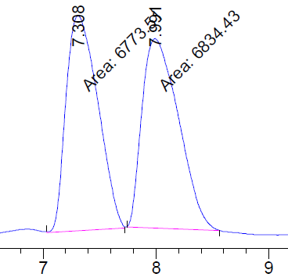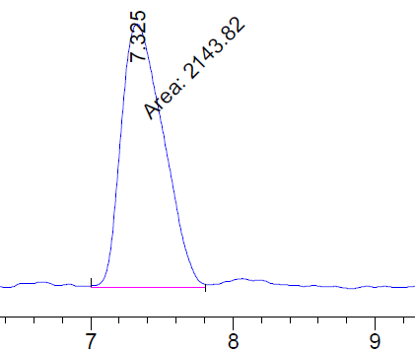
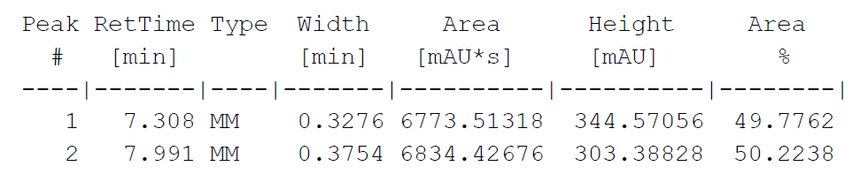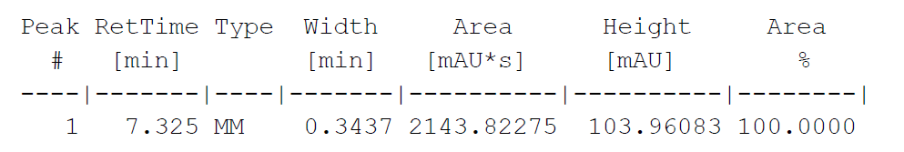

Synthesis of Enantioenriched Cyclopropylmethanol Derivative
((1S,2S)-2-Methyl-2-phenylcyclopropyl)methanol (S1)
S1 was synthesized using the enantioselective Charette cyclopropanation method from (E)-3-phenylbut-2-en-1-ol.¹ To a round bottom flask was added CH₂Cl₂ (22.6 mL) and DME (1.6 mL) followed by the addition of Et₂Zn (1.7 mL, 16.7 mmol). The reaction mixture was cooled to ‒12 °C and diiodomethane (1.4 mL, 16.7 mmol) was added dropwise over a period of 5 min while maintaining the internal temperature between ‒12 °C to – 8 °C. The reaction mixture was stirred for 10 min and dioxaborolane (2.5 g, 9.2 mmol) in CH₂Cl₂ (11.3 mL) was cannulated into the reaction flask followed by the addition of (E)-3-phenylbut-2-en-1-ol (1.13 g, 7.6 mmol) in CH₂Cl₂ (11.3 mL) with an internal temperature of ‒5 °C over a period of 5 min. The mixture was allowed to warm to room temperature and stirred for 12 h. The reaction mixture was quenched with a dropwise addition of NH₄Cl (5 mL), transferred to a separatory funnel, and the organic layer was separated. The aqueous layer was extracted with EtOAc (3 x 25 mL) and the organic layers were combined. The combined organic layers were transferred into an Erlenmeyer flask, and a solution containing 2 N aq. NaOH (32 mL) and 30% aq. H₂O₂ (6 mL) was added in one portion. The resulting biphasic solution was stirred vigorously for 10 min, after which the mixture was transferred into a separatory funnel and the organic layer was separated. The aqueous layer was extracted with EtOAc (3 × 10 mL) and the combined organic layers were washed with 10% aq. HCl (10 mL) and successively washed with sat. aq. Na₂SO₃ (10 mL), sat. aq. NaHCO₃ (10 mL), and brine (10 mL), dried over anhydrous Na₂SO₄, filtered, and concentrated under reduced pressure. The residue was purified by silica gel chromatography (1:4 EtOAc/hexanes, R_{f}: 0.3) to provide S1 as a white solid in 42% yield (520 mg, 3.2 mmol, 89% ee) and was identical to reported literature data.⁵ A chiral prep purification provided S1 with 99% ee.

¹H NMR (500 MHz, CDCl₃) δ 7.31 ‒ 7.25 (m, 4H, H_{Ar}), 7.24 – 7.12 (m, 1H, H₉), 3.91 (dd, J = 11.5, 6.4 Hz, 1H, H₂), 3.71 (dd, J = 11.5, 8.6 Hz, 1H, H₂), 1.49 (br, 1H, H₁), 1.46 (s, 3H, H₆), 1.45 ‒ 1.39 (m, 1H, H₃), 1.14 (dd, J = 8.9, 4.8 Hz, 1H, H₄), 0.60 (t, J = 5.3, Hz, 1H, H₄).

¹³C NMR (126 MHz, CDCl₃) δ 147.7, 128.5 (2C), 127.4 (2C), 126.0, 63.7, 27.9, 25.0, 20.6, 18.8.

IR (film) ν_{max}: 3339, 3060, 2954, 2865, 1496, 1025, 762, 698, 578 cm⁻¹.
HRMS (ESI, m/z): calculated for [M + Na]⁺ : C₁₁H₁₄O requires m/z 185.0937, found m/z 185.0939.
mp 45‒46 °C.

[α]_{D}²⁵ = +38 (c 0.20, MeOH).

SFC (Chiralpak OJ-H 21 x 250 mm, 5 µm, 30 °C, 150 bar, 6% of co-solvent of 20% IPA/hexanes, 60 g/min) t_{R} major: 5.30 min. t_{R} minor: 4.15 min.

Racemate S1 (before chiral purification), 80% ee

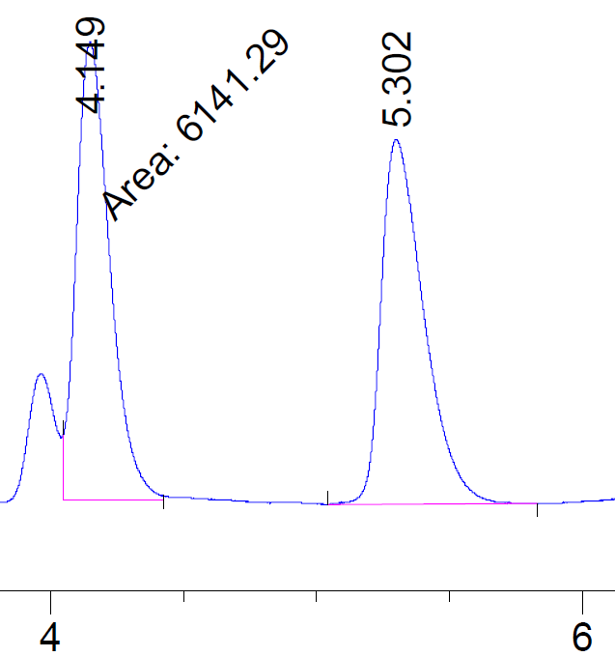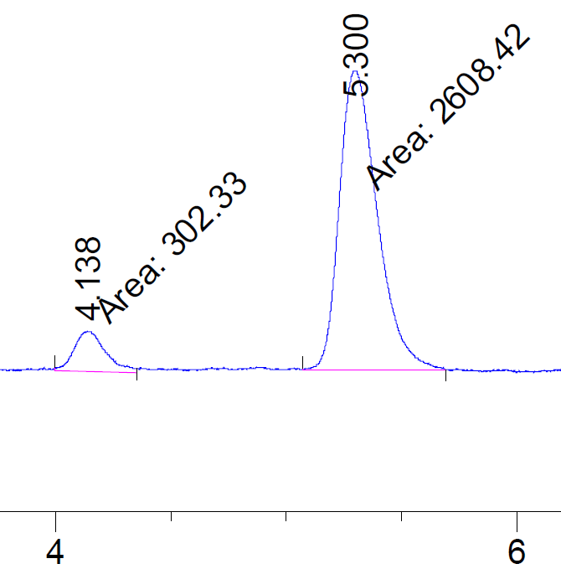
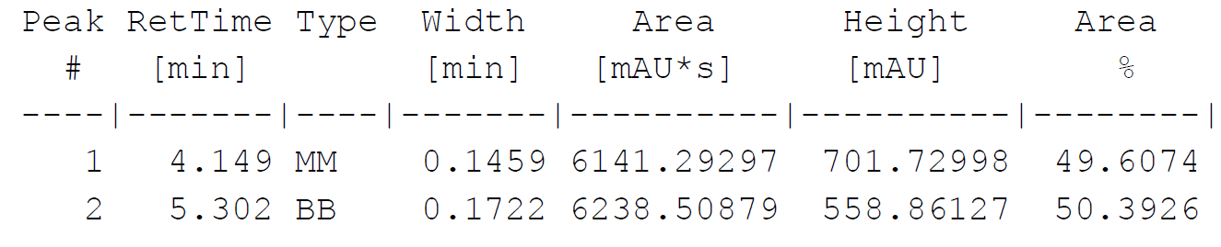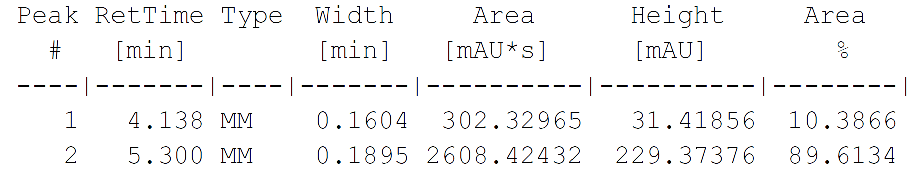

S1 (after chiral purification), 99% ee
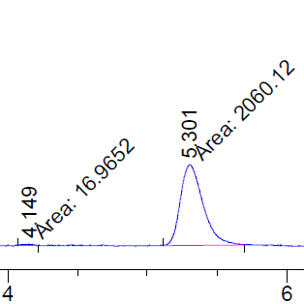

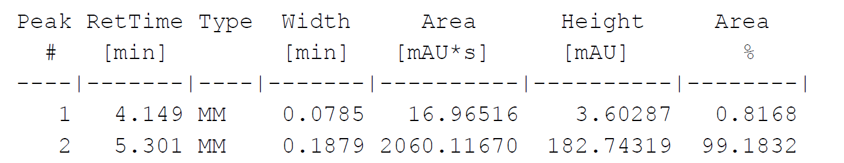

1,4-Bis(cyclopropylmethyl)piperazine borane (1ab)
A solution of cyclopropanecarbonyl chloride (1.04 mL, 11.5 mmol) in CH₂Cl₂ (2.75 mL) was added dropwise to a solution of piperazine (494 mg, 5.74 mmol) in CH₂Cl₂ (4 mL) at 0 °C over 10 min (exothermic reaction!). After stirring for 20 min, 10 mL of 10% aq. NaOH solution was added, and the organic layer was separated. The aqueous layer was extracted with CH2Cl2 (2 x 10 mL), and the combined organic layers were dried over anhydrous Na₂SO₄, filtered, and concentrated under reduced pressure. The crude amide was converted to CAB 1ab using general procedure C to obtain the title compound as a viscous oil in 76% yield (968 mg, 4.4 mmol).

¹H NMR (500 MHz, CDCl₃) δ 3.77 – 3.59 (m, 4H, H_{5,6,7,8}), 2.96 – 2.86 (m, 4H, H_{5,6,7,8}), 2.81 (d, J = 6.9 Hz, 4H, H_{4,10}), 2.04 – 1.47 (m, 5H, H₉), 1.48 – 1.38 (m, 3H, H_{2,} H_{9,} H₁₁), 0.75 – 0.67 (m, 4H, H_{1,3}, H_{12,13}), 0.34 – 0.23 (m, 4H, H_{1,3}, H_{12,13}).

¹³C NMR (126 MHz, CDCl₃) δ 72.04 (2C), 52.42 (4C), 4.81 (2C), 4.60 (4C).

¹¹B NMR δ ‒14.0 ppm

IR: 3001, 2357, 2333, 2280, 1347, 1416, 1155, 1124, 1027, 976, 889 cm⁻¹.

HRMS (ESI, m/z): calculated for [M ‒ 6H]⁺ C₁₂H₂₂N₂ requires m/z 195.1856, found m/z 195.1861.

1-([1,1'-Bi(cyclopropan)]-2-ylmethyl)pyrrolidine borane (1ac)
[1,1'-Bi(cyclopropane)]-2-carboxylic acid (316 mg, 2.5 mmol) was converted to CAB 1ac according to general procedure C. Purification by column chromatography (1:9 EtOAc:Hexanes, R_{f}: 0.4) provided CAB 1ac as a clear oil in 78% yield (347 mg, 1.9 mmol).

¹H NMR (500 MHz, CDCl₃) δ 3.20 – 3.10 (m, 2H, H_{5,8}), 2.86 (dd, J = 11.3, 5.4 Hz, 2H, H_{5,8}), 2.77 (dd, J = 12.8, 6.1 Hz, 1H, H₄), 2.55 (dd, J = 12.8, 7.5 Hz, 1H, H₄), 2.22 – 2.09 (m, 2H, H_{6,7}), 1.92 – 1.79 (m, 3H, H_{6,7}, H₉), 1.72 (br, 1H, H₉), 1.51 (br, 1H, H₉), 1.18 – 1.08 (m, 1H, H₂), 0.85 – 0.78 (m, 1H, H₁₀), 0.71 – 0.65 (m, 1H, H₁), 0.43 – 0.38 (m, 2H, H_{11, 12}), 0.38 – 0.31 (m, 1H, H₃), 0.23 (dt, J = 8.7, 5.1 Hz, 1H, H₃), 0.07 (q, J = 4.7 Hz, 2H, H_{11,12}).

¹³C NMR (126 MHz, CDCl₃) δ 67.0, 60.7, 60.3, 22.9 (2C), 20.6, 12.9, 11.8, 9.0, 3.3, 2.7.

¹¹B NMR δ ‒11.8 ppm.

IR (film) ν_{max}: 2995, 2957, 2880, 2364, 2325, 2273, 1475, 1165, 1017 cm⁻¹.

HRMS (ESI, m/z): calculated for [M + Na]⁺ C₁₁H₂₂BN requires m/z 202.1738, found m/z 202.1738.

Synthesis of Spirocyclic Amine-Boranes (SABs) ‒ General Procedure D
CAB (~0.2 mmol) was added to an oven dried microwave reaction vial equipped with a stir bar followed by the addition of Tf₂NH (5 mol%) under an argon atmosphere. To the vial was added toluene (0.4 M) and the formation of H₂ gas via bubbling was observed. The reaction mixture was stirred for 10 min under an argon atmosphere until the bubbling ceased. The vial was then sealed with a microwave vial cap and stirred at 125 °C (oil bath) for the indicated time. The reaction mixture was cooled, and reaction was quenched by adding solid nBu₄NBH₄ (5 mol%) under an argon atmosphere. The mixture was diluted with CH₂Cl₂ and filtered through a short pad of silica gel. The pad of silica gel was washed with CH₂Cl₂ (2 x 5 mL). The SABs were isolated by concentrating the filtrate. If necessary, the SABs can also be isolated by column chromatography (1:5 EtOAc/hexanes, R_{f}: 0.3).

3-Methyl-5-aza-1-boraspiro[4.4]nonane (2a)
The title compound was obtained in 99% yield (2.0 g, 14.4 mmol) as a clear oil. Reaction time: 4.5 h.
¹H NMR (400 MHz, CDCl₃) δ 3.26 ‒ 3.17 (m, 2H, H_{5,8}), 2.83 ‒ 2.72 (m, 2H, H_{5,8}), 2.64 ‒ 2.52 (m, 2H, H₄), 2.25 – 2.00 (m, 4H, H₂, H_{6,7}, H₉), 1.99 – 1.78 (m, 3H, H_{6,7}, H₉), 1.04 (d, J = 6.7 Hz, 3H, H₁) 1.11 ‒ 0.96 (m, 1H, H₃), 0.48 ‒ 0.37 (m, 1H, H₃).

¹³C NMR (126 MHz, CDCl₃) δ 70.0, 61,6, 60.4, 53.6, 33.0, 22,9, 22.6, 21.2.

¹¹B NMR δ ‒3.6 ppm.

IR (film) ν_{max}: 2952, 2868, 2780, 1456, 1361, 1208, 1153, 835, 607 cm⁻¹.

HRMS (ESI, m/z): calculated for [M + H]⁺ C₈H₁₈BNO₂ requires m/z 172.1503, found m/z 172.1498.
*Note: The mass of the spirocycles is often reported as the corresponding boronic acid derivative due to mass spectrometer conditions*

3-Methyl-5-aza-1-boraspiro[4.6]undecane (2b)
The title compound was obtained in 99% yield (30 mg, 0.18 mmol) a clear oil. Reaction time: 4.5 h.
¹H NMR (500 MHz, CDCl₃) δ 3.19 ‒ 3.09 (m, 2H, H_{5,10}), 2.98 ‒ 2.92 (m, 1H, H₄), 2.90 – 2.84 (m, 1H, H₅), 2.82 – 2.75 (m, 1H, H₁₀), 2.24 (t, J = 11.0 Hz, 1H, H₄), 2.21 – 2.02 (m, 1H, H₂), 1.93 – 1.73 (m, 3H, H_{6,8}, H₁₁), 1.73 – 1.49 (m, 7H, H_{6,8,7}, H₁₁) 1.03 (d, J = 6.5 Hz, 3H, H₁), 1.03 – 0.95 (m, 1H, H₃), 0.43 – 0.33 (m, 1H, H₃).

¹³C NMR (126 MHz, CDCl₃) δ 70.4, 63.2, 60.2, 31.8, 28.6, 28.3, 24.2, 23.1, 21.3, 21.0.

¹¹B NMR δ ‒2.6 ppm.

IR (film) ν_{max}: 2922, 2861, 2334, 2246, 1454, 1188, 1129, 999, 806, 745 cm⁻¹.

HRMS (ESI, m/z): calculated for [M + H]⁺ C₁₀H₂₂BNO₂ requires m/z 200.1816, found m/z 200.1810.

1,1-Diethyl-4-methyl-1,2-azaborolidine (2c)
The title compound was obtained in 99% yield (28 mg, 0.19 mmol) as clear oil. Reaction time: 4.5 h.
¹H NMR (500 MHz, CDCl₃) δ 2.99 – 2.68 (m, 5H, H_{5,8}, H₄), 2.28 ‒ 2.23 (m, 1H, H₄), 2.22 – 2.14 (m, 1H, H₂), 1.81 (br, 2H, H₉), 1.15 (t, J = 7.2 Hz, 3H, H₇), 1.10 (t, J = 7.2 Hz, 3H, H₆), 1.02 (d, J = 6.4 Hz, 3H, H₁), 0.98 ‒ 0.89 (m, 1H, H₃), 0.38 ‒ 0.29 (m, 1H, H₃).

¹³C NMR (126 MHz, CDCl₃) δ 67.2, 52.9, 49.4, 31.7, 21.7, 21.2, 9.6, 8.6.

¹¹B NMR δ ‒3.9 ppm

IR (film) ν_{max}: 2948, 2922, 2868, 2345, 1456, 1385, 1265, 1128, 1026, 829, 770 cm⁻¹.

HRMS (ESI, m/z): calculated for [M ‒ 2H]⁺ C₈H₁₈BN requires m/z 140.1605, found m/z 140.1607.

3-Methyl-5-aza-1-boraspiro[4.5]decane (2d)

The title compound was obtained in 98% yield (30 mg, 0.19 mmol) as a clear oil. Reaction time: 4.5 h.

¹H NMR (500 MHz, CDCl₃) δ 3.03 – 2.88 (m, 2H, H_{5,9}), 2.87 ‒ 2.80 (m, 1H, H₄), 2.74 – 2.59 (m, 1H, H₅), 2.56 ‒ 2.47 (m, 1H, H₉), 2.24 (t, J = 11.2 Hz, 1H, H₄), 2.19 – 2.00 (m, 2H, H_{6,8}), 1.99 – 1.77 (m, 3H, H_{6,8}, H₁₀), 1.65 – 1.49 (m, 3H, H₇, H₁₀), 1.45 ‒ 1.35 (m, 1H, H₂), 0.99 (d, J = 6.5 Hz, 3H, H₁), 0.94 – 0.83 (m, 1H, H₃), 0.36 – 0.24 (m, 1H, H₃).

¹³C NMR (126 MHz, CDCl₃) δ 70.5, 61.0, 58.1, 31.2, 23.1, 22.8, 21.8, 21.7, 21.0.

¹¹B NMR δ ‒4.5 ppm.

IR (film) ν_{max}: 2837, 2863, 2350, 1372, 1272, 1228, 1119, 997, 859, 781 cm⁻¹.

HRMS (ESI, m/z): calculated for [M + H]⁺ C₉H₂₀BNO₂ requires m/z 186.1660, found m/z 186.1669.

3-Benzyl-5-aza-1-boraspiro[4.4]nonane (2e)
The title compound was obtained in 99% yield (43 mg, 0.19 mmol) as a white solid. Reaction time: 1.5 h.

¹H NMR (500 MHz, CDCl₃) δ 7.29 ‒ 7.25 (m, 2H, ArH), 7.20 ‒ 7.16 (m, 3H, ArH), 3.30 – 3.11 (m, 2H, H_{5,8}), 2.85 (dd, J = 13.5, 6.5 Hz, 1H, H₄), 2.80 ‒ 2.73 (m, 1H, H₅), 2.73 – 2.64 (m, 2H, H₁), 2.64 – 2.56 (m, 1H, H₄), 2.63 ‒ 2.49 (m, 1H, H₈), 2.45 – 2.31 (m, 1H, H₂), 2.18 ‒ 2.02 (m, 3H, H_{6,7,} H₉), 1.97 – 1.70 (m, 3H, H_{6,7}, H₉), 1.07 ‒ 0.98 (m, 1H, H₃), 0.63 ‒ 0.55 (m, 1H, H₃).

¹³C NMR (126 MHz, CDCl₃) δ 141.9, 128.8 (2C), 128.4 (2C), 125.9, 68.1, 61.6, 60.4, 43.1, 40.3, 22.9, 22.6, 20.3.

¹¹B NMR δ ‒3.9 ppm.

IR (film) ν_{max}: 3023, 2958, 2922, 2358, 2330, 1452, 1365, 1214, 1133, 700 cm⁻¹.

HRMS (ESI, m/z): calculated for [M + H]⁺ C₁₄H₂₂BNO₂ requires m/z 248.1816, found m/z 248.1823.
mp 62‒63 °C.

4-Benzyl-1,1-diethyl-1,2-azaborolidine (2f)
The title compound was obtained in 97% yield (44 mg, 0.19 mmol) as a pale-yellow viscous oil. Reaction time: 1.5 h.

¹H NMR (500 MHz, CDCl₃) δ 7.34 – 7.23 (m, 2H, ArH), 7.22 – 7.19 (m, 3H, ArH), 2.93 – 2.62 (m, 6H, H_{5,8}, H₁), 2.56 (dd, J = 13.5, 7.5 Hz, 1H, H₄), 2.45 – 2.26 (m, 2H, H_{2,} H₄), 2.23 – 1.98 (br, 1H, H₉), 1.14 (t, J = 7.2 Hz, 3H, H₇), 1.06 (t, J = 7.2 Hz, 4H, H_{6,} H₉), 0.98 ‒ 0.89 (m, 1H, H₃), 0.54 ‒ 0.45 (m, 1H, H₃).

¹³C NMR (126 MHz, CDCl₃) δ 141.8, 128.8 (2C), 128.4 (2C), 125.9, 65.5, 53.0, 49.6, 43.1, 39.1, 19.5, 9.6, 8.7.

¹¹B NMR δ ‒4.1 ppm.

IR (film) ν_{max}: 2965, 2926, 1495, 1452, 1395, 1268, 1213, 742, 700 cm⁻¹.

HRMS (ESI, m/z): calculated for [M + H]⁺ C₁₄H₂₄BNO₂ requires m/z 250.1973, found m/z 250.1982.

3-Benzyl-5-aza-1-boraspiro[4.5]decane (2g)
The title compound was obtained in 98% yield (49 mg, 0.21 mmol) as a pale-yellow viscous oil. Reaction time: 1.5 h.

¹H NMR (500 MHz, CDCl₃) δ 7.32 – 7.27 (m, 2H, ArH), 7.18 – 7.23 (m, 3H, ArH), 3.04 ‒ 2.95 (m, 2H, H_{5,9}), 2.91 – 2.77 (m, 2H, H_{1,} H₄), 2.77 – 2.65 (m, 1H, H₅), 2.62 – 2.55 (m, 1H, H₄), 2.56 – 2.47 (m, 1H, H₉), 2.47 – 2.35 (m, 2H, H₂, H₁), 2.32 – 2.10 (br, 1H, H₁₀), 2.08 – 1.80 (m, 3H, H_{6,8}, H₁₀), 1.75 – 1.48 (m, 3H, H_{6,8}, H₇), 1.49 – 1.35 (m, 1H, H₇), 1.11 – 0.91 (m, 1H, H₃), 0.63 – 0.44 (m, 1H, H₃).

¹³C NMR (126 MHz, CDCl₃) δ 141.8, 128.8 (2C), 128.4 (2C), 125.9, 68.9, 61.1, 58.2, 43.1, 38.7, 23.2, 22.9, 21.8, 19.5.

¹¹B NMR δ ‒4.8 ppm.

IR (film) ν_{max}: 3023, 2958, 2922, 2782, 2358, 2330, 1365, 1214, 1133, 700 cm⁻¹.

HRMS (ESI, m/z): calculated for [M + H]⁺ C₁₅H₂₄BNO₂ requires m/z 262.1973, found m/z 262.1966.

3-Benzyl-8-oxa-5-aza-1-boraspiro[4.5]decane (2h)

The title compound was obtained in 96% yield (44 mg, 0.19 mmol) pale-yellow viscous oil. Reaction time: 1.5 h.

¹H NMR (500 MHz, CDCl₃) δ 7.32 ‒ 7.27 (m, 2H, ArH), 7.23 – 7.17 (m, 3H, ArH), 4.22 – 4.09 (m, 1H, H₆), 4.06 ‒ 3.99 (m, 1H, H₇), 3.76 (tt, J = 12.5, 2.9 Hz, 2H, H_{6,7}), 3.14 – 2.92 (m, 1H, H₁), 2.98 – 2.81 (m, 3H, H_{5,8}, H₄), 2.78 (dd, J = 11.0, 6.0 Hz, 1H, H₁), 2.73 – 2.50 (m, 3H, H_{4,} H_{5,8}), 2.46 – 2.24 (m, 1H, H₂), 1.94 (br, 2H, H₉), 1.09 – 0.92 (m, 1H, H₃), 0.63 ‒ 0.53 (m, 1H, H₃).

¹³C NMR (126 MHz, CDCl₃) δ 141.5, 129.8 (2C), 128.5 (2C), 126.0, 71.7, 64.2, 63.2, 59.9, 58.1, 42.8, 38.4, 19.7.

¹¹B NMR δ ‒5.3 ppm.

IR (film) ν_{max}: 3024, 2960, 2353, 1494, 1451, 1276, 1200, 1119, 866, 700 cm⁻¹.

HRMS (ESI, m/z): calculated for [M + H]⁺ C₁₄H₂₂BNO₃ requires m/z 264.1766, found m/z 262.1762.

3-(Naphthalen-1-ylmethyl)-5-aza-1-boraspiro[4.4]nonane (2i)
The title compound was obtained in 88% yield (46 mg, 0.17 mmol) as a pale-yellow solid. Reaction time: 1.5 h.

¹H NMR (400 MHz, CDCl₃) δ 7.86 – 7.70 (m, 3H, ArH), 7.63 (s, 1H, ArH), 7.46 (dq, J = 6.8, 5.4 Hz, 2H, ArH), 7.36 (dd, J = 8.4, 1.6 Hz, 1H, ArH), 3.26 ‒ 3.17 (m, 2H, H_{5,8}), 3.05 (dd, J = 13.5, 6.3 Hz, 1H, H₁), 2.87 – 2.63 (m, 4H, H₁, H_{4,} H₉), 2.62 – 2.38 (m, 2H, H_{5,8}), 2.27 – 1.96 (m, 3H, H₂, H_{6,7}), 1.95 – 1.68 (m, 3H, H_{6,7}, H₉), 1.12 ‒ 1.02 (m, 1H, H₃), 0.71 ‒ 0.59 (m, J = 13.3, 8.1 Hz, 1H, H₃).

¹³C NMR (126 MHz, CDCl₃) δ 139.4, 133.7, 132.1, 128.0, 127.73, 127.68, 127.6, 126.0, 125.2, 68.1, 61.6, 60.4, 43.2, 40.3, 29.8, 22.8, 22.6, 20.4.

¹¹B NMR δ ‒3.8 ppm.

IR (film) ν_{max}: 2955, 2920, 2848, 2321, 2264, 1459, 1379, 1138, 857, 748, 475 cm⁻¹.

HRMS (ESI, m/z): calculated for [M ‒ 2H]⁺ C₁₈H₂₂BN requires m/z 264.1918, found m/z 264.1918.

mp: 127‒128 °C.

3-(2-Fluorobenzyl)-5-aza-1-boraspiro[4.4]nonane (2j)
The title compound was obtained in 97% yield (45 mg, 0.19 mmol) as a white solid. Reaction time: 1.5 h.

¹H NMR (500 MHz, CDCl₃) δ 7.21 ‒ 7.13 (m, 2H, ArH), 7.05 (t, J = 7.3 Hz, 1H, ArH), 6.99 (t, J = 9.2 Hz, 1H, ArH), 3.22 (q, J = 8.8 Hz, 2H, H_{5,8}), 2.84 – 2.75 (m, 2H, H_{4,} H₅), 2.75 – 2.63 (m, 3H, H₁, H₄), 2.56 – 2.49 (m, 1H, H₈), 2.48 – 2.32 (m, 1H, H₂), 2.16 ‒ 2.02 (m, 3H, H_{6,7}, H₉), 1.90 ‒ 1.81 (m, 2H, H_{6,7}), 1.75 – 1.54 (m, 1H, H₉), 1.05 ‒ 0.96 (m, 1H, H₃), 0.64 ‒ 0.55 (m, 1H, H₃).

¹³C NMR (126 MHz, CDCl₃) δ 161.2, 160.2, 131.2, 127.5, 123.97, 115.3, 67.9, 61.6, 60.4, 39.2, 35.6, 22.7, 22.4, 20.1.

¹¹B NMR δ ‒3.8 ppm.

IR (film) ν_{max}: 2951, 2922, 2862, 2360, 2330, 1490, 1455, 1365, 1226, 754 cm⁻¹.

HRMS (ESI, m/z): calculated for [M + H]⁺ C₁₄H₂₁BFNO₂ requires m/z 266.1722, found m/z 266.1710.

mp: 61‒62 °C.

3-(4-Fluorobenzyl)-5-aza-1-boraspiro[4.4]nonane (2k)
The title compound was obtained in 97% yield (46 mg, 0.19 mmol) as a white solid. Reaction time: 1.5 h.

¹H NMR (500 MHz, CDCl₃) δ 7.15 ‒ 7.09 (m, 2H, ArH), 6.98 ‒ 6.91 (m, 2H, ArH), 3.26 ‒ 3.18 (m, 2H, H_{5,8}), 2.87 – 2.71 (m, 2H, H₅, H₄), 2.66 (d, J = 8.8 Hz, 2H, H₁), 2.62 – 2.47 (m, 2H, H₄, H₈), 2.37 ‒ 2.27 (m, 1H, H₂), 2.16 ‒ 2.01 (m, 3H, H_{6,7}, H₉), 1.91 ‒ 1.80 (m, 3H, H_{6,7}, H₉), 1.04 ‒ 0.94 (m, 1H, H₃), 0.62 ‒ 0.51 (m, 1H, H₃).

¹³C NMR (126 MHz, CDCl₃) δ 162.3, 160.4, 137.4, 130.1, 115.2, 115.2, 68.0, 61.6, 60.4, 42.0, 40.4, 22.7, 22.4, 19.8.

¹¹B NMR δ ‒3.8 ppm.

IR (film) ν_{max}: 2964, 2916, 2852, 2358, 2341, 1508, 1364, 1218 cm⁻¹.

HRMS (ESI, m/z): calculated for [M + H]⁺ C₁₄H₂₁BFNO₂ requires m/z 266.1722, found m/z 226.1717.
mp: 64‒65 °C.

3-(4-Bromobenzyl)-5-aza-1-boraspiro[4.4]nonane (2l)
The title compound was obtained in 99% yield (58 mg, 0.19 mmol) as a white solid. Reaction time: 1.5 h.

¹H NMR (500 MHz, CDCl₃) δ 7.38 (d, J = 8.3 Hz, 2H, ArH), 7.05 (d, J = 8.3 Hz, 2H, ArH), 3.35 – 3.11 (m, 2H, H_{5,8}), 2.88 – 2.69 (m, 2H, H₄, H₅), 2.65 (d, J = 8.9 Hz, 2H, H₁), 2.61 – 2.46 (m, 2H, H₄, H₈), 2.43 – 2.24 (m, 1H, H₂), 2.22 – 1.98 (m, 3H, H_{6,7}, H₉), 1.95 – 1.70 (m, 3H, H_{6,7}, H₉), 1.03 – 0.94 (m, 1H, H₃), 0.59 ‒ 0.51 (m, 1H, H₃).

¹³C NMR (126 MHz, CDCl₃) δ 140.8, 131.4 (2C), 130.6 (2C), 119.6, 68.0, 61.7, 60.4, 42.3, 40.2, 22.82, 22.6, 20.0.

¹¹B NMR δ ‒3.4 ppm.

IR (film) ν_{max}: 2955, 2880, 2359, 1486, 1365, 1212, 1072, 1011 cm⁻¹.

HRMS (ESI, m/z): calculated for [M + H]⁺ C₁₄H₂₁BBrNO₂ requires m/z 326.0922, found m/z 326.0937.

mp: 101‒102 °C.

3-(2-Bromobenzyl)-5-aza-1-boraspiro[4.4]nonane (2m)
The title compound was obtained in 97% yield (49 mg, 0.16 mmol) as a white solid. Reaction time: 1.5 h.

¹H NMR (500 MHz, CDCl₃) δ 7.55 (d, J = 8.1 Hz, 1H, ArH), 7.37 – 7.16 (m, 2H, ArH), 7.16 – 7.01 (m, 1H, ArH), 3.37 – 3.17 (m, 2H, H_{5,8}), 2.99 – 2.79 (m, 4H, H₁, H₄, H₅), 2.79 – 2.64 (m, 1H, H₄), 2.64 – 2.53 (m, 1H, H₈), 2.53 – 2.44 (m, 1H, H₂), 2.19 ‒ 2.05 (m, 3H, H_{6,7}, H₉), 1.98 – 1.69 (m, 3H, H_{6,7}, H₉), 1.07 ‒ 0.98 (m, 1H, H₃), 0.68 ‒ 0.59 (m, 1H, H₃).

¹³C NMR (126 MHz, CDCl₃) δ 141.0, 132.9, 131.1, 127.6, 127.4, 124.6, 67.9, 61.7, 60.5, 42.6, 38.7, 22.9, 22.6, 19.9.

¹¹B NMR δ ‒3.8 ppm.

IR (film) ν_{max}: 2922, 2852, 2331, 1467, 1200, 1135, 1024, 750 cm⁻¹.

HRMS (ESI, m/z): calculated for [M + H]⁺ C₁₄H₂₁BBrNO₂ requires m/z 326.0921, found m/z 326.0927.

mp: 98‒99 °C.

3-(4-(tert-Butyl)benzyl)-5-aza-1-boraspiro[4.4]nonane (2n)

The title compound was obtained in 96% yield (55 mg, 0.20 mmol) as a viscous oil. Reaction time: 1.5 h.

¹H NMR (500 MHz, CDCl₃) δ 7.30 (d, J = 8.3 Hz, 2H, ArH), 7.11 (d, J = 8.2 Hz, 2H, ArH), 3.26 ‒ 3.19 (m, 2H, H_{5,8}), 2.89 – 2.75 (m, 2H, H₄, H₅), 2.70 (d, J = 9.4 Hz, 2H, H₁), 2.60 ‒ 2.51 (m, 2H, H₄, H₈), 2.48 – 2.26 (m, 1H, H₂), 2.22 – 1.98 (m, 3H, H_{6,7}, H₉), 1.96 – 1.72 (m, 3H, H_{6,7}, H₉), 1.32 (s, 9H, H₁₂), 1.09 ‒ 1.00 (m, 1H, H₃), 0.63 ‒ 0.55 (m, 1H, H₃).

¹³C NMR (126 MHz, CDCl₃) δ 148.6, 138.7 (2C), 128.4 (2C), 125.2, 68.2, 61.6, 60.3, 42.5, 40.2, 34.5, 31.5 (3C), 22.8, 22.6, 20.0.

¹¹B NMR δ ‒3.8 ppm.

IR (film) ν_{max}: 2960, 2925, 2870, 2355, 1511, 1363, 1209, 1133, 829 cm⁻¹.

HRMS (ESI, m/z): calculated for [M + H]⁺ C₁₈H₃₀BNO₂ requires m/z 304.2442, found m/z 304.2457.

3-(2,4,6-Trimethylbenzyl)-5-aza-1-boraspiro[4.4]nonane (2o)
The title compound was obtained in 96% yield (49 mg, 0.19 mmol) as a pale-yellow solid. Reaction time: 1.5 h.

¹H NMR (500 MHz, CDCl₃) δ 6.83 (s, 2H, ArH), 3.28 ‒ 3.16 (m, 2H, H_{5,8}), 2.86 ‒ 2.74 (m, 3H, H₁, H₄, H₅), 2.73 – 2.59 (m, 2H, H₁, H₄), 2.56 – 2.43 (m, 1H, H₈), 2.35 – 2.27 (m, 7H, H₂, H₁₀, H₁₄), 2.25 (s, 3H, H₁₂), 2.20 – 1.97 (m, 3H, H_{6,7}, H₉), 1.93 – 1.65 (m, 3H, H_{6,7}, H₉), 1.09 ‒ 1.01 (m, 1H, H₃), 0.71 ‒ 0.62 (m, 1H, H₃).

¹³C NMR (126 MHz, CDCl₃) δ 136.2, 135.8, 134.9, 129.1 (2C), 68.2, 62.0 (2C), 60.6, 38.6, 35.5, 22.7, 22.5, 21.2, 20.9, 20.6 (2C).

¹¹B NMR δ ‒3.6 ppm.

IR (film) ν_{max}: 2984, 2946, 2879, 2360, 2237, 2208, 2036, 1458, 1364, 1216 cm⁻¹.

HRMS (ESI, m/z): calculated for [M + H]⁺ C₁₇H₂₈BNO₂ requires m/z 290.2286, found m/z 290.2302.

mp:74‒75 °C.

3-(3-Methylbenzyl)-5-aza-1-boraspiro[4.4]nonane (2p)
The title compound was obtained in 98% yield (47 mg, 0.21 mmol) as a viscous clear oil. Reaction time: 1.5 h.

¹H NMR (500 MHz, CDCl₃) δ 7.16 (t, J = 7.8 Hz, 1H, ArH), 7.01 ‒ 6.95 (m, 3H, ArH), 3.31 – 3.09 (m, 2H, H_{5,8}), 2.84 ‒ 2.74 (m, 2H, H₄, H₅), 2.68 (d, J = 9.7 Hz, 2H, H₁), 2.57 ‒ 2.49 (m, 2H, H₄, H₈), 2.41 ‒ 2.33 (m, 1H, H₂), 2.33 (s, 3H, H₁₁), 2.20 – 1.98 (m, 3H, H_{6,7}, H₉), 1.90 ‒ 1.79 (m, 3H, H_{6,7}, H₉), 1.09 – 0.97 (m, 1H, H₃), 0.63 ‒ 0.54 (m, 1H, H₃).

¹³C NMR (126 MHz, CDCl₃) δ 141.8, 137.9, 129.7, 128.3, 126.6, 125.8, 68.2, 61.6, 60.3, 43.0, 40.3, 22.9, 22.6, 21.6, 20.4.

¹¹B NMR δ ‒3.8 ppm.

IR (film) ν_{max}: 2952, 2920, 2874, 2357, 2334, 1458, 1364, 1211, 1135, 781 cm⁻¹.

HRMS (ESI, m/z): calculated for [M + H]⁺ C₁₅H₂₄BNO₂ requires m/z 262.1973, found m/z 262.1961.

3-(4-Methylbenzyl)-5-aza-1-boraspiro[4.4]nonane (2q)
The title compound was obtained in 99% yield (45 mg, 0.19 mmol) as a pale-yellow solid. Reaction time: 1.5 h.

¹H NMR (500 MHz, CDCl₃) δ 7.11 ‒ 7.04 (m, 4H, ArH), 3.28 – 3.12 (m, 2H, H_{5,8}), 2.85 ‒ 2.74 (m, 2H, H₄, H₅), 2.67 (d, J = 9.1 Hz, 2H, H₁), 2.58 ‒ 2.49 (m, 2H, H₄, H₈), 2.43 – 2.35 (m, 1H, H₂), 2.32 (s, 3H, H₁₂), 2.21 – 1.98 (m, 3H, H_{6,7}, H₉), 1.89 ‒ 1.80 (m, 3H, H_{6,7}, H₉), 1.08 ‒ 0.98 (m, 1H, H₃), 0.63 ‒ 0.54 (m, 1H, H₃).

¹³C NMR (126 MHz, CDCl₃) δ 138.8, 135.3, 129.1 (2C), 128.7 (2C), 68.1, 61.6, 60.3, 42.6, 40.3, 22.8, 22.6, 21.2, 20.2.

¹¹B NMR δ ‒3.8 ppm.

IR (film) ν_{max}: 2824, 2356, 2331, 2250, 2156, 2031, 1977, 807 cm⁻¹.

HRMS (ESI, m/z): calculated for [M + H]⁺ C₁₅H₂₄BNO₂ requires m/z 262.1972, found m/z 262.1983.

mp:68‒69 °C.

3-(2-Methylbenzyl)-5-aza-1-boraspiro[4.4]nonane (2r)
The title compound was obtained in 97% yield (49 mg, 0.21 mmol) as a viscous clear oil. Reaction time: 1.5 h.

¹H NMR (500 MHz, CDCl₃) δ 7.17 ‒ 7.08 (m, 4H, ArH), 3.36 – 3.12 (m, 2H, H_{5,8}), 2.88 (dd, J = 13.9, 6.2 Hz, 1H, H₄), 2.79 – 2.71 (m, 1H, H₅), 2.75 – 2.63 (m, 2H, H₁), 2.60 (dd, J = 13.9, 8.3 Hz, 1H, H₄), 2.56 ‒ 2.49 (m, 1H, H₈), 2.43 ‒ 2.35 (m, 1H, H₂), 2.35 (s, 3H, H₁₀), 2.21 – 1.98 (m, 3H, H_{6,7}, H₉), 1.98 – 1.76 (m, 3H, H_{6,7}, H₉), 1.11 ‒ 1.01 (m, 1H, H₃), 0.67 ‒ 0.57 (m, 1H, H₃).

¹³C NMR (126 MHz, CDCl₃) δ 140.0, 136.0, 130.3, 129.3, 126.0, 125.8, 68.2, 61.7, 60.4, 40.2, 38.8, 22.8, 22.6, 20.8, 19.7.

¹¹B NMR δ ‒3.8 ppm.

IR (film) ν_{max}: 2918, 2874, 2327, 2492, 1458, 1377, 1198, 1134, 740 cm⁻¹.

HRMS (ESI, m/z): calculated for [M + H]⁺ C₁₅H₂₄BNO₂ requires m/z 262.1973, found m/z 262.1980.

3-((4'-Methoxy-[1,1'-biphenyl]-4-yl)methyl)-5-aza-1-boraspiro[4.4]nonane (2s)
The title compound was obtained in 98% yield (59 mg, 0.18 mmol) as a white solid. Reaction time: 1.5 h.

¹H NMR (500 MHz, CDCl₃) δ 7.55 (d, J = 8.7 Hz, 2H, ArH), 7.49 (d, J = 8.1 Hz, 2H, ArH), 7.25 (d, J = 8.0 Hz, 2H, ArH), 7.00 (d, J = 8.7 Hz, 2H, ArH), 3.88 (s, 3H, H₁₆), 3.33 – 3.15 (m, 2H, H_{5,8}), 2.90 (dd, J = 13.5, 6.5 Hz, 1H, H₄), 2.81 ‒ 2.75 (m, 1H, H₅), 2.74 (d, J = 8.8 Hz, 2H, H₁), 2.64 (dd, J = 13.5, 8.3 Hz, 1H, H₄), 2.59 – 2.48 (m, 1H, H₈), 2.49 – 2.33 (m, 1H, H₂), 2.25 – 2.00 (m, 3H, H_{6,7}, H₉), 1.98 – 1.76 (m, 3H, H_{6,7}, H₉), 1.10 ‒ 1.03 (m, 1H, H₃), 0.68 ‒ 0.59 (m, 1H, H₃).

¹³C NMR (126 MHz, CDCl₃) δ 159.1, 140.3, 138.4, 133.8, 129.2 (2C), 128.1 (2C), 126.7 (2C), 114.3 (2C), 68.1, 61.6, 60.3, 55.5, 42.6, 40.3, 29.8, 22.6, 20.3.

¹¹B NMR δ ‒3.7 ppm.

IR (film) ν_{max}: 2918, 2850, 2323, 1608, 1497, 1457, 1244, 1175, 1037, 806, 515 cm⁻¹.

HRMS (ESI, m/z): calculated for [M ‒ 2H]⁺ C₂₁H₂₆BNO requires m/z 320.2180, found m/z 320.2180.

mp: 171‒172 °C.
3-Ethyl-5-aza-1-boraspiro[4.4]nonane (2t) and (2S,3S)-2,3-dimethyl-5-aza-1-boraspiro[4.4]nonane (2ta)
The mixture of products was obtained in 76% yield (26 mg, 0.17 mmol) of 2t and 24% yield (8.2 mg, 0.05 mmol) of 2ta as a pale-yellow oil. Reaction time: 1 h (Tf₂NH = 50 mol%).
Data for major isomer 2t:
¹H NMR (500 MHz, CDCl₃) δ 3.31 – 3.15 (m, 2H, H_{5,8}), 2.86 – 2.76 (m, 3H, H_{5,8}, H₄), 2.68 – 2.60 (m, 2H, H₄, H₁), 2.18 – 2.06 (m, 1H, H₄), 1.98 – 1.85 (m, 3H, H₂, H_{6,7}), 1.48 – 1.39 (m, 1H, H₉), 1.37 – 1.27 (m, 3H, H_{6,7}, H₉), 1.01 – 0.97 (m, 1H, H₃), 0.96 – 0.90 (m, 3H, H₁₀), 0.47 – 0.40 (m, 1H, H₃).

¹³C NMR (126 MHz, CDCl₃) δ 68.5, 61.5, 60.3, 40.2, 29.2, 22.9, 22.6, 19.5, 12.6.

¹¹B NMR δ ‒3.7 ppm, ‒0.03 ppm.

IR (film) ν_{max}: 2953, 2366, 2273, 1456, 1165, 1079, 1037, 882 cm⁻¹.

HRMS (ESI, m/z): calculated for [M + H]⁺ C₉H₂₀BNO₂ requires m/z 186.1660, found m/z 186.1667.

3-Butyl-5-aza-1-boraspiro[4.4]nonane (2u) and (2S,3S)-3-methyl-2-propyl-5-aza-1-boraspiro[4.4]nonane (2ua)

The product was obtained as a mixture of compound 2u in 86% yield (31.9 mg, 0.19 mmol) and compound 2ua in 7% yield (2.6 mg, 0.02 mmol) as a pale-yellow oil. Reaction time: 1 h (Tf₂NH = 50 mol%).
Data for major isomer 2u:
¹H NMR (500 MHz, CDCl₃) δ 3.39 – 3.01 (m, 2H, H_{5,8}), 2.85 – 2.74 (m, 2H, H_{5,8}), 2.64 ‒ 2.58 (m, 1H, H₄), 2.17 ‒ 2.04 (m, 3H, H₄, H_{6,7}), 2.04 – 1.99 (m, 1H, H₂), 1.93 – 1.76 (m, 3H, H_{6,7}, H₉), 1.76 – 1.62 (m, 1H, H₉), 1.40 – 1.16 (m, 6H, H₁, H₁₀, H₁₁), 0.89 – 0.78 (m, 4H, H₃, H₁₂), 0.45 – 0.26 (m, 1H, H₃).

¹³C NMR (126 MHz, CDCl₃) δ 68.7, 61.5, 60.3, 38.4, 36.4, 30.7, 23.1, 22.9, 22.6, 19.8, 14.2.

¹¹B NMR δ ‒3.9 ppm, ‒0.7 ppm.

IR (film) ν_{max}: 2953, 2921, 2870, 2333, 1457, 1363, 1215, 1137, 854 cm⁻¹.

HRMS (ESI, m/z): calculated for [M + H]⁺ C₁₁H₂₄BNO₂ requires m/z 214.1973, found m/z 214.1963.

8-Benzyl-5-aza-6-boraspiro[4.5]decane (2v)

The title compound 2v was obtained in 95% yield (45 mg, 0.19 mmol) as a viscous oil. Reaction time: 1.5 h.

¹H NMR (300 MHz, CDCl₃) δ 7.25 (d, J = 7.1 Hz, 2H, ArH), 7.16 (dd, J = 7.4, 1.7 Hz, 3H, ArH), 3.40 – 3.07 (m, 2H, H_{5,8}), 2.91 (ddd, J = 13.1, 11.8, 3.0 Hz, 1H, H₄), 2.78 – 2.52 (m, 4H, H_{5,8}, H_{10,} H₄), 2.43 (dd, J = 13.2, 8.2 Hz, 1H, H₁₀), 2.25 – 1.97 (m, 3H, H_{6,7}, H₉), 1.97 – 1.69 (m, 4H, H_{6,7}, H₉, H₁), 1.68 – 1.46 (m, 1H, H₂), 1.37 – 1.10 (m, 1H, H₂), 0.66 (d, J = 14.1 Hz, 1H, H₃), 0.27 (td, J = 14.0, 3.3 Hz, 1H, H₃).

¹³C NMR (126 MHz, CDCl₃) δ 142.1, 129.4 (2C), 128.1 (2C), 125.5, 64.0, 61.3, 55.9, 46.7, 40.1, 31.5, 23.0, 22.7, 22.3.

¹¹B NMR δ ‒5.6 ppm.

IR (film) ν_{max}: 3023, 2909, 2804, 2320, 2238, 1494, 1451, 1158, 730, 698 cm⁻¹.

HRMS (ESI, m/z): calculated for [M ‒ 2H]⁺ C₁₅H₂₂BN requires m/z 228.1918, found m/z 228.1917.

3,3-Dimethyl-5-aza-1-boraspiro[4.4]nonane (2w)
The title compound 2w was obtained in 92% yield (27 mg, 0.18 mmol) as a clear oil. Reaction time: 4.5 h.

¹H NMR (500 MHz, CDCl₃) δ 3.31 – 3.20 (m, 2H, H_{5,8}), 2.77 – 2.66 (m, 4H, H_{5,8}, H₄), 2.17 – 2.02 (m, 2H, H_{6,7}), 1.99 – 1.76 (m, 4H, H_{6,7}, H₉), 1.11 (s, 6H, H₁, H₁₀), 0.74 (t, J = 5.6 Hz, 2H, H₃).

¹³C NMR (126 MHz, CDCl₃) δ 75.8, 61.8 (2C), 37.8, 32.0, 30.6 (2C), 22.8 (2C).

¹¹B NMR δ ‒4.2 ppm.

IR (film) ν_{max}: 2952, 2870, 2336, 2196, 1457, 1351, 1239, 1191, 1143, 869 cm⁻¹.

HRMS (ESI, m/z): calculated for [M + H]⁺ C₉H₂₀BNO₂ requires m/z 186.1660, found m/z 186.1661.

9-Phenyl-5-aza-6-boraspiro[4.5]decane (2x)
The title compound 2x was obtained in 93% yield (43 mg, 0.19 mmol) as a clear crystalline solid. Reaction time: 1.5 h.

¹H NMR (500 MHz, CDCl₃) δ 7.38 – 7.30 (m, 2H, ArH), 7.30 – 7.14 (m, 3H, ArH), 3.53 – 3.46 (m, 1H, H₅), 3.44 – 3.28 (m, 1H, H₈), 3.10 (dd, J = 12.5, 11.6 Hz, 1H, H₄), 2.87 – 2.76 (m, 2H, H₂, H₅), 2.76 – 2.65 (m, 2H, H₄, H₈), 2.24 ‒ 2.12 (m, 2H, H_{6,7}), 2.12 ‒ 2.02 (m, 1H, H₁), 2.01 – 1.82 (m, 3H, H_{6,7}, H₉), 1.73 (ddd, J = 25.2, 12.6, 3.9 Hz, 2H, H₁), 0.78 ‒ 0.72 (m, 1H, H₃), 0.72 ‒0.60 (m, 1H, H₃).

¹³C NMR (126 MHz, CDCl₃) δ 144.2, 128.7 (2C), 127.4 (2C), 126.8, 67.4, 65.0, 56.3, 43.7, 34.4, 23.2, 22.1, 14.9.

¹¹B NMR δ ‒5.5 ppm.

IR (film) ν_{max}: 2907, 2357, 2329, 2220, 1454, 1139, 700 cm⁻¹.

HRMS (ESI, m/z): calculated for [M + H]⁺ C₁₄H₂₂BNO₂ requires m/z 248.1816, found m/z 248.1822.
mp: 85‒87 °C.

3-Benzyl-2-phenyl-5-aza-1-boraspiro[4.4]nonane (2y)
The title compound 2y was obtained as a white solid in 95% yield (57 mg, 0.19 mmol). Reaction time: 1.5 h. Reaction temperature: 150 °C.

¹H NMR (300 MHz, CDCl₃) δ 7.35 ‒ 7.28 (m, 7H, ArH), 7.26 ‒ 7.20 (m, J = 7.1 Hz, 1H, ArH), 7.17 ‒ 7.12 (m, J = 7.3 Hz, 2H, ArH), 3.43 (t, J = 8.6 Hz, 1H, H₅), 3.32 (t, J = 8.7 Hz, 1H, H₈), 3.08 (dd, J = 13.7, 3.5 Hz, 1H, H₄), 2.97 – 2.77 (m, 3H, H₁, H₄), 2.76 – 2.61 (m, 3H, H₂, H_{5,8}), 2.45 – 2.30 (m, 2H, H_{6,7}), 2.27 – 1.99 (m, 3H, H_{6,7}, H₉), 1.99 – 1.84 (m, 2H, H₃, H₉).

¹³C NMR (126 MHz, CDCl₃) δ 148.9, 141.5, 128.8, 128.1 (4C), 127.8 (4C), 126.0, 123.7, 67.2, 62.9, 62.7, 47.4, 44.2, 40.1, 22.5, 22.4.

¹¹B NMR δ ‒0.1 ppm.

IR (film) ν_{max}: 3379, 2935, 2356, 2310, 1599, 1491, 1454, 11188, 1129, 757, 703 cm⁻¹.

HRMS (ESI, m/z): calculated for [M ‒ 2H]⁺ C₂₀H₂₄BN requires m/z 290.2075, found m/z 290.2079.
mp: 162‒163 °C.

3-Isopropyl-5-aza-1-boraspiro[4.4]nonane (2z)
The title compound 2z was obtained in 99% yield (33 mg, 0.19 mmol) as a clear oil. Reaction time: 4.5 h.

¹H NMR (500 MHz, CDCl₃) δ 3.26 ‒ 3.16 (m, 2H, H_{5,8}), 2.83 ‒ 2.73 (m, 2H, H_{4,} H₅), 2.68 (t, J = 11.1 Hz, 1H, H₄), 2.59 ‒ 2.52 (m, 1H, H₈), 2.23 – 1.96 (m, 3H, H_{6,7}, H₉), 1.96 – 1.79 (m, 3H, H_{6,7}, H₉), 1.79 – 1.60 (m, 1H, H₂), 1.48 ‒ 1.39 (m, 1H, H₁), 0.96 ‒ 0.87 (m, 4H, H₃, H₁₁), 0.85 (d, J = 6.6 Hz, 3H, H₁₀), 0.56 – 0.37 (m, 1H, H₃).

¹³C NMR (126 MHz, CDCl₃) δ 67.2, 61.6, 60.2, 45.9, 33.9, 22.8, 22.6, 21.6, 21.2, 17.6.

¹¹B NMR δ ‒3.9 ppm.

IR (film) ν_{max}: 2953, 2925, 2871, 2334,1459, 1365, 1205, 1130, 873 cm⁻¹.

HRMS (ESI, m/z): calculated for [M + H]⁺ C₁₀H₂₂BNO₂ requires m/z 200.1816, found m/z 200.1812.

3-((S)-1-Phenylethyl)-5-aza-1-boraspiro[4.4]nonane (2aa)
The title compound 2aa was obtained in 99% yield (45 mg, 0.19 mmol) as clear viscous oil. Reaction time: 1.5 h. Procedure to obtain crystals for X-ray diffraction: Pure SAB 2aa was dissolved in a minimal amount of CH₂Cl₂ and transferred into a 20 mL vial. To the vial was added 1 mL of H₂O. The vial was frozen by swirling in liquid nitrogen and then placed in an insulated foam container filled with dry ice for 1 h. The vial was then removed from the container and quickly placed on the lyophilizer for 24 h which resulted in the formation of SAB 2aa crystals.

¹H NMR (500 MHz, CDCl₃) δ 7.35 – 7.25 (m, 2H, ArH), 7.25 – 7.08 (m, 3H, ArH), 3.28 – 3.09 (m, 2H, H_{5,8}), 2.72 ‒ 2.64 (m, 1H, H₅), 2.59 (t, J = 11.1 Hz, 1H, H₄), 2.53 – 2.40 (m, 2H, H₁, H₈), 2.36 ‒ 2.30 (m, 1H, H₄), 2.29 – 2.19 (m, 1H, H₂), 2.19 – 1.99 (m, 3H, H_{6,7}, H₉), 1.92 – 1.73 (m, 3H, H_{6,7}, H₉), 1.35 (d, J = 6.9 Hz, 3H, H₁₀), 1.21 ‒ 1.11 (m, 1H, H₃), 0.67 ‒ 0.57 (m, 1H, H₃).

¹³C NMR (126 MHz, CDCl₃) δ 147.9, 128.6 (2C), 127.1 (2C), 126.1, 67.9, 61.5, 60.3, 47.3, 45.7, 22.8, 22.6, 21.5, 19.1.

¹¹B NMR δ ‒3.8 ppm.

IR (film) ν_{max}: 3060, 2996, 2954, 2922, 2865, 1601, 1444, 1025, 762, 698, 578 cm⁻¹.

HRMS (ESI, m/z): calculated for [M + H]⁺ C₁₅H₂₄BNO₂ requires m/z 262.1973, found m/z 262.1968.
[α]_{D}²⁵ = +40 (c 0.20, MeOH).

SFC (Chiralpak OJ-H 21mm x 250 mm, 5 µm, 30 °C, 150 bar, 95% CO₂; 5% Modifier (IPA), 60 g/min).

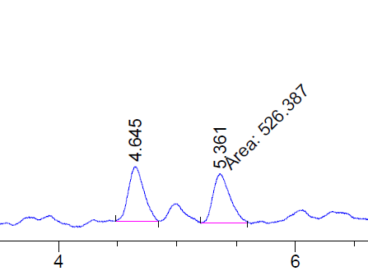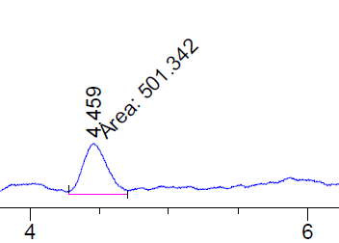
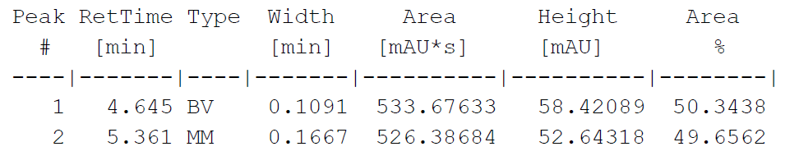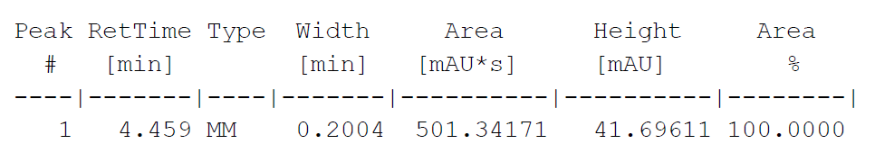

3,11-Dimethyl-5,8-diaza-1,9-diboradispiro[4.2.4]tetradecane (2ab)
Compound 2ab was obtained as a viscous oil in 95% (47.5 mg, 0.21 mmol). Reaction time: 1 h (Tf₂NH = 2 equivalents) *Note: Two equivalents of nBu₄NBH₄ were used to quench the reaction*

¹H NMR (500 MHz, CDCl₃) δ 3.61 – 3.49 (m, 1H, H₅), 3.42 (d, J = 8.5 Hz, 1H, H₄), 3.28 (d, J = 8.9 Hz, 1H, H₁₀), 3.19 ‒ 3.12 (m, 1H, H₈), 3.04 ‒ 2.98 (m, 2H, H_{5,8}), 2.91 – 2.77 (m, 4H, H_{6,7,} H_{4,10}), 2.52 – 2.47 (m, 2H, H_{6,7}), 2.39 – 2.22 (m, 2H, H_{9,14}), 2.22 – 2.07 (m, 3H, H₂, H₁₁, H₉), 1.98 (br, 1H, H₁₄), 1.07 – 1.01 (d_{(two doublets)}, J = 6.5 Hz_{(each)}, 6H, H₁, H₁₂), 0.99 – 0.90 (m, 2H, H₃, H₁₃), 0.39 (tt, J = 8.3, 4.3 Hz, 2H, H₃, H₁₃).

¹³C NMR (176 MHz, CDCl₃) δ 73.9, 57.0 (2C), 56.1, 55.1, 54.1, 31.2, 31.1, 29.9, 22.1, 20.6 (2C).

¹¹B NMR δ ‒5.6 ppm.

IR (film) ν_{max}: 2923, 2419, 2389, 2238, 2003, 1456, 1349, 1189, 1109 cm⁻¹.

HRMS (ESI, m/z): calculated for [M + H]⁺ C₁₂H₂₈BN₂O₄ requires m/z 287.23079, found m/z 287.2314.

3-(Cyclopropylmethyl)-5-aza-1-boraspiro[4.4]nonane (2ac)
The title compound 2ac was obtained as a clear oil in 98% yield (35 mg, 0.19 mmol). Reaction time: 4.5 h.

¹H NMR (500 MHz, CDCl₃) δ 3.28 ‒ 3.17 (m, 2H, H_{5,8}), 2.91 – 2.72 (m, 2H, H₄, H₅), 2.67 ‒ 2.58 (m, 2H, H₄, H₈), 2.25 – 2.02 (m, 4H, H₂, H_{6,7}, H₉), 1.99 – 1.77 (m, 3H, H_{6,7}, H₉), 1.43 (dt, J = 13.3, 6.6 Hz, 1H, H₁), 1.19 – 1.08 (m, 1H, H₁), 1.02 (dd, J = 13.7, 6.0 Hz, 1H, H₃), 0.73 – 0.60 (m, 1H, H₁₀), 0.56 – 0.42 (m, 1H, H₃), 0.42 – 0.31 (m, 2H, H_{11,12}), 0.07 – 0.001 (m, 1H, H₁₁), -0.006 – -0.07 (m, 1H, H₁₂).

¹³C NMR (126 MHz, CDCl₃) δ 68.5, 61.6, 60.3, 41.7, 39.1, 22.9, 22.6, 20.5, 9.9, 4.8, 4.5.

¹¹B NMR δ ‒3.9 ppm.

IR (film) ν_{max}: 3073, 2995, 2916, 2840, 2330, 1459, 1363, 1207, 1139, 1013, 823 cm⁻¹.
HRMS (ESI, m/z): calculated for [M + H]⁺ C₁₁H₂₂BNO₂ requires m/z 212.1816, found m/z 212.1820.

Post-Functionalization

Synthesis to SAB-F₂ Analogues
SAB (0.2 mmol) was added to a microwave vial followed by the addition of Tf₂NH (115 mg, 0. 41 mmol) and KF (35.7 mg, 0.62 mmol) under an argon atmosphere. To the vial was then added CH₂Cl₂ (683 μL) and the vial was sealed. The reaction mixture was stirred for 12 h at 60 °C. The vial was cooled, and the reaction mixture was filtered over a short pad of silica gel. The pad of silica gel was washed with CH₂Cl_{2,} and the filtrate was concentrated under reduced pressure. The products were obtained as pale-yellow viscous oils.
1,1-Difluoro-3-methyl-5-aza-1-boraspiro[4.4]nonane (3a)
The title compound was obtained in 87% yield (31 mg, 0.17 mmol).

¹H NMR (500 MHz, CDCl₃) δ 3.53 – 3.40 (m, 2H, H_{5,8}), 2.77 – 2.71 (m, 1H, H₅), 2.71 – 2.65 (m, 1H, H₄), 2.61 – 2.46 (m, 2H, H₄, H₈), 2.12 – 2.01 (m, 3H, H_{6,7}, H₂), 2.00 – 1.81 (m, 2H, H_{6,7}), 1.01 (d, J = 6.6 Hz, 3H, H₁), 0.96 ‒ 0.88 (m, 1H, H₃), 0.27 ‒ 0.15 (m, 1H, H₃).

¹³C NMR (126 MHz, CDCl₃) δ 67.2, 54.7 (2C), 28.8, 23.1, 22.8, 22.0, 20.8.

¹¹B NMR δ 9.5 ppm.

IR (film) ν_{max}: 2954, 2930, 2902, 1459, 1232, 1190, 1150, 1099, 1063, 930, 812 cm⁻¹.
HRMS (ESI, m/z): calculated for [M + H]⁺ C₈H₁₆BF₂N requires m/z 176.14166, found m/z 176.14245.

1,1-Difluoro-3-(4-fluorobenzyl)-5-aza-1-boraspiro[4.4]nonane (3b)
The title compound was obtained in 82% yield (44 mg, 0.16 mmol).

¹H NMR (500 MHz, CDCl₃) δ 7.21 – 7.06 (m, 2H, ArH), 7.06 – 6.94 (m, 2H, ArH), 3.48 ‒ 3.42 (m, 2H, H_{5,8}), 2.76 – 2.69 (m, 1H, H₄), 2.56 – 2.47 (m, 3H, H₁, H₅), 2.47 – 2.38 (m, 2H, H₄, H₈), 2.28 – 2.15 (m, 1H, H₂), 2.13 – 1.99 (m, 2H, H_{6,7}), 1.96 – 1.84 (m, 2H, H_{6,7}), 0.92 – 0.83 (m, 1H, H₃), 0.32 ‒ 0.29 (m, 1H, H₃).

¹³C NMR (126 MHz, CDCl₃) δ 135.5, 130.5, 115.5, 115.2, 65.4, 56.2, 54.9, 54.8, 41.7, 36.1, 23.3, 23.0, 22.9, 20.6.

¹¹B NMR δ 9.4 ppm.

IR (film) ν_{max}: 2951, 1349, 1181, 1135, 1054, 823, 652, 508 cm⁻¹.

HRMS (ESI, m/z): calculated for [M + H]⁺ C₁₄H₂₁BFNO₂ requires m/z 266.1724, found m/z 266.1738.

1,1-Difluoro-3-isopropyl-5-aza-1-boraspiro[4.4]nonane (3c)
The title compound was obtained in 78% yield (31 mg, 0.15 mmol).

¹H NMR (500 MHz, CDCl₃) δ 3.49 ‒ 3.43 (m, 2H, H_{5,8}), 2.82 – 2.75 (m, 1H, H₅), 2.73 – 2.63 (m, 1H, H₄), 2.53 (d, J = 9.0 Hz, 1H, H₈), 2.19 – 2.13 (m, 1H, H₄), 2.12 – 2.01 (m, 1H, H₆), 1.99 – 1.86 (m, 2H, H_{6,7}), 1.67 ‒ 1.67 (m, 2H, H_{7,} H₂), 1.45 – 1.33 (m, 1H, H₁), 0.93 (d, J = 6.6 Hz, 3H, H₁₀), 0.89 ‒ 0.86 (m, 1H, H₃), 0.86 (d, J = 6.6 Hz, 3H, H₉), 0.37 – 0.24 (m, 1H, H₃).

¹³C NMR (126 MHz, CDCl₃) δ 64.6, 54.8 (2C), 41.4, 33.6, 23.24, 23.4, 20.8 (2C), 17.1.

¹¹B NMR δ 9.4 ppm.

IR (film) ν_{max}: 2959, 2876, 1464, 1351, 1228, 1057, 787, 653, 614, 511 cm⁻¹.
HRMS (ESI, m/z): calculated for [M + H]⁺ C₁₀H₂₂BNO₂ requires m/z 200.18183, found m/z 200.18258.

1,1-Difluoro-3-((4'-methoxy-[1,1'-biphenyl]-4-yl)methyl)-5-aza-1-boraspiro[4.4]nonane (3d)
The title compound was obtained in 70% yield (45 mg, 0.13 mmol).

¹H NMR (500 MHz, CDCl₃) δ 7.51 (dd, J = 6.6, 2.0 Hz, 2H, ArH), 7.47 (dd, J = 8.1, 2.8 Hz, 2H, ArH), 7.21 (d, J = 8.1 Hz, 2H, ArH), 7.00 ‒ 6.93 (m, 2H, ArH), 3.85 (s, 3H, H₁₇), 3.53 – 3.40 (m, 2H, H_{5,8}), 2.90 – 2.76 (dd, J = 13.2, 5.5 Hz, 1H, H₄), 2.77 – 2.62 (m, 3H, H₁, H₅), 2.55 (dd, J = 13.2, 8.3 Hz, 1H, H₄), 2.52 – 2.40 (m, 1H, H₈), 2.33 ‒ 2.22 (m, 1H, H₂), 2.08 – 1.93 (m, 2H, H_{6,7}), 1.94 – 1.80 (m, 2H, H_{6,7}), 0.89 – 0.76 (m, 1H, H₃), 0.47 ‒ 0.35 (m, 1H, H₃).

¹³C NMR (126 MHz, CDCl₃) δ 159.2, 139.1, 138.6, 133.6, 129.2 (2C), 128.1 (2C), 126.8 (2C), 114.3 (2C), 65.5, 55.4, 54.8, 54.7, 42.3, 36.0, 23.3, 23.1, 20.0.

¹¹B NMR δ 9.5 ppm.

IR (film) ν_{max}: 2923, 2853, 1609, 1498, 1349, 1189, 1139, 1057, 816, 597, 514 cm⁻¹.

HRMS (ESI, m/z): calculated for [M + H]⁺ C₂₁H₂₈BNO₃ requires m/z 354.22388, found m/z 354.22475.

Derivatization to Boronic Acid and Boronic Esters

3-methyl-5-aza-1-boraspiro[4.4]nonane-1,1-diol (3e)
The title compound 3e and 3e’ was prepared by adding 2a (20 mg, 0.14 mmol) to a microwave vial containing H₂O (400 μL) followed by the addition of H₂SO₄ (8.0 μL, 0.14 mmol). The mixture was stirred for 12 h at 40 °C. Once completed, the reaction mixture was brought to room temperature and the solvent was removed under reduced pressure. The product was obtained as a mixture of 3e and 3e’ in the form of a clear viscous oil in 86% yield (21.2 mg, 0.12 mmol).

¹H NMR (400 MHz, MeOD) δ 3.73 ‒ 3.62 (m, 2H, H_{5,8}), 3.19 ‒ 3.08 (m, 3H, H_{4,} H_{5,8}), 3.07 ‒ 3.01 (m, 1H, H₄) 2.21 ‒ 2.11 (m, 3H, H_{2,} H_{6,7}) 2.10 ‒ 2.02 (m, 2H, H_{6,7}), 1.07 (s, J = 6.3 Hz, 3H, H₁), 0.97 (dd, J = 16.3, 5.9 Hz, 1H, H₃), 0.84 (dd, J = 16.3, 7.2 Hz, 1H, H₃)

¹³C NMR (126 MHz, CDCl₃) δ 62.9, 54.5, 54.0, 26.6, 22.5 (2C), 19.1, 18.2.

¹¹B NMR δ 16.7 ppm and 31.0 ppm.

IR (film) ν_{max}: 3404, 1371, 1170, 1038, 1001, 873, 744, 576 cm⁻¹.

HRMS (ESI, m/z): calculated for [M + H]⁺ C₈H₁₈BNO₂ requires m/z 172.1503, found m/z 172.1499.

1-(2-Methyl-3-(4,4,5,5-tetramethyl-1,3,2-dioxaborolan-2-yl)propyl)pyrrolidine (3f)
The title compound 3f and 3f’ was prepared by adding 2a (450 mg, 3.24 mmol), pinacol (459 mg, 3.88 mmol) and xylenes (16 mL) into a flask equipped with a stir bar. The reaction mixture was refluxed for 16 h. Once completed, the reaction mixture was brought to room temperature and the solvent was removed under reduced pressure. The product was obtained as a mixture of 3f and 3f’ in the form of a pale-yellow oil in 96% yield (787 mg, 3.11 mmol).

¹H NMR (500 MHz, CDCl₃) δ 2.62 ‒ 2.57 (m, 4H, H_{5,8}), 2.39 ‒ 2.32 (m, 1H, H₄), 2.16 (dd, J = 11.4, 8.0 Hz, 1H, H₄), 1.93 ‒ 1.83 (m, 1H, H₂), 1.82 ‒ 1.76 (m, 4H, H_{6,7}), 1.21 (s, 12H, H_{9,10,11,12}), 0.97 (d, J = 6.6 Hz, 3H, H₁), 0.78 ‒ 0.65 (m, 2H, H₃).

¹³C NMR (126 MHz, CDCl₃) δ 82.2 (2C), 66.7, 54.8, 29.4, 25.24 (2C), 25.20 (2C), 24.9, 24.6, 23.6, 21.2, 20.3.

¹¹B NMR δ 22.1 ppm and 29.8 ppm.

IR (film) ν_{max}: 2974, 2873, 2782, 1476, 1368, 1313, 1211, 1144, 970, 886, 847 cm⁻¹.

HRMS (ESI, m/z): calculated for [M + H]⁺ C₁₄H₂₈BNO₂ requires m/z 254.2289, found m/z 254.2291.

6-Cyclohexyl-2-(2-methyl-3-(pyrrolidin-1-yl)propyl)-1,3,6,2-dioxazaborocane-4,8-dione (3g)
The cyclohexyliminodiacetic acid (CIDA) derivative was prepared according to literature procedure.⁵

SAB 2a (100 mg, 0.72 mmol) was added to a dried round bottom flask containing benzene (5 mL), DMSO (2.5 mL) and the CIDA ligand (310 mg, 1.44 mmol). The reaction mixture was refluxed for 12 h at 95 °C. The reaction mixture was cooled and diluted with brine (10 mL) and EtOAc (10 mL) and transferred into a separatory funnel. The organic layer was separated, and the aqueous layer was extracted with EtOAc (3 X 10 mL). The combined organic layers were dried with anhydrous Na₂SO₄, filtered, and concentrated under reduced pressure. The residue was transferred into a 20 mL vial and prepared for lyophilization. Lyophilization procedure: 10 drops of H₂O were added to the vial and the vial was placed ice bath for (ice bath = acetone/dry ice) until the solution became frozen. The vial was then added to an insulated foam container filled with dry ice for 1 h before being placed on the lyophilizer. Lyophilization provided the product as a mixture of 3g and 3g’ in the form of a white solid in 67% yield (176 mg, 0.48 mmol).

¹H NMR (500 MHz, Acetone) δ 4.13 (dd, J = 16.8, 11.8 Hz, 2H, H₉), 3.84 (dd, J = 30.2, 16.8 Hz, 2H, H₁₀), 3.46 ‒ 3.30 (m, 1H, H₁₁), 2.43 – 2.34 (m, 1H, H₄), 2.33 ‒ 2.25 (m, 1H, H₄), 2.10 ‒ 2.01 (m, 1H, H₅), 1.92 – 1.83 (m, 4H, H₂, H₆, H_{c-hexyl}), 1.82 ‒ 1.70 (m, 5H, H₅, H_{c-hexyl}), 1.67 ‒ 1.63 (m, 1H, H₈₎ ,1.63 ‒ 1.53 (m, 1H, H_{c-hexyl}), 1.53 ‒ 1.45 (m, 1H, H_{c-hexyl}), 1.42 ‒ 1.32 (m, 2H, H_{6,7}), 1.32 ‒ 1.21 (m, 3H, H₆, H_{c-hexyl}), 1.13 – 1.05 (m, 1H, H₇), 0.99 (d, J = 6.6 Hz, 3H, H₁), 0.91 – 0.82 (m, 1H, H₃), 0.38 (dd, J = 14.3, 9.2 Hz, 1H, H₃).

¹³C NMR (126 MHz, CDCl₃) δ 169.7, 169.0, 66.1, 63.3, 57.4, 57.2, 55.9, 54.7 (2C), 30.0, 29.9, 25.5, 26.4, 25.6, 25.5, 24.1, 21.7, 21.0.

¹¹B NMR δ 13.1 ppm.

IR (film) ν_{max}: 3307, 2941, 2856, 1717, 1588, 1366, 1305, 1241, 1103, 975, 869, 720, 516, 424 cm⁻¹.
HRMS (ESI, m/z): calculated for [M + H]⁺ C₁₈H₃₁BN₂O₄ requires m/z 351.2450, found m/z 351.2443.
mp: 67‒68 °C.

Suzuki-Miyaura Cross-Coupling
Tetrakis(triphenylphosphine)palladium(0) (5 mol%) was added to a microwave reaction vial followed by addition of degassed THF (654 μL). The reaction mixture was degassed with N₂ for 5 min. The required CAB (0.3 mmol) was taken up in degassed THF (1.3 mL) and added to the vial while purging. To the vial was then added 720 μL of 3 N KOH and the desired aryl halide (1-bromo-4-tert-butylbenzene (2 equiv) or bromobenzene (2 equiv)). The vial was sealed, and the reaction mixture was stirred for 16 h at 65 °C. The reaction mixture was brought to room temperature and H₂O (5 mL) was added. The reaction mixture was transferred into a separatory funnel and the organic layer was separated. The aqueous layer was extracted with EtOAc (3 x 5 mL) and the combined organic layers were dried over anhydrous Na₂SO₄, filtered, and concentrated under reduced pressure. The excess aryl halide was distilled off and the residue was filtered over a short pad of silica gel using a solution of 1% Et₃N/hexanes which provided compounds 3h‒3j.
1-(3-(4-(tert-Butyl)phenyl)-2-methylpropyl)piperidine (3h):
The title compound was obtained as a pale-yellow oil in 85% yield (76 mg, 0.28 mmol).

¹H NMR (500 MHz, CDCl₃) δ 7.28 (d, J = 8.3 Hz, 2H, ArH), 7.08 (d, J = 8.2 Hz, 2H, ArH), 2.78 (dd, J = 13.1, 5.6 Hz, 1H, H₉), 2.56 ‒ 2.38 (br, 3H, H_{4,8}, H₃), 2.37 ‒ 2.27 (m, 3H, H₉, H₄, H₃), 2.25 (br, 1H, H₈), 2.12 ‒ 1.96 (m, 1H, H₂), 1.72 ‒ 1.58 (br, 4H, H_{5,7}), 1.49 ‒ 1.40 (m, 2H, H₆), 1.31 (s, 9H, H₁₄), 0.99 – 0.83 (m, 3H, H₁).

¹³C NMR (126 MHz, CDCl₃) δ 148.7, 129.4, 129.0 (2C), 125.2 (2C), 65.3, 54.8, 41.1 (2C), 34.5, 32.2, 31.6 (3C), 25.4 (2C), 24.2, 18.7.

IR (film) ν_{max}: 2933, 2867, 2523,1456, 1363, 1269, 1108, 856, 734, 572 cm⁻¹.

HRMS (ESI, m/z): calculated for [M + H]⁺ C₁₉H₃₁N requires m/z 274.2529, found m/z 274.2522.
1-(2-Methyl-3-phenylpropyl)piperidine (3i)
The title compound was obtained in 91% isolate yield (65 mg, 0.29 mmol) as a pale-yellow oil.

¹H NMR (400 MHz, CDCl₃) δ 7.26 ‒ 7.33 (m, 2H, ArH), 7.24 ‒ 7.15 (m, 3H, ArH), 3.01 ‒ 2.89 2.85 (dd, J = 13.4, 4.9 Hz, 1H, H₉), 2.51 ‒ 2.39 (m, 3H, H_{4,8}, H₉), 2.37 – 2.29 (m, 2H, H₃), 2.27 – 2.12 (m, 2H, H_{4,8}), 2.11 ‒ 1.98 (m, 1H, H₂), 1.71 ‒ 1.58 (m, 4H, H_{5,7}), 1.53 ‒ 1.41 (m, 2H, H₆), 0.91 (d, J = 6.3 Hz, 3H, H₁).

¹³C NMR (126 MHz, CDCl₃) δ 132.3, 129.4 (2C), 128.3 (2C), 64.9, 54.8 (2C), 41.7 (2C), 32.3, 29.4, 24.2, 24.0, 18.7.

IR (film) ν_{max}: 2930, 2852, 1376, 1301, 1119, 1058, 974, 740, 698 cm⁻¹.
HRMS (ESI, m/z): calculated for [M + H]⁺ C₁₅H₂₃N requires m/z 218.1903, found m/z 274.1894.

1-(2-Methyl-3-phenylpropyl)pyrrolidine (3j)

The title compound was obtained in 92% isolate yield (67 mg, 0.33 mmol) as a pale-yellow oil.

¹H NMR (400 MHz, CDCl₃) δ 7.32 ‒ 7.27 (m, 2H, ArH), 7.25 – 7.09 (m, 3H, ArH), 2.84 (dd, J = 13.5, 5.8 Hz, 1H, H₃), 2.81 ‒ 2.69 (m, 4H, H_{4,7}), 2.61 ‒ 2.49 (m, 2H, H₈), 2.45 (dd, J = 13.5, 8.3 Hz, 1H, H₃), 2.13 – 2.00 (m, 1H, H₂), 1.98 – 1.86 (m, 4H, H_{5,6}), 1.03 (d, J = 6.6 Hz, 3H, H₁).

¹³C NMR (126 MHz, CDCl₃) δ 141.0, 129.4 (2C), 128.5 (2C), 125.9, 63.2, 54.6 (2C), 41.7, 34.4, 23.6 (2C), 18.5.

IR (film) ν_{max}: 2956, 2924, 2784, 1602, 1453, 1082, 740, 699 cm⁻¹.
HRMS (ESI, m/z): calculated for [M + H]⁺ C₁₄H₂₁N requires m/z 204.1747, found m/z 204.1741.

Chan-Lam Cross-Coupling

N-Methyl-N-(2-methyl-3-(pyrrolidin-1-yl)propyl)aniline (3k)

A mixture of N-methylaniline (58.4 μL, 539 umol), copper (II) acetate, anhydrous (32.7 mg, 180 umol), 2a (50.0 mg, 360 umol), di-t-butyl peroxide, 98% (131 μL, 716 umol), and toluene (719 μL) was stirred at 100 °C for 24 h in a sealed tube. The reaction was brought to room temperature and the solvent was removed under reduced pressure. The residue was purified by column chromatography (1% Et₃N in 1:9 EtOAc:Hexanes, R_{f}: 0.3). The title compound 3k was obtained as a dark yellow oil in 80% yield (67 mg, 0.29 mmol).

¹H NMR (400 MHz, CDCl₃) δ 7.26 ‒ 7.16 (m, 2H, ArH), 6.73 ‒ 6.62 (m, 3H, ArH), 3.43 (dd, J = 14.6, 5.8 Hz, 1H, H₈), 3.03 (dd, J = 14.6, 8.1 Hz, 1H, H₈), 2.96 (s, 3H, H₉), 2.57 ‒ 2.42 (m, 4H, H_{4,7}), 2.44 – 2.26 (m, 2H, H₃), 2.18 – 2.08 (m, 1H, H₂), 1.87 ‒ 1.74 (m, 4H, H_{5,6}), 0.99 (d, J = 6.6 Hz, 3H, H₁).

¹³C NMR (126 MHz, CDCl₃) δ 149.8, 129.2 (2C), 115.9, 112.1 (2C), 61.5, 58.2, 54.8 (2C), 39.7, 32.1, 23.7 (2C), 17.5.

IR (film) ν_{max}: 2957, 2904, 2785, 1597, 1505, 1370, 1032, 744, 690 cm⁻¹.

HRMS (ESI, m/z): calculated for [M + H]⁺ C₁₅H₂₄N₂ requires m/z 233.2012, found m/z 233.2016.

Oxidation of C‒B bond
1-(3-((tert-Butyldimethylsilyl)oxy)-2-methylpropyl)pyrrolidine (3l)
Into a microwave vial was added 2a (50 mg, 0.36 mmol), 2 N aq. NaOH (2.2 mL), aq. 35% H₂O₂ (1.27 mL) and THF (1.8 mL). The mixture was stirred for 12 h at 60 °C. The mixture was then filtered over a short pad of silica gel and washed with 1% Et₃N/CH₂Cl₂ (4 x 5 mL). The solvent was evaporated, and the residue was taken up in CH₂Cl₂ (816 μL) and transferred in a microwave vial. To the vial was added imidazole (22.2 mg, 0.33 mmol) and the mixture was stirred for 10 min. While stirring, tert-butyldimethylchlorosilane (54 mg, 0.36 mmol) was added to the mixture leading to the formation of a white slurry. The reaction mixture was stirred for 30 min, following which the solvent was removed under reduced pressure to obtain the product in 77% yield (69 mg, 0.25 mmol) as a clear oil.

¹H NMR (500 MHz, CDCl₃) δ 3.56 (dd, J = 9.9, 5.1 Hz, 1H, H₈), 3.51 – 3.41 (dd, J = 9.5, 5.3 Hz, 1H, H₈), 3.04 ‒ 2.88 (m, 3H, H_{4,7}, H₃), 2.86 ‒ 2.76 (m, 2H, H₃, H₄), 2.67 ‒ 2.55 (m, 1H, H₇), 1.98 ‒ 1.94 (m, 4H, H_{5,6}, H₂), 1.65 – 1.50 (m, 1H, H₆), 1.09 (d, J = 6.5 Hz, 3H, H₁), 0.88 (s, 9H, H_{11,12,13}), 0.08 – 0.05 (s, 6H, H_{9,10}).

¹³C NMR (126 MHz, CDCl₃) δ 66.4 (2C), 59.8 (2C), 54.7, 29.8, 25.0, 23.6 (3C), 18.4, 16.1, -5.3 (2C).

IR (film) ν_{max}: 2954, 2926, 2854, 1462, 1255, 1088, 1036, 835, 775 cm⁻¹.

HRMS (ESI, m/z): calculated for [M + H]⁺ C₁₄H₃₁NOSi requires m/z 258.2240, found m/z 258.2247.

Regioselectivity in the Transformation of CABs to SABs
To determine the regioselectivity, we sought the use of 1e bearing a phenyl substitution on the C1 carbon. A substitution at C1 would allow to differentiate between the products obtained from the cleavage of the three cyclopropane C‒C bonds (C1−C2, C1−C3 or C2−C3) (Fig. S1).
Figure S1: Possible regioisomers of disubstituted CABs
The reaction was found to be regioselective towards the cleavage of the distal C1−C3 bond to provide the anti-Markovnikov product 2e. No Markovnikov product resulting from the cleavage of the distal C1−C3 was observed (Fig. S1, i) and no activation of the C2−C3 carbon leading to either the anti-Markovnikov [4.5.0] spirocyclic product (Fig. S1, ii) or the highly strained Markovnikov [3.4.0] spirocyclic product was observed (Fig. S1, iii). There was also no experimental evidence that would allude to the cleavage of the C1−C2 bond (Fig. S1, iv and v).

Mechanistic Studies Using Deuterium Experiments
Deuterium experiment to study kinetic isotope effect: 1e vs. 1e-d₂
Scheme S1: Transformation to SAB 2e-d₂

The deuterated CAB 1e-d₂ was synthesized according to General procedure A-C. In general procedure A, CH₂I₂ was replaced with CD₂I₂ and no dioxaborolane ligand was used. The reaction was done on a 4.5 mmol scale. Synthesis of SAB 2e-d₂: CAB 1e-d₂ (30.0 mg, 0.14 mmol) was added to a microwave vial followed by the addition of Tf₂NH (7.8 mg, 0.03 mmol) and toluene (314 uL). The vial was sealed, and the reaction was heated for 4 h at 125 °C. Once the reaction time was complete, the mixture was cooled, and the solvent was evaporated. An NMR of the crude reaction mixture was taken and the presence of CAB 1e-d₂ and SAB 2e-d₂ was observed. Purification by silica gel chromatography resulted in pure SAB 2e-d₂ in 22% yield (6.5 mg, 0.03 mmol)
Deuterium experiment with 1a-d₃
A deuterated derivative of CAB 1a was synthesized with its BH₃ moiety replaced with BD₃ (CAB 1a-d₃).
Scheme S2: Transformation to SAB 2a-d₃
Synthesis of CAB 1a-d₃: The deuterated CAB 1a-d₃ was prepared according to general procedure A-C. In general procedure C, the amide was first reduced to the amine with LAH using the following procedure: LAH (240 mg, 6.3 mmol) was added to a flame dried flask followed by the addition of THF (14 mL). The slurry was allowed to stir for 10 minutes and then cooled to -5 °C. The cyclopropyl(pyrrolidin-1-yl)methanone (400 mg, 2.9 mmol) was dissolved in THF (4 mL) and was added dropwise to the stirring slurry at -5 °C over 5 minutes. The mixture was brought to room temperature and refluxed for 12 h. The reaction mixture was cooled to 0 °C and 2 g of sodium sulfate decahydrate was added in small portions until no hydrogen evolution was observed. The mixture was stirred for 15 minutes and decanted with ether (50 mL). The filtrate was evaporated under reduced pressure to obtain the amine as a brown oil. The oil was then dissolved in THF (5 mL) and transferred to a 20 mL microwave vial. BD3•THF (1.5 equiv) was added dropwise to the stirring solution and the reaction mixture was refluxed for 12 h. The reaction was brought to room temperature and filtered over a short pad of silica gel using CH₂Cl₂. The filtrate was concentrated under reduced pressure and the residue was purified using column chromatography (1:9 EtOAc:Hexanes, R_{f}: 0.4) to provide CAB 1a-d₃ in 59% yield (243 mg, 1.68 mmol). The ¹H spectrum of CAB 1a-d₃ is identical to CAB 1a-d₃ with respect to chemical shifts (see supporting NMR spectra document).

²H NMR (107 MHz, CDCl₃) 1.66 (br, 3D, BD₃).

Synthesis of SAB 2a-d₃: CAB 1a-d₃ (52.0 mg, 0.36 mmol) was added to a microwave vial followed by the addition of Tf₂NH (15.0 mg, 0.55 mmol) and toluene (825 uL). The vial was sealed with a cap, and the reaction stirred for 12 h at 125 °C. The reaction mixture was brought to room temperature, diluted with CH₂Cl₂, and filtered over a short pad of silica gel. The filtrate was concentrated under reduced pressure to provide the deuterated SAB 2a-d₃ in the form of a clear oil in 95% yield (49.0 mg, 0.34 mmol). The ¹H spectrum is identical to SAB 2a with respect to chemical shifts (see supporting NMR spectra document).

²H NMR (107 MHz, CDCl₃) 1.02 (m, 1D, C3-D), 0.43 (m, 1D, C3-D).

Variable Temperature NMR Experiment
To a J. Young NMR tube was added CAB 1a (32.4 mg, 0.23 mmol) and Tf₂NH (26.2 mg, 0.093 mmol) (Scheme S3). Toluene-d₈ was added to the NMR tube, and the sample was shaken for 5 minutes. The ¹⁹F NMR spectra collected at five different temperatures between 298 K and 383 K over 3 h is presented below.
Scheme S3: Variable temperature NMR experiment
Figure S2: ¹⁹F NMR spectra at varying temperatures

Single-Crystal XRD Structures of CABs and SABs
*Crystallization procedure: Unless stated otherwise, crystals were obtained by the following procedure: ~10-20 mg of the pure compound was added to a 4 mL vial and dissolved in 200-300 uL of CH₂Cl₂. The 4 mL vial was placed in a 20 mL vial containing 1.5 mL of hexanes. The 20 mL vial was sealed with a cap and set aside until the formation of crystals was observed. The crystals were then subjected to X-ray diffraction*
The ORTEP diagrams of the single crystal XRD structure of compounds 1q, 2q, 2x, 1aa, 2aa, 1ab, and 2ab are presented below with 50% ellipsoid probability. Crystallographic data for these structures has been deposited at the Cambridge Crystallographic Data Centre and their respective deposition numbers are listed below (CCDC #).

Crystallographic Data

1-((2-(p-Tolyl)cyclopropyl)methyl)pyrrolidine borane (1q) (CCDC 2307226):
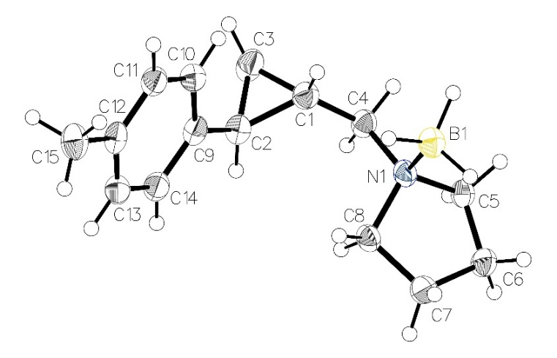
Table S4: Crystal data and structure refinement for compound 1q
Identification code | saher10
Empirical formula | C₁₅H₂₄BN
Formula weight | 229.16
Temperature/K | 100
Crystal system | monoclinic
Space group | P2₁/n
a/Å | 5.7339(2)
b/Å | 11.6824(4)
c/Å | 20.5876(7)
α/° | 90
β/° | 92.341(2)
γ/° | 90
Volume/Å³ | 1377.92(8)
Z | 4
ρ_{calc}g/cm³ | 1.105
μ/mm⁻¹ | 0.458
F(000) | 504.0
Crystal size/mm³ | 0.15 × 0.04 × 0.02
Radiation | CuKα (λ = 1.54178)
2Θ range for data collection/° | 8.596 to 140.12
Index ranges | -6 ≤ h ≤ 6, -14 ≤ k ≤ 14, -25 ≤ l ≤ 25
Reflections collected | 18518
Independent reflections | 2597 [R_{int} = 0.0567, R_{sigma} = 0.0362]
Data/restraints/parameters | 2597/0/167
Goodness-of-fit on F² | 1.058
Final R indexes [I>=2σ (I)] | R₁ = 0.0563, wR₂ = 0.1495
Final R indexes [all data] | R₁ = 0.0624, wR₂ = 0.1583
Largest diff. peak/hole / e Å⁻³ | 0.40/-0.24

3-(4-Methylbenzyl)-5-aza-1-boraspiro[4.4]nonane (2q) (CCDC 230228):
Disorder ratio: 0.819:0.0181
(Major disorder fragment shown on right)
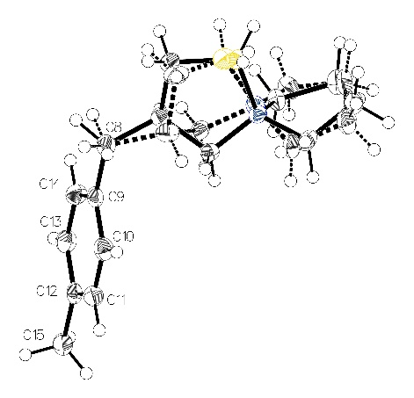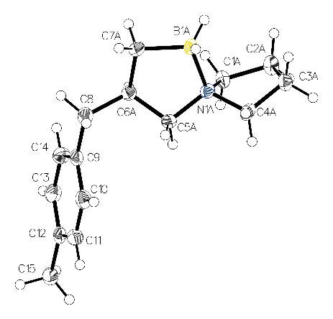
Table S5: Crystal data and structure refinement for compound 2q
Identification code | saher92
Empirical formula | C₁₅H₂₄BN
Formula weight | 229.16
Temperature/K | 100
Crystal system | monoclinic
Space group | P2₁/n
a/Å | 11.3630(5)
b/Å | 6.1934(3)
c/Å | 19.5336(9)
α/° | 90
β/° | 96.729(2)
γ/° | 90
Volume/Å³ | 1365.22(11)
Z | 4
ρ_{calc}g/cm³ | 1.115
μ/mm⁻¹ | 0.463
F(000) | 504.0
Crystal size/mm³ | 0.39 × 0.18 × 0.1
Radiation | CuKα (λ = 1.54178)
2Θ range for data collection/° | 8.59 to 140.172
Index ranges | -13 ≤ h ≤ 13, -7 ≤ k ≤ 6, -23 ≤ l ≤ 23
Reflections collected | 25123
Independent reflections | 2548 [R_{int} = 0.0240, R_{sigma} = 0.0116]
Data/restraints/parameters | 2548/295/237
Goodness-of-fit on F² | 1.037
Final R indexes [I>=2σ (I)] | R₁ = 0.0427, wR₂ = 0.1138
Final R indexes [all data] | R₁ = 0.0437, wR₂ = 0.1171
Largest diff. peak/hole / e Å⁻³ | 0.24/-0.26

9-Phenyl-5-aza-6-boraspiro[4.5]decane (2x) (CCDC 2307232):
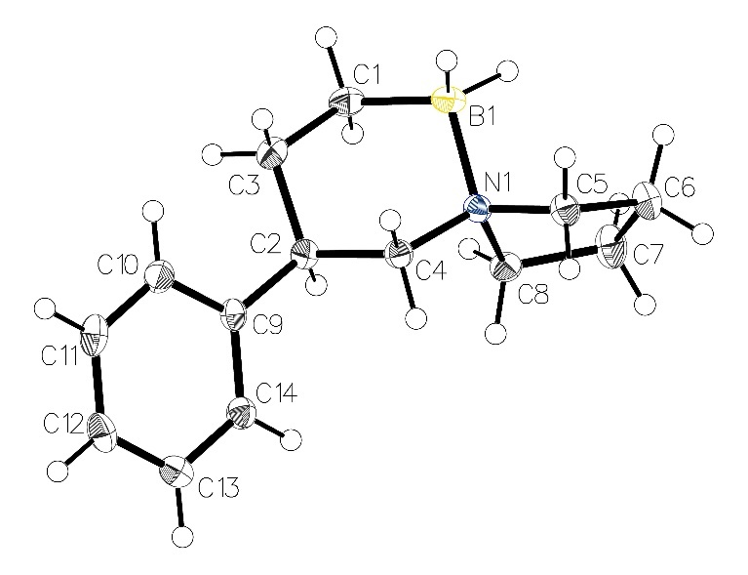
Table S6: Crystal data and structure refinement for compound 2x
Identification code | saher12
Empirical formula | C₁₄H₂₂BN
Formula weight | 215.13
Temperature/K | 100
Crystal system | monoclinic
Space group | P2₁/c
a/Å | 9.2915(4)
b/Å | 12.2620(5)
c/Å | 11.2292(5)
α/° | 90
β/° | 102.9850(10)
γ/° | 90
Volume/Å³ | 1246.65(9)
Z | 4
ρ_{calc}g/cm³ | 1.146
μ/mm⁻¹ | 0.477
F(000) | 472.0
Crystal size/mm³ | 0.34 × 0.34 × 0.17
Radiation | CuKα (λ = 1.54178)
2Θ range for data collection/° | 9.768 to 140.276
Index ranges | -11 ≤ h ≤ 10, -14 ≤ k ≤ 14, -13 ≤ l ≤ 13
Reflections collected | 24226
Independent reflections | 2360 [R_{int} = 0.0273, R_{sigma} = 0.0153]
Data/restraints/parameters | 2360/0/153
Goodness-of-fit on F² | 1.026
Final R indexes [I>=2σ (I)] | R₁ = 0.0420, wR₂ = 0.1097
Final R indexes [all data] | R₁ = 0.0422, wR₂ = 0.1100
Largest diff. peak/hole / e Å⁻³ | 0.31/-0.21

1-(((1S,2S)-2-Methyl-2-phenylcyclopropyl)methyl)pyrrolidine borane (1aa)
(CCDC 2307232):
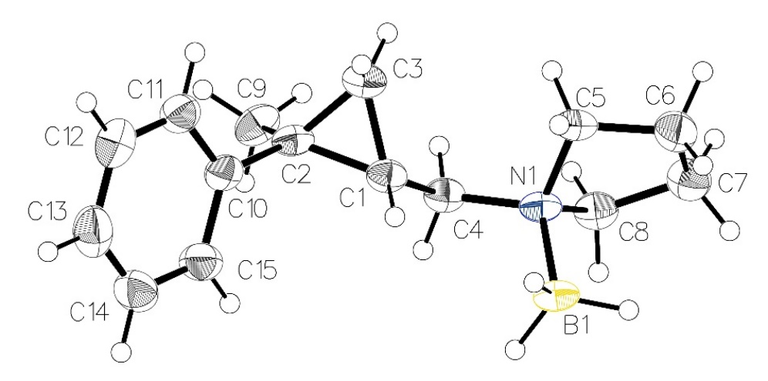
Table S7: Crystal data and structure refinement for compound 1aa
Identification code | saher11(2)
Empirical formula | C₁₅H₂₄BN
Formula weight | 229.16
Temperature/K | 100
Crystal system | monoclinic
Space group | P2₁
a/Å | 6.0342(4)
b/Å | 9.9763(6)
c/Å | 11.9260(7)
α/° | 90
β/° | 96.777(3)
γ/° | 90
Volume/Å³ | 712.92(8)
Z | 2
ρ_{calc}g/cm³ | 1.068
μ/mm⁻¹ | 0.443
F(000) | 252.0
Crystal size/mm³ | 0.16 × 0.14 × 0.01
Radiation | CuKα (λ = 1.54178)
2Θ range for data collection/° | 7.464 to 144.276
Index ranges | -7 ≤ h ≤ 6, -12 ≤ k ≤ 12, -14 ≤ l ≤ 14
Reflections collected | 18267
Independent reflections | 2726 [R_{int} = 0.0355, R_{sigma} = 0.0177]
Data/restraints/parameters | 2726/4/165
Goodness-of-fit on F² | 1.028
Final R indexes [I>=2σ (I)] | R₁ = 0.0491, wR₂ = 0.1309
Final R indexes [all data] | R₁ = 0.0499, wR₂ = 0.1322
Largest diff. peak/hole / e Å⁻³ | 0.28/-0.19
Flack parameter | -0.2(7)

3-((S)-1-Phenylethyl)-5-aza-1-boraspiro[4.4]nonane (2aa) (CCDC 2307233):

*See procedure for SAB 2aa for crystallization process*
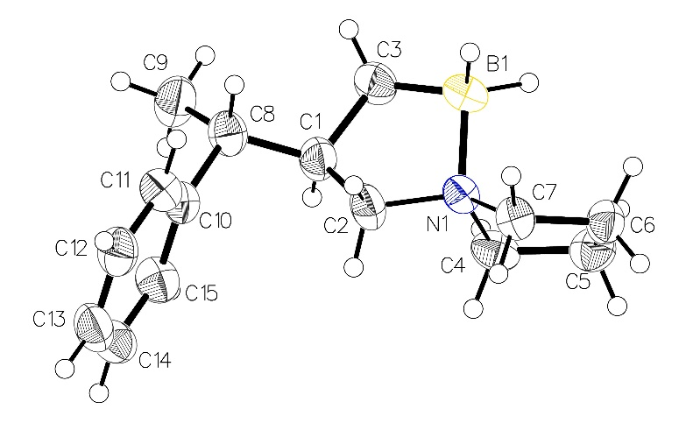
Table S8: Crystal data and structure refinement for compound 2aa
Identification code | ABC-SHS-2671 / SAHER40(2)
Empirical formula | C₁₅H₂₄BN
Formula weight | 229.16
Temperature/K | 150
Crystal system | monoclinic
Space group | P2₁
a/Å | 6.1145(5)
b/Å | 11.6448(10)
c/Å | 9.8210(8)
α/° | 90
β/° | 91.035(6)
γ/° | 90
Volume/Å³ | 699.16(10)
Z | 2
ρ_{calc}g/cm³ | 1.089
μ/mm⁻¹ | 0.288
F(000) | 252.0
Crystal size/mm³ | 0.13 × 0.06 × 0.03
Radiation | Ga Kα (λ = 1.34139)
2Θ range for data collection/° | 7.834 to 109.886
Index ranges | -7 ≤ h ≤ 7, -12 ≤ k ≤ 13, -11 ≤ l ≤ 11
Reflections collected | 5187
Independent reflections | 2336 [R_{int} = 0.0818, R_{sigma} = 0.1100]
Data/restraints/parameters | 2336/2/164
Goodness-of-fit on F² | 1.076
Final R indexes [I>=2σ (I)] | R₁ = 0.0651, wR₂ = 0.1351
Final R indexes [all data] | R₁ = 0.1170, wR₂ = 0.1548
Largest diff. peak/hole / e Å⁻³ | 0.24/-0.21
Flack parameter | -1.2(19)

1,4-Bis(cyclopropylmethyl)piperazine borane (1ab) (CCDC 2307235):
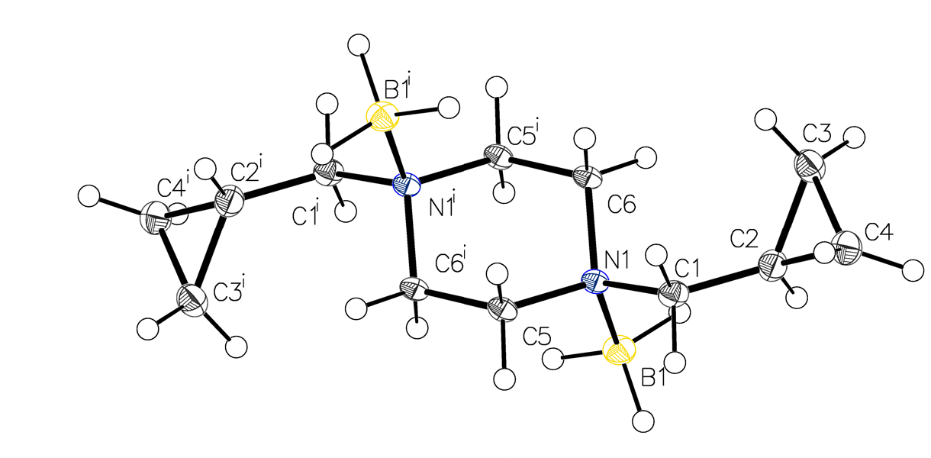
Table S9: Crystal data and structure refinement for compound 1ab
Identification code | saher161
Empirical formula | C₁₂H₂₈B₂N₂
Formula weight | 221.98
Temperature/K | 100
Crystal system | monoclinic
Space group | P2₁/c
a/Å | 11.2826(5)
b/Å | 6.0833(2)
c/Å | 10.5290(4)
α/° | 90
β/° | 107.856(2)
γ/° | 90
Volume/Å³ | 687.85(5)
Z | 2
ρ_{calc}g/cm³ | 1.072
μ/mm⁻¹ | 0.444
F(000) | 248.0
Crystal size/mm³ | 0.24 × 0.06 × 0.03
Radiation | Cu Kα (λ = 1.54178)
2Θ range for data collection/° | 8.232 to 144.094
Index ranges | -13 ≤ h ≤ 13, -6 ≤ k ≤ 7, -12 ≤ l ≤ 12
Reflections collected | 9296
Independent reflections | 1348 [R_{int} = 0.0396, R_{sigma} = 0.0243]
Data/restraints/parameters | 1348/0/85
Goodness-of-fit on F² | 1.028
Final R indexes [I>=2σ (I)] | R₁ = 0.0370, wR₂ = 0.0959
Final R indexes [all data] | R₁ = 0.0394, wR₂ = 0.0983
Largest diff. peak/hole / e Å⁻³ | 0.22/-0.22

3,11-Dimethyl-5,8-diaza-1,9-diboradispiro[4.2.4]tetradecane (2ab) (CCDC 2307234):
Disorder ratio: B1 side 0.299: 0.201 (atoms C6a, C8a: C6b, C8b) and B2 side: 0.383:0.0117 (atoms C10a, C12a: C10b, C12b)
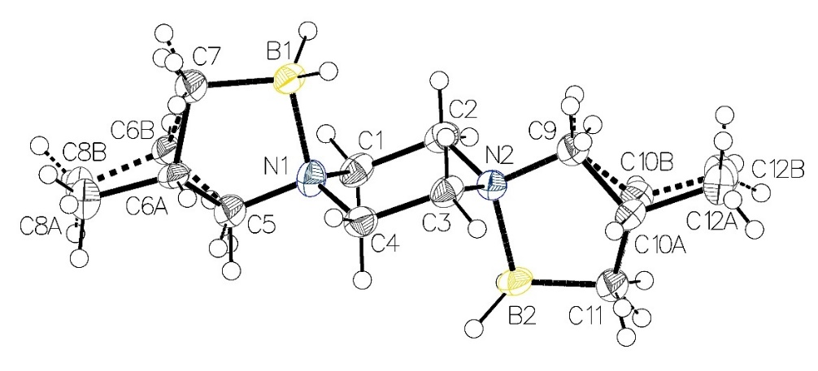
Table S10: Crystal data and structure refinement for compound 2ab
Identification code | saher177
Empirical formula | C₁₂H₂₈B₂N₂
Formula weight | 221.98
Temperature/K | 100
Crystal system | monoclinic
Space group | C2/m
a/Å | 23.0668(12)
b/Å | 5.9251(3)
c/Å | 10.9279(6)
α/° | 90
β/° | 109.254(3)
γ/° | 90
Volume/Å³ | 1410.01(13)
Z | 4
ρ_{calc}g/cm³ | 1.046
μ/mm⁻¹ | 0.433
F(000) | 496.0
Crystal size/mm³ | 0.3 × 0.075 × 0.045
Radiation | Cu Kα (λ = 1.54178)
2Θ range for data collection/° | 8.12 to 143.858
Index ranges | -28 ≤ h ≤ 26, 0 ≤ k ≤ 7, 0 ≤ l ≤ 13
Reflections collected | 1507
Independent reflections | 1507 [R_{int} = ?, R_{sigma} = 0.0211]
Data/restraints/parameters | 1507/37/180
Goodness-of-fit on F² | 1.086
Final R indexes [I>=2σ (I)] | R₁ = 0.0690, wR₂ = 0.1831
Final R indexes [all data] | R₁ = 0.0765, wR₂ = 0.1896
Largest diff. peak/hole / e Å⁻³ | 0.32/-0.23

References
1. Charette, A. B.; Juteau, H., J. Am. Chem. Soc. 1994, 116, 2651-2652.
2. Luo, G.; Xiang, M.; Krische, M. J., Org. Lett. 2019, 21, 2493-2497.
3. Veeraraghavan Ramachandran, P.; Kulkarni, A. S.; Zhao, Y.; Mei, J., Chem. Commun. 2016, 52, 11885-11888.
4. Gieuw, M. H.; Leung, V. M. Y.; Ke, Z.; Yeung, Y. Y. J. A. S.; Catalysis, Adv. Synth. Catal. 2018, 360, 4306-4311.
5. Siddiqui, S. H.; Navuluri, C.; Charette, A. B., Synthesis 2019, 51, 3834-3846.

Shriver, D. F. & Drezdzon, M. A. The Manipulation of Air-Sensitive Compounds; 2nd Edition; Wiley: New York, 1986.

