Supporting Information
Rapid stress relaxation and degradable aromatic disulfide vitrimer for recyclable carbon fiber reinforced composite
Qinghua Zhang^{a,b}, Mingzhuan Li^{a,b}, Peifeng Feng^{a,b}, Luoli Mengª, Xigao Jianª, Jian Xu^{a,b,*}
ª State Key Laboratory of Fine Chemicals, Frontiers Science Center for Smart Materials Oriented Chemical Engineering, School of Chemical Engineering, Dalian University of Technology, Dalian 116024, China
^{b} Engineering Laboratory of Advanced Energy Materials, Ningbo Institute of Material Technology & Engineering, Chinese Academy of Sciences, Ningbo, 315201, China
*Corresponding author E-mail address: xujian1028@dlut.edu.cn (Jian Xu).

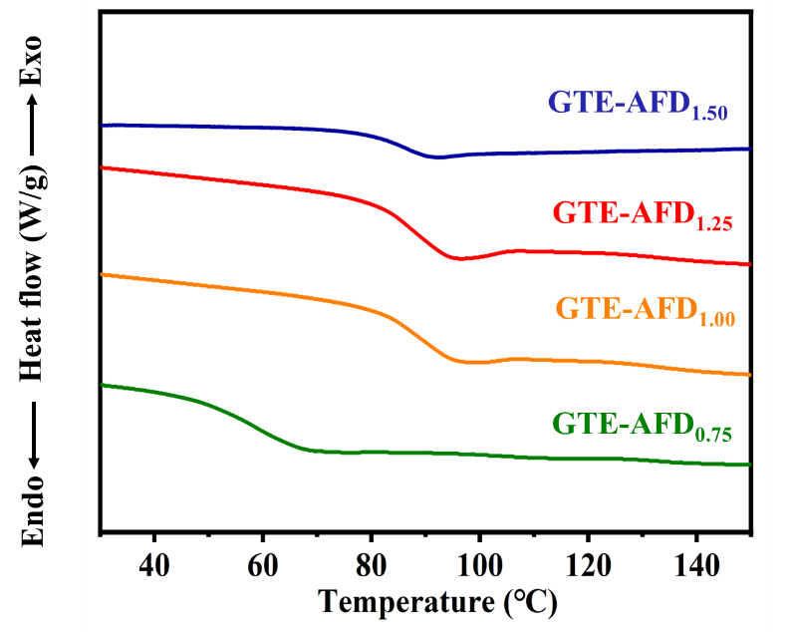
Fig. S1 DSC curves

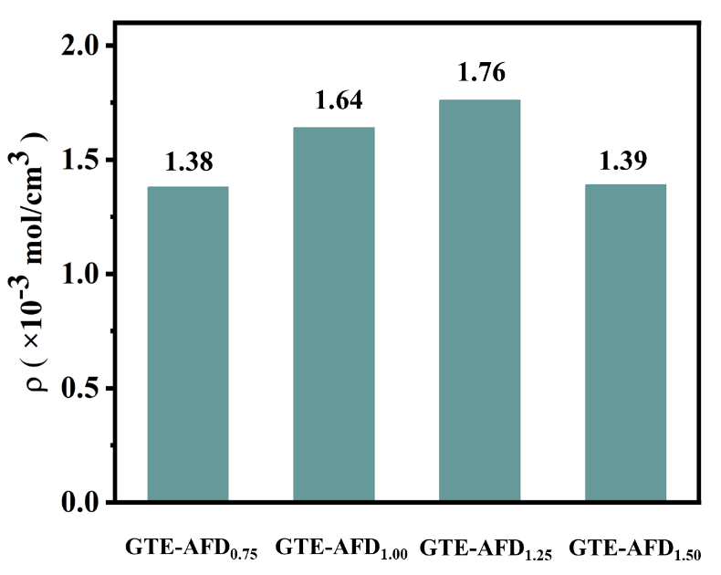
Fig. S2 cross-link density of GTE-AFD vitrimers

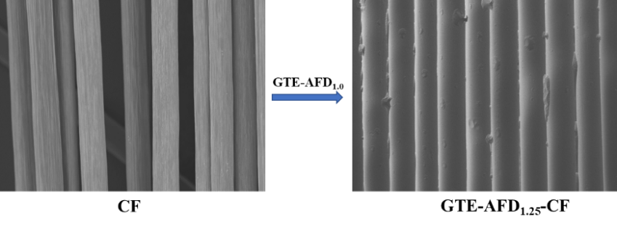
Fig. S3 SEM of CF before and after adding the GTE-AFD_{1.25} matrix

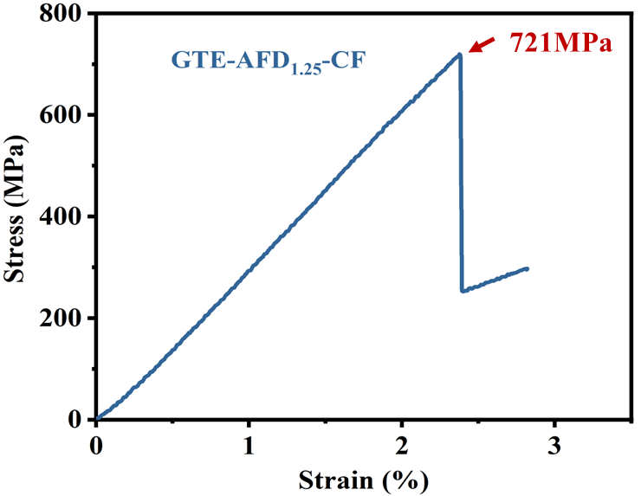
Fig. S4 Flexural stress-strain curves for GTE-AFD_{1.25} composites

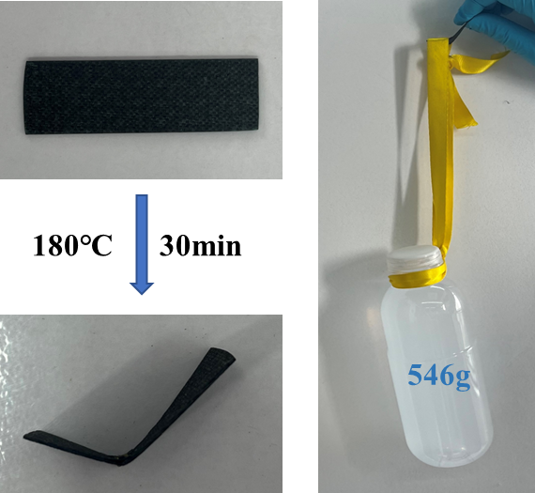
Fig S5. Reprocessing of the GTE-AFD_{1.25}-CF composites

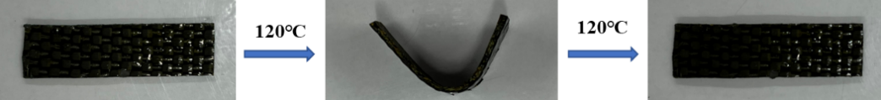
Fig S6. Shape memory photographs of GTE-AFD_{1.25}-CF composites

