Figure s1: Pie chart showing over all prevalence of hypercholesterolemia.

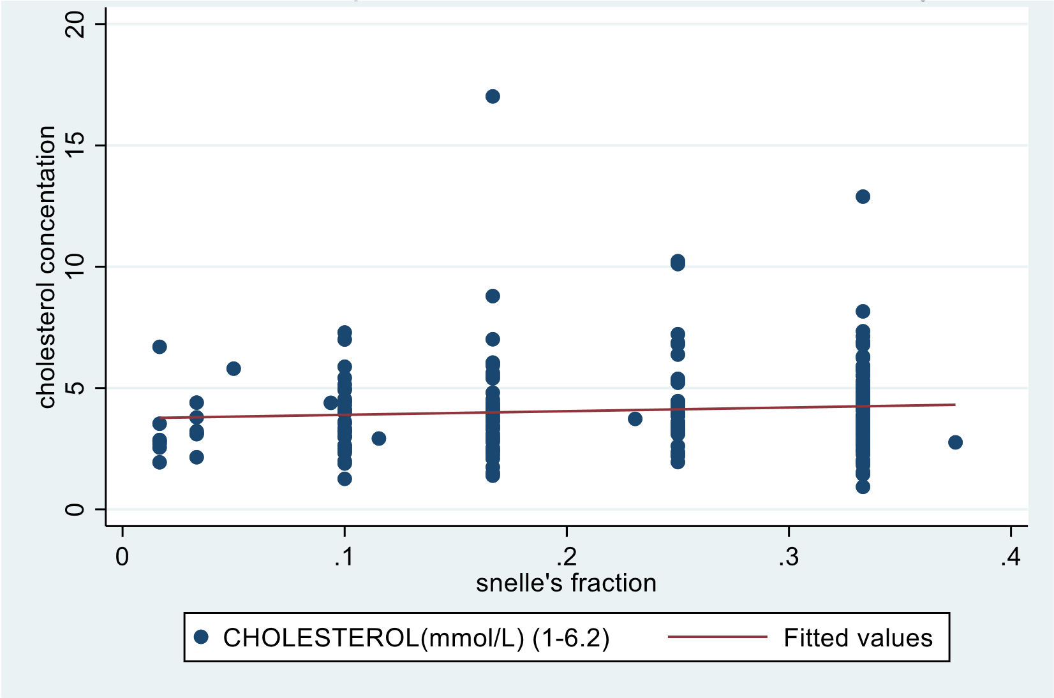
Figure s2: A scatter plot showing the relationship between cholesterol and visual acuity

Table s1-Characteristics of the study participants stratified by gender

Variable | Total  n(%) | Gender
Variable | Total  n(%) | Male  108(45.76%) | Female  128(54.24)
Age
18-30 | 61 (25.85) | 28 (25.93) | 33 (25.78)
31-40 | 32 (13.56) | 15 (13.89) | 17 (13.28)
>40 | 143 (60.59) | 65 (60.19) | 78 (60.94)
Marital status
Married | 153 (64.83) | 74 (68.52) | 79 (61.72)
Single | 58 (24.58) | 26 (24.07) | 32 (25.00)
Divorced | 7 (2.97) | 2 (1.85) | 5 (3.91)
Others | 18 (7.63) | 6 (5.56) | 12 (9.38)
Religion
Catholic | 91 (38.56) | 43 (39.81) | 48 (37.50)
Moslem | 15 (6.36) | 7 (6.48) | 8 (6.25)
SDA | 16 (6.78) | 4 (3.7) | 12 (9.38)
Others | 114 (48.31) | 54 (50.00) | 60 (46.88)
Residence
Urban | 69 (29.4) | 28 (25.93) | 41 (32.03)
Rural | 167 (70.76) | 80 (74.07) | 87 (67.97)
Occupation
Employed | 53 (22.46) | 25 (23.15) | 28 (21.88)
Self employed | 84 (35.59) | 37 (34.26) | 47 (36.72)
Unemployed | 87 (36.86) | 40 (37.04) | 47 (36.72)
Others | 12 (5.08) | 6 (5.56) | 6 (4.69)
Education level
Primary | 124 (52.54) | 57 (52.78) | 67 (52.34)
UCE | 55 (23.31) | 26 (24.07) | 29 (22.66)
UACE | 16 (6.78) | 7 (6.48) | 9 (7.03)
Institution | 24 (10.17) | 8 (7.41) | 16 (12.5)
Degree | 17 (7.20) | 10 (9.26) | 7 (5.47)

Table s2: Shows variables with a significant association with hypercholesterolemia.

Variable | Hypercholesterolemia |  | P value
Variable | Absent  188(79.66) | Present  48(20.34)
Age |  |  | 0.414
18-30 | 52(85.25) | 9(14.75)
31-40 | 24(75.00) | 8(25.00)
>40 | 112(78.32) | 31(21.68)
Alcohol status |  |  | 0.013
Never consumed | 104(74.29) | 36(25.71)
Ever consumed | 84(87.50) | 12(12.50)
F. Hypercholesterolemia
No | 109(83.35) | 21(16.15)
Yes | 14(63.64) | 8(36.36)
Chronic Condition |  |  | 0.046
No | 127 (83.55) | 25 (16.45)
Yes | 61(72.62) | 23 (27.38)

Table s3: Shows r factors of hypercholesteremia among patients with vision impairment at Ruharo Eye Center (bivariate analysis n=236)
Variable | Bivariate
Variable | Odds ratio(95%CI) | P-value
Smoking status
Ever smoked | 0.57(0.23-1.29) | 0.179
Never smoked | 1.00
Alcohol status
Ever consumed | 0.41(0.20-0.84) | 0.015
Never consumed | 1.00
Physical activity
Regularly | 0.64(0.17-2.58) | 0.520
Irregularly | 1.53(0.73-3.19) | 0.255
Never | 1.00
Familial hypercholesterolemia
Yes | 2.97(1.11-7.95) | 0.031
No | 1.00
Screening for lipid profile
Yes | 0.77(0.16-3.65) | 0.746
No | 1.00
Tx for hyperlipidemia
Yes | 0.46(0.06-3.77) | 0.469
No | 1.00
High blood pressure
Yes | 1.03(0.50-2.09) | 0.07
No | 1.00
Diabetes status
Yes | 0.89(0.36-2.21) | 0.811
Not sure | 1.47(0.63-3.46) | 0.374
No | 1.00
HIV status
Yes | 1.27(0.24-6.60) | 0.779
Not sure | 0.89(0.45-1.76) | 0.746
No | 1.00
Chronic condition status
Yes | 1.92(1.01-3.64) | 0.048
No | 1.00
SBP(mmHg)
Yes | 1.01(0.99-1.02) | 0.419
No | 1.00
aWHR
Abnormal | 0.77(0.41-1.45) | 0.428
Normal | 1.00
aWhtR
Abnormal | 1.86(0.89-3.89) | 0.098
Normal | 1.00
BMI
25-29.9 | 1.15(0.57-2.31) | 0.698
>=30 | 1.60(0.63-4.03) | 0.323
<25 | 1.00
Blood pressure
DBP only | 1.78(0.33-9.74) | 0.504
SBP only | 0.97(0.42-2.28) | 0.960
Both DBP and SBP | 1.66(0.76-3.59) | 0.202
Normal | 1.00

Table s4: Shows risk factors of hypercholesteremia among patients with visual impairment at Ruharo Eye Center (multivariate analysis N=236).

Variable | Multivariate
Variable | Odds ratio(95%CI) | p-value
Smoking status | 0.82(0.27-2.46) | 0.725
Ever smoked
Never smoked
Alcohol status | 0. 34 (0.14-0.85) | 0.021
Ever consumed | 1.00
Never consumed
Physical activity | 0.38(0.08-1.88) | 0.234
Regularly | 1.31(0.53-3.27) | 0.558
Irregularly
Never
Familial hypercholesterolemia
Yes | 3.69(1.13-12.04) | 0.031
No
High blood pressure | 0.48(0.15-1.53) | 0.215
Yes
No
Chronic condition status
Yes | 5.00(1.77-14.14) | 0.002
No
BMI
25-29.9 | 0.85(0.37-1.94) | 0.696
>=30 | 1.03(0.33-3.25) | 0.954
<25
Blood pressure
DBP only | 2.89(0.39-21.23) | 0.296
SBP only | 0.89(0.32-2.51) | 0.823
Both DBP and SBP | 3.17(1.13-8.83) | 0.028
Normal | 1.00
P<0.05 was considered statistically significant.

