Supplementary Material

De novo biosynthesis of C-arabinosylated flavones by utilization of indica rice C-glycosyltransferases

Zhuo Chen^{1,2#}, Yuwei Sun^{1#}, Guangyi Wang^{1,2}, Ying Zhang^{1,2}, Qian Zhang^{1,2}, Yulian Zhang^{1,2}, Jianhua Li¹, Yong Wang^{1*}

¹ CAS-Key Laboratory of Synthetic Biology, CAS Center for Excellence in Molecular Plant Sciences, Institute of Plant Physiology and Ecology, Chinese Academy of Sciences, Shanghai 200032, China. ² University of Chinese Academy of Sciences, Beijing 100039, China. * Corresponding author. Tel/Fax: 86-21-54924295; Email: yongwang@cemps.ac.cn. # These authors contribute equally to this work

Contents
Supplementary Figures 3
Fig. S1 An unrooted phylogenetic tree of rice CGTs. 3
Fig. S2 LC-MS/MS analyses of minor flavone glycosides present in O. sativa. 4
Fig. S3 LC-MS/MS analyses of pathway intermediates in the extracts of sCZ113 and sCZ118. 5
Fig. S4 A proposed biosynthetic network of flavone C-xylosides. 7
Fig. S5 De novo biosynthesis of vicenin-3 and vicenin-1. 8
Fig. S6 NMR spectra of apigenin 6,8-C-di-arabinoside (Api-di-C-Ara). 11
Fig. S7 Comparison of ¹H NMR spectra of Api-di-C-Ara recorded at different temperature (K). 12
Fig. S8 ¹H NMR spectra of (A) apigenin 6,8-di-C-xyloside (Api-di-C-Xyl) and (B) chrysin 6,8-di-C-arabinoside (Chr-di-C-Ara) recorded at 353 K. 13
Fig. S9 Decomposition of apigenin mono-C-arabinosides. 14
Fig. S10 De novo biosynthesis of Api-di-C-Xyl. 15
Supplementary Tables 16
Table S1 Plasmids and strains used in this study. 16
Table S2 Primers used in this study. 17

Supplementary Figures
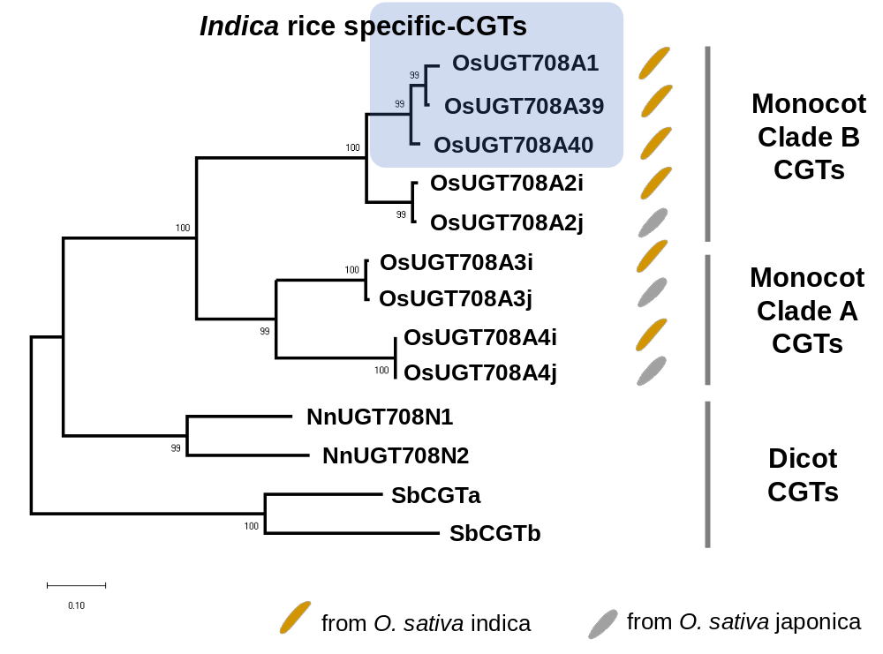

Fig. S1 Unrooted phylogenetic tree of rice CGTs.
Four recently reported dicot CGTs were used as out-group, including NnUGT708N1 (XP_010258947.1), NnUGT708N2 (XP_010265663.2) (Feng et al, 2021), SbCGTa (QLF98861.1), SbCGTb (QLF98862.1) (Wang et al., 2020). The indica rice possesses three specific CGTs (OsUGT708A1, OsUGT708A39 and OsUGT708A40, indicated in blue square) belonging to the monocot clade B. Bootstrap values (based on 1000 replications) are indicated at each node.

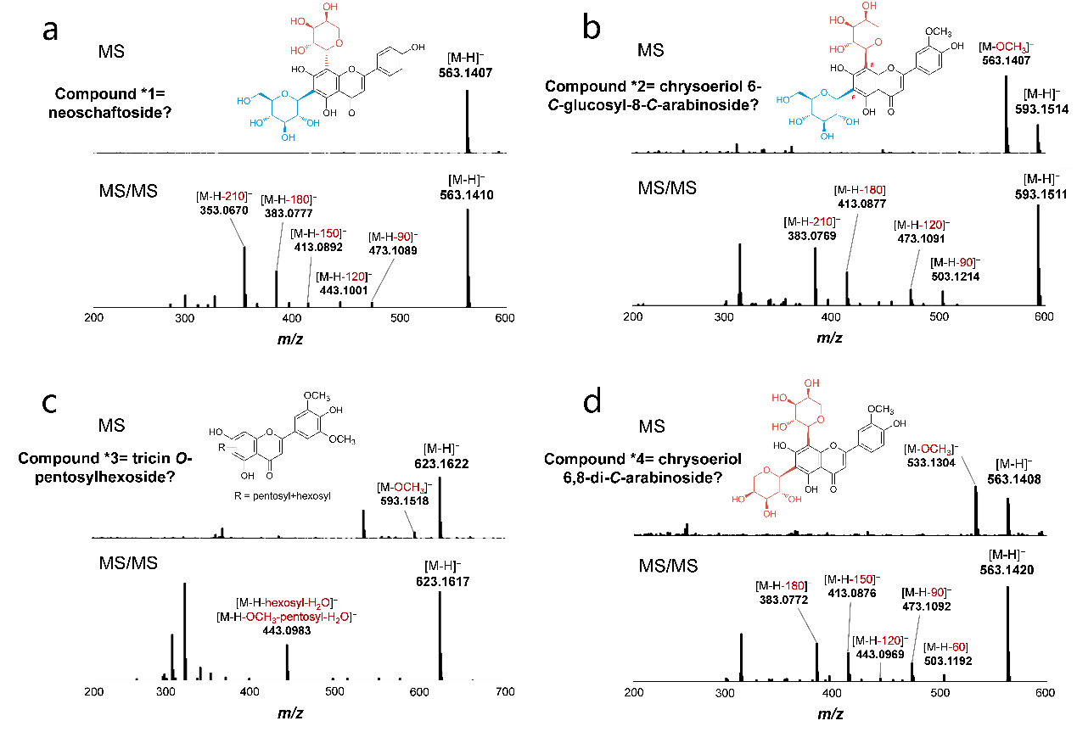

Fig. S2 LC-MS/MS analyses of minor flavone glycosides present in O. sativa.
a MS and MS/MS fragmentation of compound *1. The m/z of compound *1 ([M–H]–=563.1) is identical to schaftoside and isoschaftoside. We proposed this compound to be neoschaftoside (Neosch). b MS and MS/MS fragmentation of compound *2. Compound *2 showed m/z [M–H]–=593.2 and [M–H-OCH₃]–=563.1. MS/MS spectrum indicated a hybrid C-glycosylation pattern of pentosyl and hexosyl. We proposed this compound to be chrysoeriol 6-C-glucosyl-8-C-arabinoside or its 6-C-arabinosyl-8-C-glucoside isomer. c Compound *3 with m/z [M–H]–=623.2 and [M–H-OCH₃]–=593.2 was proposed to be an O-pentosylhexoside of tricin, because typical fragmentation of C-glycosides was not observed. d MS and MS/MS fragmentation of compound *4. We proposed this compound to be di-C-arabinoside of chrysoeriol based on MS/MS fragmentation ([M–H-180]–, [M–H-150]–, [M–H-120]–).
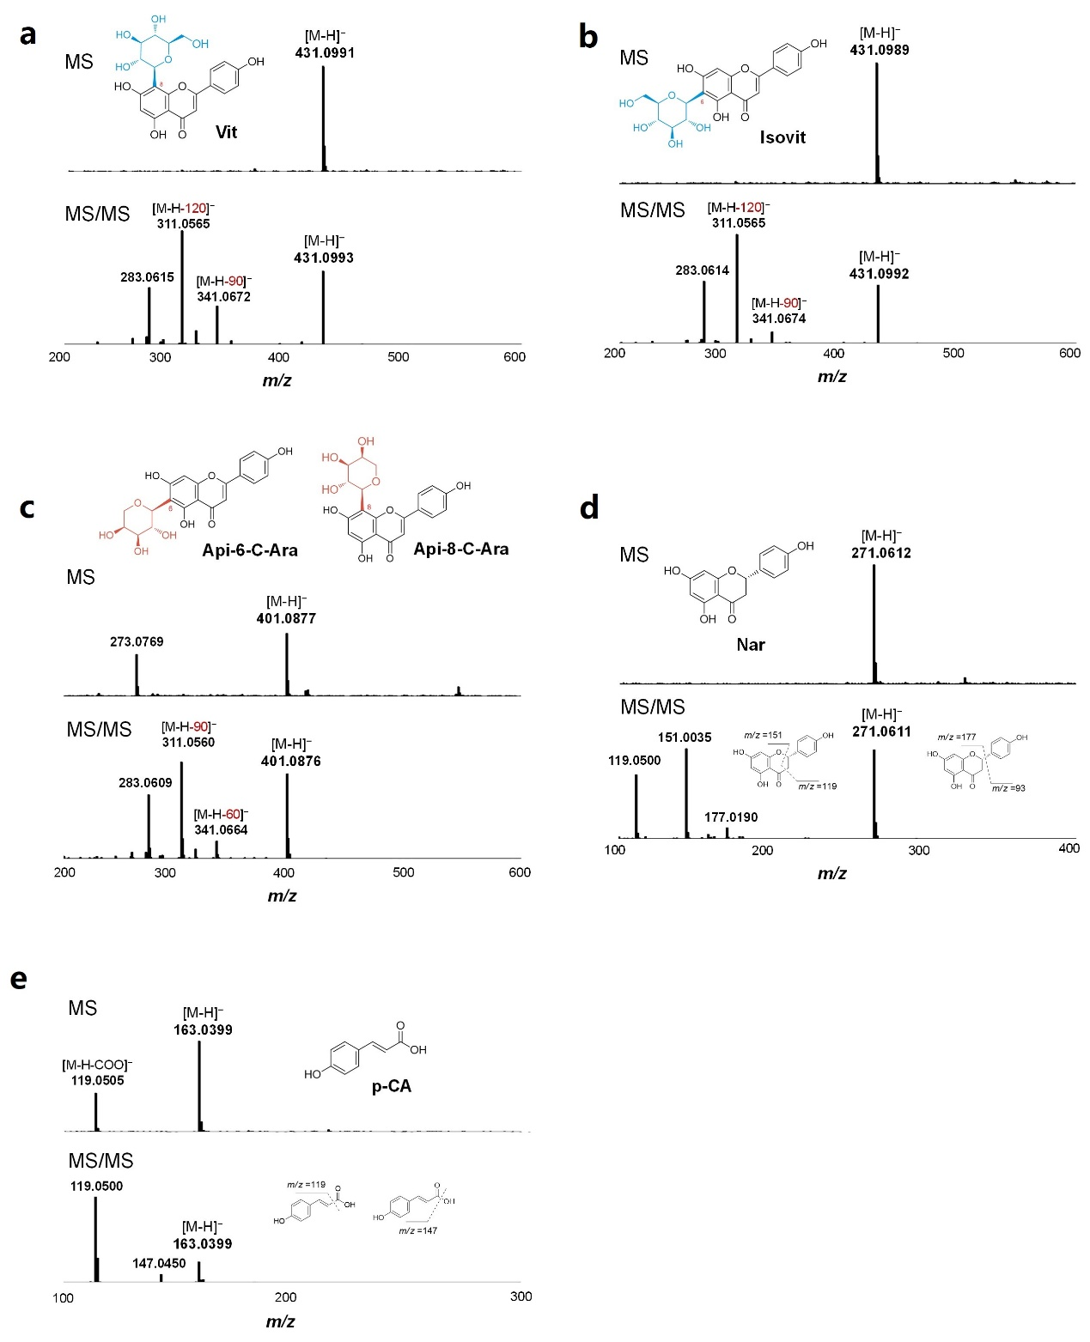

Fig. S3 LC-MS/MS analyses of pathway intermediates in the extracts of sCZ113 and sCZ118.
a MS and MS/MS spectra of vitexin (Vit) observed in the fermentation of sCZ113. b MS and MS/MS spectra of isovitexin (Isovit) observed in the fermentation of sCZ113. c MS and MS/MS spectra of apigenin 6-C-arabinoside (Api 6-C-Ara) or apigenin 8-C-arabinoside (Api 8-C-Ara) observed in the fermentation of sCZ118. d MS and MS/MS spectra of naringenin (Nar) observed in the fermentation of sCZ113 and sCZ118. e MS and MS/MS spectra of p-coumaric acid (p-CA) observed in the fermentation of sCZ113 and sCZ118.

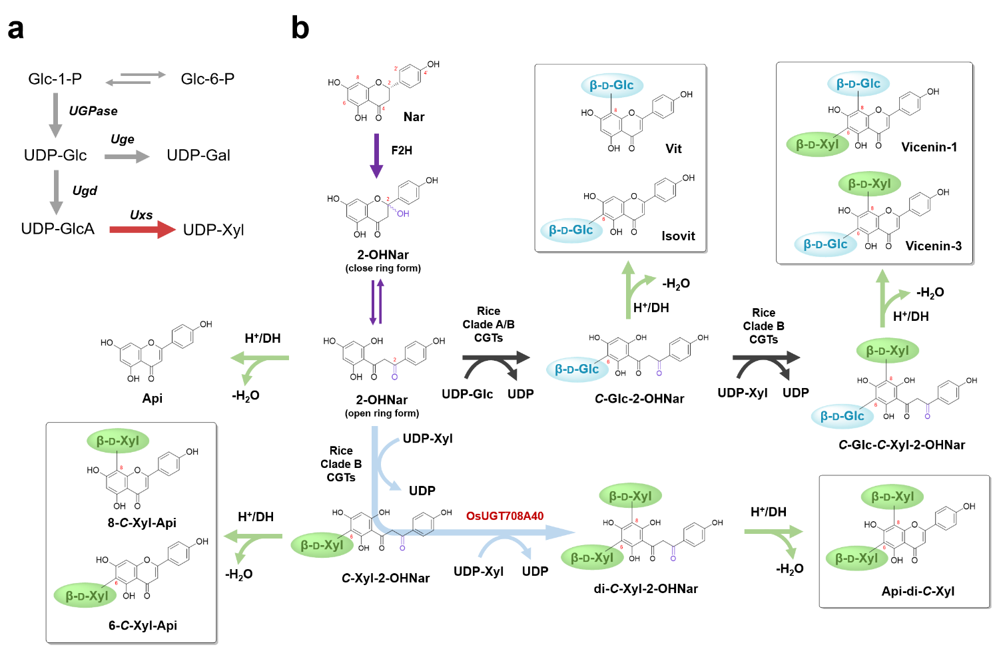

Fig. S4 A proposed biosynthetic network of flavone C-xylosides.
UDP-xylosides (xyl) is generated from glucose-1-phosphate (Glc-1-P) via UDP-glucose (Glc). The purposed C-xylosides biosynthesis pathway is highly similar to C-arabinosides.
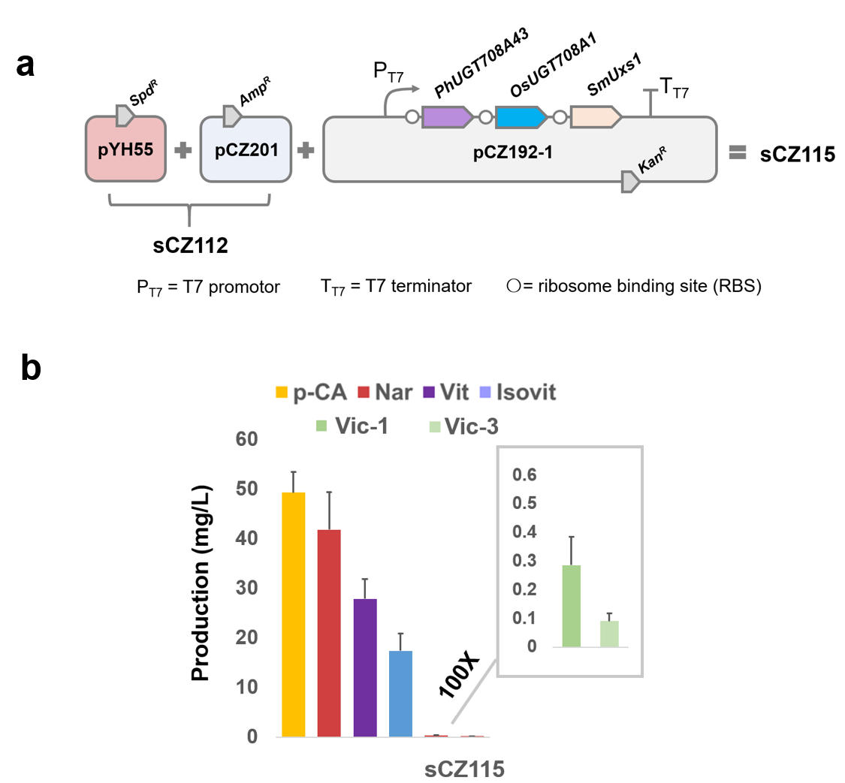

Fig. S5 De novo biosynthesis of vicenin-3 and vicenin-1.
(A) Reconstitution of vicenin-3 and vicenin-1 pathway in E. coli chases. pYH55 is assembled for naringenin (Nar) production and pCZ201 harbors cytochrome P450 module for 2-hydroxylnaringenin (2-OHNar) production. (B) Production of sCZ115.
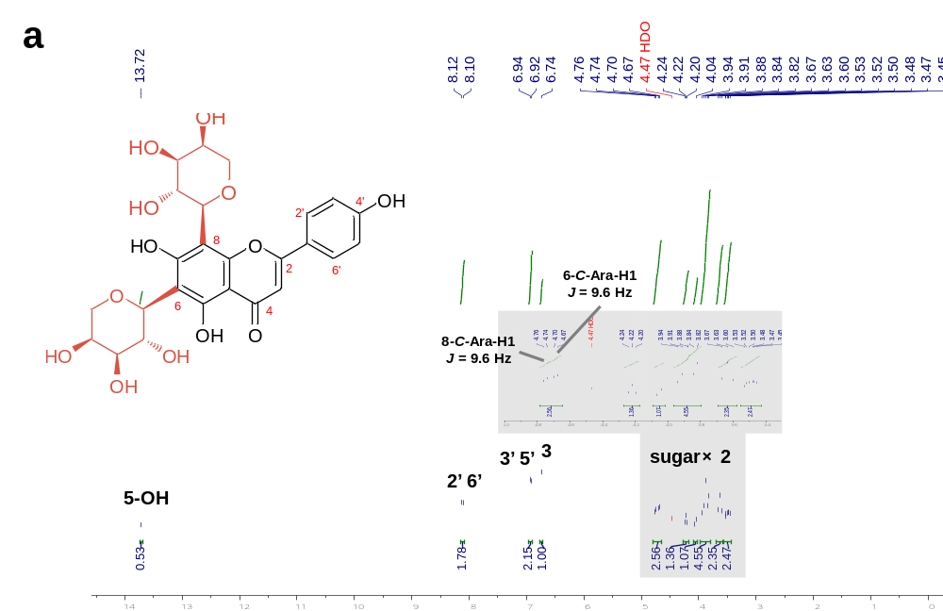
¹H NMR (500 MHz, DMSO-d₆) spectrum of Api-di-C-Ara, at 353 K

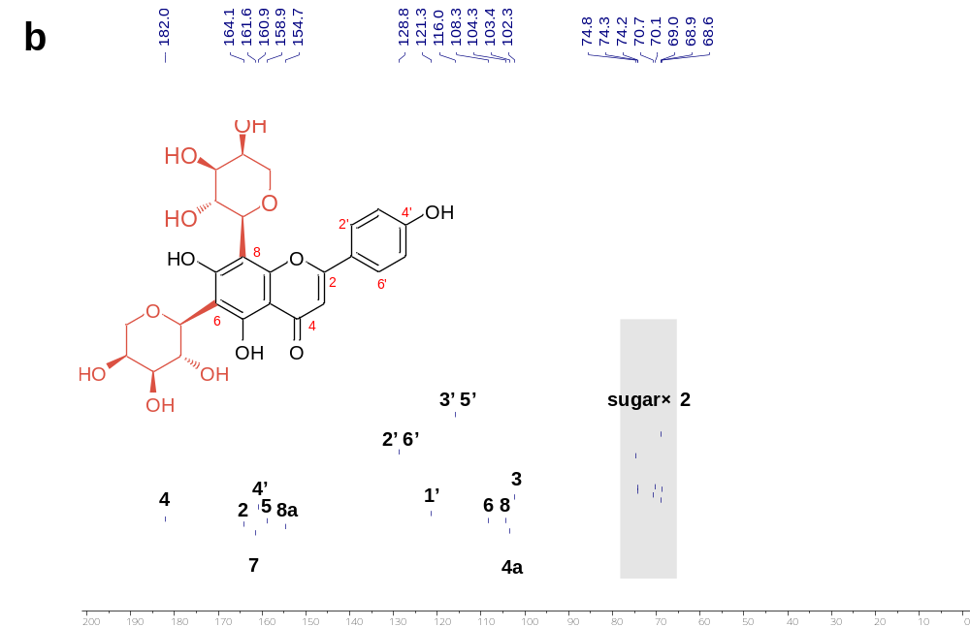
¹³C NMR (125 MHz, DMSO-d₆) spectrum of Api-di-C-Ara, at 353 K

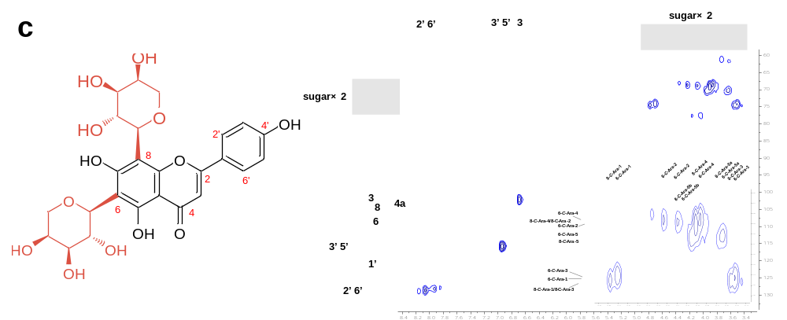
HSQC spectrum of Api-di-C-Ara in DMSO-d₆, at 353 K

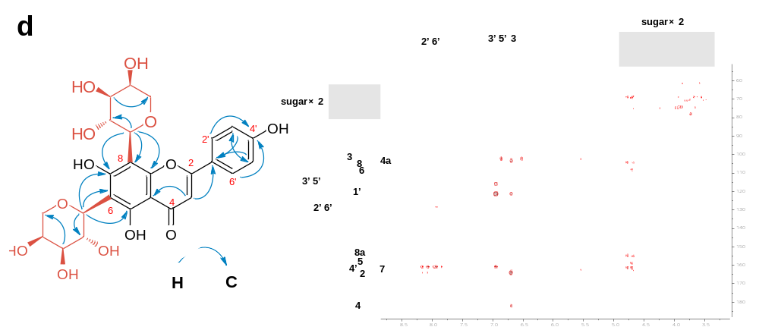
HMBC spectrum of Api-di-C-Ara in DMSO-d₆, at 353 K

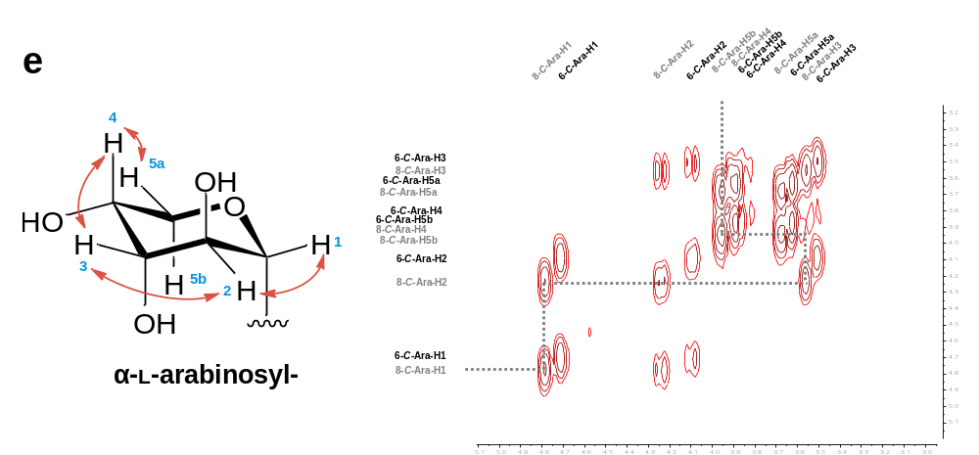
¹H-¹H COSY spectrum of sugars of Api-di-C-Ara in DMSO-d₆, at 353 K

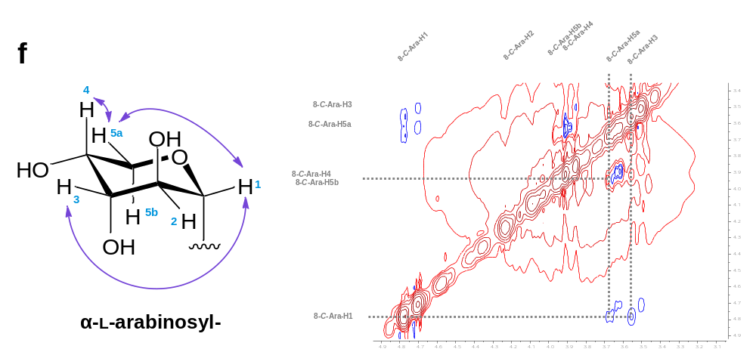
NOESY spectrum of sugars of Api-di-C-Ara in DMSO-d₆, at 353 K

Fig. S6 NMR spectra of apigenin 6,8-C-di-arabinoside (Api-di-C-Ara).
a ¹H NMR (500 MHz, DMSO-d₆) spectrum of Api-di-C-Ara recorded at 80 ℃ (353 K). b ¹³C NMR (125 MHz, DMSO-d₆) spectrum of Api-di-C-Ara recorded at 80 ℃ (353 K). c HSQC spectrum of Api-di-C-Ara in DMSO-d₆. d HMBC spectrum of Api-di-C-Ara in DMSO-d₆ and key long-range correlations (H→C). e ¹H-¹H COSY spectrum of sugars of Api-di-C-Ara in DMSO-d₆ and key ¹H-¹H correlations. f 2D-NOESY spectrum of sugars of Api-di-C-Ara in DMSO-d₆ and key NOE correlations.

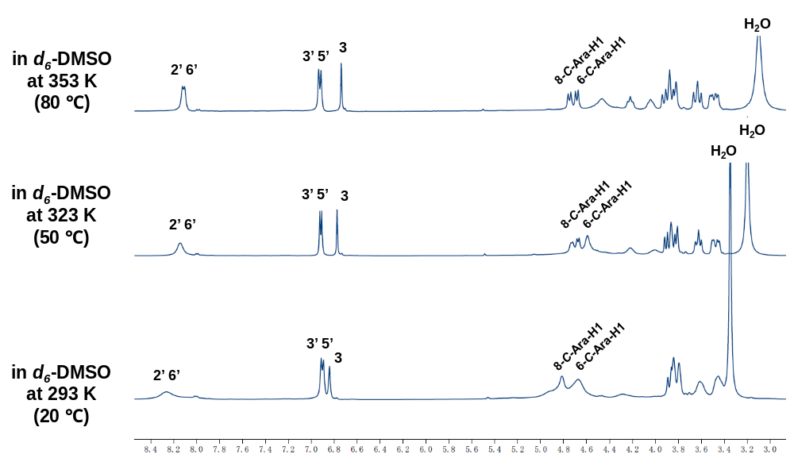

Fig. S7 Comparison of ¹H NMR spectra of Api-di-C-Ara recorded at different temperature (K).
¹H NMR (500 MHz, DMSO-d₆) spectrum of Api-di-C-Ara recorded at 353 K (80 ℃) showed sharper and more clear signals corresponding to H-2’/H-6’, H-3’/H-5’, H3 and two anomeric protons of arabinose (6-C-Ara-H1/8-C-Ara-H1), when comparing to those recorded at 323 K (50 ℃) and 293 K (20 ℃).

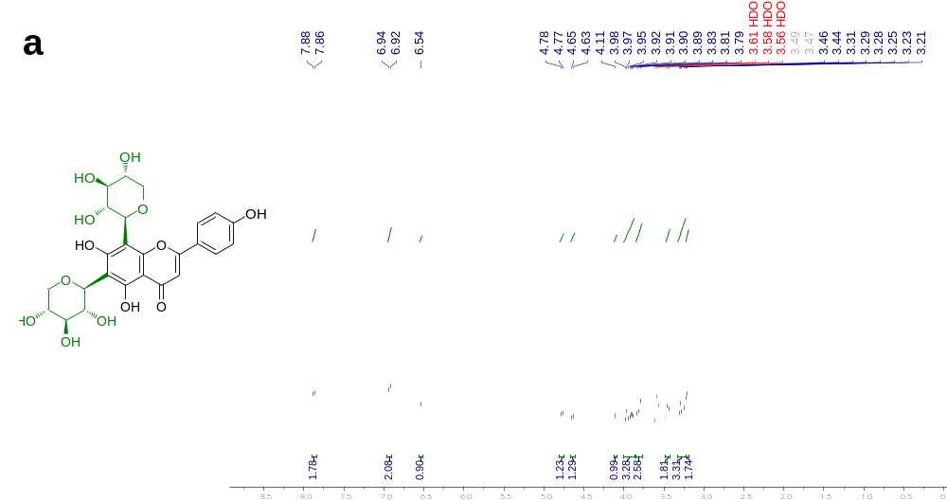
¹H NMR (500 MHz, DMSO-d₆) spectrum of Api-di-C-Xyl, at 353 K

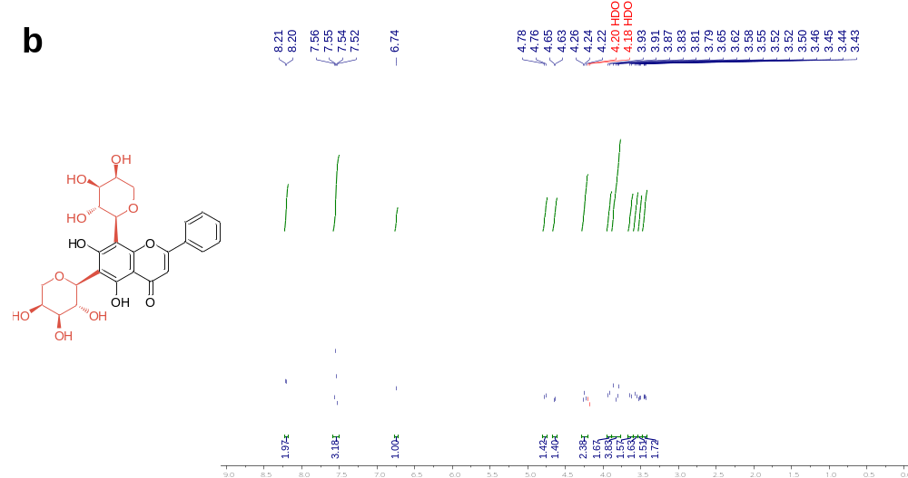
¹H NMR (500 MHz, DMSO-d₆) spectrum of Chr-di-C-Ara, at 353 K

Fig. S8 ¹H NMR spectra of a apigenin 6,8-di-C-xyloside (Api-di-C-Xyl) and b chrysin 6,8-di-C-arabinoside (Chr-di-C-Ara) recorded at 353 K.

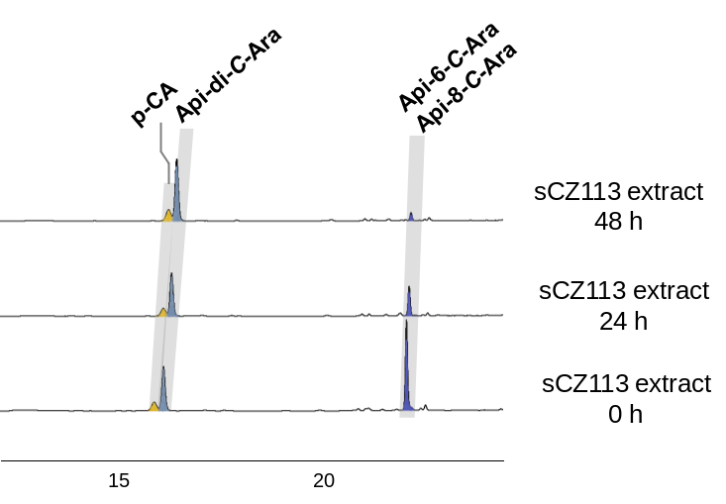

Fig. S9 Decomposition of apigenin mono-C-arabinosides.
HPLC analyses of sCZ113 extracts (re-dissolved in 50% methanol) right after extraction (0 h), incubated at room temperature for 24 h and 48 h. Gradual decrease of the peak of apigenin 6-C-arabinoside (or apigenin 8-C-arabinoside) was observed. UV absorbance at 340 nm was monitored.

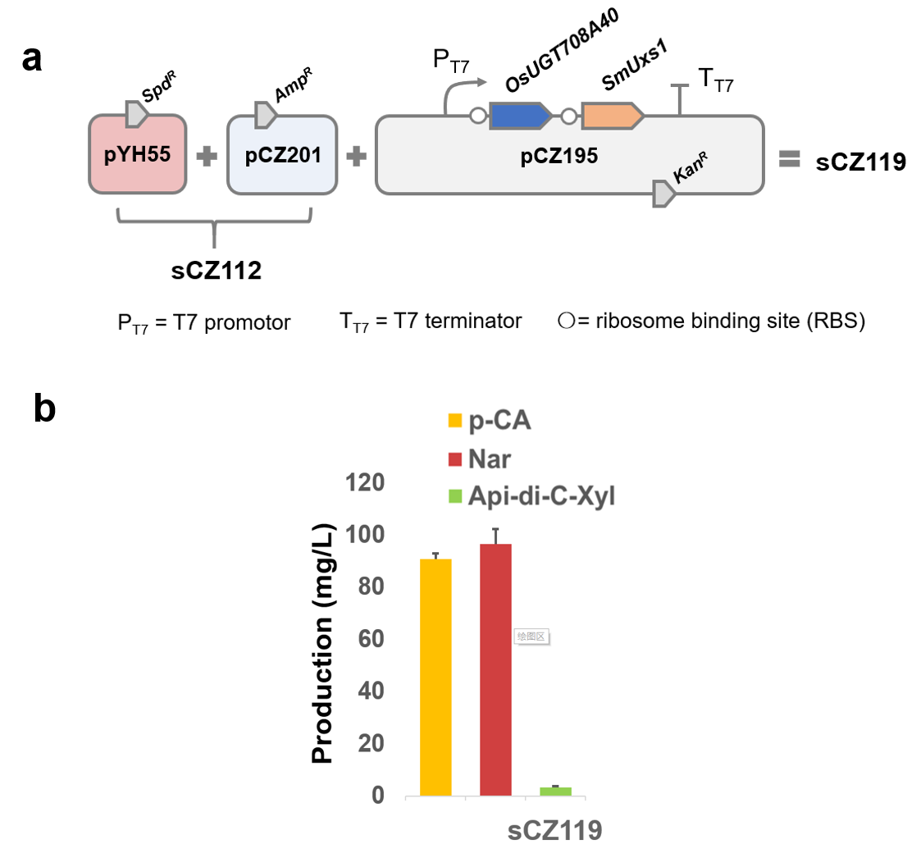

Fig. S10 De novo biosynthesis of Api-di-C-Xyl.
a Reconstitution of Api-di-C-Xyl pathway in E. coli chases. pYH55 is assembled for naringenin (Nar) production and pCZ201 harbors cytochrome P450 module for 2-hydroxylnaringenin (2-OHNar) production. b Production of sCZ119.

Supplementary Tables

Table S1 Plasmids and strains used in this study.
ID | Description | Source/references |  | ID | Description | Source/references
Plasmids |  |  |  | Strains
pYH055 | pCDF-T7-4CL-T7-PAL-T7-CHS-T7-CHI | (Li et al, 2019) |  | E. coli BL21(DE3) | E. coli chasis for pathway engineering | NEB
pCZ201 | pET-Duet-T7-2B1-tr29_Syn_ZmCYP93G5-T7-AtCPR2 | (Sun et al, 2020) |  | SCZ112 | BL21(DE3): pYH055+pCZ201 | (Sun et al, 2020)
pCZ86 | pET-28a-T7-PhUGT708A43 | (Sun et al, 2020) |  | SCZ113 | BL21(DE3): pYH055+pCZ201+pCZ193-1 | This work
pCZ162 | pET-28a-T7-OsUGT708A2 | (Sun et al, 2020) |  | SCZ114 | BL21(DE3): pYH055+pCZ201+pCZ193-2 | This work
pCZ163 | pET-28a-T7-OsUGT708A1 | (Sun et al, 2020) |  | SCZ118 | BL21(DE3): pYH055+pCZ201+pCZ194 | This work
pCZ164 | pET-28a-T7-OsUGT708A39 | (Sun et al, 2020) |  | SCZ119 | BL21(DE3): pYH055+pCZ201+pCZ195 | This work
pCZ165 | pET-28a-T7-OsUGT708A40 | (Sun et al, 2020)
pCZ191 | pET-28a-T7-PhUGT708A43-OsUGT708A1 | This work
pCZ192-1 | pET-28a-T7-PhUGT708A43-OsUGT708A1-SmUxs1 | This work
pCZ192-2 | pET-28a-T7-PhUGT708A43-OsUGT708A1-SmUxs2 | This work
pCZ193-1 | pET-28a-T7-PhUGT708A43-OsUGT708A1-SmUxs1-SmUxe | This work
pCZ193-2 | pET-28a-T7-PhUGT708A43-OsUGT708A1-SmUxs2-SmUxe | This work
pCZ194 | pET-28a-T7-OsUGT708A40-SmUxs1-SmUxe | This work
pCZ195 | pET-28a-T7-OsUGT708A40-SmUxs1 | This work

Table S2 Primers used in this study.
Name | Primers | Sequence (5’→3’)
pCZ191 | pCZ191-F | ATCTTGCAGTGTTGGACTAGTTTGTTTAACTTTAAGAAGGAGATATACCATG
pCZ191 | pCZ191-R | gtggtggtggtgctcgagtAAGCTTgcgggatccgccgcTTAAGTGGCCTTGAGCTTTT
pCZ192-1 | pCZ192-1-F | GAAAAGCTCAAGGCCACTTAAgcggcaataattttgtttaactttaagaa
pCZ192-1 | pCZ192-1-R | gtggtggtggtgctcgagtAAGCTTgcgggatccTCAGACCAGCTCCGCACT
pCZ192-2 | pCZ192-2-F | GAAAAGCTCAAGGCCACTTAAgcggcaataattttgtttaactttaagaa
pCZ192-2 | pCZ192-2-R | tggtggtggtggtgctcgagtAAGCTTgcgggatccTCACAGATCCTGACTGACGAC
pCZ193-1 | pCZ193-1-F | AAAGTGCGGAGCTGGTCTGAgcggcaataattttgtttaactttaag
pCZ193-1 | pCZ193-1-R | tggtggtgctcgagtGCGGCagggatcctcatgctagcCGcTCATGACCGGACCTCCAG
pCZ193-2 | pCZ193-2-F | TCGTCAGTCAGGATCTGTGAgcggcaataattttgtttaactttaag
pCZ193-2 | pCZ193-2-R | tggtggtgctcgagtGCGGCagggatcctcatgctagcCGcTCATGACCGGACCTCCAG
pCZ194 | pCZ194-F | GCAAAGCTCAAGGCTGCTTAgcggcaataattttgtttaactttaagaag
pCZ194 | pCZ194-R | tggtggtgctcgagtGCGGCagggatcctcatgctagcCGcTCATGACCGGACCTCCAG
pCZ195 | pCZ195-F | AAAGTGCGGAGCTGGTCTGAactcgagcaccaccac
pCZ195 | pCZ195-R | TCAGACCAGCTCCGCAC

Reference
Feng C-Y, Li SS, Taguchi G, Wu Q, Yin D-D, Gu Z-Y, Wu J, Xu W-Z, Liu C, Wang L-S (2021) Enzymatic basis for stepwise C-glycosylation in the formation of flavonoid di-C-glycosides in sacred lotus (Nelumbo nucifera Gaertn.). Plant J. https://doi.org/10.1111/tpj.15168
Li J, Tian C, Xia Y, Mutanda I, Wang K, Wang Y (2019) Production of plant-specific flavones baicalein and scutellarein in an engineered E. coli from available phenylalanine and tyrosine. Metab Eng 52:124-133. https://doi.org/10.1016/j.ymben.2018.11.008
Sun Y, Chen Z, Yang J, Mutanda I, Li S, Zhang Q, Zhang Y, Zhang Y, Wang Y (2020) Pathway-specific enzymes from bamboo and crop leaves biosynthesize anti-nociceptive C-glycosylated flavones. Commun Biol 3:110-110. https://doi.org/10.1038/s42003-020-0834-3
Wang ZL, Gao HM, Wang S, Zhang M, Chen K, Zhang YQ, Wang HD, Han BY, Xu LL, Song TQ, Yun CH, Qiao X, Ye M (2020) Dissection of the general two-step di-C-glycosylation pathway for the biosynthesis of (iso)schaftosides in higher plants. Proc Natl Acad Sci USA. Doi:10.1073/pnas.2012745117. https://doi.org/10.1073/pnas.2012745117

