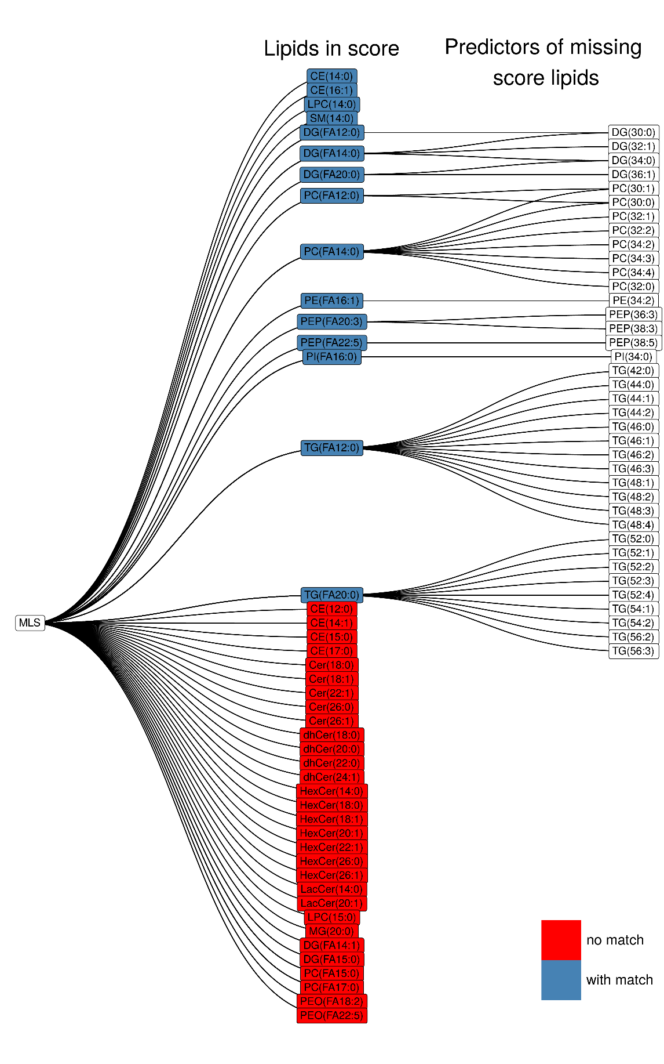
Extended Fig. 1. Matching of Metabolon and Broad Institute lipidomics data.
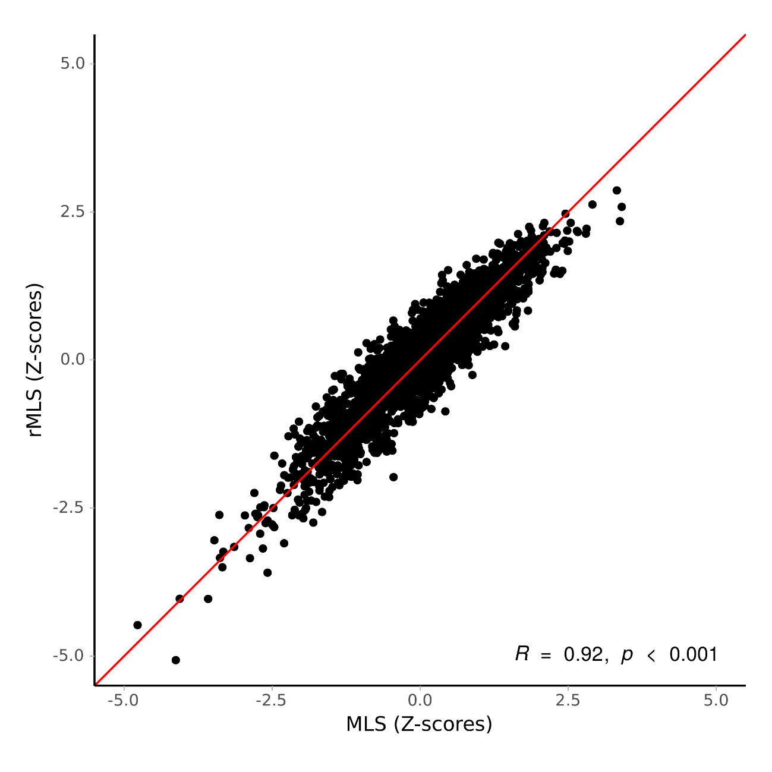
Extended Fig. 2. Pearson correlation between the original MLS based on Metabolon lipidomics data and a reduced version restricted to lipids that are also available at the Broad Institute lipidomics platform in the EPIC-Potsdam subcohort (n=1,262).
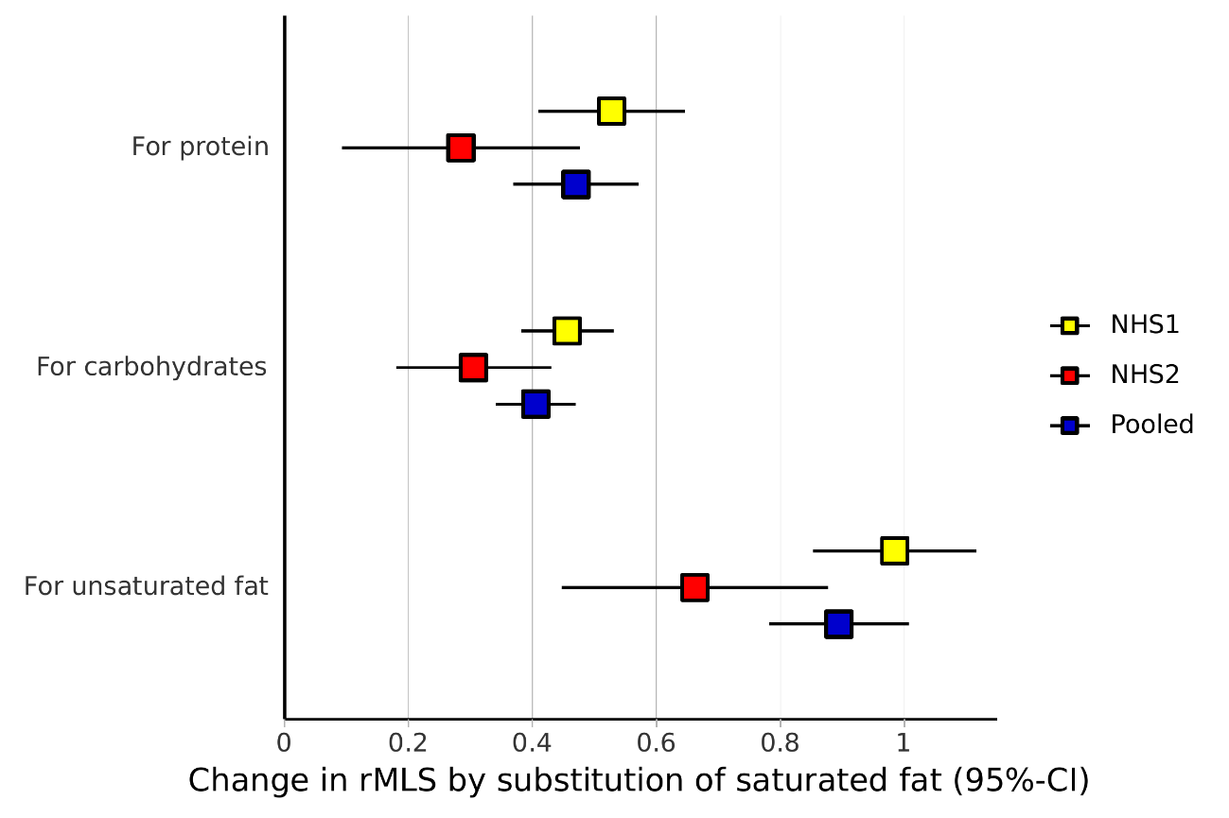
Extended Fig. 3. Estimated effect of substituting 8%TE dietary saturated fat with other nutrients on MLS levels (variance standardized, effect in SD) in the Nurses’ Health Study (NHS) and Nurses’ Health Study II (NHS2) and the pooled analysis of both cohorts.

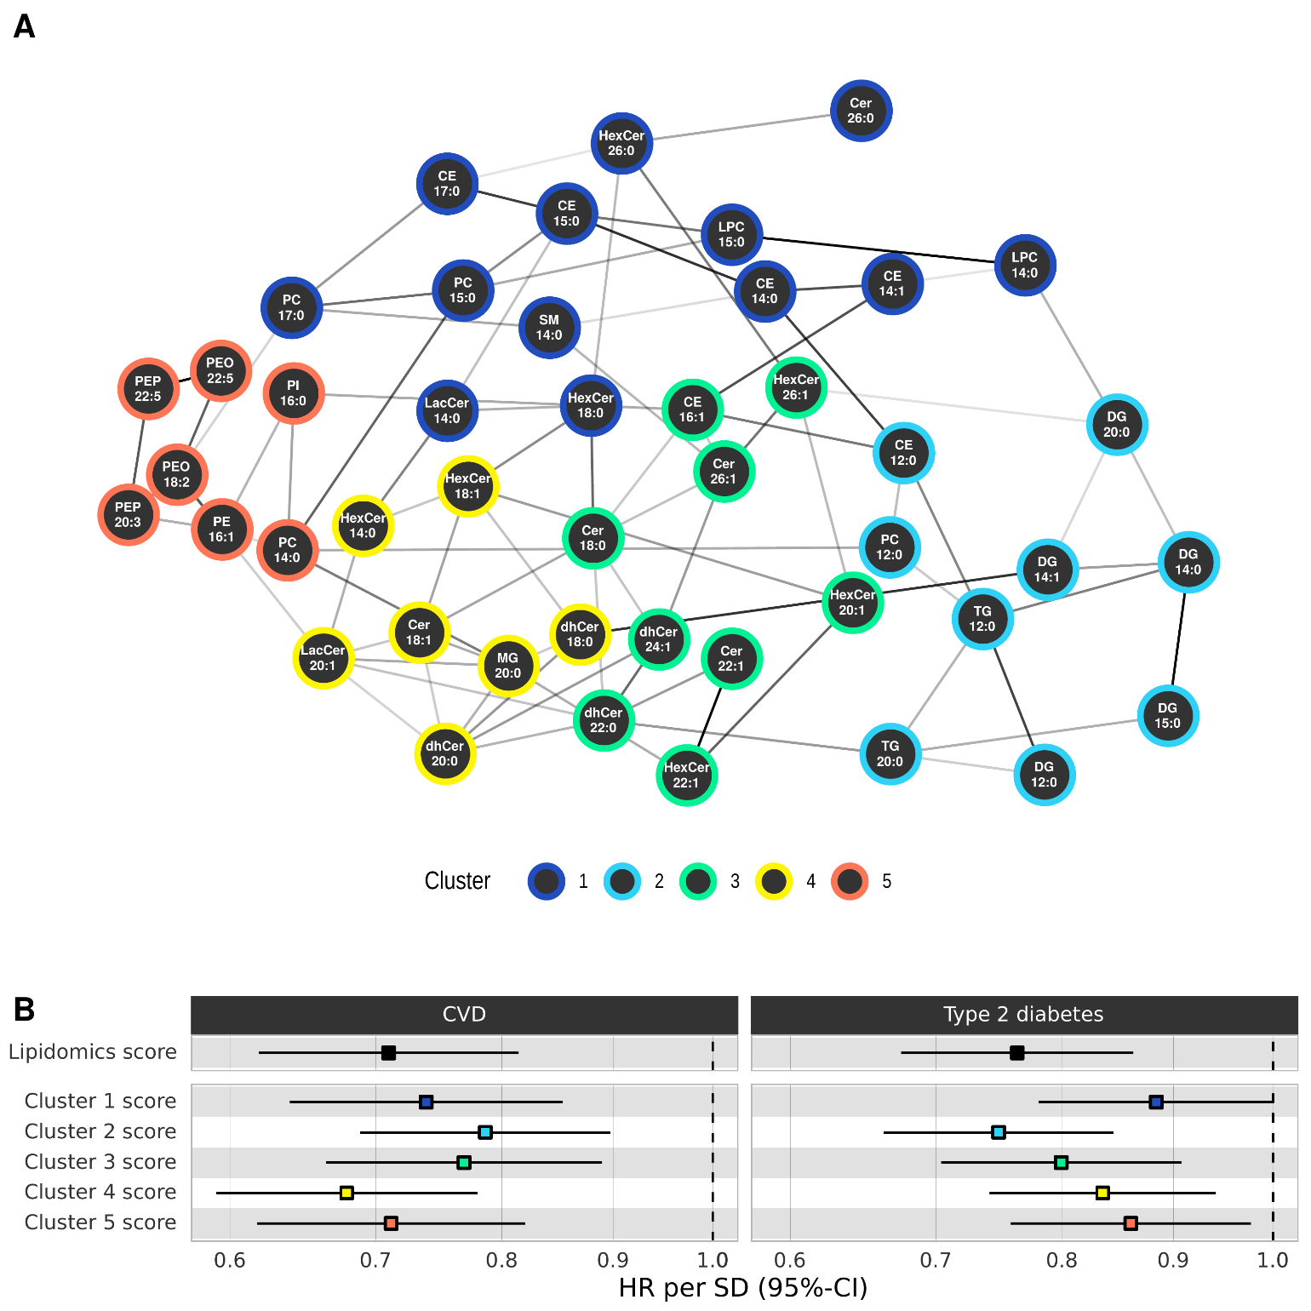
Extended Fig. 4. From an etiological perspective, the interrelation of the diet-affected lipids and the mutual dependency of their cardiometabolic risk association is of interest. Therefore, we derived a conditional independence network in the EPIC-Potsdam subcohort based on the lipid metabolites in the MLS. The nodes in this network correspond to the UFA-rich diet-affected lipids, and links correspond to correlations between a lipid pair that are robust against adjustment for any subset of other network lipids. Many links in this data-driven network connect lipid metabolites that contain the same fatty acid residual but belong to different lipid classes (e.g., C12:0 in CE, PC, TG, and DG; C18:0 in Cer and HexCer) or lipids of the same class with metabolically related fatty acid residuals (e.g., HexCer20:1 and HexCer22:1).
Based on this network, we used the Louvain modularity detection algorithm to derive data-driven lipid clusters. Cluster1 contained cholesterol esters and phosphatidylcholine, and a few sphingolipids. Cluster 2 comprised ceramides with long and very long-chain fatty acids (including dihydro- and hexosyl-ceramides). Cluster 3 was primarily composed of medium to long-chain fatty acid-containing ceramides (including dihydro-, lactosyl-, and hexosyl-ceramides). Cluster 4 mainly featured di- and triglycerides. Cluster 5 was dominated by phosphatidylethanolamines (including those with ether bonds).

Extended figure 5. The CVD risk associations were remarkably robust when restricted MLS were constructed based only on lipids from each cluster. The strongest CVD risk association was assessed for the Cluster 3 MLS, and all cluster-restricted MLS were associated with a substantial and statistically significant CVD risk reduction. The T2D risk associations of the cluster-restricted MLS were also all directionally consistent with a T2D risk reduction related to the UFA-rich diet imprint. The di- and triglyceride-dominated cluster 4 was particularly informative for T2D risk. The T2D risk association of the hexosyl- and lactosyl-ceramide-enriched cluster 3-based MLS was suggestively inverse but not statistically significant. These robust inverse cardiometabolic risk associations of UFA-rich diet imprint in granular lipidomics network clusters suggest that the depth of lipidomics profiling may be more critical than breadth. However, it appears that ceramide and phosphatidylethanolamine metabolites are particularly informative for the link between UFA-rich diets and CVD risk. At the same time, reduced concentrations of medium and long-chain fatty acid-containing di- and triglycerides are critical to linking UFA-rich diets to T2D risk.

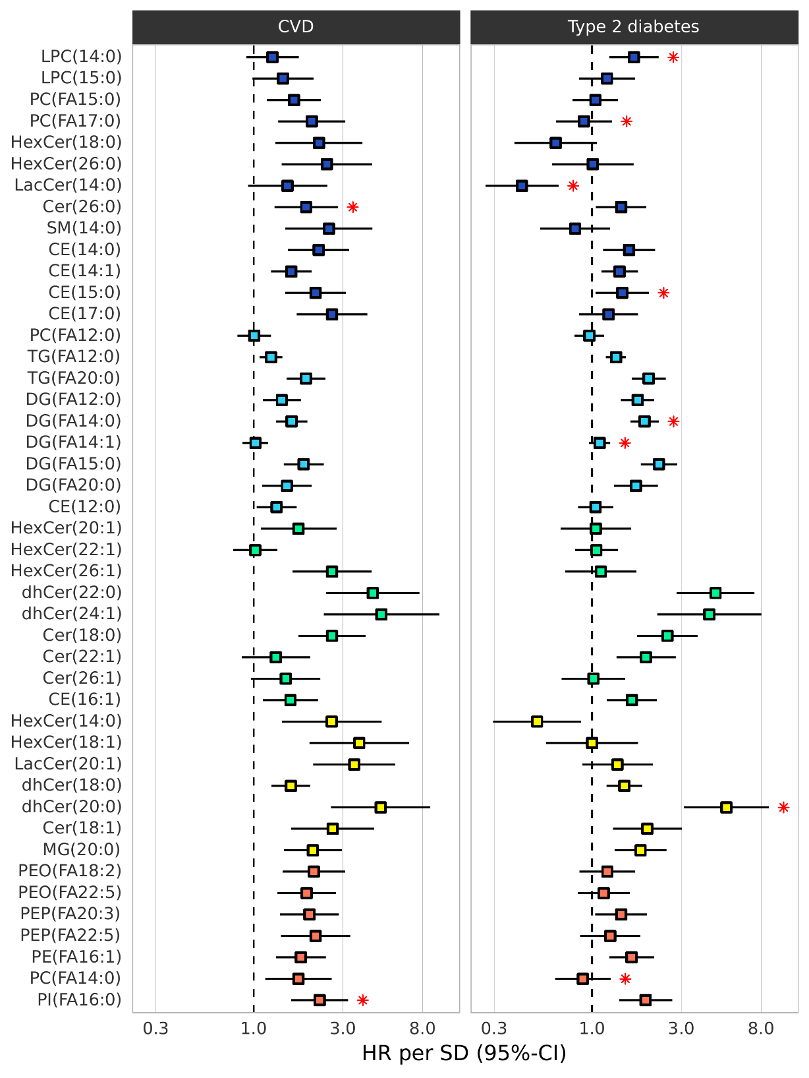
Extended Fig. 6. Our analyses of individual lipids with cardiometabolic risk support the conclusions from the network cluster analyses. Most lipid metabolites that were reduced through a high UFA diet in DIVAS and, therefore, included in the MLS were either neutral or high cardiometabolic risk markers (Fig. 6C). For example, several dihydro-ceramides (C20:0, C22:0, C24:1) and ceramide C18:0 were associated with a substantially elevated risk of CVD and T2D. Most phospholipids in the MLS, especially the phosphatidylethanolamines , and the cholesterol esters, showed stronger associations with CVD risk, and most single di- and triglycerides tended to be more strongly associated with T2D risk. However, the associations of these lipids with CVD and T2D were directionally consistent. Notable exceptions were a few hexosyl-(C14:0 and C18:0) and lactosyl- (C14:0) ceramides that were associated with higher CVD but lower T2D risk (Fig. 6C).

Finally, we applied our recently introduced NetCoupler algorithm to identify direct links between metabolites and disease risk that cannot be explained through adjustment for other lipid metabolites.41,42 This causal modeling-based analysis revealed that the ceramide C26:0 and FA16:0 in phosphatidylinositol associations with high CVD risk were robust against adjustment for interrelated diet-affected lipids (red asterisks in the CVD panel of Fig. 6C). For most other high-CVD-risk lipids in the MLS, the NetCoupler results were ambiguous, meaning that causal modeling techniques did not identify the main drivers of high CVD risk associations in sets of interrelated lipids.

In addition, the high T2D risk associations of dihydro-ceramide C20:0, FA14:0 in diglycerides and lysophospholipids, and cholesterol ester C15:0 were robust against network adjustments. Including these direct high-risk markers in the T2D models yielded robust inverse T2D risk associations of FA C17:0 in phosphatidylcholines, FA C14:1 in diglycerides, and FA C14:0 in phosphatidylcholines and lactosyl-ceramides. Once again, the majority of T2D risk associations remained ambiguous. These analyses suggest that, in addition to the encouraging results on precision nutrition biomarker applications, hypothesis-based causal modeling approaches with deep lipidomics profiling data may elucidate biological mechanisms that link dietary fat quality to cardiometabolic disease incidence.

