Supplementary Information

Catalytic Single-particle Plasmonic Nanogap Reactors
with Precisely-aligned Molecular Monolayers
Gyeongwon Kang,†,‡ Shu Hu,† Jeremy J. Baumberg*,†
†Nanophotonics Centre, Department of Physics, Cavendish Laboratory, University of Cambridge, Cambridge, CB3 0HE, UK
‡Department of Chemistry, Kangwon National University, Chuncheon, 24341, South Korea
*e-mail: jjb12@cam.ac.uk

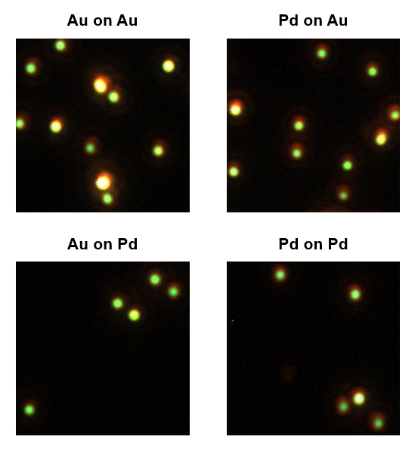
Figure S1. Dark-field images of the four types of NRs.

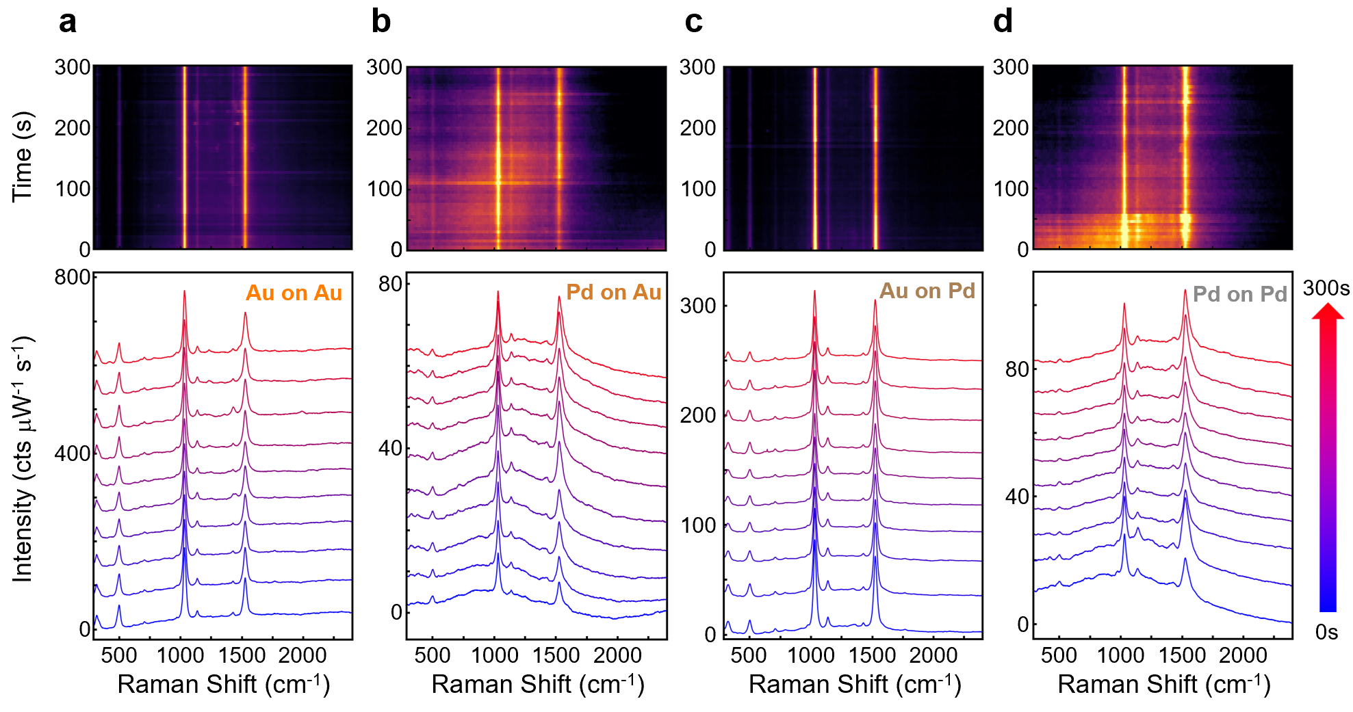
Figure S2. Time-series SERS spectra from individual NRs in ambient conditions. (Top) Representative SERS spectra colormaps of (a) Au on Au, (b) Pd on Au, (c) Au on Pd, and (d) Pd on Pd NR, respectively. Shown in each map are 300 spectra of 1s integration time. (Bottom) Stacked SERS spectra acquired every 30s from colormaps above. Each SERS spectrum is measured with acquisition time of 1s and 0.1mW of 633nm laser power.

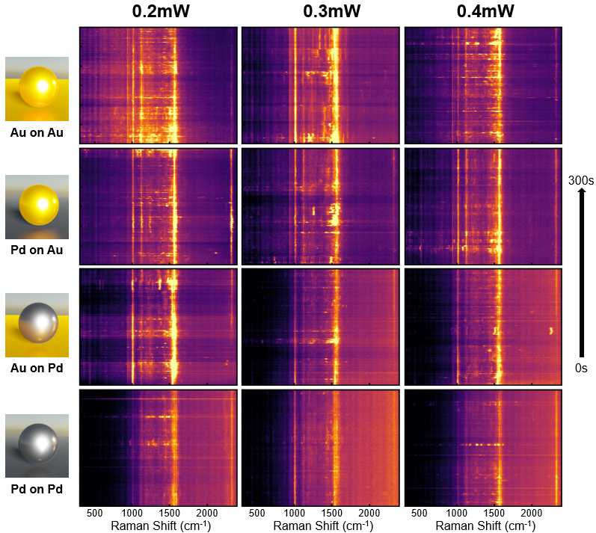
Figure S3. Colourmaps of SERS spectra (300 successive spectra @ 1s integration times) for different laser powers using Au-on-Au, Pd-on-Au, Au-on-Pd, and Pd-on-Pd nanoreactors (NRs) (from top to bottom).

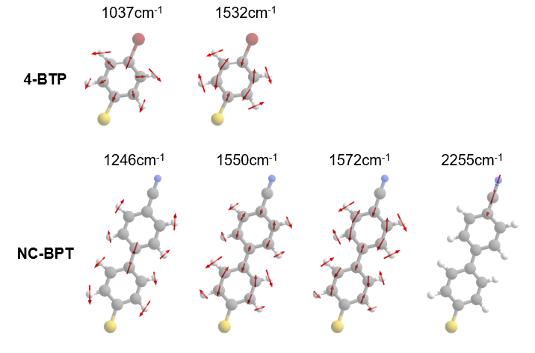
Figure S4. Calculated vibrational modes of 4-BTP (top) and NC-BPT (bottom). Dominant modes in the SERS are selected for visualization. Optimized geometry and vibrational modes are calculated using DFT with Gaussian 09 software package. B3LYP hybrid functional and def2svp basis set are used.

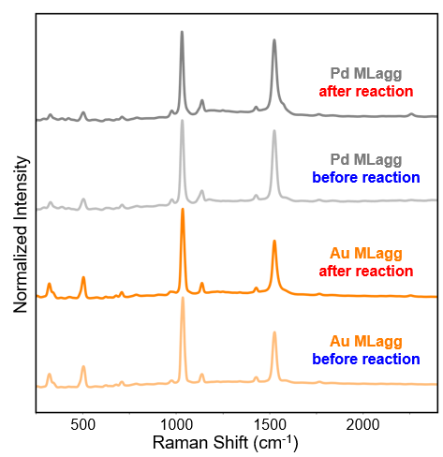
Figure S5. Averaged SERS of Au and Pd MLaggs before and after reaction, under laser illumination with 0.4mW of 633nm laser power.

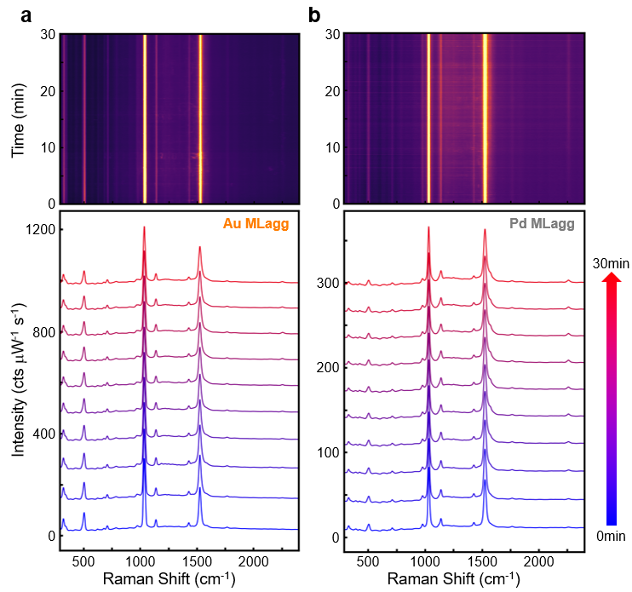
Figure S6. Time-series SERS spectra from (a) Au and (b) Pd MLaggs in aqueous solution of CPBA and K₂CO₃. (Top) SERS spectra colormaps (300 spectra with 1s integration time). (Bottom) Stacked SERS spectra taken every 3 minutes, from colormaps above. Each SERS spectrum is measured with acquisition time of 1s and 0.4mW of 633nm laser power.

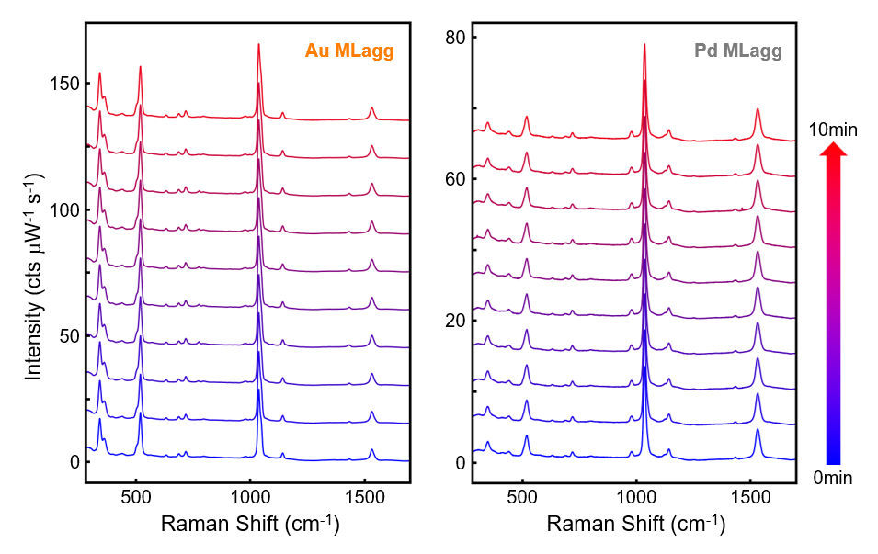
Figure S7. Stacked SERS spectra acquired every minute. Each SERS spectrum is measured with acquisition time of 1s and 0.2mW of 785nm laser power.
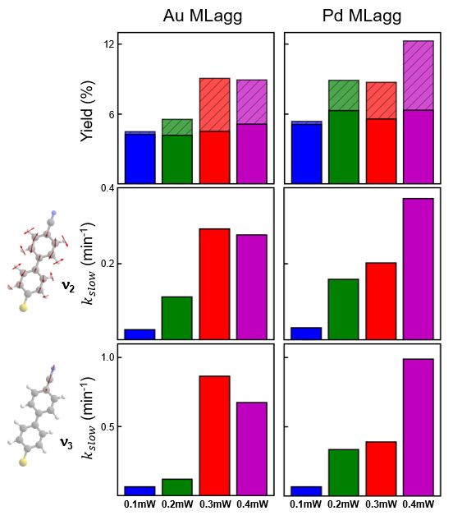
Figure S8. Peak analysis results of Au (left) and Pd (right) MLaggs at different laser powers (blue: 0.1mW, green: 0.2mW, red: 0.3mW, purple: 0.4mW). (Top) Catalytic conversion yields for laser illumination after $t$=0 (darker bars) and $t$=10min (lighter bars with hatched lines). Slow rate constants ($k_{slow}$) obtained from the peak intensity ratio of (middle) 1572cm⁻¹ ($ν_{2}$) and (bottom) 2255cm⁻¹ ($ν_{3}$) NC-BPT modes to the 1532cm⁻¹ mode of 4-BTP ($ν_{1}$).

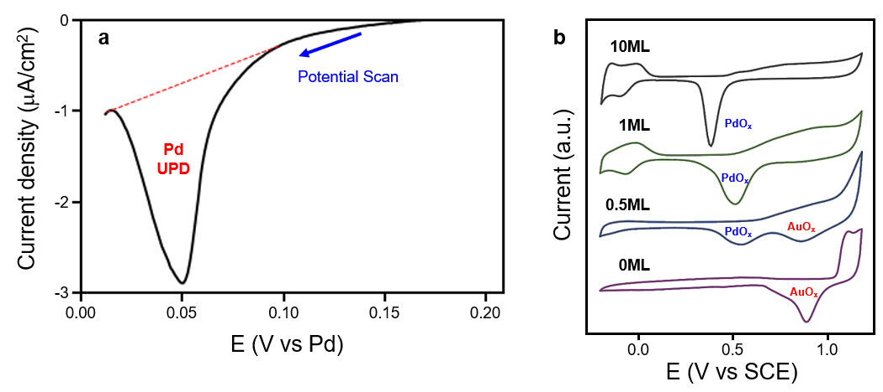
Figure S9. (a) Linear potential sweep voltammetry during the underpotential deposition of Pd on a template-stripped Au film. (b) Cyclic voltammograms of Au (0ML Pd) and Au@Pd NPs with different coverages of Pd of 0.5, 1, and 10ML. (bottom to top)

Section S1: Fitting dynamics of SERS peak intensity ratio (R₂₁ and R₃₁) in Figure 4a-d:
In the first stage of the catalysis, rapid reaction occurs upon hot-carrier generation if there is excess CPBA in the gap. The reaction yield thus follows a 1st order kinetics,
$$R=R_{0}\left(1-e^{-k_{fast}t}\right)+C$$
where C is the initial yield from reactions occurring faster than the measurement time scale (1s).
After consumption of CPBA in the gap during this rapid 1st order reaction, diffusion-limited reaction proceeds which is much slower due to the limited catalytic sites in the gap. This gives 0th order kinetics as the reaction is not dependent on the reactant population any more, and the reaction yield is
$$R=k_{slow}t+D$$
Here the constant $D$ is the yield from initial 1st order reaction.

