Supplementary material

Brick Strex – a robust device built of LEGO® bricks for mechanical manipulation of cells

Elina Mäntylä,ª Teemu O. Ihalainen^{a*}

BioMediTech, Faculty of Medicine and Health Technology, Tampere University, Tampere, Finlandª

*Address correspondence to Teemu Ihalainen, teemu.ihalainen@tuni.fi

Address: BioMediTech, Faculty of Medicine and Health Technology, Tampere University, Tampere, Finland. Arvo Ylpön katu 34, 33520 Tampere, Finland
Phone: +358 50 3187 202

Supplementary material contents:

Supplementary Table 1: Device S part list
Supplementary Table 2: Device L part list
Supplementary Figure 1: Device S, part list images
Supplementary Figure 2: Device L, part list images
Supplementary Figure 3: Device L base, part list images
Supplementary Figure 4: Device L lid, part list images
Supplementary Figure 5: Motorization scheme of Device L
Supplementary Figure 6: Cycling stretching programming example using LEGO® Mindstorms

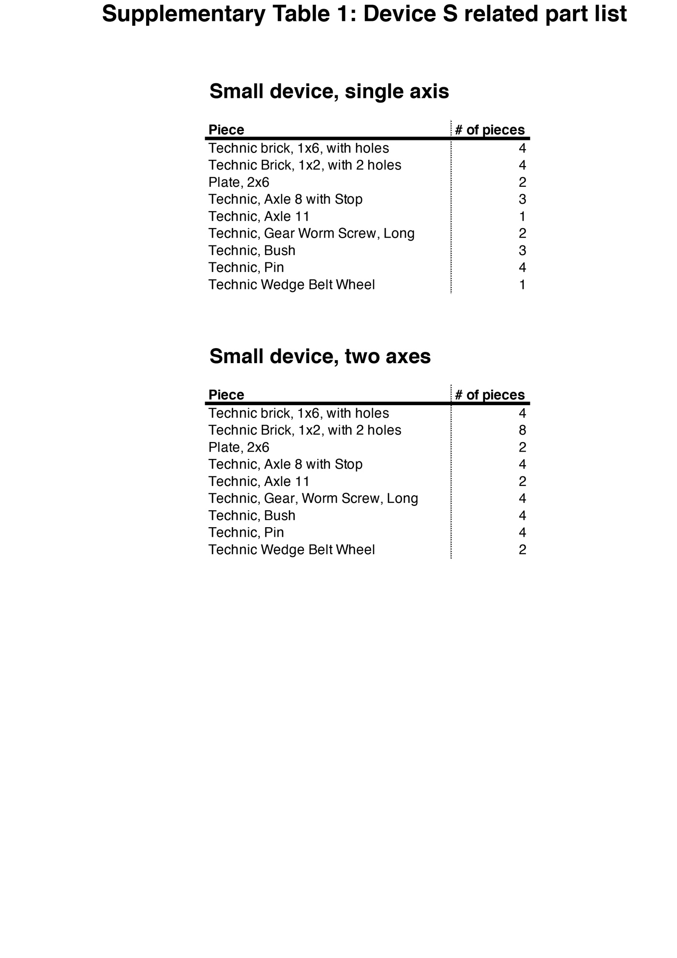
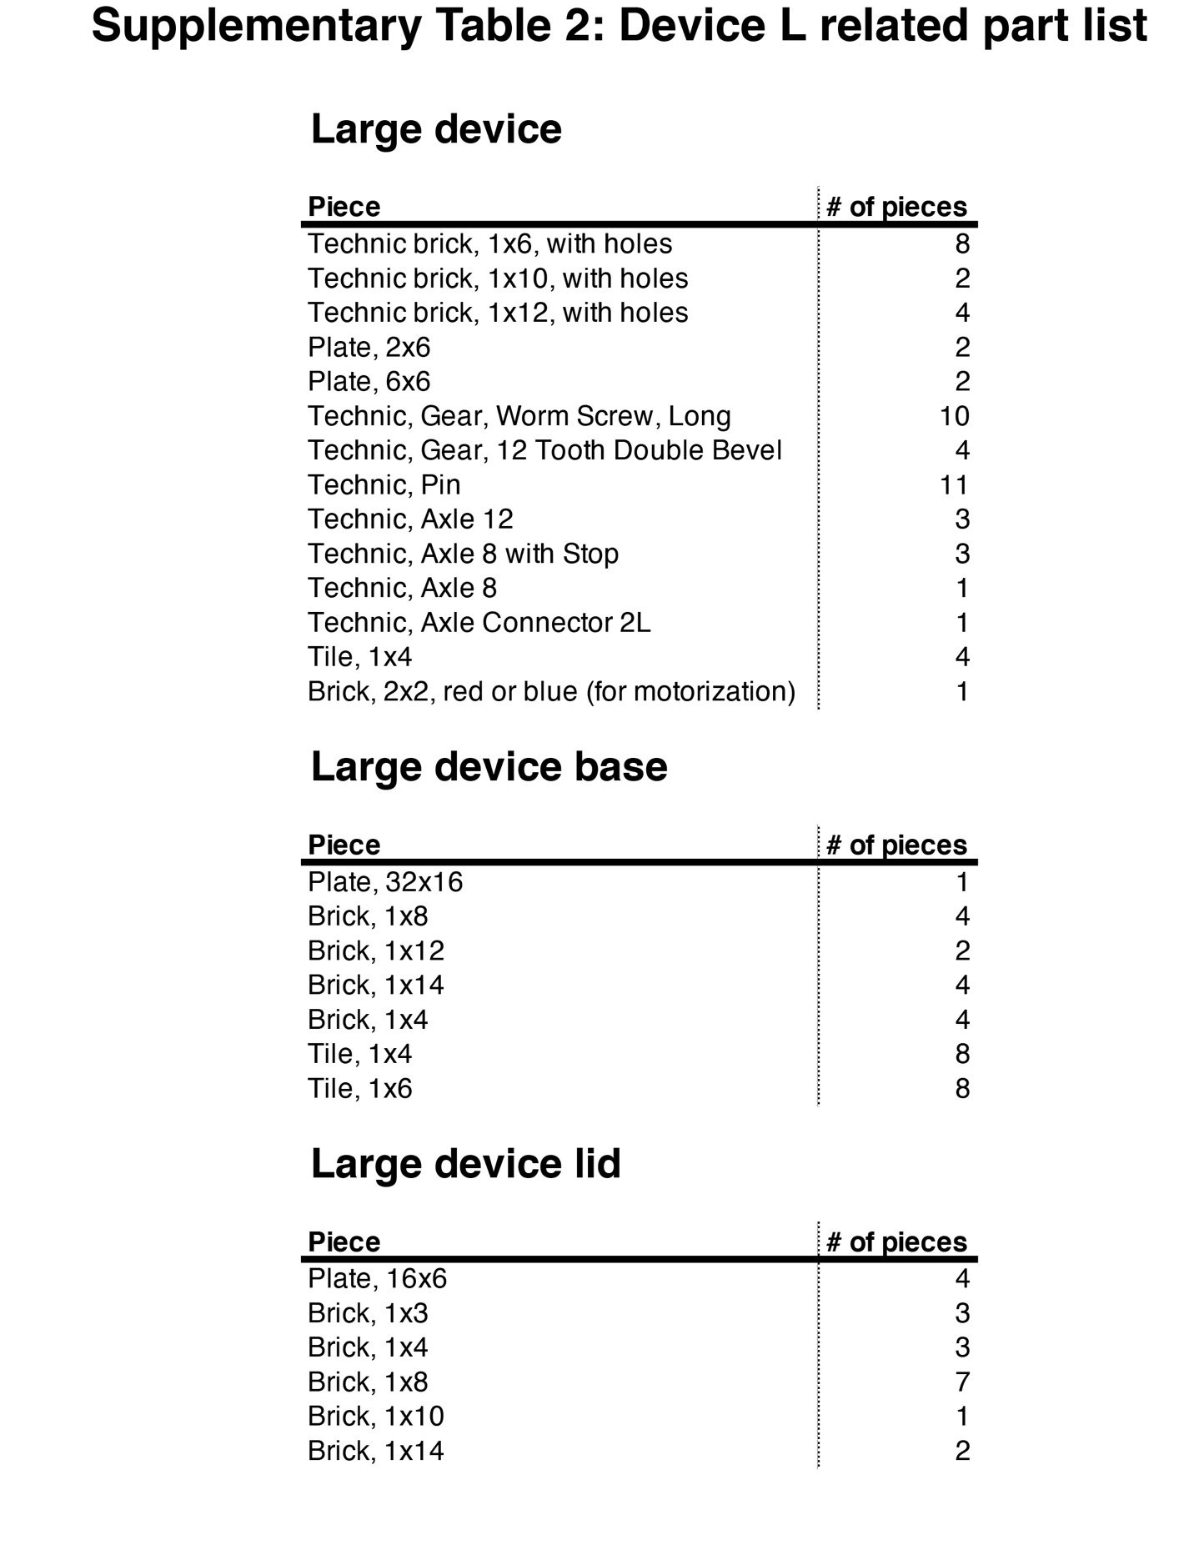

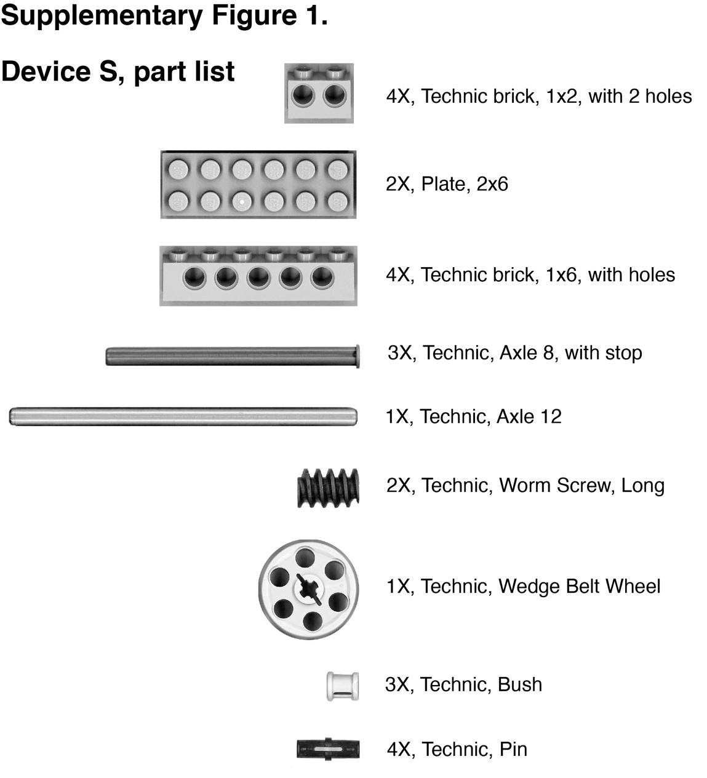

Supplementary Figure 1: Part list of Device S. Needed LEGO® blocks which allow the construction of Brick Strex S device with one axis.

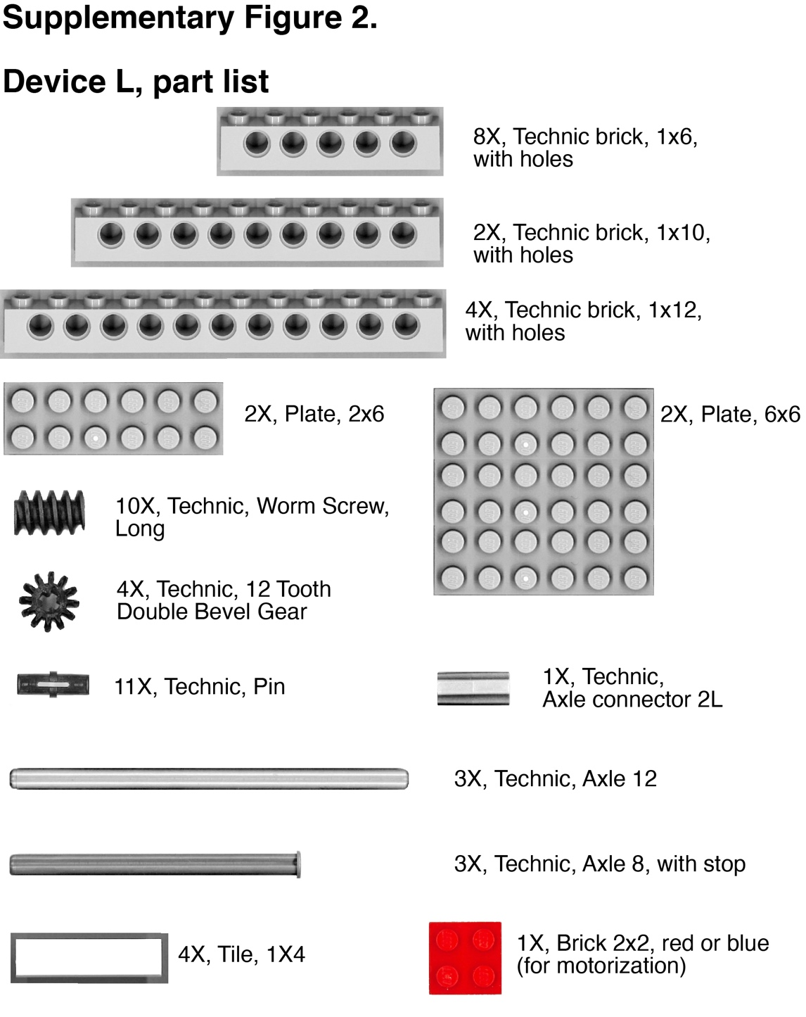

Supplementary Figure 2: Part list of Device L. Needed LEGO® blocks which allow the construction of Brick Strex L device.

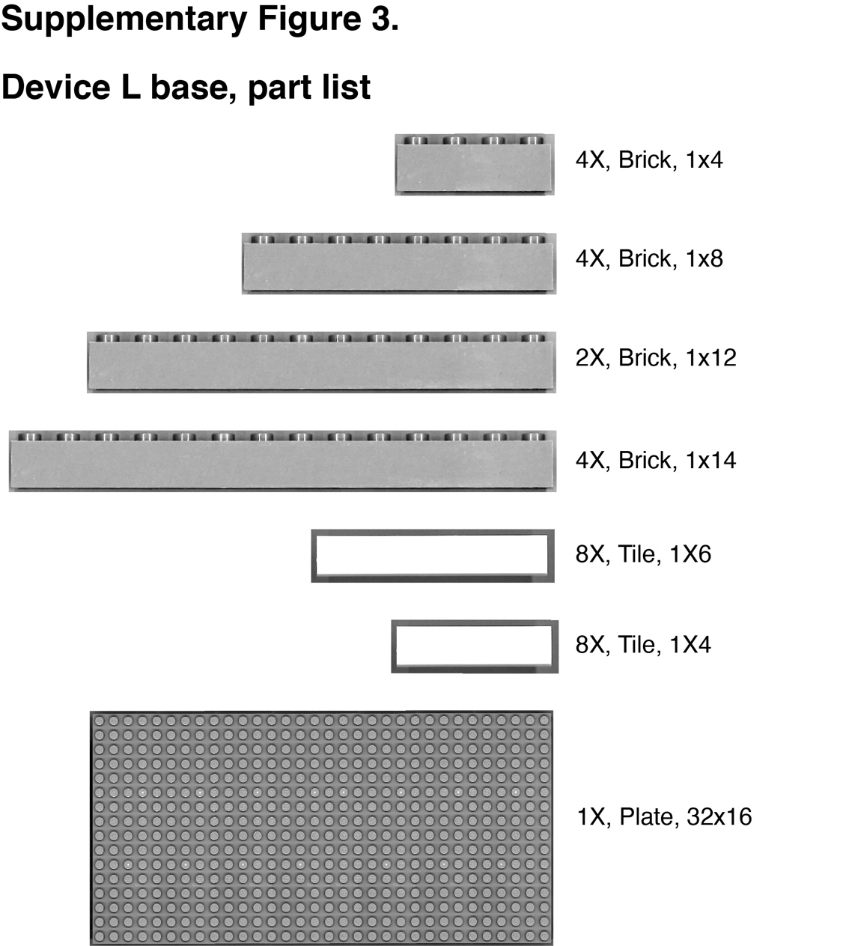

Supplementary Figure 3: Part list of Device L base. Needed LEGO® blocks which allow the construction of Brick Strex L device base.

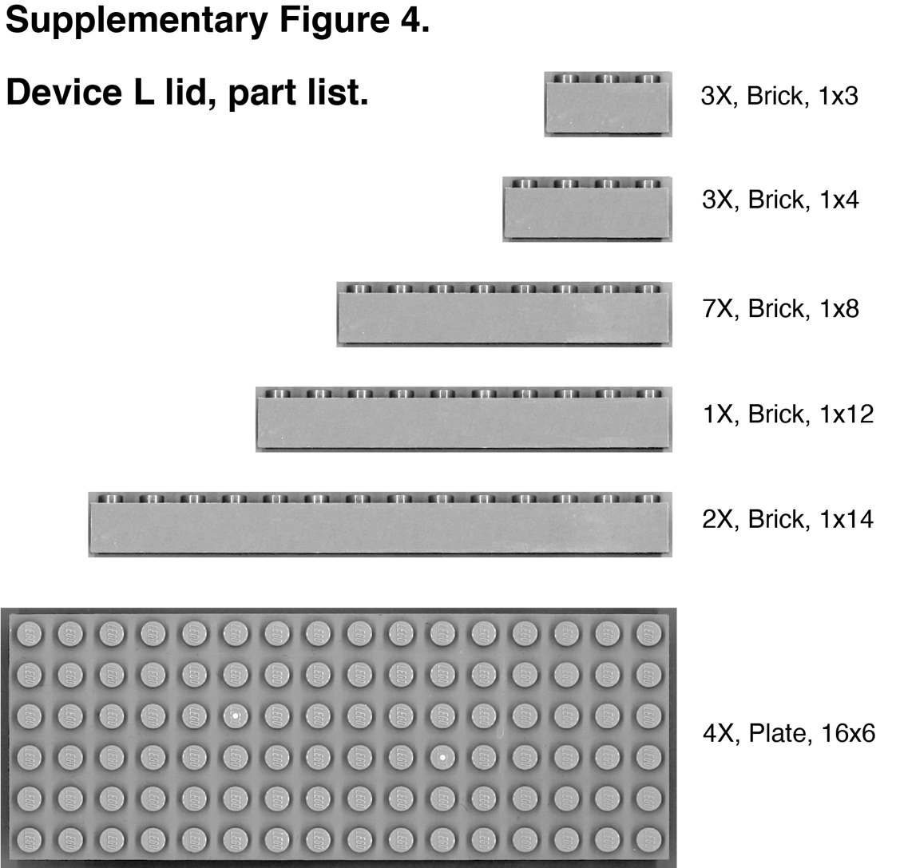

Supplementary Figure 4: Part list of Device L lid. Needed LEGO® blocks which allow the construction of Brick Strex L device lid.

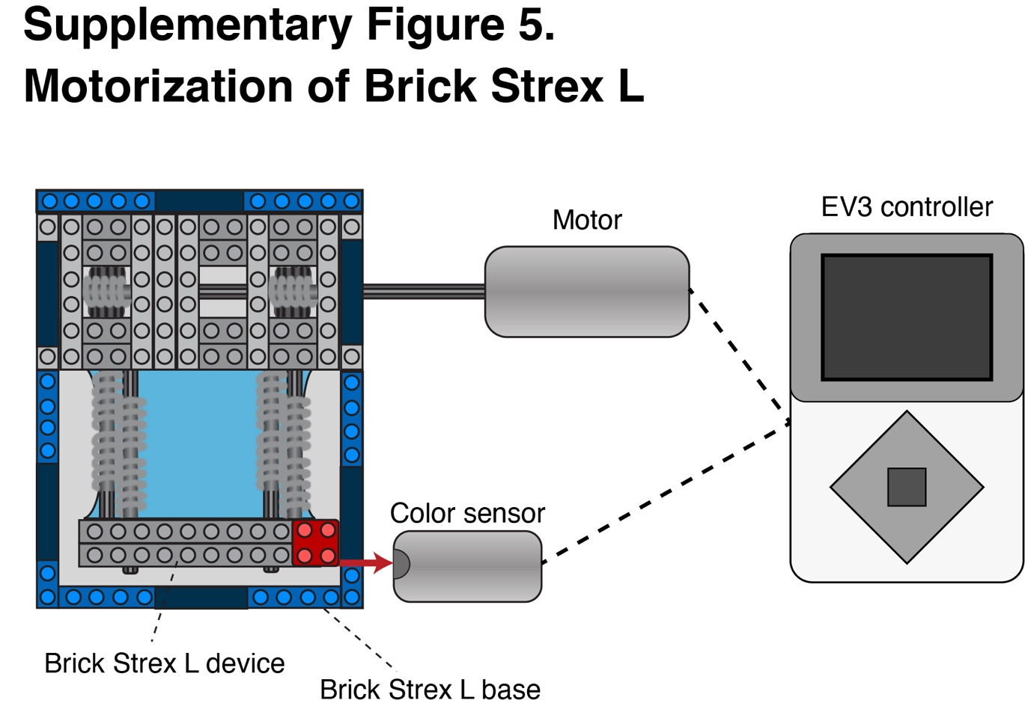
Supplementary Figure 5: Motorization of Brick Strex L. Automation of the stretching is achieved via motor and color sensor, which is used to monitor the device movement.

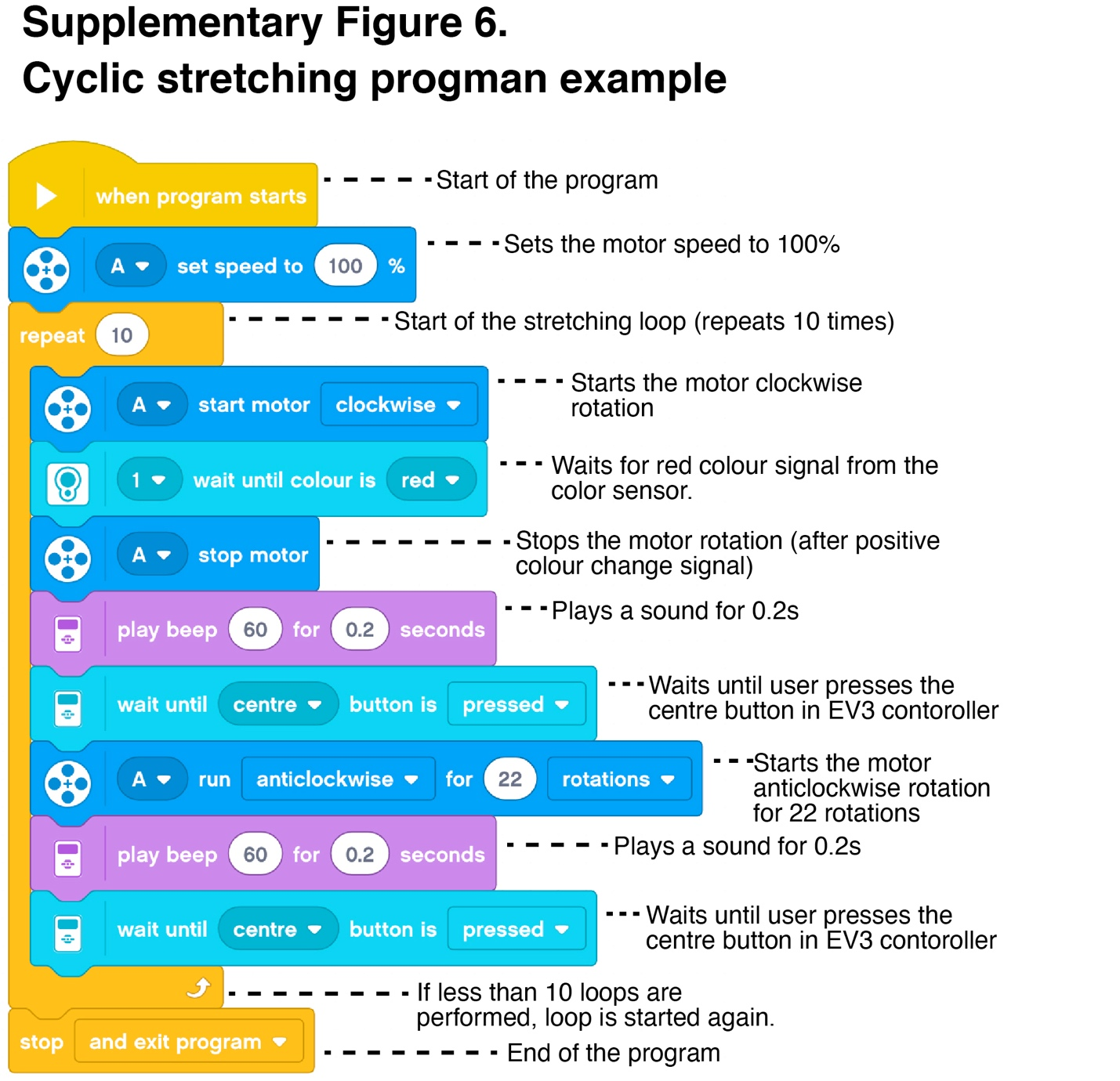
Supplementary Figure 6: Programming example for cyclic stretching experiments. LEGO® Mindstorms program for cycling stretching example using Brick Strex L device.

