The following Supporting Information is available for this article:
Supplemental Table 1. Genomic information of oak species.
Supplemental Table 2. Genomic collinearity of AEK, ACEK, and oak species.
Supplemental Table 3. Detection and characteristics of full-length LTR-RTs in oak species.
Supplemental Table 4. Number of LTR-RTs inserted within gene and promoter regions.
Supplemental Table 5. Location information of centromere regions predicted by Centromics and quarTeT methods in Q. glauca.
Supplemental Fig. 1 Homologous gene dot-plots between ancestral AEK and eight oak species.
Supplemental Fig. 2 Homologous gene dot-plots between ancestral ACEK and eight oak species.
Supplemental Fig. 3 Karyotype (ACEK) projections for eight oak species.
Supplemental Fig. 4 Homologous gene dot-plot between Q. glauca and Betula pendula.
Supplemental Fig. 5 Homologous gene dot-plots between Q. glauca and itself and seven other oak species.
Supplemental Fig. 6 Proportion of Copia, Gypsy, and Unknown elements in LTR-RTs fractions in each species.
Supplemental Fig. 7 Sequence identity distribution of LTR-RTs hits represented in a swarm plot for eight oak species. (a) Identity distribution of all elements; (b) Identity distribution of all Copia; (c) Identity distribution of all Gypsy.
Supplemental Fig. 8 Number of full-length LTR-RTs belonging to different lineages of Copia and Gypsy superfamilies.
Supplemental Fig. 9 Insertion time of the amplified LTR-RTs lineages in oak species (MYA, millions of years ago). (a) Insertion time of Copia/Ale. (b) Insertion time of Copia/SIRE; (c) Insertion time of Copia/Angela in Q. acutissima, Q. gilva, Q. glauca, and Q. variabilis; (d) Insertion time of Gypsy/Retand in all oak species.
Supplemental Fig. 10 Number of LTR-RTs inserted within gene and promoter. (a) Number of full-length LTR-RTs belonging to Copia and Gypsy superfamilies; (b) Number of different lineages of Copia superfamily; (d) Number of different lineages of Gypsy superfamily.
Supplemental Fig. 11 GO enrichment analysis of LTR-RT-associated genes among eight oak species. (a) GO enrichment of LTR-RT-associated genes with LTR-RTs insertion in genes; (b) GO enrichment of LTR-RT-associated genes with LTR-RTs insertion in promoter regions.
Supplemental Fig. 12 KEGG enrichment analysis of LTR-RT-associated genes among eight oak species. (a) KEGG enrichment of LTR-RT-associated genes with LTR-RTs insertion in genes; (b) KEGG enrichment of LTR-RT-associated genes with LTR-RTs insertion in promoter regions.
Supplemental Fig. 13 Map of centromeres location information predicted by various methods. (a) Discontinuous signals in the chromatin interaction heat maps; (b) Centromere localization detection results of method Centromics; (c) Centromere localization detection results of CentroMiner tools of quarTeT; (d) High-frequency repeat units of Telomeres_and_Centromeres results.
Supplemental Fig. 14 Repeat annotation in Q. glauca reference genome.

Supplemental Table 1. Genomic information of oak species.
Species | Assembly level | Genome size (Mb) | Chromosome size (Mb) | Total genes | TEs content (Mb) | TE ratio (%) | LTR content (Mb)
Quercus acutissima | chromosome | 758 | 750 | 30820 | 546.7 | 57.1 | 220.7
Quercus dentata | chromosome | 893 | 893 | 31584 | 478.7 | 53.6 | 309.2
Quercus gilva | chromosome | 890 | 859 | 36442 | 512.3 | 57.6 | 166.2
Quercus glauca | chromosome | 903 | 865 | 39023 | 668.3 | 77.3 | 168.7
Quercus lobata | chromosome | 845 | 811 | 36703 | 447.3 | 52.0 | 179.0
Quercus mongolica | chromosome | 810 | 775 | 33489 | 419.4 | 51.8 | 139.1
Quercus robur | chromosome | 790 | 717 | 32231 | 372.6 | 52.0 | 197.5
Quercus variabilis | chromosome | 796 | 787 | 32466 | 486.5 | 61.1 | 371.3

Supplemental Table 2. Genomic collinearity of AEK, ACEK, and oak species.
Species | Genomic collinearity to AEK |  | Genomic collinearity to ACEK |  | Genomic collinearity to Q. glauca
Species | Blocks number | Gene pairs number | Blocks number | Gene pairs number | Blocks number | Gene pairs number | Orthologous blocks/gene pairs | Paralogous blocks/gene pairs
Q. acutissima | 332 | 6808 | 821 | 18440 | 1072 | 20659 | 734/17355 | 338/3344
Q. dentata | 416 | 7295 | 974 | 19041 | 1116 | 21099 | 794/17870 | 322/3229
Q. gilva | 421 | 6103 | 1018 | 15865 | 1427 | 23531 | 1104/20656 | 323/2875
Q. glauca | 405 | 6250 | 1045 | 16393 | 1114 | 13553 | 785/10382 | 329/3171
Q. lobata | 505 | 15865 | 1107 | 20446 | 1338 | 23403 | 939/19773 | 399/3630
Q. mongolica | 369 | 7321 | 924 | 19775 | 1144 | 21869 | 805/18525 | 339/3344
Q. robur | 430 | 7669 | 964 | 19923 | 1162 | 22730 | 815/19254 | 347/3476
Q. variabilis | 306 | 5929 | 782 | 16154 | 907 | 19027 | 597/16131 | 310/2896

Supplemental Table 3. Detection and characteristics of full-length LTR-RTs in oak species.
Species | Total chromosome length (Mb) | Full-length LTR-RTs |  |  | Solo LTR |  | Number of each type |  |  | Average length of each type (bp)
Species | Total chromosome length (Mb) | Number | Cumulative length (Mb) | Number/Mb | Number | Cumulative length (Mb) | Copia | Gypsy | Unknown | Copia | Gypsy | Unknown
Q. acutissima | 750 | 4791 | 37.83 | 6.4 | 146298 | 128.46 | 2344 | 2019 | 428 | 7069 | 9430 | 5142
Q. dentata | 893 | 4102 | 33.77 | 4.6 | 152408 | 136.69 | 2381 | 1091 | 630 | 7776 | 10556 | 5936
Q. gilva | 859 | 6879 | 56.79 | 8.0 | 101209 | 122.86 | 3642 | 2423 | 814 | 7699 | 9872 | 5898
Q. gluaca | 865 | 7455 | 55.55 | 8.6 | 118688 | 134.59 | 3952 | 2541 | 962 | 7600 | 10029 | 5776
Q. lobata | 811 | 4461 | 35.89 | 5.5 | 88713 | 106.47 | 2050 | 1772 | 639 | 7278 | 9900 | 5335
Q. mongolica | 775 | 5618 | 47.03 | 7.3 | 86029 | 93.22 | 2751 | 2164 | 703 | 7720 | 10092 | 5576
Q. robur | 717 | 5595 | 47.25 | 7.8 | 83118 | 94.48 | 2795 | 2171 | 629 | 7666 | 10158 | 5930
Q. variabilis | 787 | 5248 | 41.99 | 6.7 | 84415 | 129.80 | 2664 | 2163 | 421 | 7314 | 9395 | 5178

Supplemental Table 4. Number of LTR-RTs inserted within gene and promoter regions.
Species | Number of LTR-RTs inserted within gene |  |  |  | Number of LTR-RTs inserted within promoter |  |  |  | Number of LTR-RTs inserted within R-genes | Number of LTR-RTs inserted within R-genes promoter regions
Species | Total | Copia | Gypsy | Unknown | Total | Copia | Gypsy | Unknown | Number of LTR-RTs inserted within R-genes | Number of LTR-RTs inserted within R-genes promoter regions
Q. acutissima | 501 | 272 | 195 | 34 | 1035 | 400 | 563 | 72 | 33 | 55
Q. dentata | 350 | 209 | 106 | 35 | 745 | 372 | 298 | 75 | 22 | 63
Q. gilva | 302 | 174 | 101 | 27 | 1443 | 615 | 705 | 123 | 10 | 33
Q. glauca | 437 | 263 | 121 | 53 | 1772 | 804 | 787 | 181 | 13 | 36
Q. lobata | 914 | 243 | 626 | 45 | 293 | 81 | 179 | 33 | 80 | 23
Q. mongolica | 1267 | 513 | 635 | 119 | 1531 | 542 | 867 | 122 | 54 | 66
Q. robur | 1495 | 551 | 851 | 93 | 1760 | 633 | 1024 | 103 | 86 | 52
Q. variabilis | 550 | 282 | 238 | 30 | 1057 | 451 | 545 | 61 | 48 | 64

Supplemental Table 5. Location information of centromere regions predicted by Centromics and quarTeT methods in Q. glauca.
Chromosome | Centromics |  | quarTeT
Chromosome | Start site (bp) | End site (bp) | Start site (bp) | End site (bp)
Chr01 | 59640000 | 60570000 | 31452150 | 31839403
Chr02 | 101110000 | 101500000 | 86814905 | 87194684
Chr03 |  |  | 4664143 | 4865439
Chr04 |  |  | 46734945 | 49137326
Chr05 | 37190000 | 37320000 | 11526862 | 13049109
Chr06 | 53690000 | 54180000 | 47526203 | 47628736
Chr07 |  |  | 20376565 | 21408450
Chr08 | 1 | 1160000 | 1851224 | 1977564
Chr09 |  |  | 13565850 | 13737604
Chr10 | 1 | 1250000 | 1 | 1231101
Chr11 |  |  | 32251787 | 32369422
Chr12 |  |  | 27216531 | 27320280

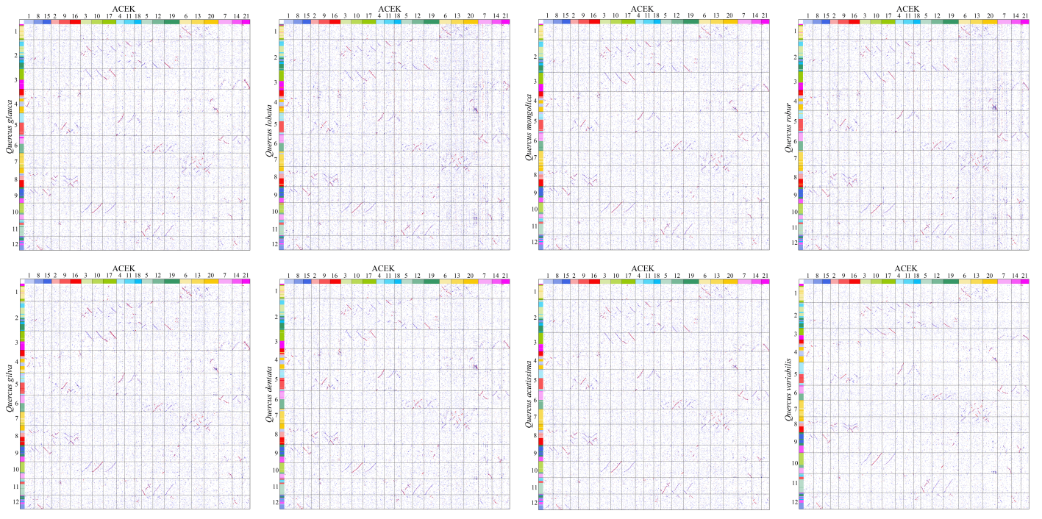
Supplemental Fig. 1 Homologous gene dot-plots between ancestral AEK and eight oak species.

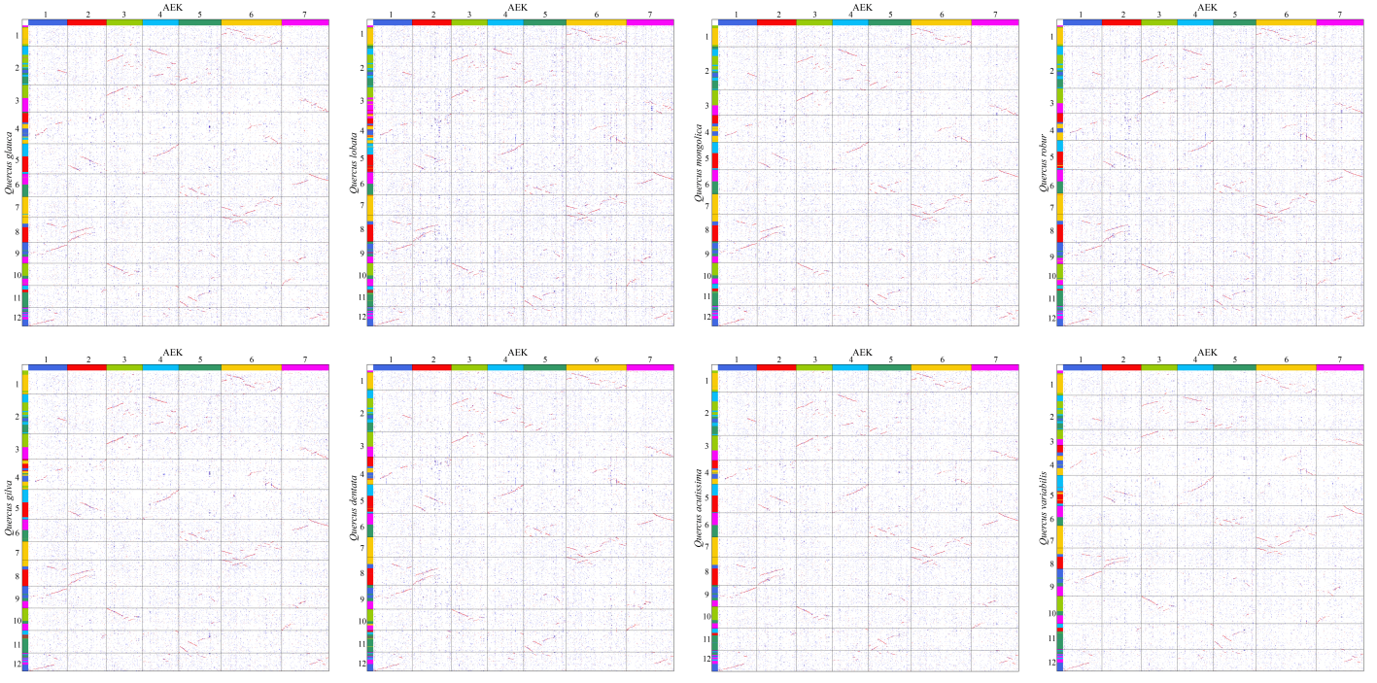
Supplemental Fig. 2 Homologous gene dot-plots between ACEK and eight oak species.

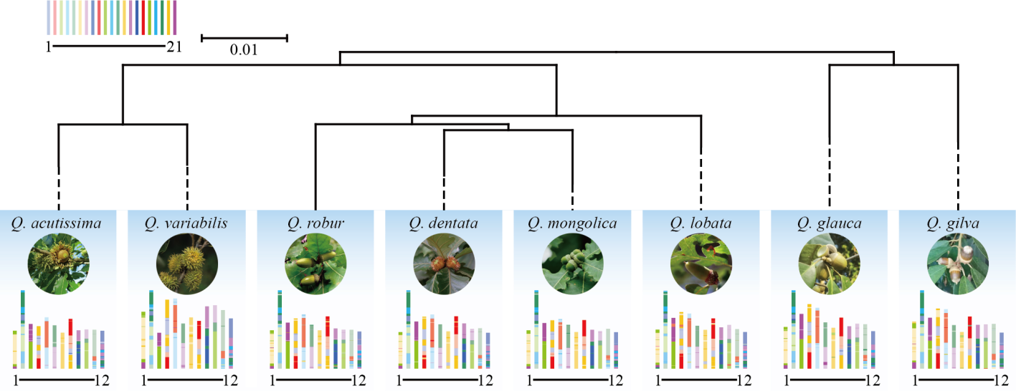
Supplemental Fig. 3 Karyotype (ACEK) projections for eight oak species.

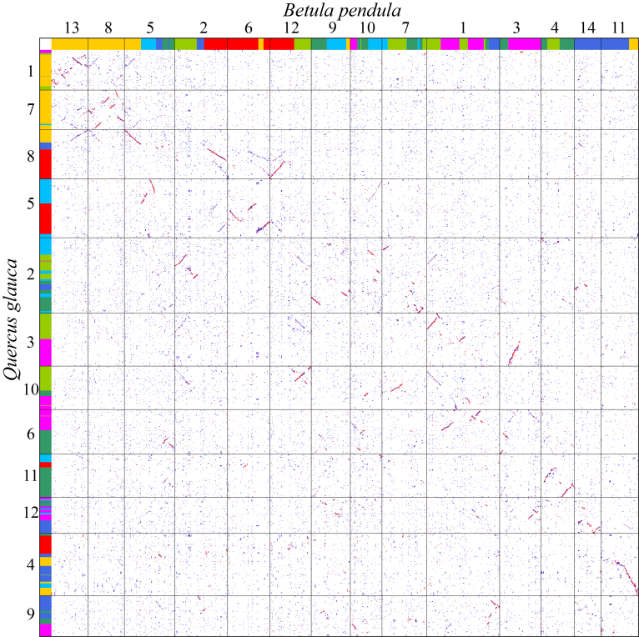
Supplemental Fig. 4 Homologous gene dot-plot between Q. glauca and B. pendula.

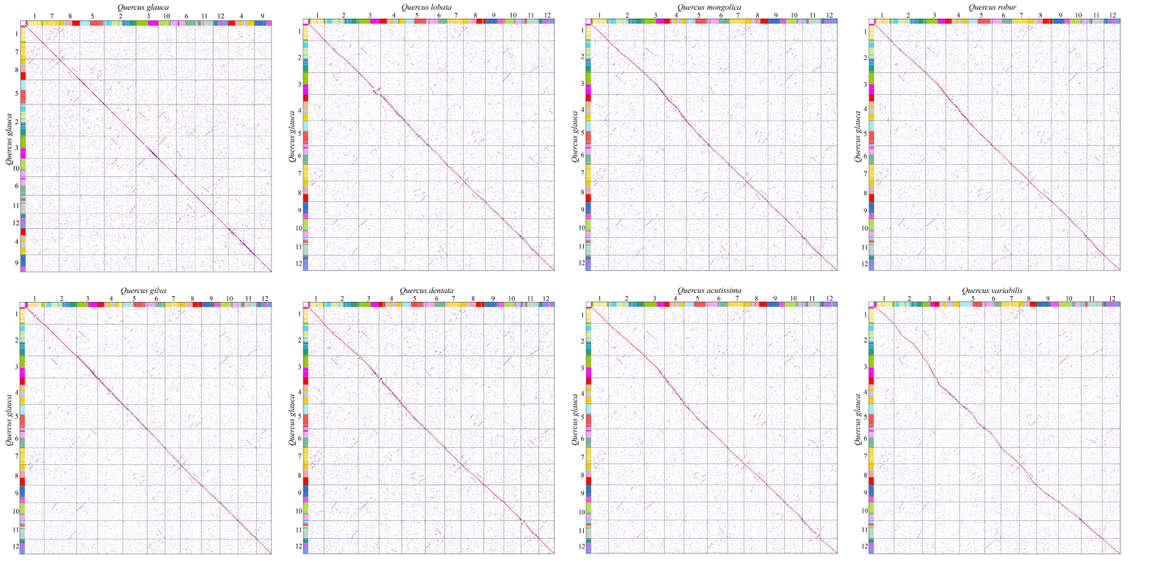
Supplemental Fig. 5 Homologous gene dot-plots between Q. glauca and itself and seven other oak species.

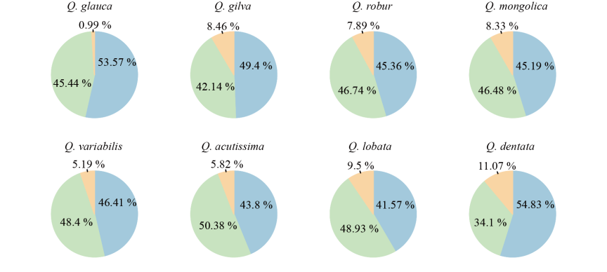
Supplemental Fig. 6 Proportion of Copia, Gypsy, and Unknown elements in LTR-RTs fractions in each species.

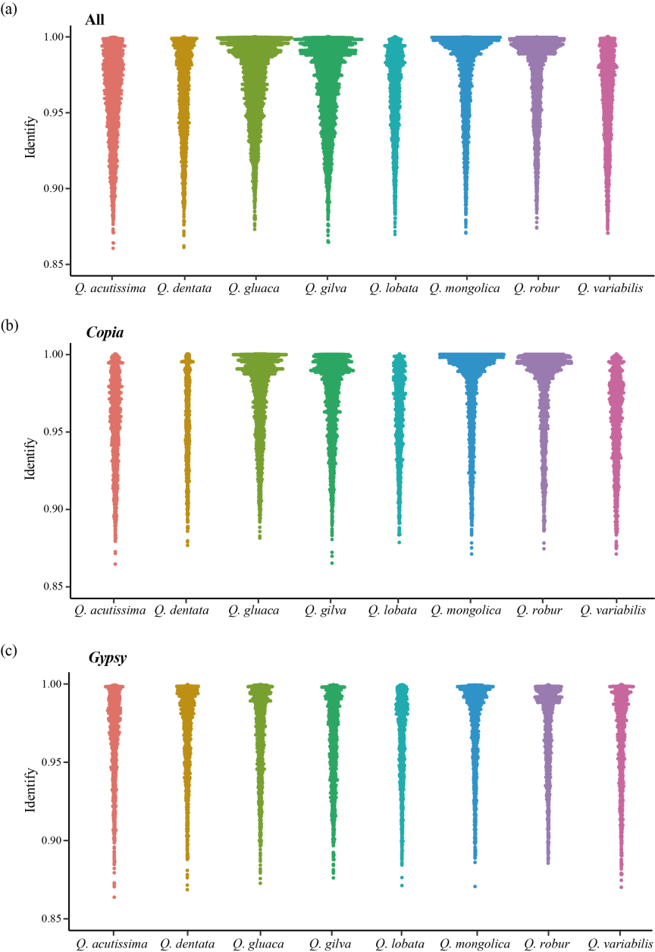
Supplemental Fig. 7 Sequence identity distribution of LTR-RTs hits represented in a swarm plot for eight oak species. (a) Identity distribution of all elements; (b) Identity distribution of all Copia; (c) Identity distribution of all Gypsy.

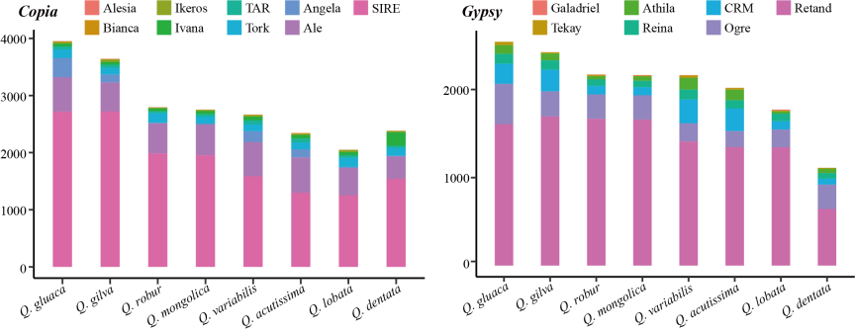
Supplemental Fig. 8 Number of full-length LTR-RTs belonging to different lineages of Copia and Gypsy superfamilies.

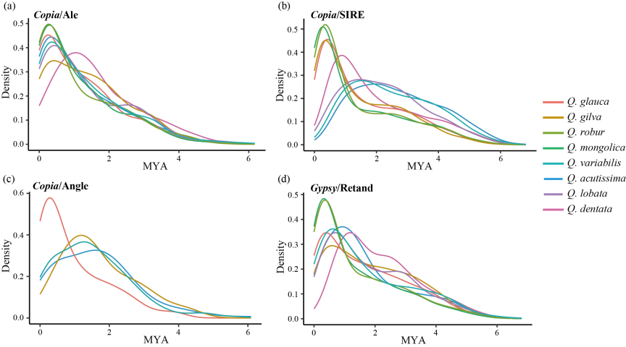
Supplemental Fig. 9 Insertion time of the amplified LTR-RTs lineages in oak species (MYA, millions of years ago). (a) Insertion time of Copia/Ale; (b) Insertion time of Copia/SIRE; (c) Insertion time of Copia/Angela in Q. acutissima, Q. gilva, Q. glauca, and Q. variabilis; (d) Insertion time of Gypsy/Retand in all oak species.

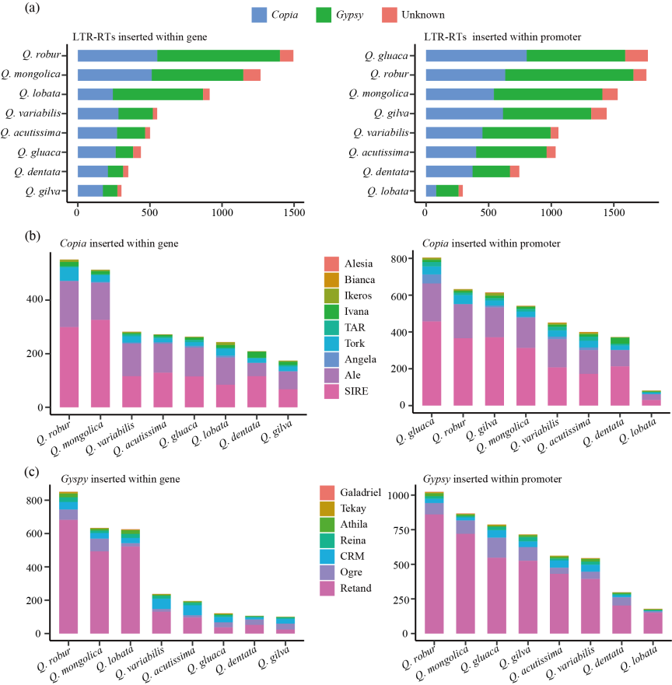
Supplemental Fig. 10 Number of LTR-RTs inserted within gene and promoter. (a) Number of full-length LTR-RTs belonging to Copia and Gypsy superfamilies; (b) Number of different lineages of Copia superfamily; (c) Number of different lineages of Gypsy superfamily.

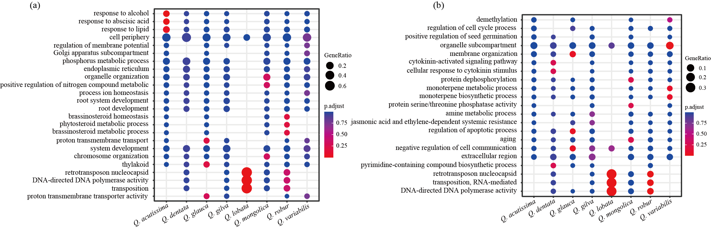
Supplemental Fig. 11 GO enrichment analysis of LTR-RT-associated genes among eight oak species. (a) GO enrichment of LTR-RT-associated genes with LTR-RTs insertion in genes; (b) GO enrichment of LTR-RT-associated genes with LTR-RTs insertion in promoter regions.

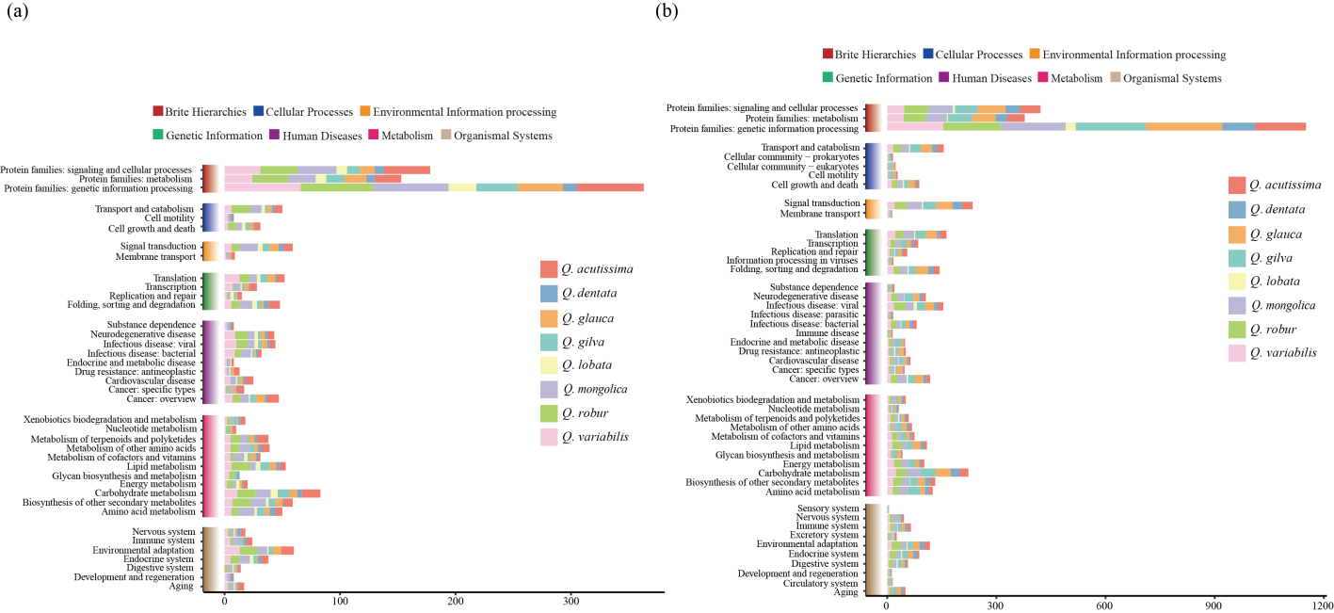
Supplemental Fig. 12 KEGG enrichment analysis of LTR-RT-associated genes among eight oak species. (a) KEGG enrichment of LTR-RT-associated genes with LTR-RTs insertion in genes; (b) KEGG enrichment of LTR-RT-associated genes with LTR-RTs insertion in promoter regions.

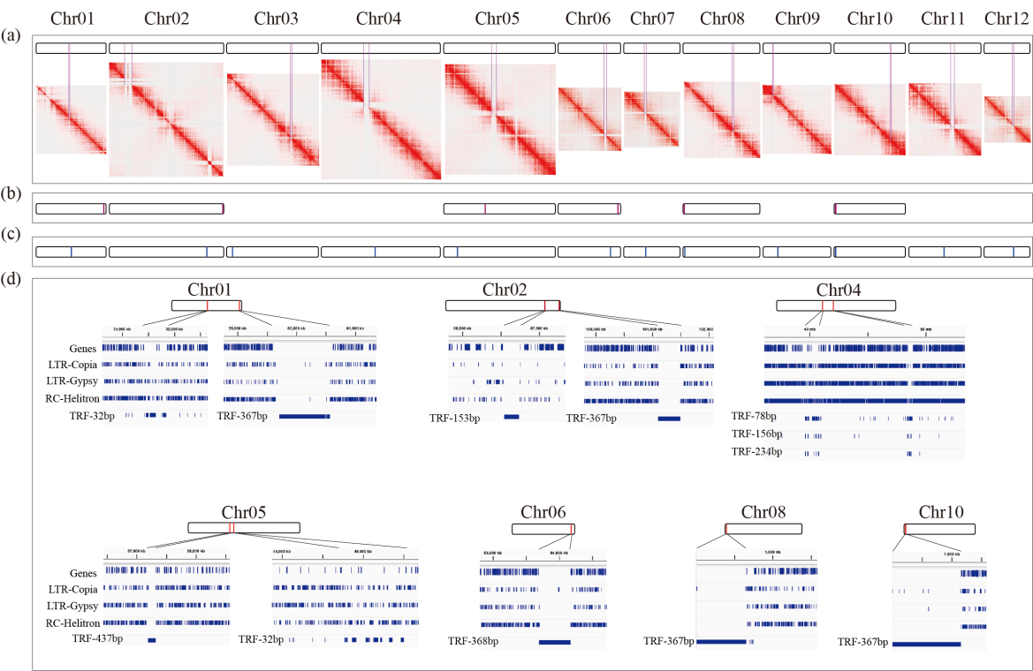
Supplemental Fig. 13 Map of centromeres location information predicted by various methods. (a) Discontinuous signals in the chromatin interaction heat maps; (b) Centromere localization detection results of method Centromics; (c) Centromere localization detection results of CentroMiner tools of quarTeT; (d) High-frequency repeat units of Telomeres_and_Centromeres results.
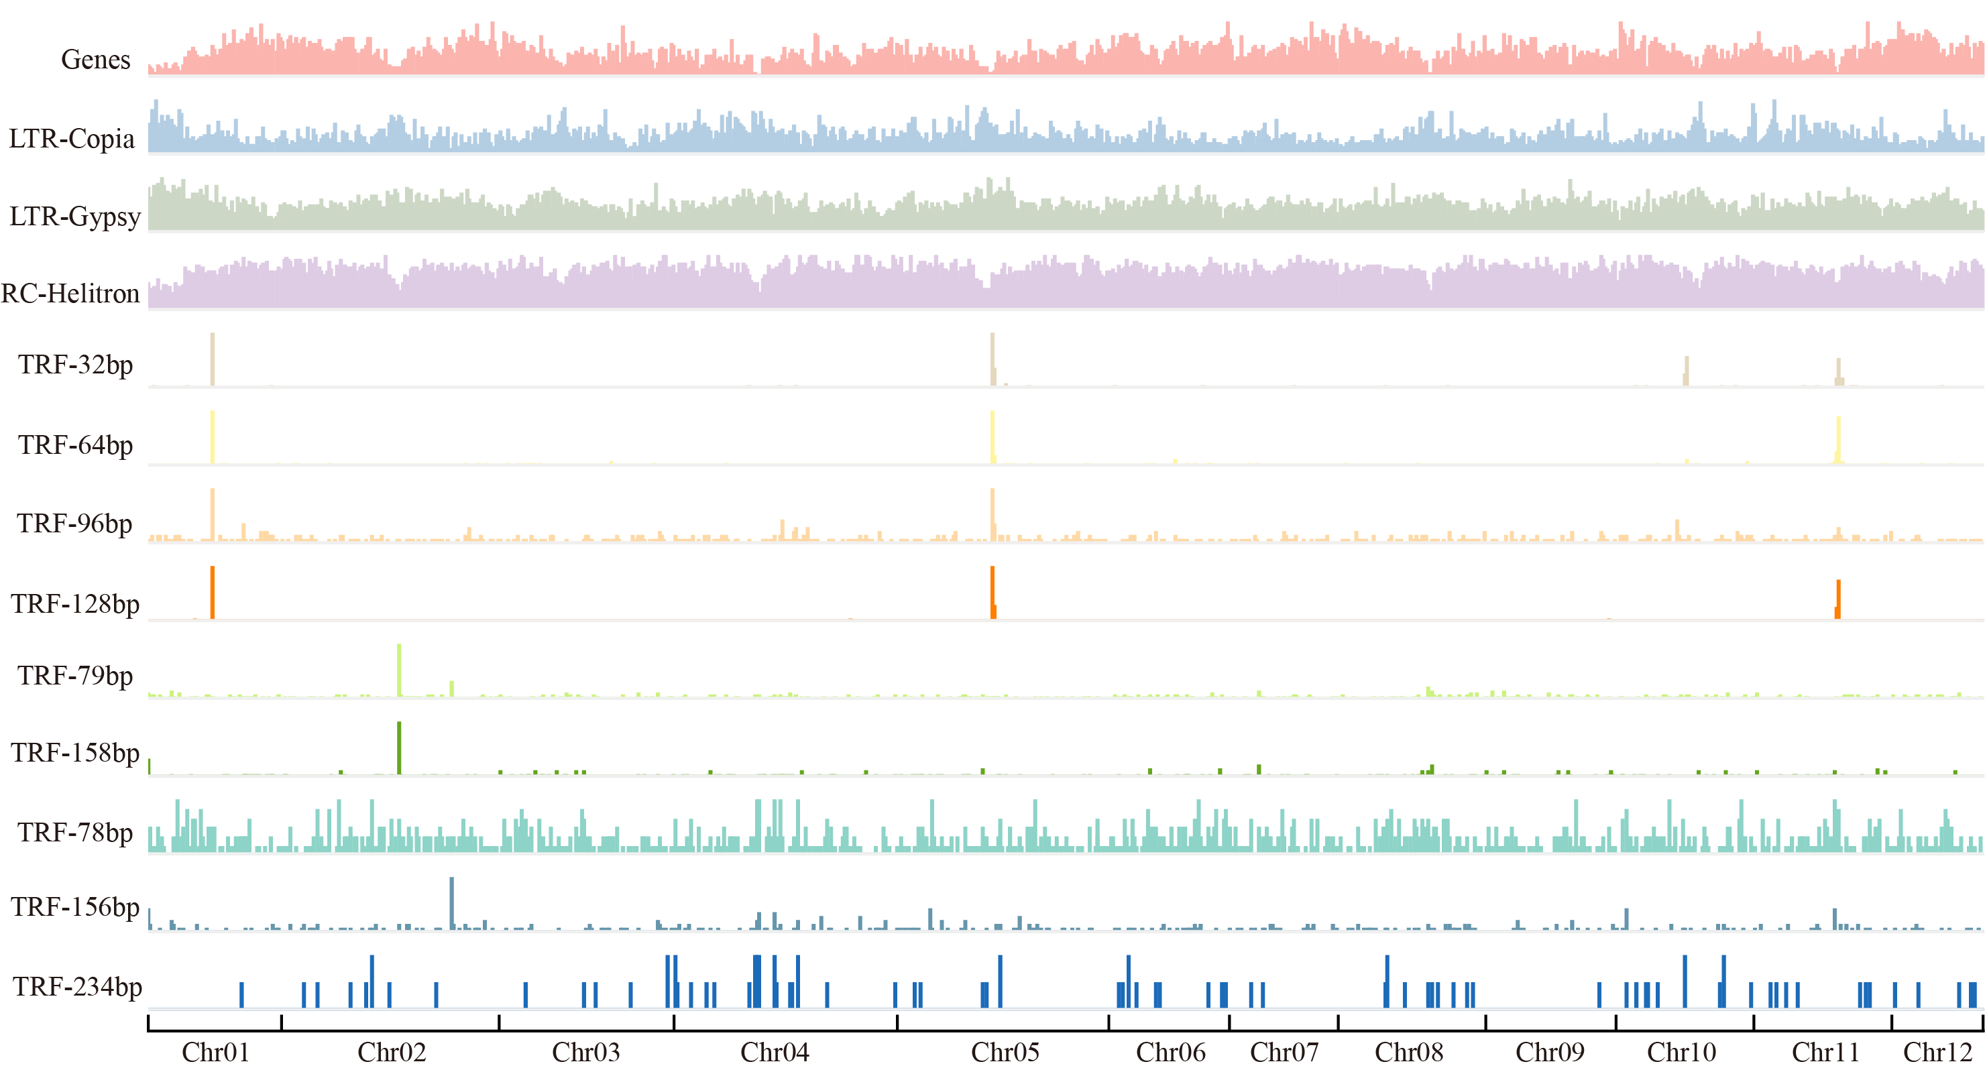
Supplemental Fig. 14 Repeat annotation in Q. glauca reference genome.

