Supplementary information for:
Compact hyperspectral imaging of extreme-depth-of-field diffractive lenses based on spatial–spectral sparse deep learning

Yitong Pan^{1,2,3,4}, Zhenqi Niu^{1,2,3,4✉}, Yuying Lu^{1,2,3,4}, Songlin Wan^{1,2,3,4}, Chaoyang Wei^{1,2,3,4✉}, Jianda Shao^{1,2,3,4✉}

¹Precision Optical Manufacturing and Testing Center, Shanghai Institute of Optics and Fine Mechanics, Chinese Academy of Sciences, Shanghai 201800, China

²Key Laboratory for High Power Laser Material of Chinese Academy of Sciences, Shanghai Institute of Optics and Fine Mechanics, Shanghai 201800, China

³Center of Material Science and Optoelectronics Engineering, University of Chinese Academy of Sciences, Beijing 100049, China

⁴China-Russian Belt and Road Joint Laboratory on Laser Science, Shanghai 201800, China

Correspondence: Zhenqi Niu (niuzhenqi@siom.ac.cn), Chaoyang Wei (siomwei@siom.ac.cn) or Jianda Shao (jdshao@siom.ac.cn)

Contents:
S1. Additional simulation results
S2. Experiment scenario diagram
S3. The details and accuracy of reconstructed hyperspectral imaging
S4. Reconstruction results of the moving object

S1.Additional simulation results
In order to further verify the achromatic ability of our proposed system, we choose a picture which is quite different from the Fig. 2 in the main paper as the object in the simulation experiment as shown in Fig. S1. As can be seen from the house in the lower right corner of the simulation result, the advantages of the proposed system in terms of achromaticity and extended-DoF are obvious.

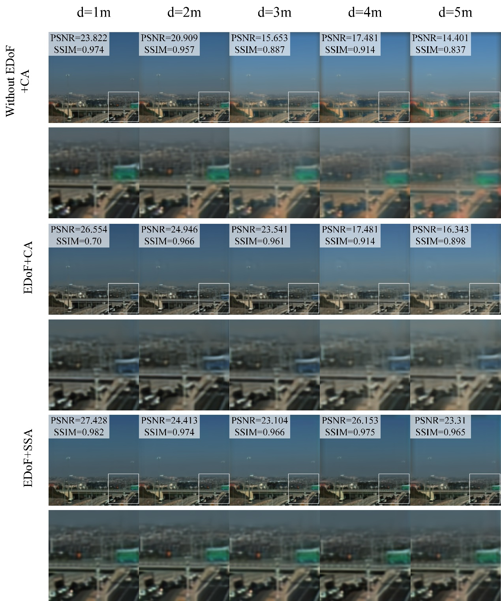
Fig. S1. Comparison simulation results of three different hyperspectral imaging system for the same object at different object distance d. The images are illstraucted by RGB false color.

S2.Experiment scenario diagram
In the experiment 1, we placed target objects at object distances of 1.2 m (digital blocks), 2.2 m (3D portrait sculpture), 3.2 m (cartoon dog) and 5.2 m (house) in order to verify the function of extended DoF in proposed system as shown in Fig. 3a in the main paper. In addition, because that object placed close to the lens would obscure distant object, we were forced to split the experiment into two parts. In the experiment 2, we verified the performance of close-range multi-target imaging, where two objects were placed at 0.5 m (avocado doll) and 0.7 m (tiger doll) separately as shown in Fig. 3b. Fig. S2 shows the experimental scenario diagram.

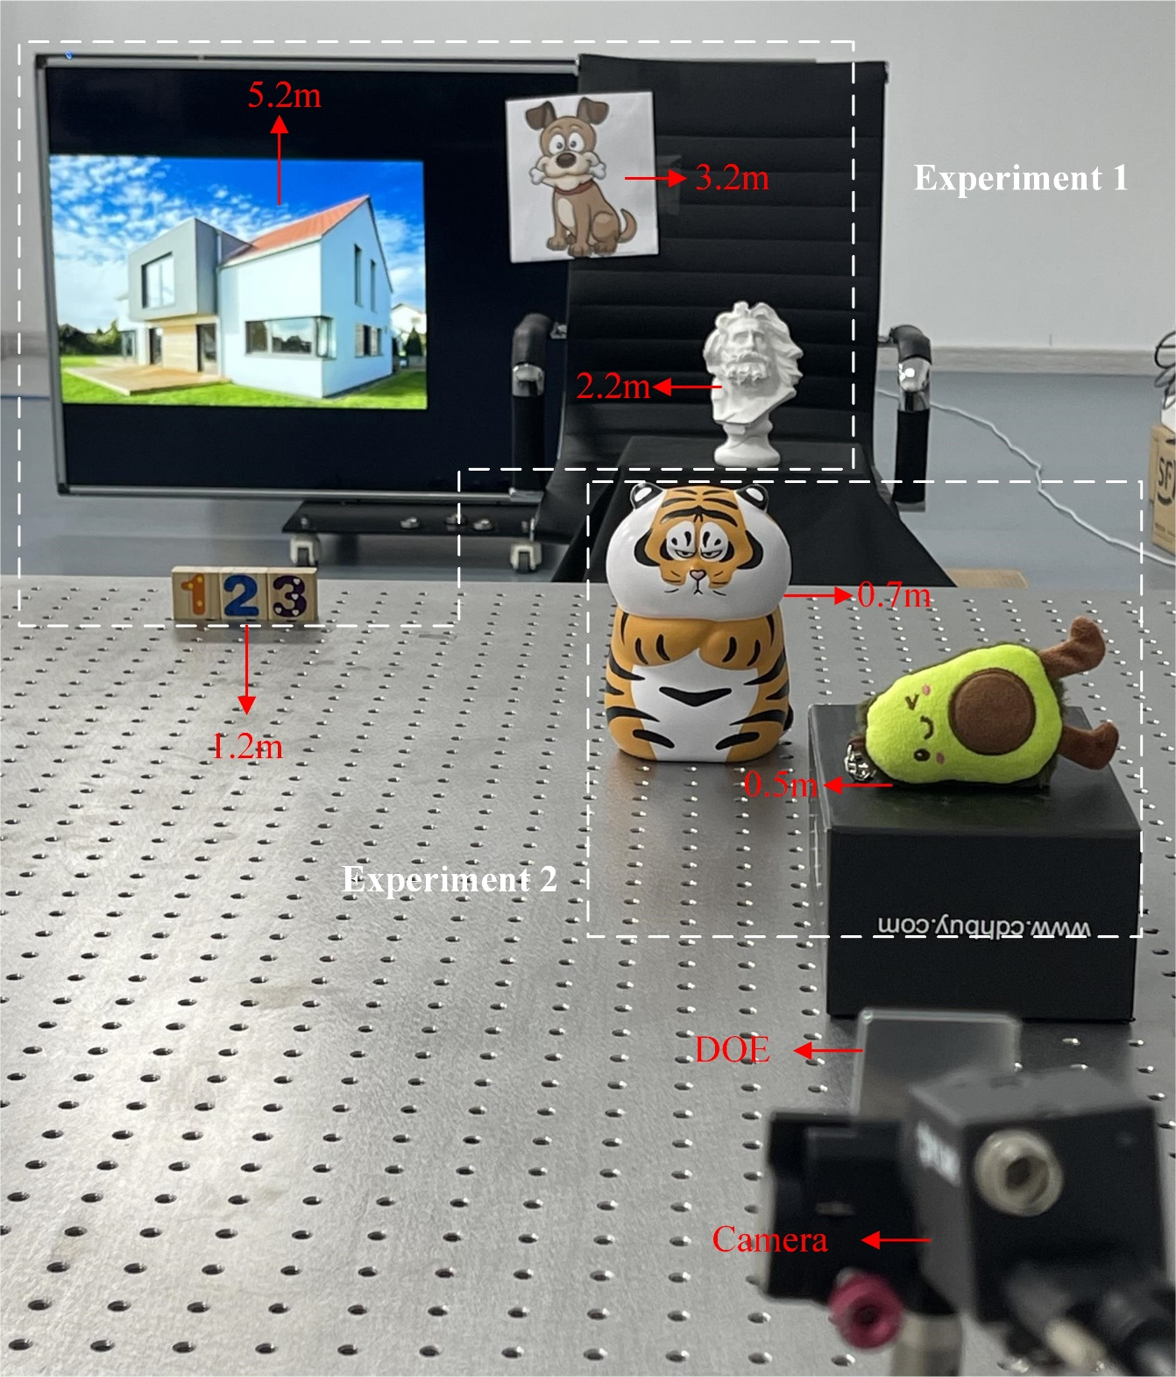
Fig. S2. The experimental scenario digram of experiment (1).

S3.The details and accuracy of reconstructed hyperspectral imaging
The comparison results and accuracy rate of light intensity at different wavelengths of the selected points P1, P2, P3 are shown in following Table S1, Table S2, Table S3 saperately. Therefore, we also calculted the average of the accuracy rate of chosen dots at different wavelengths to make a more visual and comprehensive view of the spectral reconstruction capability of the proposed system, as shown in Table S4.

Table S1. The intensity value and accuracy rate of P1 at different wavelengths
Wavelengh[nm]  Intensity | 420 | 430 | 440 | 450 | 460 | 470 | 480
Proposed system | 0.4664 | 0.4711 | 0.5117 | 0.5652 | 0.5884 | 0.6041 | 0.6094
GT | 0.4312 | 0.4350 | 0.4857 | 0.5400 | 0.5760 | 0.5954 | 0.6054
Accuracy rate[%] | 91.82 | 91.71 | 94.65 | 95.33 | 97.85 | 98.55 | 99.33
Wavelengh[nm]  Intensity | 490 | 500 | 510 | 520 | 530 | 540 | 550
Proposed system | 0.6072 | 0.6176 | 0.6185 | 0.6153 | 0.6285 | 0.6470 | 0.6577
GT | 0.6108 | 0.6155 | 0.6172 | 0.6218 | 0.6350 | 0.6484 | 0.6559
Accuracy rate[%] | 99.42 | 99.66 | 99.79 | 98.95 | 98.97 | 99.79 | 99.71
Wavelengh[nm]  Intensity | 560 | 570 | 580 | 590 | 600 | 610 | 620
Proposed system | 0.6630 | 0.6625 | 0.6643 | 0.6664 | 0.6655 | 0.6738 | 0.6661
GT | 0.6585 | 0.6598 | 0.6604 | 0.6585 | 0.6580 | 0.6568 | 0.6503
Accuracy rate[%] | 99.32 | 99.58 | 99.42 | 98.80 | 98.87 | 97.42 | 97.57
Wavelengh[nm]  Intensity | 630 | 640 | 650 | 660
Proposed system | 0.6682 | 0.6630 | 0.6638 | 0.6602
GT | 0.6421 | 0.6343 | 0.6259 | 0.6225
Accuracy rate[%] | 95.93 | 95.47 | 93.95 | 93.94

Table S2. The intensity value and accuracy rate of P2 at different wavelengths
Wavelengh[nm]  Intensity | 420 | 430 | 440 | 450 | 460 | 470 | 480
Proposed system | 0.0535 | 0.0551 | 0.0601 | 0.0647 | 0.0670 | 0.0681 | 0.0661
GT | 0.0371 | 0.0374 | 0.0419 | 0.0473 | 0.0514 | 0.0544 | 0.0566
Accuracy rate[%] | 55.87 | 52.91 | 56.60 | 63.22 | 69.72 | 74.65 | 83.23
Wavelengh[nm]  Intensity | 490 | 500 | 510 | 520 | 530 | 540 | 550
Proposed system | 0.0635 | 0.0611 | 0.0617 | 0.0616 | 0.0698 | 0.0767 | 0.0848
GT | 0.0589 | 0.0617 | 0.0652 | 0.0700 | 0.0771 | 0.0864 | 0.0984
Accuracy rate[%] | 92.09 | 99.09 | 94.62 | 87.96 | 90.51 | 88.70 | 86.17
Wavelengh[nm]  Intensity | 560 | 570 | 580 | 590 | 600 | 610 | 620
Proposed system | 0.0937 | 0.1077 | 0.1243 | 0.1453 | 0.1710 | 0.1919 | 0.2025
GT | 0.1130 | 0.1300 | 0.1480 | 0.1652 | 0.1812 | 0.1944 | 0.2036
Accuracy rate[%] | 82.94 | 82.80 | 83.99 | 87.96 | 94.37 | 98.71 | 99.47
Wavelengh[nm]  Intensity | 630 | 640 | 650 | 660
Proposed system | 0.2139 | 0.2188 | 0.2222 | 0.2211
GT | 0.2104 | 0.2159 | 0.2207 | 0.2272
Accuracy rate[%] | 98.32 | 98.65 | 99.28 | 97.35

Table S3. The intensity value and accuracy rate of P3 at different wavelengths
Wavelengh[nm]  Intensity | 420 | 430 | 440 | 450 | 460 | 470 | 480
Proposed system | 0.2931 | 0.2950 | 0.3136 | 0.3375 | 0.3445 | 0.3413 | 0.3324
GT | 0.2978 | 0.2986 | 0.3121 | 0.3278 | 0.3321 | 0.3253 | 0.3136
Accuracy rate[%] | 98.41 | 98.70 | 99.51 | 97.05 | 96.27 | 95.09 | 94.01
Wavelengh[nm]  Intensity | 490 | 500 | 510 | 520 | 530 | 540 | 550
Proposed system | 0.3211 | 0.3130 | 0.3025 | 0.2888 | 0.2806 | 0.2739 | 0.2617
GT | 0.3004 | 0.2872 | 0.2743 | 0.2644 | 0.2581 | 0.2515 | 0.2426
Accuracy rate[%] | 93.13 | 91. 02 | 89.73 | 90.77 | 91.28 | 91.08 | 92.12
Wavelengh[nm]  Intensity | 560 | 570 | 580 | 590 | 600 | 610 | 620
Proposed system | 0.2487 | 0.2348 | 0.2220 | 0.2106 | 0.2042 | 0.2033 | 0.1942
GT | 0.2311 | 0.2177 | 0.2047 | 0.1935 | 0.1884 | 0.1854 | 0.1775
Accuracy rate[%] | 92.40 | 92.17 | 91.52 | 91.17 | 91.63 | 90.37 | 90.61
Wavelengh[nm]  Intensity | 630 | 640 | 650 | 660
Proposed system | 0.1911 | 0.1868 | 0.1819 | 0.1787
GT | 0.1678 | 0.1595 | 0.1527 | 0.1493
Accuracy rate[%] | 86.05 | 82.91 | 80.90 | 80.34

Table S4. The average of the accuracy rate of chosen dots at different wavelengths
Wavelengh[nm] | 420 | 430 | 440 | 450 | 460 | 470 | 480
Accuracy rate[%] | 82.03 | 80.80 | 82.22 | 84.93 | 88.70 | 90.97 | 93.95
Wavelengh[nm] | 490 | 500 | 510 | 520 | 530 | 540 | 550
Accuracy rate[%] | 96.59 | 99.39 | 97.75 | 95.62 | 96.21 | 95.21 | 94.72
Wavelengh[nm] | 580 | 590 | 600 | 610 | 620 | 630 | 640
Accuracy rate[%] | 93.96 | 94.96 | 96.89 | 98.25 | 97.41 | 97.89 | 97.54
Wavelengh[nm] | 650 | 660
Accuracy rate[%] | 96.82 | 97.00

S4.Reconstruction results of the moving object
To assess the imaging speed of our system, we recorded the motion of falling blocks using proposed system. We push down the blocks from about 0.3 m height by a pen and capture the falling process with a speed of camera about 33 ms/frame. As can be seen from Fig. 5, each shape of the blocks in the falling process can be completely captured. Due to the page limitations, a video of the falling process and its slow video are attached to this supporting information.

