Additional file 1

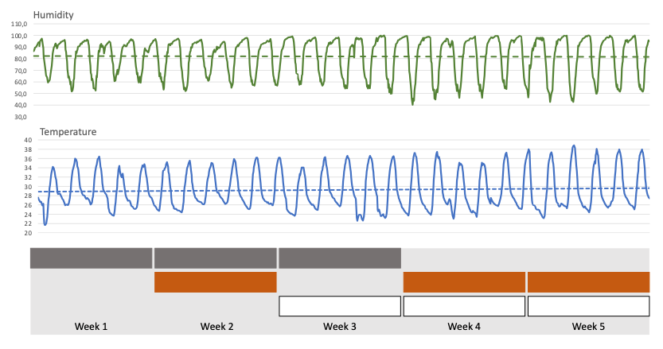
Fig. 1 Outdoor temperature and humidity during the study Grey = bare metal roofs, red = red roof and white = white roof.

