Additional file 2

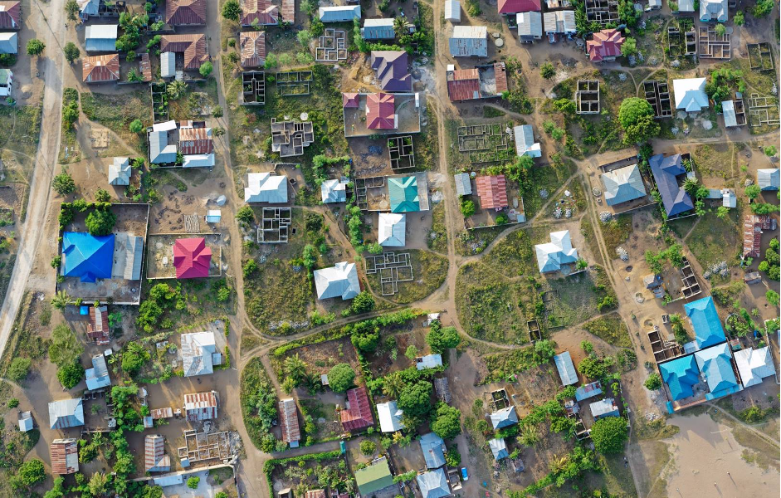
Fig. 2. Aerial view showing different roof colours in Tanzania © Jakob B. Knudsen

