Supplemental Information
Dual-channel Mechano-phosphorescence: A Combined Locking Effect with Twisted Molecular Structures and Robust Interactions
Zongliang Xie, Zhu Mao, Hailan Wang, Yuxin Xiao, Xiayu Zhang, Tao Yu, Zhongfu An, and Wei Huang

Table of Contents

Table of Contents 2

Experimental Procedures 4

General Methods 4

Materials and Syntheses 4

Supplementary Information 5

Supplemental Figures 5

Single crystal data 15

Characterization of chemical structure 18

References 24

Experimental Procedures

General Methods
¹H NMR, ¹³C NMR, and ³¹P NMR spectra for the materials were performed on a Bruker Avance NEO 500 Nuclear Magnetic Resonance Spectrometer with Chloroform-d as solvent and tetramethylsilane (TMS) as the internal standard. High-resolution Mass spectra (MS) were recorded on an Exactive GC high-resolution mass spectrometer. Elemental analysis studies were determined with a vario EI analyzer. TG-DSC Q600 (TA Instruments) was used to obtain the differential thermogravimetry curves. PXRD data were obtained on a Bruker X-ray diffractometer (D8 Advance) by using a Cu Kα (λ= 0.154184 nm) X-ray source in the circumstances of 40 kV and 30 mA, with a speed of 10° (2θ) per 1 min. Single-crystal X-ray analyses were collected using a Bruker D8 Venture X-ray Single Crystal Diffractometer with a (Cu) X-ray source. UV-vis absorption spectra, photoluminescence (PL) spectra, phosphorescence spectra, and phosphorescence lifetimes were obtained on a UV-vis spectrometer (Hitachi U-3900H) and a Hitachi F-7100 fluorescence spectrophotometer. Absolute PL quantum yields were measured on a Hamamatsu absolute PL quantum yield spectrometer C11347-11 Quantaurus-QY (The phosphorescence quantum yields of o-TATP and o-TATPO were calculated from the proportion in their steady-state emission spectra and phosphorescence spectra). Mechanoluminescence (ML) spectra and delayed emission spectra were measured on an Ocean Optic QE 65Pro spectrometer with Ocean Optic reflection probes R600-125F, respectively. TD-DFT calculations at B3LYP functional with 6-311G* basis set level were performed based on single crystal structure in Gaussian 09 software on the grounds of previous literatures^{1,2}.

Materials and syntheses
All reagents and solvents were purchased from Aladdin, Titan, or Adamas, and were used as received. Synthetic routes for o-TATP and o-TATPO were described in Scheme S1. The intermediate compound o-TAI and target compounds o-TATP and o-TATPO were synthesized following the previous literatures^{3,4}. All the products were purified by column chromatography and were confirmed by ¹H NMR, ¹³C NMR, and ³¹P NMR spectra and elemental analysis.
Scheme S1. Synthetic routes for o-TATP and o-TATPO.
Synthesis of 2-(diphenylphosphaneyl)-N, N-diphenylaniline (o-TATP)
o-TAI (3.00 g, 8.08 mmol) was dissolved in anhydrous tetrahydrofuran (THF) (50 mL). Then n-butyl lithium (5.51 mL, 8.82 mmol, 1.6 M) was added dropwise under the N₂ atmosphere. After stirring at -78 ºC for 1 h, chlorodiphenyl phosphine (1.62 g, 7.35 mmol) in 10 mL anhydrous THF was added in sequence (over 10 min) to the solution. The reaction mixture was stirred at -78 ºC for an additional 2 h and warmed up to room temperature gradually. After stirring overnight, 100 mL water was added to quench the reaction. The resulting mixture was extracted with dichloromethane three times. The separated organic layer was evaporated under reduced pressure to get the crude product as a light-yellow powder. Chromatography on a silica-gel column with dichloromethane-hexane (1/3, v/v) as eluent was then performed for further purification to get white powder of o-TATP (2.31 g, 5.38 mmol) with 73.2% yield. ¹H NMR (500 MHz, DMSO-d₆) δ 7.50 – 7.45 (m, 1H), 7.33 – 7.25 (m, 7H), 7.21 – 7.17 (m, 1H), 7.13 – 7.08 (m, 4H), 7.07 – 7.01 (m, 5H), 6.86 – 6.80 (m, 2H), 6.79 – 6.72 (m, 4H). ¹³C NMR (126 MHz, Chloroform-d) δ 151.57, 151.38, 148.06, 137.78, 137.66, 137.03, 136.93, 136.37, 133.82, 133.66, 130.71, 130.34, 128.75, 128.29, 128.20, 126.29, 122.55, 121.64. ³¹P NMR (202 MHz, Chloroform-d): δ = -16.38. High resolution EIMS: m/z found: 428.16124 [M]⁺; calcd for C₃₀H₂₄NP: 429.16464.
Synthesis of (2-(diphenylamino)phenyl) diphenylphosphine oxide (o-TATPO)
To a solution of o-TATP (1.50 g, 3.49 mmol) in dichloromethane (DCM) (50 mL), 30% hydrogen peroxide (H₂O₂, 5 mL) was added dropwise. The reaction mixture was stirred and reacted overnight at room temperature. The resulting mixture was poured into 100 mL water. The organic layer was separated, dried, and then concentrated under reduced pressure. The crude product was purified by Chromatography on a silica-gel column with DCM-MeOH (30/1, v/v) as eluent to afford the target product of o-TATPO as a white powder (1.25 g, 2.81 mmol) with 80.3% yield. ¹H NMR (500 MHz, DMSO-d₆) δ 7.67 (t, 1H), 7.45 (t, 6H), 7.40 – 7.32 (m, 5H), 7.30 – 7.22 (m, 2H), 7.00 (t, 4H), 6.78 (t, 2H), 6.73 – 6.64 (m, 4H). ¹³C NMR (126 MHz, Chloroform-d) δ 151.00, 148.14, 136.14, 136.05, 133.51, 133.49, 133.18, 132.74, 132.68, 132.34, 132.16, 131.67, 131.59, 131.36, 131.15, 131.13, 128.46, 128.10, 128.00, 125.65, 125.55, 123.06, 122.01. ³¹P NMR (202 MHz, Chloroform-d): δ = 25.76. High resolution EIMS: m/z found: 445.15833 [M]⁺; calcd for C₃₀H₂₄NPO: 445.15955.

Supplementary Information

Supplemental Figures
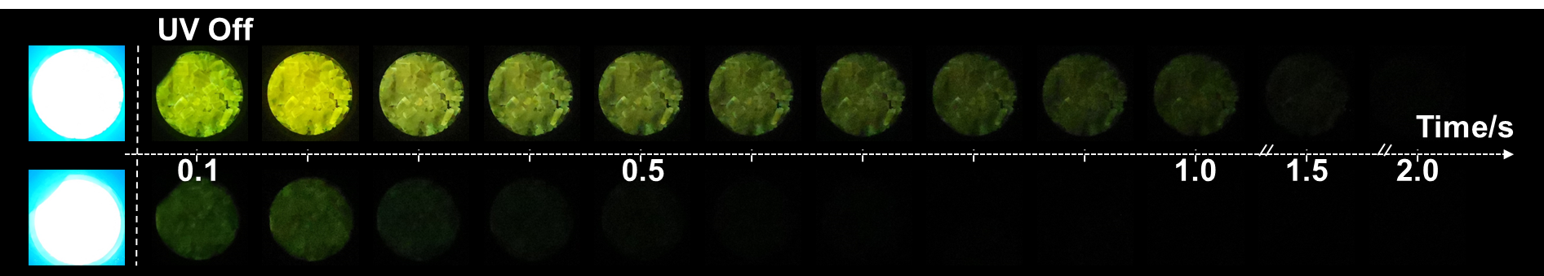
Figure S1. Photographs of o-TATPO and o-TATP taken under a 365 nm UV lamp on and off.
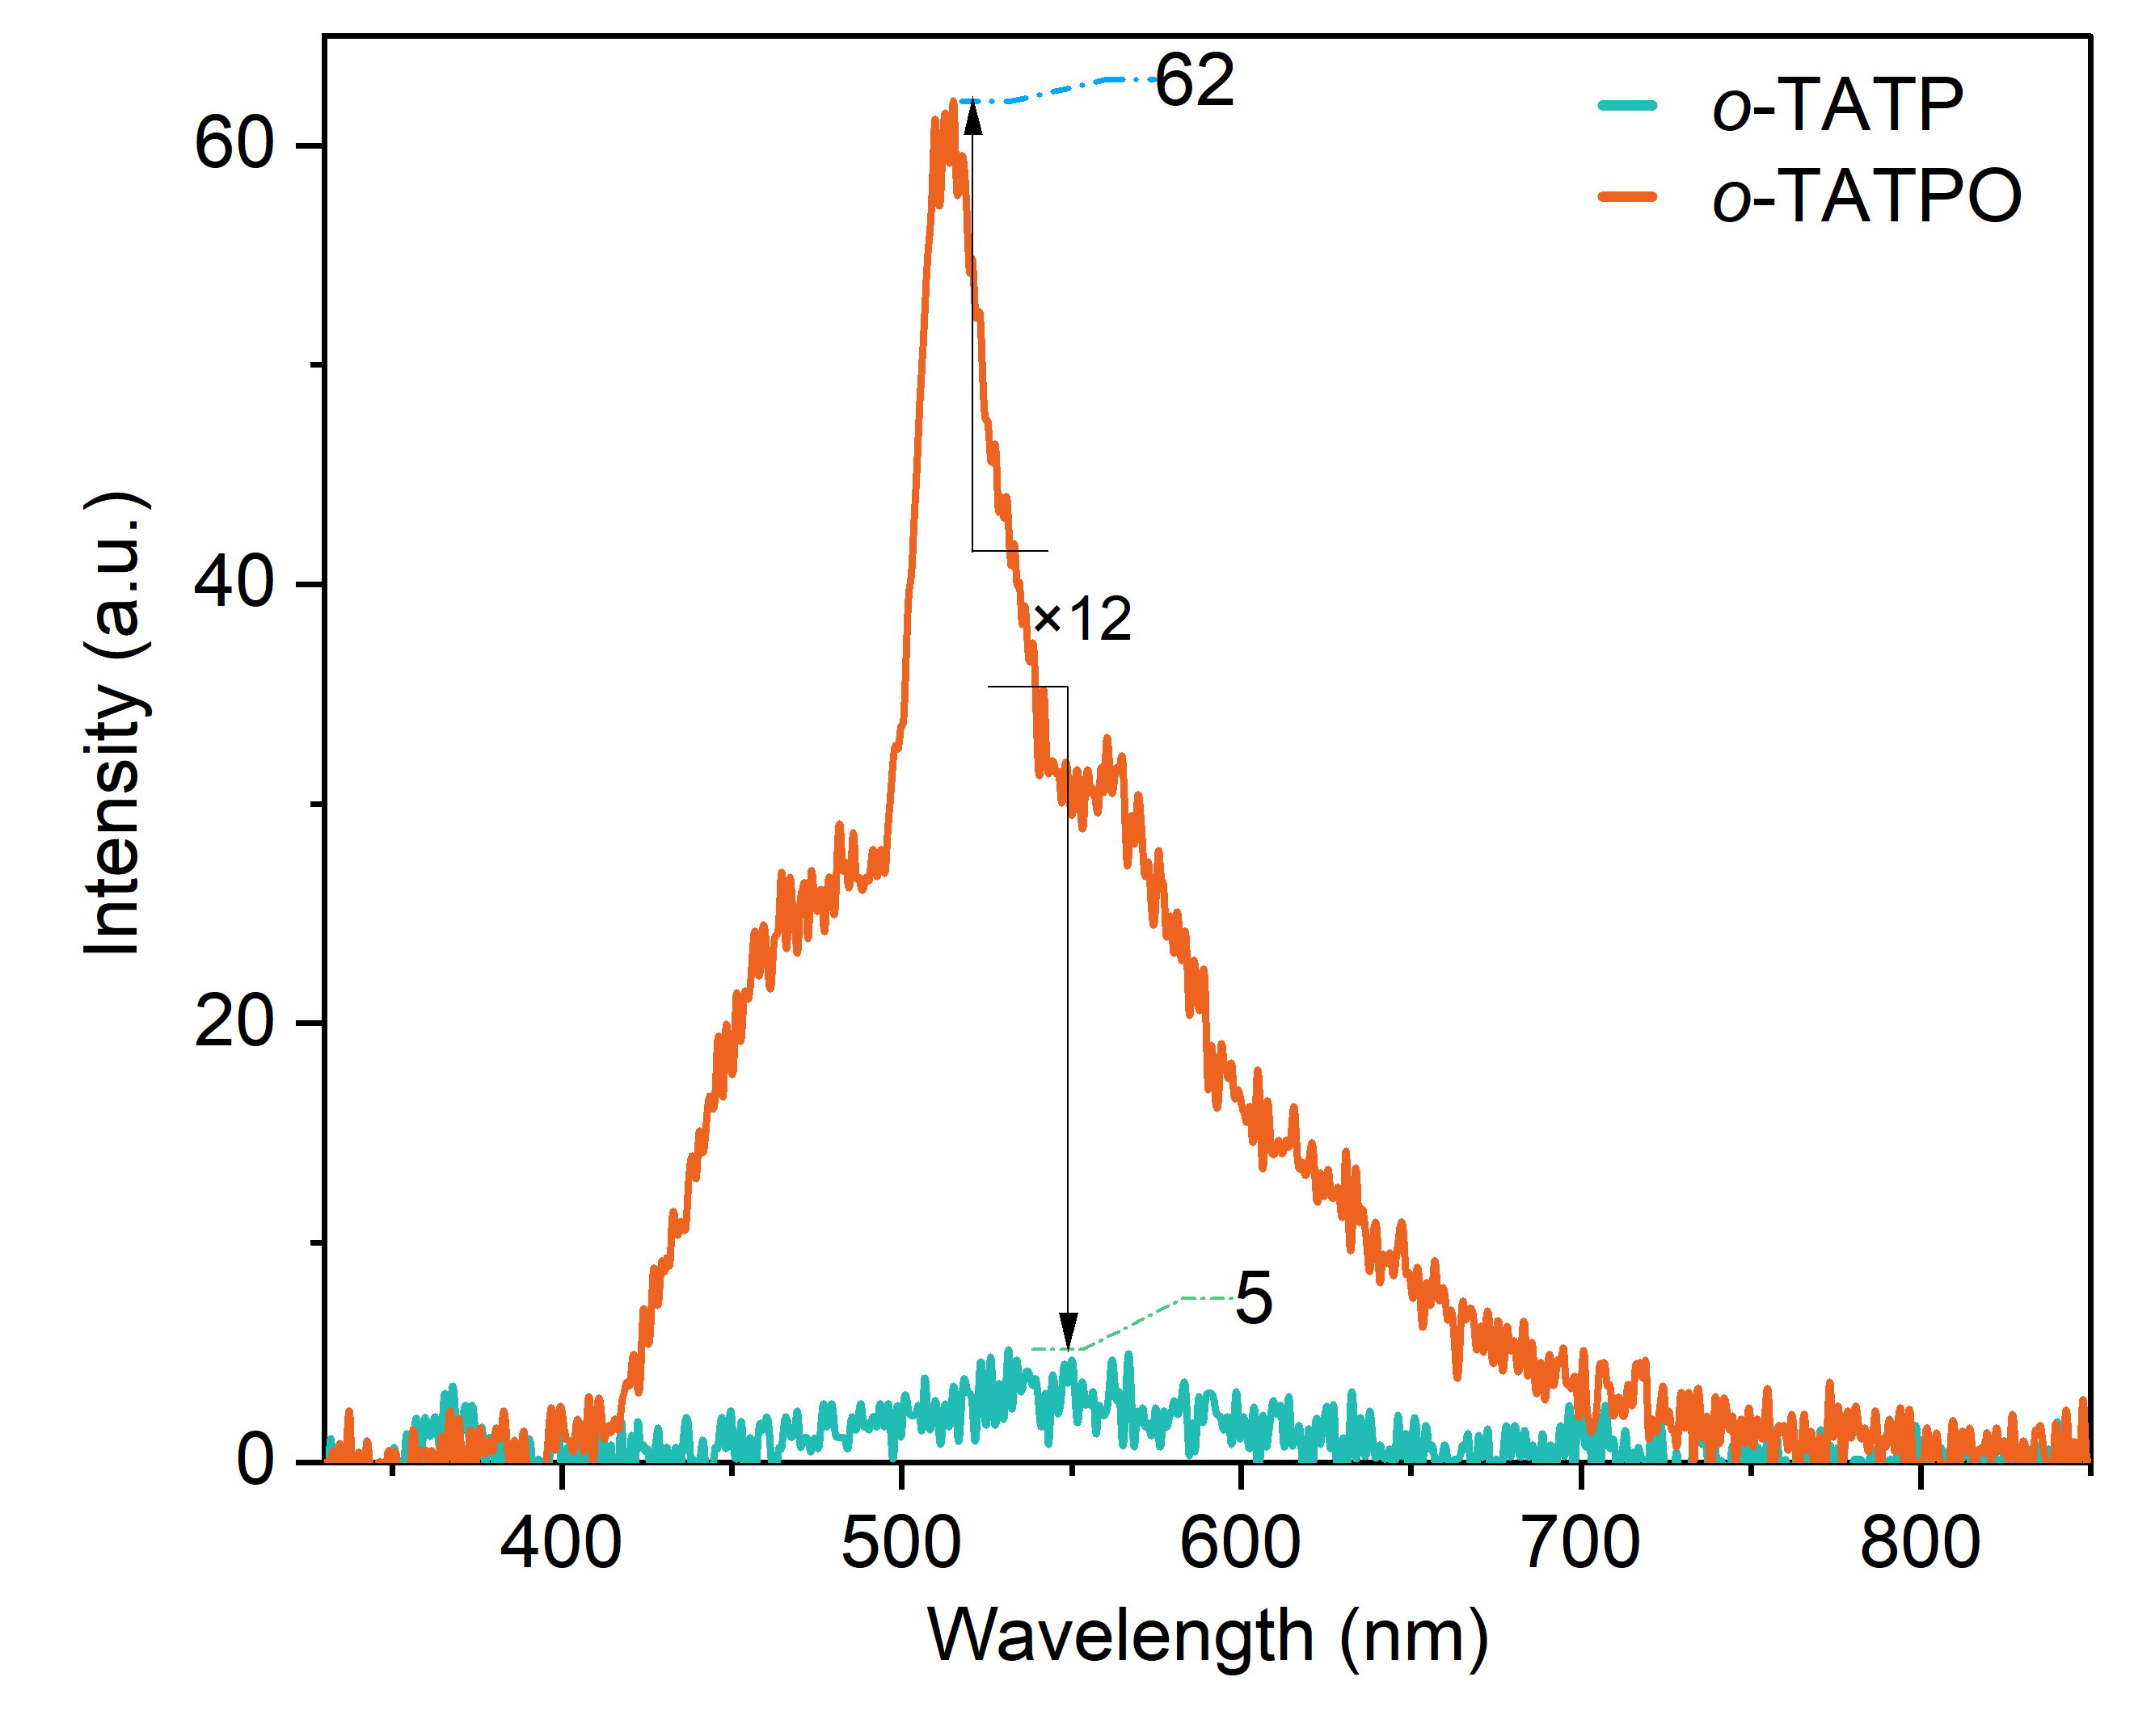
Figure S2. Delayed spectra at 8 ms after stoppage of 365 nm excitation.
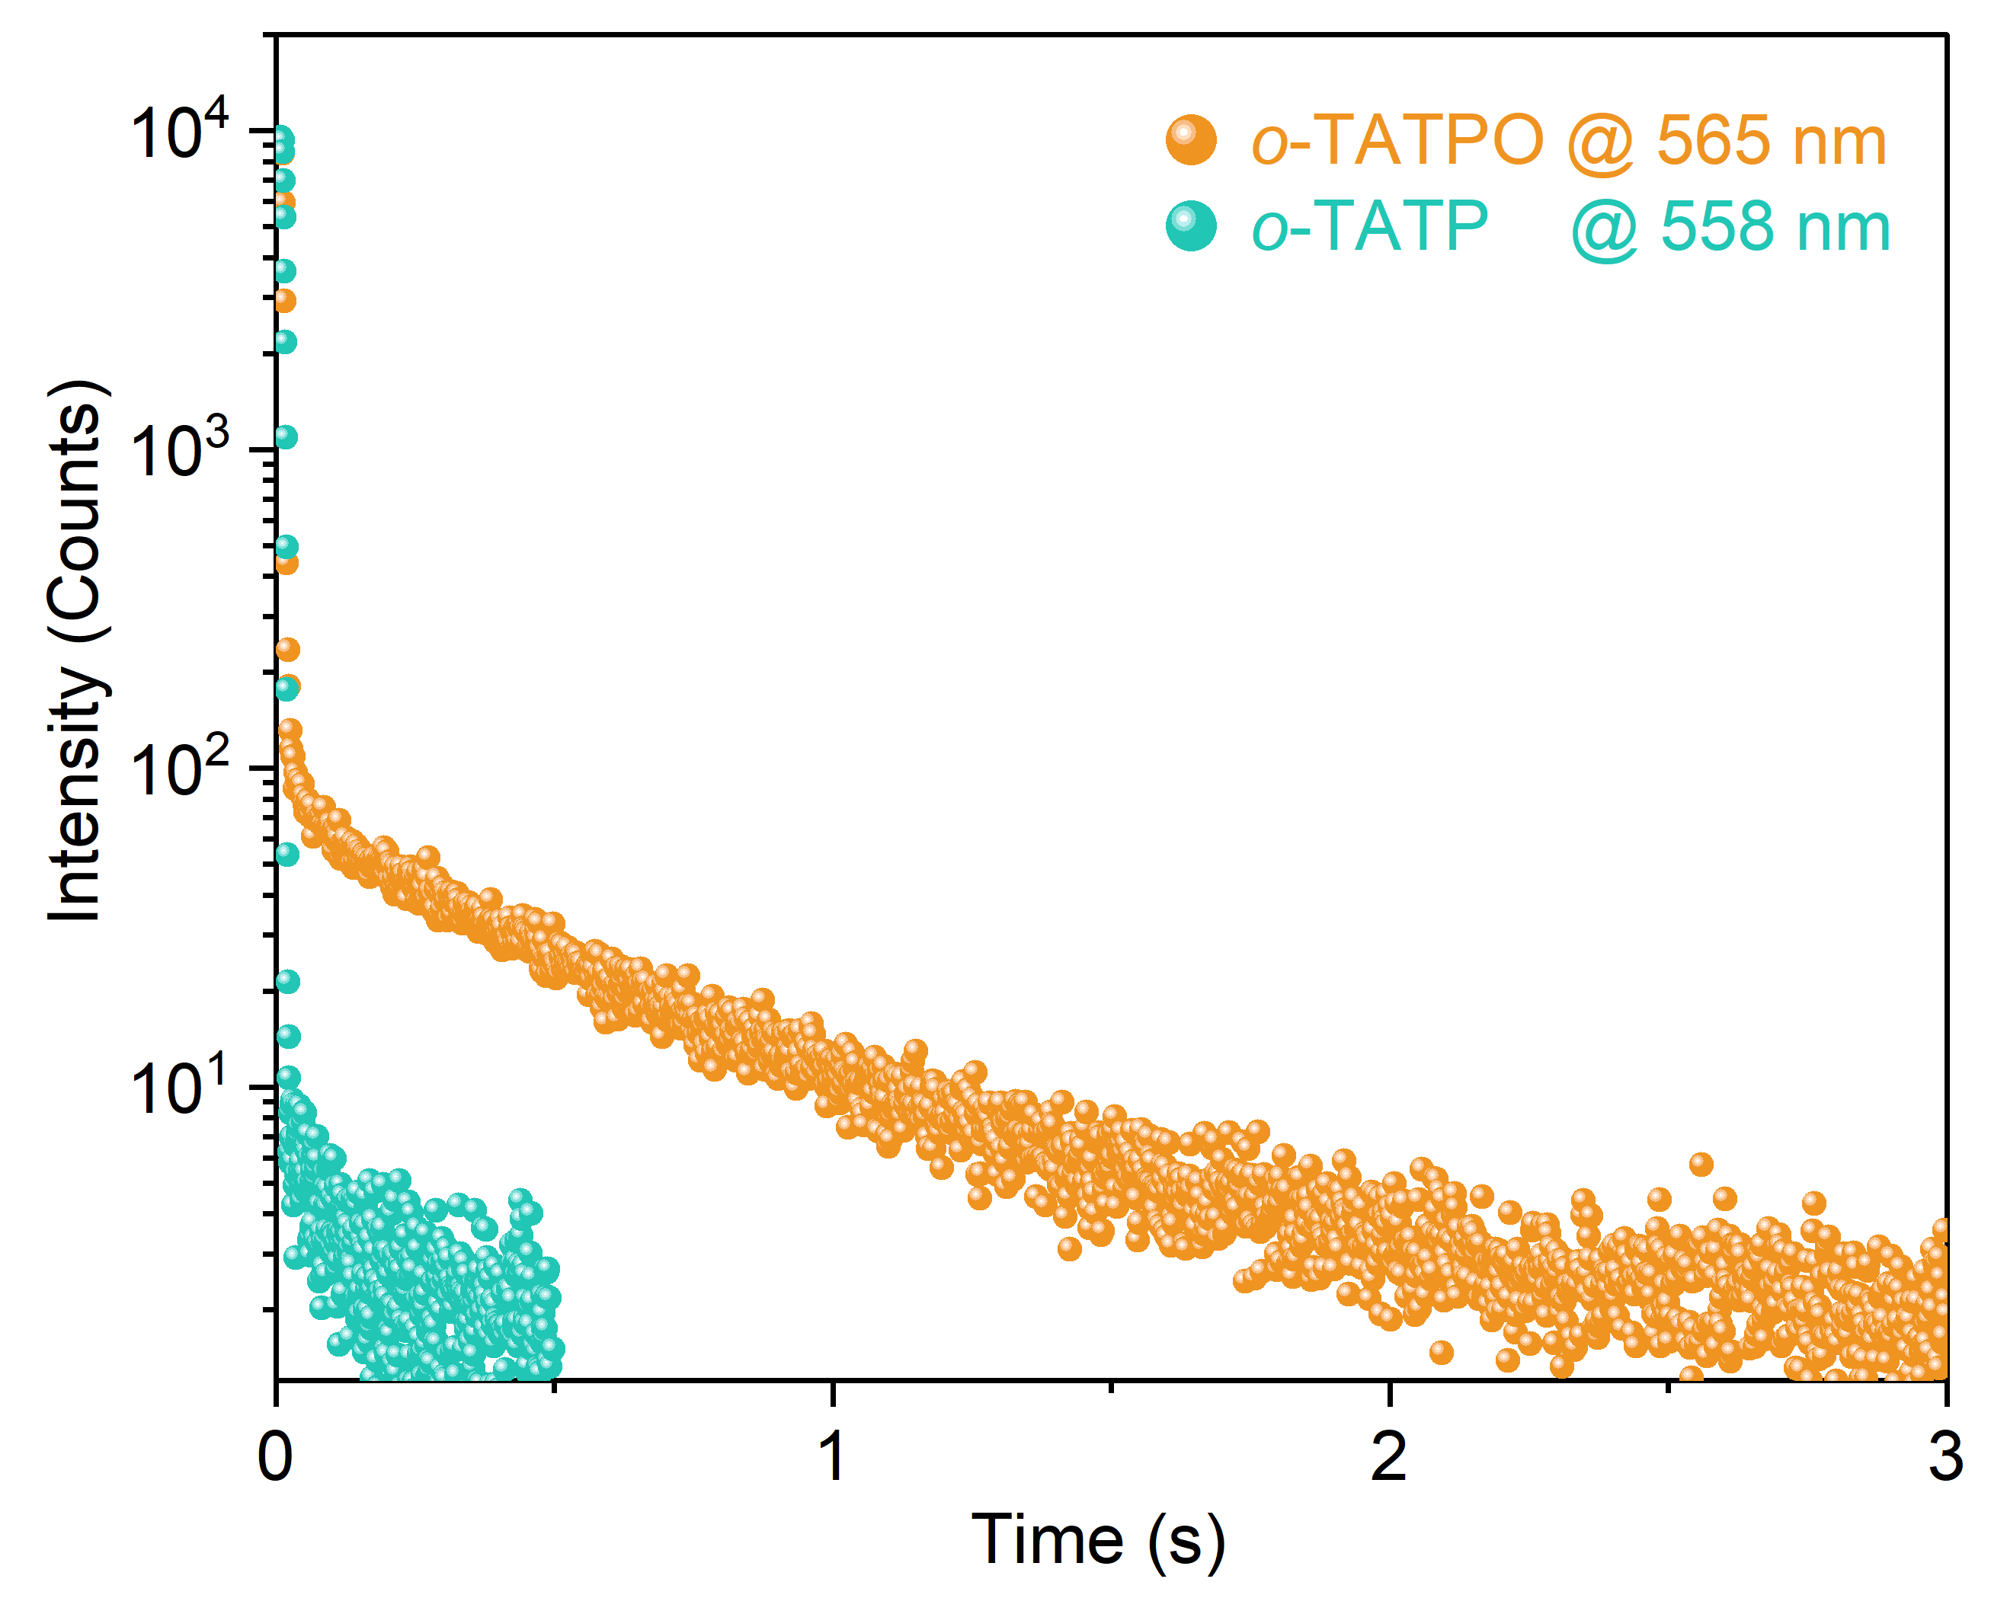
Figure S3. Time-resolved decay curves of o-TATPO and o-TATP
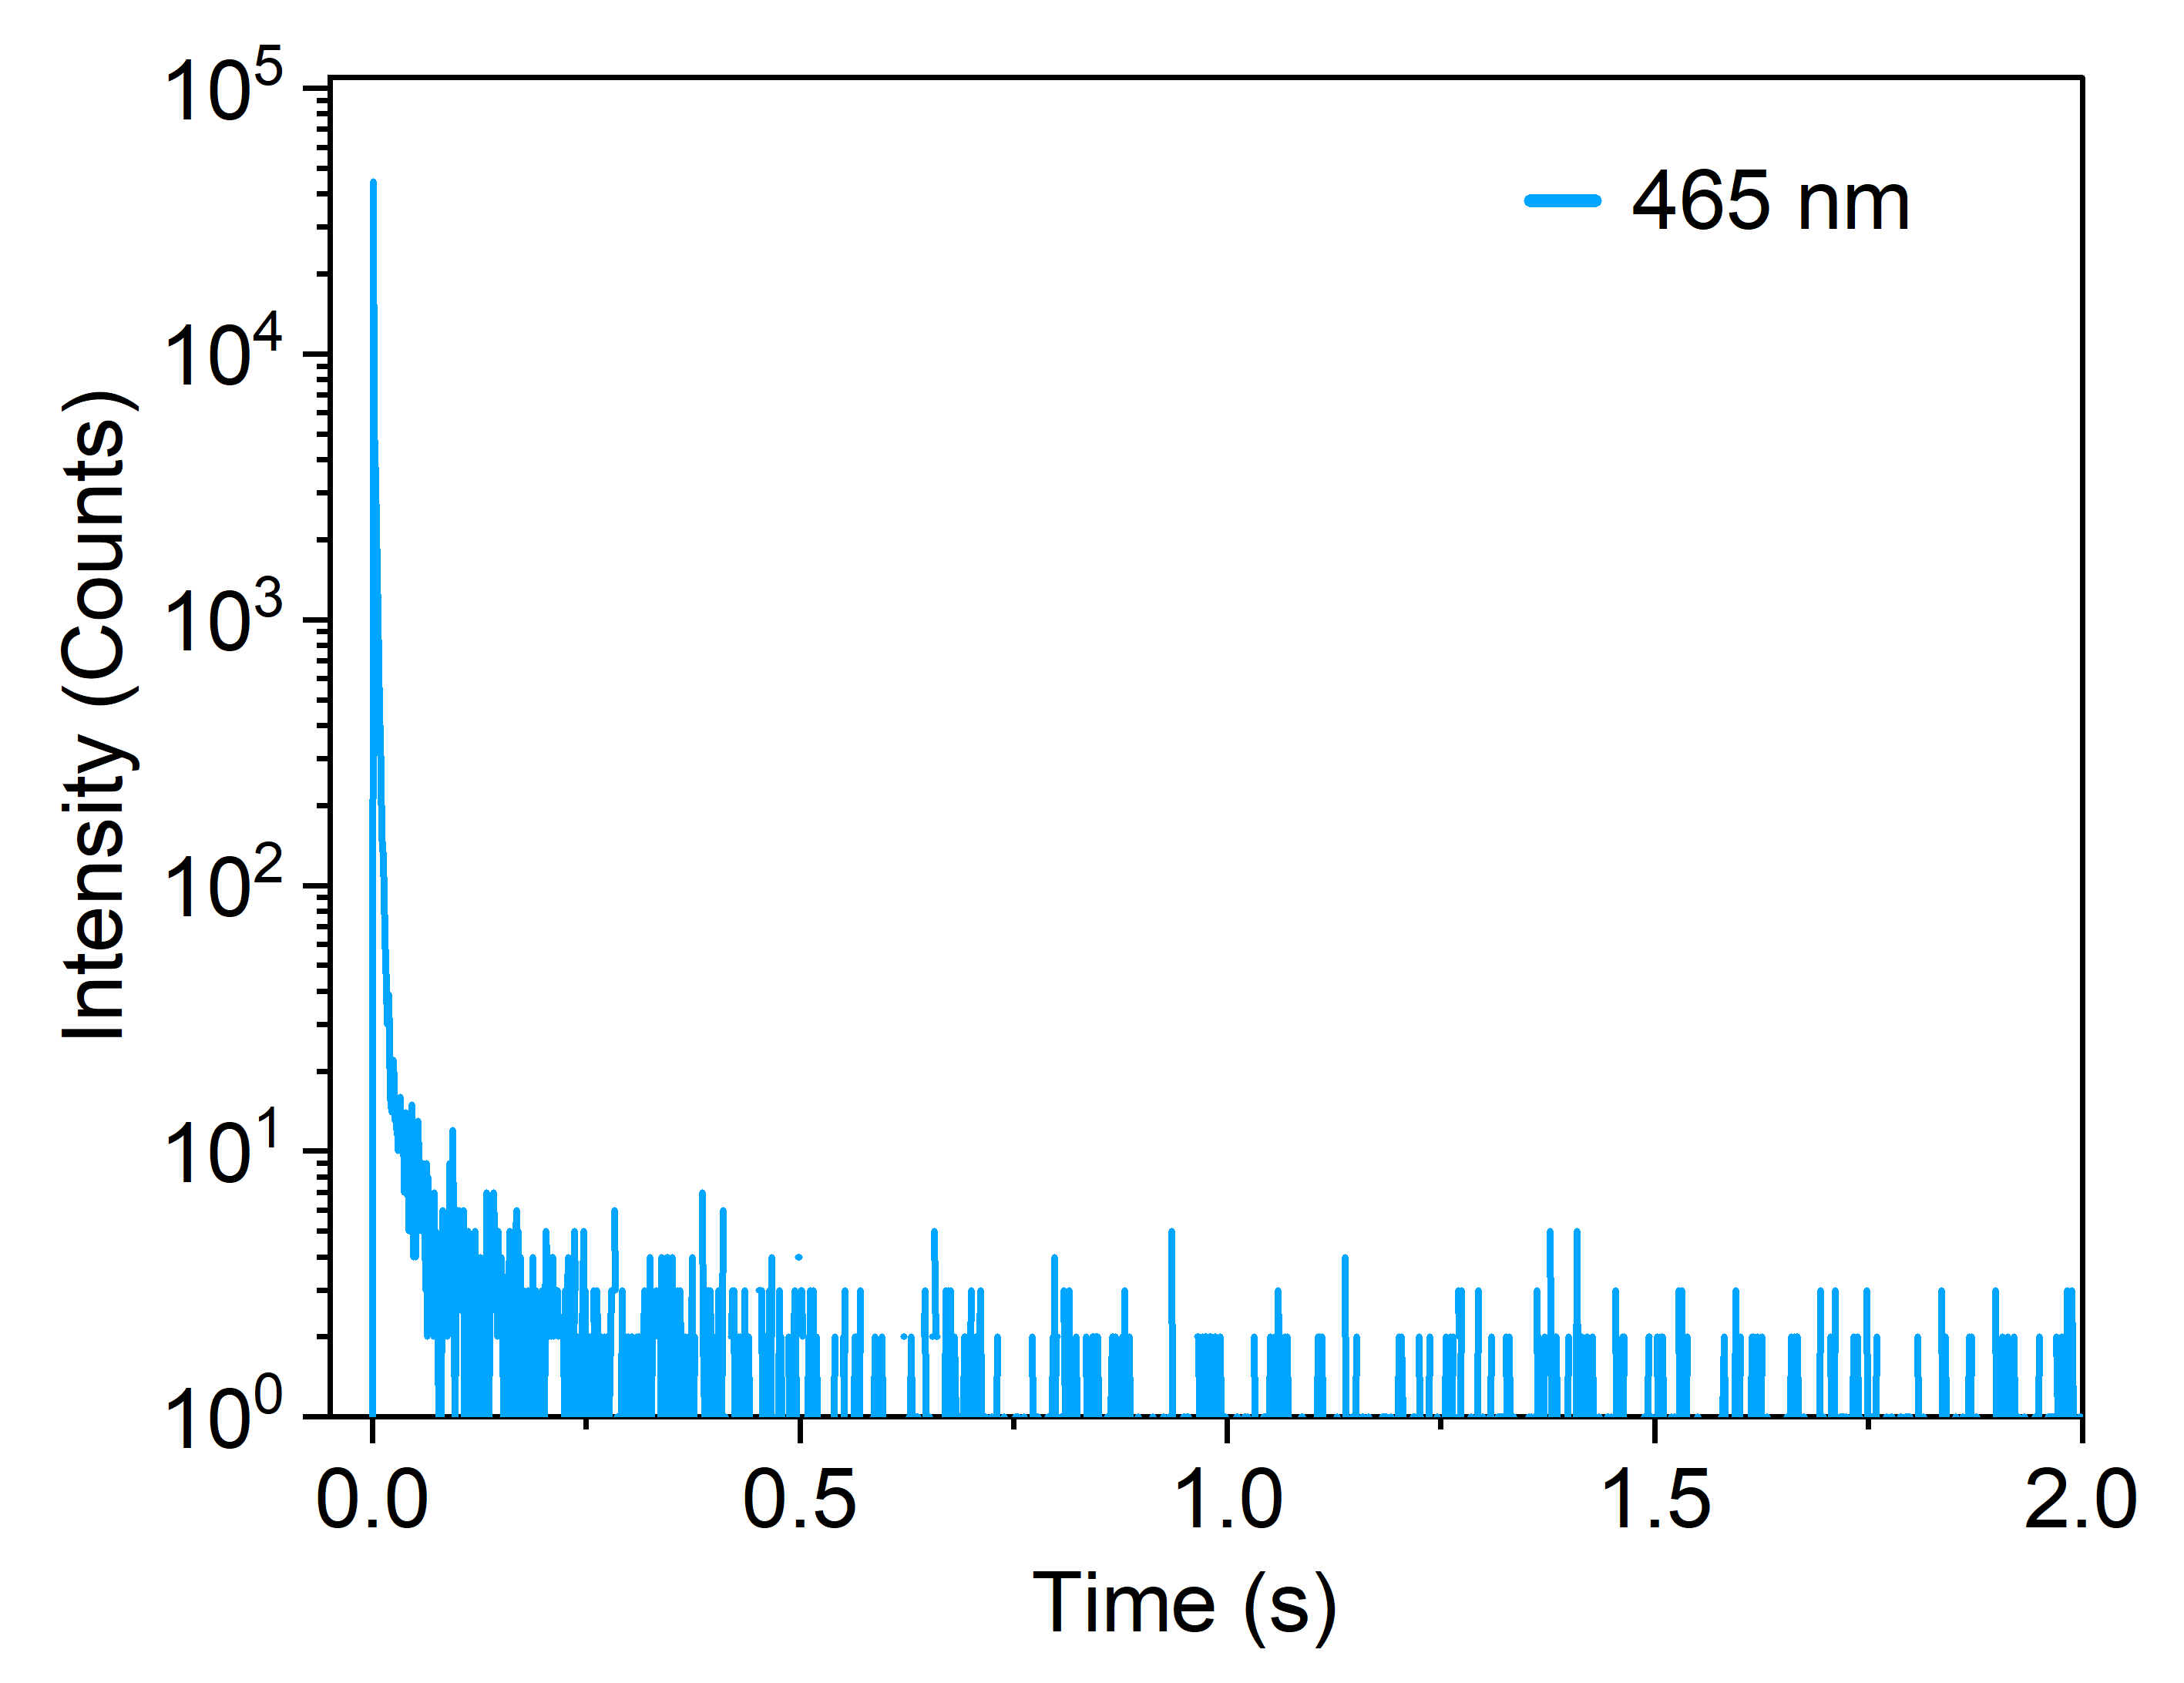
Figure S4. Time-resolved decay curves of o-TATPO at 465 nm excited at 365 nm.
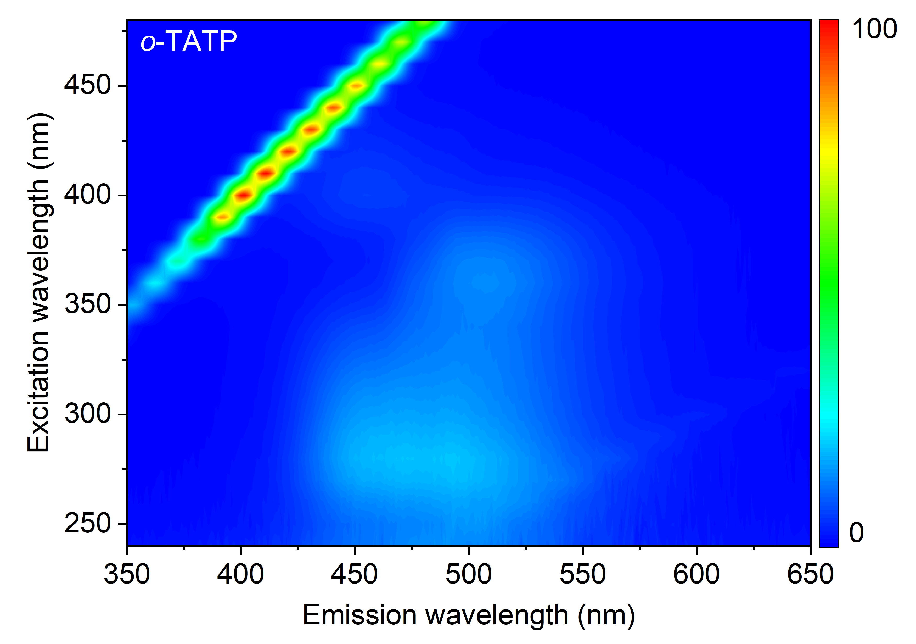
Figure S5. Excitation-delayed emission mapping of o-TATP under ambient conditions.
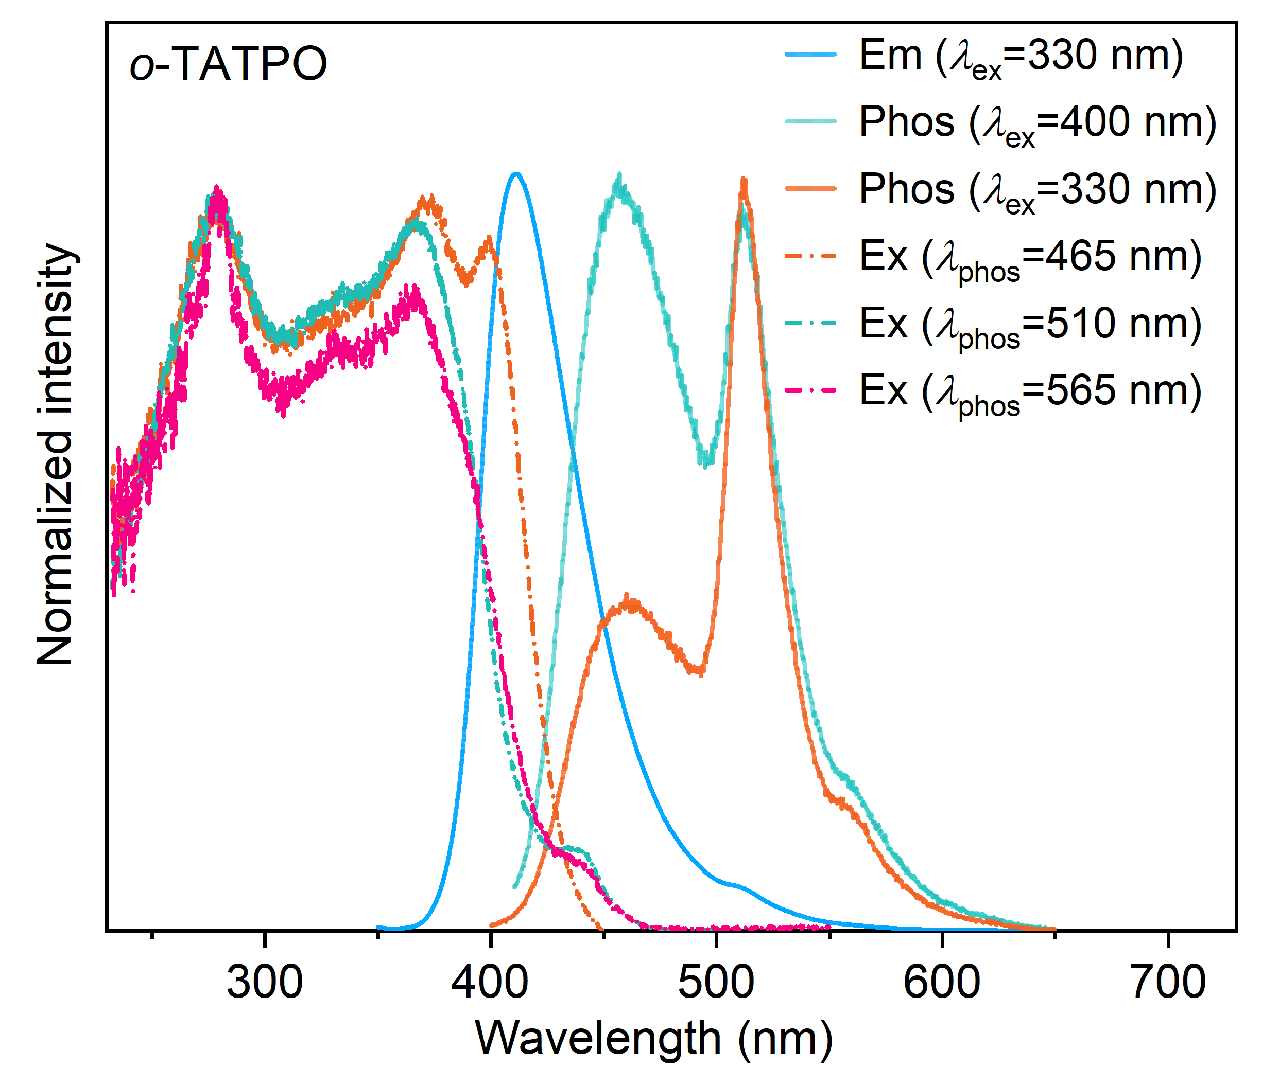
Figure S6. Normalized fluorescence, phosphorescence, and excitation spectra of o-TATPO.
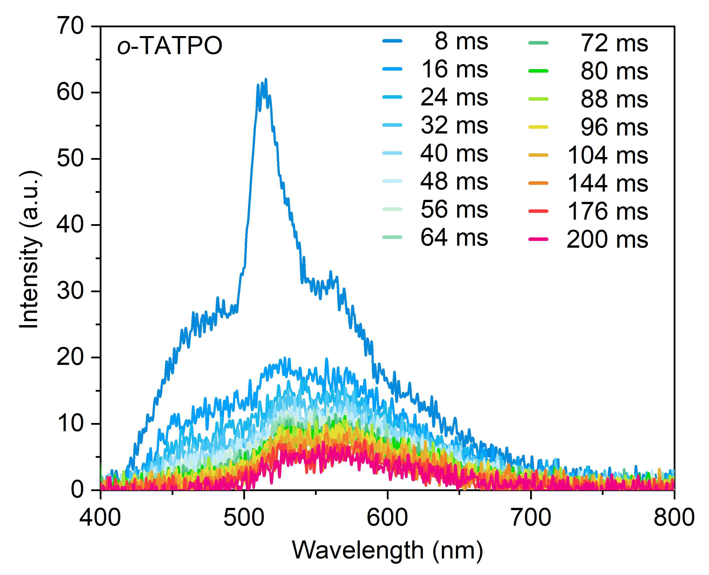
Figure S7. Delayed spectra of o-TATPO
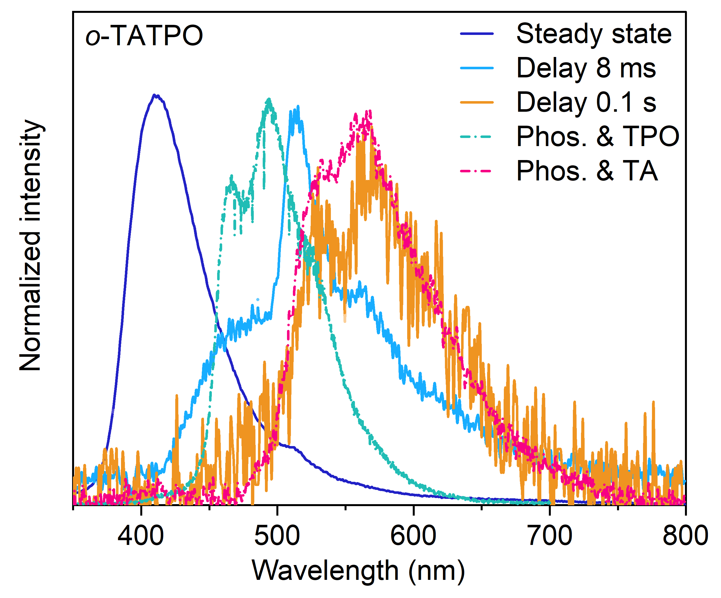
Figure S8. Delayed spectra of the crystalline powders of o-TATPO, TA, and TPO.
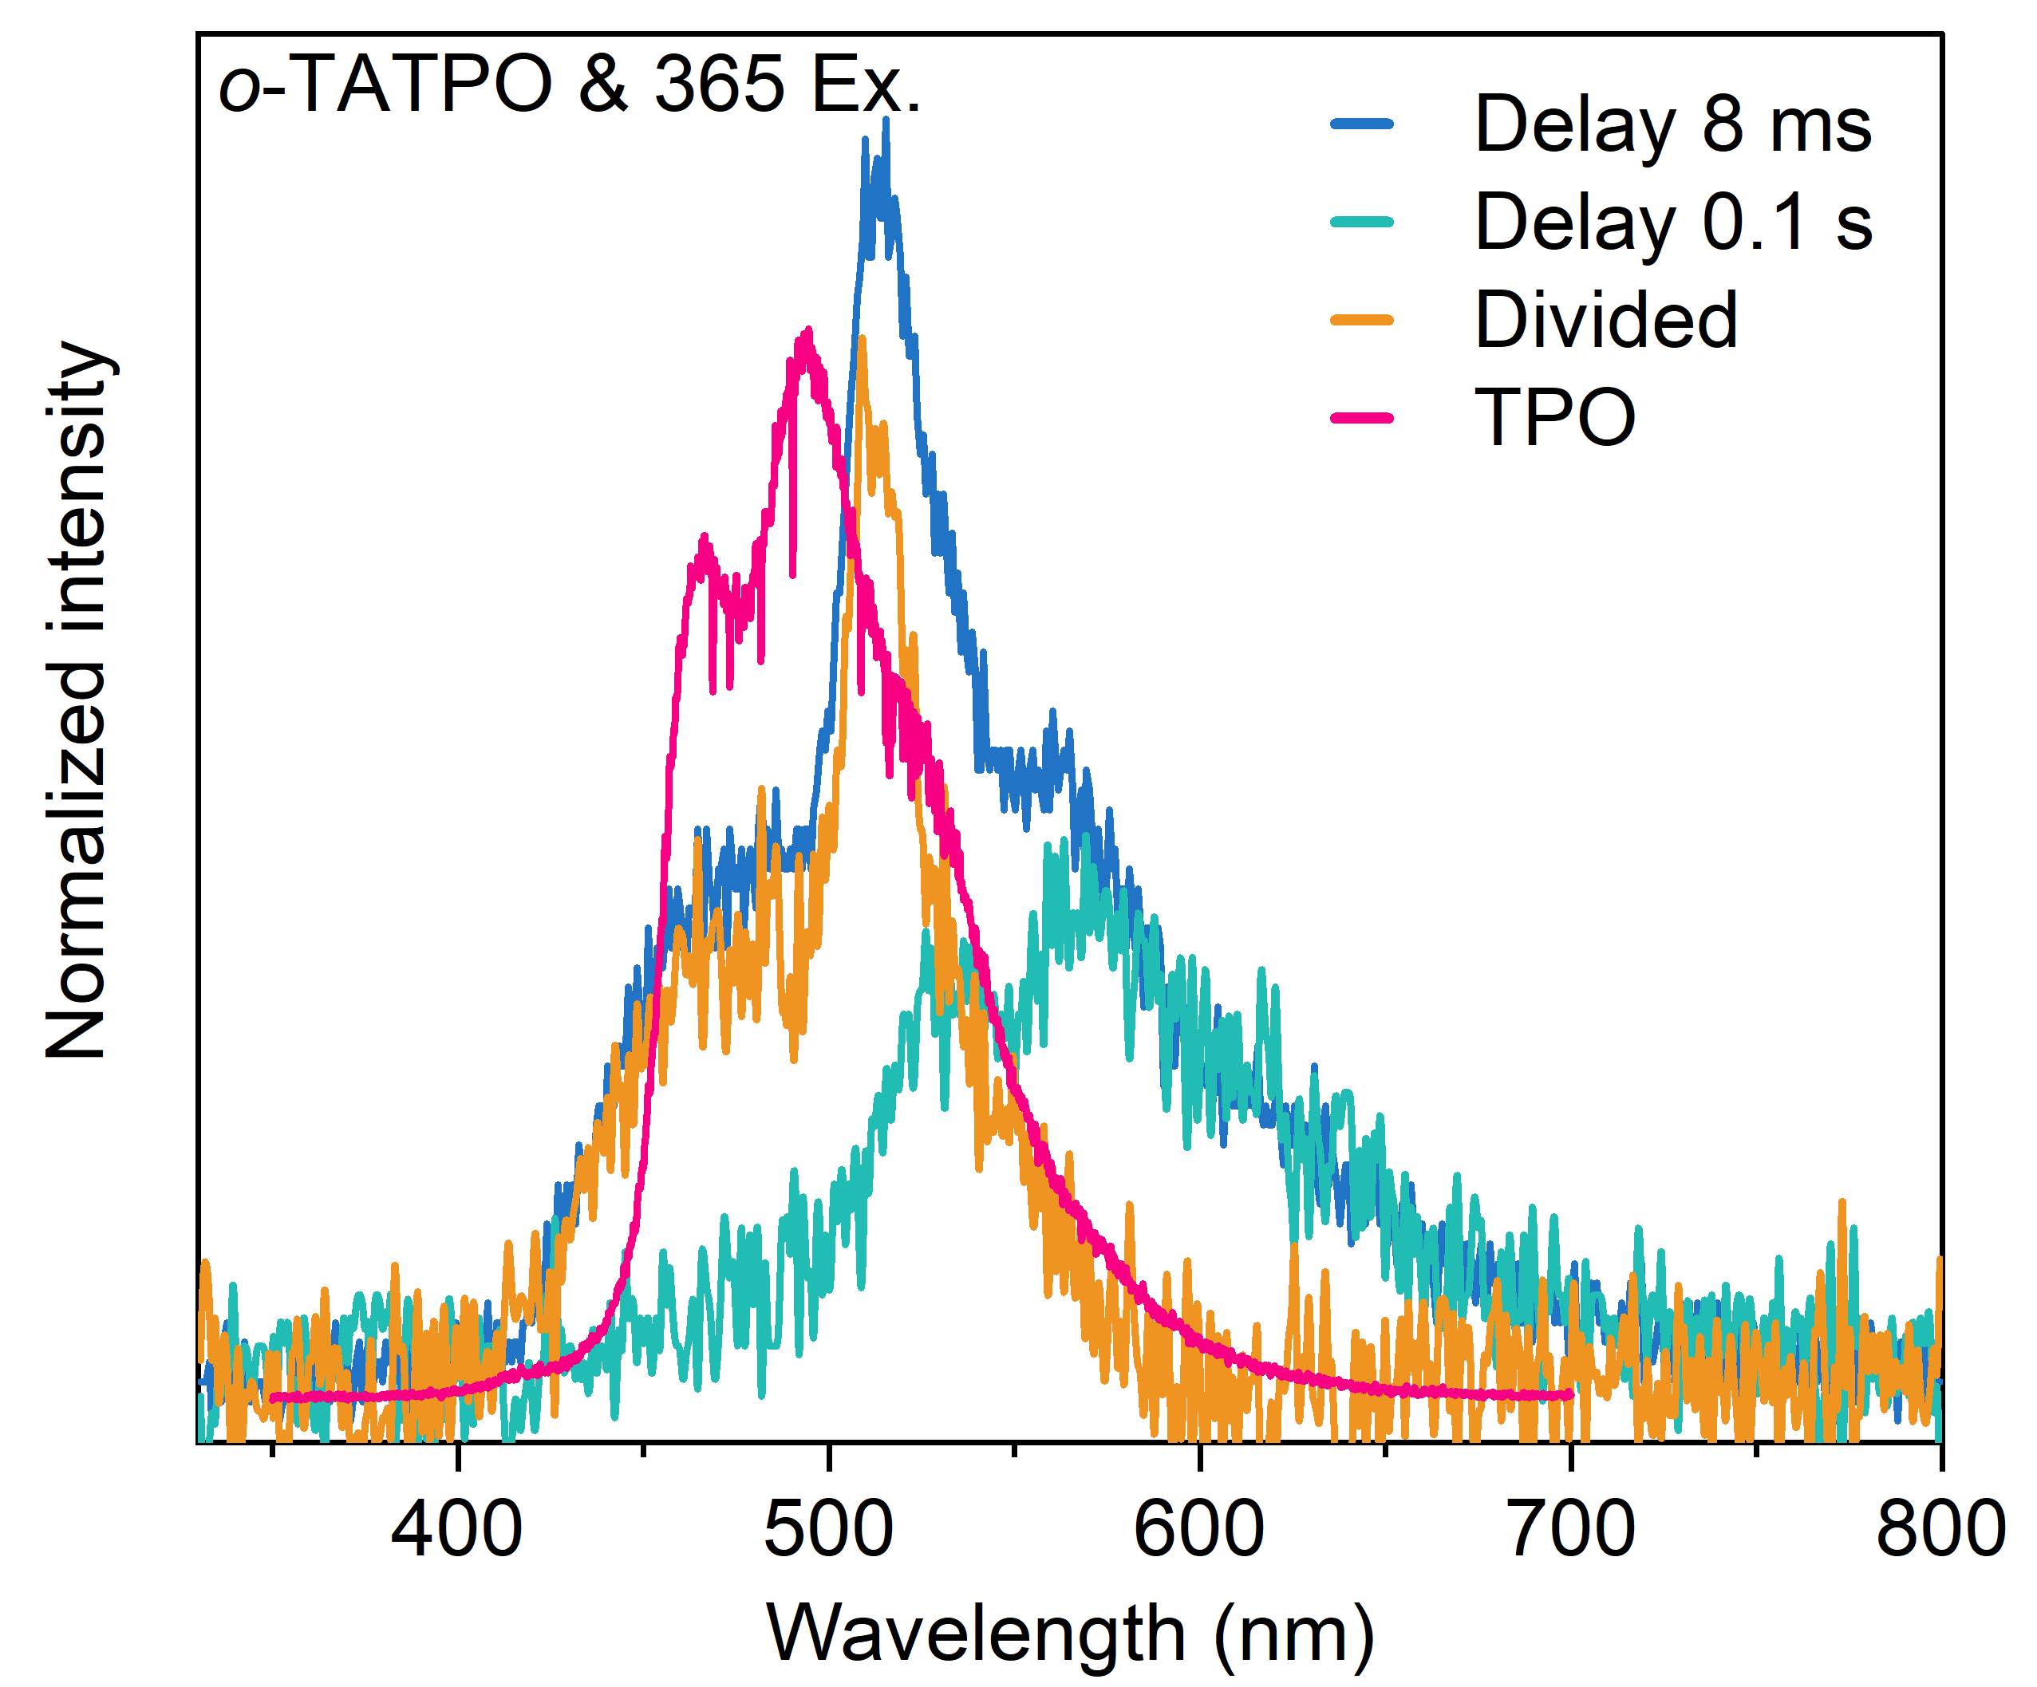
Figure S9. Delayed spectra of o-TATPO excited at 365 nm and the corresponding divided spectrum.
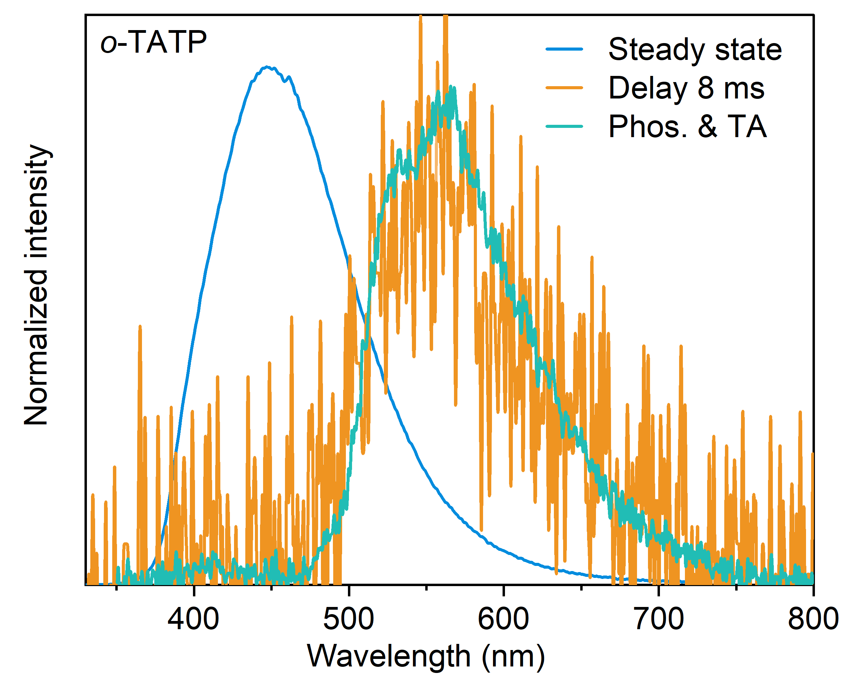
Figure S10. Delayed spectra of the crystalline powders of o-TATP and TA.
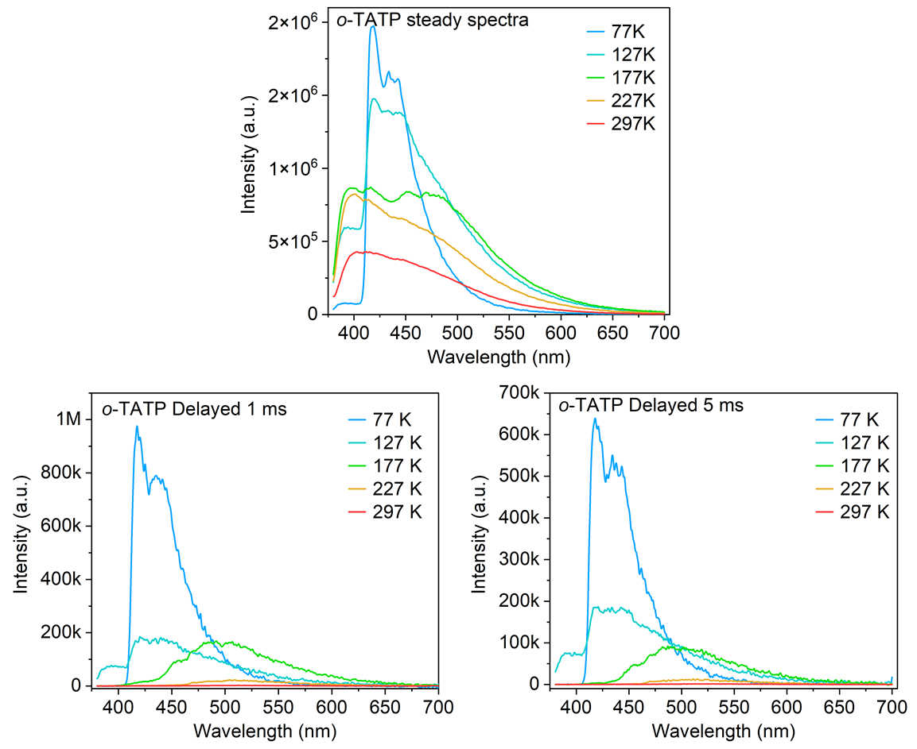
Figure S11. Variable-temperature steady-state and delayed spectra for crystalline o-TATP.
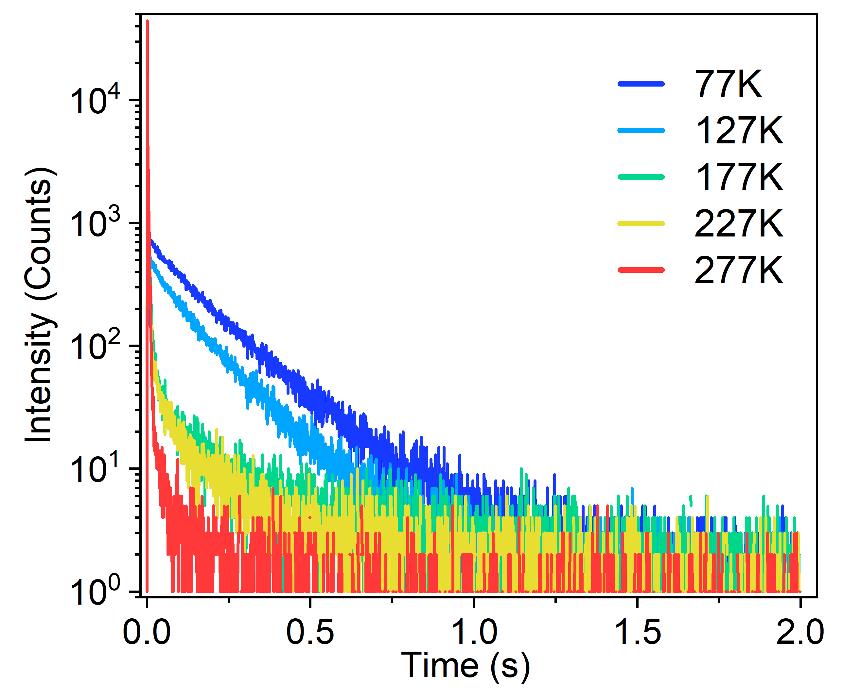
Figure S12. Variable-temperature time-resolved decay curves of o-TATPO at 465 nm.
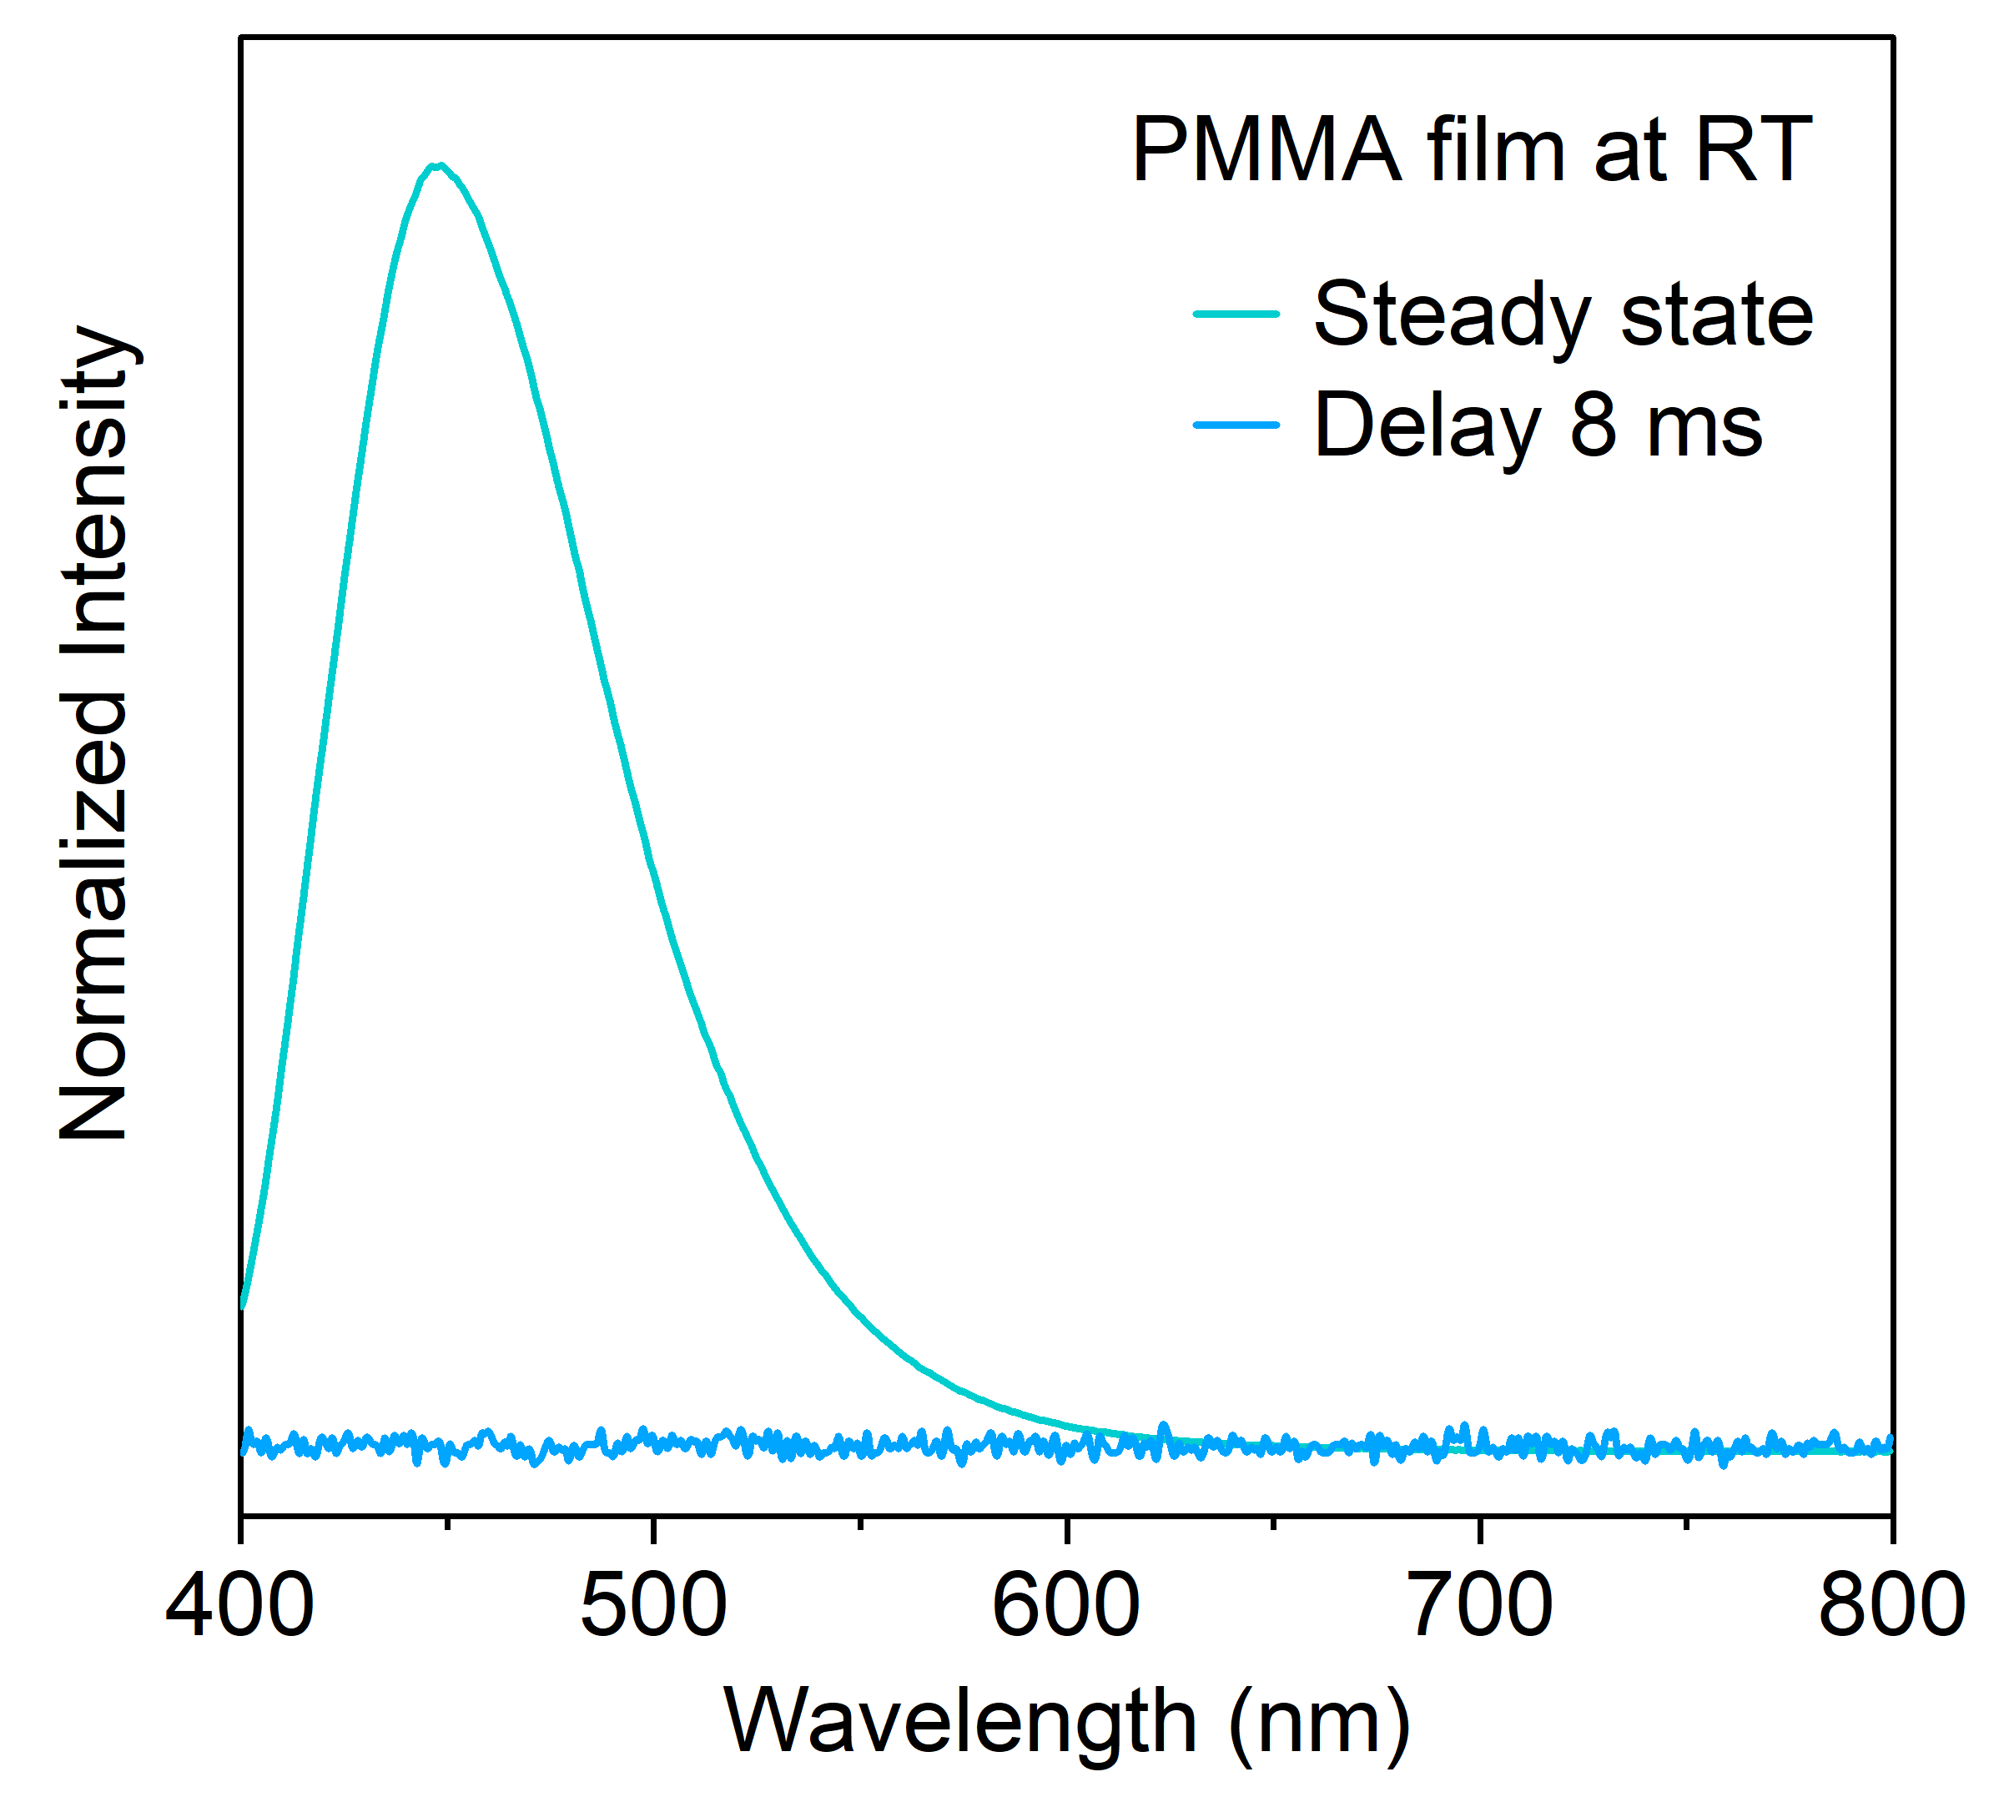
Figure S13. Steady-state and delayed spectra of o-TATPO in PMMA film at room temperature.
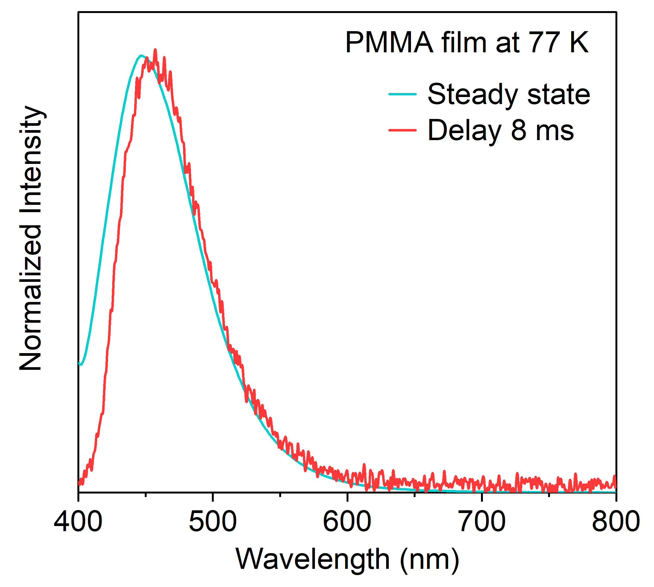
Figure S14. Steady-state and delayed spectra of o-TATPO in PMMA film at 77 K.
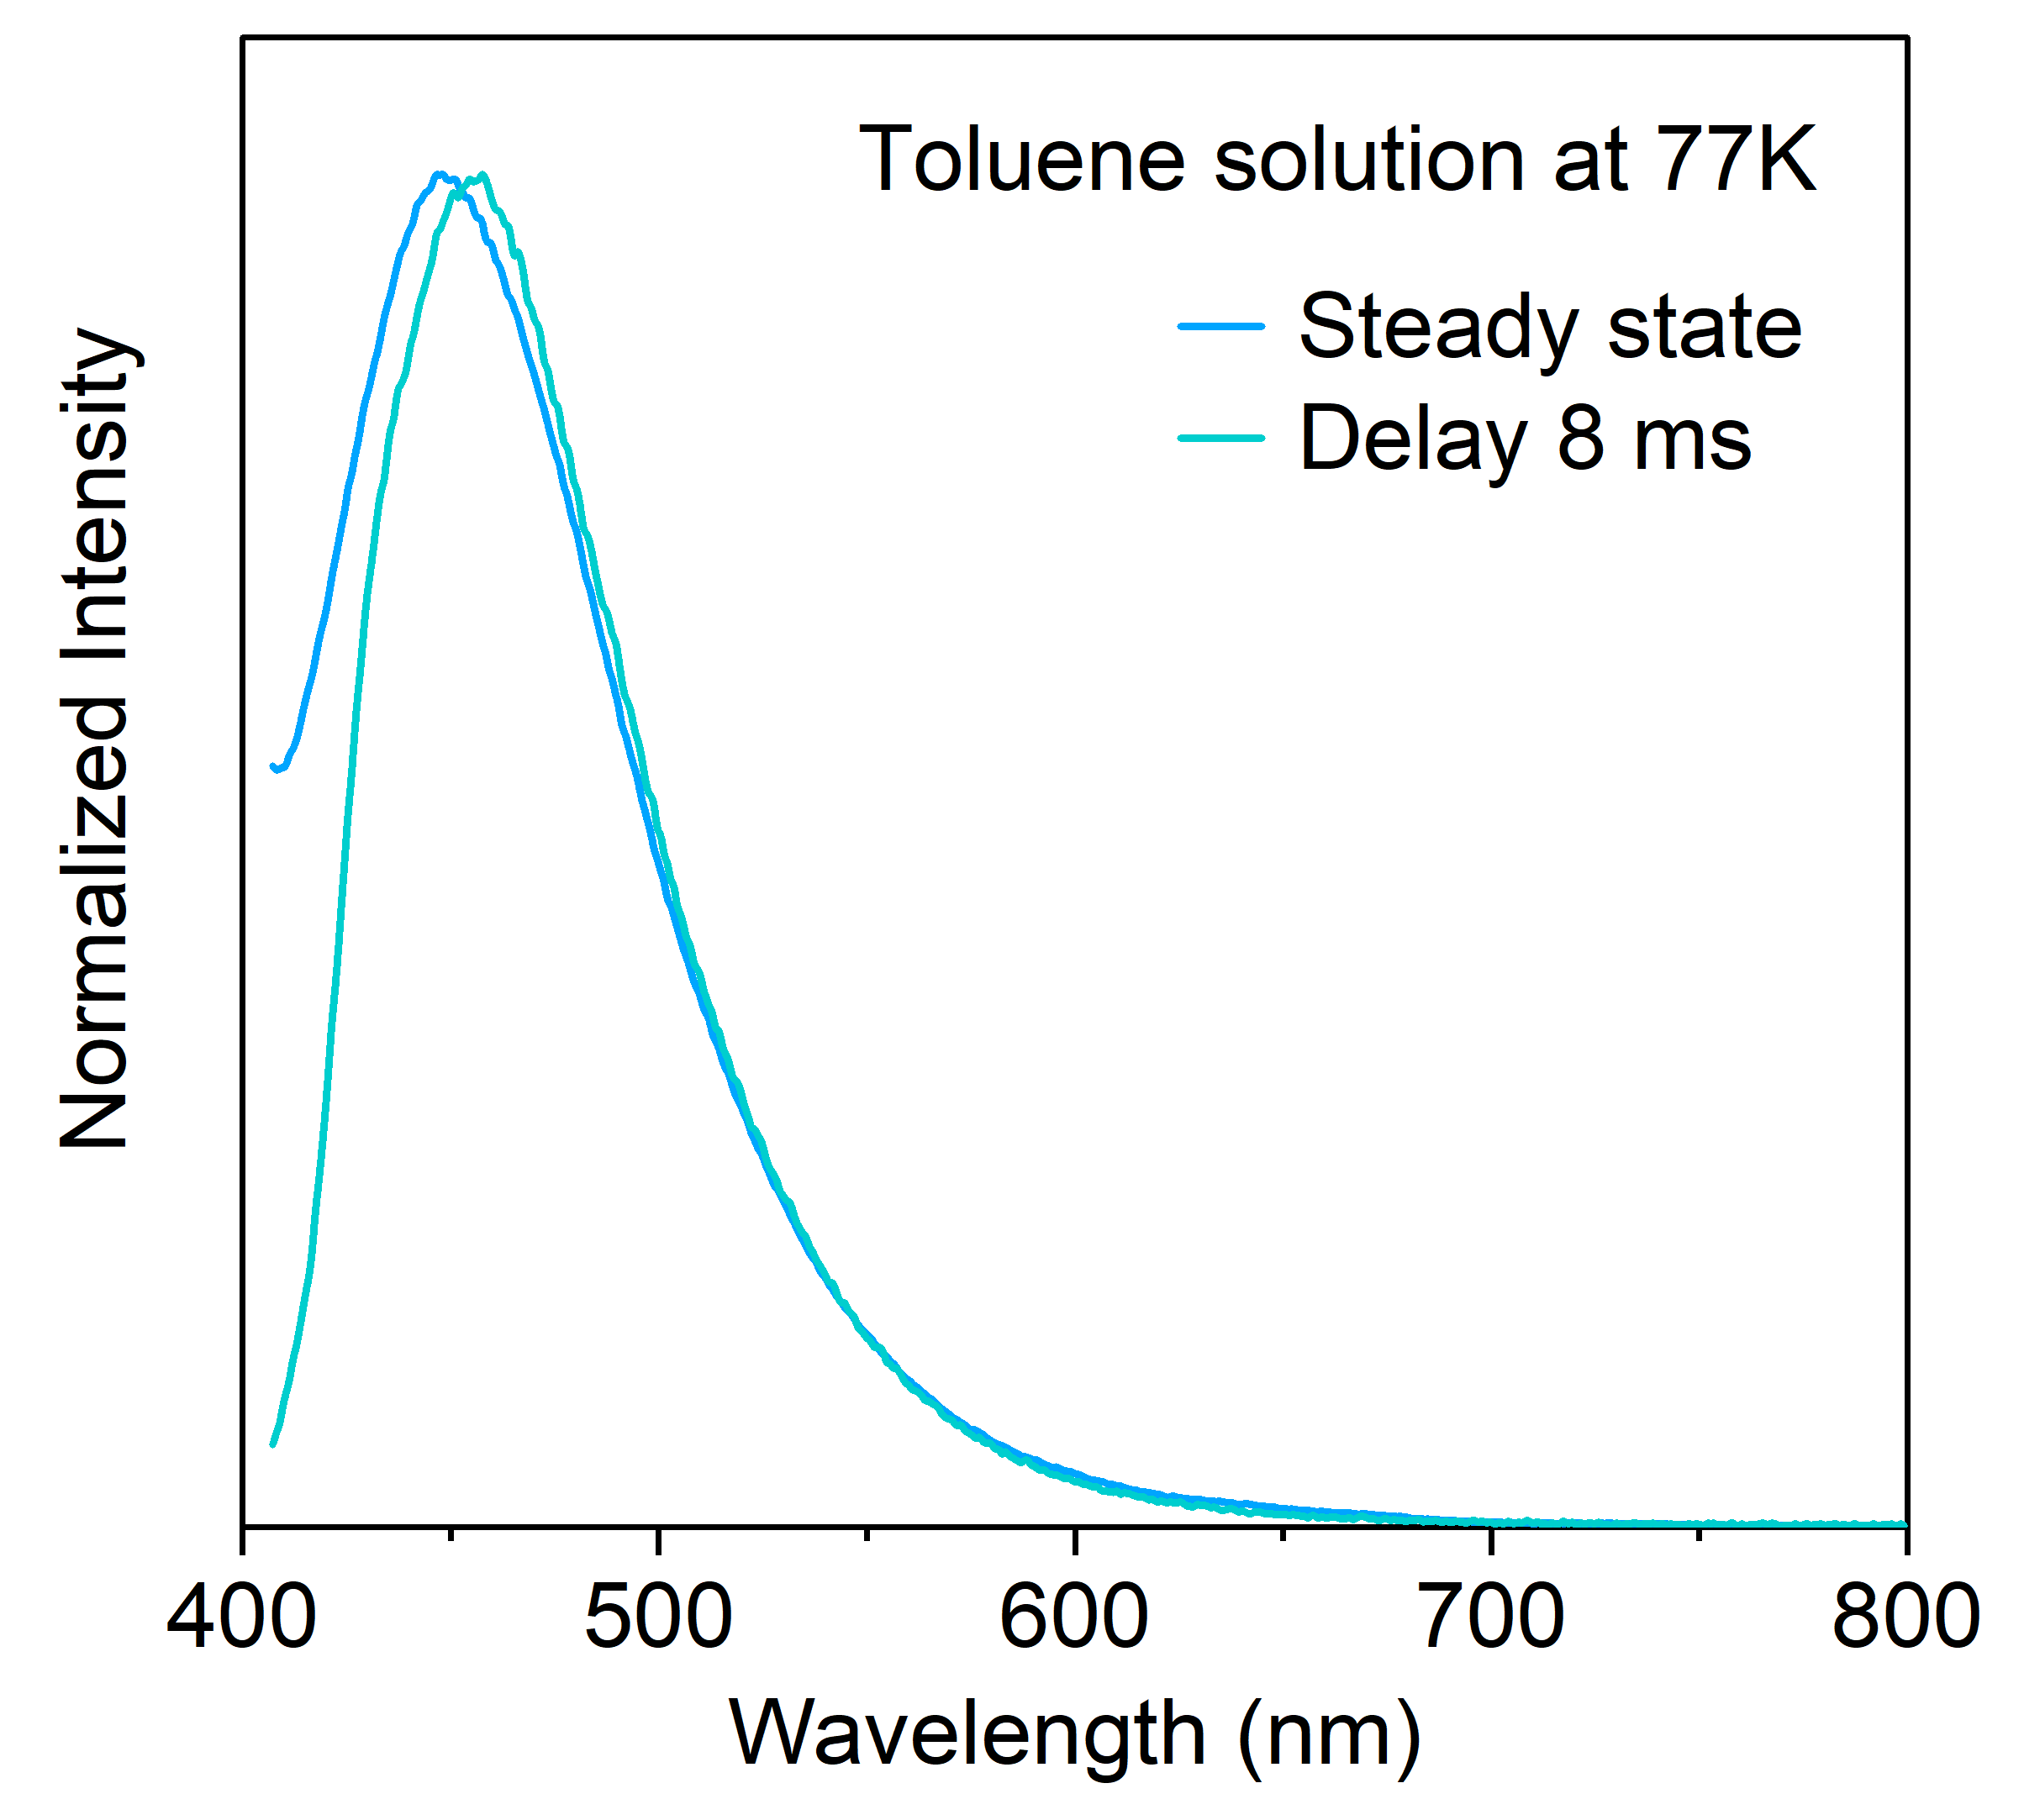
Figure S15. Steady-state and delayed spectra of o-TATPO in toluene solution (1×10^⁻⁵ mol/L) at 77 K.
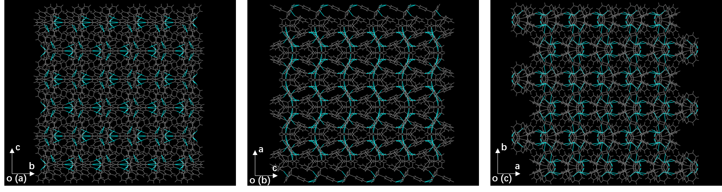
Figure S16. Packing patterns in the single crystals of o-TATPO.
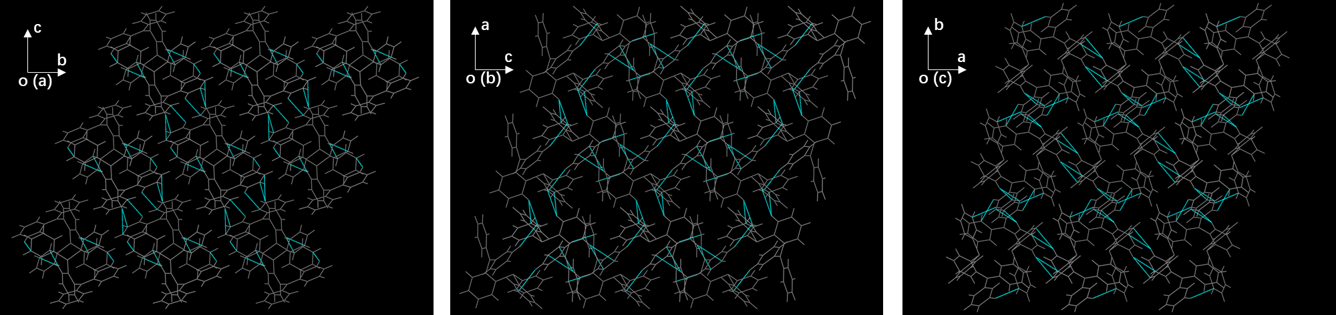
Figure S17. Packing patterns in the single crystals of o-TATP.
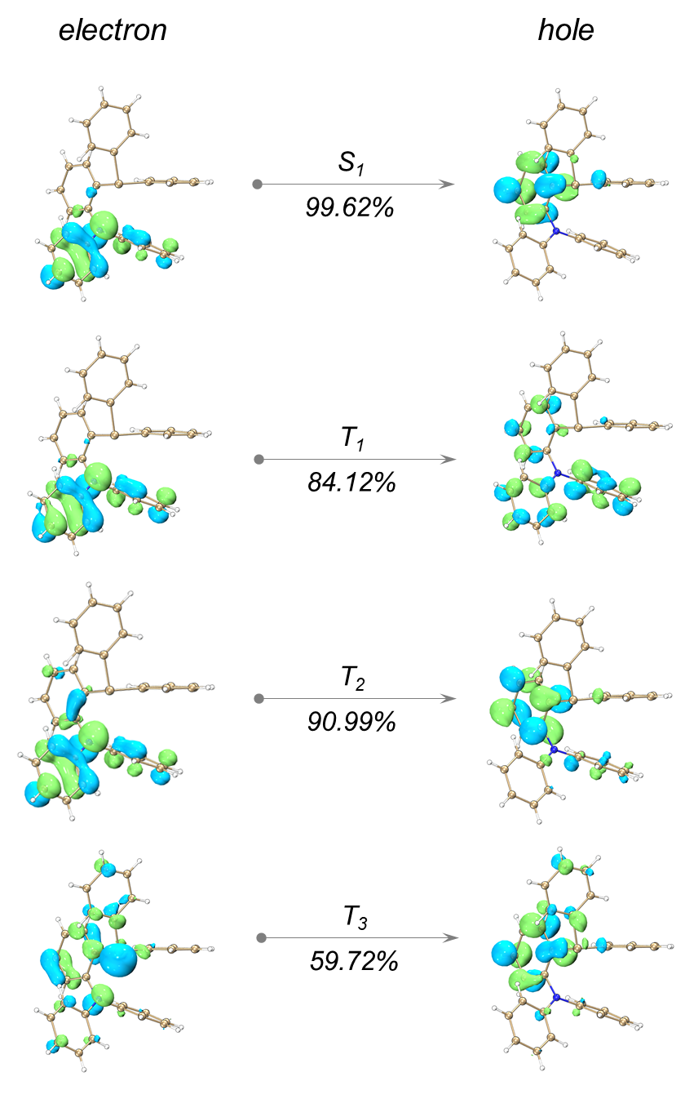
Figure S18. Natural transition orbitals of o-TATP.
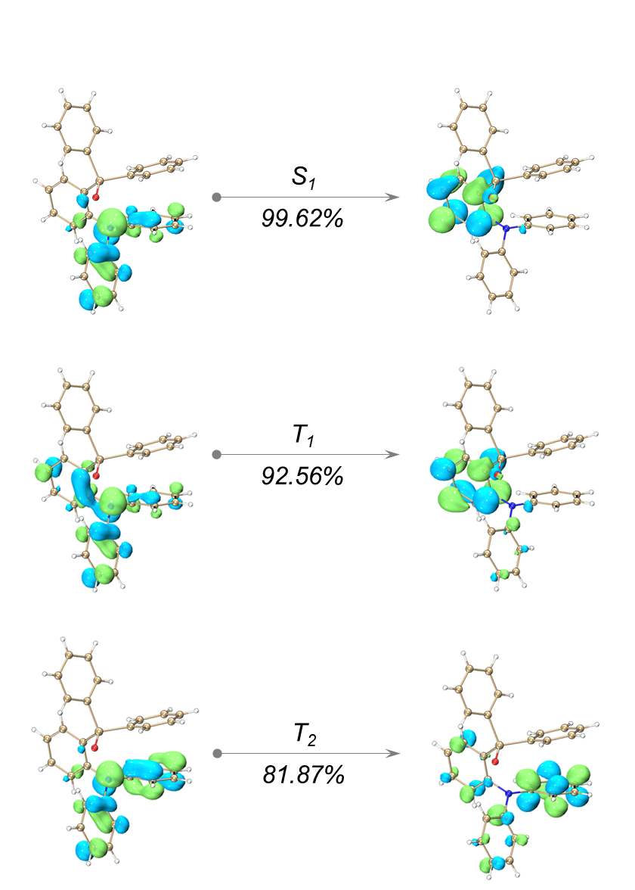
Figure S19. Natural transition orbitals of o-TATPO.
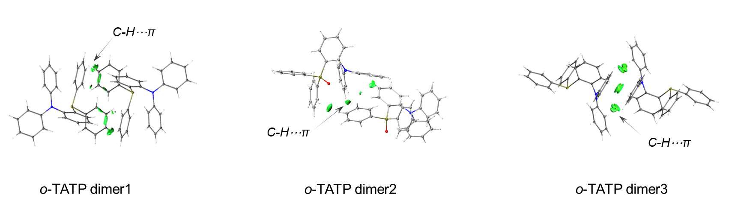
Figure S20. IGM isosurface maps in dimers of o-TATP with an isovalue of 0.1.
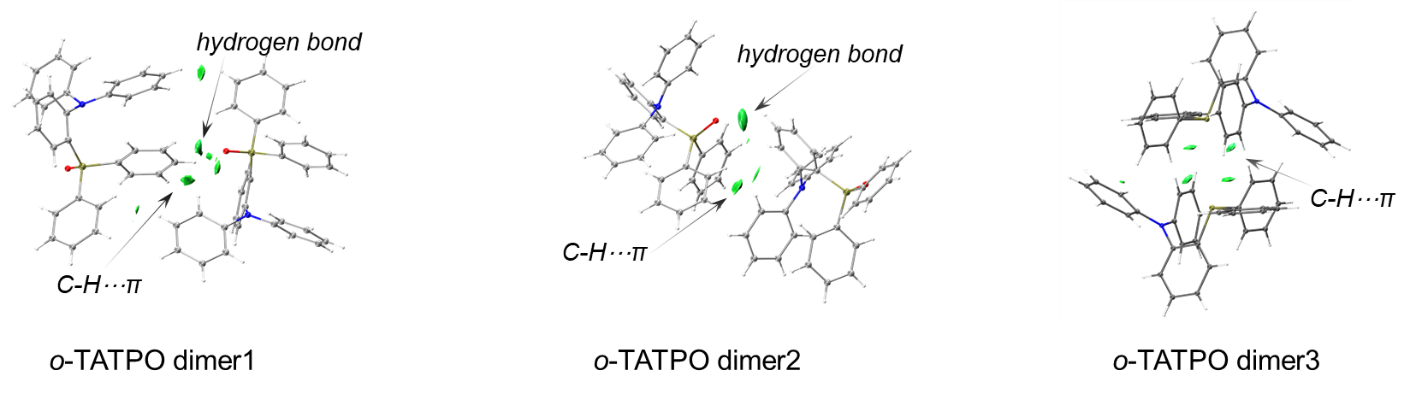
Figure S21. IGM isosurface maps in dimers of o-TATPO with an isovalue of 0.1.
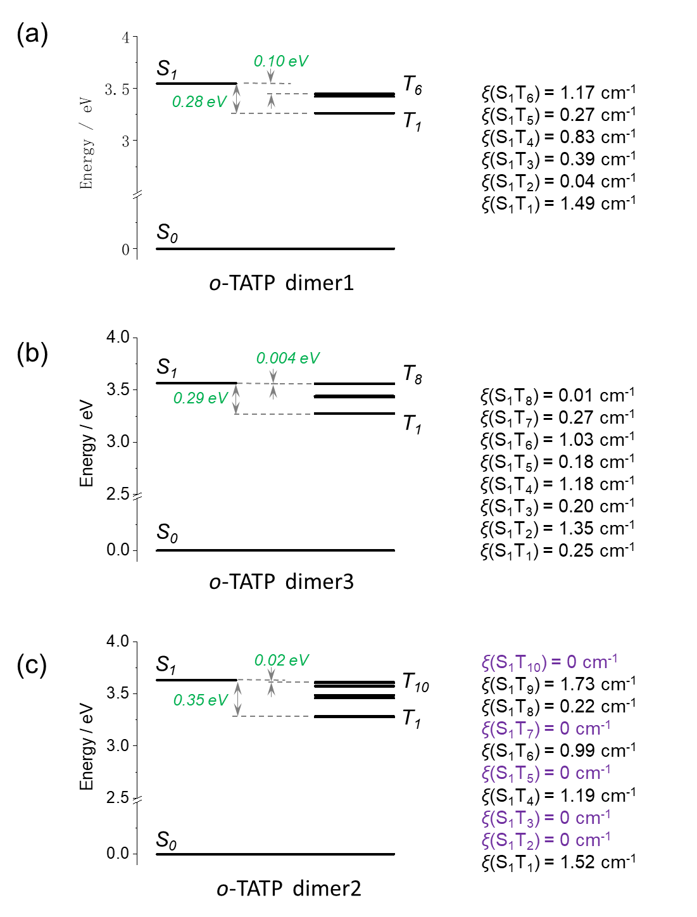
Figure S22. SOC matrix of the o-TATP dimers.
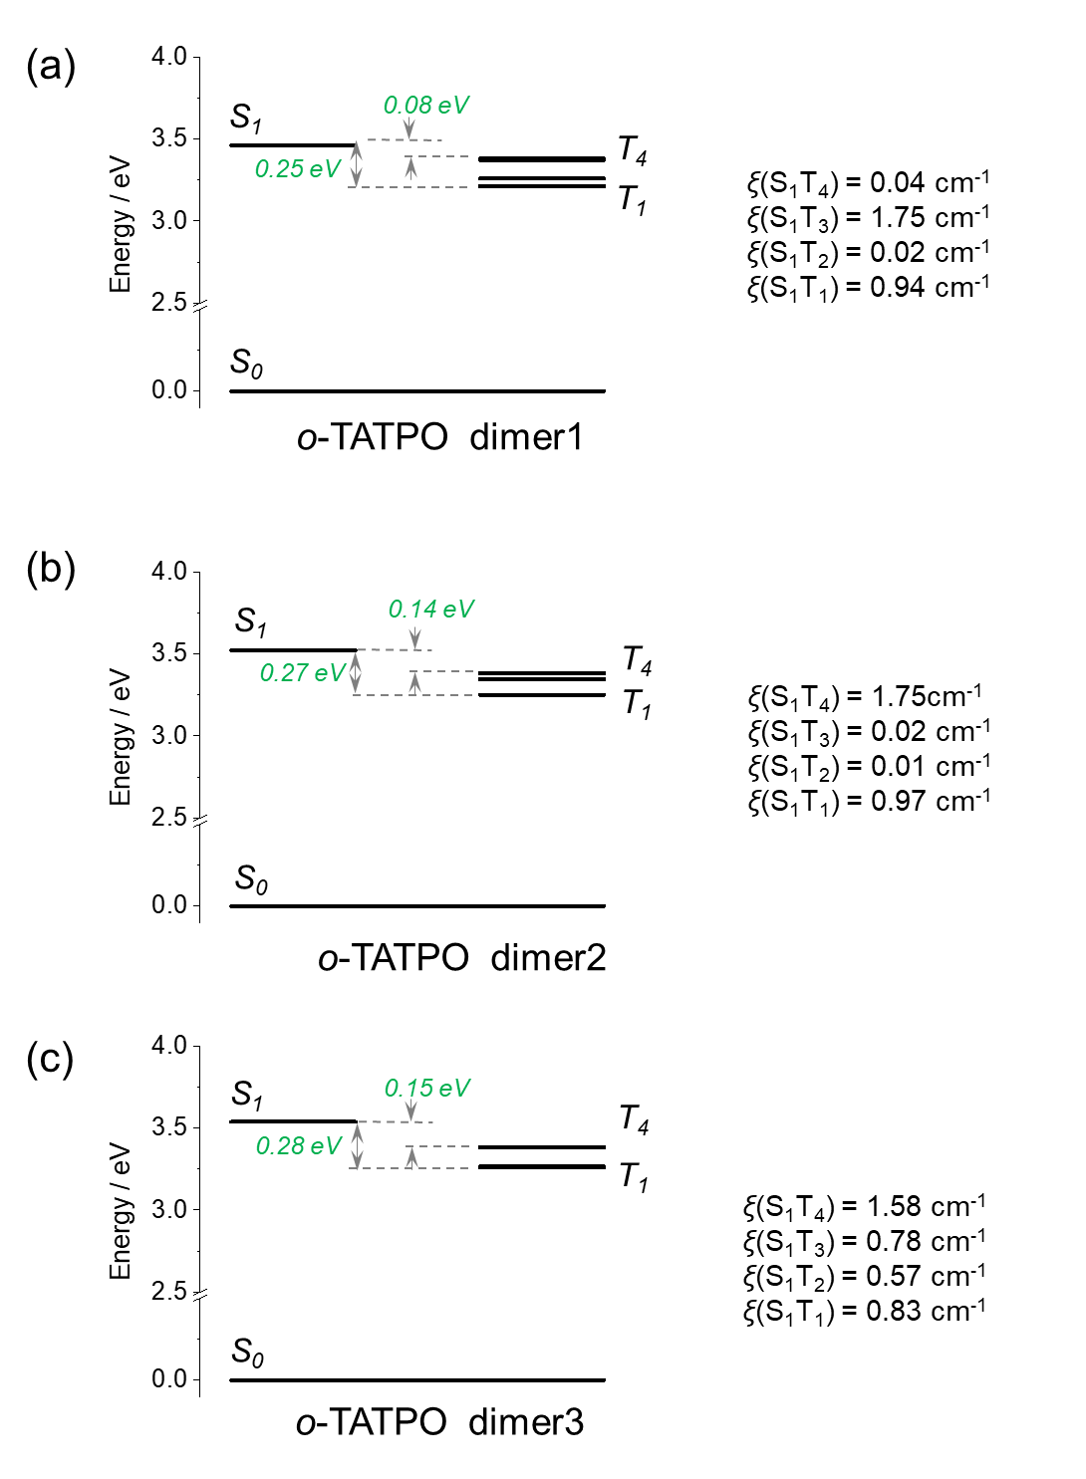
Figure S23. SOC matrix of the o-TATPO dimers.
Table S1. Photophysical properties of crystalline powders for o-TATP and o-TATPO.
Sample | Space group | Φ_{PL} (%) | Fluo. |  | Phos. |  | ML
Sample | Space group | Φ_{PL} (%) | λ_{F} (nm) | τ_{F} (ns) | λ_{P} (nm) | τ_{P} (ms) |  | λ_{ML} (nm)
o-TATP | P-1 | 2.0 | 448 | 4.7 | 558 | 76.80 | Inactive | -
o-TATPO | Pbca | 5.4 | 410 | 8.8 | 465; 565 | 23.24 (465 nm)  471.75 (565 nm) | Active | 450; 565
Table S2. Calculated dipole moment of o-TATP and o-TATPO based on single crystal structures.
 | o-TATP |  |  |  | o-TATPO
 | Monomer | Dimer 1 | Dimer 2 | Dimer 3 | Monomer | Dimer 1 | Dimer 2 | Dimer 3
Dipole moment  (Debye) | 2.4603 | 0.0005 | 0.0005 | 0.0000 | 4.5158 | 6.6645 | 7.6995 | 7.9552

Single crystal data
Table S3. Crystal data and structure refinement for single crystal of o-TATPO.
Formula | C₃₀H₂₄NOP | μ/mm⁻¹ | 1.230
Formula weight | 445.47 | F(000) | 1872.0
Temperature/K | 153.0 | Crystal size/mm³ | 0.5 × 0.2 × 0.1
Crystal system | orthorhombic | Radiation | CuKα (l = 1.54184)
Space group | Pbca | Reflections collected | 60551
a/Å | 16.0526(6) | Data/restraints/parameters | 4171/0/298
b/Å | 16.6684(6) | D_{x}/g cm⁻³ | 1.287
c/Å | 17.1822(7) | Unique (R_{int}) | 0.1065
α/° | 90 | Goodness-of-fit on F² | 1.092
β/° | 90 | R₁,^{[a]} wR₂^{[b]} [I≥2σ (I)] | R₁ = 0.0472, wR₂ = 0.1370
γ/° | 90 | R₁, wR₂ [all data] | R₁ = 0.0776, wR₂ = 0.1783
Volume/Å³ | 4597.5(3)
ρ_{calc}/g cm⁻³ | 1.287
ª R₁ = Σ⎥⎥F_{o}⎥ -⎥Fc⎥⎥/Σ⎥F_{o}⎥. ^{b} wR₂ = [Σ[w(F_{o}² - F_{c}²)²]/Σw(F_{o}²)²]^{1/2}, where w = 1/[²(F_{o})² + (aP)² + bP] and P = (F_{o}² + 2F_{c}²)/3.
Table S4. Bond lengths for single crystal of o-TATPO.
Atom | Atom | Length/Å | Atom | Atom | Length/Å
P1 | O1 | 1.4885(17) | C26 | C27 | 1.387(4)
P1 | C25 | 1.793(2) | C30 | C29 | 1.391(4)
P1 | C19 | 1.813(2) | C8 | C9 | 1.389(4)
P1 | C18 | 1.816(2) | C6 | C5 | 1.389(3)
N1 | C13 | 1.438(3) | C20 | C21 | 1.383(4)
N1 | C7 | 1.426(3) | C16 | C15 | 1.386(3)
N1 | C1 | 1.432(3) | C14 | C15 | 1.389(3)
C13 | C18 | 1.404(3) | C12 | C11 | 1.383(4)
C13 | C14 | 1.393(3) | C4 | C5 | 1.381(4)
C17 | C18 | 1.404(3) | C4 | C3 | 1.383(4)
C17 | C16 | 1.393(3) | C24 | C23 | 1.384(3)
C25 | C26 | 1.395(3) | C21 | C22 | 1.385(4)
C25 | C30 | 1.393(3) | C9 | C10 | 1.388(4)
C7 | C8 | 1.393(3) | C27 | C28 | 1.378(4)
C7 | C12 | 1.401(3) | C28 | C29 | 1.372(4)
C19 | C20 | 1.398(3) | C10 | C11 | 1.374(4)
C19 | C24 | 1.387(3) | C22 | C23 | 1.376(4)
C1 | C6 | 1.397(3) | C2 | C3 | 1.390(4)
C1 | C2 | 1.388(3)
Table S5. Bond angles for single crystal of o-TATPO.
Atom | Atom | Atom | Angle/˚ | Atom | Atom | Atom | Angle/˚
O1 | P1 | C25 | 113.90(10) | C17 | C18 | P1 | 119.36(17)
O1 | P1 | C19 | 111.06(10) | C17 | C18 | C13 | 118.5(2)
O1 | P1 | C18 | 111.86(10) | C27 | C26 | C25 | 120.5(2)
C25 | P1 | C19 | 103.46(11) | C29 | C30 | C25 | 120.3(2)
C25 | P1 | C18 | 110.40(10) | C9 | C8 | C7 | 120.2(2)
C19 | P1 | C18 | 105.54(10) | C5 | C6 | C1 | 119.6(2)
C7 | N1 | C13 | 116.07(18) | C21 | C20 | C19 | 120.3(2)
C7 | N1 | C1 | 118.18(19) | C15 | C16 | C17 | 119.6(2)
C1 | N1 | C13 | 116.79(18) | C15 | C14 | C13 | 120.9(2)
C18 | C13 | N1 | 120.2(2) | C11 | C12 | C7 | 119.8(2)
C14 | C13 | N1 | 119.9(2) | C5 | C4 | C3 | 119.1(2)
C14 | C13 | C18 | 119.9(2) | C23 | C24 | C19 | 120.6(2)
C16 | C17 | C18 | 121.2(2) | C20 | C21 | C22 | 119.9(2)
C26 | C25 | P1 | 124.08(19) | C10 | C9 | C8 | 120.5(2)
C30 | C25 | P1 | 116.69(18) | C28 | C27 | C26 | 119.6(3)
C30 | C25 | C26 | 118.9(2) | C16 | C15 | C14 | 119.9(2)
C8 | C7 | N1 | 122.2(2) | C29 | C28 | C27 | 121.0(2)
C8 | C7 | C12 | 119.0(2) | C11 | C10 | C9 | 119.2(2)
C12 | C7 | N1 | 118.8(2) | C10 | C11 | C12 | 121.3(2)
C20 | C19 | P1 | 118.27(18) | C28 | C29 | C30 | 119.7(2)
C24 | C19 | P1 | 122.88(18) | C23 | C22 | C21 | 120.2(2)
C24 | C19 | C20 | 118.9(2) | C1 | C2 | C3 | 120.2(2)
C6 | C1 | N1 | 118.4(2) | C22 | C23 | C24 | 120.0(3)
C2 | C1 | N1 | 122.2(2) | C4 | C5 | C6 | 121.1(2)
C2 | C1 | C6 | 119.3(2) | C4 | C3 | C2 | 120.7(3)
C13 | C18 | P1 | 120.92(17)
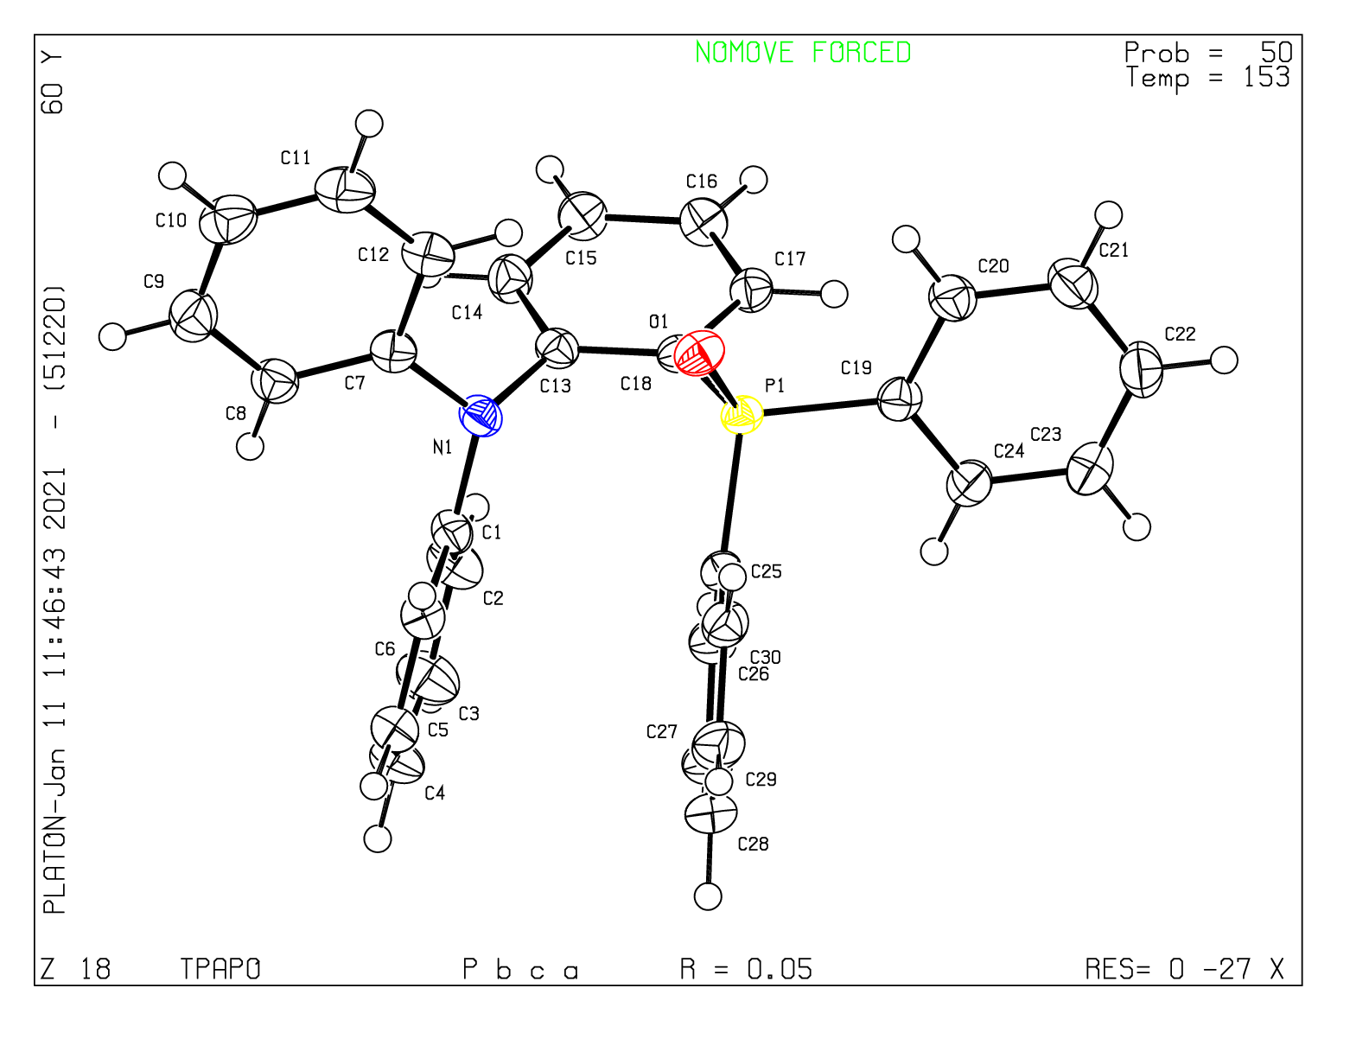
Figure S24. Single crystal structure of o-TATPO.
Table S6. Crystal data and structure refinement for single crystal of o-TATP.
Formula | C₃₀H₂₄NOP | μ/mm⁻¹ | 1.207
Formula weight | 429.47 | F(000) | 452.0
Temperature/K | 153.0 | Crystal size/mm³ | 0.5 × 0.4 × 0.2
Crystal system | triclinic | Radiation | CuKα (l = 1.54184)
Space group | P-1 | Reflections collected | 18985
a/Å | 10.3145(16) | Data/restraints/parameters | 3863/0/290
b/Å | 11.0107(17) | D_{x}/g cm⁻³ | 1.272
c/Å | 11.2287(18) | Unique (R_{int}) | 0.0495
α/° | 111.844(4) | Goodness-of-fit on F² | 1.133
β/° | 101.995(4) | R₁,^{[a]} wR₂^{[b]} [I≥2σ (I)] | R₁ = 0.0549, wR₂ = 0.1764
γ/° | 98.621(4) | R₁, wR₂ [all data] | R₁ = 0.1043, wR₂ = 0.2233
Volume/Å³ | 1121.0(3)
ρ_{calc}/g cm⁻³ | 1.272
ª R₁ = Σ⎥⎥F_{o}⎥ -⎥Fc⎥⎥/Σ⎥F_{o}⎥. ^{b} wR₂ = [Σ[w(F_{o}² - F_{c}²)²]/Σw(F_{o}²)²]^{1/2}, where w = 1/[²(F_{o})² + (aP)² + bP] and P = (F_{o}² + 2F_{c}²)/3.
Table S7. Bond lengths for single crystal of o-TATP.
Atom | Atom | Length/Å | Atom | Atom | Length/Å
P1 | C19 | 1.845(3) | C30 | C25 | 1.392(4)
P1 | C25 | 1.834(3) | C30 | C29 | 1.389(4)
P1 | C18 | 1.839(3) | C17 | C18 | 1.397(4)
N1 | C13 | 1.438(3) | C24 | C23 | 1.399(5)
N1 | C7 | 1.409(3) | C14 | C15 | 1.396(4)
N1 | C1 | 1.429(3) | C1 | C2 | 1.392(4)
C26 | C25 | 1.383(4) | C1 | C6 | 1.386(4)
C26 | C27 | 1.392(4) | C27 | C28 | 1.377(4)
C19 | C24 | 1.392(4) | C2 | C3 | 1.394(4)
C19 | C20 | 1.402(4) | C28 | C29 | 1.374(5)
C8 | C7 | 1.405(4) | C23 | C22 | 1.382(4)
C8 | C9 | 1.395(4) | C20 | C21 | 1.383(5)
C13 | C14 | 1.381(4) | C6 | C5 | 1.391(4)
C13 | C18 | 1.396(4) | C4 | C3 | 1.374(4)
C12 | C7 | 1.400(4) | C4 | C5 | 1.391(4)
C12 | C11 | 1.393(4) | C21 | C22 | 1.392(4)
C16 | C17 | 1.385(4) | C9 | C10 | 1.381(4)
C16 | C15 | 1.385(4) | C11 | C10 | 1.386(5)
P1 | C19 | 1.845(3) | C30 | C25 | 1.392(4)
Table S8. Bond angles for single crystal of o-TATP.
Atom | Atom | Atom | Angle/˚ | Atom | Atom | Atom | Angle/˚
C25 | P1 | C19 | 102.69(12) | C30 | C25 | P1 | 117.6(2)
C25 | P1 | C18 | 102.51(12) | C13 | C14 | C15 | 119.5(3)
C18 | P1 | C19 | 100.55(13) | C13 | C18 | P1 | 117.8(2)
C7 | N1 | C13 | 119.5(2) | C13 | C18 | C17 | 118.7(2)
C7 | N1 | C1 | 123.4(2) | C17 | C18 | P1 | 123.5(2)
C1 | N1 | C13 | 116.5(2) | C2 | C1 | N1 | 119.3(2)
C25 | C26 | C27 | 120.5(3) | C6 | C1 | N1 | 121.9(2)
C24 | C19 | P1 | 124.6(2) | C6 | C1 | C2 | 118.7(2)
C24 | C19 | C20 | 118.1(3) | C16 | C15 | C14 | 120.2(2)
C20 | C19 | P1 | 117.2(2) | C28 | C27 | C26 | 120.6(3)
C9 | C8 | C7 | 119.8(3) | C1 | C2 | C3 | 120.8(3)
C14 | C13 | N1 | 119.2(2) | C29 | C28 | C27 | 119.3(3)
C14 | C13 | C18 | 121.0(3) | C22 | C23 | C24 | 120.8(3)
C18 | C13 | N1 | 119.8(2) | C21 | C20 | C19 | 121.2(3)
C11 | C12 | C7 | 120.5(3) | C1 | C6 | C5 | 120.2(3)
C15 | C16 | C17 | 119.9(3) | C3 | C4 | C5 | 119.2(3)
C29 | C30 | C25 | 120.5(3) | C20 | C21 | C22 | 120.4(3)
C8 | C7 | N1 | 122.0(2) | C10 | C9 | C8 | 121.4(3)
C12 | C7 | N1 | 119.5(3) | C4 | C3 | C2 | 120.3(3)
C12 | C7 | C8 | 118.5(2) | C28 | C29 | C30 | 120.5(3)
C16 | C17 | C18 | 120.7(3) | C6 | C5 | C4 | 120.7(3)
C19 | C24 | C23 | 120.5(3) | C23 | C22 | C21 | 119.0(3)
C26 | C25 | P1 | 123.8(2) | C10 | C11 | C12 | 120.8(3)
C26 | C25 | C30 | 118.5(2) | C9 | C10 | C11 | 118.9(3)
C25 | P1 | C19 | 102.69(12) | C30 | C25 | P1 | 117.6(2)
C25 | P1 | C18 | 102.51(12) | C13 | C14 | C15 | 119.5(3)
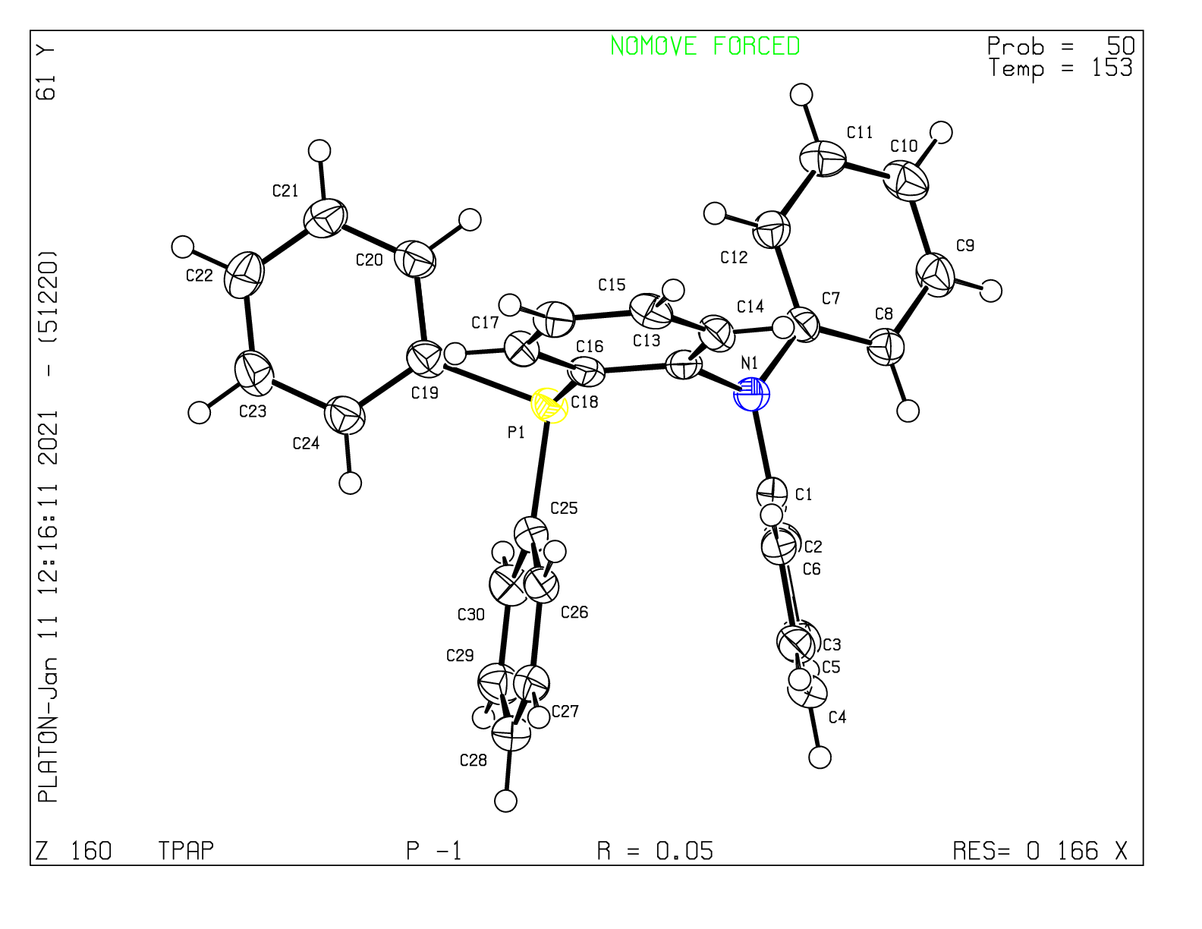
Figure S25. Single crystal structure of o-TATP.

Characterization of chemical structure
Figure S26. ¹H NMR spectrum of o-TATP (in DMSO-d₆).
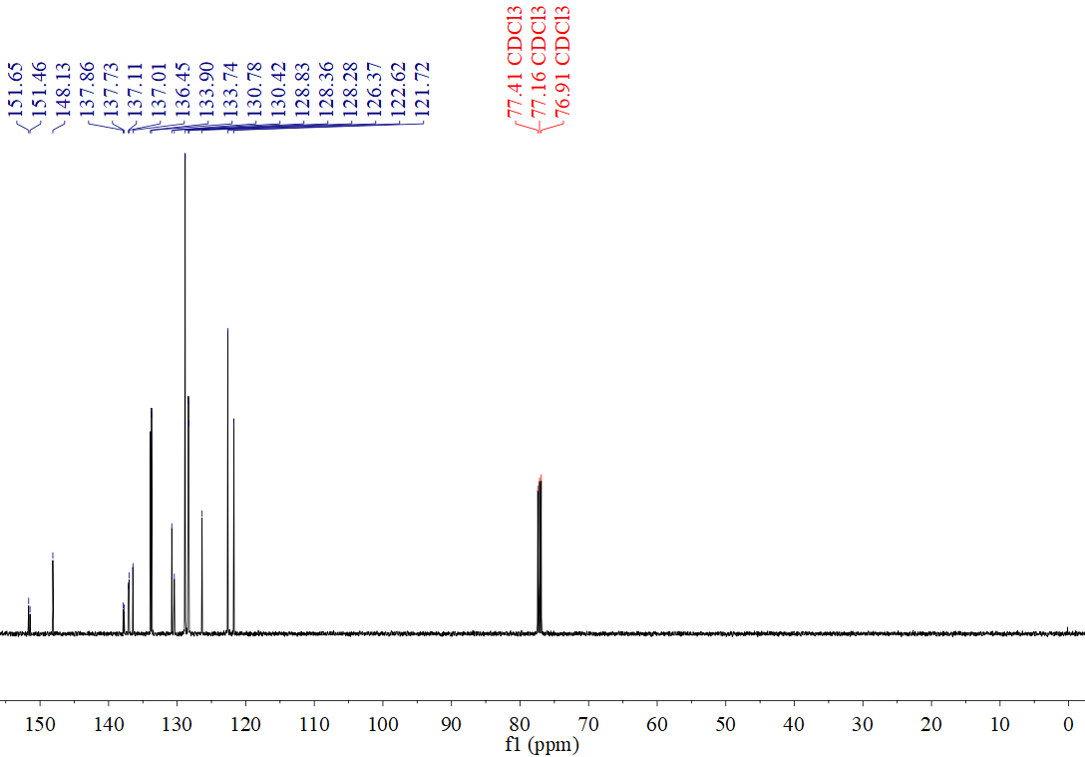
Figure S27. ¹³C NMR spectrum of o-TATP (in Chloroform-d).
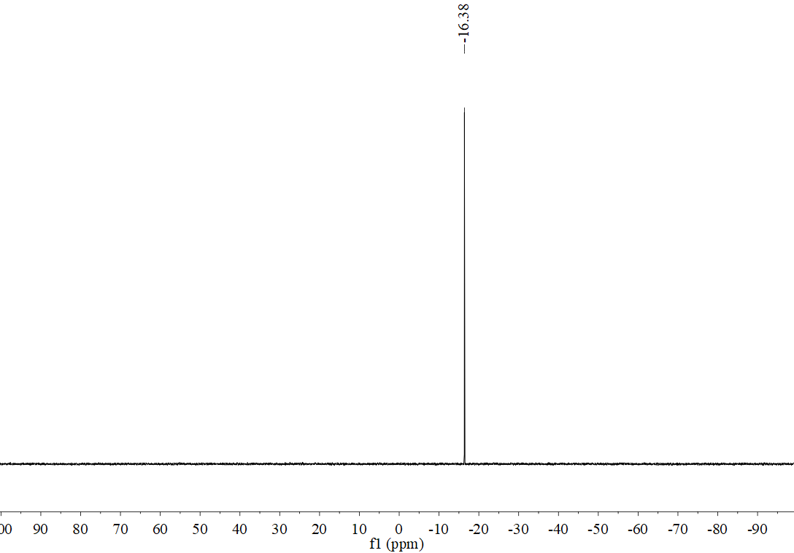
Figure S28. ³¹P NMR spectrum of o-TATP (in Chloroform-d).
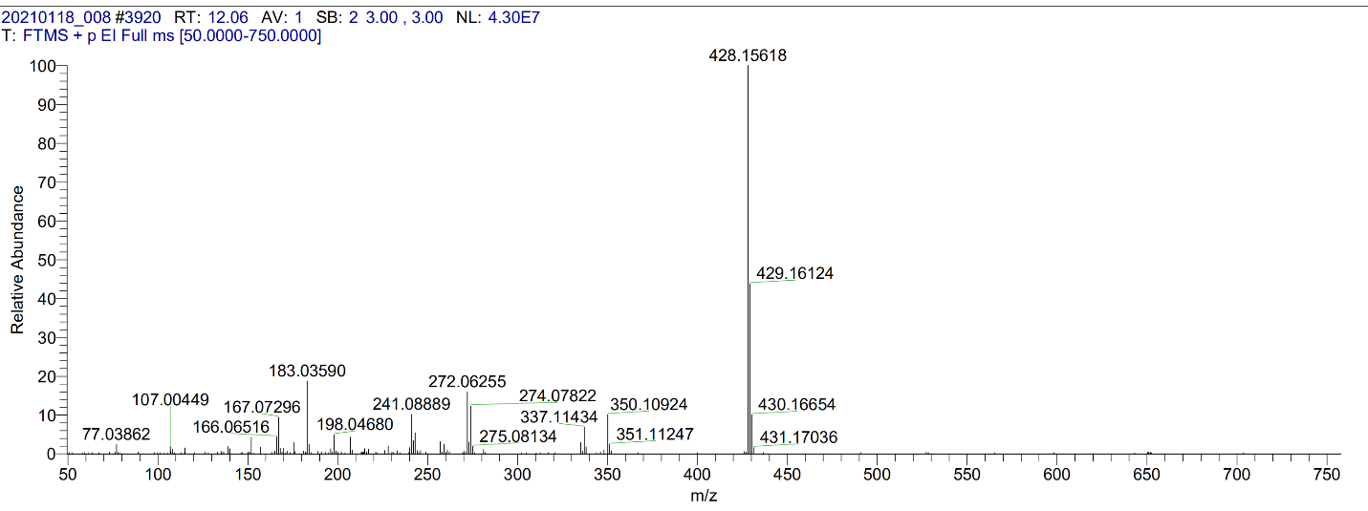
Figure S29. High-resolution Mass spectrum of o-TATP.
Figure S30. ¹H NMR spectrum of o-TATPO (in DMSO-d₆).
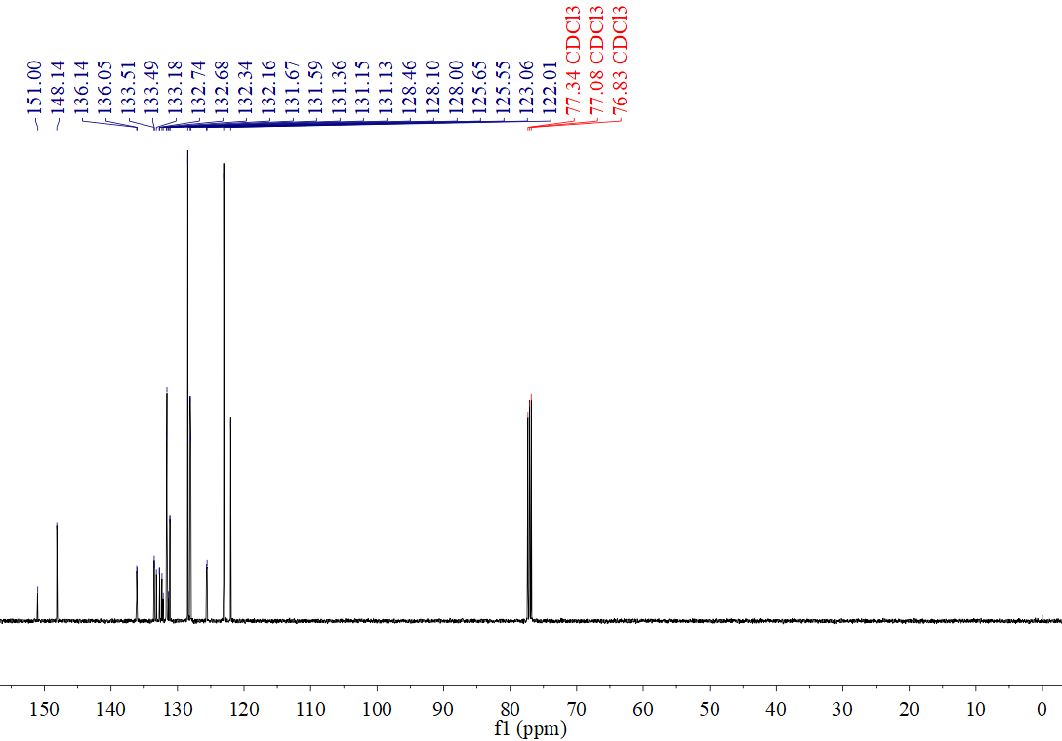
Figure S31. ¹³C NMR spectrum of o-TATPO (in Chloroform-d).
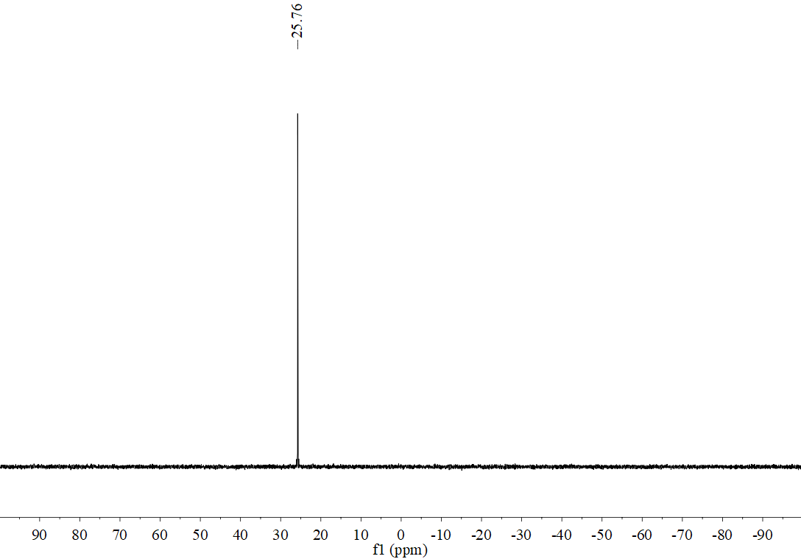
Figure S32. ³¹P NMR spectrum of o-TATPO (in Chloroform-d).
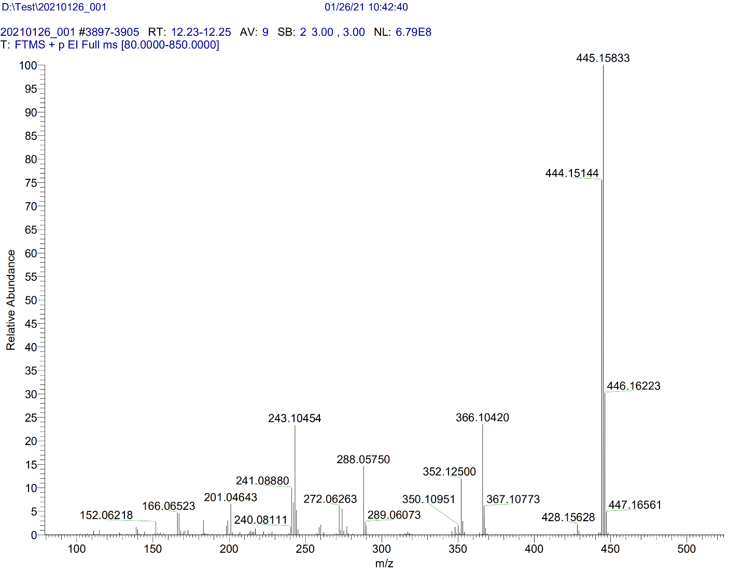
Figure S33. High-resolution Mass spectrum of o-TATPO.

Figure S34. ¹H NMR spectrum of TA (in DMSO-d₆).
Figure S35. ¹³C NMR spectrum of TA (in DMSO-d₆).
Figure S36. ¹H NMR spectrum of TPO (in DMSO-d₆).
Figure S37. ¹³C NMR spectrum of TPO (in DMSO-d₆).

References
1 Mao, Z. et al. Two-photon-excited ultralong organic room temperature phosphorescence by dual-channel triplet harvesting. Chem. Sci. 10, 7352-7357 (2019).
2 Yang, Z. et al. Boosting the Quantum Efficiency of Ultralong Organic Phosphorescence up to 52 % via Intramolecular Halogen Bonding. Angew. Chem. Int. Ed. 59, 17451-17455 (2020).
3 Liu, X. Y., Tian, Q. S., Zhao, D., Fan, J. & Liao, L. S. Novel o-D-π-A arylamine/arylphosphine oxide hybrid hosts for efficient phosphorescent organic light-emitting diodes. Org. Electron. 56, 186-191 (2018).
4 Wang, L. et al. “Push–pull” 1,8-naphthalic anhydride with multiple triphenylamine groups as electron donor. J. Mol. Struc. 1056-1057, 339-346 (2014).

