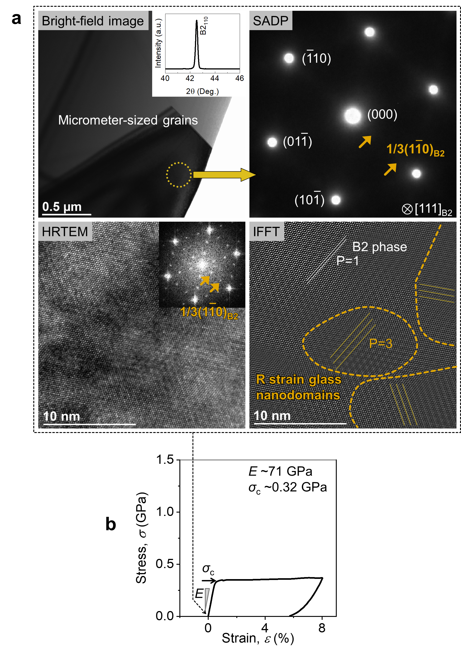
Extended Data Fig. 1: The microstructure and mechanical property of the starting solution-treated Ti-50.8Ni alloy at room temperature. a, The alloy exhibits an average B2 structure but contains nano-sized R domains manifested as 1/3(110)_{B2} faint spots in the diffraction pattern and lattice fringes with a spacing of 3d₁₁₀^{B2} or P=3 shown in HRTEM and noised-filtered IFFT images. Such a state of this alloy has been identified to be an unfrozen strain glass³¹⁻³³. b, Imperfect superelasticity with low yield strength (~0.32 GPa) and high Young’s modulus (~71 GPa) associated with the starting solution-treated Ti-50.8Ni alloy which has a sub-zero martensitic transformation temperature of M_{s} ~250 K (Extended Data Fig. 5).
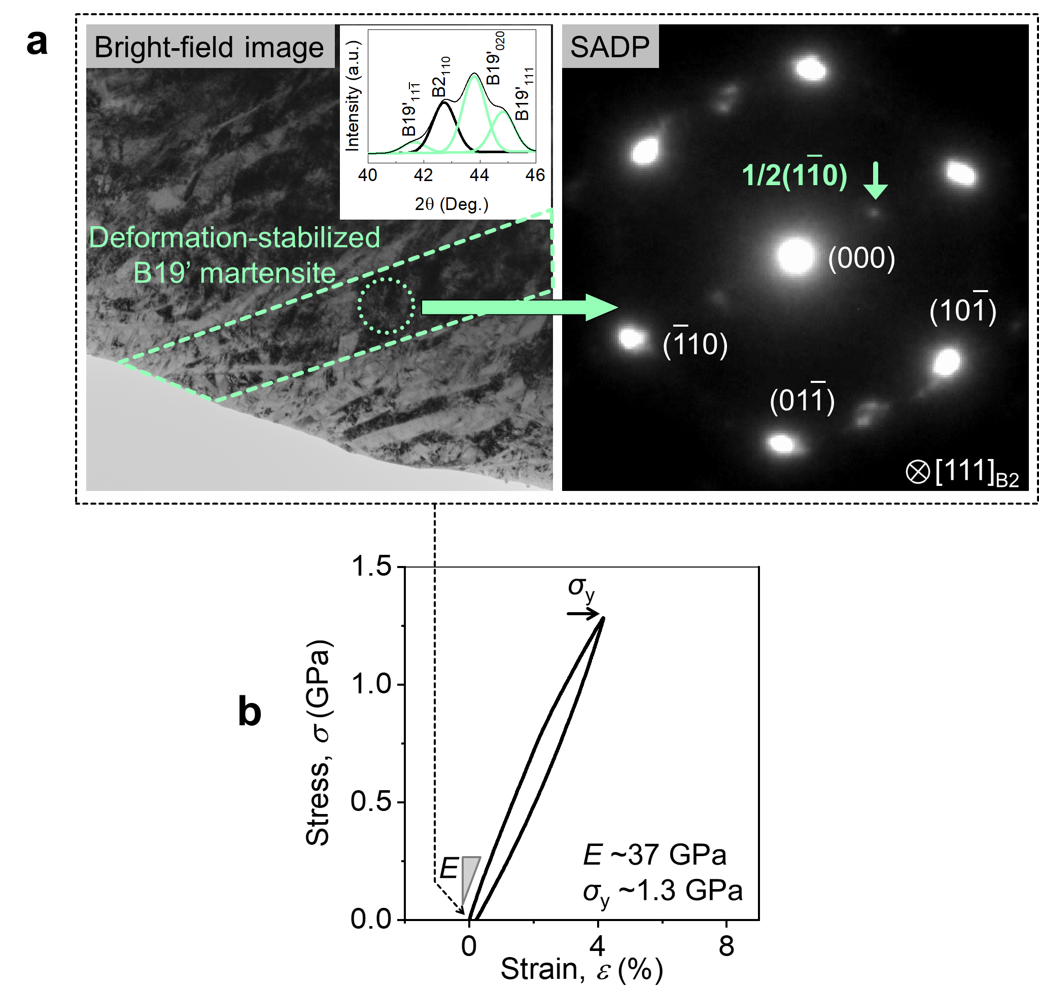
Extended Data Fig. 2: The microstructure and mechanical property of severely-deformed Ti-50.8Ni alloy (i.e., after step-1 processing). a, Ti-50.8Ni alloy after Step-1 processing reveals high-density dislocations and deformation-stabilized B19’ martensite plates at ambient temperature. The metastable B19’ martensite is identified by XRD (inset) and 1/2{101}B2 spots in the selected area diffraction pattern (SADP). b, the severely-deformed Ti-50.8Ni alloy reveals a quasi-linear elastic behavior with a high strength ~1.3 GPa and a moderate elastic modulus of ~37 GPa.

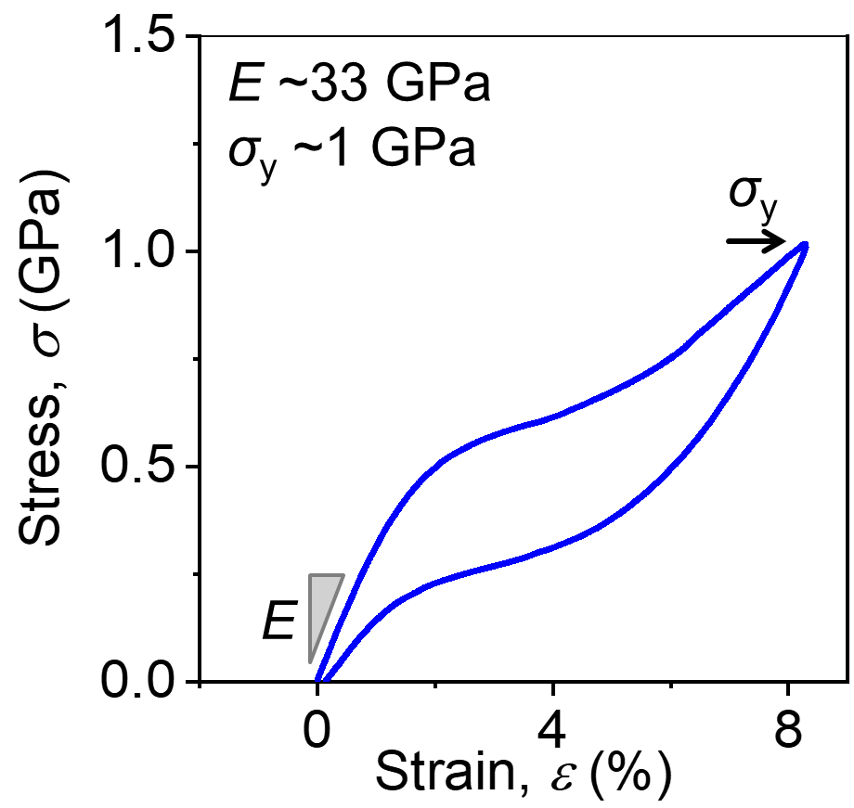
Extended Data Fig. 3: DC-STG sample shows superelasticity of at room temperature (i.e., the sample after Step-2 processing) with a moderately high strength of ~1.0 GPa and a moderate initial modulus of ~32 GPa together with a large non-linearity and hysteresis.

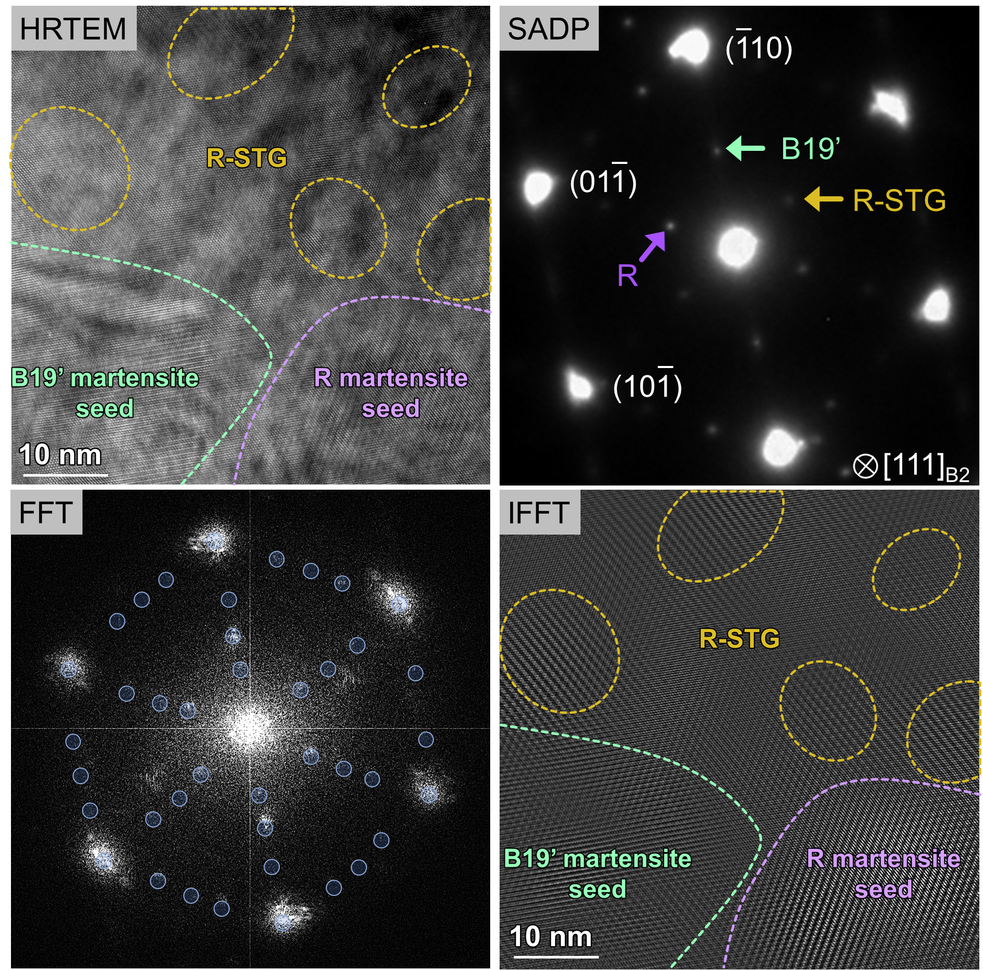
Extended Data Fig. 4: Room-temperature HRTEM image (top left) and noise-filtered IFFT image (bottom right) of the DS-STG alloy showing R and B19’ martensite seeds embedded in a R-STG matrix. The corresponding diffraction pattern shows sharp R and B19’ spots from R and B19’ seeds. The IFFT image is produced by using the FFT pattern (bottom left).

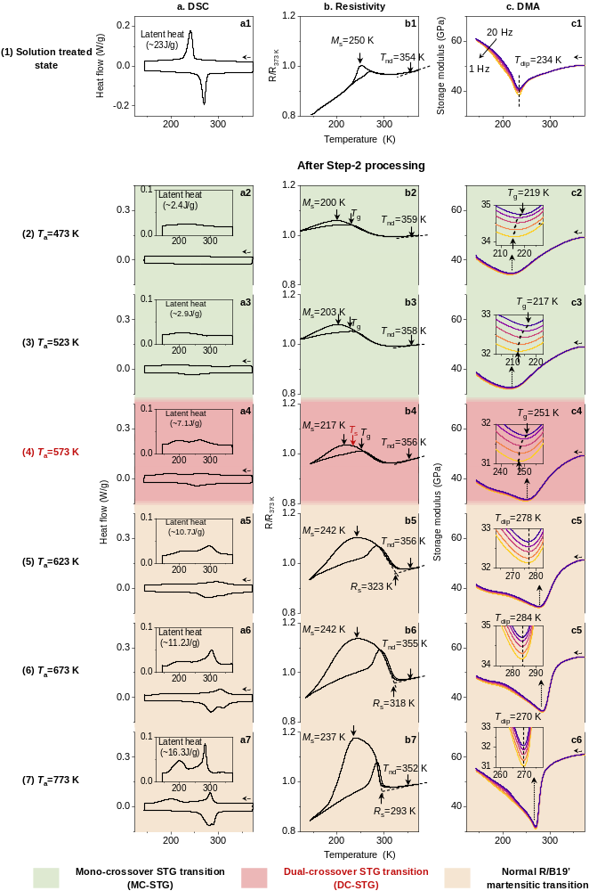
Extended Data Fig. 5: Determination of transition temperatures of T_{nd}, R_{s}, M_{s}, T_{g}, and T_{s} in the phase diagram of Fig. 4b by a combination of DSC, electrical resistivity, and DMA measurements, where T_{nd}, R_{s}, M_{s}, T_{g}, and T_{s} represent nanodomain starting temperature, R martensitic transformation starting temperature, B19’ martensitic transformation starting temperature, strain glass transition temperature, and spontaneous transition temperature from STG to R martensite, respectively. a1, b1, c1, show the starting solution-treated Ti-50.8Ni alloy undergoes transitions from B2 parent phase to unfrozen STG (at T_{nd}) then to B19’ martensite (at M_{s}), being consistent with recent reports³¹⁻³³. a2, b2, c2, a3, b3, c3, annealing at low Step-2 temperatures T_{a} =473 K and T_{a} =523 K leads to a mono-crossover strain glass (MC-STG) state, which first shows a strain glass transition into a frozen R strain glass and followed by a crossover transition to a single martensite B19’. The strain glass transition is evidenced by a nearly vanishing DSC peak, and a Vogel-Fulcher type frequency-dependent elastic modulus dip at T_{g} ~219 K in DMA curves; the mono-crossover transition to B19’ is evidenced by a decreasing resistivity below M_{s} and the existence of large transformation hysteresis characteristic of B19’ formation, as well as the appearance of B19’ peaks at low temperature in XRD profiles (Extended Figure 5a). a4, b4, c4 annealing at a moderate Step-2 annealing temperature T_{a} =573 K leads to a dual-crossover strain glass (DC-STG) state, which first shows a strain glass transition into a frozen R strain glass and followed by a dual-crossover transition to R martensite then to B19’ martensite. The strain glass transition is evidenced by a Vogel-Fulcher type frequency-dependent elastic modulus dip at T_{g} ~251 K in DMA curves; The crossover transition into R and B19’ martensites is evidenced by the appearance of R and B19’ peaks at low temperatures in XRD profiles (Extended Data Fig. 5b), which is a key measurement for a crossover strain glass transition³². The second crossover transition to B19’ martensite is also evidenced by a decreasing resistivity below M_{s} and the existence of large transformation hysteresis. a5, b5, c5, a6, b6, c6, a7, b7, c7 annealing at high Step-2 annealing temperatures T_{a} =623, 673, 773 K, which is the standard annealing temperature for Ti-Ni alloys, leads to a familiar two-step martensitic transition, first to R martensite, and then to B19’ martensite. As evidenced by two prominent DSC peaks, and frequency-independent elastic modulus dip in DMA curves. The martensitic transition to R martensite is evidenced by the sharp increase below R_{s} and the existence of a ~5 K transition hysteresis characteristic of R transition. The martensitic transition to B19’ martensite is evidenced by the decrease in resistivity below M_{s} and the existence of large transition hysteresis, being consistent with the literature^{41,42}. Direct evidence from XRD (Extended Data Fig. 5c) confirms this transition sequence.

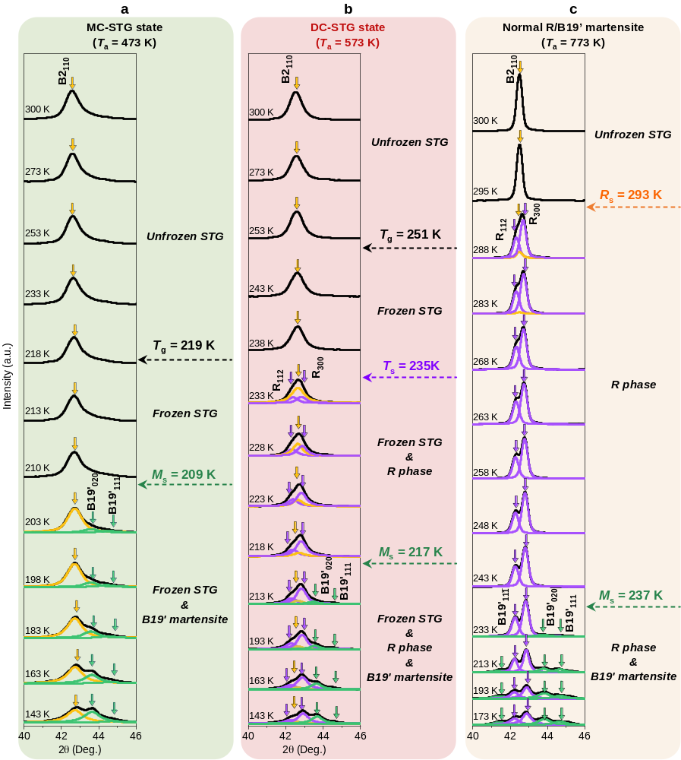
Extended Data Fig. 5: In-situ XRD during cooling for (a) a mono-crossover strain glass (MC-STG) sample (with T_{a} = 473 K), (b) a dual-crossover strain glass (DC-STG) sample (with T_{a} = 573 K), and (c) a conventional R/B19’ martensite sample (with T_{a} =773 K). a, MC-STG sample maintains an average B2 structure below strain glass transition temperature T_{g}, and crossovers into single B19’ martensite below M_{s}, but the transition is incomplete. b, DC-STG sample maintains an average B2 structure down to strain glass transition temperature T_{g}, then transforms to R phase first and then to B19' martensite, but the transitions are incomplete. c, Normal R/B19’ martensitic sample with high (T_{a} = 773 K) undergoes a spontaneous transformation from unfrozen STG (Extended data Fig.1, R local structure with an average B2 structure³¹⁻³³) to R phase and finally to B19' martensite.

