Supplementary Information
Decentralized pilot-scale biofilm-based system integrated with microbial electrolysis cell for household wastewater treatment: Enhanced pollutant removal and hydrogen production

Edson Baltazar Estrada-Arriaga^{1*}, Raúl Montero-Farías², Cornelio Morales-Morales^{3*}, Liliana García-Sánchez¹, Axel Falcón-Rojas⁴, Marco A. Garzón-Zúñiga⁵, Tania Gutierrez-Macias⁶

¹Subcoordinación de Sistemas de Saneamiento y Reutilización de Aguas Residuales, Instituto Mexicano de Tecnología del Agua, Paseo Cuauhnáhuac 8532, Progreso, Jiutepec, Morelos C.P. 62550, México.
²Facultad de Ingeniería, Universidad Nacional Autónoma de México, Paseo Cuauhnáhuac 8532, Progreso, Jiutepec, Morelos C.P. 62550, México.
³Instituto Tecnológico de San Juan del Río, Tecnológico Nacional de México, Av. Tecnológico No. 2, Quintas de Guadalupe, San Juan del Río, Querétaro, C.P. 76800, México
⁴Subcoodinación de Monitoreo y Evaluación de Calidad del Agua, Instituto Mexicano de Tecnología del Agua, Paseo Cuauhnáhuac 8532, Progreso, Jiutepec, Morelos C.P. 62550, México
⁵Laboratorio de Evaluación, Desarrollo e Innovación de Tecnología del Agua, Instituto Politécnico Nacional, CIIDIR-Durango, Sigma 119, 20 de Noviembre II, Durango, C.P. 34220, México.
⁶Consejo Nacional de Humanidades, Ciencias y Tecnologías, Instituto Mexicano de Tecnología del Agua, Paseo Cuauhnáhuac 8532, Progreso, Jiutepec, Morelos C.P. 62550, México.

*Corresponding author
Tel.: +52 777 3293600 ext 297. Email: edson_estrada@tlaloc.imta.mx
Tel.: +52 777 4501009. Email: cornelio.mm@sjuanrio.tecnm.mx

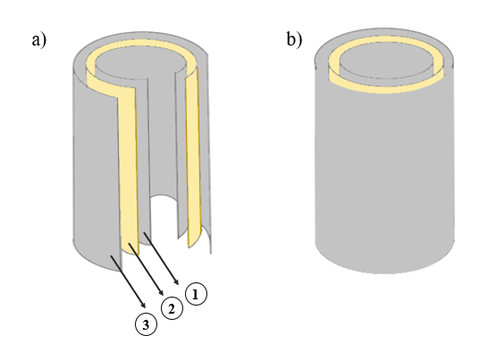
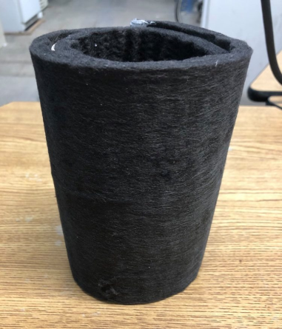

Fig. S1. Electrode configuration. 1- Anode. 2- CEM. 3- Cathode

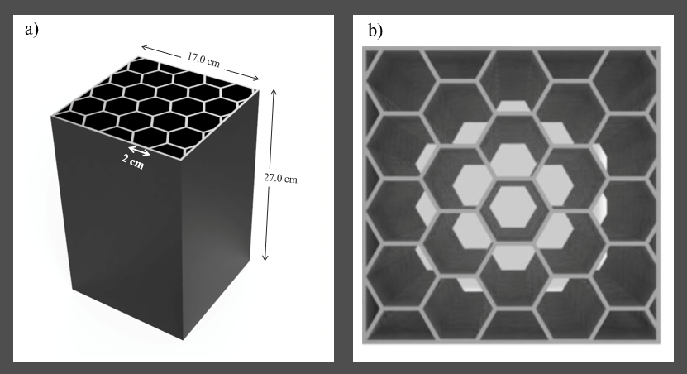
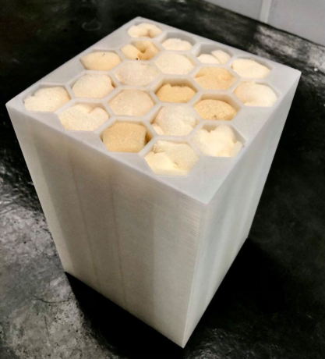

Fig. S2. Cassette filtration module

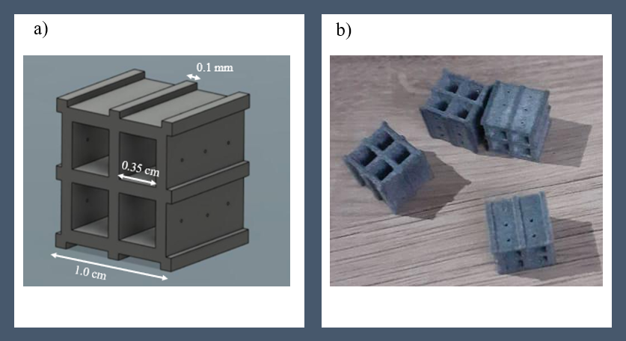
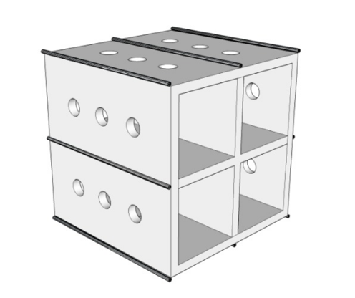
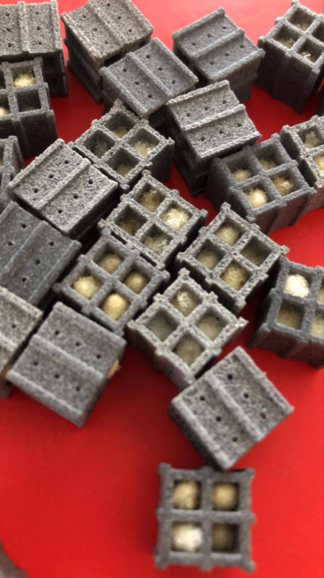

Fig. S3. Biocarriers

Fig. S4 Organic matter removal evolution during biofilm formation in the DEWATS pilot-scale biofilm-based system coupled with MEC fed with household wastewater

Fig. S5. Effect of pollutant loading over the performace of DEWATS pilot-scale biofilm-based technology coupled with MEC for household wastewater treatment

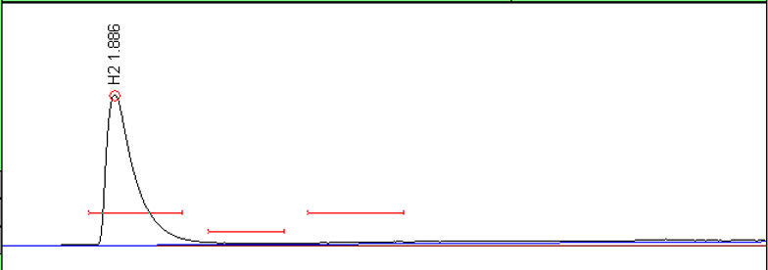

Fig. S6. Chromatogram of biogas release from MEC during household wastewater treatment

Table S1. Attached solids obtained in the DEWATS pilot-scale biofilm-based system integrated with MEC during household wastewater treatment

Parameter | MEC |  | APBBR | aeMBBR
Parameter | Anode | Cathode | APBBR | aeMBBR
TSS (g/m²) | 231.3 | 226.6 | 0.0087 | 7.2
VSS (g/m²) | 140.6 | 137.5 | 0.0023 | 3.3
MLVSS | 20 |  | - | 35

Table S2. Pollutan removal in stable conditions from DEWATS pilot-scale biofilm-based technology coupled with MEC during household wastewater treatment

Stage | Sample point | Organic loading  (kg COD/m^{3.}d)  HRT (d)  Voltage (Volts) | COD  (mg/L) | Removal  (%) | BOD  (mg/L) | Removal  (%) | TN  (mg/L) | Removal  (%) | NH₄⁺  (mg/L) | Removal  (%) | NO₃⁻  (mg/L) | TP  (mg/L) | Removal  (%) | TSS  (mg/L) | Removal  (%)
1 | Influent | 0.23  1.5  0.7 | 293 |  | 169 |  | 26.3 |  | 22 |  | 0 | 7.5 |  | 377
1 | MEC effluent | 0.23  1.5  0.7 | 198 | 32 | 110 | 35 |  |  | 17 | 16 | 1 | 7.1 | 4 | 47 | 63
1 | APBBR effluent | 0.23  1.5  0.7 | 89 | 55 | 42 | 62 |  |  | 16 | 5 | 0 | 6.7 | 7 | 36 | 22
1 | aeMBBR effluent | 0.23  1.5  0.7 | 55 | 38 | 25 | 40.4 | 10 |  | 3 | 85 | 8.5 | 6.6 | 0.7 | 19 | 46
1 | Global removal | 0.23  1.5  0.7 |  | 81 |  | 85.2 |  | 62 |  | 88 |  |  | 11.4 |  | 85
2 | Influent | 0.25  1.5  1 | 300 |  | 162 |  | 31 |  | 23 |  | 0 | 8.4 |  | 128
2 | MEC effluent | 0.25  1.5  1 | 180 | 40 | 100 | 37 |  |  | 16 | 31 | 2 | 7.5 | 10 | 61 | 54
2 | APBBR effluent | 0.25  1.5  1 | 89.1 | 51 | 47 | 53 |  |  | 15 | 3 | 0 | 6.6 | 12.1 | 41 | 33
2 | aeMBBR effluent | 0.25  1.5  1 | 48 | 46 | 26 | 45 | 10 |  | 0.5 | 97 | 10 | 6.2 | 6 | 16 | 61
2 | Global removal | 0.25  1.5  1 |  | 84 |  | 84 |  | 68 |  | 98 |  |  | 25.7 |  | 88
3 | Influent | 0.44  0.75  1 | 336 |  | 178 |  | 40 |  | 28 |  | 0 | 8.3 |  | 306
3 | MEC effluent | 0.44  0.75  1 | 242 | 28 | 131 | 30 |  |  | 24 | 16 | 1 | 7.5 | 8.7 | 128 | 57
3 | APBBR effluent | 0.44  0.75  1 | 132 | 46 | 69 | 47 |  |  | 23 | 3 | 0 | 6 | 19.5 | 90 | 28
3 | aeMBBR effluent | 0.44  0.75  1 | 57 | 57 | 26 | 63 | 19 |  | 1 | 95 | 17 | 5.8 | 4.2 | 72 | 20
3 | Global removal | 0.44  0.75  1 |  | 83 |  | 85 |  | 53 |  | 96 |  |  | 29.7 |  | 76
4 | Influent | 0.4  0.75  0.7 | 299 |  | 181 |  | 37 |  | 28 |  | 0 | 9.6 |  | 133
4 | MEC effluent | 0.4  0.75  0.7 | 211 | 29 | 110 | 39 |  |  | 25 | 10 | 1 | 8.8 | 8.8 | 61 | 55
4 | APBBR effluent | 0.4  0.75  0.7 | 115 | 46 | 74 | 33 |  |  | 24 | 3 | 0 | 8.2 | 6.3 | 43 | 29
4 | aeMBBR effluent | 0.4  0.75  0.7 | 54 | 54 | 28 | 63 | 18 |  | 2 | 93 | 15 | 8 | 2.6 | 33 | 24
4 | Global removal | 0.4  0.75  0.7 |  | 83 |  | 85 |  | 53 |  | 94 |  |  | 16.7 |  | 76
5 | Influent |  | 302 |  | 162 |  | 25 |  | 20 |  | 0 | 9.4 |  | 136
5 | MEC effluent | 0.2  1.5  Without input voltage | 229 | 26 | 118 | 26 |  |  | 19 | 5 | 0 | 9.1 | 2.6 | 45 | 66
5 | APBBR effluent | 0.2  1.5  Without input voltage | 88 | 62 | 49 | 59 |  |  | 18 | 3 | 0 | 8.7 | 8.7 | 35 | 22
5 | aeMBBR effluent | 0.2  1.5  Without input voltage | 66 | 25 | 30 | 39 | 12 |  | 1 | 95 | 11 | 8.5 | 2.5 | 17 | 51
5 | Global removal | 0.2  1.5  Without input voltage |  | 79 |  | 81 |  | 52 |  | 95 |  |  | 9.6 |  | 87

