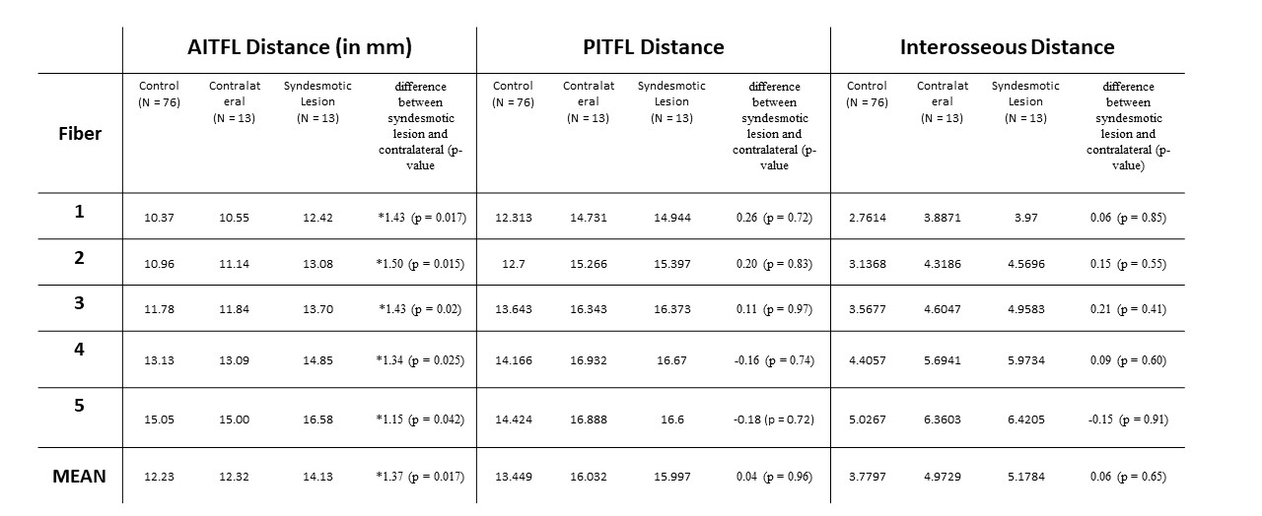
Table 1. Mean calculated lengths of the 5 different fibers for the Anterior Inferior TibioFibular Ligament (AITFL), Posterior Inferior TibioFibular Ligament (PITFL) and Interosseous Ligament (IOL). The difference between the syndesmotic lesion and it’s contralateral healthy counterpart are reported, together with its respective p-value. Statistically significant differences are marked with an asterisk (*).

