Supplementary files
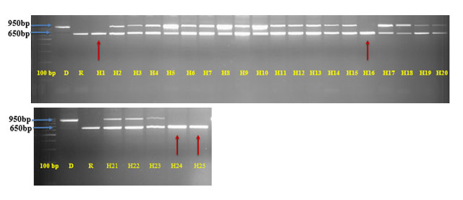
S1 Fig: Confirmation of true F₁s of a cross between MTU1010 IL and Jaya using pTA248 marker
R-Recurrent parent, Jaya; D-Donor parent, MTU1010 (IL); H1 to H25 indicates total number of hybrids genotyped; Arrows indicate a selfed negative plant for pTA248. Double bands indicate true F₁s.
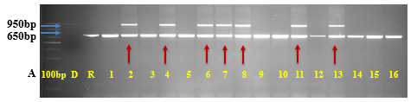
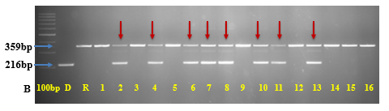
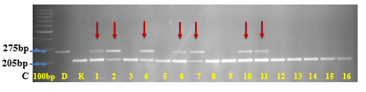
S2 Fig: Foreground selection of BC₁F₁ plants for Xa21, Pi54 and Gn1a genes using gene linked markers
(A) Foreground selection for Xa21 gene using pTA248 marker (B) Foreground selection for Pi54 gene using PikhMas marker (C) Foreground selection for Gn1a gene using Gn1a Indel-3 marker. D-Donor parent, MTU1010; R-Recurrent parent; Plant number 2, 4, 6, 7 and 11 are positive for all the 3 targeted genes. Red color arrows indicate a single positive plant for the targeted trait.
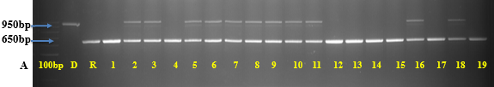

S3 Fig (A): Foreground selection of BC₂F₁ plants for Xa21 gene using pTA248 marker
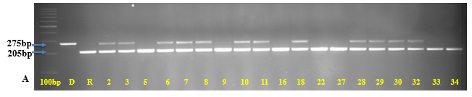
Confirmation of Xa21 gene, using pTA248 marker BC₂F₁; D- Donor parent MTU1010 (IL); R-Recurrent parent Jaya; Double bands indicates the positive BC₂F₁ plants and recurrent parent band type indicates negative plants. Band size-950bp indicates positive plants; Band size-650bp indicates negative plants.
B

S3 Fig (B): Foreground selection of BC₂F₁ plants for Gn1a gene using Gn1a Indel-3 marker
D- Donor parent MTU1010 (IL); R-Recurrent parent Jaya; Double bands indicates the positive BC₂F₁ plants. Band size-275bp indicates positive plants; Band size-205bp indicates negative plants.
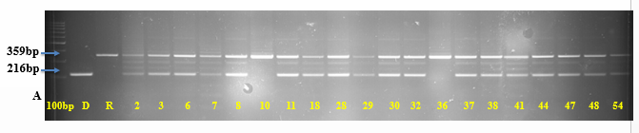
C

S3 Fig (C): Foreground selection of BC₂F₁ plants for Pi54 gene using PikhMas marker
D- Donor parent MTU1010 (IL); R-Recurrent parent Jaya; Double bands indicates the positive BC₂F₁ plants. Band size-216bp indicates positive plants; Band size-359bp indicates negative plants.

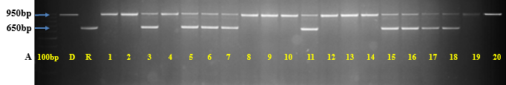
S4 Fig (A): Foreground selection of BC₂F₂ plants for Xa21 gene using pTA248 marker
Foreground selection of BC₂F₂ plants for Xa21 using pTA248 marker; D- Donor parent MTU1010 (IL); R- recurrent parent Jaya. Base pair 650 indicates negative plants; Base pair 950 indicates positive plants.
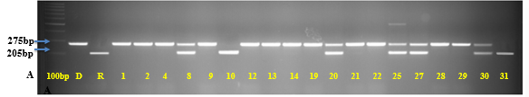
B

S4 Fig (B): Foreground selection of BC₂F₂ plants for Gn1a gene using Gn1a Indel-3 marker
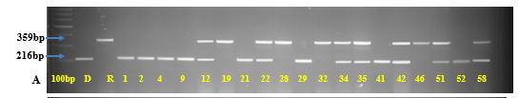
Foreground selection of BC₂F₂ plants for GN1a using Gn1a Indel-3 marker; Samples in figures includes the BC₂F₂ plants which were already found positive for Xa21; D-Donor parent MTU1010 (IL); R- recurrent parent Jaya. Base pair 275 indicates positive plants; Base pair 205 indicates negative plants.
C

S4 Fig (C): Foreground selection of BC₂F₂ plants for Pi54 using PikhMas marker
Foreground selection of BC₂F₂ plants for Pi54 using PikhMas marker; Samples in figures includes, selected BC₂F₂ plants which were already found positive for Xa21 and Gn1a; D- Donor parent MTU1010 (IL); R- Recurrent parent Jaya. Base pair 359 indicates susceptible band size; Base pair 216 indicates resistant band size.

