cSupplementary materials:

The influence of nickel electrode's morphology on glucose detection
- CVs of Electrodes with different glucose concentration in 0.1M NaOH solution
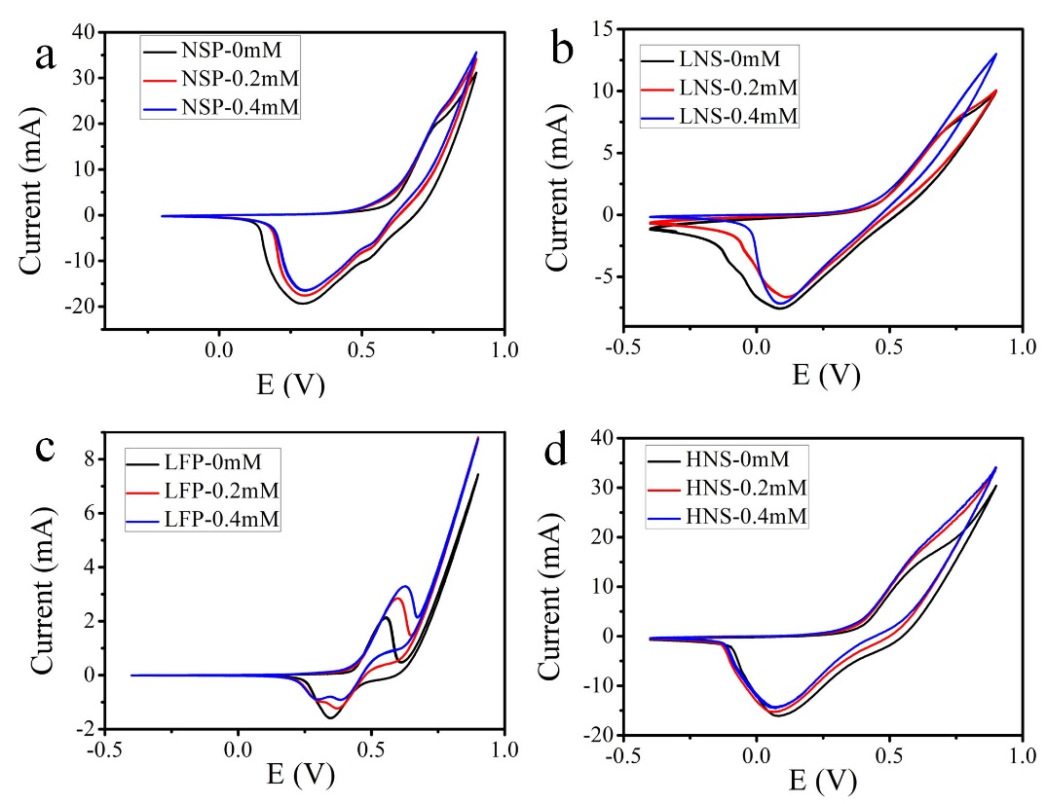
Figure S1 CV measurements of the electrodes in different concentration (0mM, 0.2mM, 0.4mM) glucose contained 0.1 M NaOH aqueous solution at scan speed of 20mV/s.

- Determination of electrodes surface area.
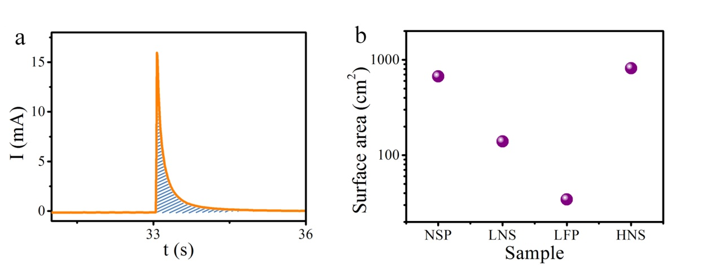
Figure S2 The surface areas of all electrodes were roughly calculated from the capacitance of the electrical double layer vs. capacitance by chronoamperometry at the potential of 0.2V. The capacitivity can be estimated as 20μF/cm² ¹.

3. The oxidation currents in CV measurements in the absent and 1mM glucose aqueous solution. 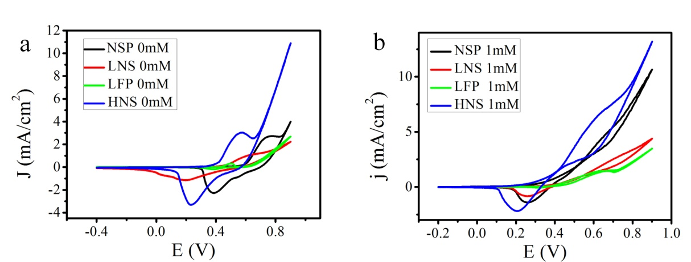
Figure S3 CV of the electrodes in 0mM (a) and 1mM (b) glucose alkaline solution at a scan speed of 5mV/s

- Testing the detection limit in low glucose concentration by chronoamperometry.

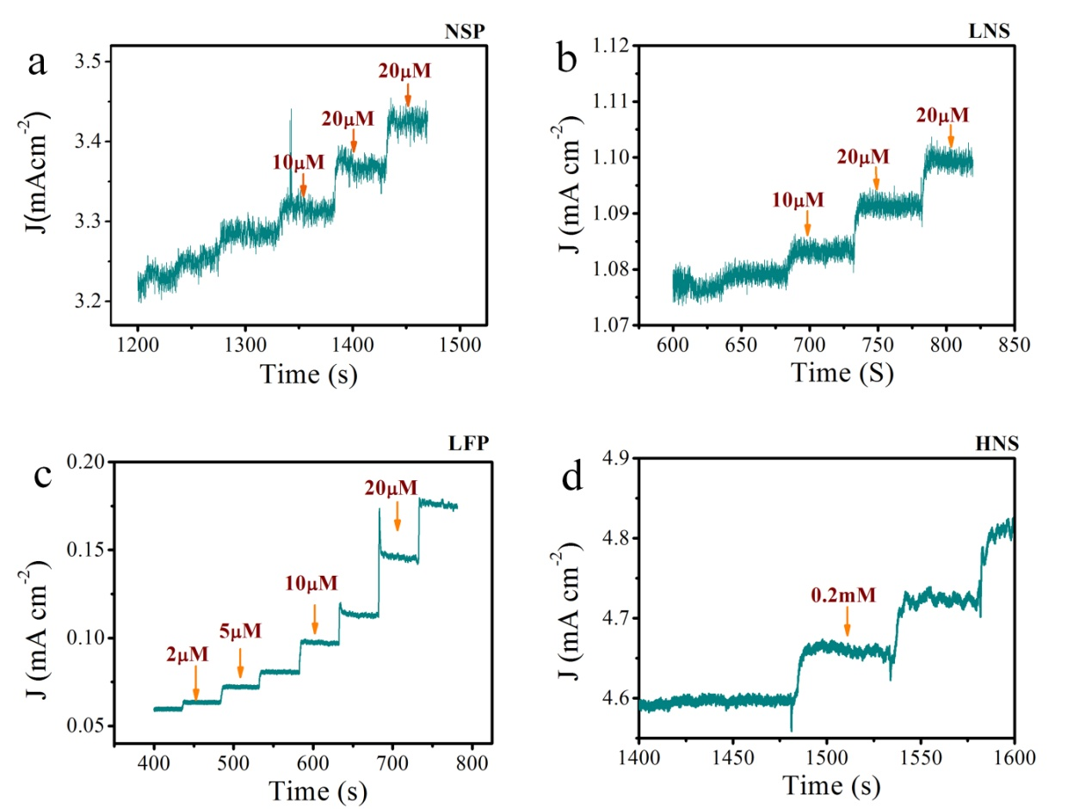
Figure S4, Amperometric responses of electrodes in low glucose concentration.

- Calculated sensitivity of nickel electrodes with different morpology
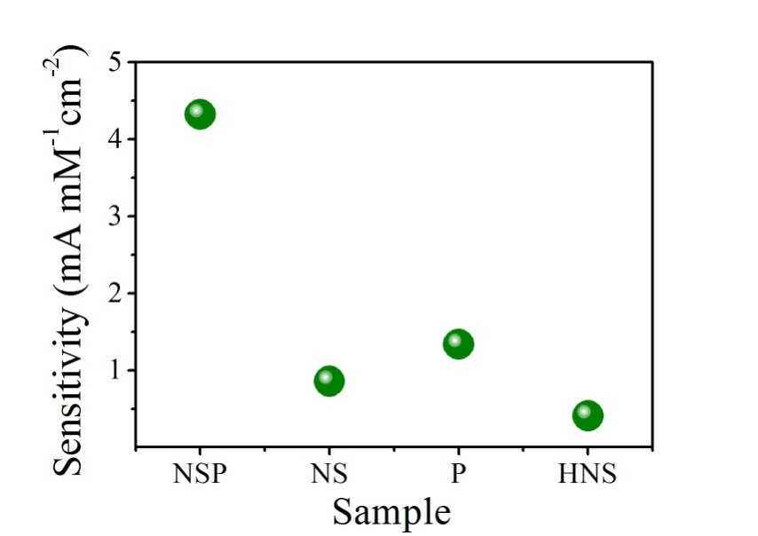
Figure S5. The sensitivity of electrode that calculated from amperometric response curve at the glucose concentration range of 0 to 1mM.

- Measurement of the response time for electrode.
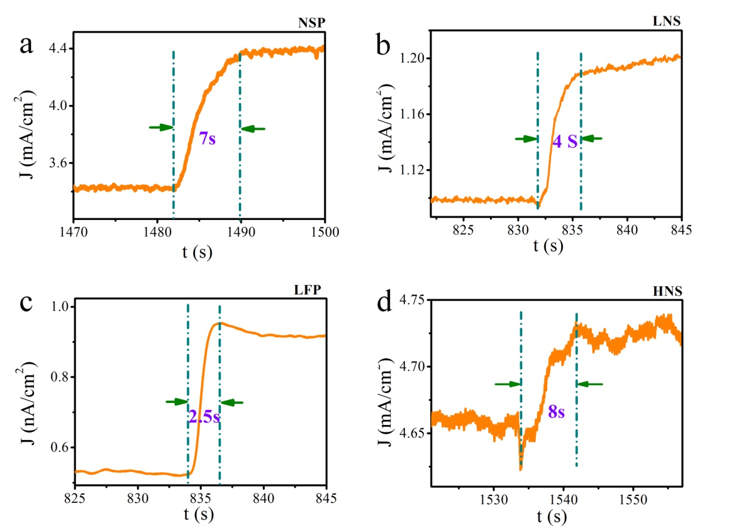 Figure S6 The response time for the electrodes in glucose amperometric responses measurement.

References
1. Soliman, K. Electrochemical behaviour of pseudomorphic Ag and Cu monolayers on well-ordered single crystal surfaces and of Ir(210) nanofacets. Universität Ulm, 2008.

