Extended Data
Extended Data Fig. 1| Distribution of tree ages for the current forests.

Extended Data Fig. 2| Reconstructed temperature of different regions in the Northern hemisphere. Red line: Northern Hemisphere summer temperature constructions during the last 1,500 years⁴⁶; Green line: long-term standardized temperature anomalies in China (“H-res”)⁴⁷; Blue lines: reconstructed April temperature of Changbaishan for more than a century for the pre-ME and modern periods (blue line, ref.⁴⁸), with an 11-year moving average (blue bold line). The temperature anomaly is relative to the mean during the entire period.

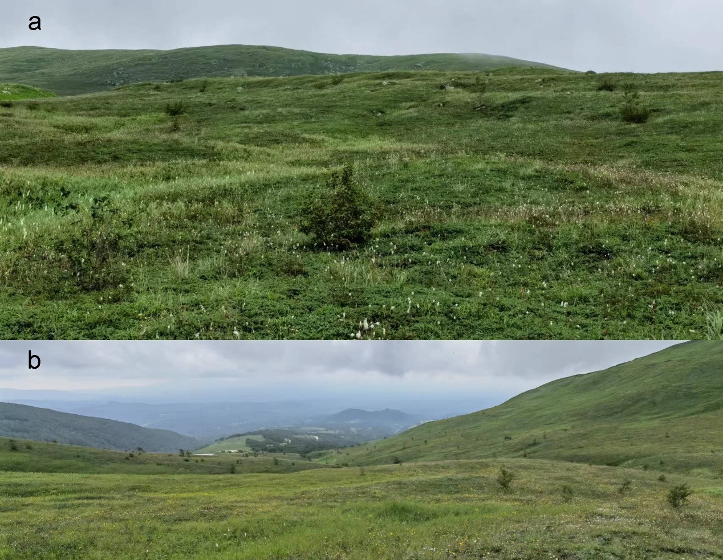
Extended Data Fig. 3| Trees (Betula ermanii) occurring in the tundra on the western slope of Changbaishan. (a) the view uphill at 2200 m; b looking downhill at 2200 m. Photographs taken by Haibo Du on 1 August 2023.

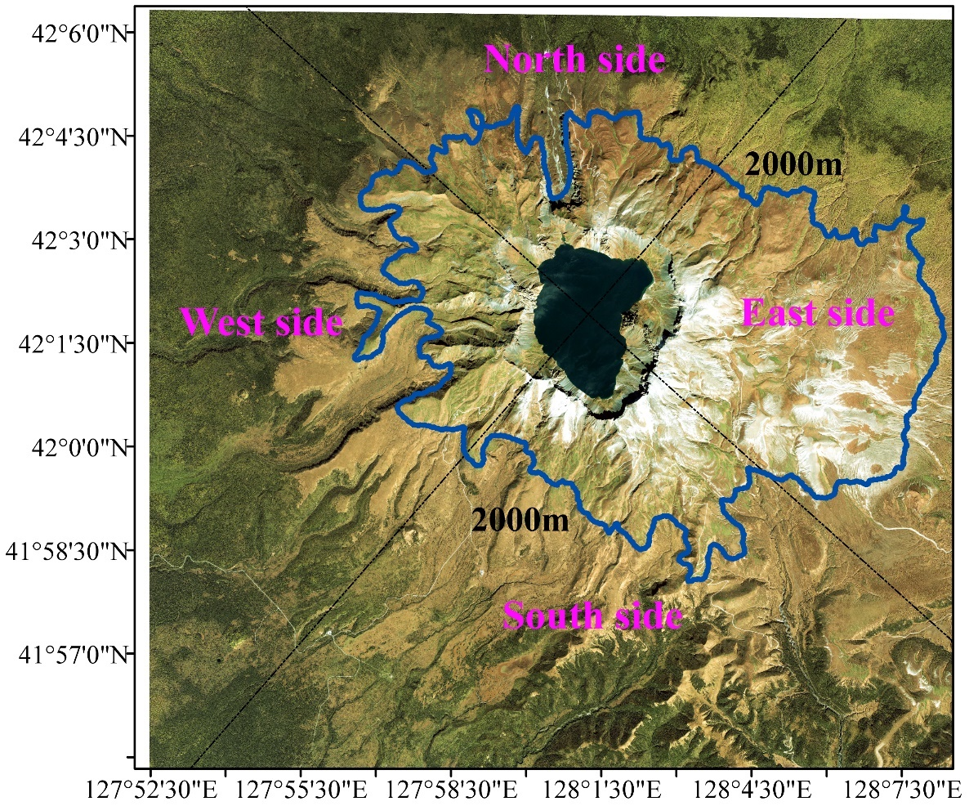
Extended Data Fig. 4| Gaofen-2 satellite remote sensing image of the alpine tundra zone of Changbaishan (acquired date: 23 September 2017; Also see Extended Data Table 2). Blue line depicts the 2000 m elevation contour, representing the alpine tundra-forest ecotone and delimiting the major alpine tundra area within. White patches represent exposed volcanic ash.

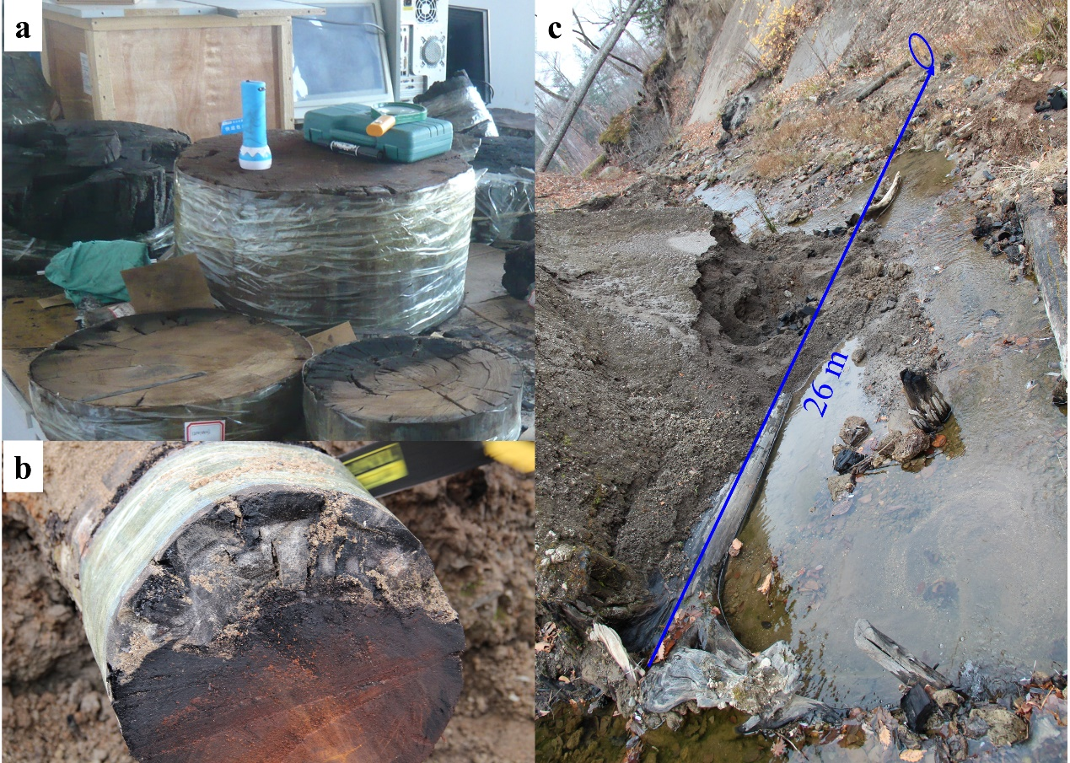
Extended Data Fig. 5| Parts of incompletely carbonized trees in the laboratory (a) and the field context (b) and situation of the whole carbonized trees in the field (c).

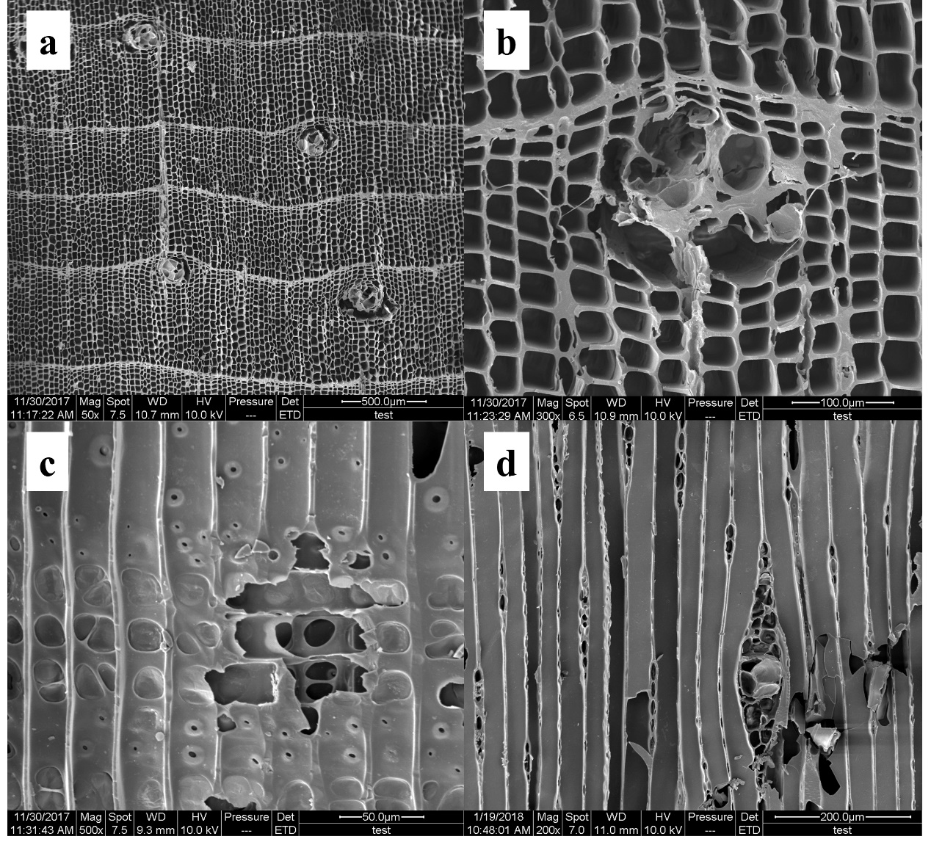
Extended Data Fig. 6| Microscopic wood-anatomical features of carbonized Pinus koraiensis wood showing cross-sectional (a and b), radial (c), and tangential planes (d).

Extended Data Fig. 7| Distinguishing tundra different vegetation cover using spectral reflectivity of vegetation and NDVI values. (a) Difference of the spectral reflectivity of Rhododendron aureum and Deyeuxia angustifolia at the yellowing and withering phenological phases in autumn. (b) Definition of the four sectors of Changbaishan and NDVI values (color scale) in 2010s from 1800 to 2400 m.

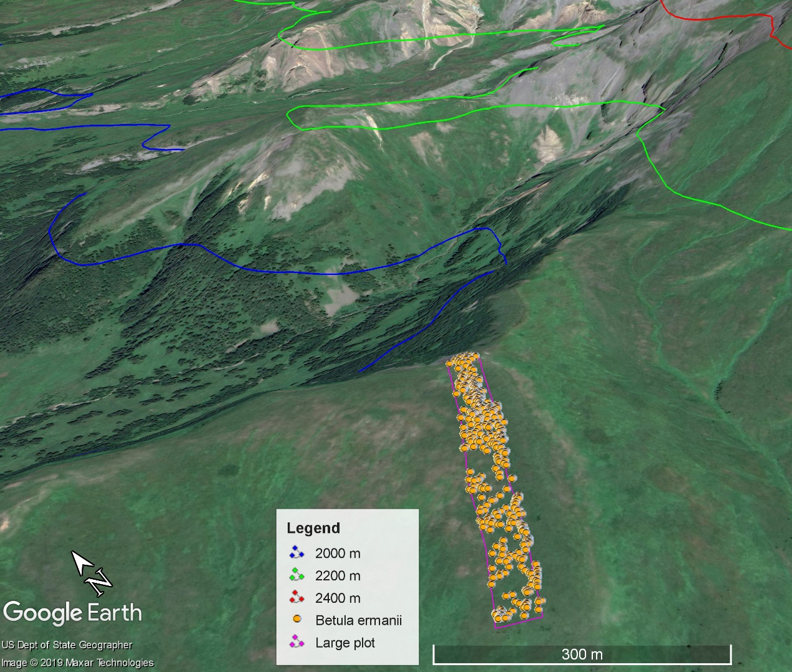
Extended Data Fig. 8| The large plot (slope length of 450 m × width of 50 m; 120 m in elevation) used for investigating the recruitment of Betula ermanii in tundra. Orange dots represent measured and mapped B. ermanii individuals. This plot is located in tundra (2074 to 2194 m a.s.l.). Blue, green, and red lines are the contour lines for 2000 m, 2200 m, and 2400 m elevations, respectively.
Extended Data Table 1. AMS ¹⁴C age and tree-ring calibration age of carbonized samples.
Lab ID# | Site | AMS ¹⁴C age (yr BP)* | Tree-ring calibration age  (yr CE; ±2σ, 95.4%)
BA150220 | F1 | 1155 ± 20 | 770–970
BA121705 | F2 | 1010 ± 20 | 980–1040
BA121692 | F3 | 1090 ± 20 | 890–1020
WT01 | T | 1094 ± 88 | 704–1158
WT02 | T | 1321 ± 65 | 605–877
WT03 | T | 1482 ± 53 | 436–656
WT04 | T | 1203 ± 53 | 678–975
WT05 | T | 1324 ± 56 | 605–872
WT06 | T | 1254 ±52 | 663–885
WT07 | T | 1346 ± 101 | 443–956
WT08 | T | 1299 ± 52 | 647–876
WT09 | T | 1286 ± 67 | 641–892
WT10 | T | 1379 ± 65 | 551–776
WT11 | T | 1256 ± 78 | 648–973
#: The complete outermost ring of three carbonized trees was collected respectively from forest sites F1–F3, and 11 samples from the tundra site T. *: AMS ¹⁴C ages were measured at the Peking University AMS Laboratory for F1–F3 and the National Taiwan University AMS Laboratory for T and reported in yr BP (years before 1950).
Extended Data Table 2. Satellite images used for extracting the distribution of different vegetation types near the tundra of Changbaishan.
Satellite image ID | Acquired Date | Spatial resolution | Cloudiness (%)
LT51160311988271HAJ01 | 27 September 1988 | 30 m | 2
LT51160311990276HAJ01 | 03 October 1990 | 30 m | 1
LT51160311992266HAJ01 | 22 September 1992 | 30 m | 3
LT51160311999269BJC00 | 26 September 1999 | 30 m | 9
LT51160312004267BJC00 | 23 September 2004 | 30 m | 0
LE71160312006264EDC00 | 21 September 2006 | 30 m | 0
LT51160312007275IKR00 | 02 October 2007 | 30 m | 0
LE71160312009272EDC00 | 29 September 2009 | 30 m | 1
LE71160312012281EDC00 | 07 October 2012 | 30 m | 0
LE71160312013283EDC00 | 10 October 2013 | 30 m | 0
LE71160312017278EDC00 | 05 October 2017 | 30 m | 0
GF2_PMS2_E128.0_N42.0_20170923_L1A0002620874 | 23 September 2017 | 0.8 m | 0

