Electronic Supplementary Information (ESI)

Cobalt-molybdenum bimetallic phosphide grown in situ on nickel foam as a bifunctional electrocatalyst for efficient water splitting
Qiangqiang Wang ¹ , Yameng Song ¹ , Xiuzhen Liu ¹ , Haojun Liang ¹ , Shiqi Li ¹ ,
Shanshan Wang ¹ , Yanyan Sun ¹ , Yingjiu Zhang ^{1*}
¹ Key Laboratory of Materials Physics (Ministry of Education), School of Physics, Zhengzhou University, Zhengzhou, Henan450052, China
Corresponding authors: zhangyj2006@zzu.edu.cn (YJ. Zhang),

Materials
Cobalt chloride hexahydrate(CoCl₂·6H₂O)，ammonium molybdate tetrahydrate((NH₄)₆Mo₇O₂₄·4H₂O)，urea(CH₄N₂O)，sodiumhypophosphite (NaH₂PO₂･H2O)，hydrochloric acid (HCl) and potassium,hydroxide (KOH) were acquired from Shanghai Macklin Biochemical Co. Ltd.All chemicals and reagents were analytical grade without further purification during use.
Characterization
The microscopic morphology and x-ray spectroscopy (EDS) of the images were observed using scanning electron microscopy (SEM, Sigma 300, ZEISS).Transmission electron microscopy ( TEM ) and high-resolution transmission electron microscopy ( HRTEM ) tests were performed using 200 kV JEM 2010 ( JEOL ).The crystalline structures of electrodes were analyzed by XRD using a SmartLab Rigaku diffractometer equipped with Cu Ka radiation.Chemical compositions and status were analyzed by X-ray photoelectron spectroscopy(XPS,ESCALAB 250Xi,Thermo) using a monochromatic Al Kα X-ray source. All binding energies of the XPS analysis were referenced to a C 1s binding energy of 284.8 eV.
Electrochemical measurements
All electrochemical measurements are performed in a conventional three-electrode system at room temperature with a Wuhan Coster CS2350 electrochemical workstation. The graphite rods were used as counter electrodes and the Hg/HgO electrodes as reference electrodes, respectively, while the as-prepared catalysts with dimensions of 0.5cm×1cm were used directly as working electrodes. The1M KOH aqueous solution was used as electrolyte, all polarization curves were recorded at a scan rate of 5 mV s⁻¹. All polarization curves were corrected using iR compensation unless specifically indicated. Tafel slopes were fitted according to the equation ŋ = a + b log(j) , where η is the overpotential, b is the Tafel slope, j is the current density, and a is a constant. electrochemical impedance spectroscopy (EIS) was obtained under open circuit potentials for all catalysts from 100 kHz to 0.1 Hz with an amplitude of 5 mV. Cyclic voltammetry ( CV ) was performed at different scan rates(ranging from 20 to100 mV s⁻¹) to evaluate the double layer capacitance ( C_{dl} ) ,as ECSA is proportional to the double layer capacitance ( C_{dl} ). All measured potentials are corrected according to the following formula Equation : E_{RHE} = E_{Hg / HgO} + 0.098 V + 0.059 × pH.

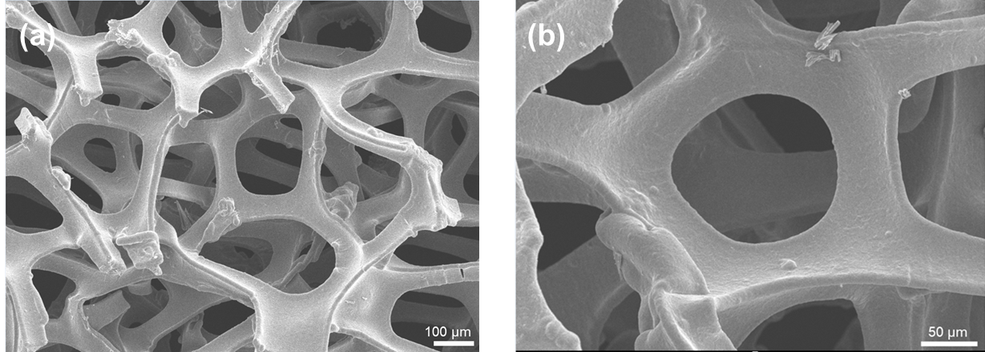
Figure S1. SEM images of NF(100 μm and 50μm)

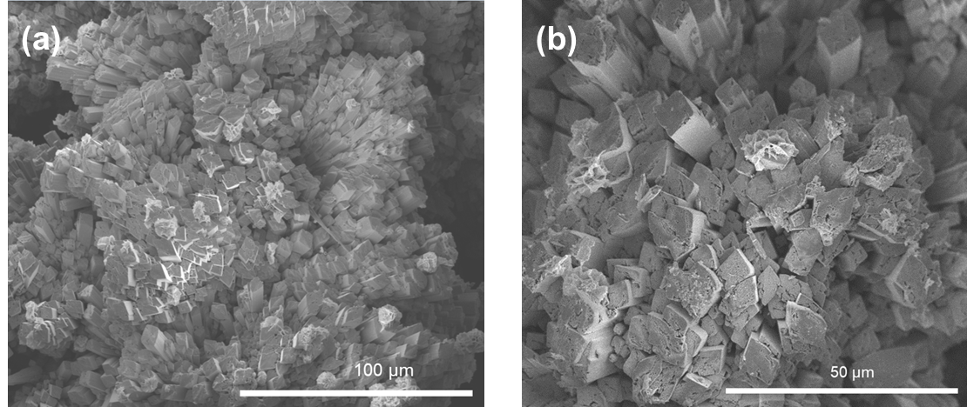
Figure S2. SEM images of Co-Mo/NF(100 μm and 50μm)

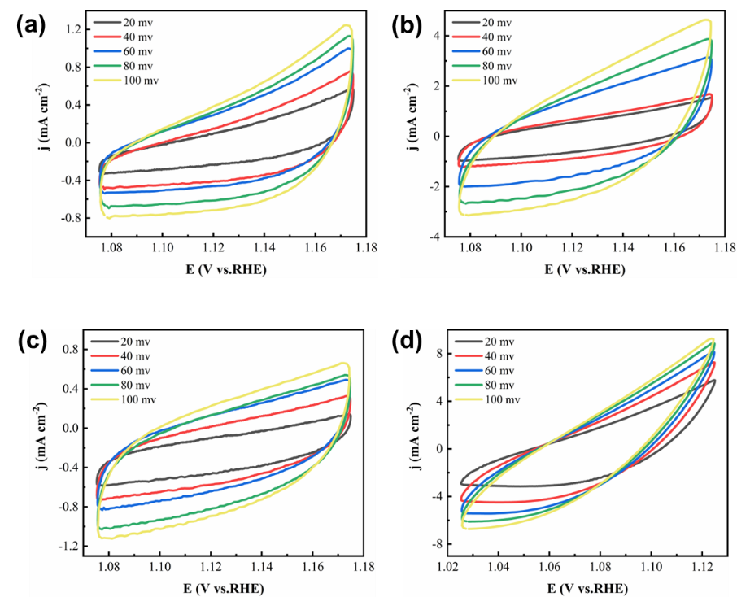
Figure S3. HER cyclic voltammetry curves of (a) MoP/NF, (b) Co-Mo/NF, (c) Co-P/NF
and (d) Co-Mo-P/NF at different scan rates (20、40、60、80 and 100 mV/s).

