Supplementary Material

Supplementary Figure S1

Figure S1：Scatter plot in the Mendelian randomization analysis of endometriosis and cardiovascular disease. (A) coronary heart disease; (B) myocardial infarction; (C) heart failure; (D) atrial fibrillation; (E) hypertension;(F) stroke.

(A) | （B） | (C)
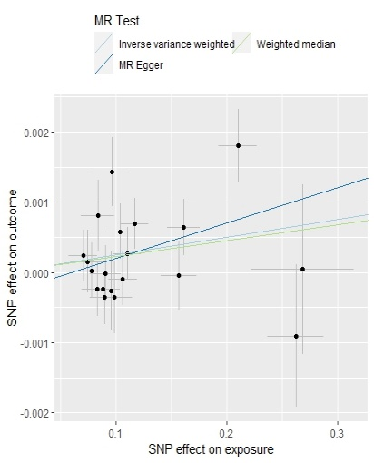 |  | 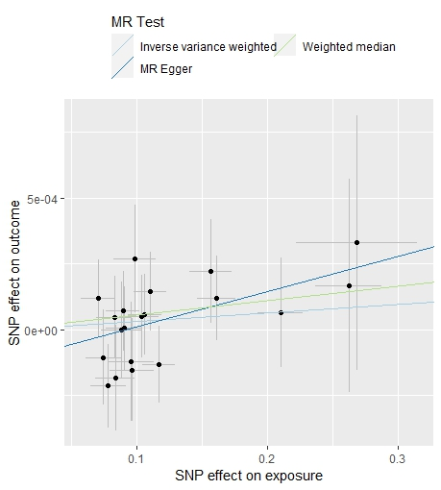
(D) | (E) | (F)
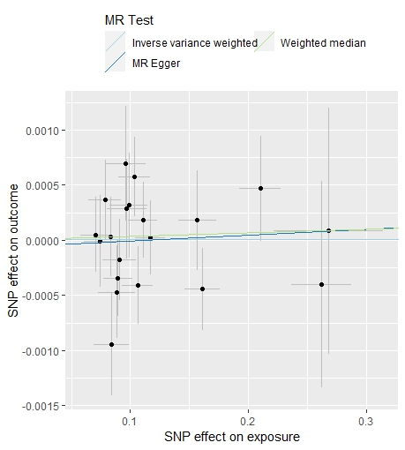 | 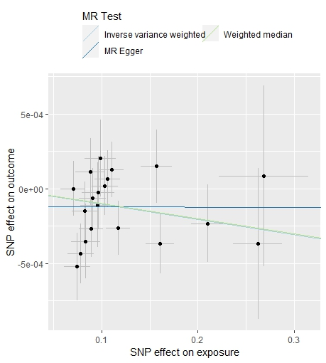 | 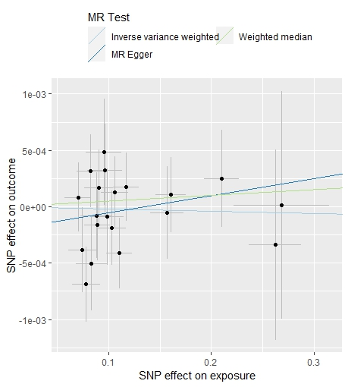
Supplementary Figure S2
(A) | (B) | (C)
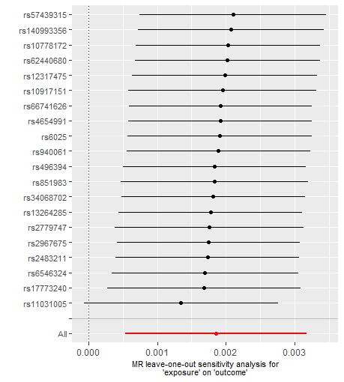 |  | 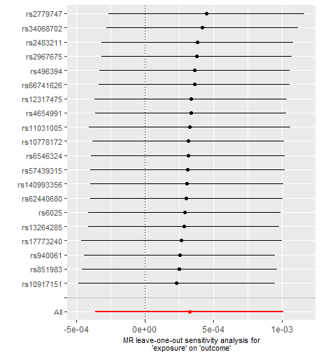
(D) | (E) | (F)
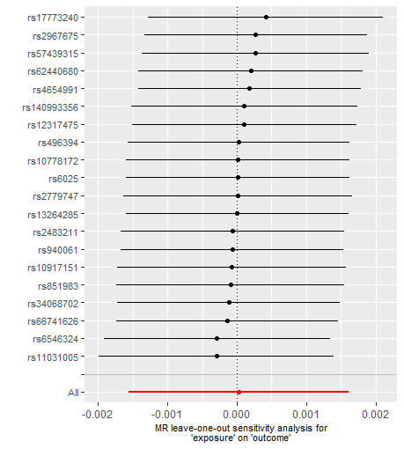 |  | 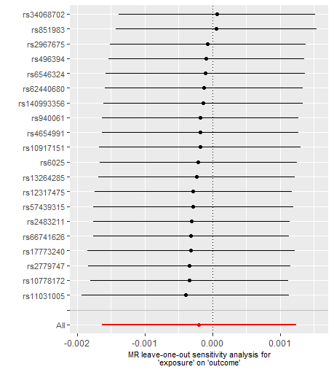

Figure S2：Leave-one-out sensitivity analysis in the Mendelian randomization analysis of endometriosis and cardiovascular disease in FinnGen study in the Mendelian randomization analysis of endometriosis and cardiovascular disease. (A) coronary heart disease; (B) myocardial infarction; (C) heart failure; (D) atrial fibrillation; (E) hypertension;(F) stroke.

