Supplementary Figures and Tables
Table S1 List of primers used for validation of DEGs using RT-PCR.
Classification | Gene id | Direction | Sequence(5'- 3’) | Size(bp)
Up regulated | Vn4695 | Forward | CTAAAACAGTATATCTGCTACGGACG | 246
Up regulated |  | Reverse | GGCGTATAAAAGGATGGTTGGTGA
Up regulated | Vn2069 | Forward | TAAACGGACCAAGCCAATAGATCC | 244
Up regulated |  | Reverse | GCTGTGCTGATGGAGGTAGTTTT
Up regulated | Vn4624 | Forward | CTCCATCGCCTTATTCACATAATC | 244
Up regulated |  | Reverse | TCCACACTCGCTTCAGCAATTG
Up regulated | Vn4193 | Forward | GGTCAAGGAAGAGGAAAGATTATGA | 248
Up regulated |  | Reverse | TGAACAGTGTAAGGTTCTCCACTC
Up regulated | Vn2361 | Forward | TCGATGCATCACTACACGCTTTAT | 238
Up regulated |  | Reverse | TACTAGCCATGTCGCGAGCAAT
Up regulated | Vn5354 | Forward | TAGCCAGTGAAGATCATACGTTGC | 247
Up regulated |  | Reverse | GAGTCAGCTCCAATCGATTTACAG
Downregulated | Vn1489 | Forward | CCATATGAGGAAGCCCCATTGA | 241
Downregulated |  | Reverse | GCTCATTGCCCATCAGTTAATCG
Downregulated | Vn2603 | Forward | CATTACACTTGAAACGGCCATG | 243
Downregulated |  | Reverse | GGACTTCTTGGGCCATTTGAAG
Downregulated | Vn2631 | Forward | CTGAGCTAACGACTGAAGATTGCA | 241
Downregulated |  | Reverse | CAGCATGGAGAGGCTAGAGAT
Downregulated | Vn3411 | Forward | TCTGGGCCATCAGGATACTCAT | 247
Downregulated |  | Reverse | GCACAACTAGGAGAAGCTCAGAT
Downregulated | Vn4108 | Forward | ATTATAGACTCCCCAGCACCTCA | 226
Downregulated |  | Reverse | TGTAGCAAGGGCAGAACTGCTT
Downregulated | Vn4241 | Forward | GTTCTATGGAGCCCACATGGTT | 244
Downregulated |  | Reverse | CCCTTTCCTCTCCAAATAGGCAT
Downregulated | Vn4778 | Forward | CAACTCTAGCATATTTGAACCCG | 245
Downregulated |  | Reverse | ATCGTTGCCACCAAGCGTGATAA
Actin | VnACT8-1 | Forward | CATTACCTCATTCACTCGCCATT | 229
Actin |  | Reverse | ACAATACTTGGGAAAACCGCCCT
Table S2 List of Heat shock proteins identified in transcriptome of Veronica nakaiana response to drought stress
Gene ID | Gene description
Vn5724 | heat shock 70 kDa protein
Vn1392 | small heat shock protein, chloroplastic-like
Vn4081 | Heat shock transcription factor
Vn4518 | heat shock 70 kDa protein 8
Vn1299 | 17.3 kDa class I heat shock protein-like
Vn3249 | heat shock protein 1
Vn5249 | 16.9 kDa class I heat shock protein 1-like
Vn5727 | 16.9 kDa class I heat shock protein 1-like
Vn3069 | 15.7 kDa heat shock protein, peroxisomal
Vn4815 | heat shock protein 17.9
Vn4814 | 18.2 kDa class I heat shock protein-like
Vn2569 | Class I heat shock protein
Vn1106 | heat shock factor protein HSF24-like
Vn2543 | 17.9 kDa class II heat shock protein
Vn1298 | heat shock protein 1
Vn3004 | heat shock 70 kDa protein, mitochondrial

Table S3 List of major transcription factors (TFs) identified in transcriptome of Veronica nakaiana, in response to drought stress.
TF Family | Gene ID | Gene description
NAC | Vn1221 | NAC transcription factor 56-like
AP2/ERF | Vn291 | PREDICTED: ethylene-responsive transcription factor ERF017-like
AP2/ERF | Vn12 | PREDICTED: ethylene-responsive transcription factor RAP2-10-like
AP2/ERF | Vn2435 | ethylene-responsive transcription factor 4-like
AP2/ERF | Vn2434 | ethylene-responsive transcription factor 4-like
AP2/ERF | Vn158 | ethylene-responsive transcription factor ABR1-like
AP2/ERF | Vn157 | ethylene-responsive transcription factor ABR1-like
AP2/ERF | Vn4670 | ethylene-responsive transcription factor RAP2-3
AP2/ERF | Vn5182 | LOW QUALITY PROTEIN: ethylene-responsive transcription factor ERF061
AP2/ERF | Vn2974 | ethylene-responsive transcription factor ERF069
AP2/ERF | Vn4283 | PREDICTED: ethylene-responsive transcription factor 12
AP2/ERF | Vn2975 | ethylene-responsive transcription factor ERF069
AP2/ERF | Vn5183 | LOW QUALITY PROTEIN: ethylene-responsive transcription factor ERF061
AP2/ERF | Vn1165 | AP2/ERF and B3 domain-containing transcription factor At1g50680
AP2/ERF | Vn1930 | ethylene-responsive transcription factor ERF109
AP2/ERF | Vn1047 | ethylene-responsive transcription factor ERF054-like
AP2/ERF | Vn4117 | PREDICTED: ethylene-responsive transcription factor TINY-like
AP2/ERF | Vn4284 | ethylene-responsive transcription factor 12
AP2/ERF | Vn5184 | LOW QUALITY PROTEIN: ethylene-responsive transcription factor ERF061
AP2/ERF | Vn13 | PREDICTED: ethylene-responsive transcription factor RAP2-10-like
AP2/ERF | Vn3336 | ethylene-responsive transcription factor 9
bZIP | Vn413 | bZIP transcription factor 23
bZIP | Vn1404 | bZIP transcription factor 53
bZIP | Vn1405 | bZIP transcription factor 53
bZIP | Vn3126 | bZIP transcription factor 23-like
bZIP | Vn3125 | bZIP transcription factor 23-like
bZIP | Vn232 | bZIP transcription factor 17
bHLH | Vn4695 | Transcription factor SPATULA like
bHLH | Vn728 | Transcription factor SPATULA like
bHLH | Vn235 | transcription factor SPATULA
bHLH | Vn804 | transcription factor bHLH130
bHLH | Vn3878 | transcription factor bHLH18-like
bHLH | Vn806 | transcription factor bHLH130
bHLH | Vn4885 | PREDICTED: transcription factor bHLH147-like
bHLH | Vn1071 | transcription factor bHLH51-like
bHLH | Vn1565 | transcription factor bHLH13-like
bHLH | Vn4313 | transcription factor bHLH137
GATA | Vn82 | GATA transcription factor-like protein
GATA | Vn330 | GATA transcription factor 12-like
GATA | Vn3894 | GATA transcription factor 24-like isoform X2
GATA | Vn2356 | PREDICTED: GATA transcription factor 7
GATA | Vn329 | GATA transcription factor 12
GATA | Vn4264 | GATA-4/5/6 transcription factor
WRKY | Vn1895 | probable WRKY transcription factor 23
WRKY | Vn4965 | probable WRKY transcription factor 3 isoform X2
WRKY | Vn3780 | probable WRKY transcription factor 71
WRKY | Vn5552 | WRKY transcription factor 20
WRKY | Vn5429 | probable WRKY transcription factor 57
WRKY | Vn3547 | double WRKY type transcription factor
MYB | Vn366 | Transcription factor, Myb supERFamily
MYB | Vn1587 | MYB-like transcription factor ETC1
MYB | Vn171 | transcription factor MYB108-like
MYB | Vn172 | transcription factor MYB62
MYB | Vn548 | transcription factor MYB1R1
MYB | Vn2381 | MYB-related transcription factor
MYB | Vn3150 | transcription factor MYB36-like
MYB | Vn3989 | transcription factor MYB3R-3-like isoform X1
MYB | Vn1578 | transcription factor MYB25
MYB | Vn3990 | transcription factor MYB3R-3-like isoform X1
MYB | Vn2315 | transcription factor MYB3R-5
MYB | Vn4021 | transcription factor MYB3 isoform X1
MYB | Vn2688 | transcription factor MYB1R1
MYB | Vn4669 | Transcription factor, Myb supERFamily
MYB | Vn3364 | MYB-related transcription factor
MYB | Vn4738 | MYB-related transcription factor

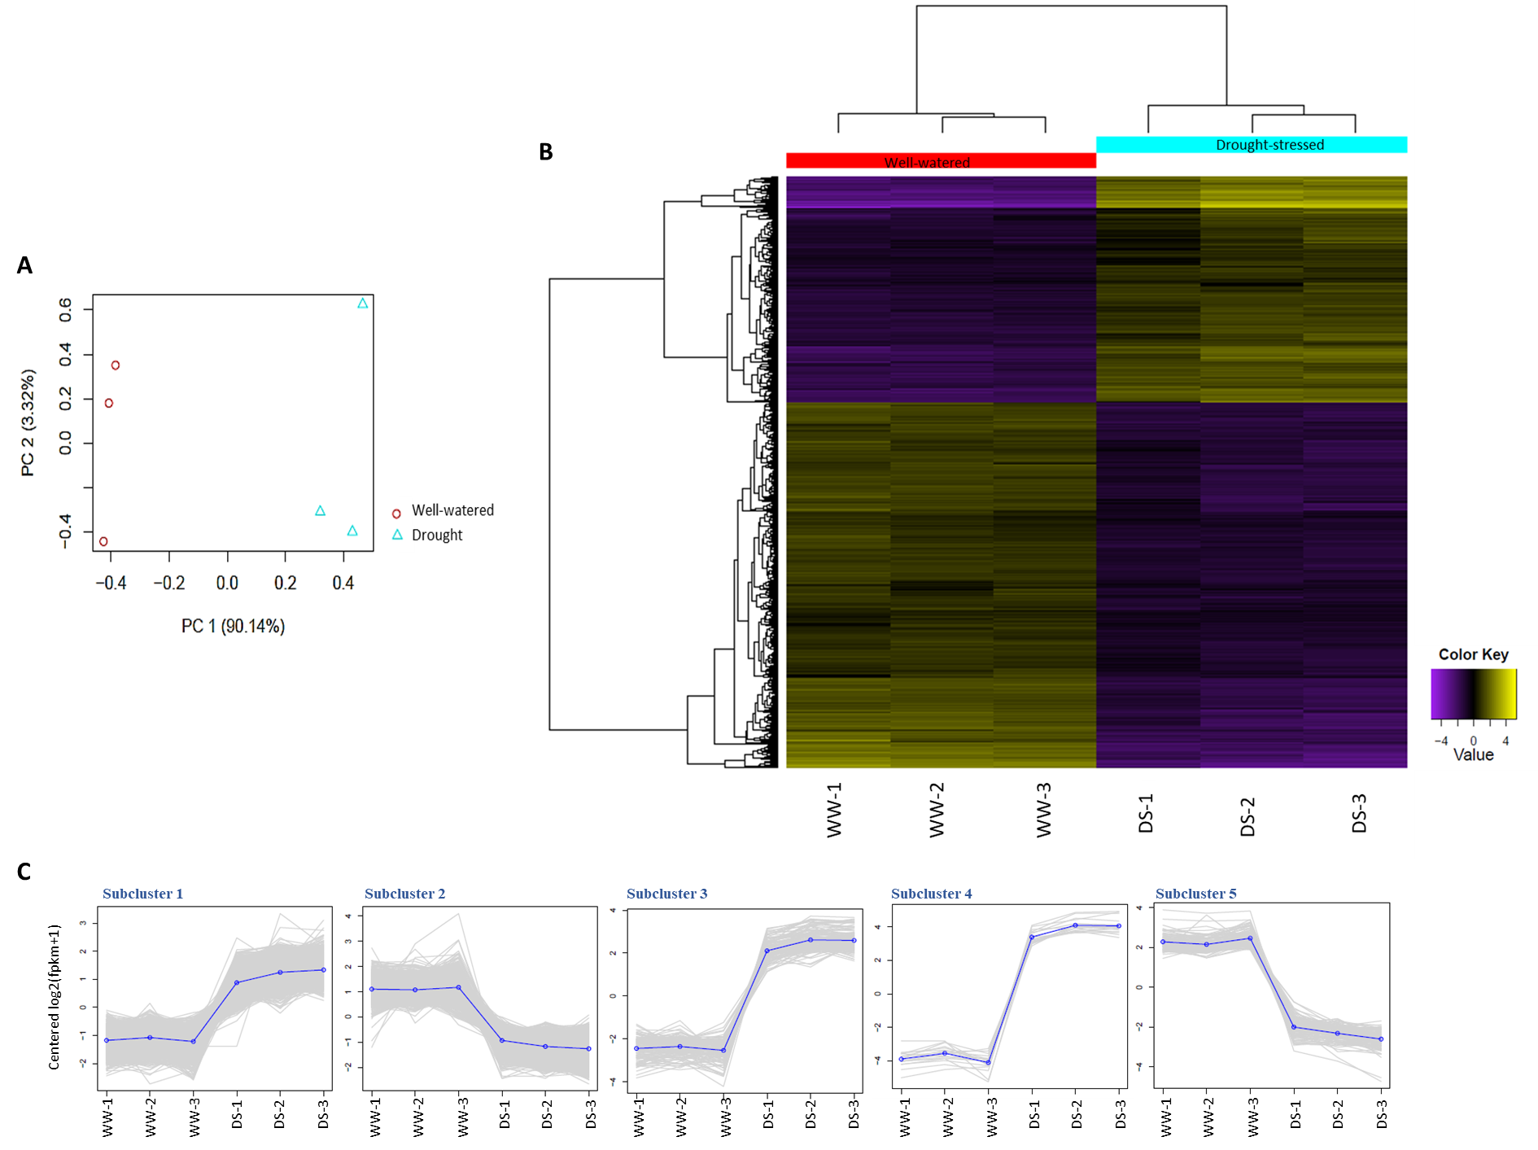
Fig. S1 A) Principal component, B) Clustered heatmap and C) Sub-clustering analysis of the well-watered and drought stress induced transcriptome data of Veronica nakaiana.

