Supporting Information for
Supraphysiological glutamine as a means of depleting intracellular amino acids to enhance pancreatic cancer chemosensitivity

Hayato Muranaka, Sandrine Billet, Carlos D. Cruz-Hernández, Johanna ten Hoeve, Gabrielle Gonzales, Omer H.M. Elmadbouh, Le Zhang, Bethany Smith, Mourad Tighiouart, Sungyong You, Mouad Edderkaoui, Andrew Hendifar, Stephen J. Pandol, Jun Gong and Neil A. Bhowmick

Neil A. Bhowmick
Email: bhowmickn@cshs.org

This PDF file includes:

Supplemental Materials and Methods
Supplementary Fig. S1 to S9
Tables S1 to S2
SI References

Supporting Information Text

Supplementary Materials and Methods

Compounds. Gemcitabine (Gem; Hospira, Lake Forest, IL) and Digoxin (Sandoz, Princeton, NJ) were dissolved in sterile water. L-Glutamine (Thermo Fisher Scientific, Waltham, MA), L-Threonine (Cayman Chemical, Los Angeles, CA), and D-Glutamine (Cayman Chemical) were dissolved in cell culture media for in vitro experiments. Ouabain octahydrate (Thermo Fisher Scientific, Waltham, MA), CB-839 (Calithera Biosciences, South San Francisco, CA) were dissolved in Dimethyl sulfoxide (DMSO). Final DMSO concentration was < 0.1% in vitro.

Cell lines and cell culture. MIA PaCa-2, HPAF-II, PANC-1, BxPC-3, HCT116, 22Rv1 and JHOC5 were cultured in RPMI-1640. UN-KPC-960, UN-KPC-961 and C2C12 were cultured in Dulbecco's Modified Eagle Medium (DMEM). Amino acid deprivation media was made up of DMEM low glucose and amino acid-free supplemented with sodium pyruvate (0.11 g/l), D-glucose (4.5 g/l). Gln studies were performed in Gln-free media supplemented with indicated concentrations of L-Gln and/or D-Gln. Thr studies were performed in methionine and threonine-free DMEM supplemented with L-methionine (0.03 g/l), D-glucose (4.5 g/l), and indicated concentrations of L-Thr. The culture media were all supplemented with 10% fetal bovine serum and 1% penicillin/streptomycin (all component from Fisher Scientific; Hampton, NH). The cells were tested for mycoplasma using MycoAlertTM PLUS Mycoplasma Detection Kit (Lonza, Rockland, ME) regularly. Mycoplasma-negative cells were used for the studies.

Cell counting and clonogenic assay. Cells proliferation studies were performed by seeded cells in 6-well plates, allowed to attach overnight, and exposed to indicated agents for 2-4 days. Cells harvested using 0.05% trypsin-EDTA were stained with 0.4% trypan blue staining (in 0.81% sodium chloride and 0.06% potassium phosphate dibasic solution) and enumerated by TC20 Automated Cell Counter (Bio-Rad, Hercules, CA).

Clonogenicity was measured on cells seeded in 12-well plates exposed to different concentrations of indicated agents for 9-12 days. The medium was changed every three days. Cells were fixed and stained with 6% Glutaraldehyde (Thermo Fisher Scientific) and 0.5% Crystal Violet (Sigma-Aldrich). The bound dye was released with 10% acetic acid (Sigma-Aldrich), and the optical density of the solution at 595 nm was measured by using iMarkTM Microplate Absorbance Reader (Bio-Rad).

Cell cycle and cell viability. For cell cycle analysis, cells were dissociated to a single-cell suspension and fixed with 70% EtOH for 30 minutes at -20 °C. Then the cells were incubated with 10 μg/ml RNase A (Thermo Fisher Scientific) for 30 minutes at 37 °C, 50 μg/ml propidium iodide (Sigma-Aldrich) in 50% EtOH for analysis by BD AccuriTM Flow Cytometer (BD Biosciences, San Jose, CA). Similar single-cell suspensions were directly incubated with 10 μg/ml propidium iodide in 1% bovine serum albumin and PBS at room temperature for 15 minutes for cell viability determination by flow cytometry (in the absence of cell permeabilization). Data analysis was performed using FlowJo v10.6.2. software in both experiments.

Small interfering RNA (siRNA) cell transfection. MIA PaCa-2 cells and BXPC-3 cells were transiently transfected with siRNA according to the manufacturer’s protocol by Lipofectamine 3000 (Thermo Fisher Scientific) with control siRNA (sc-37007) and siRNA targeting human xCT (SLC7A11) (sc-76933), human ASCT1 (SLC1A4) (sc-60208), purchased from Santa Cruz Biotechnology (Santa Cruz, CA). Transfected cells were cultured in medium with gemcitabine for 2 days for cell viability or for intracellular ROS measurement.

Intracellular ROS. Cells were dissociated to a single-cell suspension and incubated with 20 μM H₂DCFDA (Thermo Fisher Scientific) for intracellular ROS measurement. After incubation, cells were immediately analyzed by flow cytometry. Data analysis was performed using FlowJo v10.6.2. software.

Seahorse metabolic flux analysis. MIA PaCa-2 cells were cultured with different concentration of L-Gln for 24 hours, then seeded to Seahorse XF24 Cell Culture Microplate (Agilent Technologies, Santa Clara, CA). A sensor cartridge (Agilent Technologies) was hydrated in Seahorse XF Calibrant (Agilent Technologies) at 37 °C in a non-CO₂ incubator overnight. After an additional 24 hours incubation, cells were washed with the assay medium: Seahorse XF Base Medium (Agilent Technologies) supplemented with 10 mM glucose, 1 mM sodium pyruvate and 2 mM glutamine (pH 7.4). The cell culture microplate was placed in 37 °C non-CO₂ incubator for one hour prior to the assay. Oxygen consumption rate (OCR) measurement was performed using Seahorse XFe24 Analyzer (Agilent Technologies) under basal conditions or in response to sequential treatment with 2 μM oligomycin, 0.72 μM FCCP, and 1 μM rotenone/antimycin A.

Macropinocytosis assay. Cells were treated with 0.2 mg/ml FITC-Dextran (40 kDa, Thermo Fisher Scientific) for 48 hours. Cells were dissociated to a single-cell suspension and immediately analyzed by flow cytometry. Data analysis was performed using FlowJo v10.6.2. software.

Intracellular sodium levels and membrane potential. Cells were dissociated to a single-cell suspension and incubated with either 1 μM Sodium GreenTM tetraacetate (Thermo Fisher Scientific) for intracellular sodium measurement or with 100 nM Bis(1,3-dibutylbarbituric acid) trimethine oxonol (DiBAC₄(3); Sigma-Aldrich) for determining changes in plasma membrane potential. After incubation, cells were immediately analyzed by flow cytometry. Data analysis was performed using FlowJo v10.6.2. software.

Quantitative reverse transcriptase-PCR. The amount and purity of purified RNA was measured by using NanoDropTM spectrophotometer (Thermo Fisher Scientific). A High-Capacity cDNA Reverse Transcription Kit (Thermo Fisher Scientific) was used to synthesize cDNA. Real-time polymerase chain reaction (qPCR) was performed using PowerTrack™ SYBR Green Master Mix (Thermo Fisher Scientific), in a reaction mixture (10 μl) containing cDNA solution (1 μl), 2×Master Mix (5 μl), forward primers (0.4 μl), and reverse primers (0.4 μl). The following thermal profile was used for PCR amplification: 40 cycles of 95°C for 15 sec, and 60°C for 1 min on a QuantStudioTM 3 Real-Time PCR System (Thermo Fisher Scientific). PCR primers used are shown in Supplementary Table S2. Expression levels of target genes were normalized to TBP (TATA-box binding protein) expression.

RNA isolation, RNA-sequencing, and gene set enrichment analysis. Total RNA was extracted following 2 days of treatment and prepared using the RNeasy Mini extraction kit (Qiagen, Germantown, MA) according to the manufacturer’s instructions. Preparation of RNA library and transcriptome sequencing was conducted by Novogene (Sacramento, CA). The read counts were normalized using the Trimmed Mean of the M-values (TMM) method and differential expression analysis was performed using integrated hypothesis testing method [1, 2]. False discovery rate (FDR) was computed using Benjamini-Hochberg method. Finally, differentially expressed genes were selected with FDR < 0.05 and absolute fold change |FC| > 1.5. Gene set enrichment analysis of differentially expressed genes was per-formed by the GSEA tool (version 4.0.3).

Metabolomics analysis. Cells treated for 48 hours and tumor tissues were subject to metabolomic analysis. Metabolites were extracted by adding four-volumes of 50:50 Methanol: Ethanol extraction buffer and dried. The metabolite extract was resuspended in 20% methanol 80% water buffer for analysis. Extractions were analyzed with an Agilent 6470A triple quadrupole mass spectrometer, operating in negative mode, connected to an Agilent 1290 Ultra High-Performance Liquid Chromatography (UHPLC) system (Agilent Technologies, Santa Clara CA) using ZORBAX RRHD Extend-C18 1.8 µm 2.1 x 150 mm coupled with a ZORBAX Extend Fast Guard column Extend-C18, 1.8 µm, 2.1 mm x 5 mm with the following buffers: Buffer A (3% methanol, 10 mM tributylamine [TBA] and 15 mM acetic acid), Buffers B (isopropanol), Buffer C (methanol with 10 mM TBA and 15 mM acetic acid), and Buffer D (acetonitrile). The MassHunter Metabolomics dMRM Database and Method was used to scan for up to 219 polar metabolites within each sample (Agilent Technologies, Santa Clara CA). Resulting chromatograms were visualized in Agilent MassHunter Quantitative Analysis for QQQ. The final peaks were manually checked for consistent and proper integration.

Dried metabolites extracted from cell lysates were resuspended in 50% acetonitrile: water and 1/10th loaded onto a Luna 3 µM NH₂ 100A (150 × 2.0 mm) column (Phenomenex, Torrance, CA). The chromatographic separation was performed on a Vanquish Flex (Fisher Scientific) with mobile phases Buffer A (5 mM NH₄AcO, pH 9.9) and Buffer B (acetonitrile) at a flow rate of 200 μl/min. A linear gradient from 15% to 95% Buffer A over 18 min was followed by 9 min isocratic flow and re-equilibration to 15% Buffer A. Metabolites were detected with a Thermo Scientific Q Exactive mass spectrometer, run with polarity switching (+3.5 kV/− 3.5 kV) in full scan mode having an m/z range of 70-975 and 70.000 resolution. TraceFinder 4.1 (Thermo Fisher Scientific) was used to quantify the targeted metabolites by area under the curve using expected retention time and accurate mass measurements (< 5 ppm). Relative amounts of metabolites were calculated by summing up the values for all isotopologues of a given metabolite. Metabolite isotopologue distributions were corrected for natural C13 abundance. Data analysis, including principal component analysis, metabolic pathway analysis, and heat map generation were performed using R and MetaboAnalyst 5.0 (https://www.metaboanalyst.ca).

Amino acid uptake. MIA PaCa-2 and BxPC-3 were suspended in Gln-free RPMI 1640 Medium supplemented with 40 nM L-[3,4-³H(N)]-Glutamine (PerkinElmer, Waltham, MA) and incubated at 37 °C for 30 min in the presence of indicated concentrations of L-Thr. Radio-labeled cells were washed with PBS, resuspended in 100 µl of PBS, and mixed with 5 mL of ScintiVerse™ BD Cocktail (Thermo Fisher Scientific). Radioactivity was measured using the Tri-Carb 3110TR Liquid Scintillation Analyzer (PerkinElmer).

Animal studies. Briefly, UN-KPC-960 cells were suspended in DMEM, and mixed with the same volume of CorningTM MatrigelTM Membrane Matrix (Thermo Fisher Scientific) 1-1.5 x 10⁷ cells/ml. One million cells were inoculated subcutaneously into both right and left side of the abdominal flank of 8 weeks old male athymic nude mice (Envigo, Madison, WI). After a week, mice were injected with gemcitabine (50 mg/kg, intraperitoneal, twice a week) and/or L-Gln/D-Gln (30 mg/kg, subcutaneously, daily). During the treatment, body weight and tumor volume were measured every 2-3 days. 7-10 days after starting the treatment, tumor tissues and blood were collected for the analysis. Tumor volume was calculated using the modified ellipsoid formula: volume = π/6 × (width)² × length. All mouse studies were approved by the Institutional Animal Care and Use Committee at Cedars-Sinai Medical Center and conducted in accordance with mandated standards of humane animal care.

Immunoblotting and immunohistochemistry. Antibodies against CHOP (#2895), ATF4 (#11815), and PARP (#9542) were from Cell Signaling (Danvers, MA) with ß-actin (sc-47778) from Santa Cruz Biotechnology (Santa Cruz, CA). Protein expression was visualized using alkaline phosphatase-conjugated secondary antibody (Sigma-Aldrich) on Immobilon® PVDF membranes (Millipore). Paraffin sections of tumor tissues (5 μm) were subjected to hematoxylin and eosin (H&E) and histochemical staining for phosphorylated histone H3 (1:200, Cell Signaling), TUNEL (Millipore, Bedford, MA), CHOP (1:200, Cell Signaling) as previously described [3].

Liver physiological functions. Mouse liver functions were assessed by measuring serum lactate dehydrogenase (LDH), alkaline phosphatase (ALP), alanine aminotransferase (ALT), and aspartate aminotransferase (AST) according to the manufacturer’s protocol (Biomedical Research Service Center at University at Buffalo, Buffalo, NY).

Statistics. All statistical analyses except synergistic capacity were performed using GraphPad Prism 7 (GraphPad Software, San Diego, CA). Data were analyzed by one-way ANOVA followed by a Tukey post-hoc test or Student’s t test, or by two-way ANOVA followed by a Tukey post-hoc test. P value < 0.05 was considered significant. All assays were performed a minimum of three times. The synergistic capacity of combination therapies was tested based on the Chou-Talalay’s method where combination index (CI) was calculated to determine synergism (CI < 1), additive effect (CI = 1), or antagonism (CI > 1) [4] . DDIT3 expression in the pancreatic cancer TCGA dataset presented in a Kaplan-Meier plot was generated using a scan-based expression cutoff of 16.28.

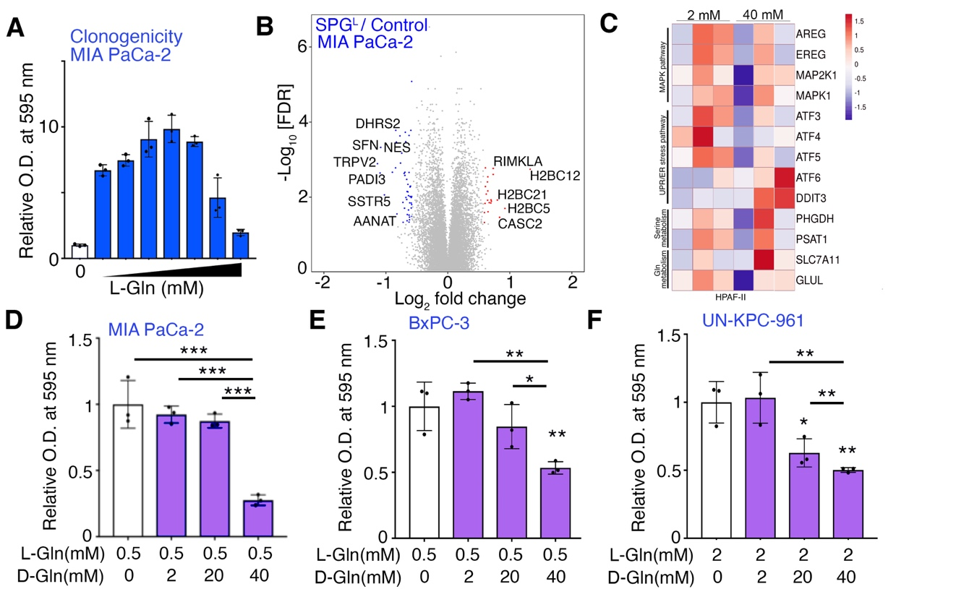

Supplementary Fig. S1. Effects of supraphysiological L-Gln and D-Gln on PDAC cells. (A) Clonogenic assays were performed in MIA PaCa-2 cells cultured with L-Gln (0, 0.2, 0.5, 2, 10, 20, 30 and 40 mM) for 11 days (n = 3). (B) MIA PaCa-2 cells were treated with 40 mM L-Gln (SPG^{L}) or 2 mM L-Gln (Control) for two days. Volcano plot depicted differentially expressed genes in RNA-seq data based on their -log₁₀ FDR and log₂ fold change (FC) (n = 3). (C) The gene expression of the indicated signaling/metabolic pathways in HPAF-II cells incubated with 0.2, 2 and 40 mM Gln for 2 days. (D-F) Clonogenic assays in MIA PaCa-2, BxPC-3, and UN-KPC-961 cells were performed under the indicated concentrations of D-Gln and L-Gln for 7-11 days (n = 3). Values are mean ± SEM. *P < 0.05, **P < 0.01, ***P < 0.001.

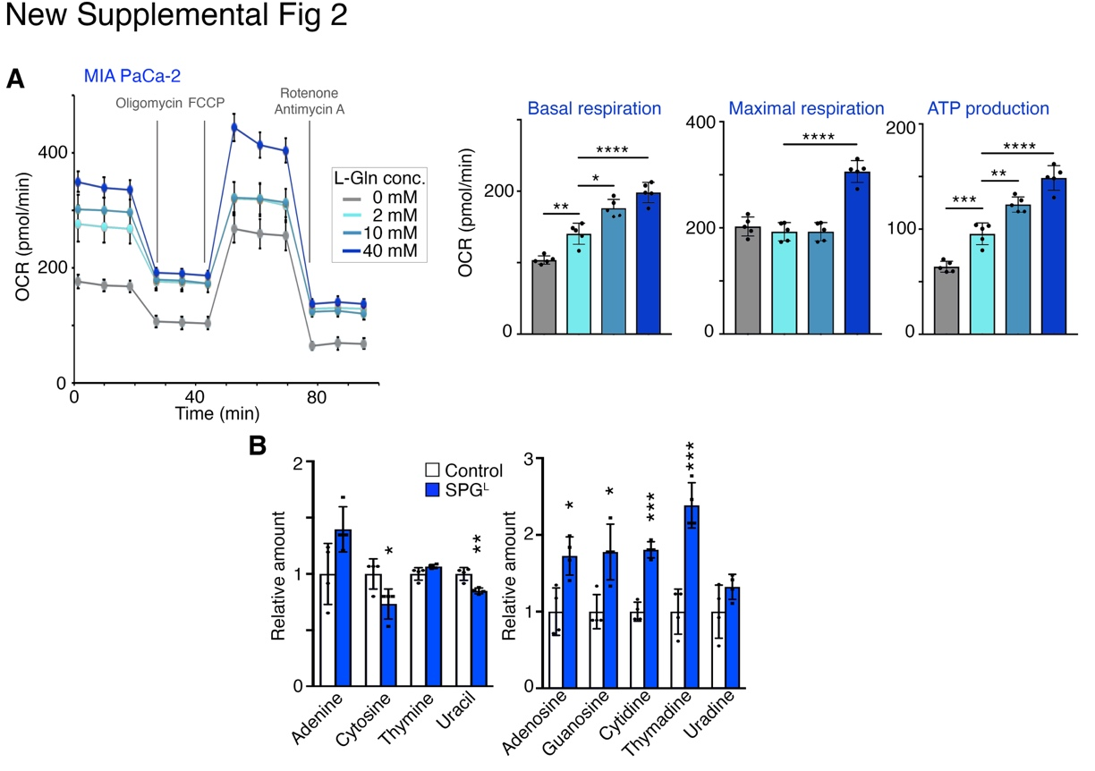

Supplementary Fig. S2. The effects of supraphysiological L-Gln on metabolism. (A) The oxygen consumption rate (OCR) in MIA PaCa-2 cells was measured by seahorse metabolic flux analysis after the treatment with different concentrations of L-Gln (0, 2, 10 and 40 mM). Basal respiration, maximal respiration and ATP production are shown as bar graphs (n = 5). (B) Intracellular base and nucleoside levels in MIA PaCa-2 cells treated with 2 mM L-Gln (Control) or 40 mM L-Gln (SPG^{L}). Values are mean ± SEM. *P < 0.05, **P < 0.01, ***P < 0.001, ****P < 0.0001.

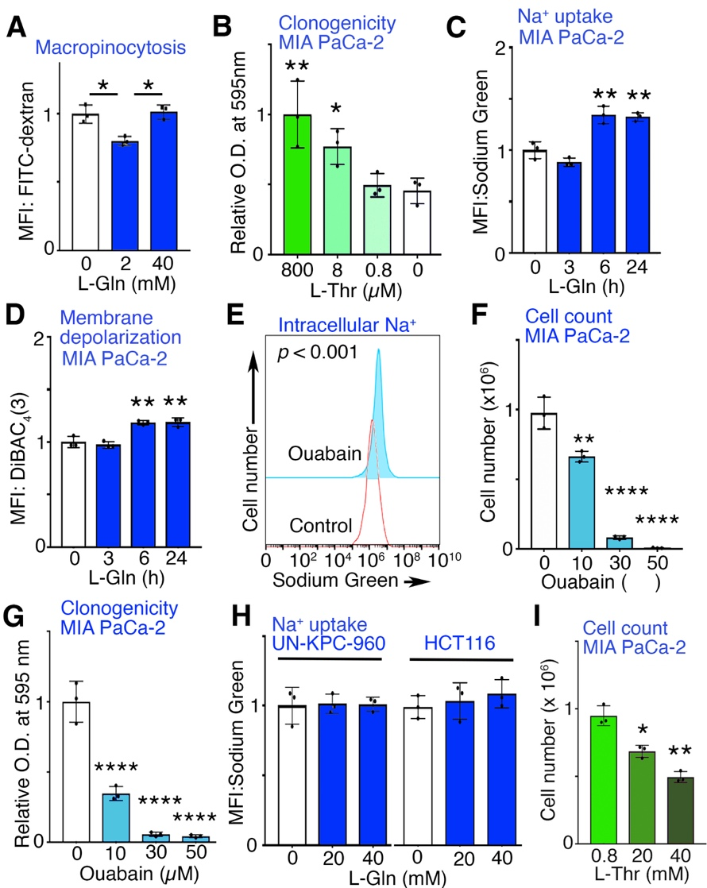
Supplementary Fig. S3. Possible mechanisms involved in supraphysiological Gln-mediated cell growth inhibition. (A) Macropinocytosis was measured in MIA PaCa-2 cells following incubation with the indicated L-Gln concentrations for 48 hours. Mean fluorescent intensity (MFI) of FITC-dextran was measured by flow cytometry (n = 3). (B) Clonogenic assays were performed in MIA PaCa-2 cells cultured in indicated concentrations of L-Thr for 10 days (n = 3). (C) Intracellular sodium levels were measured in MIA PaCa-2 cells following incubation with 40 mM L-Gln for indicated time points. MFI of Sodium Green was measured by flow cytometry (n = 3). (D) Membrane potential was measured in MIA PaCa-2 cells following incubation with 40 mM L-Gln for indicated time points. MFI of DiBAC₄(3) was measured by flow cytometry (n = 3) (E) Intracellular sodium levels were measured in MIA PaCa-2 cells following incubation with vehicle (Control) or 10 µM Ouabain. MFI of Sodium Green was measured by flow cytometry. Histogram for one representative experiment is shown with p value calculated from 3 independent experiments. (F) MIA PaCa-2 cells were cultured with indicated concentrations of ouabain for four days. Live cells were counted with trypan blue staining (n = 3). (G) Clonogenic assays for MIA PaCa-2 cells cultured with indicated concentrations of ouabain for 11 days were quantitated (n = 3). (H) Relative intracellular sodium levels were determined in UN-KPC-960 and HCT116 cells after culture with indicated L-Gln concentrations, determined by Sodium Green uptake (n = 3). (I) Cell number measured after four days of incubation with indicated concentrations of Threonine (L-Thr). Values are mean ± SEM. *P < 0.05, **P < 0.01, ****P < 0.0001.

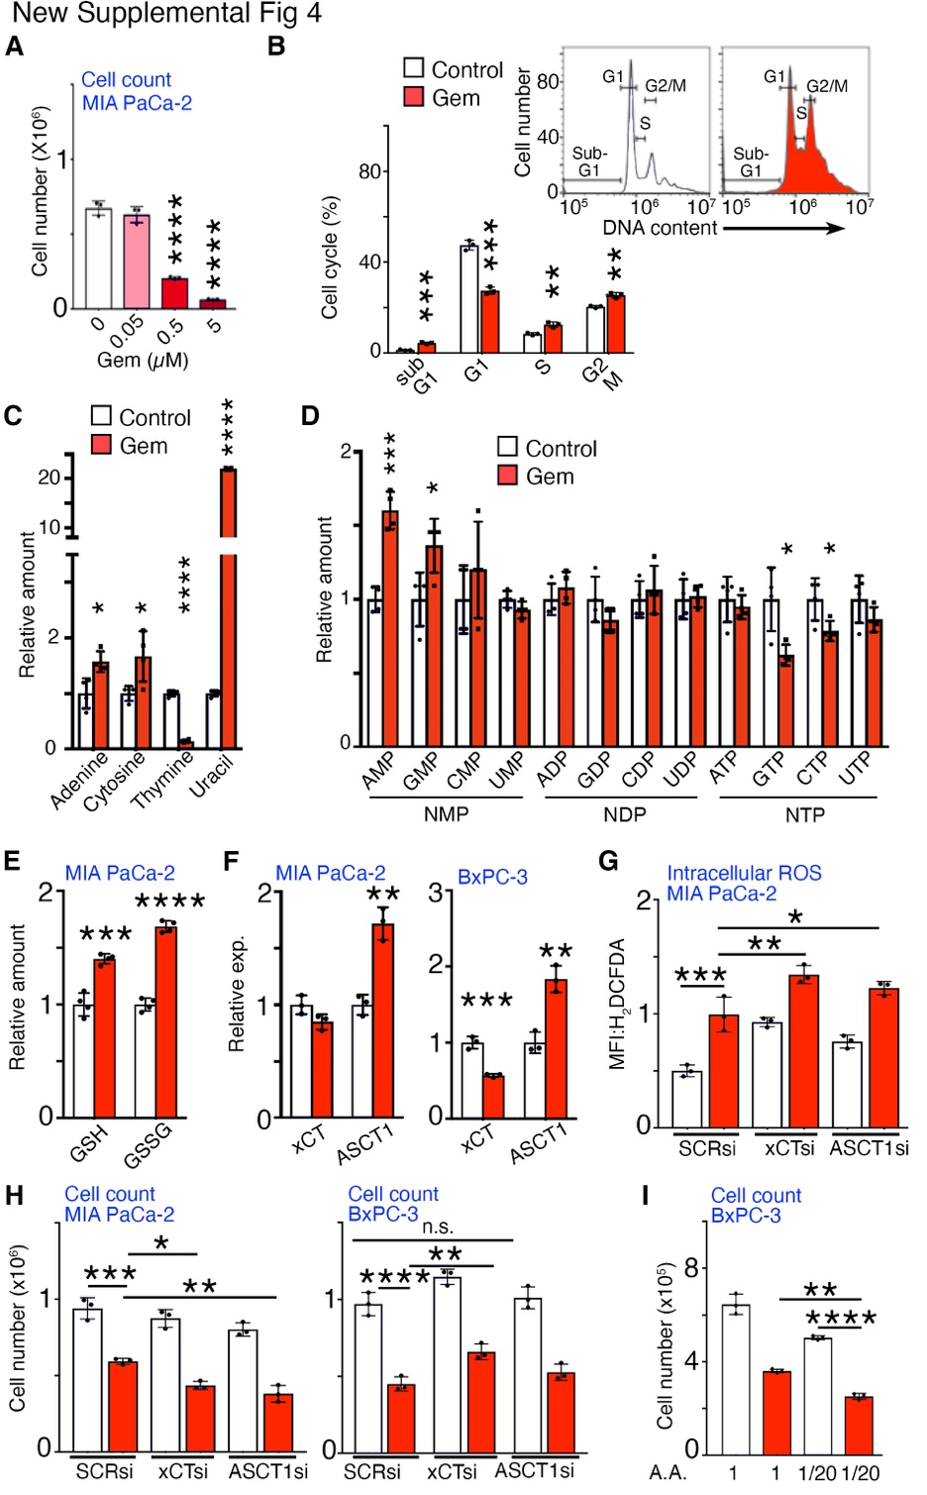

Supplementary Fig. S4. The effects of gemcitabine treatment on cell growth and metabolism in PDAC. (A) MIA PaCa-2 cells were cultured with indicated concentrations of gemcitabine (Gem) for 48 hours. Live cells were counted with trypan blue staining (n = 3). (B) Cell cycle distribution analysis by flow cytometry following PI staining of MIA PaCa-2 cells cultured with vehicle (Control) or 0.5 μM Gem for 48 hours (n = 3). (C and D) Intracellular base and nucleotide levels were detected in MIA PaCa-2 cells cultured with control or 0.5 μM Gem (n = 4). (E) Intracellular GSH and GSSG levels were detected in MIA PaCa-2 cells under the indicated conditions (n = 4). (F) mRNA expression of xCT and ASCT1, membrane transporters for cystine and cysteine, were detected in MIA PaCa-2 and BxPC-3 cells under the indicated conditions (n = 3). (G) Intracellular ROS levels in MIA PaCa-2 cells were determined after siRNA knockdown of xCT, ASCT1, or scrambled control following the treatment with control or 0.5 μM Gem. MFI of H₂DCFDA were measured by flow cytometric analysis (n = 3). (H) Under the same conditions, live cells in MIA PaCa-2 and BxPC-3 were counted (n = 3). (I) BxPC-3 cells were cultured with indicated concentration of Gem and amino acids (A.A.) for two days. Live cells were counted (n = 3). Values are mean ± SEM. n.s.- not significant, *P < 0.05, **P < 0.01, ***P < 0.001, ****P < 0.0001.

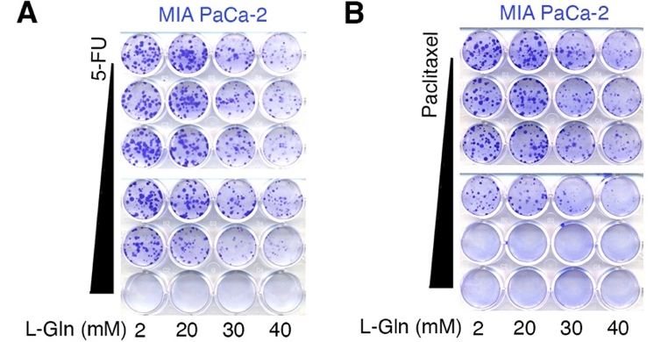

Supplementary Fig. S5. The effects of supraphysiological L-Gln on chemotherapy drug sensitivity. (A and B) Clonogenic assays were performed on MIA PaCa-2 cells cultured with different concentrations of 5-fluorouracil (5-FU; 0, 0.001, 0.01, 0.1, 1, and 10 µM) or paclitaxel (0, 0.0005, 0.001, 0.003, 0.005, and 0.01 µM) at the indicated doses of L-Gln for 11 days.

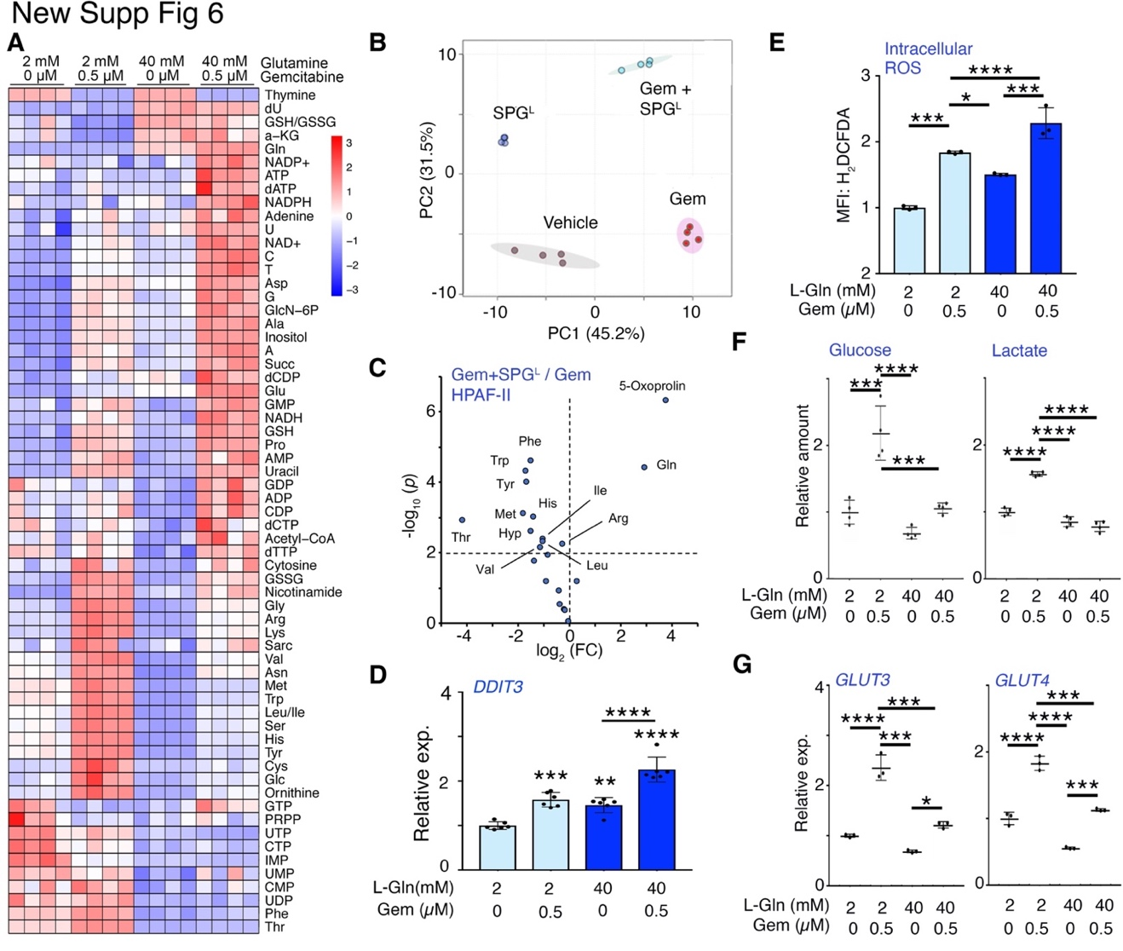

Supplementary Fig. S6. The effects of supraphysiological L-Gln on metabolism in gemcitabine-treated PDAC cells. Type or paste legend here. Paste figure above the legend. (A) Heatmap of the changes in selected metabolites in MIA PaCa-2 cells cultured under indicated conditions for 48 hours (n = 4). Metabolites in blue color represent the trend of decrease, while red represents a rise in enrichment. (B) PCA score plot of metabolites in MIA PaCa-2 cells under the indicated conditions. (C) Volcano plot of differentially enriched metabolites in HPAF-II cells treated with Gem in the absence or presence of SPG^{L}. Metabolites with -log₁₀(p) > 2 were indicated (n = 3). (D) mRNA expression of DDIT3 in MIA PaCa-2 cells cultured with indicated concentrations of Gem and L-Gln for two days (n = 6). (E) Intracellular ROS levels in MIA PaCa-2 cells treated with the indicated concentrations of Gem and L-Gln for two days. Mean fluorescence intensity (MFI) of H₂DCFDA were determined by flow cytometric analysis (n = 3). (F) Glucose and lactate levels in MIA PaCa-2 cells cultured with indicated concentrations of Gem and L-Gln for two days (n = 4). (G) mRNA expression of GLUT3 and GLUT4 in MIA PaCa-2 cells cultured with indicated concentrations of Gem and L-Gln for two days (n = 3). Values are mean ± SEM. *P < 0.05, **P < 0.01, ***P < 0.001, ****P < 0.0001.

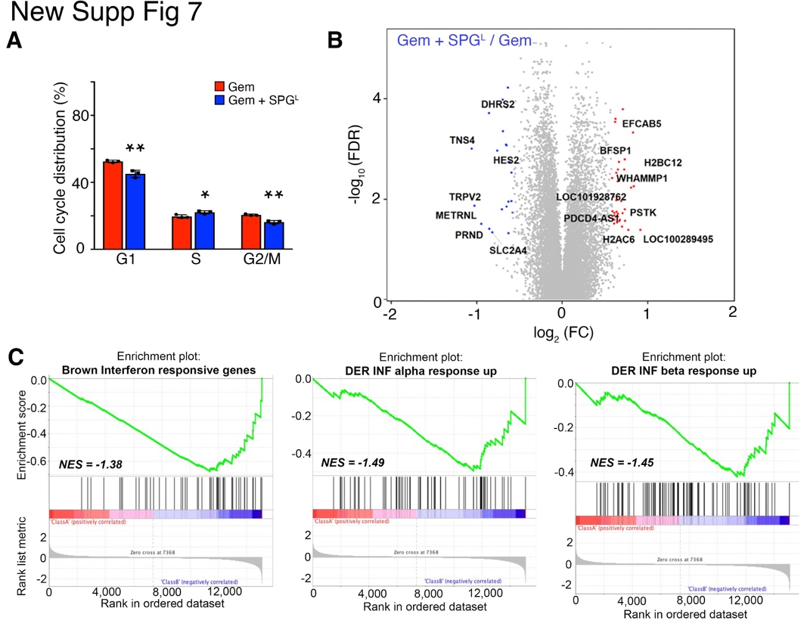

Supplementary Fig. S7. Gene expression profiles in supraphysiological Gln and gemcitabine-treated PDAC cells. (A) Cell cycle distribution analysis of MIA PaCa-2 cells by flow cytometry was performed following culture with 2 mM L-Gln or 40 mM L-Gln (SPG^{L}) in the presence of 0.5 μM gemcitabine (Gem) for four days (n = 3). (B) MIA PaCa-2 cells were treated with SPG^{L} or 2 mM L-Gln in the presence of 0.5 μM Gem for two days. Volcano plot depicted differentially expressed genes in RNA-seq data based on their -log₁₀ FDR and log₂ fold change (FC) (n = 3). (C) GSEA indicated an enrichment of interferon (IFN) response-related gene sets in MIA PaCa-2 cells cultured in SPG^{L} and Gem compared to Gem alone. Values are mean ± SEM. *P < 0.05, **P < 0.01.

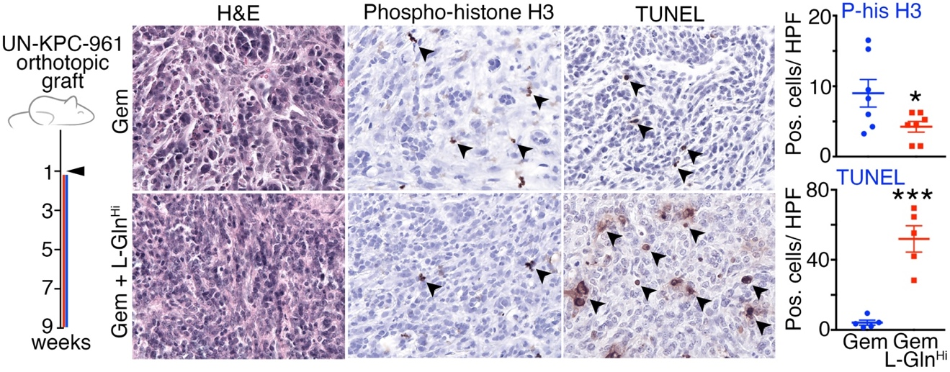

Supplementary Fig. S8. The effects of high dose Gln on orthotopic PDAC allografts. Schematic of the study design represents pancreatic grafting of UN-KPC-961 male 129Sv/C57BL/6 mice. One week after tumor introduction, the mice were administered Gem (50 mg/kg, i.p., twice a week) alone or in combination with L-Gln (250 mg/kg/ twice daily) orally for eight weeks. At endpoint tumor tissues were subjected to histologic analysis (n > 5). At least 6 fields of positive phosphorylated-histone H3 and TUNEL were quantitated to determine the level of significance. Values are mean ± SEM; *P < 0.05, **P < 0.01, ***P < 0.001.

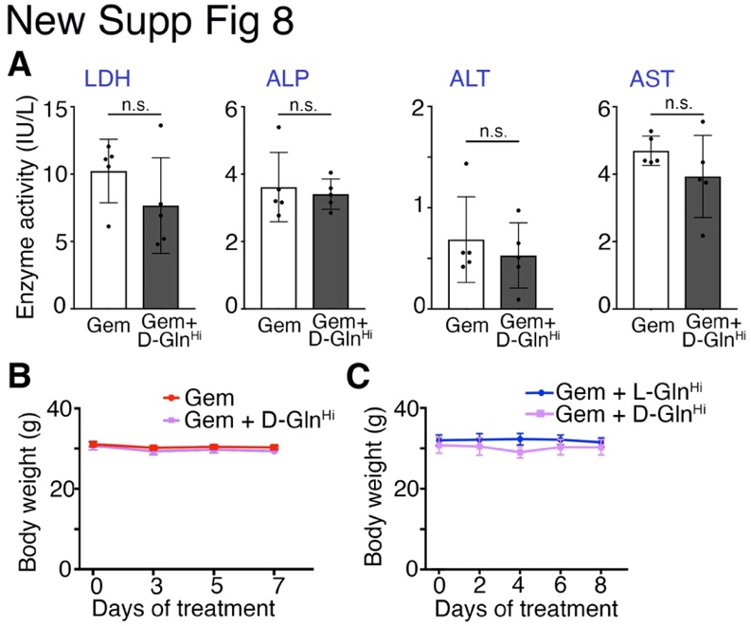

Supplementary Fig. S9. Effects of high dose Gln on mice bearing PDAC tumors. (A) LDH, ALP, ALT, and AST activity were measured in the plasma of mice treated for 1 weeks with gemcitabine in the presence or absence of D-Gln^{Hi}. LDH, lactate dehydrogenase; ALP, alkaline phosphatase; ALT, alanine transaminase; AST, aspartate transaminase (n = 5). (B) Body weight of mice treated with gemcitabine in the presence or absence of D-Gln^{Hi} were monitored longitudinally (n = 5). (C) Body weight of mice treated with gemcitabine in the presence of L-Gln^{Hi} or D-Gln^{Hi} were monitored longitudinally (n = 4). Values are mean ± SEM, n.s. – not significant.

Supplementary Table. S1. Solute carrier family genes upregulated by gemcitabine in MIA PaCa-2 cells

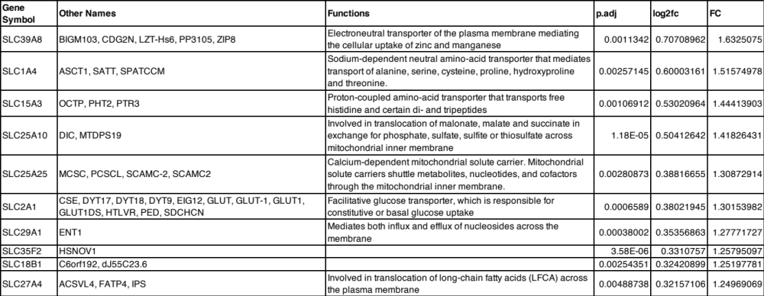

Supplementary Table. S2. PCR primer sequences for qPCR

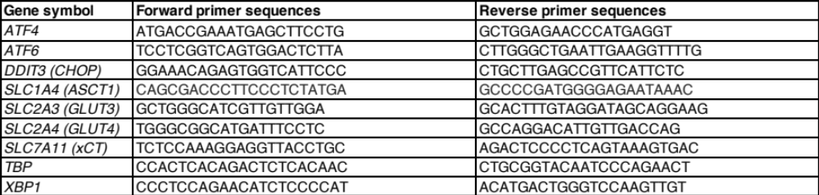

SI References

1 Robinson MD, Oshlack A. A scaling normalization method for differential expression analysis of RNA-seq data. Genome Biol 2010; 11: R25.

2 Hwang D, Rust AG, Ramsey S, Smith JJ, Leslie DM, Weston AD et al. A data integration methodology for systems biology. Proc Natl Acad Sci USA 2005; 102: 17296-17301.

3 Smith BN, Mishra R, Billet S, Placencio-Hickok VR, Kim M, Zhang L et al. Antagonizing CD105 and androgen receptor to target stromal-epithelial interactions for clinical benefit. Molecular Therapy 2023; 31: 78-89.

4 Chou T-C, Talalay P. Generalized Equations for the Analysis of Inhibitions of Michaelis-Menten and Higher-Order Kinetic Systems with Two or More Mutually Exclusive and Nonexclusive Inhibitors. European Journal of Biochemistry 2005; 115: 207-216.

