Investigation of Carbonaceous fractions and elemental composition of PM_{2.5} in residential microenvironments in Mumbai
(Supplementary Information)
1. Minimum detection limit for different OC and EC fractions :
Table 1 Minimum detection limit of OC and EC fractions used in the DRI TOA analyser
 | Analytical MDL values
OC1 | 0.14
OC2 | 0.14
OC3 | 0.14
OC4 | 0.14
OP | 0.04
EC1 | 0.04
EC2 | 0.04
EC3 | 0.04
TC | 0.49
2. Quality assurance quality control for Ion Chromatography :
First and foremost, the correlation coefficient of the individual ions should be at least 0.995.If this is violated those data are discarded. Quality check standards are analysed at the beginning and also after every 10 analytical runs . The results are compared with known QC, it should not exceed the 10% of the known value.

3. Limit of detection of different elements measured by XRF analysis :
Table 2 Limit of detection of different elements(ng/m³) measured by XRF analysis
Ions | Detection Limit | Elements | Detection Limit
Chloride | 4.1 | Al | 3.5
Nitrate | 2.2 | Ca | 0.7
Sulphate | 2.9 | Fe | 0.7
Sodium | 4.3 | Ba | 1.7
Ammonium | 4.1 | Cu | 0.2
Potassium | 2.4 | Pb | 0.4
Calcium | 3.3 | Mn | 0.5
Magnesium | 6 | Zn | 0.2
 |  | As | 0.4

4. Inputs used in exposure assessment
Table 3 Input used for exposure calculation
S. No. |  | Values
1 | Exposure Frequency | 240 days (~8 months excluding monsoon)
2 | Body weight (Kg) | 70 for adults
3 | Averaging Time | 240 to ED for non-carcinogen risk and carcinogen risk, its value is16880
4 | Conversion Fraction | 10⁻⁶ kg mg⁻¹
5 | Absorption factor dermal | 0.03 for As and 0.001 for Cd; for the other metals 0.01 value was taken

Schematic diagram of the study locations :
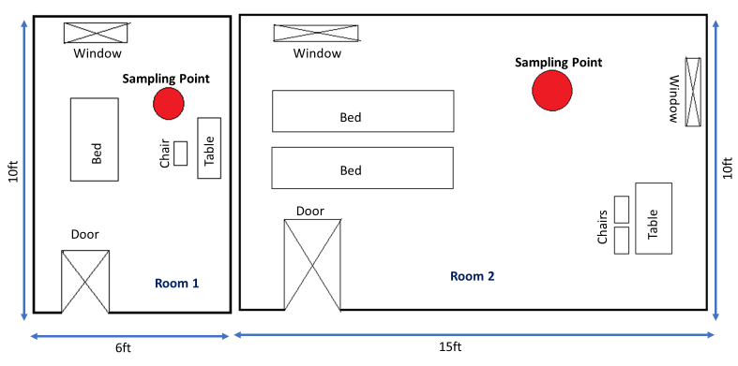
Figure 1 Schematic diagram of the study locations; the red circle indicates the position of the mini vol. sampler
Air Exchange Rate of the Rooms :
The air exchange rate, more precisely, the exfiltration rate, was calculated using CO as the tracer. Incense stick was burnt in the middle of the rooms. After the room filled with smoke, the incense stick was stopped and the decay was monitored. In both rooms, the CO decay showed an exponential decrease. Using the following formula the exfiltration of the Room 1 was found to be 52.93m³/min, and Room 2 was found 39.93 m³/min. The doors were closed, and the window was open during the experiments as it was the most common condition of the rooms during the sample collection period.
Formula : $\frac{Q}{V}$:= $\frac{ln⁡(\frac{C2}{C1})}{T2-T1}$
Q volume of the room in m³; C2 = final concentration; C1 = initial concentration; T2 and T1 are final and initial times, respectively.
Correlation between [H⁺] and SOC :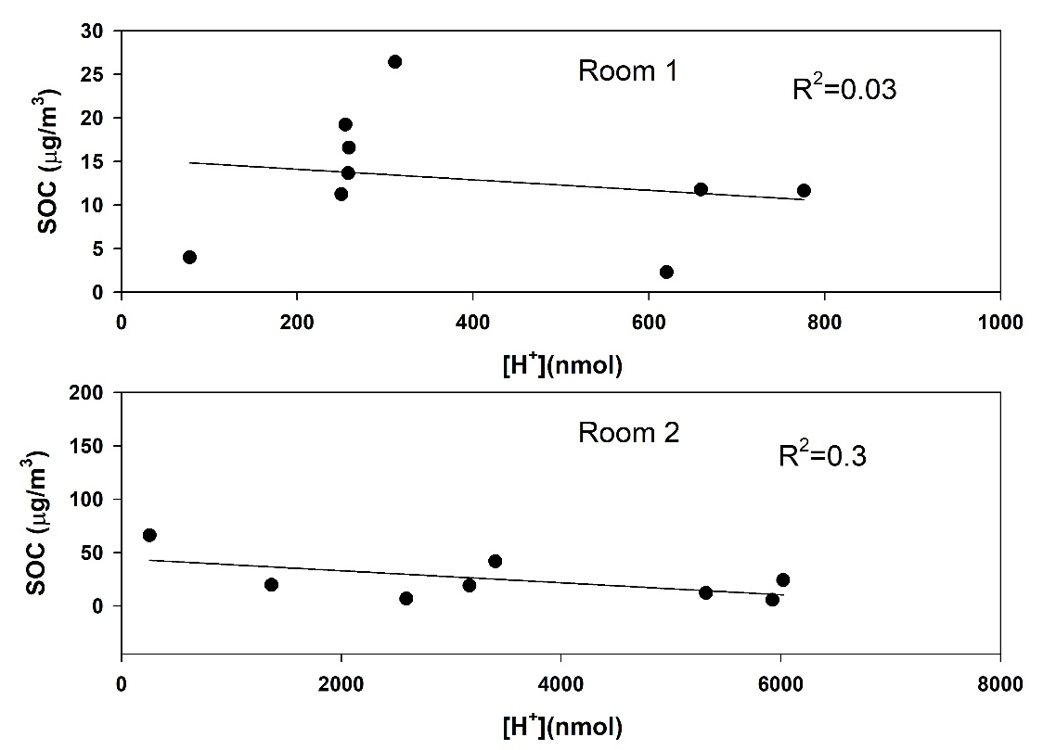
Figure 2 [H⁺] to SOC correlation in both the microenvironment , the [H⁺] concentration is poor , so with SOC no significance correlation observed

Correlation between Char and Soot EC in different environment:
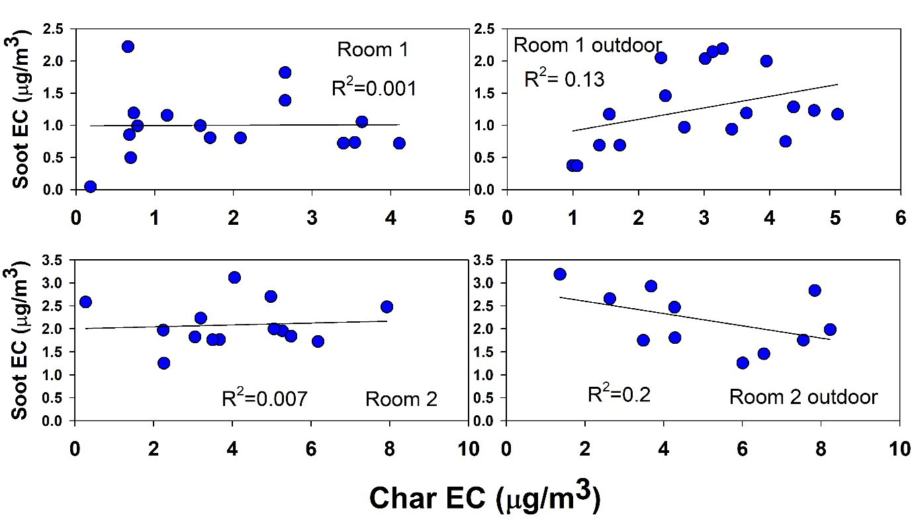
Figure 3 Pearson correlation between char and soot EC in all the rooms and corresponding outdoors.
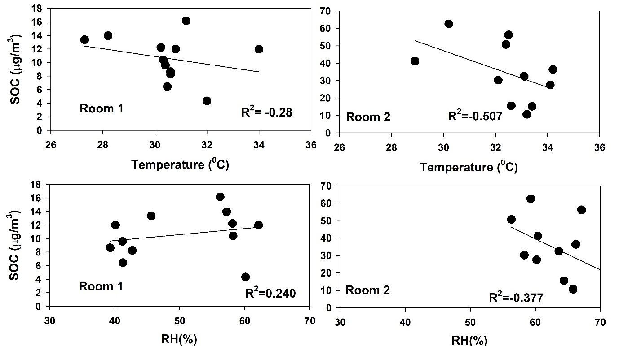
Figure 4 Correlation between SOC and indoor meteorology; no significant correlation found

