Nano-Engineered Versatile Janus Natural-Skin with Sandwich Structure for Wearable All-Season Personal Thermal Management
Long Xie¹, Xuechuan Wang^{1,2,}*, Chao Wei¹, Siwei Sun³, Shuang Liang², Zhongxue Bai², Xiaoliang Zou², Yi Zhou², Ouyang Yue^{2,}*, Xinhua Liu^{2,}*.

¹ College of Chemistry and Chemical Engineering, Institute of Biomass & Functional Materials, Shaanxi University of Science & Technology, Xi’an, Shaanxi 710021, China.

² College of Bioresources Chemical and Materials Engineering, Institute of Biomass & Functional Materials, Shaanxi University of Science & Technology, Xi’an 710021, China.

³Institute of Basic and Translational Medicine, Xi’an Medical University, Xi’an, Shaanxi, 710021, China

*Corresponding authors: wangxc@sust.edu.cn (X. Wang); ouyangyue@sust.edu.cn (O. Yue); liuxinhua@sust.edu.cn (X. Liu)

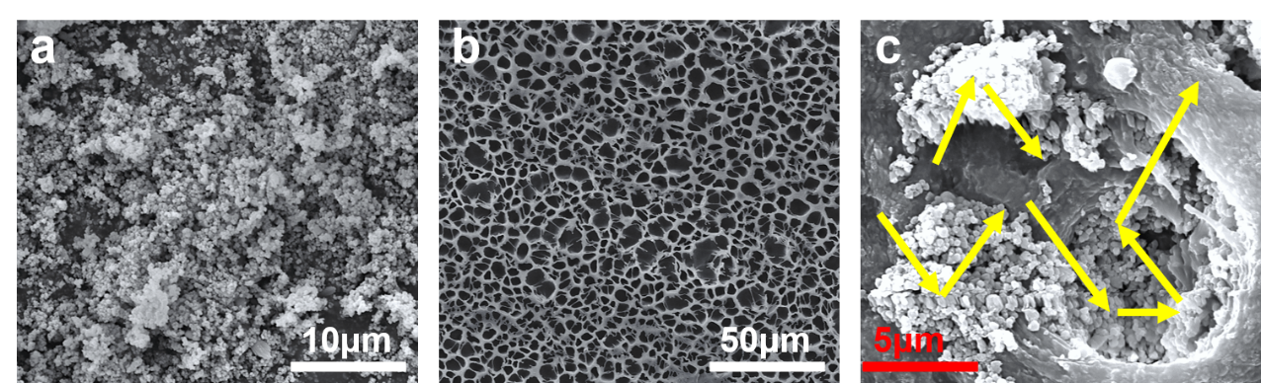
Figure S1. a) SEM of Mg₁₁(HPO₃)₈(OH)_{6.} b) SEM of CA coating. c) SEM of CA/ Mg₁₁(HPO₃)₈(OH)₆ composite coating and its effect on incident light.

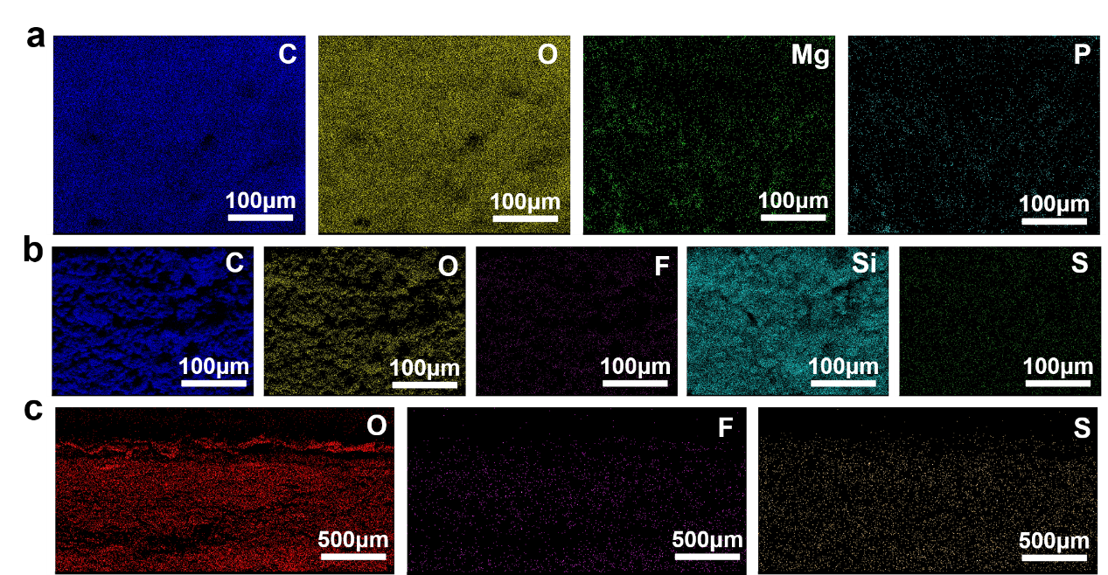
Figure S2. a) SHRC-skin radiatively cooled side (RC-side) EDS mapping. b) SHRC-skin solar heating Side (SH-side) EDS mapping. c) SHRC-skin cross-section EDS mapping.

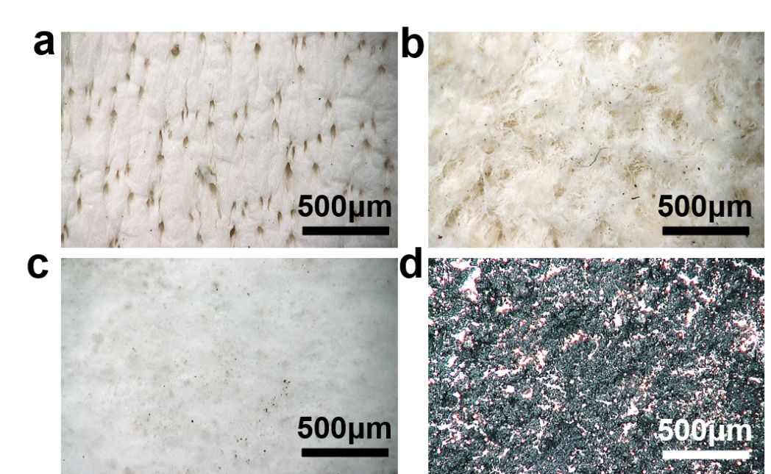
Figure S3. a) 2D plane image of a natural-skin granular super depth-of-field microscope. b) 2D plane image of a natural-skin fleshy surface super depth-of-field microscope. c) 2D plane image of SHRC-skin radiatively cooled side super depth-of-field microscope. d) 2D plane image of SHRC-skin solar heating side super depth-of-field microscope.

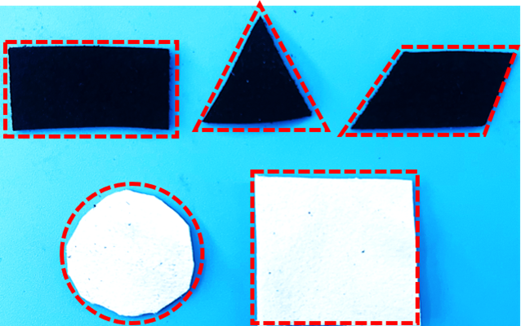
Figure S4. SHRC-skin cut into different shapes.

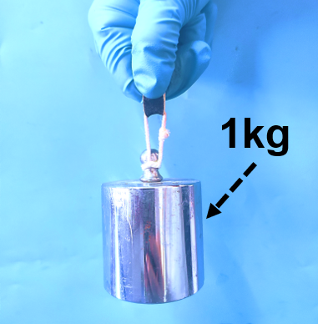
Figure S5. SHRC-skin can lift 1 kg weights.

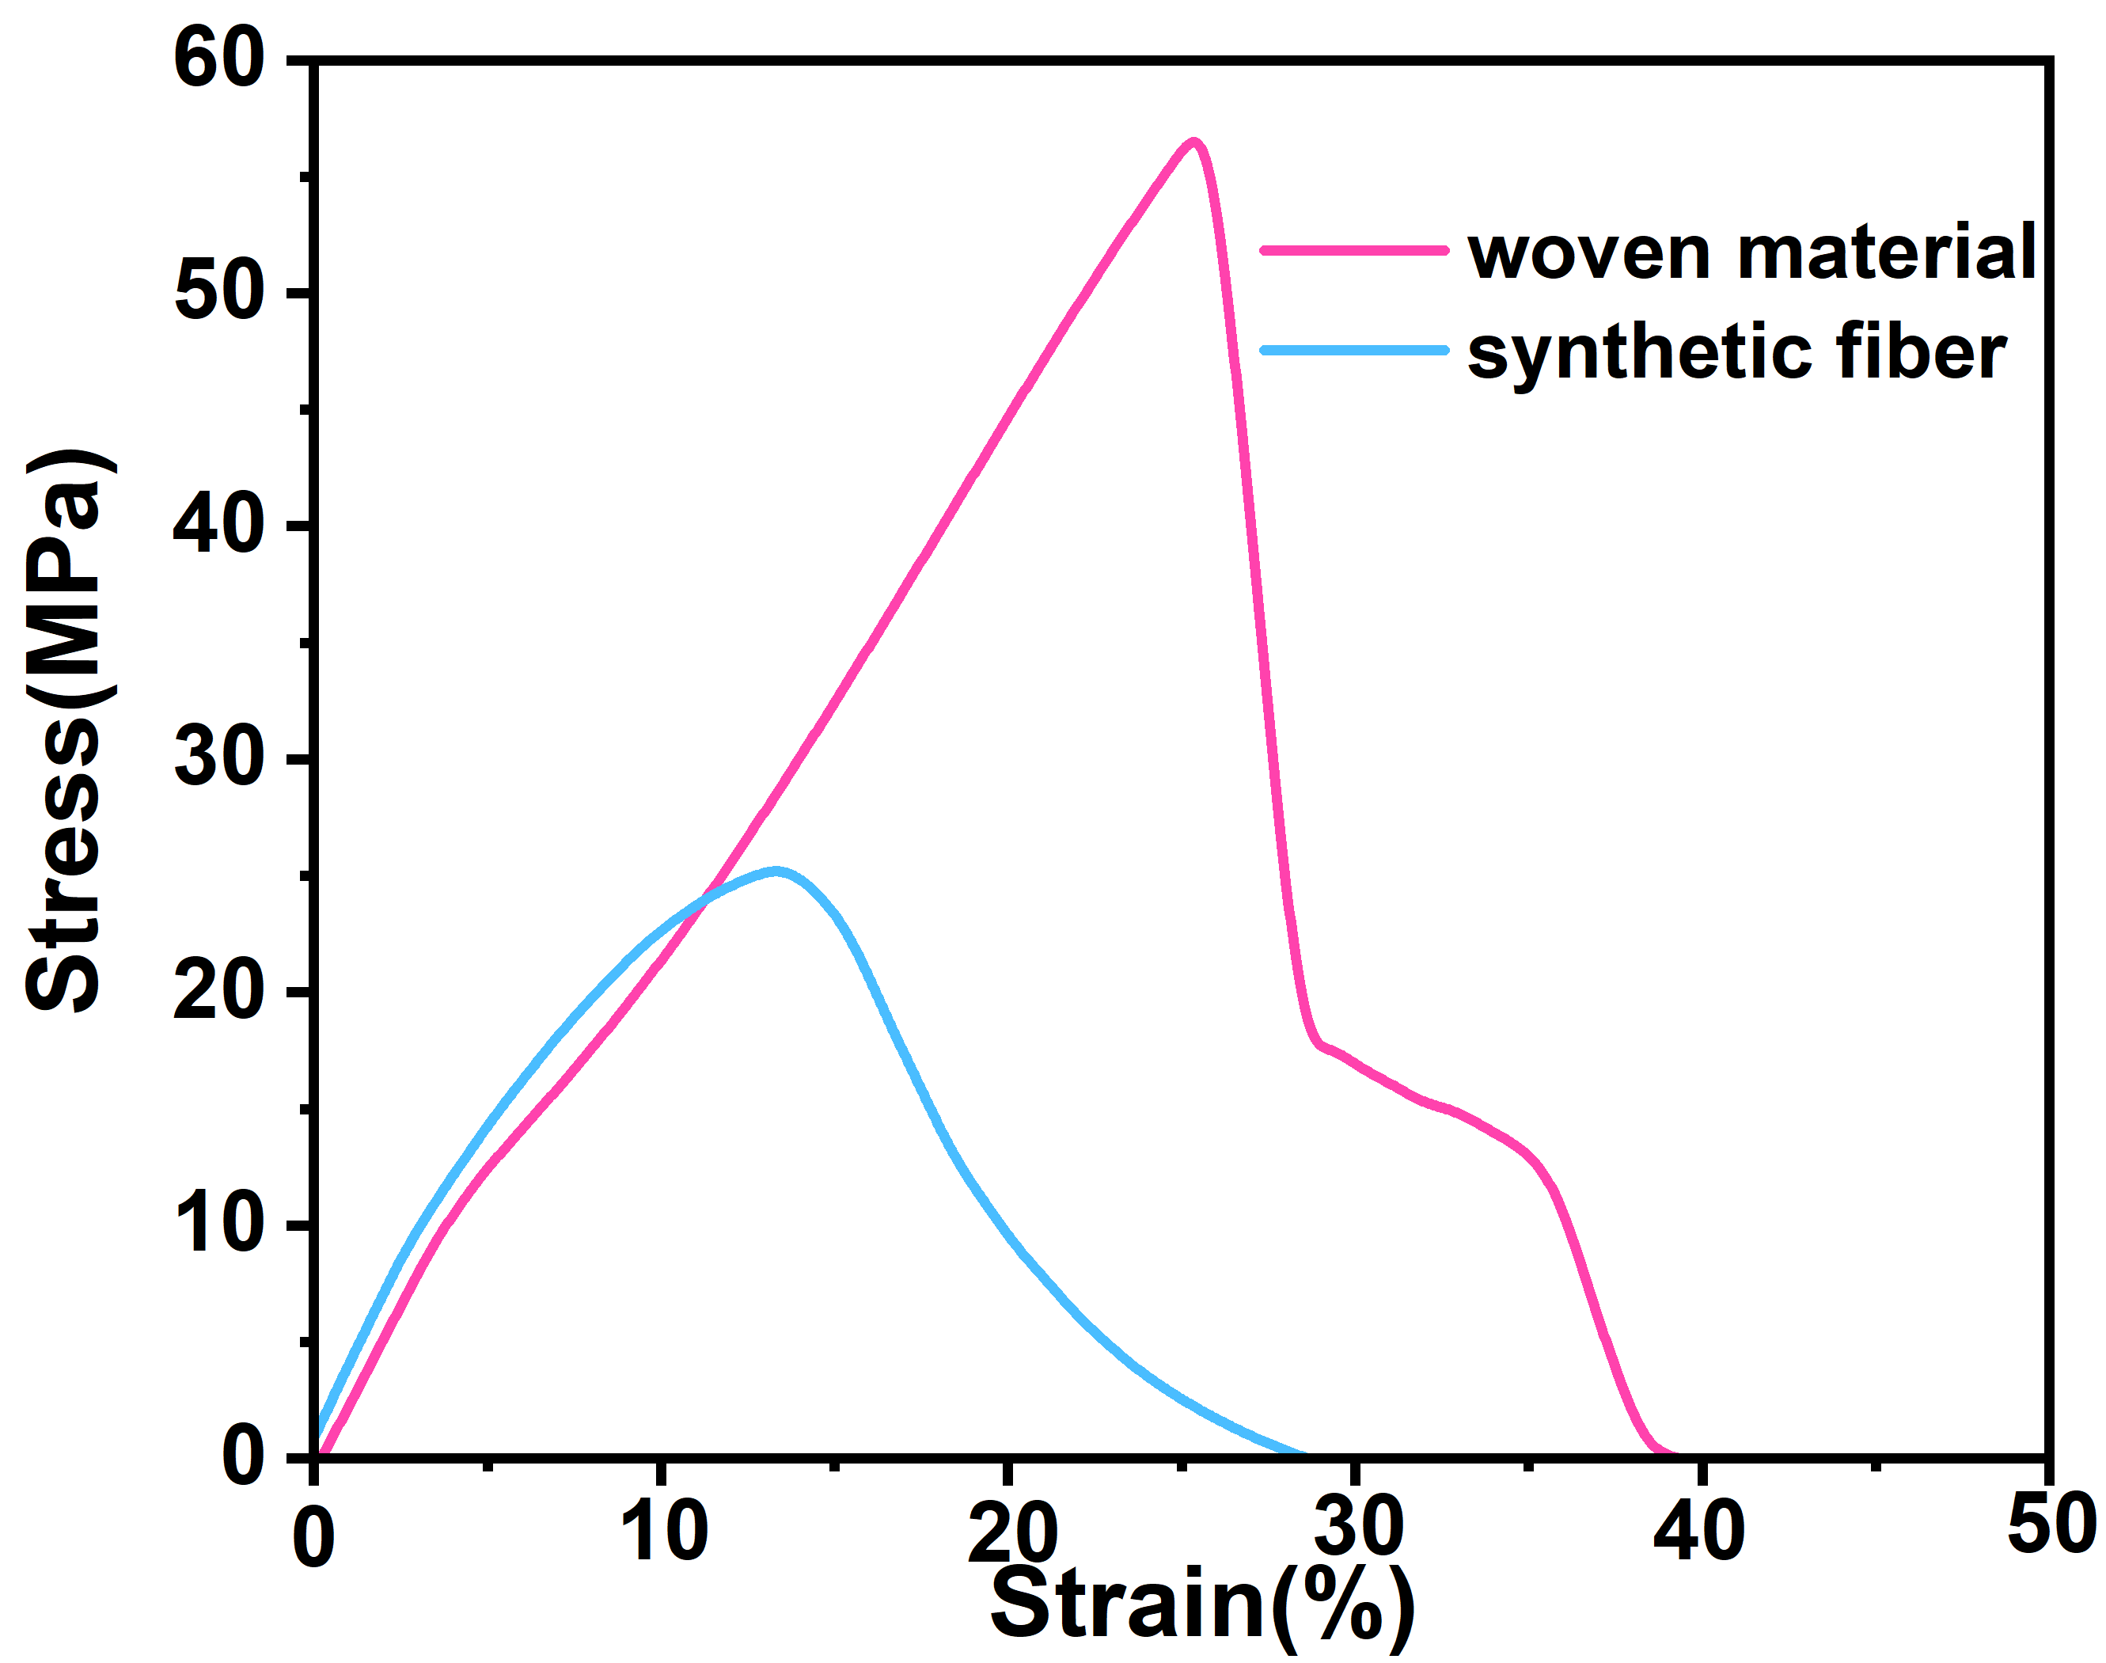
Figure S6. Stress-strain curves for woven materials and synthetic fiber.

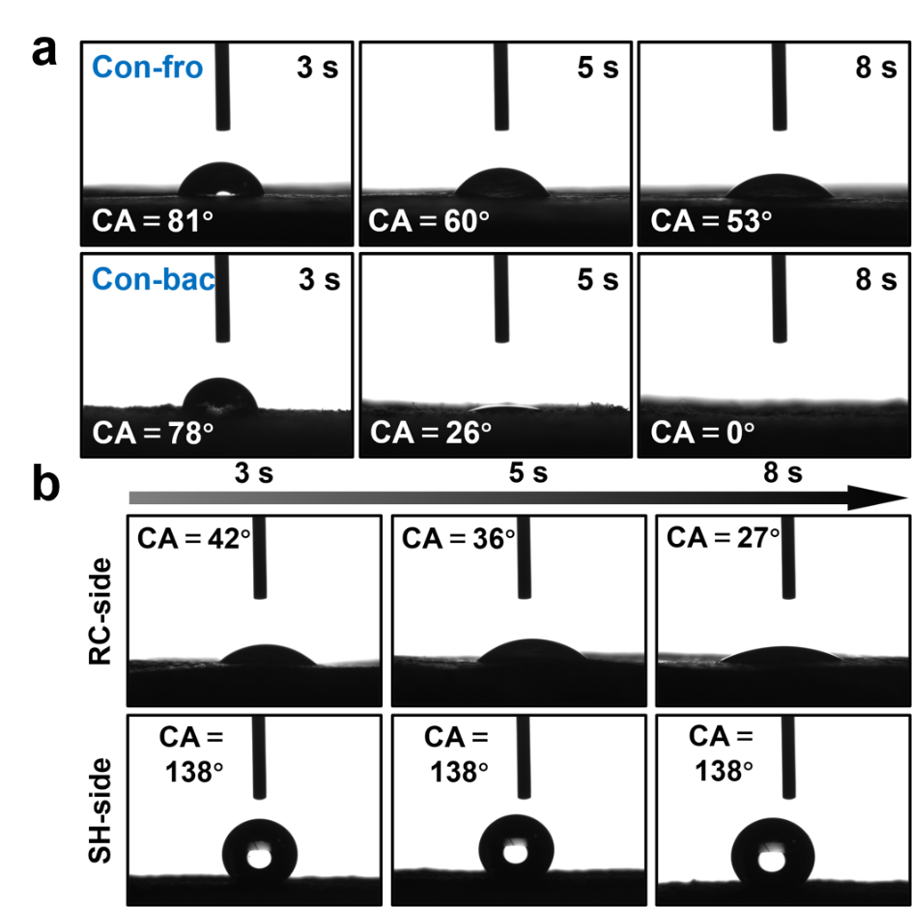
Figure S7. a) Optical contact angle graphs at 3 s, 5 s and 8 s on both sides of the control group. b) Optical contact angle graphs at 3 s, 5 s and 8 s on both sides of the SHRC-skin.

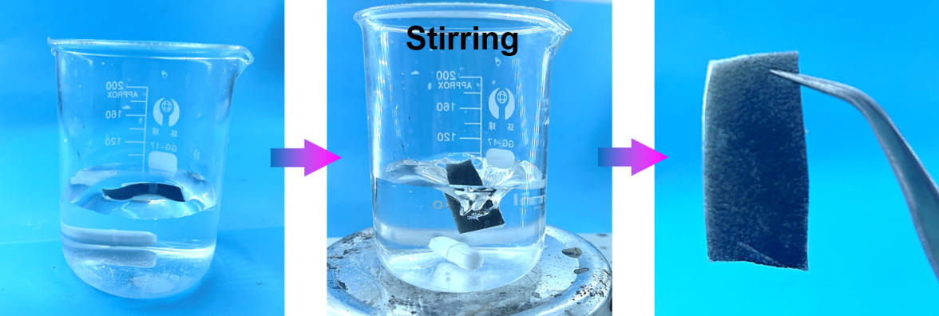
Figure S8. SHRC-skin contact angle and optical performance stability testing process.

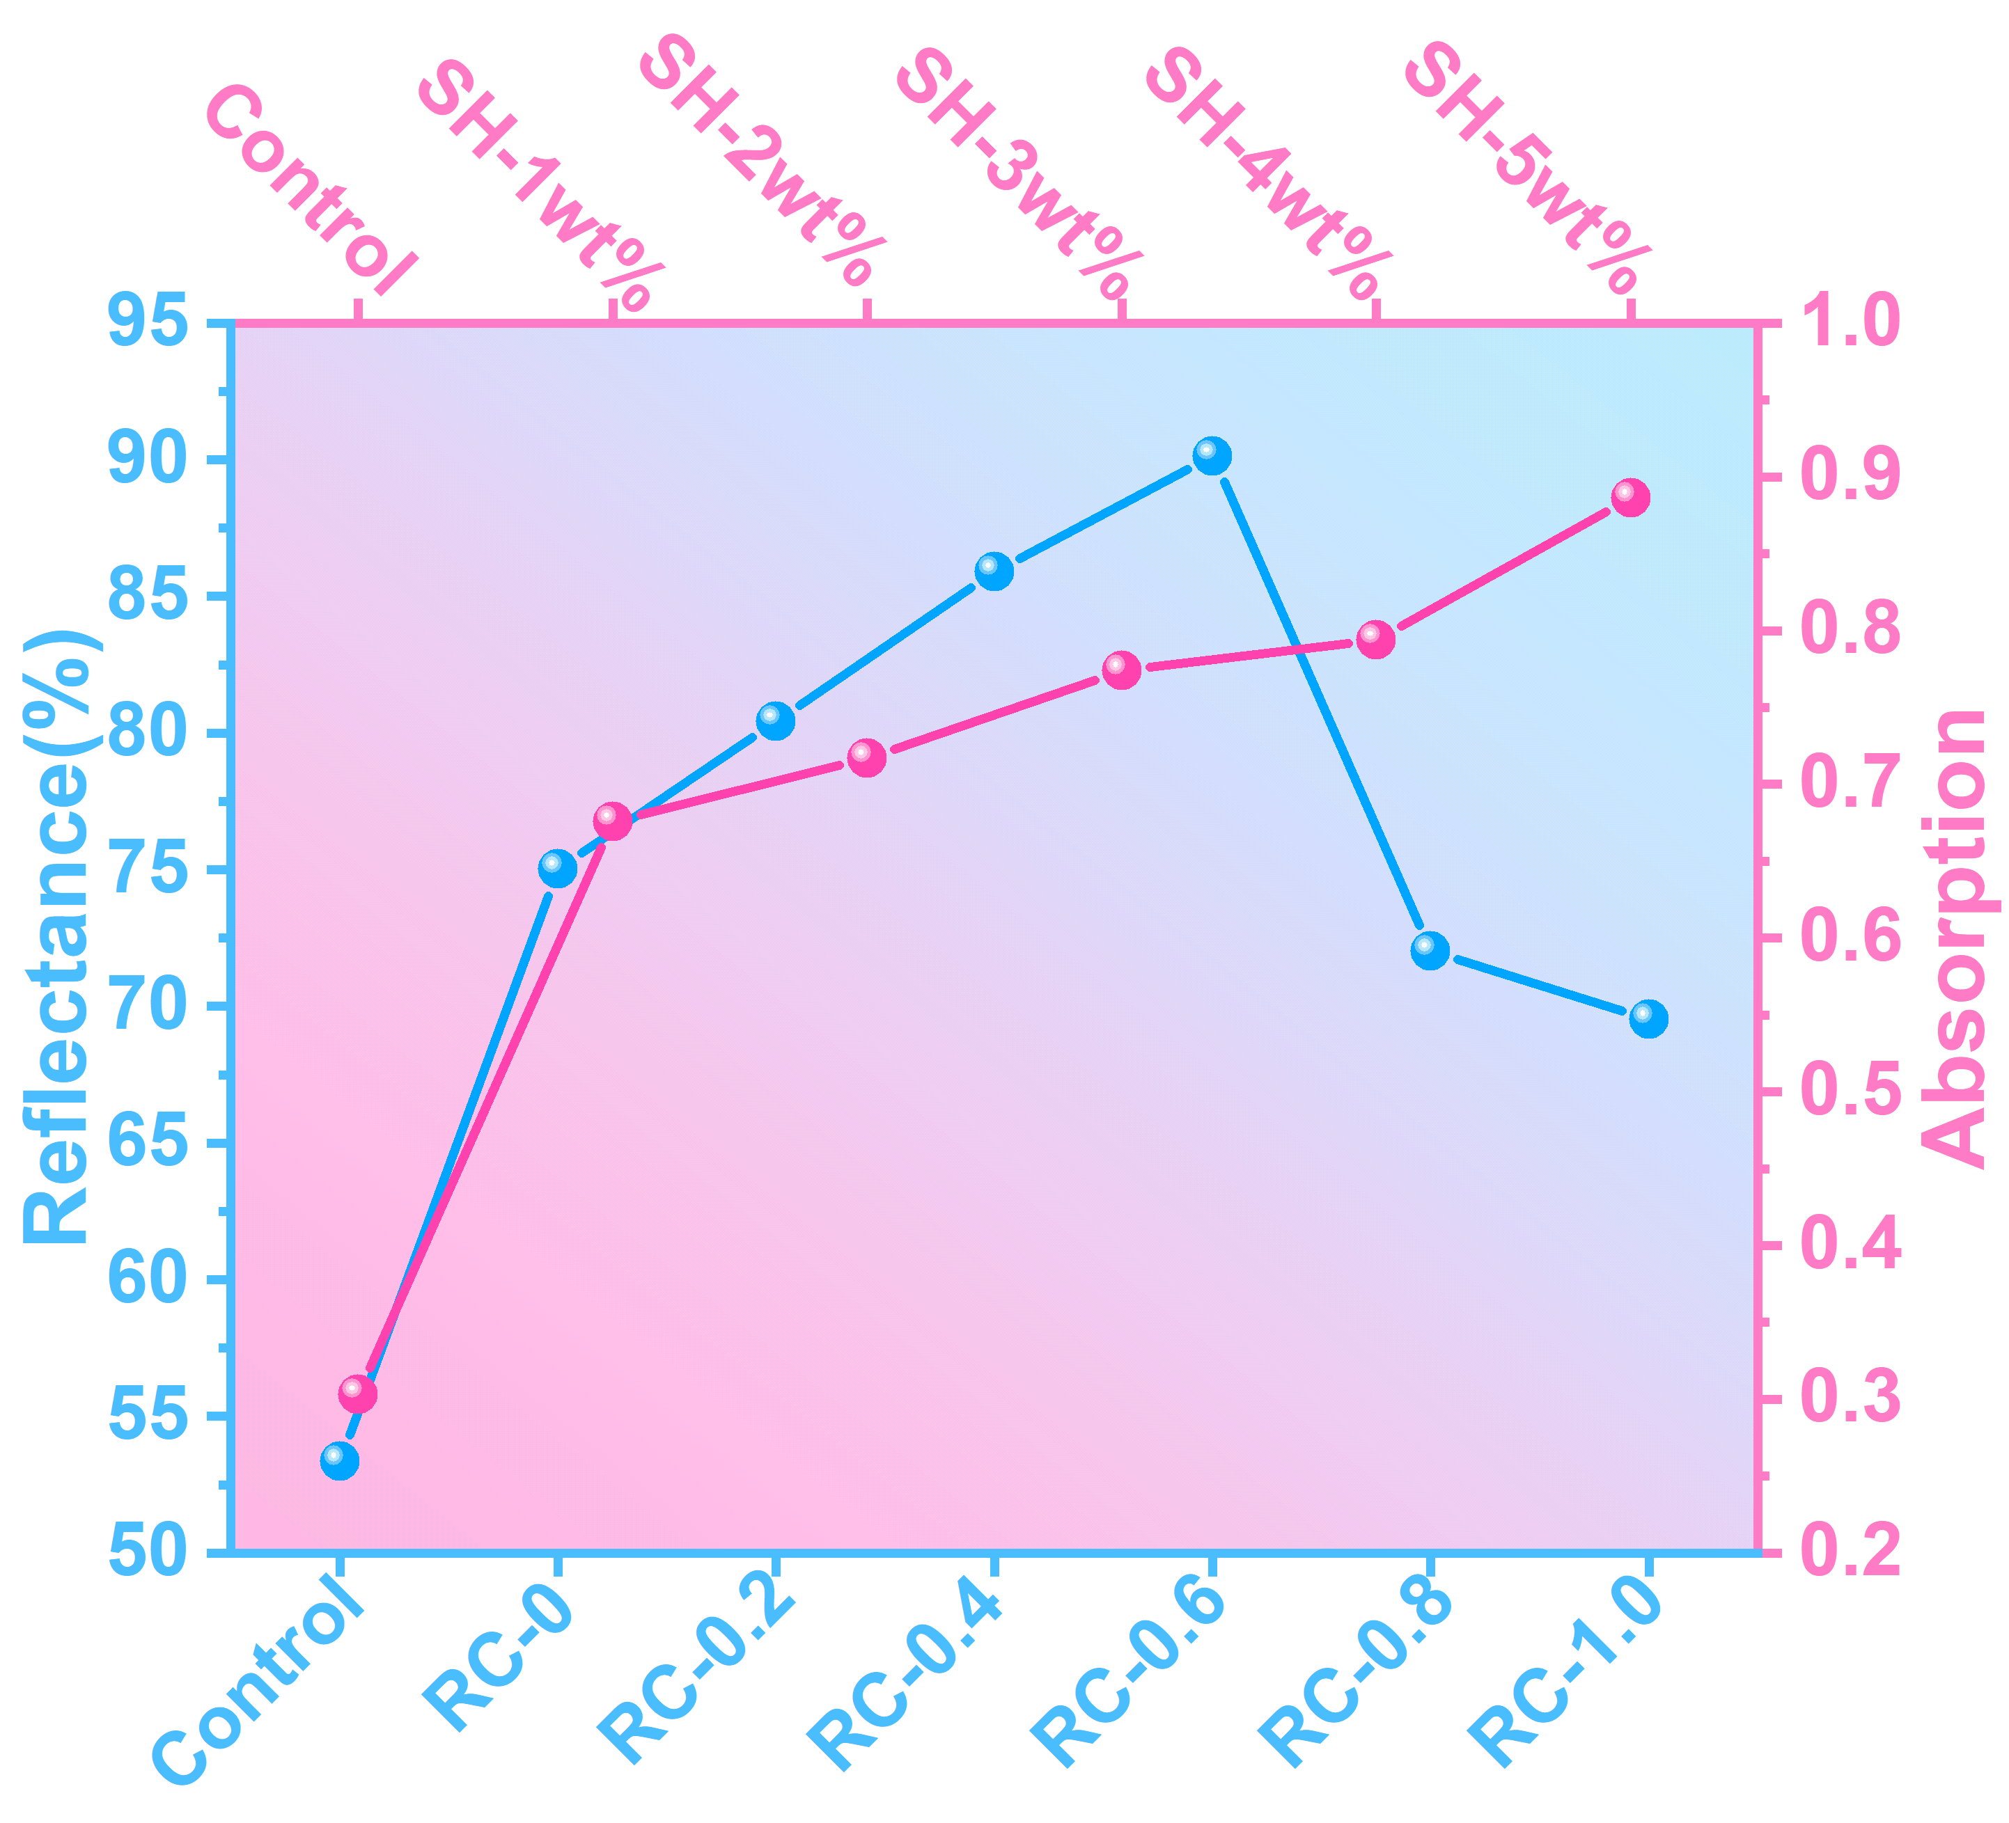
Figure S9. Comparison of the corresponding reflectance and absorptance for different content components on both sides of SHRC-skin.

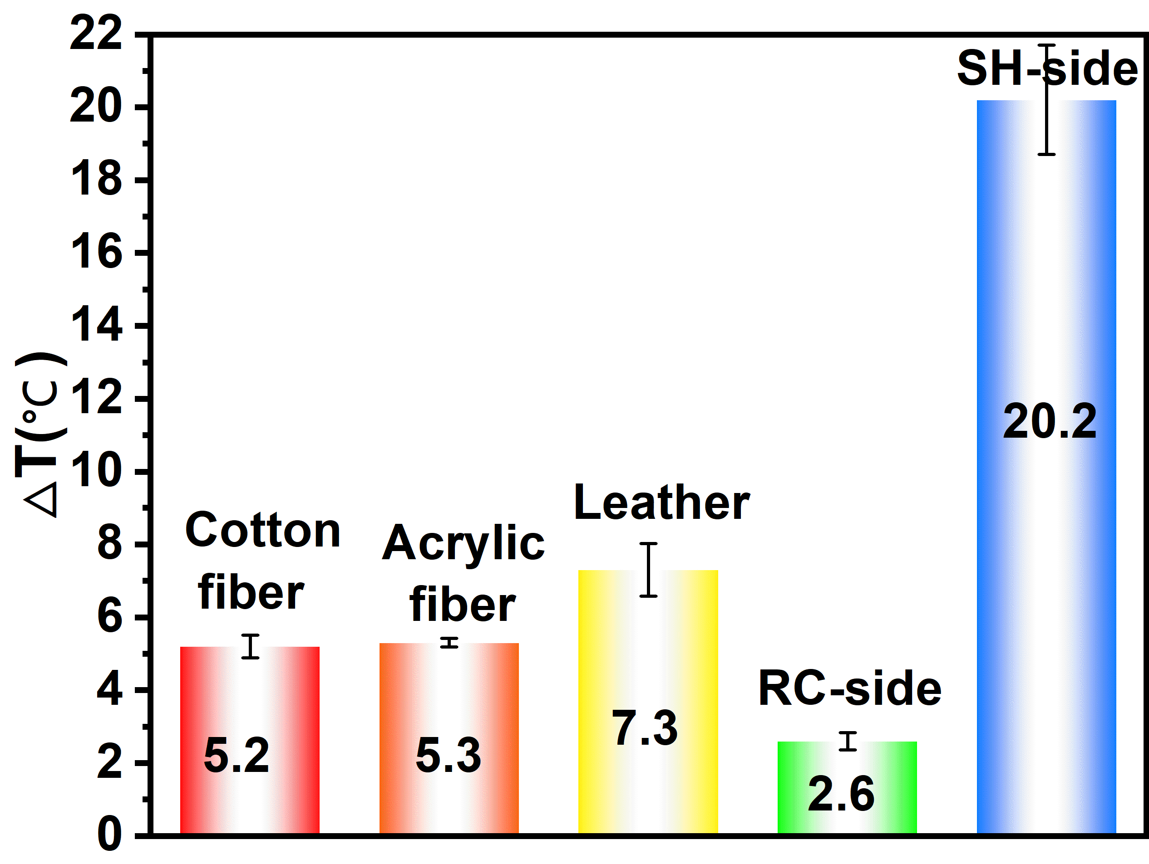
Figure S10. Temperature difference between SHRC-skin and different commercial fabric arm coverings under 1000 Wm⁻² light irradiation for 200 s.

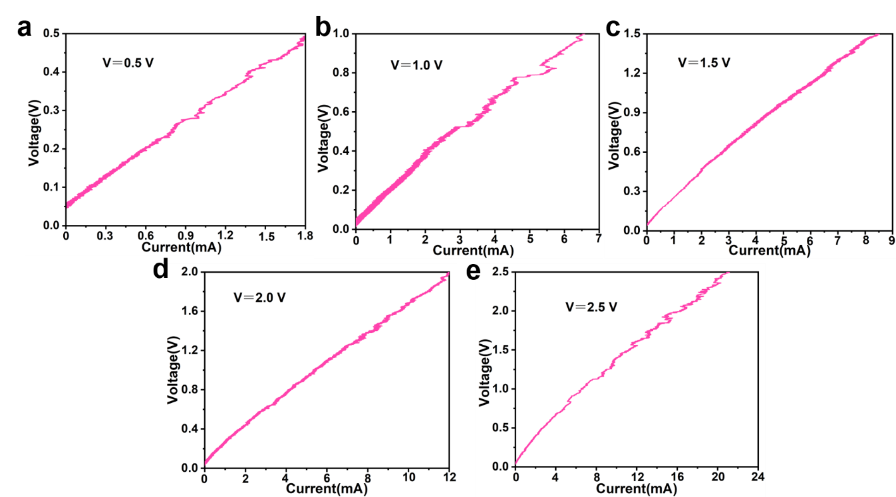
Figure S11. a) Voltammetric curve of SHRC-skin at 0.5 V input voltage. b) Voltammetric curve of SHRC-skin at 1.0 V input voltage. c) Voltammetric curve of SHRC-skin at 1.5 V input voltage. d) Voltammetric curve of SHRC-skin at 2.0 V input voltage. e) Voltammetric curve of SHRC-skin at 2.5 V input voltage.

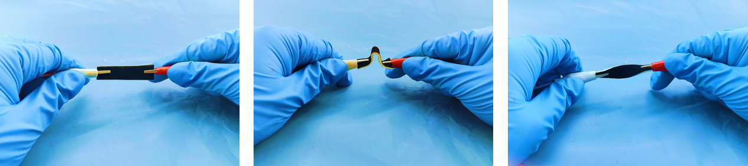
Figure S12. SHRC-skin deformation performance demonstration.

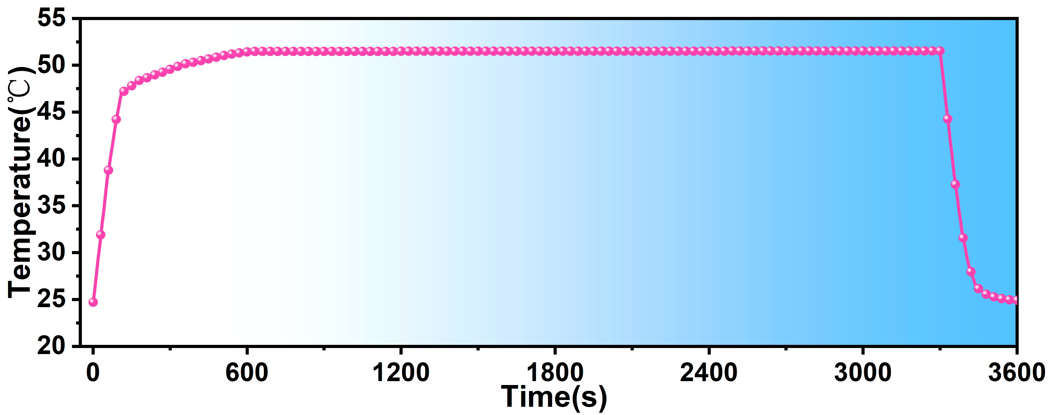
Figure S13. SHRC-skin Joule heating performance stability test over 3600 s at 16 V voltage input.

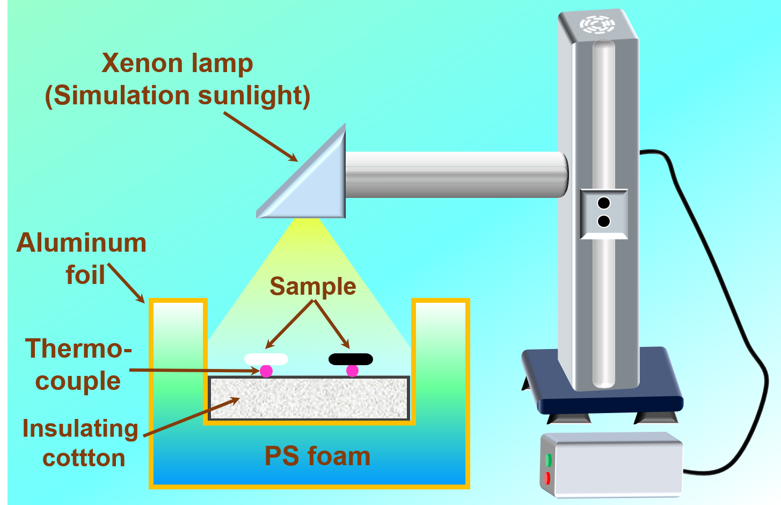
Figure S14. SHRC-skin Photothermal Conversion Performance Test Equipment.

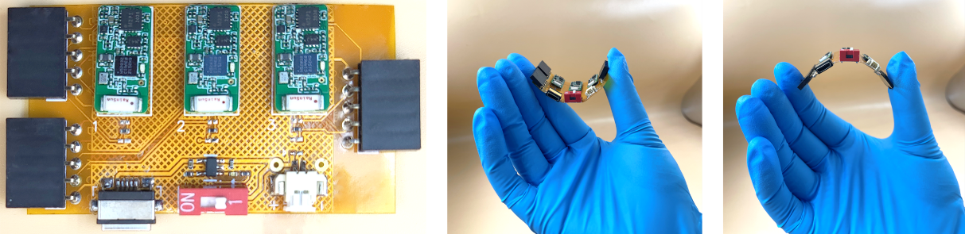
Figure S15. Schema of multi-channel mini electrochemical workstation.

