Supplementary information
Dissecting the Impact of the Gut Microbiome on Cancer Immunotherapy
Andreas Hadjigeorgiou¹*, Constantinos Harkos¹*, Aditya K. Mishra², Golnaz Morad³, Sarah B. Johnson³, Nadim J. Ajami², Jennifer A. Wargo^{2,3,}†, Lance L. Munn^{4,}†, Triantafyllos Stylianopoulos¹†, and Rakesh K. Jain⁴†

- Mathematical model of interactions between the immune system and tumor cells
Figure S1 represents the interactions between the immune components and the tumor cells as well as the interactions of the PD-1 and PD-L1 receptors considered in our mathematical model. Each component of the model corresponds to a variable. These variables are presented in Table S1 along with their description. These variables are included in ordinary differential equations or algebraic equations. Then, these equations are solved simultaneously by a MATLAB source code. The detailed equations are presented in the following sections.
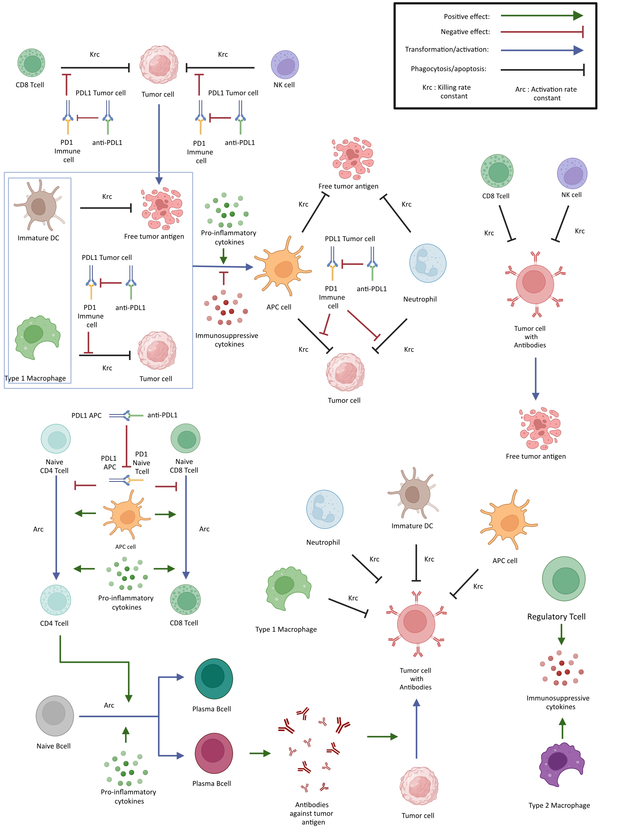
Figure S1: Schematic of mathematical model and its components. The arrows represent the interactions among model components. Some arrows represent the killing rate constant (Krc) and activation rate constant (Arc). The model includes the cytolytic effect of CD8+ T cells and NK cells that induce the tumor cells to make antigen(s). M1 macrophages and dendritic cells interact with tumor cells and become antigen-presenting cells (APCs). APCs and Neutrophils can phagocytose tumor cells and the free tumor antigen. APCs also activate naïve CD4+ and naïve CD8+ T cells to turn them into effector CD4+ and CD8+ T cells, respectively. CD4+ T cells help the activation of Naïve B cells in becoming Plasma and Memory B cells. Plasma cells produce antibodies, which bind to tumor cells. Phagocytosis/apoptosis arrows represent the killing rate constant (Krc). Also, the killing of cancer cells by immune cells as well as the activation of naive immune are affected negatively by the binding of PD-1 to PD-L1. Anti-PD-L1 and anti-PD-1 reduce the binding of PD-1 to PD-L1, increasing the intensity of these interactions. In addition, the model incorporates the effects of pro-inflammatory and immunosuppressive cytokines and the adverse effects of M2 macrophages and regulatory T cells (Tregs). Created with BioRender.com

Table S1: The variables of that are calculated by our mathematical model. Each variable corresponds to a model component shown in Figure S1.
 | Variable | Description
 | $$c$$ | Pro-Inflammatory cytokines
 | $$a$$ | Immunosuppressive cytokines
 | $$NK$$ | Natural killer cells
 | $$T^{N}$$ | Naïve CD8⁺ T cells
 | $$T^{E}$$ | Effector CD8⁺ Tcells
 | $$DC$$ | Dendritic cells
 | $$APC$$ | Antigen-presenting cells
 | $${Th}^{N}$$ | Naive CD4⁺ T cells
 | $${Th}^{Ε}$$ | Effector CD4⁺ T cells
 | $$N$$ | Neutrophils
 | $$M_{1}$$ | Type 1 Macrophages
 | $$M_{2}$$ | Type 2 Macrophages
 | $$Β^{N}$$ | Naïve B cells
 | $$P$$ | Plasma B cells
 | $$MB$$ | Memory B cells
 | $$T_{reg}$$ | Regulatory T cells
 | $$A$$ | Antibodies against tumor antigen
 | $$\overset{̑}{T}$$ | Cancer cells
 | $${\overset{̑}{T}}_{D}$$ | Dead cancer cells or free tumor antigen
 | $${\overset{̑}{T}}_{A}$$ | Cancer cells carrying antibodies
 | $$\left[PDL1\right]$$ | Amount of available PD-L1 on the cells
 | $$\left[PD1\right]$$ | Amount of the available PD-1 on the cells
 | $$\left[PD1-PDL1\right]$$ | The concentration of PD-1 – PD-L1 complex
 | $$\left[anti-PD1\right]$$ | Concentration of anti-PD-1
 | $$\left[PD1-antiPD1\right]$$ | The concentration of anti-PD-1 - PD-1 complex
 | $$\left[anti-PDL1\right]$$ | Concentration of anti-PD-L1
 | $$\left[PDL1-antiPDL1\right]$$ | The concentration of anti-PD-L1 - PD-1 complex

  - Pro-inflammatory cytokines:
Description
Pro-inflammatory cytokines are produced by natural killer cells ($NK$), effector CD8⁺ T cells ($T^{E}$), antigen-presenting cells ($APC$), effector CD4⁺ T cells (${Th}^{Ε}$), neutrophils ($N$), type 1 macrophages ($M_{1}$) and plasma cells ($P$).
Description of Equations
The rate of change of the concentration of the pro-inflammatory ($c$) cytokines (e.g., Il2, IFN_{γ}, TNF-α) is described by the following equation:

$$\frac{dc}{dt}=R_{c}=k_{cNK}NK+k_{cT^{E}}T^{E}{+k}_{cAPC}APC+k_{c{Th}^{Ε}}{Th}^{Ε}+k_{cN}N+k_{cM1}M_{1}+k_{cP}P-δ_{c} c$$ | (1)

Where the first 7 terms describe the production rates of $c$ by the natural killer ($NK$), effector CD8⁺ T ($T^{E}$), antigen-presenting cells ($APC$), effector CD4⁺ T cells (${Th}^{Ε}$), neutrophils ($N$), macrophages type 1 ($M_{1}$) and plasma B cells ($P$) respectively, and the last term is the degradation rate of $c$.

  - Immunosuppressive cytokines
Description
Immunosuppressive cytokines (e.g., IL10, TGF-β) are produced by regulatory T cells ($T_{reg}$) and type 2 macrophages ($M_{2}$).
Description of Equations
The rate of change of the concentration of the immunosuppressive ($a$) cytokines (e.g., IL10, TGF-β) is described by the following equation:

$$\frac{da}{dt}=R_{a}=k_{ant-T_{reg}}T_{reg}+k_{ant-M2}M_{2}-δ_{a}a$$ | (2)

Where the first two terms describe the production of immunosuppressive cytokines by regulatory T cells ($T_{reg}$), type 2 macrophages ($M_{2}$). The last term is the degradation rate of immunosuppressive cytokines.

  - Interactions between PD-L1, PD-1, anti-PD-1, and anti-PD-L1
Description
PD-1 exists on natural killer cells, effector CD8⁺ T cells, antigen-presenting cells, effector CD4⁺ T cells, neutrophils, macrophages type 1 and 2, naïve CD8⁺ and CD4⁺ T cells.
PD-L1 exists on tumor cells, antigen-presenting cells, macrophages type 1 and 2, dendritic cells, naïve B cells, memory cells and plasma cells.
PD-1 on any cell can bind to PD-L1 on other cells or to anti-PD-1 antibody. Similarly, PD-L1 on any cell can bind to PD-1 on other cells or to anti-PD-L1 antibody.
Description of Equations
The concentration of the available PD-L1 for binding ^{1,2} depends on the amount of the available PD-L1 on the cells and is described by the following equation:
$$\left[PDL1\right]=β_{\hat{T}}\hat{T}+β_{APC}APC+β_{DC}DC+β_{M1}M_{1}+β_{M2}M_{2}+β_{Β^{N}}Β^{N}+β_{P}P-\left[PD1-PDL1\right]-\left[PDL1-antiPDL1\right]$$ | (3)

where the constants $β$ describe the amount of PD-L1 on each type of cell. The first terms describe the amount of PD-L1 on tumor cells, APCs ($APC$), dendritic cells ($DC$), macrophages type 1 and 2 ($M_{1}$ and $M_{2}$), naïve B cells ($Β^{N}$) and plasma B cells ($P$). The last two terms describe the amount of PD-L1 which has been already bound to PD-1 and anti-PD-L1 respectively.

The concentration of the available PD-1 for binding ^{1,2} depends on the amount of the available PD-1 on the cells and is described by the following equation :

$$\left[PD1\right]=a_{T^{E}}T^{E}+a_{{Th}^{Ε}}{Th}^{Ε}+a_{T_{N}}T^{N}+a_{{Th}_{N}}{Th}^{N}+a_{N}N+a_{NK}NK+a_{M_{1}}M_{1}+a_{M_{2}}M_{2}+a_{APC}APC+a_{DC}DC+a_{T_{reg}}T_{reg}-\left[PD1-PDL1\right]-\left[PD1-antiPD1\right]$$ | (4)

where the parameters $α$ represent the amount of PD-1 on each type of cell. The terms except for the last two describe the amount of PD-1 ligand on the following immune cells $T^{E}$, ${Th}^{Ε}$, , $T^{N}$, ${Th}^{N}$, $N$ , $NK$, $M_{1}$, $M_{2}$, $APC$, $DC$ and $T_{reg}$. The last two terms describe the amount of PD-1 which is already bound to PD-L1 and anti-PD-1 respectively.

The rate of change in the concentration of the PD-1 – PD-L1 complex is described by the following equation:

$$\frac{d\left[PD1-PDL1\right]}{dt}=a_{PL}\left[PD1\right]\left[PDL1\right]-d_{Q}\left[PD1-PDL1\right]$$ | (5)

where the first term is the binding of PD-1 to the PD-L1 and the last term is their unbinding.
The rate of change in the concentration of the anti-PD-1 - PD-1 complex is:

$$\frac{d\left[PD1-antiPD1\right]}{dt}=μ_{PD1-aPD1}\left[PD1\right]\left[anti-PD1\right]-d_{PD1-aPD1} \left[PD1-antiPD1\right]$$ | (6)
where the first term is the binding of PD-1 to the anti-PD-1 and the last term is their unbinding.
The rate of change in the concentration of the anti-PD-1 is:

$$\frac{d\left[anti-PD1\right]}{dt}=γ_{anti-PD1}-μ_{PD1-aPD1}\left[PD1\right]\left[anti-PD1\right]+d_{PD1-aPD1} \left[PD1-antiPD1\right]-d_{anti-PD1}\left[anti-PD1\right]$$ | (7)

where the first term represents the source term of the anti-PD-1, the second term is the binding of the anti-PD-1 to PD-1, the following term is their unbinding, and the last term is the degradation of anti-PD-1.

The rate of change in the concentration of the anti-PD-L1 - PD-L1 complex is given by the following equation:

$$\frac{d\left[PDL1-antiPDL1\right]}{dt}=μ_{PDL1-aPDL1}\left[PDL1\right]\left[anti-PDL1\right]-d_{PDL1-aPDL1} \left[PDL1-antiPDL1\right]$$ | (8)
where the first term describes the binding of PD-L1 to the anti-PD-L1 and the last term is their unbinding.
The rate of change in the concentration of the anti-PD-L1 is

$$\frac{d\left[anti-PDL1\right]}{dt}=γ_{anti-PDL1}-μ_{PDL1-aPDL1}\left[PDL1\right]\left[anti-PDL1\right]+d_{PDL1-aPDL1} \left[PDL1-antiPDL1\right]-d_{anti-PDL1}\left[anti-PDL1\right]$$ | (9)

where the first term represents the source term of the anti-PD-L1, the second term is the binding of the anti-PD-L1 to PD-L1, the following term describes their unbinding, and the last term is the degradation of the anti-PD-L1.

$Φ_{x-y}$ is the fraction of the total PD-1-PD-L1 complex, referring to the binding of PD-1 receptor on x-cell to PD-L1 receptor on y-cell.

$$Φ_{x-y}=\frac{a_{x}x}{\sum_{x}{a_{x}x}}\frac{β_{y}y}{\sum_{y}{β_{y}y}}$$ | (10)

Where x can be any of the following cell types:
$$T^{E},{Th}^{Ε},T^{N},{Th}^{N},N,NK,M_{1},M_{2},APC,DC,T_{reg}$$
and y can be any of the following:
$$\hat{T},APC,DC, M_{1}, M_{2}, B^{N},P,MB$$
The reduction of PD-1, PD-L1 and PD-1-PD-L1 complex is assumed to be equally distributed among the receptors on the different cell types.
  - Cancer Cells
Description
The rate of increase in the number of cancer cells ($\overset{̑}{T}$) is equal to their rate of proliferation minus their death rate. The death of cancer cells ($\overset{̑}{T}$) is induced by CD8⁺ T cells ($T^{E}$) and natural killer cells ($Nk$). $\overset{̑}{T}$ can be phagocytosed by neutrophils ($N$), type one macrophages ($M_{1}$), dendritic cells ($DC$), and/or antigen presenting cells ($APC$). The interaction between the tumor cells and either CD8⁺ T cells ($T^{E}$) or natural killer cells ($Nk$) or type one macrophages ($M_{1}$) or neutrophils ($N$) or dendritic cells ($DC$), or antigen presenting cells ($APC$) is inhibited by the binding of PD-1 of the immune cells to PD-L1 of the tumor cells. The antibodies can bind to receptors on the tumor cells and neutralize them.
Description of Equations
The rate of change in the concentration of the cancer cells is given by:
$$\frac{d\overset{̑}{T}}{dt}=R_{\overset{̑}{T}}=k_{\overset{̑}{T}}\overset{̑}{T}-d_{A}A\overset{̑}{T}-\left({Krc}_{T^{E}}\frac{K_{T}}{{K_{T}+Φ}_{T_{T}^{Ε}-\overset{̑}{T}} \left[PD1-PDL1\right]}T^{E}+{Krc}_{Nk}\frac{K_{T}}{K_{T}+Φ_{Nk-\overset{̑}{T}} \left[PD1-PDL1\right]}Nk+{Krc}_{M_{1}}\frac{K_{T}}{K_{T}+Φ_{M_{1}-\overset{̑}{T}} \left[PD1-PDL1\right]}M_{1}+{Krc}_{N}\frac{K_{T}}{{K_{T}+Φ}_{N-\overset{̑}{T}} \left[PD1-PDL1\right]}N+{Krc}_{DC}\frac{K_{T}}{{K_{T}+Φ}_{DC-\overset{̑}{T}} \left[PD1-PDL1\right]}DC+{Krc}_{APC}\frac{K_{T}}{{K_{T}+Φ}_{{DC}_{T}^{*}-\overset{̑}{T}} \left[PD1-PDL1\right]}APC\right)\overset{̑}{T}$$ | (11)

Where the first term is the proliferation rate of the tumor cells. The second term describes the neutralization of tumor cells by the binding of antibodies. The remaining terms are the death rates which depend on the tumor cell density and the immune cells (effector CD8⁺, natural killer, type 1 macrophage, neutrophils, dendritic cells and antigen presenting cells)³.

  - Dead Cancer Cells or free tumor antigen
Description
The dead cancer cells or free tumor antigen (${\overset{̑}{T}}_{D}$) are produced when an immune cell induces cytolysis of a tumor cell. ${\overset{̑}{T}}_{D}$ is phagocytosed by $N$, $M_{1}$, $DC$ or $APC$. The phagocytosis of dead cancer cells does not depend on PD-1-PD-L1 binding.
Description of Equations
The rate of change in the concentration of the dead tumor cells or free tumor antigen is:
$$\frac{d{\overset{̑}{T}}_{D}}{dt}=R_{{\overset{̑}{T}}_{D}}=d_{Tc}\overset{̑}{T}+\overset{̑}{T}\left({Krc}_{T^{E}}\frac{K_{T}}{{K_{T}+Φ}_{T^{E}-\overset{̑}{T}} \left[PD1-PDL1\right]}T^{E}+{Krc}_{Nk}\frac{K_{T}}{K_{T}+Φ_{Nk-\overset{̑}{T}} \left[PD1-PDL1\right]}Nk\right)+\left({Krc}_{T^{E}}T^{E}+{Krc}_{Nk}Nk\right){\overset{̑}{T}}_{A}-\left({Krc}_{M_{1}}M_{1}+{Krc}_{N}N+{Krc}_{DC}DC+{Krc}_{APC}APC\right){\overset{̑}{T}}_{D}$$ | (12)

The first term is the rate of apoptosis of tumor cells which increases the number of ${\overset{̑}{T}}_{D}$. The following six terms describe the increase in ${\overset{̑}{T}}_{D}$ when $T^{E}$and $Nk$ induce cytolysis $of\overset{̑}{T}$ or tumor cell with antibody (${\overset{̑}{T}}_{A}$). The remaining terms represent the phagocytosis of ${\overset{̑}{T}}_{D}$ by $N$, $M_{1}$, $DC$ or $APC$
  - Cancer Cells with Antibody
Description
The cancer cells with antibodies ${\overset{̑}{T}}_{A}$ bound to their membrane are produced when an antibody binds to a cancer cell. Cancer cells with antibodies are easily recognized and killed by the immune cells. ${\overset{̑}{T}}_{A}$ can be consumed by the following immune cells$T^{E}$, $Nk$, $M_{1}$, $N$ $DC$ or $APC$.
The rate of change in the concentration of cancer cells with antibodies bound to their membrane is:

$$\frac{d{\overset{̑}{T}}_{A}}{dt}=R_{{\overset{̑}{T}}_{A}}=d_{A}A\overset{̑}{T}-\left({Krc}_{T^{E}}T^{E}+{Krc}_{Nk}Nk+{Krc}_{M_{1}}M_{1}+{Krc}_{N}N+{Krc}_{DC}DC+{Krc}_{APC}APC\right){\overset{̑}{T}}_{A}$$ | (13)

where the first term is the production of ${\overset{̑}{T}}_{A}$ by the binding of antibodies on tumor cells. The remaining terms are the elimination of ${\overset{̑}{T}}_{A}$ by the following immune cells $T^{E}$, $Nk$, $M_{1}$, $N$ $DC$ or $APC$.

  - Neutrophils
Description
The recruitment of neutrophils depends on the pro-inflammatory cytokines.
The rate of change in the concentration of the neutrophils is:

$$\frac{dN}{dt}=R_{N}=\frac{λ_{N} c}{K_{N}+c}-δ_{N}N$$ | (14)

where the first term describes the recruitment of the neutrophils and its dependence on pro-inflammatory cytokines and the last term describes their death rate.
  - Macrophage, dendritic, and antigen presenting cells
Description
Macrophages recruitment depends on concentration of pro- and anti- inflammatory cytokines. The concentration of pro-inflammatory cytokines relative to the total cytokines increases the concentration of type 1 macrophages. The concentration of immunosuppressive cytokines relative to the total cytokines increases the concentration of type 2 macrophages. Type 1 macrophages can also become antigen presenting cells in the same manner as dendritic cells. APCs production depends on the killing of tumor cells, dead tumor cells (or free tumor antigen) and tumor cells with antibody, killed by dendritic cells or type 1 macrophages. Their activation depends on pro-inflammatory and immunosuppressive cytokines.

Macrophages
The rate of change in the concentration of type 1 and type 2 macrophages is given by:

$$\frac{dM1}{dt}=R_{M1}=λ_{M1}\frac{c}{a+c}-\frac{χ_{M1} c}{K_{APC}+a}\frac{K_{aAPC}}{K_{aAPC}+a} M_{1}\left[{Krc}_{M_{1}}\left(\frac{K_{T}\overset{̑}{T}}{K_{T}+Φ_{M_{1}-\overset{̑}{T}} \left[PD1-PDL1\right]}+{\overset{̑}{T}}_{D}+{\overset{̑}{T}}_{A}\right)\right]-δ_{Μ1}M1$$ | (22)

$$\frac{dM2}{dt}=R_{M2}=λ_{M2}\frac{α}{c+α}-δ_{Μ2}M2$$ | (23)

where type 1 macrophages production depends on the ratio of pro-inflammatory to total cytokines. The second term describes their transformation to antigen-presenting cells by phagocytosis of $\overset{̑}{T}$, ${\overset{̑}{T}}_{D}$, or ${\overset{̑}{T}}_{A}$. Type 2 macrophages production depends on the ratio of immunosuppressive to total cytokines. Both equations include a death rate term ^{1,4}

Dendritic cells (DC)
The rate of change in the concentration of the dendritic cells is:

$$\frac{dDC}{dt}=R_{DC}=S_{DC}-δ_{DC}DC-χ_{DC}\frac{ c}{K_{cAPC}+c}\frac{K_{aAPC}}{K_{aAPC}+a} DC\left[{Krc}_{DC}\left(\frac{K_{T}\overset{̑}{T}}{{K_{T}+Φ}_{DC-\overset{̑}{T}} \left[PD1-PDL1\right]}+{\overset{̑}{T}}_{D}+{\overset{̑}{T}}_{A}\right)\right]$$ | (15)

where the first term describes the source term of DCs, and the next term is the death rate of DCs. The next term describes the conversion of dendritic cells to antigen-presenting cells which depends on the tumor cells ($\overset{̑}{T}$), dead tumor cells (${\overset{̑}{T}}_{D}$) and tumor cells bearing antibodies on their membrane (${\overset{̑}{T}}_{A}$).

Antigen-presenting cells APCs (APC)

The rate of change in the concentration of the APCs is:

$$\frac{dAPC}{dt}=R_{{DC}^{*}}=\frac{ c}{K_{cAPC}+c}\frac{K_{aAPC}}{K_{aAPC}+a} \left[χ_{DC}{Krc}_{DC}DC\left(\frac{K_{T}\overset{̑}{T}}{{K_{T}+Φ}_{DC-\overset{̑}{T}} \left[PD1-PDL1\right]}+{\overset{̑}{T}}_{D}+{\overset{̑}{T}}_{A}\right)+χ_{M1}{Krc}_{M_{1}}M_{1}\left(\frac{K_{T}\overset{̑}{T}}{K_{T}+Φ_{M_{1}-\overset{̑}{T}} \left[PD1-PDL1\right]}+{\overset{̑}{T}}_{D}+{\overset{̑}{T}}_{A}\right)\right]-δ_{APC}APC$$ | (16)

where the first term describes the conversion rates of dendritic cells and type 1 macrophages to APCs ($APC$) and the next term describes the death rate of APCs.

  - CD4⁺ T cells
Description
Naïve CD4⁺ T cells can become effector CD4⁺ T cells. Activation of effector CD4⁺ T cells depends on pro-inflammatory cytokines and the PD-1-PD-L1 complex especially on the binding of naïve CD+4 T cell PD-1 to the APC PD-L1.

Naïve CD4⁺ T cells (Th^{N})
The rate of change in the concentration of the Naive CD4⁺ T cells (${Th}^{N}$) is:

$$\frac{d{Th}^{N}}{dt}=R_{{Th}^{N}}=S_{Th^{N}}-{Th}^{N}\left(\frac{c}{K_{Th}+c}\right)\left({Arc}_{Th}\frac{K_{T}}{K_{T}+Φ_{T^{N}-{DC}^{*}}\left[PD1-PDL1\right]}APC\right)-δ_{Th^{N}}{ Th}^{N}$$ | (17)

where the first term describes the source term of Naïve CD4⁺ T cells, and the second term describes the activation rate of naive CD4⁺ T cells by APCs ($APC$). The last term describes the death rate of naïve CD4⁺ T cells.

Effector CD4⁺ T cells (Th^{E})
The rate of change in the concentration of the effector CD4⁺ T cells is:

$$\frac{d{Th}^{Ε}}{dt}=R_{{Th}^{Ε}}={Arc}_{Th}{Th}^{N}\left(\frac{c}{K_{Th}+c}\right)\left( \frac{K_{T}}{K_{T}+Φ_{{Th}^{N}-{DC}^{*}}\left[PD1-PDL1\right]}APC\right)-δ_{{Th}^{Ε}}{Th}^{Ε}$$ | (18)

where the first term describes the activation of naïve CD4⁺ T cells by $APC$ and the second term describes their death.
  - Regulatory T cells ($T_{reg}$)
Description
Regulatory T cells can be supplied from thymus and regulate the immune system by producing immunosuppressive cytokines.
The rate of change in the concentration of the regulatory T cells is:

$$\frac{dT_{reg}}{dt}=R_{T_{reg}}=S_{Treg}-δ_{Treg}T_{reg}$$ | (19)

where the first term describes their production rate from the thymus. The last term describes their death rate ⁵.
  - CD8⁺ T cells
Description
Naïve CD8⁺ T cells can become effector CD8⁺ T cells. Activation of effector CD8⁺ T cells in general depends on cytokines and the PD-1-PD-L1 complex.

Naïve CD8⁺ T cells (T^{N})
The rate of change in the concentration of the naïve CD8⁺ T cells is:

$$\frac{dT^{N}}{dt}=R_{T^{N}}=S_{T^{N}}-T^{N}\left(\frac{c}{K_{T^{N}}+c}\right) \left({Arc}_{T^{N}}\frac{K_{T}}{K_{T}+Φ_{T^{N}{-DC}_{T}^{*}}\left[PD1-PDL1\right]}APC \right)-δ_{T^{N}}{ T}^{N}$$ | (20)

where the first term represents the source term of Naïve CD8⁺ T cells, and the second term describes the activation rate of naïve CD8⁺ T cells by $APC$. The last term describes the death rate of naïve CD8⁺ T cells.

Effector CD8⁺ T cells (T^{E})
The rate of change in the concentration of the effector CD8⁺ T cells ($T^{E}$) is:

$$\frac{dT^{E}}{dt}=R_{T^{E}}={Arc}_{T^{N}}T^{N}\left(\frac{c}{K_{T^{N}}+c}\right)\left( \frac{K_{T}}{K_{T}+Φ_{T^{N}{-DC}_{T}^{*}}\left[PD1-PDL1\right]}APC \right)-δ_{T^{Ε}}T^{E}$$ | (21)

where the first term describes the activation rate of the naïve CD8⁺ T cells by $APC$ and the second term describes their death.

  - Natural killer cells
Description
The production of natural killer cells depends on the ratio of pro- to immunosuppressive cytokines.
The rate of change in the concentration of the natural killer cells is:

$$\frac{dNK}{dt}=R_{NK}=\frac{λ_{NΚ} c}{K_{NΚ}+c}-δ_{NK}NK$$ | (24)

The first term is the production of natural killer cells depending on the pro-inflammatory cytokines. The second term is their death rate.

  - B cells
Description
Naïve B cells can become Plasma cells and Memory cells. Pro-inflammatory cytokines and effector CD4⁺ T cells help the Naïve B cells to become memory B cells and plasma cells.

Naıve Β cells (Β^{N})

$$\frac{dΒ^{N}}{dt}=R_{Β^{N}}=S_{Β}-{ \left[\left({Arc}_{B^{N}M}+{Arc}_{B^{N}P}\right){Th}^{Ε}\right]B}^{N}\left(\frac{c}{K_{B}+c}\right)-δ_{B}B^{N}$$ | (25)

where the first term describes the source of naïve B cells. The second term describes the conversion of naïve B cells to plasma and memory cells and the last term describes the death of naïve B cells.

Memory Β cells (Β)

$$\frac{dMB}{dt}=R_{MB}={Arc}_{B^{N}M}B^{N}{Th}^{Ε}\left(\frac{c}{K_{B}+c}\right) -δ_{MB}MB$$ | (26)
where the first term describes the production rate of memory B cells from naïve B cells which depends on effector CD4⁺ cells and pro-inflammatory cytokines. The second term describes the death of memory B cells.

Plasma cells
$$\frac{dP}{dt}=R_{P}={Arc}_{B^{N}P}B^{N}{Th}^{Ε}\left(\frac{c}{K_{B}+c}\right) -δ_{P}P$$ | (27)
where the first term describes the production of plasma cells from naïve B cells which depends on effector CD4⁺ and pro-inflammatory cytokines. The second term describes the death of plasma cells.
  - Antibodies
Description
Antibodies are produced by plasma cells and can bind to tumor cells.

Antibodies

$$\frac{dA}{dt}=R_{A}=k_{A}P -d_{A}A\overset{̑}{T}$$ | (28)
where the first term describes the production of antibodies by plasma cells. The last term describes the binding of antibodies to tumor cells.
  - Calculation of the Tumor Volume
To calculate the tumor volume, the initial density (or concentration) of the tumor (including the cancer cells and immune cells) was assumed equal to the initial cancer cell density ${\hat{T}}_{0}$, because the initial concentrations of the immune cells was negligible. The density of the tumor (whole system) was assumed to remain constant through time (equal to ${\hat{T}}_{0}$). These assumptions allow to calculate the rate of change of the volume with the total rate of change of the mass:
$$\frac{dV}{dt}=\frac{1}{{\overset{̑}{T}}_{0}}V\sum_{i}{R_{i}}$$ | (29)
Where $R_{i}$ is the rate of change in concentration (reaction rates) of i^{th} cell. The reaction rates of the following cells were considered:
$$T^{E},{Th}^{Ε},T^{N},{Th}^{N},N,NK,M_{1},M_{2},APC,DC,T_{reg},\hat{T}, B^{N},P,MB,{\overset{̑}{T}}_{A}$$
The volume of the tumor is calculated at the same time with the mass balances of all components.
  - Calculation of the mass balance of each component
The rates of change of concentrations are functions of the concentrations (equations 1,2, 5-9 and 11-28). They have the following form, and they are calculated first.
$$\frac{dq}{dt}=R_{q}$$ | (30)
Where $q=$($c,α,T^{E},{Th}^{Ε},T^{N},{Th}^{N},N,NK,M_{1},M_{2},APC,DC,T_{reg},\hat{T}, B^{N},P,$
$$MB,{\overset{̑}{T}}_{D},{\overset{̑}{T}}_{A} ,A,\left[PD1-PDL1\right],\left[PD1-antiPD1\right],$$
$\left[anti-PD1\right],\left[PDL1-antiPDL1\right],\left[anti-PDL1\right]$)
Then they are introduced in the mass balance of each component as follows:
$$\frac{d(m_{q})}{dt}=\frac{d(Vq)}{dt}=VR_{q}$$ | (31)
Where $m_{q}$, $q$ and $R_{q}$ are the mass, concentration, and rate of change in concentration (reaction rate) of the q component respectively and $V$ is the current volume.
The concentrations are calculated by dividing each mass with the total volume
$$q=\frac{m_{q}}{V}$$ | (32)
- Parameters

Table S2: The values of model parameters taken from the literature
Name |  |  | Symbol | Value | Reference | Description
Production of proinflammatory cytokines by the immune cells |  |  | $$k_{cNK}$$ | 0.02 day⁻¹ |  | Assumed
 |  |  | $$k_{cT^{E}}$$ | 0.02 day⁻¹ |  | Assumed
 |  |  | $$k_{cAPC}$$ | 0.02 day⁻¹ |  | Assumed
 |  |  | $$k_{c{Th}^{Ε}}$$ | 0.02 day⁻¹ |  | Assumed
 |  |  | $$k_{cN}$$ | 0.02 day⁻¹ |  | Assumed
 |  |  | $$k_{cM1}$$ | 0.02 day⁻¹ |  | Assumed
 |  |  | $$k_{cP}$$ | 0.02 day⁻¹ |  | Assumed
Production of immunosuppressive cytokines by the immune cells |  |  | $$K_{ant-T_{reg}}$$ | 1.78 × 10⁻¹⁵ day⁻¹ |  | Assumed
 |  |  | $$K_{ant-M2}$$ | 1.78 × 10⁻¹⁵ day⁻¹ |  | Assumed
Amount of PD-L1 on the immune cells |  |  | $$β_{\hat{T}}$$ | 5.3x0⁻¹³-8.77x10⁻¹⁵ |  | Define in table S3
 |  |  | $$β_{{DC}^{*}}$$ | 5.22 × 10⁻⁷ | ⁶ | Originally for T cells
 |  |  | $$β_{DC}$$ | 5.22 × 10⁻⁷ | ⁶ | Originally for T cells
 |  |  | $$β_{M2}$$ | 5.22 × 10⁻⁷ | ⁶ | Originally for T cells
 |  |  | $$β_{M1}$$ | 5.22 × 10⁻⁷ | ⁶ | Originally for T cells
 |  |  | $$β_{Β^{N}}$$ | 5.22 × 10⁻⁷ | ⁶ | Originally for T cells
 |  |  | $$β_{P}$$ | 5.22 × 10⁻⁷ | ⁶ | Originally for T cells
Amount of PD-1 on the immune cells |  |  | $$a_{T^{E}}$$ | 2.49 × 10⁻⁷ | ⁶ | Originally for effector Tcells or define in table S3
 |  |  | $$a_{{Th}^{Ε}}$$ | 2.49 × 10⁻⁷ | ⁶ | Originally for effector Tcells or define in table S3
 |  |  | $$a_{T_{N}}$$ | 2.49 × 10⁻⁷ | ⁶ | Originally for effector Tcells or define in table S3
 |  |  | $$a_{{Th}_{N}}$$ | 2.49 × 10⁻⁷ | ⁶ | Originally for effector Tcells or define in table S3
 |  |  | $$a_{N}$$ | 2.49 × 10⁻⁷ | ⁶ | Originally for effector Tcells or define in table S3
 |  |  | $$a_{NK}$$ | 2.49 × 10⁻⁷ | ⁶ | Originally for effector Tcells or define in table S3
 |  |  | $$a_{M_{1}}$$ | 2.49 × 10⁻⁷ | ⁶ | Originally for effector Tcells or define in table S3
 |  |  | $$a_{M_{2}}$$ | 2.49 × 10⁻⁷ | ⁶ | Originally for effector Tcells or define in table S3
 |  |  | $$a_{APC}$$ | 2.49 × 10⁻⁷ | ⁶ | Originally for effector Tcells or define in table S3
 |  |  | $$a_{DC}$$ | 2.49 × 10⁻⁷ | ⁶ | Originally for effector Tcells or define in table S3
 |  |  | $$a_{T_{reg}}$$ | 2.49 × 10⁻⁷ | ⁶ | Originally for effector Tcells or define in table S3
Binding of PD-1 to the PD-L1 |  |  | $$a_{PL}$$ | 44.58 [cm³/g/day] | ⁶⁷ | Same order
Unbinding of PD-1 to the PD-L1 |  |  | $$d_{Q}$$ | 4.34 [1/d] | ⁷ | Same order
Binding of PD-1 to the anti-PD-1 |  |  | $$μ_{PD1-aPD1}$$ | 180.62 [day⁻¹ cm³/g] | ⁷ | Define in table S3
Binding of PD-L1 to the anti-PD-L1 |  |  | $$μ_{PDL1-aPDL1}$$ | 102.91 [day⁻¹ cm³/g] | ⁷ | Define in table S3
Unbinding of PD-1 to the anti-PD-1 |  |  | $$d_{PD1-aPD1}$$ | 0.1 day⁻¹ | ⁷
Unbinding of PD-L1 to the anti-PD-L1 |  |  | $$d_{PDL1-aPDL1}$$ | 0.1 day⁻¹ | ⁷ | Assumed same as the unbinding of PD-1 to the anti-PD-1
Source term of the anti-PD-1 |  |  | $$γ_{anti-PD1}$$ | 0 [g/(cm³ day)] |  | Or define in table S3
Source term of the anti-PD-L1 |  |  | $$γ_{anti-PDL1}$$ | 0 [g/(cm³ day)] |  | Or define in table S3
Degradation of antiPD-1 |  |  | $$d_{anti-PD1}$$ | 25.21 [1/d] |  | Define in table S3
Degradation of antiPD-L1 |  |  | $$d_{anti-PDL1}$$ | (2.21-2.4)x10⁻¹⁰ [1/d] | 2.40e-10 [1/d] | Define in table S3
Half saturation Concentration of PD-1 PD-L1 complex |  |  | $$K_{T}$$ | 3.87x10⁻²² [g/cm3] |  | Or define in table S3
Proliferation rate of tumor cells |  |  | $$k_{\overset{̑}{T}}$$ | (0.16-0.25) [1/day] |  | define in table S3
Death rate of Tumor cells |  |  | $$d_{Tc}$$ | 0
Binding of antibodies to Tumor cells |  |  | $$d_{A}$$ | 2.65x10⁻⁴ [cm³/g/day] | estimated
Source of Immune cells |  |  | $$S_{DC}$$ | 1.128 x 10⁻⁴ [g/ cm³/d] | estimated
 |  |  | $$S_{TN}$$ | 1.128 x 10⁻⁴ [g/ cm³/d] | estimated
 |  |  | $$S_{Β}$$ | 1.128 x 10⁻⁴ [g/ cm³/d] | estimated
 |  |  | $$S_{ThN}$$ | 1.128 x 10⁻⁴ [g/ cm³/d] | estimated
 |  |  | $$S_{Treg}$$ | 1.128 x 10⁻⁷ [g/ cm³/d] | estimated
Degradation of Immune cells |  |  | $$δ_{DC}$$ | 0.23 day⁻¹ | ⁸ | Same order
 |  |  | $$δ_{APC}$$ | 0.23 day⁻¹ | ⁸ | Same order
 |  |  | $$δ_{Th^{N}}$$ | 0.23 day⁻¹ | ⁸ | Same order
 |  |  | $$δ_{Th^{Ε}}$$ | 0.23 day⁻¹ | ⁸ | Same order
 |  |  | $$δ_{Treg}$$ | 0.08 day⁻¹ | ⁸ | Same order
 |  |  | $$δ_{T^{N}}$$ | 0.23 day⁻¹ | ⁸ | Same order
 |  |  | $$δ_{T^{Ε}}$$ | 0.23 day⁻¹ | ⁸ | Same order
 |  |  | $$δ_{Μ1}$$ | 0.23 day⁻¹ | ⁸ | Same order
 |  |  | $$δ_{Μ2}$$ | 0.23 day⁻¹ | ⁸ | Same order
 |  |  | $$δ_{N}$$ | 0.23 day⁻¹ | ⁸ | Same order
 |  |  | $$δ_{NK}$$ | 0.23 day⁻¹ | ⁸ | Same order
 |  |  | $$δ_{B}$$ | 0.23 day⁻¹ | ⁸ | Same order
 |  |  | $$δ_{MB}$$ | 0.23 day⁻¹ | ⁸ | Same order
 |  |  | $$δ_{P}$$ | 0.23 day⁻¹ | ⁸ | Same order
Degradation of cytokines |  |  | $$δ_{c}$$ | 6.5 day⁻¹ | ⁸ | Degradation of Il-12, same order
 |  |  | $$δ_{a}$$ | 6.5 day⁻¹ | ⁸ | Degradation of Il-12, same order
Activation of effector CD4+ |  |  | $${Arc}_{Th}$$ |  |  | Varying parameters for fitting experimental data (Arc Figure 3D)
Activation of effector CD8 |  |  | $${Arc}_{T^{N}}$$
Activation of Memory Bcells |  |  | $${Arc}_{B^{N}M}$$
Activation of Plasma cells |  |  | $${Arc}_{B^{N}P}$$
Production of Antibodies |  |  | $$k_{A}$$ | 0.1 day⁻¹ | ⁹ | Secretion rate of antibody 0.06-0.8 1/day ⁹
Effectiveness of DC to APCs |  |  | $$χ_{DC}$$ | 0.54 | estimated
Effectiveness of M1 to APCs |  |  | $$χ_{DC}$$ | 0.37 | estimated
Production of NK |  |  | $$λ_{NΚ}$$ | 1.0x 10⁻⁴ [g/ cm³/d] | estimated
Production of M1 |  |  | $$λ_{M1}$$ | 1.0x 10⁻⁴ [g/ cm³/d] | estimated
Production of M2 |  |  | $$λ_{M2}$$ | 1.0x 10⁻⁴ [g/ cm³/d] | estimated
Production of Neutrophils |  |  | $$λ_{N}$$ | 1.0x 10⁻⁴ [g/ cm³/d] | estimated
Half saturation Concentration Neutrophils |  |  | $$K_{N}$$ | 2.37x10⁻¹¹ [g/cm³] | ⁸ | Assumed the same as half saturation time of IL2
Half saturation Concentration Natural killer cells |  |  | $$K_{NΚ}$$ | 2.37x10⁻¹¹ [g/cm³] | estimated
Half saturation Concentration B cells |  |  | $$K_{B}$$ | 2.37x10⁻¹¹ [g/cm³] | estimated
Half saturation Concentration of pro inflammatory cytokines for Dendritic cells’ activation |  |  | $$K_{cDC}$$ | 1.18x10⁻⁸ [g/cm³] | estimated
Half saturation Concentration of anti inflammatory cytokines for APC’s activation |  |  | $$K_{aAPC}$$ | 1.20x10⁻¹² [g/cm³] | estimated
Half saturation Concentration for CD4+ activation |  |  | $$K_{Th}$$ | 2.37x10⁻¹¹ [g/cm³] | estimated
Half saturation Concentration for CD8+ activation |  |  | $$K_{T^{N}}$$ | 2.37x10⁻¹¹ [g/cm³] | estimated
Half saturation Concentration for B cells activation |  |  | $$K_{B}$$ | 2.37x10⁻¹¹ [g/cm³] | estimated
Killing rate constants of tumor cells by | $$T^{E}$$ | $${Krc}_{adaptive}$$ | $${Krc}_{T^{E}}$$ |  |  | Varying parameters for fitting experimental data (Krc Figure 3D)
Killing rate constants of tumor cells by | $$Nk$$ | $${Krc}_{innate}$$ | $${Krc}_{Nk}$$
Killing rate constants of tumor cells by | $$M_{1}$$ | $${Krc}_{innate}$$ | $${Krc}_{M_{1}}$$
Killing rate constants of tumor cells by | $$N$$ | $${Krc}_{innate}$$ | $${Krc}_{N}$$
Killing rate constants of tumor cells by | $$DC$$ | $${Krc}_{innate}$$ | $${Krc}_{DC}$$
Killing rate constants of tumor cells by | $${DC}^{*}$$ | $${Krc}_{innate}$$ | $${Krc}_{{DC}^{*}}$$

Table S3: The values of model parameter that were determined by an optimization procedure
Name | Symbol | Value of each study |  |  | Description
Name | Symbol | Matson et. al | Gopalakrishnan et. al | Spencer et. al | Description
Proliferation rate of tumor cells | $$k_{\overset{̑}{T}}$$ | 0.16 [1/day] | 0.25 [1/day] | 0.18 [1/day]
Half saturation Concentration of PD-1 PD-L1 complex | $$K_{T}$$ | 1.87x10⁻²³ [g/cm³] | 3.87x10⁻²² [g/cm³] | -
Amount of PD-L1 on the tumor cells | $$β_{\hat{T}}$$ | 1.70x10⁻¹³ | 5.3x10⁻¹³ | 8.77x10⁻¹⁵
Unbinding of PD-1 to the PD-L1 | $$d_{Q}$$ | 48.31 [1/d] | 4.34 [1/d] | -
Source term of the anti-PD-L1 | $$γ_{anti-PDL1}$$ | 4.34 [g/(cm³ day)] | 4.34 [g/(cm³ day)] | -
Binding of PD-L1 to the anti-PD-L1 | $$μ_{PDL1-aPDL1}$$ | 180.62 [day⁻¹ cm³/g] | 180.62[day⁻¹ cm³/g] | -
Degradation of antiPD-L1 | $$d_{anti-PDL1}$$ | 2.21x10⁻¹⁰ [1/d] | 2.40x10⁻¹⁰ [1/d] | -
Source term of the anti-PD-1 | $$γ_{anti-PD1}$$ | - | - | 84.19 [g/(cm³ day)]
Binding of PD-1 to the anti-PD-1 | $$μ_{PD1-aPD1}$$ | - | - | 102.91 [day⁻¹ cm³/g]
Degradation of antiPD-1 | $$d_{anti-PD1}$$ |  |  | 25.21 [1/d]
Amount of PD-1 on the immune cells | $a_{T^{E}}$, $a_{{Th}^{Ε}}$, , $a_{N}$, $a_{NK}$, $a_{M_{1}}$, $a_{M_{2}}$, $a_{APC}$, $a_{T_{reg}}$ | - | - | 1.48x10⁻⁴
Amount of PD-1 on the immune cells | $a_{T_{N}}$, $a_{{Th}_{N}}$, $a_{DC}$ | - | - | 3.08x10⁻⁸

- Baseline parameters for fitting the clinical data.
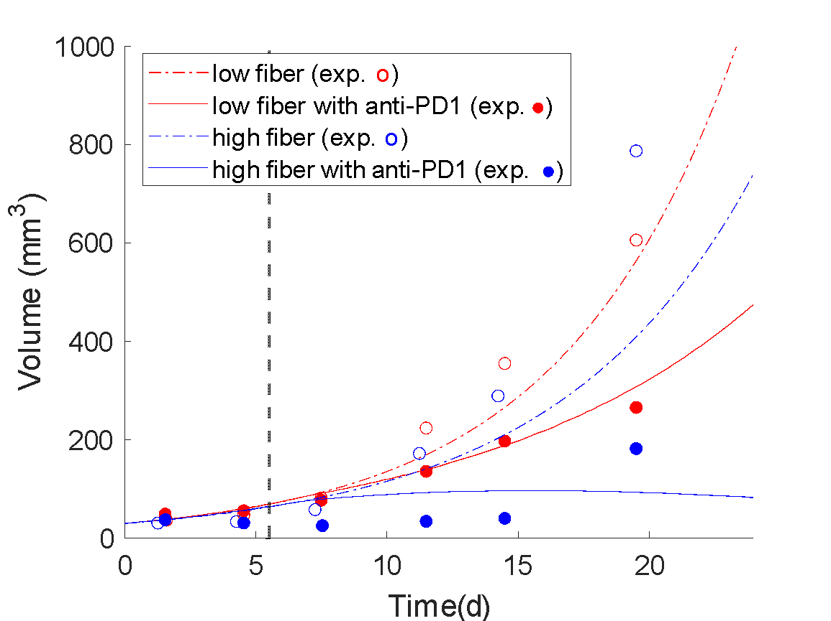
Figure S2 Comparison of experimental tumor growth curves with model prediction to define baseline values of model parameters. The bullet points represent the experimental data, and the continuous curves represent the model predictions. Day 0 is the initiation of the simulation and day 1.5 of the experiment. The vertical dashed black line represents the initiation of immunotherapy (anti-PD1). The experimental data are from Spencer et al. (HCmel1274 melanoma cells) ¹⁰. The mice were kept in specific pathogen-free conditions and fed with low- or high-fiber diet.

- Comparison of simulated CD8 T with available experimental data from the human clinical trial ¹¹
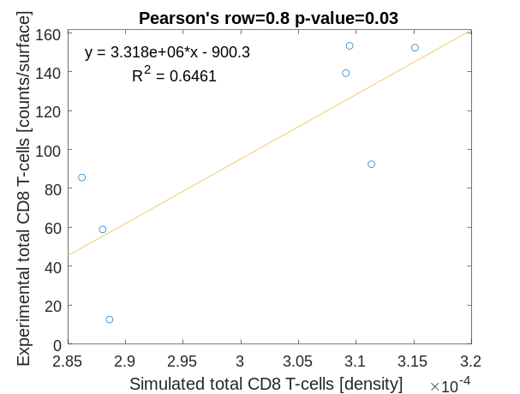
Figure S3: Comparison of simulated CD8 T with available experimental data from the human clinical trial after treatment¹¹
- References
1. Lu, D. et al. Beyond T Cells: Understanding the Role of PD-1/PD-L1 in Tumor-Associated Macrophages. Journal of Immunology Research vol. 2019 (2019).
2. Gordon, S. R. et al. PD-1 expression by tumour-associated macrophages inhibits phagocytosis and tumour immunity. Nature vol. 545 495–499 (2017).
3. Dranoff, G. Cytokines in cancer pathogenesis and cancer therapy. Nature Reviews Cancer vol. 4 11–22 (2004).
4. Roszer, T. Understanding the mysterious M2 macrophage through activation markers and effector mechanisms. Mediators of Inflammation vol. 2015 (2015).
5. Sakaguchi, S. & Powrie, F. Emerging challenges in regulatory T cell function and biology. Science vol. 317 627–629 (2007).
6. Lai, X. & Friedman, A. Combination therapy of cancer with cancer vaccine and immune checkpoint inhibitors: A mathematical model. PLoS One 12, e0178479 (2017).
7. Voutouri, C. et al. In silico dynamics of COVID-19 phenotypes for optimizing clinical management. Proc. Natl. Acad. Sci. 118, e2021642118 (2021).
8. Friedman, A. & Hao, W. The Role of Exosomes in Pancreatic Cancer Microenvironment. Bull. Math. Biol. 2017 805 80, 1111–1133 (2017).
9. Lee, H. Y. et al. Simulation and Prediction of the Adaptive Immune Response to Influenza A Virus Infection. J. Virol. 83, 7151–7165 (2009).
10. Spencer, C. N. et al. Dietary fiber and probiotics influence the gut microbiome and melanoma immunotherapy response. Science (80-. ). 374, 1632–1640 (2021).
11. Baruch, E. N. et al. Fecal microbiota transplant promotes response in immunotherapy-refractory melanoma patients. Science (80-. ). 371, 602–609 (2021).

