Supporting Information

Lateral Heterostructures of WS₂ and MoS₂ Monolayers for Photo-Synaptic Transistor

Jaeseo Park^{1,†}, Jun Oh Kim^{1,†}, and Sang-Woo Kang^{1,2,}*

¹Advanced Instrumentation Institute, Korea Research Institute of Standards and Science, Daejeon 34113, Republic of Korea
²Precision Measurement, University of Science and Technology, Daejeon 34113, Republic of Korea

†Jaeseo Park and Jun Oh Kim contributed equally to this work
*Corresponding author. E-mail: swkang@kriss.re.kr

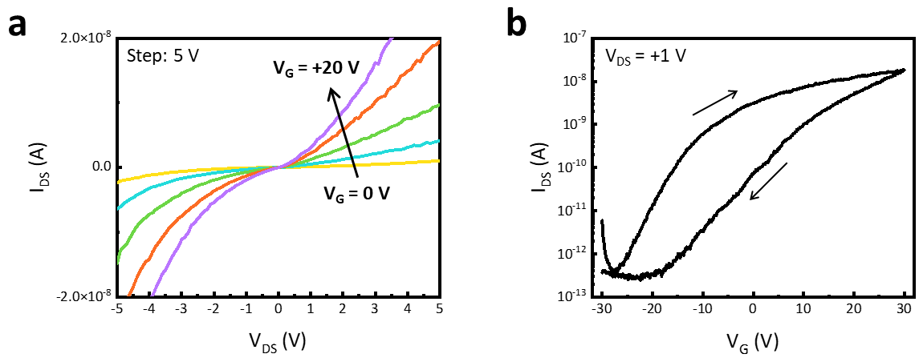
Figure S1. Output and transfer characteristics of the laterally-heterostructured WS₂/MoS₂-FET. (a) Output curves of I_{DS}-V_{DS} for various V_{G} values from 0 V to +20 V in step of 5 V. (b) Transfer curve of I_{DS}-V_{G} at V_{DS} of +1 V with a sweeping range from −30 V to +30 V.

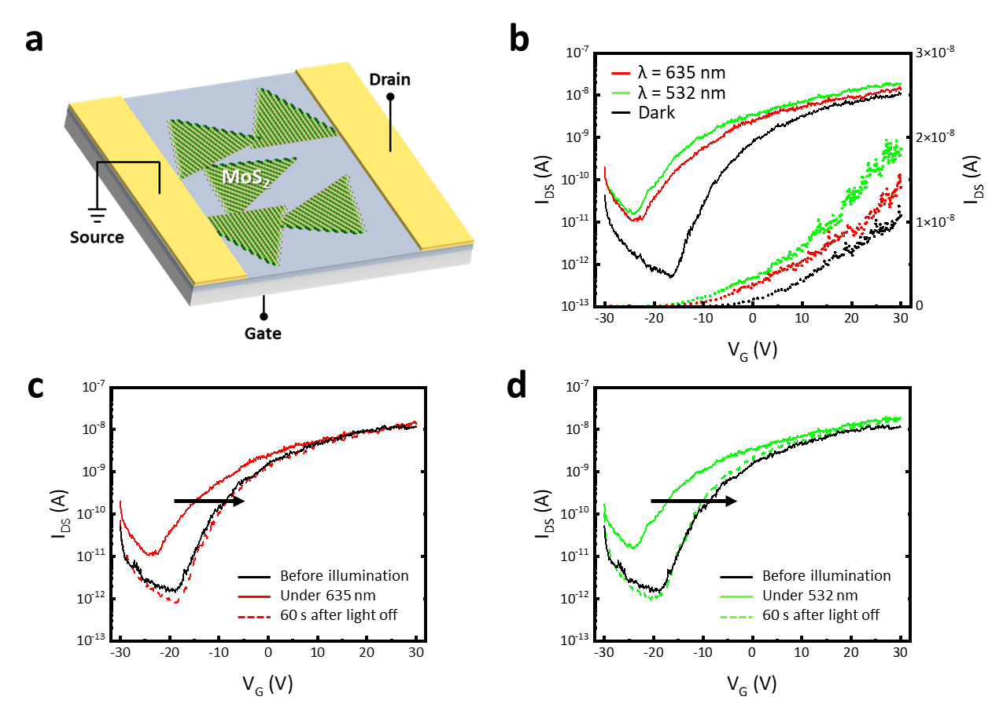
Figure S2. Device structure and transfer characteristics of the MoS₂-based back-gated FET. (a) Schematic illustration of the back-gated MoS₂-based photo-transistor. Transfer characteristics with a wavelength of (b) 635 nm and (c) 532 nm are shown. Based on the I_{DS}-V_{G} transfer characteristic of the MoS₂-FET, the on/off ratio of ~10⁴, threshold voltage (V_{TH}) of −16.98 V, and sub-threshold voltage (SS) of 3.93 V/dec are calculated (Experimental Section).

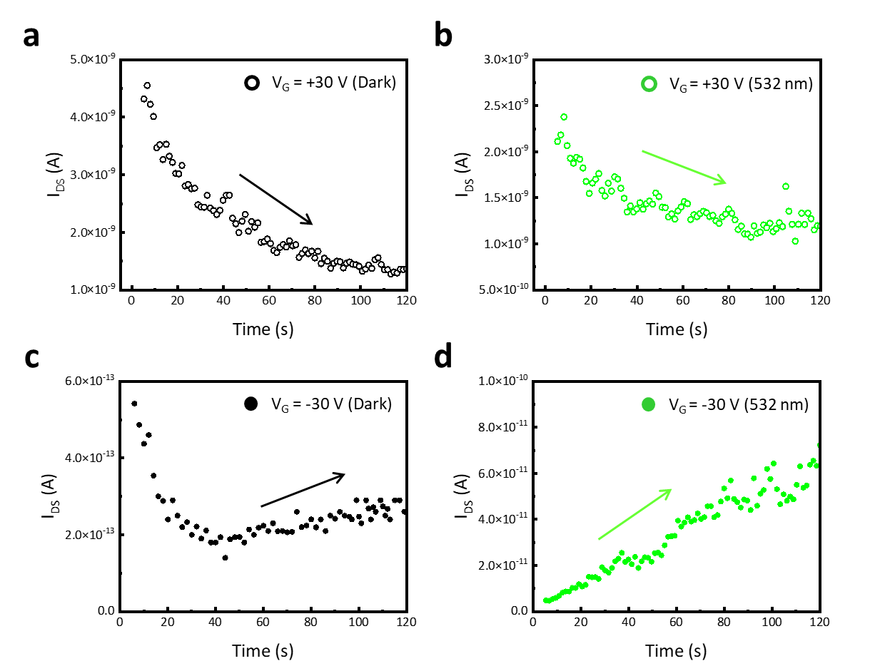
Figure S3. Time-resolved I_{DS} under dark and 532 nm light illumination conditions at V_{DS} of +1 V for 120 seconds. At V_{G} of +30 V, the time-resolved I_{DS} under (a) dark and (b) 532 nm light illumination conditions are shown. At V_{G} of −30 V, the time-resolved I_{DS} under (c) dark and (d) 532 nm light illumination conditions are shown.

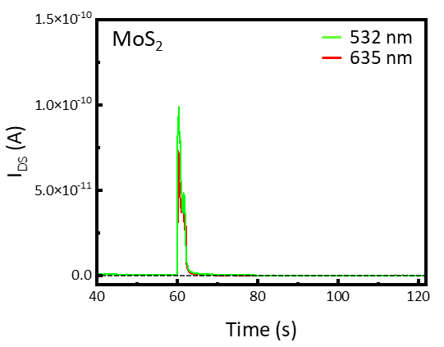
Figure S4. Photo-response behavior of the MoS₂-based photo-transistor under the illumination with different wavelengths of 532 nm (green) and 635 nm (red). The I_{DS} of the photo-transistor was measured to time when illuminated by a single light pulse of 2 seconds at V_{G} = −30 V and V_{DS} = +1 V. After a single light pulse of 532 nm and 635 nm, the current immediately returned to its initial state.

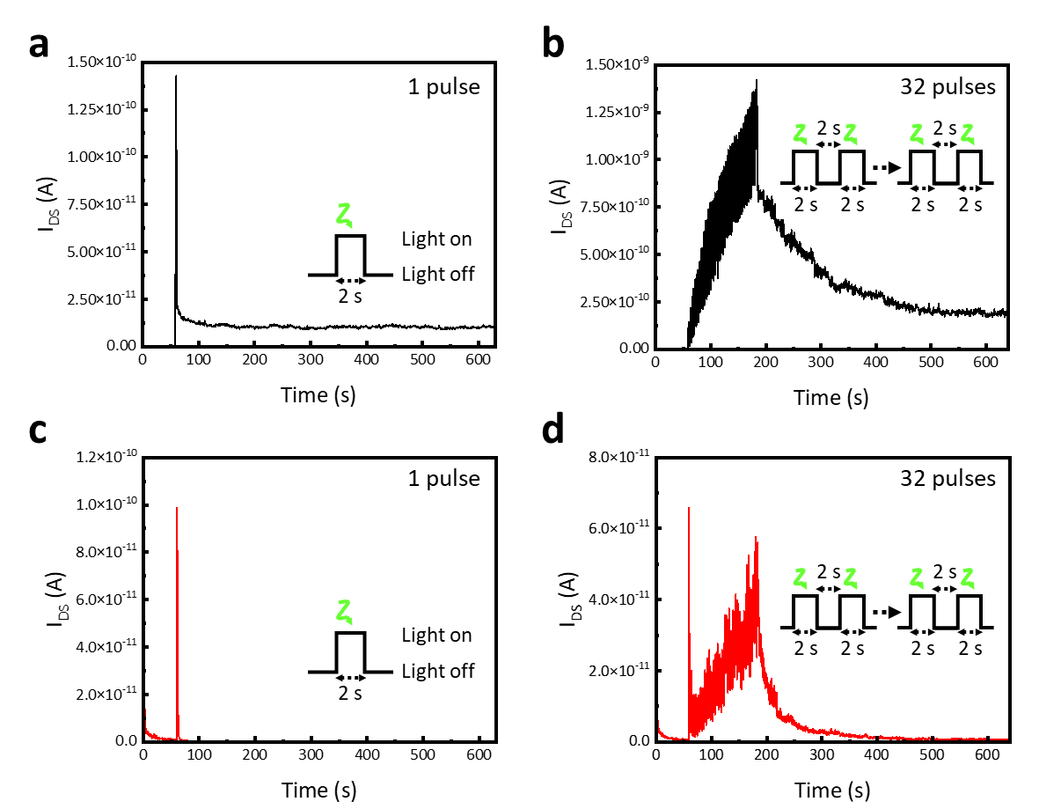
Figure S5. Characteristics of (a-b) WS₂/MoS₂- and (c-d) MoS₂-based photo-synaptic transistor under V_{G} = −30 V, V_{DS} = +1 V, and a 2-second light pulse with a wavelength of 532 nm. (a,c) EPSC triggered by a single light pulse. (b,d) EPSC triggered by 32 light pulses with an applied pulse width and time interval 2 seconds.

