Supplementary Figures
Title: Epigenetic Modulation of Short Interspersed Nuclear Elements Activity Influences Neural Precursor Cell Proliferation

Journal: Nature Communications

Authors: Dai-jing Sun^{1†}, Yue-yan Zhu^{1†}, Wen-zhu Peng^{1†}, Jie Weng¹, Shu-long Dong², Jia-qi Li¹, Qi Chen¹, Chuan-hui Ge¹, Li-yong Liao¹, Yu-hao Dong¹, Yun Liu², Wei-da Meng²*, Yan Jiang¹*

¹Institutes of Brain Science, State Key Laboratory of Medical Neurobiology and MOE Frontiers Center for Brain Science, Fudan University, 200032, Shanghai, China.
²The MOE Key Laboratory of Metabolism and Molecular Medicine, Department of Biochemistry and Molecular Biology, School of Basic Medical Sciences, Fudan University, 200032, Shanghai, China.

†D.S., Y.Z. and W.P. contributed equally to this work
*W.M. and Y.J. are co-senior authors

Correspondence: Yan Jiang, yan_jiang@fudan.edu.cn

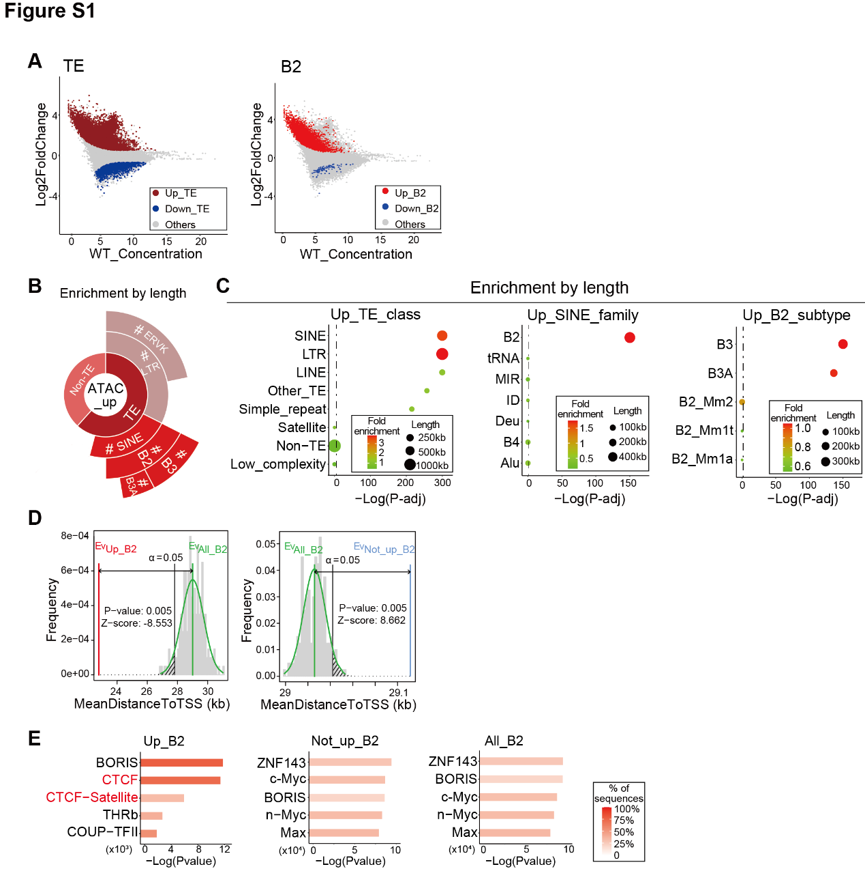

Fig. S1: SETDB1 selectively inhibited the chromatin accessibility on SINE_B2 elements. (A) MA plots of differential ATAC-seq peaks annotated as TE (left) and SINE_B2 (right). Cutoff for significance: FDR < 0.05, Log2FoldChange >= 0.585 (red, up) or <= -0.585 (blue, down), overlapping >= 50%. (B) Annotation enrichment of up-regulated ATAC-seq peaks (ATAC_up) by accumulative length. (C) “TE_class” (left), “SINE_family” (middle) and “B2_subtype” (right) annotation enrichment of ATAC_up by accumulative length. Fisher’s exact test, B-H adjusted, #: P-adj. < 0.0001. Dotted lines indicate P-adj. = 0.05. (D) Mean distance to transcription start site (TSS) from B2 overlapping ATAC_up (Up_B2, red) or B2 not overlapping ATAC_up (Not_up_B2, blue). Permutation tests were conducted against all B2 loci (All_B2, green). (E) Top 5 enriched Homer known motifs of Up_B2, Not_up_B2 and All_B2. Note CTCF and CTCF-Satellite were only enriched in Up_B2.

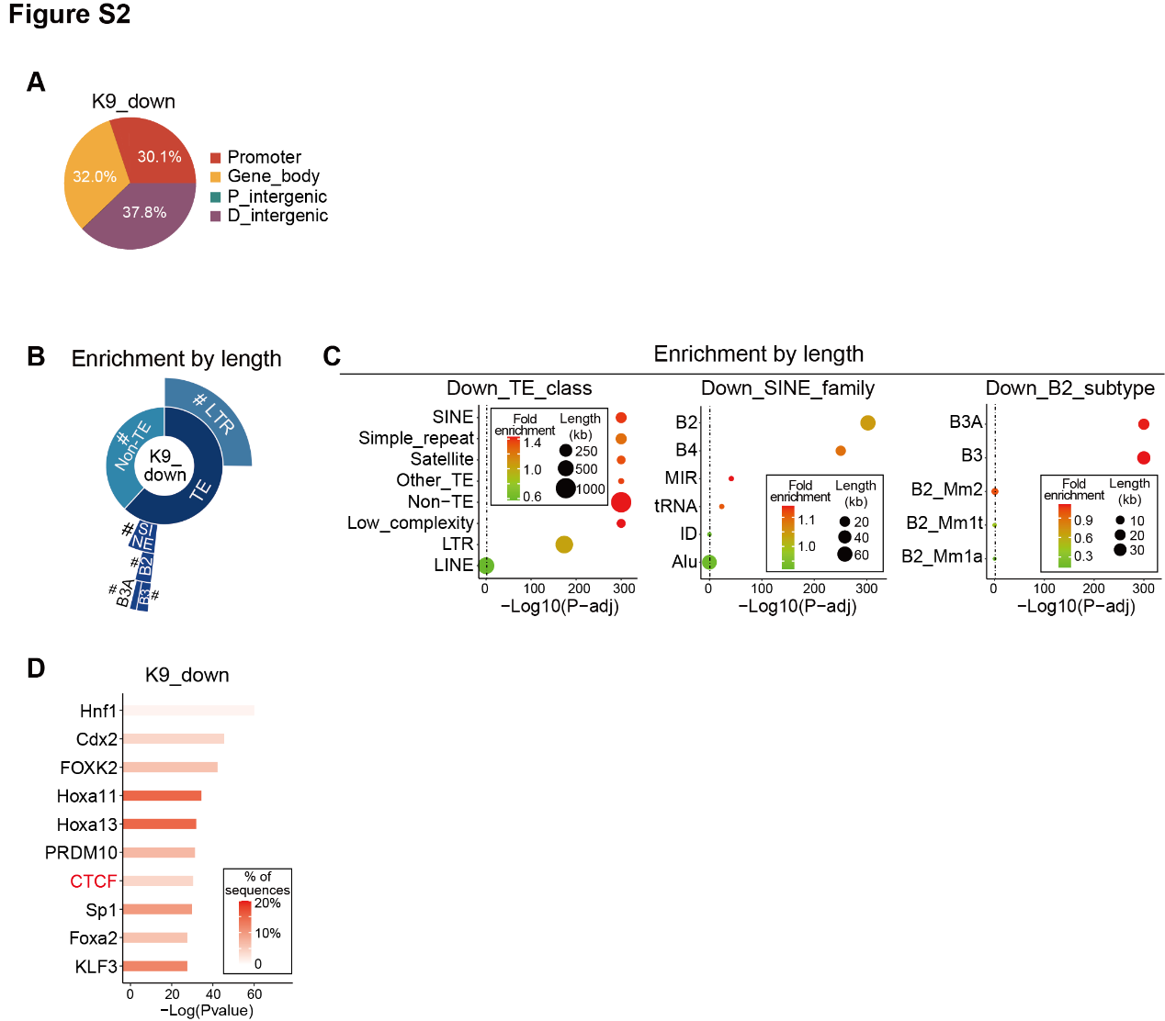

Fig. S2: SETDB1 suppressed chromatin accessibility of SINE_B2 via H3K9me3 deposition. (A) Genomic distribution of down-regulated H3K9me3 ChIP-seq peaks (“K9_down”). P_intergenic, proximal intergenic. D_intergenic, distal intergenic. (B) Annotation enrichment of K9_down by accumulative length. (C) “TE_class” (left), “SINE_family” (middle) and “B2_subtype” (right) annotation enrichment of K9_down by accumulative length. Fisher’s exact test, B-H adjusted, #: P-adj. < 0.0001. Dotted lines indicate P-adj. = 0.05. (D) Top 10 enriched Homer known motifs of K9_down. Note CTCF motif was significantly enriched.

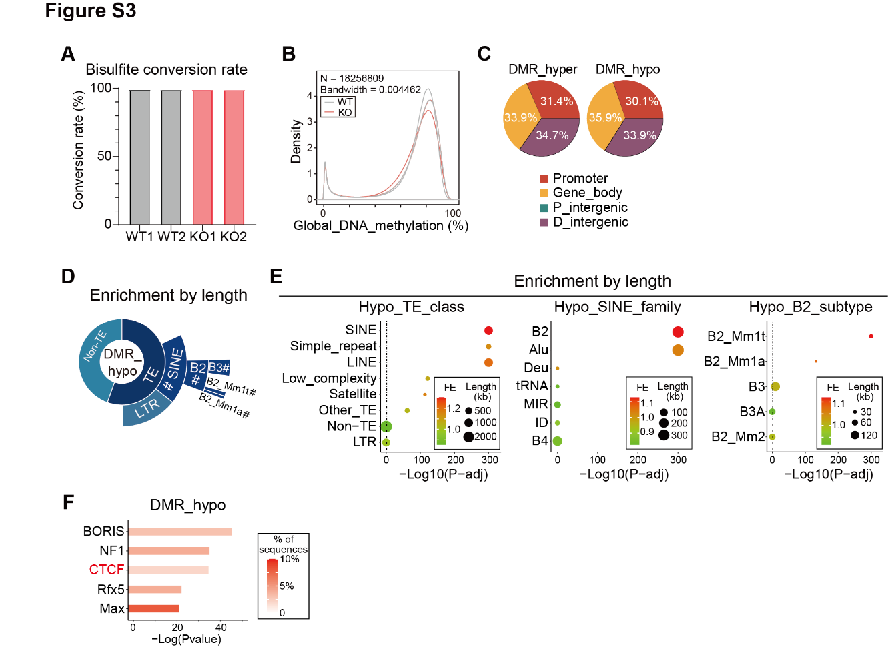

Fig. S3: DNA methylation participated in SETDB1-mediated repression of SINE_B2. (A) Bisulfite conversion rate of whole-genome bisulfite sequencing (WGBS) samples. (B) Global DNA methylation distribution of WT & KO NPC. (C) Genomic distribution of significantly hypermethylated (DMR_hyper, left) and hypomethylated (DMR_hypo, right) regions. (D) Annotation enrichment of DMR_hypo by accumulative length. (E) “TE_class” (left), “SINE_family” (middle) and “B2_subtype” (right) annotation enrichment of DMR_hypo by accumulative length. Fisher’s exact test, B-H adjusted, #: P-adj. < 0.0001. Dotted lines indicate P-adj. = 0.05. (F) Top 5 enriched Homer known motifs of DMR_hypo. Note CTCF motif was significantly enriched.

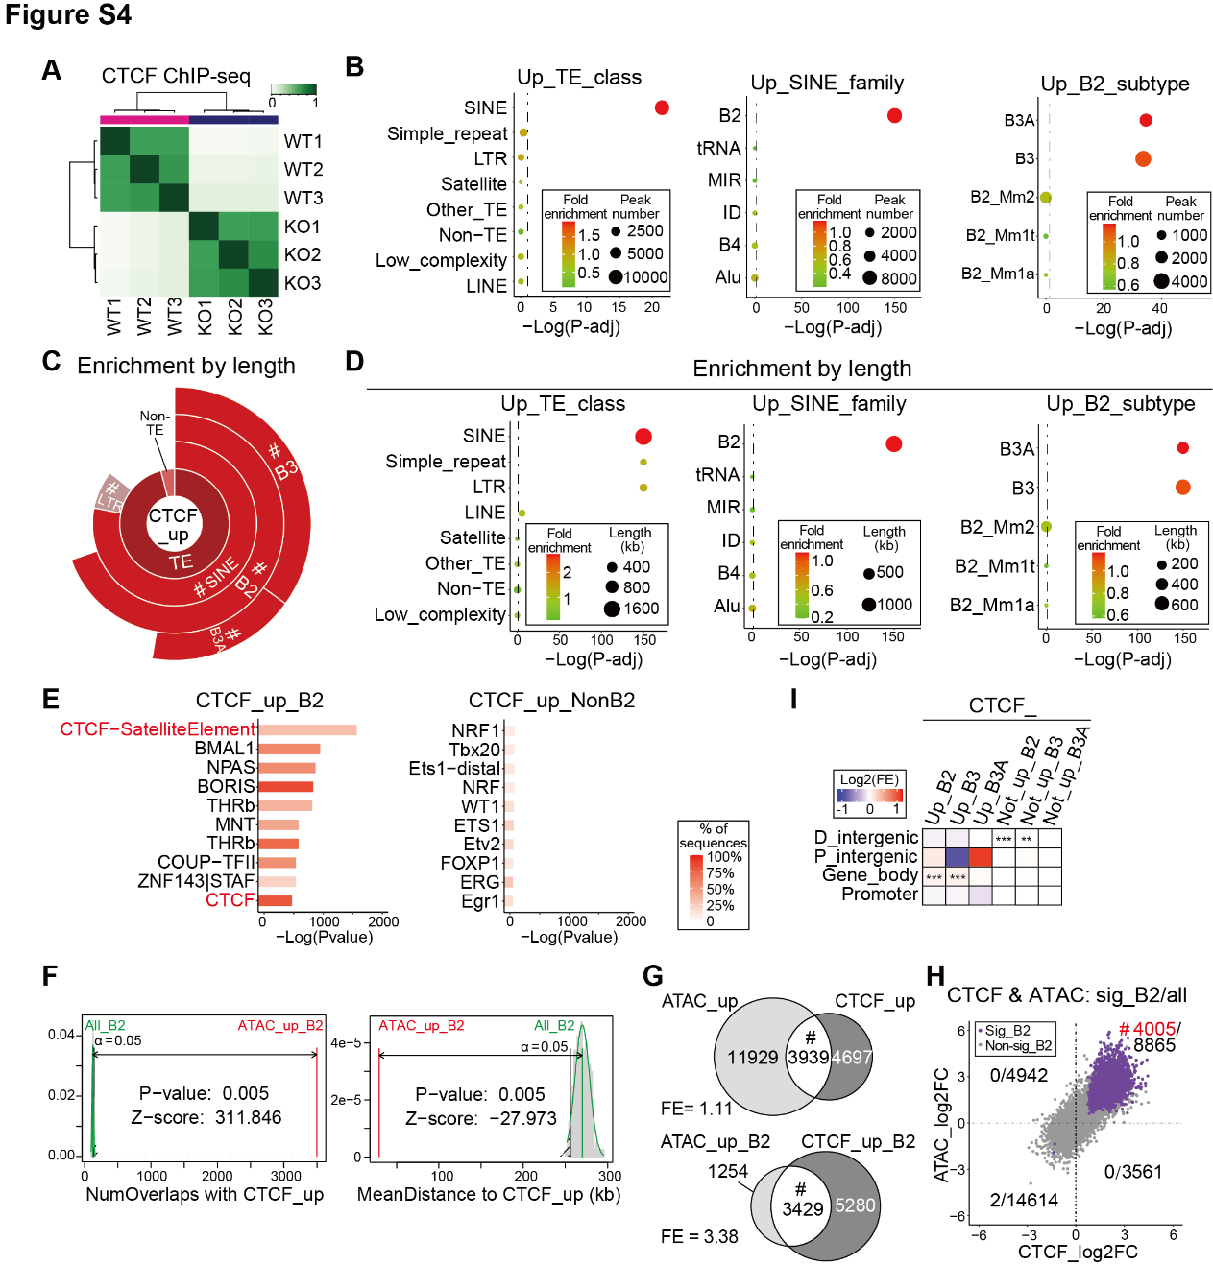

Fig. S4: SETDB1 constrained excessive CTCF binding at SINE_B2. (A) Correlation heatmap of CTCF ChIP-seq (CTCF) samples derived from WT and KO NPC. (B) “TE_class” (left), “SINE_family” (middle) and “B2_subtype” (right) enrichment of up-regulated CTCF peaks (“CTCF_up”) by number. Fisher’s exact test, B-H adjusted, #: P-adj. < 0.0001. Dotted lines indicate P-adj. = 0.05. (C) Annotation enrichment of CTCF_up by accumulative length. (D) “TE_class” (left), “SINE_family” (middle) and “B2_name” (right) annotation enrichment of CTCF_up by accumulative length. Fisher’s exact test, B-H adjusted, #: P-adj. < 0.0001. Dotted lines indicate P-adj. = 0.05. (E) Top 10 enriched Homer known motifs of CTCF_up overlapping B2 elements (“CTCF_up_B2”, left) and CTCF_up not overlapping B2 (“CTCF_up_NonB2”, right). Enrichment analysis was conducted against the background of all CTCF peaks. Note CTCF-SatelliteElement and CTCF motifs were only enriched for CTCF_up_B2. (F) Number of overlaps between ATAC_up_B2 and CTCF_up (left), and mean distance from ATAC_up_B2 to CTCF_up (right). Permutation tests were conducted against all B2 loci (All_B2, green). (G) Overlap between ATAC_up & CTCF_up (top), and ATAC_up_B2 & CTCF_up_B2 (bottom). FE, fold enrichment. Fisher’s exact test, #: P-value < 0.0001. (H) Log2FoldChange (log2FC) of all overlapping ATAC & CTCF peaks (“all”), and significantly differential ATAC & K9 peaks overlapping B2 elements (“sig_B2”). Note sig_B2 were almost exclusively and significantly distributed in the 2nd quadrant. Sig, significant. Non_sig, non-significant. Fisher’s exact test, #: P-value < 0.0001. (I) Genomic distribution enrichment of B2 overlapping CTCF_up (CTCF_up_B2, including CTCF_up_B3 and CTCF_up_B3A) and B2 not overlapping CTCF_up (CTCF_not_up_B2, including CTCF_not_up_B3 and CTCF_not_up_B3A). FE, fold enrichment. Fisher’s exact test, B-H adjusted, **: P-adj. < 0.01, ***: P-adj. < 0.001.

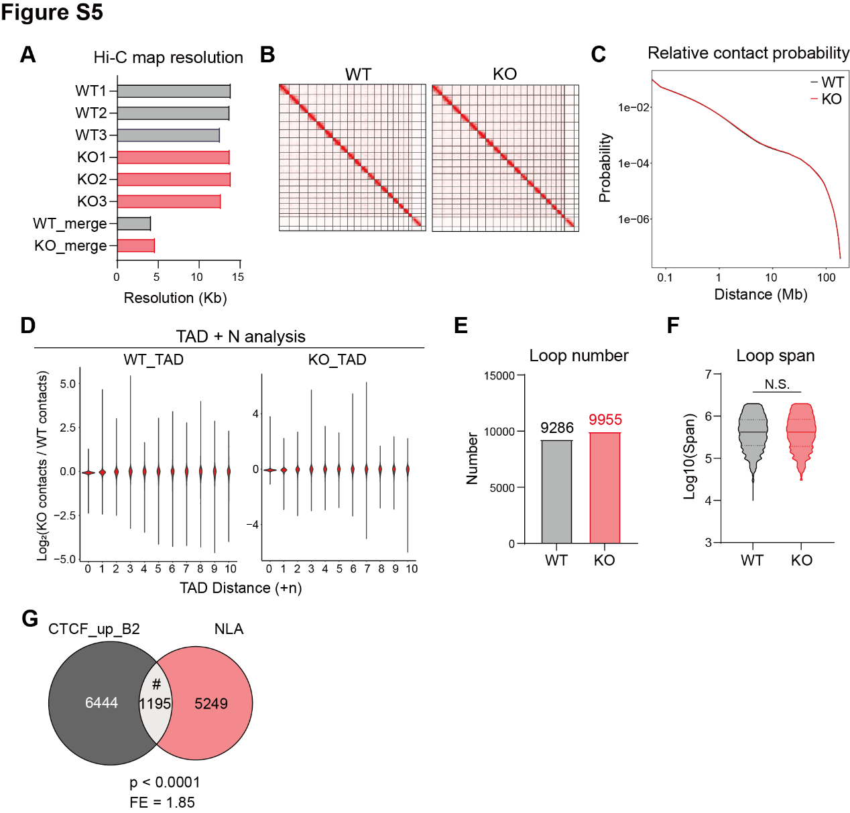

Fig. S5: Chromatin loop formation due to increased CTCF occupancy at SINE_B2 elements. (A) Hi-C map resolution of individual and genotype-merged Hi-C samples. (B) Hi-C contact maps of WT and KO NPC. (C) Relative contact probability genome-wide. (D) Differential (KO/WT) interaction density between neighboring TADs in WT TAD regions (left) and KO TAD regions (right). (E) The number of chromatin loops in WT and KO NPC. (F) The span of chromatin loops in WT and KO NPC. Solid lines: medians. Dotted lines: quartiles. Mann-Whitney U test, N.S., non-significant. (G) Overlap between CTCF_up_B2 and “new loop anchors” (NLA). Fisher’s exact test, #: P-value < 0.0001. FE, fold enrichment.

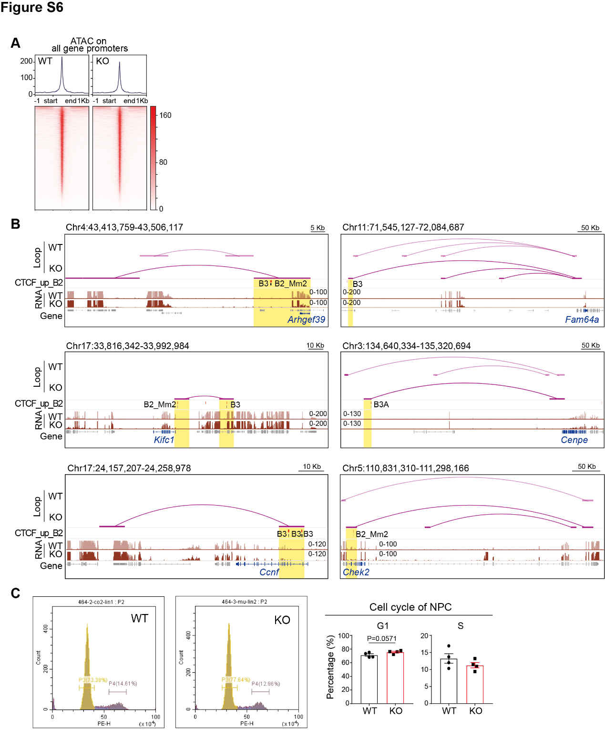

Fig. S6: SETDB1 maintained cell cycle in NPC by restraining aberrant loop formation. (A) ATAC-seq signal profiles on promoters of all detected genes in RNA-seq. (B) Examples of B2_new_loop-regulated, transcriptionally down-regulated cell cycle cluster genes (“cluster_gene” for short, gene name and gene body in blue). Yellow shades indicate CTCF_up_B2-mediated new loop anchors. The overlapping SINE_B2 element was marked with black lines and subtypes. (C) Count and propidium iodide fluorescence distribution of WT and KO NPC analyzed by flow cytometry (left). Bar plots displayed the percentages of NPC in G1 and S phase, respectively (right). Mean ± SEM, Mann-Whitney U test.

