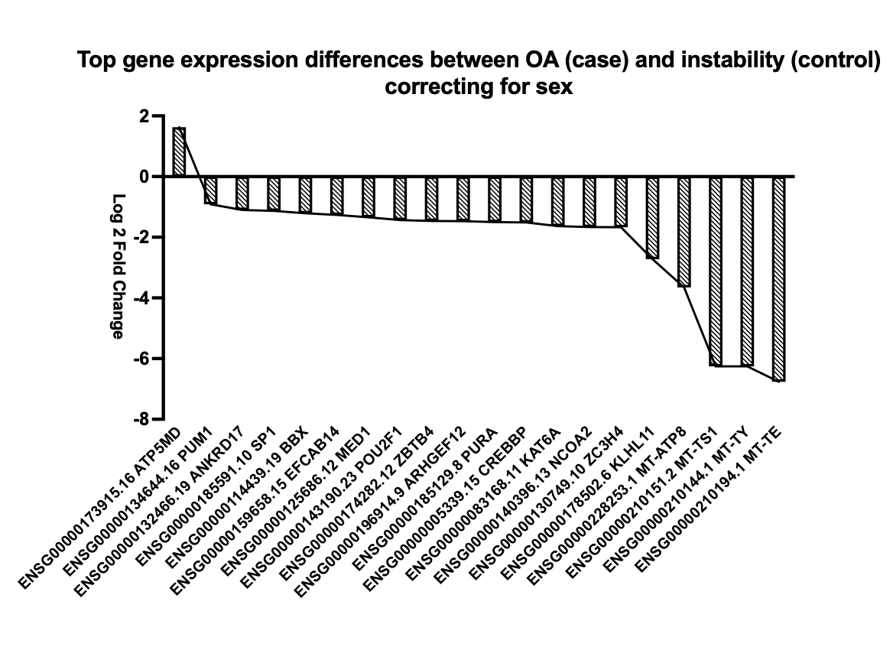 Supplementary Figure 1. Top 20 differentially expressed genes in capsular tissue biopsies between OA (case) and instability (control), correcting for sex. Mitochondrial related genes exhibited the highest fold change of all significantly downregulated genes.

