SUPPLEMENTARY DATA

Contents |  | Page
Supplementary Fig. 1: | Summary of study protocol flow | 1
Supplementary Method 1: | The criteria of metabolic syndrome and exclusion of this study | 1
Supplementary Method 2: | Dietary intervention | 1
Supplementary Table 1: | Daily nutrition profiling over the course of the study | 3
Supplementary Fig. 2: | Changes in lipid profile | 5
Reference |  | 5

Supplementary Fig. 1: Summary of study protocol flow
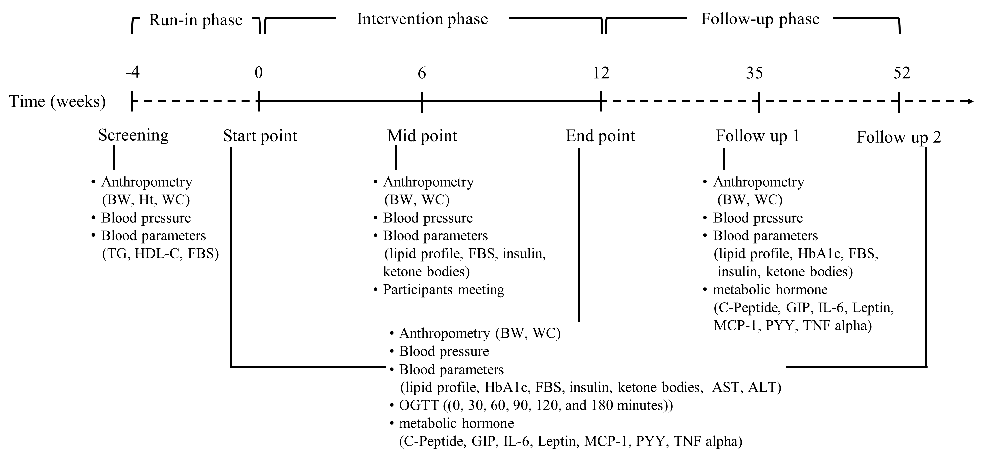
BW, body weight; Ht, height; WC, waist circumference; TG, triglyceride; FBS, fasting blood sugar; HbA1C, Hemoglobin A1C; AST, aspartate transaminase; ALT, alanine aminotransferase; GIP, glucose-dependent insulinotropic polypeptide; IL-6, interleukin-6; MCP-1, monocyte chemoattractant protein-1; PYY, peptide YY; TNF alpha, tumor necrosis factor alpha.

Supplementary Method 1:: The criteria of metabolic syndrome and exclusion of this study
The criteria for metabolic syndrome (Mets) are based on having three or more of the following risk factors: (1) waist circumference ≥ 80 cm in women and ≥ 90 cm in men; (2) fasting blood sugar ≥ 100 mg/dl; (3) triglyceride ≥ 150 mg/dl; (4) high-density lipoprotein cholesterol ≤ 50 mg/dl in women and ≤ 40 mg/dl in men; (5) systolic blood pressure ≥ 130 mmHg and diastolic blood pressure ≥ 85 mmHg
The exclusion criteria included individuals with uncontrolled hypertension or metabolic disease, as well as those with diabetes, heart disease, chronic kidney disease, cancer, or who were pregnant. Other exclusion criteria included the use of hypoglycemic and medications that could affect energy expenditure, recent significant changes in body weight (BW, exceeding 5%), engaging in vigorous-intensity physical activity ( > 150 minutes/week), consuming alcoholic beverages more than once a week, or being current smokers.

Supplementary Method 2: Dietary intervention
The main objectives were to achieve differentiated intake of carbohydrate and fat among the 3 diet groups. The macronutrient targets for the healthy egg yolk Asian ketogenic diet (Yolk-AKD), the healthy egg white Asian ketogenic diet group (White-AKD), and the balanced low-caloric diet (BLC) were expressed as a percentage of total daily energy intake (% en and per gram (g) basis): (1) Yolk-AKD: <50 g/day carbohydrate, ad libitum protein and fat with at least 3 whole eggs/day (20 g of protein), sourced from S.W. Foodtech., Co., Ltd., Thailand; (2) White-AKD: <50 g/day carbohydrate, ad libitum protein and fat with at least 20 g protein from egg whites/day, sourced by Khaisook., Co., Ltd., Thailand and limited other dietary cholesterol intakes; (3) BLC: 50-60% carbohydrate, 30-35% fat, 15-20% protein with a 20% reduction in caloric intake based on estimated total energy expenditure (TEE). TEE was calculated using the Harris-Benedict equation, taking into account actual, ideal, and adjusted body weight, which has been shown to provide the highest precision for individuals with overweight and obesity (1). Participants were guided to reduce total fat and calorie intake compared to digestible carbohydrates during the first 12 weeks. This involved the reduction of edible oils, fatty meats, fried foods, whole-fat dairy, and nuts, while increasing the consumption of grilled or boiled low-fat menus in the BLC group. For the AKD groups, the focus was on reducing rice, starchy vegetables, tropical sugary fruits, noodles, bread, and juice, while increasing grilled meats, eggs, seafoods, and whole foods.
There were some central components to the dietary strategy that were communicated with the participants. Participants were instructed about carbohydrate counting based on Thai foods while in both AKD groups, participants were asked to “go as low as 20-50 g of carbohydrate per day to reduce chances of ketosis and other side effects from KD. Participants received advice that the rate of restriction was not critical to the study. The rate could be variable and individually adjusted. Precise nutrient calculation was not necessary. All participants were encouraged to focus on whole, real foods but to processed foods that were either purchased from local restaurants or street-food markets or at home as they were comfortable and realistically affordable.
The second component of the dietary strategy involved BW measurement. if satisfaction and weight loss progress were acceptable, they had the option of maintaining that fat or carbohydrate intake regardless of their intake. Those assigned to the healthy BLC were instructed to select low glycemic index rice, reduced cooking oils, and consume a wide range of legumes, vegetables, fresh fruits, low-fat dairy products, and lean meats. Those assigned to the healthy KD were instructed to select whole foods without over fat and oil consumption to prevent risk of hypercholesterolemia.
After week 12, individuals were encouraged to maintain their diet intervention without a strict plan. No explicit instructions for energy restriction were provided. Instead, they were advised to: (1) maximize fiber and vegetable intake, (2) minimize added sugar intake, refined carbohydrate, and saturated fat, and (3) focus on whole foods and nutrient dense. Participants were encouraged to follow current physical activity recommendations. Except for the first 8 weeks of the AKD groups who were advised not to perform aerobic exercise while they were overweight or obese. All educators taught their classes by focusing on making sustainable lifestyle changes rather than very strict rules on either the KD or BLC concepts. Participants were allowed to make individual contact with their educator via online chat and phone to address specific dietary questions.

Supplementary Table 1: Daily nutrition profiling over the course of the study
Variable | Time (weeks) | BLC | White-AKD | Yolk-AKD | P-valueª
Energy, kcal | Run in phase | 1359.9 ± 102.24 | 1365.6 ± 92.48 | 1453.2 ± 108.44 | 0.783
 | 4 | 1306.5 ± 153.67 | 1368.5 ± 139.00 | 1388.2 ± 162.99 | 0.928
 | 8 | 1232.8 ± 137.02 | 1383.1 ± 123.94 | 1333.6 ± 145.33 | 0.717
 | 12-35 | 1137.6 ± 74.66 | 1130.0 ± 67.53 | 1177.2 ± 79.19 | 0.894
 | 52 | 1087.7 ± 72.51 | 1254.5 ± 65.59 | 1420.9 ± 76.91‡ | 0.015
P-value by time^{b} |  | 0.528 | 0.287 | 0.174
Carbohydrate, g  (% of energy) | Run in phase | 169.4 ± 21.07  (49.8) | 149.3 ± 19.06*  (43.7) | 192.6 ± 22.35*  (53.0) | 0.352
 | 4 | 160.5 ± 9.30  (49.1) | 42.6 ± 8.41*†  (12.5) | 43.8 ± 9.86*‡  (12.6) | <0.001
 | 8 | 138.2 ± 8.69  (44.8) | 47.4 ± 7.86*†  (13.7) | 49.7 ± 9.22*‡  (14.9) | <0.001
 | 12-35 | 137.4 ± 9.83  (48.3) | 96.0±8.89*†  (34.0) | 88.0 ± 10.42*‡  (29.9) | 0.003
 | 52 | 116.6 ± 10.63*  (42.9) | 107.8 ± 9.61  (34.4) | 130.5 ± 11.27*  (36.7) | 0.324
P-value by time^{b} |  | 0.032 | <0.001 | <0.001
Protein, g  (% of energy) | Run in phase | 63.8 ± 7.21  (18.8) | 73.5 ± 6.52  (21.5) | 59.8 ± 7.65  (16.5) | 0.370
 | 4 | 57.7 ± 18.21  (17.7) | 123.6 ± 16.47*†  (36.1) | 144.4 ± 19.31 *‡  (41.6) | 0.007
 | 8 | 60.6 ± 13.90  (19.7) | 96.2 ± 12.57  (27.8) | 117.9 ± 14.74*‡  (35.4) | 0.028
 | 12-35 | 51.3 ± 6.94  (18.0) | 74.3 ± 6.28†  (26.3) | 76.3 ± 7.36‡  (25.9) | 0.030
 | 52 | 53.4 ± 7.42  (19.6) | 76.4 ± 6.71†  (24.4) | 78.5 ± 7.87‡  (22.1) | 0.045
P-value by time^{b} |  | 0.579 | <0.001 | <0.001
Fat, g  (% of energy) | Run in phase | 47.5 ± 4.11  (31.4) | 52.7 ± 3.72  (34.7) | 49.3 ± 4.36  (30.5) | 0.629
 | 4 | 48.2 ± 8.36  (33.2) | 78.2 ± 7.56*†  (51.4) | 70.6 ± 8.87*  (45.8) | 0.039
 | 8 | 48.6 ± 9.86  (35.5) | 89.9 ± 8.92*†  (58.5) | 73.7 ± 10.46*  (49.7) | 0.017
 | 12-35 | 42.5 ± 5.00  (33.6) | 49.9 ± 4.52  (39.7) | 57.8 ± 5.30‡  (44.2) | 0.034
 | 52 | 45.3 ± 3.09  (37.5) | 57.6 ± 2.79†  (41.3) | 65.0 ± 3.27*‡  (41.2) | 0.001
P-value by time^{b} |  | 0.356 | <0.001 | 0.004
Cholesterol, mg | Run in phase | 200.8 ± 34.10 | 213.5 ± 30.84 | 133.7 ± 36.17 | 0.234
 | 4 | 232.5 ± 68.20 | 321.1 ± 61.69 | 1179.1 ± 72.34*‡§ | <0.001
 | 8 | 335.8 ± 63.96 | 351.6 ± 57.86* | 972.4 ± 67.85*‡§ | <0.001
 | 12-35 | 316.8 ± 45.19 | 395.7 ± 40.87* | 593.4 ± 47.93*‡§ | 0.001
 | 52 | 302.0 ± 56.40 | 483.1 ± 51.01*† | 534.7 ± 59.82*‡ | 0.020
P-value by time^{b} |  | 0.769 | <0.001 | <0.001

Supplementary Table 1: Daily nutrition profiling over the course of the study (Count.)
Variable | Time (weeks) | BLC | White-AKD | Yolk-AKD | P-valueª
Saturated fat, g  (% of energy) | Run in phase | 13.2 ± 1.55  (8.7) | 15.1 ± 1.40  (10.0) | 12.5 ± 1.65  (7.7) | 0.447
 | 4 | 11.6 ± 2.51  (8.0) | 21.9 ± 2.27*†  (14.4) | 15.4 ± 2.66  (10.0) | 0.017
 | 8 | 16.1 ± 2.82  (11.7) | 24.8 ± 2.56*†  (16.1) | 21.3 ± 3.00*  (14.4) | 0.049
 | 12-35 | 9.6 ± 1.46  (7.6) | 13.6 ± 1.32  (10.8) | 17.3 ± 1.55*‡  (13.2) | 0.005
 | 52 | 12.5 ± 1.59  (10.3) | 18.1 ± 1.44†  (13.0) | 15.0 ± 1.69  (9.5) | 0.046
P-value by time^{b} |  | 0.047^{d} | 0.001 | 0.029
Unsaturated fat, g^{c} | Run in phase | 34.3 ± 3.00 | 37.6 ± 2.72 | 36.8 ± 3.18 | 0.707
 | 4 | 36.6 ± 5.96 | 56.3 ± 5.39*† | 55.3 ± 6.32*‡ | 0.043
 | 8 | 32.5 ± 8.02 | 65.1 ± 7.25*† | 52.4 ± 8.51 | 0.021
 | 12-35 | 33.0 ± 3.85 | 36.3 ± 3.48 | 40.4 ± 4.08 | 0.426
 | 52 | 32.8 ± 2.35 | 39.5 ± 2.12† | 50.0 ± 2.49*‡§ | <0.001
P-value by time^{b} |  | 0.527 | <0.001 | 0.034
ªP-values are for time effects and time x group interactions (i.e., BLC, a healthy balanced low-caloric diet; White-AKD, a healthy egg white Asian ketogenic diet; Yolk-AKD, a healthy egg yolk Asian ketogenic diet) for all subjects analyzed by repeated measures ANOVA (p-value < 0.05). ^{b}Within a row, values with different superscript letters are significantly different using Bonferroni adjusted (p-value < 0.05). ^{c}Unsaturated fat = Δtotal fat-saturated fat. ^{d}Data were significant difference between time points except for baseline. *Data were significant differences from baseline. Significant difference between diet groups: †BLC and White-AKD; ‡BLC and Yolk-AKD; §White-AKD and Yolk-AKD.

Supplementary Fig. 2: Changes in lipid profile
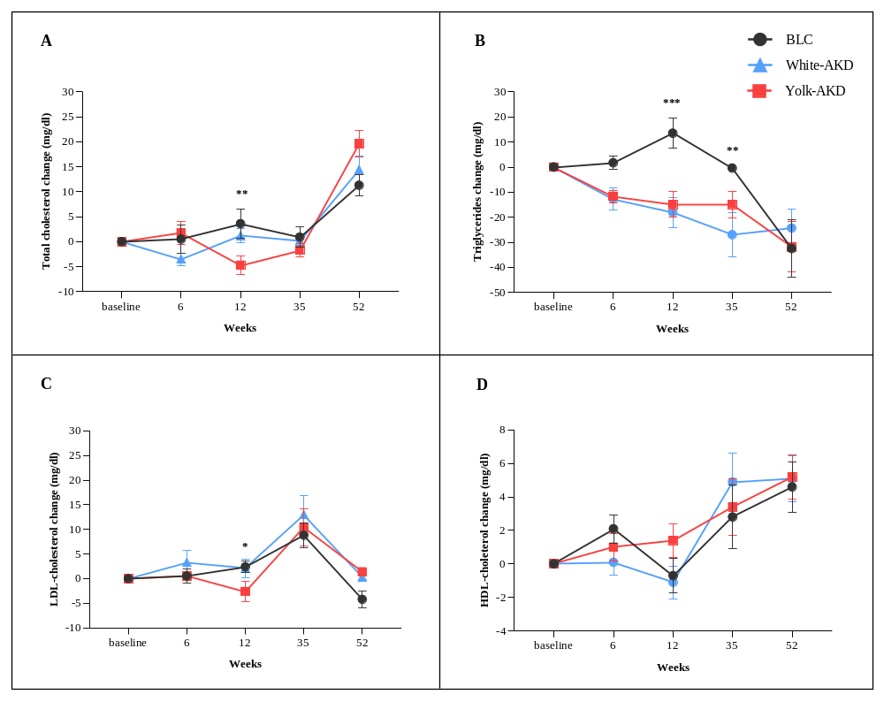
Changes in lipid profile over 1 year across different diet groups. Panel A presents the results for serum total cholesterol, Panel B for serum triglycerides, Panel C for LDL-cholesterol, and Panel D for serum HDL-cholesterol. Repeated measures ANOVA model and significantly different using Bonferroni adjusted were used to evaluate the changes in weight measurements over time statistically. The explanatory variables were age, sex, time point, diet group, and time x group interactions. Asterisks indicate a significant difference (*p < 0.05; ** p < 0.01; *** p < 0.001) between the groups. BLC, A healthy balanced low caloric diet; White-KD, yolk-free ketogenic diet with egg white supplementation; Yolk-KD, yolk-free ketogenic diet with egg white supplementation.

References
1. Macena ML, Paula D, da Silva Júnior AE, et al. Estimates of resting energy expenditure and total energy expenditure using predictive equations in adults with overweight and obesity: a systematic review with meta-analysis. Nutr Rev 2022;80(11):2113-2135.

