SUPPLEMENTARY INFORMATION
Supplementary Figures

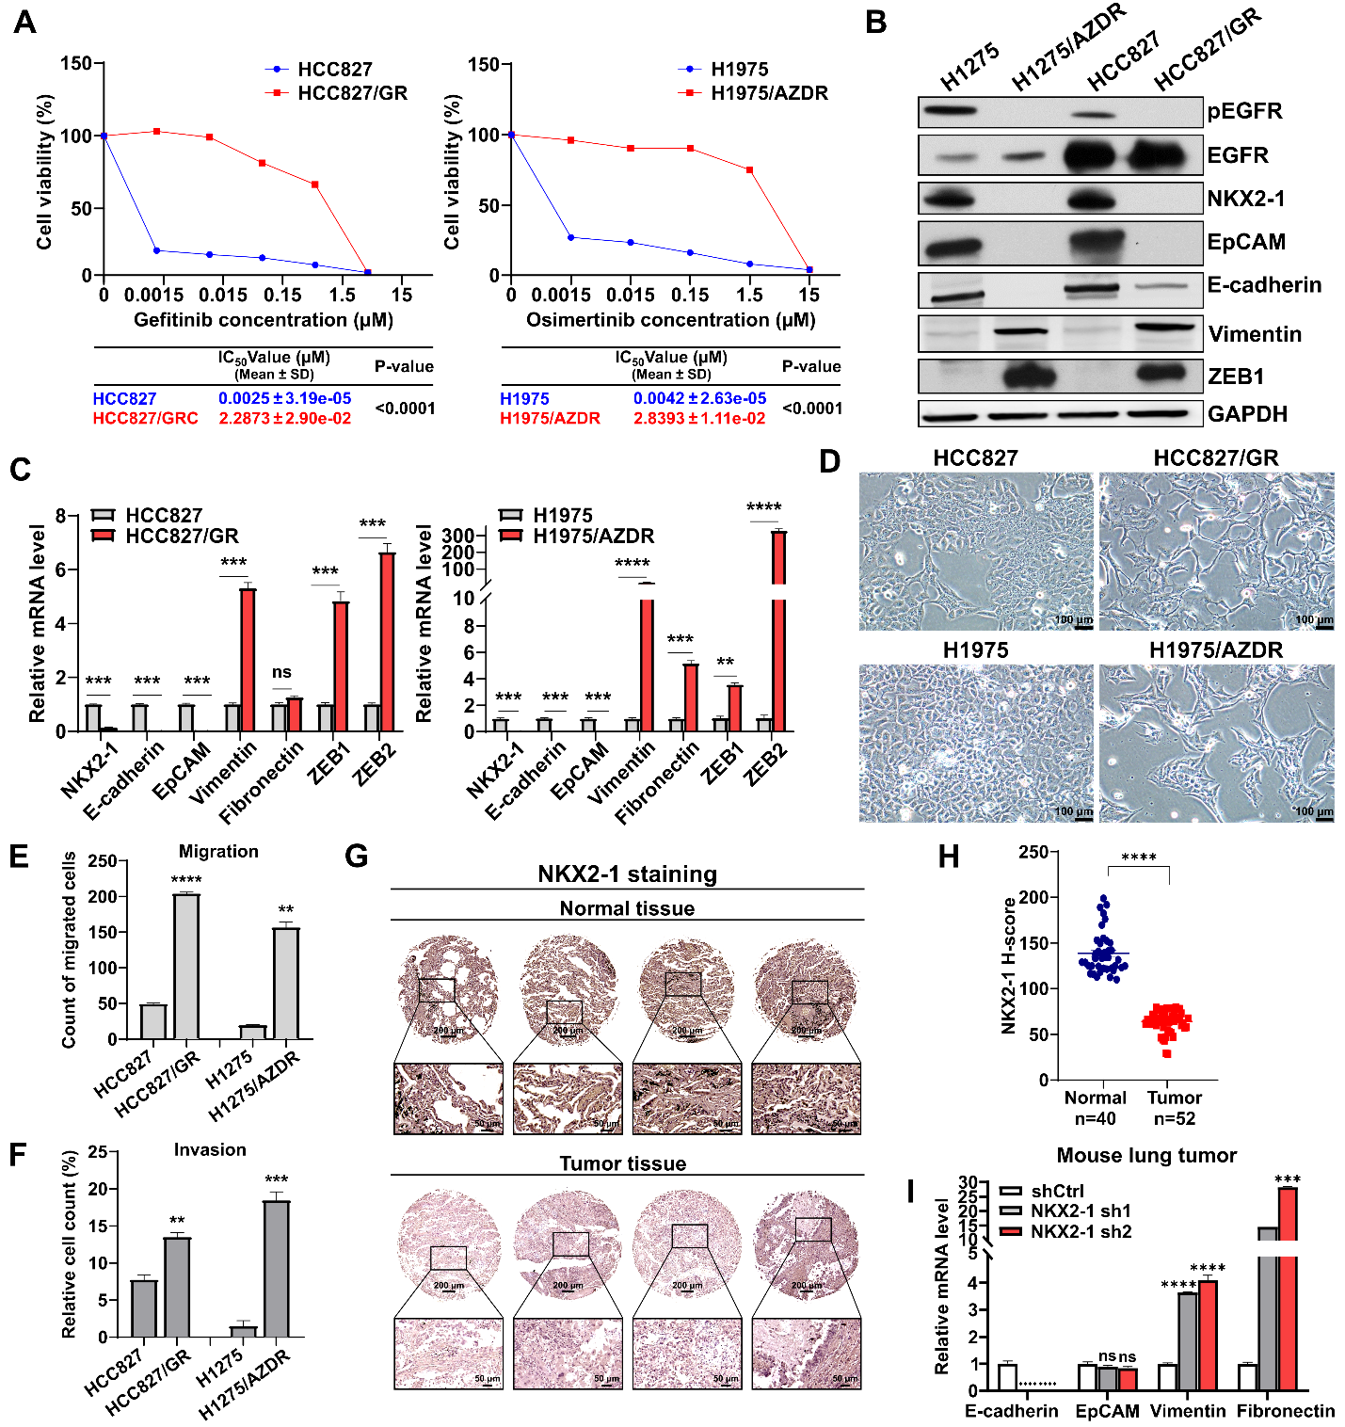
Supplementary Fig. 1. EGFR-TKI resistance and high-grade LUAD tumors display low NKX2-1 expression. (A) AlamarBlue cell viability assay was performed on parental and EGFR-TKI-resistant lung cancer cells treated with different concentrations of gefitinib (left panel) or osimertinib (right panel). IC₅₀ values with relevant statistical parameters are shown at the bottom. (B) Western blot analysis showing the expression levels of NKX2-1 and EMT markers in the indicated parental and EGFR-TKI-resistant lung cancer cells. GAPDH – loading control. (C) qRT-PCR analysis validating the expression of NKX2-1 and EMT markers in the indicated parental and EGFR-TKI-resistant lung cancer cells. Mean fold changes relative to parental cells are shown with SD error bars (N=3), **P<0.01, ***P<0.001, ****P<0.0001, ns – not significant (Student’s t-test). (D) Bright-field microscopy images showing the morphology of parental (HCC827 and H1975) and EGFR-TKI-resistant (HCC827/GR and H1975/AZDR) lung cancer cells. (E and F) Transwell migration (E) and invasion (F) assays showing the migration and invasion potential of parental and EGFR-TKI resistant lung cancer cells. The mean numbers of migrated cells (N=3) with SD error bars are shown, **p<0.01, ***p<0.001, ****p<0.0001, ns – not significant (Student’s t-test). (G - H) Immunohistochemical staining of NKX2-1 was performed on tumor tissue microarrays (TMAs) of LUAD and normal lung tissue. Representative image (G) and score intensity (H) were performed by using ImageJ of normal (N = 40) and LUAD (N = 52) tissues. ****P< 0.0001 (Student’s t-test). (I) qRT-PCR analysis of the expression of EMT markers in shCtrl and shNKX2-1 lung tumor tissues derived from orthotopically injected mice. Mean fold changes relative to shCtrl /LL2 cells are shown with SD error bars (N=3), ***P<0.001, ****P<0.0001, ns – not significant (Student’s t-test).
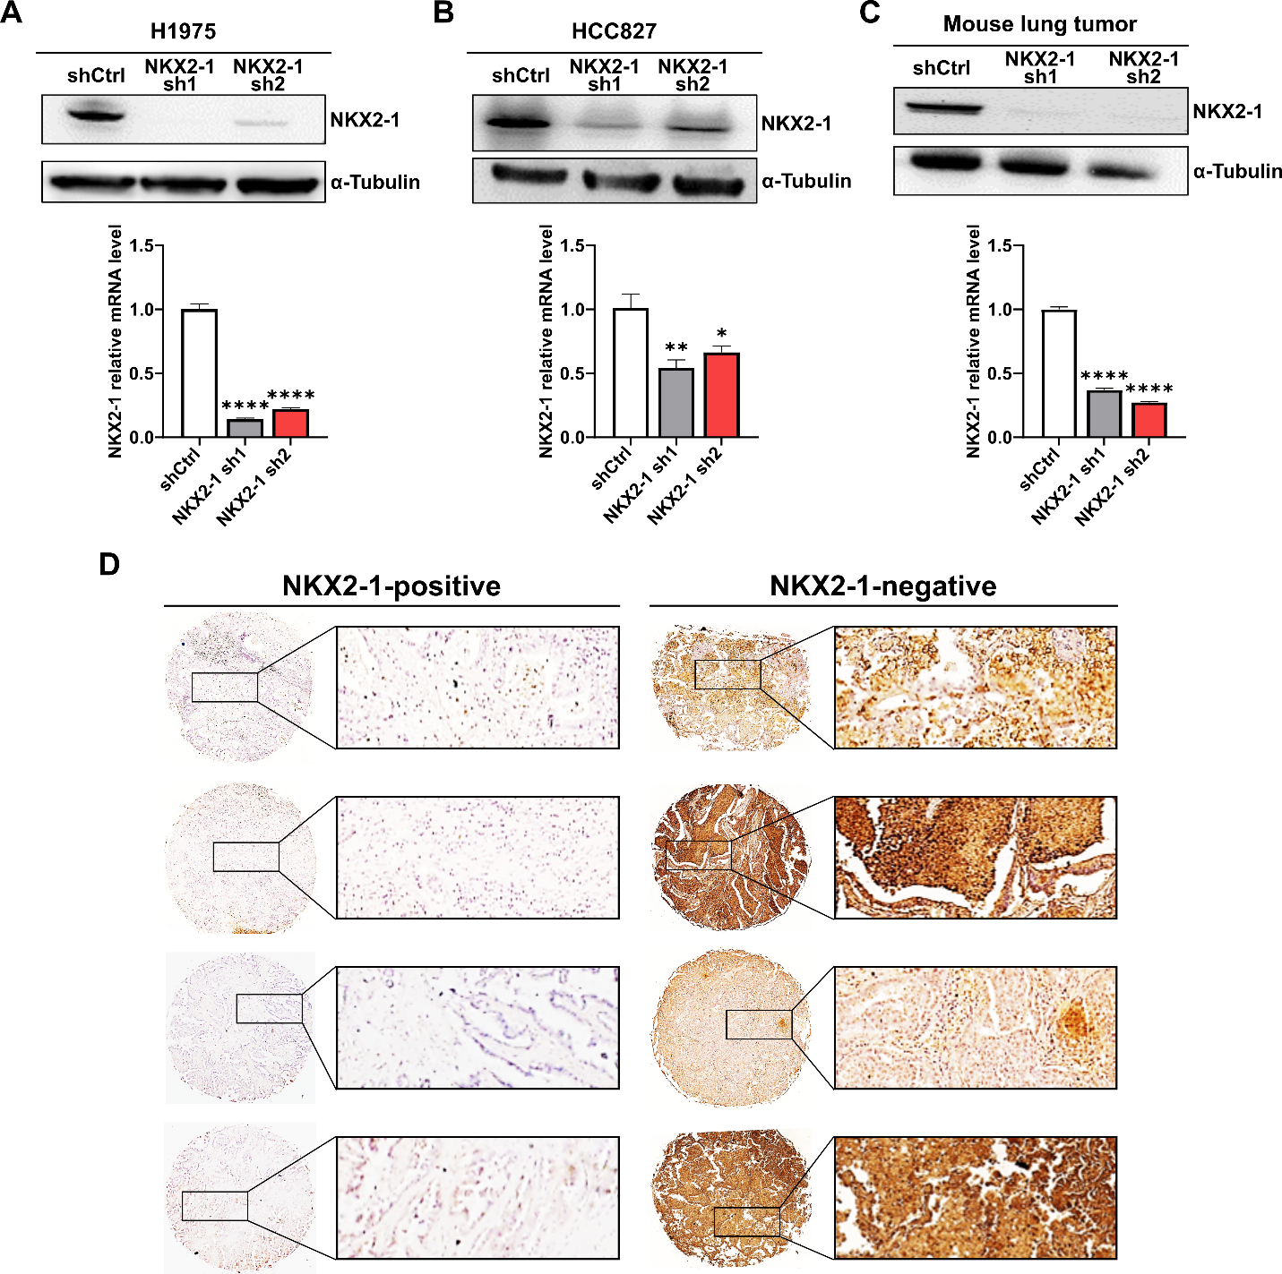

Supplementary Fig. 2. Validating NKX2-1 knockdown in LUAD cell lines and the infiltration of Neutrophils in LUAD tissue. (A - C) Western blot and qRT-PCR analysis validating the expression of NKX2-1 in H1975 (A), HCC827 (B), and mouse lung tumor (C) by using NKX2-1-targeting shRNAs (shNKX2-1 #1 and shNKX2-1 #2). Top: western blot, and bottom: qRT-PCR. Mean fold changes relative to shCtrl are shown with SD error bars (N=3), *p<0.05, **P<0.01, ****P<0.0001 (Student’s t-test). (D) IHC staining representative images showing the expression of neutrophil markers (ITGAM, CEACAM8, ELANE, and CXCR2) performed on tumor tissue microarrays of NKX2-1-positive and negative LUAD.

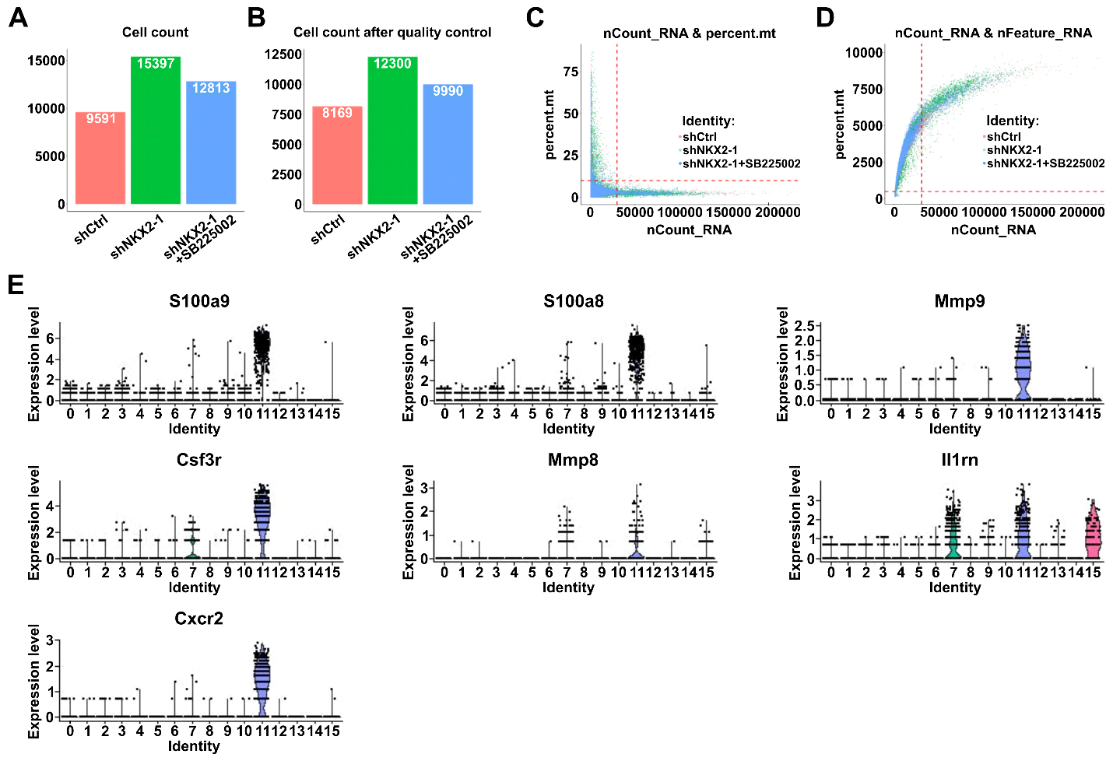
Supplementary Fig. 3. Characterization of cell population in mouse xenograft tumors with NKX2-1 knockdown from Single-cell NGS analysis. (A and B) Graphical representations from scRNA-seq quality control processing on shCtrl, shNKX2-1 + Vehicle, and shNKX2-1 + SB225002 cells such as the number of cells in scRNA-seq raw data (A) and the number of cells after quality control in scRNA-seq (B). (C and D) Scatter plots showing the correlation between UMI count and mitochondrial ratio (C), and scatter plots showing the correlation between the RNA and UMI count (D). The red dotted lines indicated the filtered criteria cutoff. (E) Violin plot showing the neutrophil markers used to distinguish the neutrophil population from other cell types in scRNA-seq analysis.

Supplementary Tables
Supplementary Table 1. Primers for quantitative real-time PCR.
Species | Gene name |  | Primers
Mouse | NKX2-1 | forward | 5’- CATGTCGATGAGTCCAAAGC - 3’
 |  | reverse | 5’- CTCCATGCCCACTTTCTTGT - 3’
 | Cxcl1 | forward | 5’- TGCACCCAAACCGAAGTCAT - 3’
 |  | reverse | 5’- ACTTGGGGACACCTTTTAGCA - 3’
 | Cxcl2 | forward | 5’- CTGCCAAGGGTTGACTTCAAGA - 3’
 |  | reverse | 5’- GCTTCAGGGTCAAGGCAAACT - 3’
 | Cxcl3 | forward | 5’- CCAGACAGAAGTCATAGCCAC - 3’
 |  | reverse | 5’- CTTCATCATGGTGAGGGGCTT - 3’
 | Cxcl5 | forward | 5’- TGCCCTACGGTGGAAGTCAT - 3’
 |  | reverse | 5’- GCGAGTGCATTCCGCTTA - 3’
 | GAPDH | forward | 5’ - GGAGGAACCTGCCAAGTATG - 3’
 |  | reverse | 5’ - TGGGAGTTGCTGTTGAAG - 3’
 | EpCAM | forward | 5’- AAGAACCGACAAGGACACGG - 3’
 |  | reverse | 5’ - TCTGATGGTCGTAGGGGCTT- 3’
 | E-cadherin | forward | 5’- ATGTCCTGGGCAGAGTGAGA -3’
 |  | reverse | 5’- TGGAGCTTTAGATGCCGCTT - 3’
 | Vimentin | forward | 5’- TTCTCTGGCACGTCTTGACC - 3’
 |  | reverse | 5’- GCTTGGAAACGTCCACATCG - 3’
 | Fibronectin | forward | 5’- CAACCCTGGGTATGACACCG - 3’
 |  | reverse | 5’- CCGCCTAAAGCCATGTTCCT - 3’
Human | NKX2-1 | forward | 5’- AGCACACGACTCCGTTCTC - 3’
 |  | reverse | 5’ - GCCCACTTTCTTGTAGCTTTCC - 3’
 | CXCL1 | forward | 5’ - CACCCCAAGAACATCCAAAG - 3’
 |  | reverse | 5’ - TAACTATGGGGGATGCAGGA - 3’
 | CXCL2 | forward | 5’ - CACCTCAAGAACATCCAAAGTG - 3’
 |  | reverse | 5’ - GATTTTCTTAACCATGGGCG - 3’
 | CXCL3 | forward | 5’ - GAGCGTCCGTGGTCACTGAA - 3’
 |  | reverse | 5’ - CCGGGGGACCTTACATTCAC - 3’
 | CXCL5 | forward | 5’ - ACCACGCAAGGAGTTCATCC - 3’
 |  | reverse | 5’ - GGGGCTTCTGGATCAAGACA - 3’
 | EpCAM | forward | 5’ - GCAGGGTCTAAAAGCTGGTGTT - 3’
 |  | reverse | 5’ - TCCCTATGCATCTCACCCATCT - 3’
 | E-cadherin | forward | 5’ - ATTTTTCCCTCGACACCCGAT - 3’
 |  | reverse | 5’ - TCCCAGGCGTAGACCAAGA - 3’
 | Vimentin | forward | 5’ - GGCGAGGAGAGCAGGATTTC - 3’
 |  | reverse | 5’ - AGTGGGTATCAACCAGAGGGA - 3’
 | Fibronectin | forward | 5’ - ACCCCCACCAGCCTACTGAT - 3’
 |  | reverse | 5’ - ACTTGCTCCCAGGCACAGTG - 3’
 | ZEB1 | forward | 5’ - AGCAGTGAAAGAGAAGGG - 3’
 |  | reverse | 5’ - GGTCCTCTTCAGGTGCCT - 3’
 | ZEB2 | forward | 5’ - CCTCTGTAGATGGTCCAGAAGAA - 3’
 |  | reverse | 5’- CTGTACCATTGTTAATTGCGGTC - 3’
ChIP-qPCR | CXCL1 promoter | forward  reverse | 5’ - CCAGCCCCAACCATGCATAAAA - 3’  5’ - CTGTGAGAGGAGCGGAAGAGC - 3’
 | Control-CXCL1 | forward  reverse | 5’ - ACTCTACCTGCACACTGTCCTA - 3’
5’ - ATGACTGGAGAACATTTGAAAACA
- 3’
 | CXCL2 promoter | forward  reverse | 5’ - ATTCCCGGAGCTCCAGATCG - 3’  5’ - AAGACAGTCAGACCCGGACG - 3’
 | Control-CXCL2 | forward | 5’ -TGCTACAACAATGTTCAAAGTCA - 3’
 |  | reverse | 5’ – GCATTGGGATTTTATAGATTCTGGA- 3’
 | CXCL5 promoter | forward | 5’- CATAGTGGTCAAGAGAGCG - 3’
 |  | reverse | 5’ - GGGGAGAGATGAGTGTAGAT - 3’
 | Control-CXCL5 | forward | 5’ - AAACATAACTTAGTGACAAGC - 3’
 |  | reverse | 5’ - CTCTGTACGATTTAAGTAACA - 3’

Supplementary Table 2. Antibody for Western blot, ChIP-qPCR, and Flow cytometry
Antibodies | Supplier | Species | Catalog No.
TTF-1 (NKX2-1) | Cell Signaling Technology (CST) | Rb-Mono | 12373
E-cadherin (24E10) | Cell Signaling Technology (CST) | Rb-Mono | 3195
EpCAM | Cell Signaling Technology (CST) | Rb-Mono | 2626
Vimentin | Sigma | Mouse-Mono | V6630
ZEB1 | Cell Signaling Technology (CST) | Rb-Mono | 3396
Phosphor-EGFR | Cell Signaling Technology (CST) | Rb-Mono | 3777
EGFR | Cell Signaling Technology (CST) | Rb-Mono | 4267
Alpha-tubulin | Sigma | Mouse-Mono | T6074
CXCR2 | GeneTex | Mouse-Mono | GTX631667
CD66b | Abcam | Rb-Poly | ab197678
Neutrophil Elastase | Abcam | Rb-Poly | ab68672
CD11b | Invitrogen | Rb-Mono | 14-0112-82
PerCP/Cyanine5.5 CD170 (Siglec-F) | Biolegend | Mouse-Mono | 155525
Pacific Blue™ CD11b | Biolegend | Mouse-Mono | 301316
APC/Cyanine7 Ly-6G | Biolegend | Mouse-Mono | 127623
PerCP Ly6-C | Biolegend | Mouse-Mono | 128027
PE/Cyanine7, Ly-6G | Biolegend | Mouse-Mono | 127617
BV421 Rat, Siglec-F | Biolegend | Mouse-Mono | 562681

Supplementary Table 3. List of plasmids
Plasmids | Target sequence | Catalog No.
pcDNA3.1(+) wt TTF-1 | CDS region: NM_003317 | 49989
p3xFLAG-Myc-CMV-26 | Vector backbone | Addgene
pHAGE PGK-GFP-IRES-LUC-W | Empty backbone | 46793
pLKO.1 empty | Empty backbone | RNA icore
Human shRNA NKX2-1 pLKO.1 | CGCTTGTAAATACCAGGATTT | TRCN0000020449
Human shRNA NKX2-1 pLKO.1 | CGGCATGAACATGAGCGGCAT | TRCN0000020450
Mouse shRNA NKX2-1 pLKO.1 | CGGCATGAATATGAGTGGCAT | TRCN000086265
Mouse shRNA NKX2-1 pLKO.1 | GTTCTCAGTGTCTGACATCTT | TRCN000008626 7

Supplementary Table 4. List of cancer-promoting genes from Single-cell RNA-seq
No. | Gene name | Gene Symbol | References
1. | Cyclin Dependent Kinase Inhibitor 1A | CDKN1A | [1-3]
2. | Plasminogen activator, urokinase receptor | PLAUR | [4-6]
3. | Prostaglandin-Endoperoxide Synthase 2 | PTGS2 | [7-9]
4. | Cytochrome C Oxidase Copper Chaperone COX17 | COX17 | [10]
5. | Leukocyte Immunoglobulin Like Receptor B4 | LILRB4 | [11-13]
6. | G0/G1 Switch 2 | G0S2 | [14, 15]
7. | Early growth response protein 1 | EGR1 | [16-18]
8. | C-X-C Motif Chemokine Ligand 2 | CXCL2 | [19, 20]

References
1. Zaremba-Czogalla M, Hryniewicz-Jankowska A, Tabola R, Nienartowicz M, Stach K, Wierzbicki J, et al. A novel regulatory function of CDKN1A/p21 in TNFα-induced matrix metalloproteinase 9-dependent migration and invasion of triple-negative breast cancer cells. Cell Signal. 2018;47:27-36. Epub 20180326. doi: 10.1016/j.cellsig.2018.03.010. PubMed PMID: 29588220.
2. Wei CY, Tan QX, Zhu X, Qin QH, Zhu FB, Mo QG, et al. Expression of CDKN1A/p21 and TGFBR2 in breast cancer and their prognostic significance. Int J Clin Exp Pathol. 2015;8(11):14619-29. Epub 20151101. PubMed PMID: 26823785; PubMed Central PMCID: PMCPMC4713571.
3. Li Z, Qiu R, Qiu X, Tian T. SNHG6 Promotes Tumor Growth via Repression of P21 in Colorectal Cancer. Cell Physiol Biochem. 2018;49(2):463-78. Epub 20180829. doi: 10.1159/000492986. PubMed PMID: 30157475.
4. Xue A, Xue M, Jackson C, Smith RC. Suppression of urokinase plasminogen activator receptor inhibits proliferation and migration of pancreatic adenocarcinoma cells via regulation of ERK/p38 signaling. Int J Biochem Cell Biol. 2009;41(8-9):1731-8. Epub 20090321. doi: 10.1016/j.biocel.2009.03.004. PubMed PMID: 19433314.
5. LeBeau AM, Duriseti S, Murphy ST, Pepin F, Hann B, Gray JW, et al. Targeting uPAR with antagonistic recombinant human antibodies in aggressive breast cancer. Cancer Res. 2013;73(7):2070-81. Epub 20130211. doi: 10.1158/0008-5472.Can-12-3526. PubMed PMID: 23400595; PubMed Central PMCID: PMCPMC3618559.
6. Wang Z, Wang K, Gao X, Liu Z, Xing Z. Comprehensive analysis of the importance of PLAUR in the progression and immune microenvironment of renal clear cell carcinoma. PLoS One. 2022;17(6):e0269595. Epub 20220608. doi: 10.1371/journal.pone.0269595. PubMed PMID: 35675366; PubMed Central PMCID: PMCPMC9176830.
7. Saindane M, Rallabandi HR, Park KS, Heil A, Nam SE, Yoo YB, et al. Prognostic Significance of Prostaglandin-Endoperoxide Synthase-2 Expressions in Human Breast Carcinoma: A Multiomic Approach. Cancer Inform. 2020;19:1176935120969696. Epub 20201106. doi: 10.1177/1176935120969696. PubMed PMID: 33223820; PubMed Central PMCID: PMCPMC7656875.
8. Ogino S, Kirkner GJ, Nosho K, Irahara N, Kure S, Shima K, et al. Cyclooxygenase-2 expression is an independent predictor of poor prognosis in colon cancer. Clin Cancer Res. 2008;14(24):8221-7. doi: 10.1158/1078-0432.Ccr-08-1841. PubMed PMID: 19088039; PubMed Central PMCID: PMCPMC2679582.
9. Zahedi T, Hosseinzadeh Colagar A, Mahmoodzadeh H. PTGS2 Over-Expression: A Colorectal Carcinoma Initiator not an Invasive Factor. Rep Biochem Mol Biol. 2021;9(4):442-51. doi: 10.52547/rbmb.9.4.442. PubMed PMID: 33969138; PubMed Central PMCID: PMCPMC8068447.
10. Suzuki C, Daigo Y, Kikuchi T, Katagiri T, Nakamura Y. Identification of COX17 as a therapeutic target for non-small cell lung cancer. Cancer Res. 2003;63(21):7038-41. PubMed PMID: 14612491.
11. Kumata S, Notsuda H, Su MT, Saito-Koyama R, Tanaka R, Suzuki Y, et al. Prognostic impact of LILRB4 expression on tumor-infiltrating cells in resected non-small cell lung cancer. Thorac Cancer. 2023. Epub 20230608. doi: 10.1111/1759-7714.14991. PubMed PMID: 37290427.
12. Su MT, Kumata S, Endo S, Okada Y, Takai T. LILRB4 promotes tumor metastasis by regulating MDSCs and inhibiting miR-1 family miRNAs. Oncoimmunology. 2022;11(1):2060907. Epub 20220405. doi: 10.1080/2162402x.2022.2060907. PubMed PMID: 35402083; PubMed Central PMCID: PMCPMC8986222.
13. Sharma N, Atolagbe OT, Ge Z, Allison JP. LILRB4 suppresses immunity in solid tumors and is a potential target for immunotherapy. J Exp Med. 2021;218(7). Epub 20210511. doi: 10.1084/jem.20201811. PubMed PMID: 33974041; PubMed Central PMCID: PMCPMC8117208.
14. Nobeyama Y, Watanabe Y, Nakagawa H. Silencing of G0/G1 switch gene 2 in cutaneous squamous cell carcinoma. PLoS One. 2017;12(10):e0187047. Epub 20171026. doi: 10.1371/journal.pone.0187047. PubMed PMID: 29073263; PubMed Central PMCID: PMCPMC5658152.
15. Corbet AK, Bikorimana E, Boyd RI, Shokry D, Kries K, Gupta A, et al. G0S2 promotes antiestrogenic and pro-migratory responses in ER+ and ER- breast cancer cells. Transl Oncol. 2023;33:101676. Epub 20230420. doi: 10.1016/j.tranon.2023.101676. PubMed PMID: 37086619; PubMed Central PMCID: PMCPMC10214302.
16. Park SY, Kim JY, Lee SM, Chung JO, Lee KH, Jun CH, et al. Expression of early growth response gene-1 in precancerous lesions of gastric cancer. Oncol Lett. 2016;12(4):2710-5. Epub 20160805. doi: 10.3892/ol.2016.4962. PubMed PMID: 27698846; PubMed Central PMCID: PMCPMC5038579.
17. Kuo PL, Chen YH, Chen TC, Shen KH, Hsu YL. CXCL5/ENA78 increased cell migration and epithelial-to-mesenchymal transition of hormone-independent prostate cancer by early growth response-1/snail signaling pathway. J Cell Physiol. 2011;226(5):1224-31. doi: 10.1002/jcp.22445. PubMed PMID: 20945384.
18. Feng YH, Su YC, Lin SF, Lin PR, Wu CL, Tung CL, et al. Oct4 upregulates osteopontin via Egr1 and is associated with poor outcome in human lung cancer. BMC Cancer. 2019;19(1):791. Epub 20190809. doi: 10.1186/s12885-019-6014-5. PubMed PMID: 31399076; PubMed Central PMCID: PMCPMC6688208.
19. Zhang H, Ye YL, Li MX, Ye SB, Huang WR, Cai TT, et al. CXCL2/MIF-CXCR2 signaling promotes the recruitment of myeloid-derived suppressor cells and is correlated with prognosis in bladder cancer. Oncogene. 2017;36(15):2095-104. Epub 20161010. doi: 10.1038/onc.2016.367. PubMed PMID: 27721403.
20. Zhang F, Jiang J, Xu B, Xu Y, Wu C. Over-expression of CXCL2 is associated with poor prognosis in patients with ovarian cancer. Medicine (Baltimore). 2021;100(4):e24125. doi: 10.1097/md.0000000000024125. PubMed PMID: 33530204; PubMed Central PMCID: PMCPMC7850676.

