Supplementary information
Hydrocarbon Bioremediation: Scaling Up from Lab to Field for Petroleum-Contaminated Soils
Sandra Curiel-Alegre^{a,b}, Aqib Hassan Ali Khanª, Carlos Rad^{b}, Blanca Velasco-Arroyo^{c}, Carlos Rumboª, Rafael Rivilla^{d}, David Durán^{d}, Miguel Redondo-Nieto^{d}, Eduard Borràs^{e}, Daniele Molognoni^{e}, Soledad Martín-Castellote^{f}, Blanca Juez^{f}, Rocío Barros^{a*}

ª International Research Center in Critical Raw Materials for Advanced Industrial Technologies (ICCRAM). University of Burgos, Centro de I+D+I. Plaza Misael Bañuelos s/n. 09001 Burgos, Spain.
^{b} Research Group in Composting (UBUCOMP). University of Burgos, Faculty of Sciences. Plaza Misael Bañuelos s/n. 09001 Burgos Spain.
^{c} Department of Biotechnology and Food Science, University of Burgos, Faculty of Sciences. Plaza Misael Bañuelos s/n. 09001 Burgos Spain.
^{d} Department of Biology, Faculty of Sciences, University Autónoma of Madrid, Darwin 2, 28049 Madrid, Spain
^{e} LEITAT Technology Center, Circular Economy & Decarbonization Department, Carrer de la Innovació, 2. 08225, Terrassa, Barcelona, Spain.
^{f} ACCIONA, C/ Valportillo II, 8. 28108, Alcobendas, Madrid, Spain.
*Corresponding authors: rbarros@ubu.es

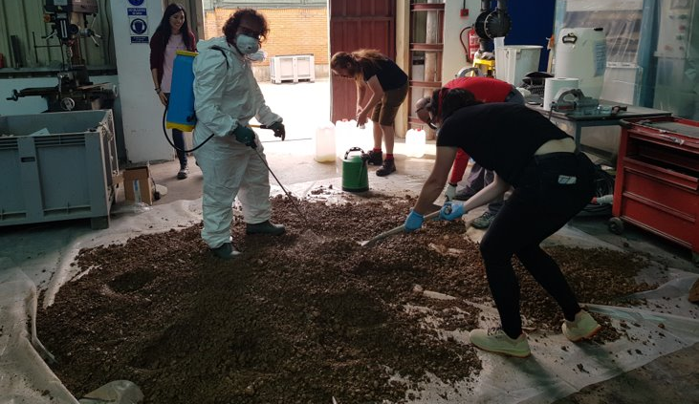
Supplementary Figure 1. The application of nutrients and bacterial suspension at the start of experiment during first addition of bacterial inoculants spray.
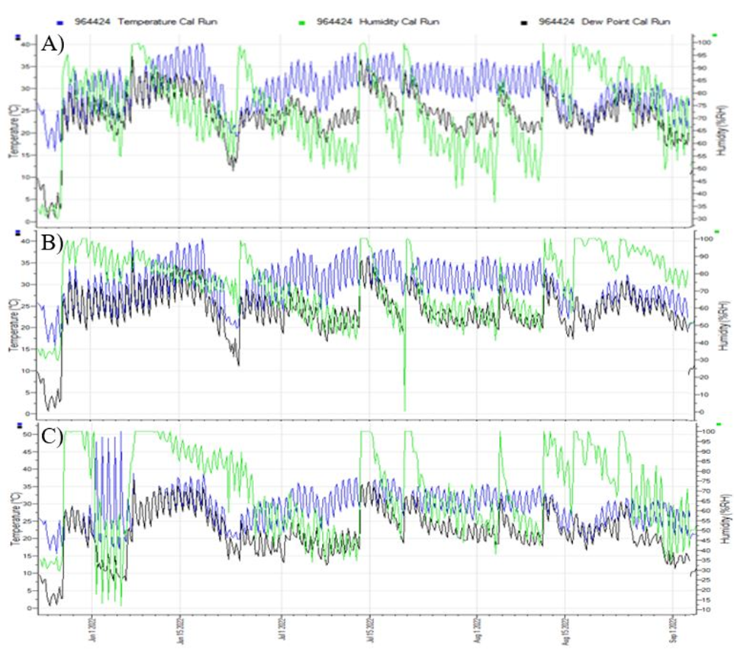
Supplementary Figure 2. Results of monitorization for temperature and moisture of: A) CT treatment, B) BAVC treatment, and C) BESBAVC treatment.

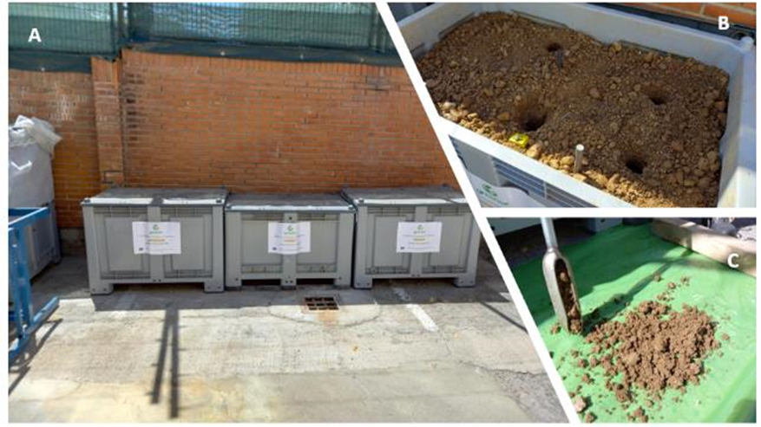
Supplementary Figure 3. Pilot scale in ACCIONA´s Facilities - off site (Alcobendas, Madrid): ​A) three containers for treatments under study, B) Visualization of soils under study, and C) sample collected using auger.

Supplementary Table 1. The evolution of extractable metals in the soil of applied treatment with reference to time (0, 7, 30, 60, and 90 days)
CT | Al | Ca | Fe | K | Mg | Mn | Na | S | Cu | Zn
T0 | 0.299 ± 0.110 | 3182.847 ± 12.057 | 12.447 ± 0.567 | 10.057 ± 0.754 | 110.976 ± 0.139 | 7.577 ± 0.228 | 98.489 ± 5.800 | 11.872 ± 0.782 | 0.232 ± 0.041 | 5.211 ± 0.031
T7 | 0.267 ± 0.005 | 2577.350 ± 62.009 | 11.472 ± 0.429 | 7.530 ± 0.274 | 102.186 ± 2.168 | 11.526 ± 0.314 | 106.862 ± 5.410 | 17.106 ± 0.559 | 0.308 ± 0.021 | 5.242 ± 0.190
T30 | 1.359 ± 0.015 | 2862.010 ± 150.951 | 14.286 ± 1.021 | 16.823 ± 0.336 | 109.750 ± 10.483 | 21.497 ± 3.146 | 105.276 ± 12.242 | 16.028 ± 1.542 | 0.291 ± 0.082 | 4.228 ± 0.301
T60 | 0.236 ± 0.064 | 2373.213 ± 288.629 | 11.166 ± 0.838 | 8.209 ± 0.616 | 98.884 ± 0.107 | 12.809 ± 1.703 | 103.496 ± 7.432 | 14.499 ± 1.929 | 0.315 ± 0.020 | 4.401 ± 0.219
T90 | 2.837 ± 0.0956 | 2997.600 ± 128.505 | 9.058 ± 0.896 | 13.920 ± 0.895 | 104.186 ± 9.586 | 17.947 ± 6.235 | 104.014 ± 8.668 | 19.821 ± 2.365 | 0.340 ± 0.015 | 4.349 ± 0.211
BAVC | Al | Ca | Fe | K | Mg | Mn | Na | S | Cu | Zn
T0 | 0.130 ± 0.025 | 3647.233 ± 72.823 | 12.170 ± 0.937 | 40.138 ± 2.890 | 111.582 ± 0.676 | 9.846 ± 0.239 | 95.791 ± 2.117 | 118.193 ± 6.096 | 0.180 ± 0.005 | 3.578 ± 0.086
T7 | 0.158 ± 0.017 | 3477.753 ± 36.154 | 12.536 ± 0.380 | 33.674 ± 0.494 | 109.761 ± 1.020 | 12.185 ± 0.196 | 101.627 ± 10.420 | 122.387 ± 3.868 | 0.197 ± 0.021 | 3.549 ± 0.061
T30 | 2.515 ± 0.017 | 3673.750 ± 128.245 | 9.418 ± 1.754 | 14.205 ± 1.441 | 112.638 ± 5.734 | 11.538 ± 2.571 | 90.910 ± 5.437 | 123.284 ± 7.154 | 0.294 ±0.016 | 3.601 ± 0.472
T60 | 0.239 ± 0.068 | 3246.860 ± 129.035 | 10.145 ± 0.507 | 37.653 ± 2.260 | 97.403 ± 3.148 | 12.464 ± 0.650 | 94.156 ± 8.924 | 129.738 ± 12.323 | 0.214 ± 0.018 | 3.456 ± 0.192
T90 | 0.701 ± 0.214 | 3100.120 ±190.661 | 7.275 ± 0.845 | 12.801 ± 0.957 | 105.192 ± 4.861 | 10.658 ± 1.498 | 100.459 ± 8.847 | 103.911 ± 4.878 | 0.345 ± 0.007 | 3.190 ± 0.954
BESBAVC | Al | Ca | Fe | K | Mg | Mn | Na | S | Cu | Zn
T0 | 0.229 ± 0.052 | 3403.890 ± 77.352 | 13.057 ± 0.279 | 43.351 ± 0.327 | 109.455 ± 0.039 | 11.988 ± 0.172 | 110.132 ± 8.247 | 78.799 ± 2.233 | 0.248 ± 0.044 | 4.705 ± 0.096
T7 | 0.310 ± 0.080 | 3238.033 ± 56.610 | 13.574 ± 0.822 | 38.739 ± 0.046 | 109.075 ± 1.648 | 14.364 ± 0.098 | 95.434 ± 4.189 | 108.575 ± 1.571 | 0.236 ± 0.008 | 4.842 ± 0.093
T30 | 0.406 ± 0.084 | 3235.760 ± 32.321 | 12.729 ± 0.296 | 40.991 ± 1.553 | 100.799 ± 0.258 | 15.136 ± 0.335 | 99.171 ± 14.792 | 105.451 ± 0.658 | 0.242 ± 0.033 | 4.703 ± 0.088
T60 | 0.176 ± 0.021 | 2928.855 ± 28.631 | 13.721 ± 0.375 | 35.896 ± 0.375 | 101.671 ± 1.442 | 14.069 ± 0.364 | 99.176 ± 4.627 | 97.363 ± 6.975 | 0.221 ± 0.011 | 4.481 ± 0.093
T90 | 0.515 ± 0.080 | 3237.160 ± 15.302 | 12.409 ± 0.537 | 34.119 ± 1.127 | 99.336 ± 3.593 | 15.761 ± 0.543 | 102.572 ± 7.168 | 117.189 ± 4.881 | 0.273 ± 0.016 | 5.021 ± 0.120

Supplementary Table 2. Enzymatic evolution from the initial contaminated soil (T0) to the different sampling points (T0, T1, T2, T3, and T4), expressed in nmol g⁻¹ min⁻¹.
Treatment | Soil enzyme | T0 |  |  | T1 |  |  | T2 |  |  | T3 |  |  | T4
CT | AcPA | 18.55 | ± | 1.80 | 19.92 | ± | 1.88 | 23.07 | ± | 1.89 | 11.26 | ± | 1.21 | 18.96 | ± | 0.88
CT | bGA | 5.31 | ± | 0.96 | 9.32 | ± | 1.31 | 9.15 | ± | 0.95 | 4.39 | ± | 0.34 | 8.89 | ± | 1.64
CT | aGA | 5.98 | ± | 0.25 | 4.47 | ± | 0.28 | 7.11 | ± | 0.51 | 3.27 | ± | 0.19 | 6.16 | ± | 0.47
CT | bXyl | 6.48 | ± | 0.52 | 4.45 | ± | 0.30 | 7.01 | ± | 0.52 | 3.06 | ± | 0.21 | 5.43 | ± | 0.26
CT | bNAG | 12.59 | ± | 0.57 | 18.52 | ± | 1.17 | 19.35 | ± | 0.71 | 6.83 | ± | 0.64 | 13.60 | ± | 1.65
CT | AS | 5.42 | ± | 0.18 | 3.16 | ± | 0.25 | 5.54 | ± | 0.35 | 2.23 | ± | 0.14 | 4.09 | ± | 0.16
CT | AlkPA | 59.94 | ± | 1.90 | 107.00 | ± | 1.76 | 107.94 | ± | 3.09 | 50.76 | ± | 2.53 | 102.92 | ± | 2.51
CT | LeuAMP | 39.28 | ± | 2.22 | 35.72 | ± | 1.22 | 50.29 | ± | 2.27 | 36.37 | ± | 2.90 | 40.95 | ± | 1.90
BAVC | AcPA | 16.99 | ± | 1.07 | 21.97 | ± | 1.91 | 22.97 | ± | 0.62 | 24.92 | ± | 1.81 | 24.38 | ± | 1.76
BAVC | bGA | 3.05 | ± | 0.74 | 7.71 | ± | 1.50 | 4.65 | ± | 0.44 | 10.95 | ± | 0.57 | 8.52 | ± | 0.43
BAVC | aGA | 5.40 | ± | 0.23 | 11.65 | ± | 0.54 | 15.30 | ± | 0.46 | 9.38 | ± | 0.46 | 9.64 | ± | 0.39
BAVC | bXyl | 4.33 | ± | 0.17 | 7.25 | ± | 0.21 | 9.74 | ± | 0.41 | 13.62 | ± | 0.62 | 13.41 | ± | 0.77
BAVC | bNAG | 5.97 | ± | 0.59 | 9.24 | ± | 1.47 | 15.30 | ± | 0.93 | 24.62 | ± | 1.88 | 24.82 | ± | 1.31
BAVC | AS | 2.84 | ± | 0.26 | 4.86 | ± | 0.23 | 8.19 | ± | 0.29 | 5.65 | ± | 0.29 | 5.09 | ± | 0.15
BAVC | AlkPA | 22.60 | ± | 3.45 | 56.81 | ± | 1.76 | 43.27 | ± | 1.79 | 42.61 | ± | 1.54 | 43.35 | ± | 2.86
BAVC | LeuAMP | 72.65 | ± | 3.46 | 72.58 | ± | 2.00 | 52.11 | ± | 1.75 | 79.91 | ± | 1.99 | 86.50 | ± | 2.00
BESBAVC | AcPA | 20.40 | ± | 1.58 | 22.73 | ± | 1.02 | 17.51 | ± | 3.44 | 26.44 | ± | 1.59 | 24.97 | ± | 1.19
BESBAVC | bGA | 5.51 | ± | 0.43 | 5.08 | ± | 0.45 | 6.32 | ± | 0.95 | 13.41 | ± | 1.65 | 11.04 | ± | 0.53
BESBAVC | aGA | 8.49 | ± | 0.28 | 14.91 | ± | 0.61 | 10.15 | ± | 0.63 | 8.40 | ± | 0.48 | 6.62 | ± | 0.21
BESBAVC | bXyl | 6.50 | ± | 0.30 | 8.36 | ± | 0.39 | 6.24 | ± | 0.90 | 13.06 | ± | 0.46 | 9.10 | ± | 0.45
BESBAVC | bNAG | 11.53 | ± | 0.89 | 17.67 | ± | 0.87 | 17.46 | ± | 1.41 | 26.39 | ± | 1.60 | 20.05 | ± | 1.02
BESBAVC | AS | 4.98 | ± | 0.38 | 5.68 | ± | 0.14 | 3.86 | ± | 0.51 | 4.45 | ± | 0.21 | 4.02 | ± | 0.09
BESBAVC | AlkPA | 43.36 | ± | 2.97 | 50.76 | ± | 1.66 | 43.66 | ± | 2.90 | 39.91 | ± | 3.00 | 45.77 | ± | 2.36
BESBAVC | LeuAMP | 44.68 | ± | 1.50 | 89.66 | ± | 2.45 | 36.12 | ± | 2.29 | 74.76 | ± | 2.84 | 69.73 | ± | 2.91

Supplementary Table 3. Concentration of TPHs from the initial contaminated soil (T0) to the different sampling points (T2, T3, and T4) expressed in mg kg⁻¹.
Treatment ID | Sampling Point | EPH C10-C12 | EPH C12-C16 | EPH C16-C21 | EPH C21-C30 | EPH C30-C35 | EPH C35-C40 | Total EPH
CT | T0 | <30 | <50 | 430 | 22000 | 15000 | 2000 | 40000
BAVC |  | <30 | <50 | 410 | 19000 | 13000 | 200 | 34000
BESBAVC |  | <30 | <50 | 390 | 17000 | 12000 | 190 | 31000
CT | T2 | <30 | 54 | 410 | 21000 | 16000 | 2100 | 39000
BAVC |  | <30 | <50 | 280 | 12000 | 7700 | 1200 | 21000
BESBAVC |  | <30 | <50 | 300 | 11000 | 7300 | 1100 | 20000
CT | T3 | <30 | <50 | 410 | 21000 | 14000 | 2000 | 38000
BAVC |  | 9 | 52 | 230 | 3300 | 2700 | 530 | 7100
BESBAVC |  | 8 | 45 | 210 | 3900 | 2900 | 430 | 7600
CT | T4 | <30 | <50 | 380 | 19000 | 13000 | 1900 | 34000
BAVC |  | 4,7 | 30 | 120 | 1700 | 1200 | 190 | 3300
BESBAVC |  | 5,6 | 36 | 140 | 2100 | 1500 | 250 | 4100

Supplementary Table 4. Centrality measures per variable (extractable metals) for different treatments.
For Control
Variable |  | Betweenness |  | Closeness |  | Strength |  | Expected influence
Al |  | -0.204 |  | 0.677 |  | -0.113 |  | -1.315
Ca |  | -0.842 |  | -0.443 |  | -0.952 |  | -0.575
Fe |  | 0.179 |  | 0.123 |  | 0.446 |  | 0.684
K |  | -0.587 |  | -0.681 |  | 0.109 |  | 0.412
Mg |  | 0.945 |  | 0.803 |  | 0.824 |  | 1.078
Mn |  | -0.715 |  | -0.795 |  | -0.084 |  | 0.233
Na |  | -0.842 |  | 0.197 |  | -0.509 |  | -0.163
S |  | 0.817 |  | 0.901 |  | 1.342 |  | 1.56
Cu |  | -0.842 |  | -2.039 |  | -2.041 |  | -1.588
Zn |  | 2.093 |  | 1.258 |  | 0.979 |  | -0.324
For BAVC
Variable |  | Betweenness |  | Closeness |  | Strength |  | Expected influence
Al |  | 0.297 |  | 0.581 |  | 0.853 |  | -0.328
Ca |  | -0.752 |  | -0.719 |  | -1.194 |  | -0.916
Fe |  | -0.227 |  | 0.726 |  | 0.699 |  | -0.59
K |  | 0.822 |  | 0.619 |  | 1.107 |  | 1.968
Mg |  | -0.752 |  | -0.142 |  | -0.79 |  | -0.227
Mn |  | -0.752 |  | 0.113 |  | 4.784×10⁻⁶ |  | -0.54
Na |  | -0.752 |  | 0.176 |  | -0.039 |  | 1.055
S |  | 0.647 |  | 0.327 |  | -0.695 |  | -0.064
Cu |  | -0.752 |  | -2.521 |  | -1.388 |  | -1.253
Zn |  | 2.222 |  | 0.841 |  | 1.448 |  | 0.896
For BESBAVC
Variable |  | Betweenness |  | Closeness |  | Strength |  | Expected influence
Al |  | -0.588 |  | -1.105 |  | -0.915 |  | -1.142
Ca |  | -0.588 |  | 0.052 |  | -0.193 |  | -0.124
Fe |  | 0.334 |  | 0.502 |  | 1.184 |  | 1.116
K |  | -0.357 |  | 0.166 |  | 0.224 |  | 0.211
Mg |  | -0.588 |  | 0.502 |  | -0.204 |  | -0.281
Mn |  | 0.219 |  | 0.605 |  | -0.353 |  | -0.285
Na |  | 0.104 |  | 0.454 |  | 0.092 |  | 0.154
S |  | -0.588 |  | -0.192 |  | -0.643 |  | -0.563
Cu |  | -0.588 |  | -2.246 |  | -1.292 |  | -1.197
Zn |  | 2.641 |  | 1.262 |  | 2.101 |  | 2.111

Supplementary Table 5. Weight matric used for the preparation of network plots for variables (extractable metals) for different treatments.
For Control
Variable | Al | Ca | Fe | K | Mg | Mn | Na | S | Cu | Zn
Al | 0 | 0 | 0 | 0 | 0 | 0.148 | 0 | 0 | 0 | -0.322
Ca | 0 | 0 | 0.586 | 0 | 0 | 0 | 0 | 0 | 0 | 0
Fe | 0 | 0.586 | 0 | 0 | 0.514 | 0 | 0 | 0 | 0 | 0
K | 0 | 0 | 0 | 0 | 0 | 0.741 | 0 | 0.17 | 0 | 0
Mg | 0 | 0 | 0.514 | 0 | 0 | 0 | 0 | 0 | 0 | 0.671
Mn | 0.148 | 0 | 0 | 0.741 | 0 | 0 | 0 | 0 | 0 | 0
Na | 0 | 0 | 0 | 0 | 0 | 0 | 0 | 0.69 | 0 | 0
S | 0 | 0 | 0 | 0.17 | 0 | 0 | 0.69 | 0 | 0 | 0.287
Cu | 0 | 0 | 0 | 0 | 0 | 0 | 0 | 0 | 0 | 0.063
Zn | -0.322 | 0 | 0 | 0 | 0.671 | 0 | 0 | 0.287 | 0.063 | 0
For BAVC
Variable | Al | Ca | Fe | K | Mg | Mn | Na | S | Cu | Zn
Al | 0 | 0 | -0.78 | 0.75 | 0.15 | 0 | 0 | 0.39 | 0 | 0.083
Ca | 0 | 0 | 0 | 0.291 | 0 | 0 | 0 | 0 | 0 | 0
Fe | -0.78 | 0 | 0 | 0.817 | 0 | 0 | 0 | 0 | 0 | 0.405
K | 0.75 | 0.291 | 0.817 | 0 | 0 | 0.261 | 0 | 0 | 0 | -0.278
Mg | 0.15 | 0 | 0 | 0 | 0 | 0 | 0 | 0 | 0 | 0.508
Mn | 0 | 0 | 0 | 0.261 | 0 | 0 | 0.67 | 0 | 0 | -0.446
Na | 0 | 0 | 0 | 0 | 0 | 0.67 | 0 | 0 | 0 | 0.668
S | 0.39 | 0 | 0 | 0 | 0 | 0 | 0 | 0 | 0 | 0.312
Cu | 0 | 0 | 0 | 0 | 0 | 0 | 0 | 0 | 0 | 0.014
Zn | 0.083 | 0 | 0.405 | -0.278 | 0.508 | -0.446 | 0.668 | 0.312 | 0.014 | 0
For BESBAVC
Variable | Al | Ca | Fe | K | Mg | Mn | Na | S | Cu | Zn
Al | 0 | 0 | 0 | 0 | 0 | 0 | 0 | 0 | 0.036 | 0.065
Ca | 0 | 0 | 0.661 | 0 | 0 | 0 | 0 | 0 | 0 | 0
Fe | 0 | 0.661 | 0 | 0.329 | 0 | 0 | 0 | 0 | 0 | 0.249
K | 0 | 0 | 0.329 | 0 | 0 | 0 | 0.528 | 0 | 0 | 0
Mg | 0 | 0 | 0 | 0 | 0 | 0 | 0 | 0 | 0 | 0.534
Mn | 0 | 0 | 0 | 0 | 0 | 0 | 0 | 0 | 0 | 0.476
Na | 0 | 0 | 0 | 0.528 | 0 | 0 | 0 | 0 | 0 | 0.28
S | 0 | 0 | 0 | 0 | 0 | 0 | 0 | 0 | 0 | 0.228
Cu | 0.036 | 0 | 0 | 0 | 0 | 0 | 0 | 0 | 0 | 0.029
Zn | 0.065 | 0 | 0.249 | 0 | 0.534 | 0.476 | 0.28 | 0.228 | 0.029 | 0

