Supporting Information

Numerical simulation and experimental study of three-phase distribution characteristics of leaked light non-aqueous phase liquid from buried pipelines in soils containing groundwater and gas
Jie Yang^{a,b,c}, Wenming Jiang^{b,c,*}, Yang Liu^{b,c}
- School of Environment, Tsinghua University, Beijing 100084, China
- College of Pipeline and Civil Engineering, China University of Petroleum (East China), Qingdao 266580, China
- Shandong Provincial Key Laboratory of Oil & Gas Storage and Transportation Safety，Shandong Provincial Key Laboratory of Oilfield Produced Water Treatment and Environmental Pollution Control (Sinopec Petroleum Engineering Corporation)

8 Pages
Text S1
4 Figures
7 Tables
S1 Ring knife method
S1.1 Determination of bulk density
a. A pit with a length and width of about 1 foot was digged in the plot where the bulk density was to be measured, and the depth of the pit depended on the soil layer. Generally, the wall of the pit could be cut vertically when the pit depth was about 1.5 feet.
b. The ring knife was pressed into each layer of the soil vertically. When soils were compact, a wooden board could be putted on the upper of the ring knife. Then, we could hit it into the soil with an iron hammer. The ring knife should not be shaken when it entered the soil layer, so as not to damage the natural state of the soil and affect the bulk density.
c. We digged out the ring knife from the soil with a shovel and flattened the lower end of the ring knife carefully. Then the upper steel ring was removed, and the upper end of the ring knife was flattened. The soil volume in the ring knife was 100 cm³. Three soil samples were collected at the same time, of which two soil samples were used to calculate the average value of bulk density and one soil sample was used to determine the soil capillary porosity.
d. The soil samples in the ring knife were moved into the aluminum boxes without damage and we took them back to the room for weighing. It may not be weighed if the soil samples were dried directly in the large aluminum box.
e. The cover of the large aluminum box was opened and putted into the oven to bake at 105 ℃ for 8 hours, or 15-20 g of soil samples were took and putted into the small aluminum box. The percentage of soil water content was solved and calculated by alcohol burning loss method.
f. The bulk density was calculated by the following formula.
$D=\frac{g×100}{V×\left(100+W\right)}$ (1)
Where D represented the bulk density of soil samples; g represented the weight of wet soil samples in the ring knife, g; V represented the volume in the ring knife, cm³; and W represented the percentage of water content in soil samples, without %.
S1.2 Determination of specific gravity
a. The pycnometer was filled with water, then the outside of the pycnometer was wiped and the pycnometer weighed up, and the weight was A.
b. About 1/3 of the water in the pycnometer was poured out, and 10 g of dried soils were poured into the bottle carefully. Then, we added water to the bottle until it was full. The water should not overflowed from the pycnometer, then the outside of the pycnometer was wiped and the pycnometer was weighed up, and the weight was B.
c. The water weight of the same volume of 10 g dry soil was C.
C=10+A-B (2)
d. The specific gravity was calculated by the following formula
$S=\frac{10}{C}$ (3)
Where S represented the specific gravity of soil samples.
S1.3 Determination of soil porosity
The soil porosity was calculated by the following formula
$P=100\left(1-\frac{D}{S}\right)$ (4)
Where P represented the soil porosity of soil samples.

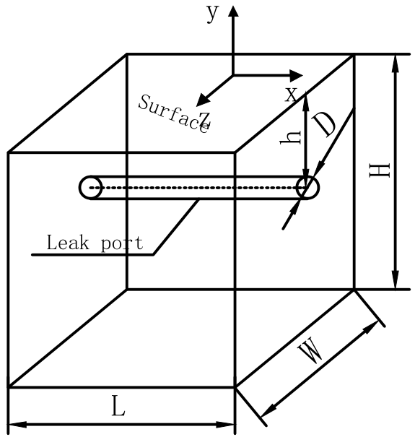
Fig.S1 A three-dimensional physical model for distributions of leaked diesel in porous media
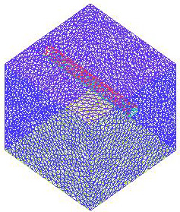
Fig.S2 A three-dimensional mesh model for distributions of leaked diesel in porous media
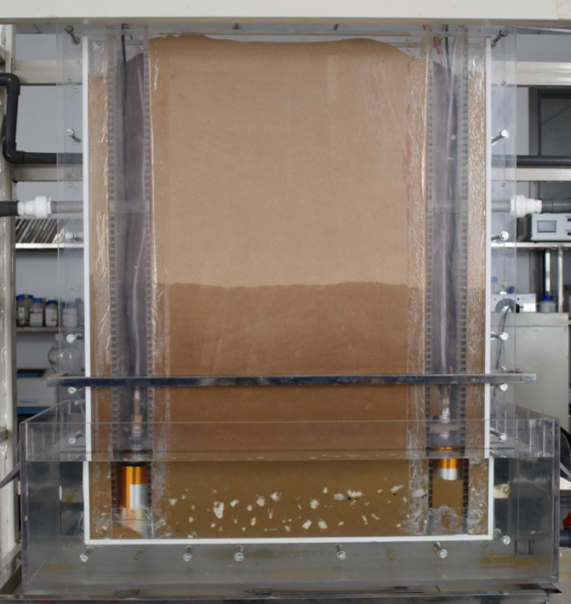
Fig.S3 Sandbox with soils and groundwater

Fig.S4 Groundwater gradient distribution in the numerical simulation model

Table S1 Porosity parameters
Serial number | Dry sand weight (g) | Sand weight after soaking for 6 hours (g) | Porosity | Ring cutter specification (cm²)
1 | 72.11 | 86.40 | 0.405 | 50
2 | 62.30 | 82.25 | 0.399 | 50
3 | 65.54 | 86.05 | 0.410 | 50
4 | 63.58 | 84.09 | 0.410 | 50
5 | 63.71 | 83.81 | 0.402 | 50

Table S2 Viscous drag coefficient and inertial drag coefficient
Porosity | Viscous drag coefficient (m⁻²) | Inertial drag coefficient (m⁻¹)
0.1 | 4.4×10⁹ | 1.9×10⁵
0.2 | 8.0×10⁹ | 5.2×10⁵
0.3 | 1.6×10¹⁰ | 2.0×10⁶
0.4 | 4.0×10¹⁰ | 1.8×10⁷

Table S3 Solver parameters
Setting project | Setting parameters
Space | Three-dimensional
Time | Unsteady
Solver | Based on pressure
Difference equation | Implicit
Difference equation | Implicit
Governing equation | Continuity equation, Turbulent kinetic energy equation, Momentum conservation equation, Energy conservation equation, Turbulent energy dissipation rate equation

Table S4 Material properties
Material name | Density (kg/m³) | Constant pressure specific heat capacity (J / kg·K) | Thermal conductivity  (W / m·K) | Kinematic viscosity  (kg / m·s)
Diesel | 730 | 2090 | 0.149 | 0.0024
Water | 998.2 | 4182 | 0.6 | 0.001003
Gas | 1.225 | 1006.43 | 0.0242 | 1.7894×10⁻⁵

Table S5 Operating parameters
Setting parameters | Boundary condition setting
Velocity inlet | 1.3 m / s、3.4 m / s、4.6 m / s、4.9 m / s
Acceleration of gravity | 9.8 m/s²
Pressure inlet | 0.002 Mpa

Table S6 Experimental equipment and reagents
Name | Model | Remark
DC power supply | PS-305DM | HK Long Wei Instrument Co., Ltd.
UV-visible spectrophotometer | A360 | Aoyi Instrument Shanghai Co., Ltd.
Analytical Balances | FA1004 | Shanghai Sunny Sunny Scientific Instrument Co., Ltd.
Digital camera | Nikon D3400 | SLR camera
Thermometer | Accuracy of 0.1 ℃ | Mercury
Sudan Ⅳ dye solution |  | Chemically Pure
0# diesel |  | Commercial
Petroleum ether |  | Chemically Pure
Table S7 The properties of diesel
The room temperature (℃) | 23
The specific gravity (kg / m³) | 906.48
The specific heat (kJ / kg•℃) | 1.8494
The thermal conductivity (W / m•℃) | 0.12712
The kinematic viscosity (m² / s) | 5.18×10⁻⁴

