Figure S1. Missing value threshold and corresponding size of the dataset. E.g. removing variables with missingness greater than 60% will result in the dataset with variables size 472.

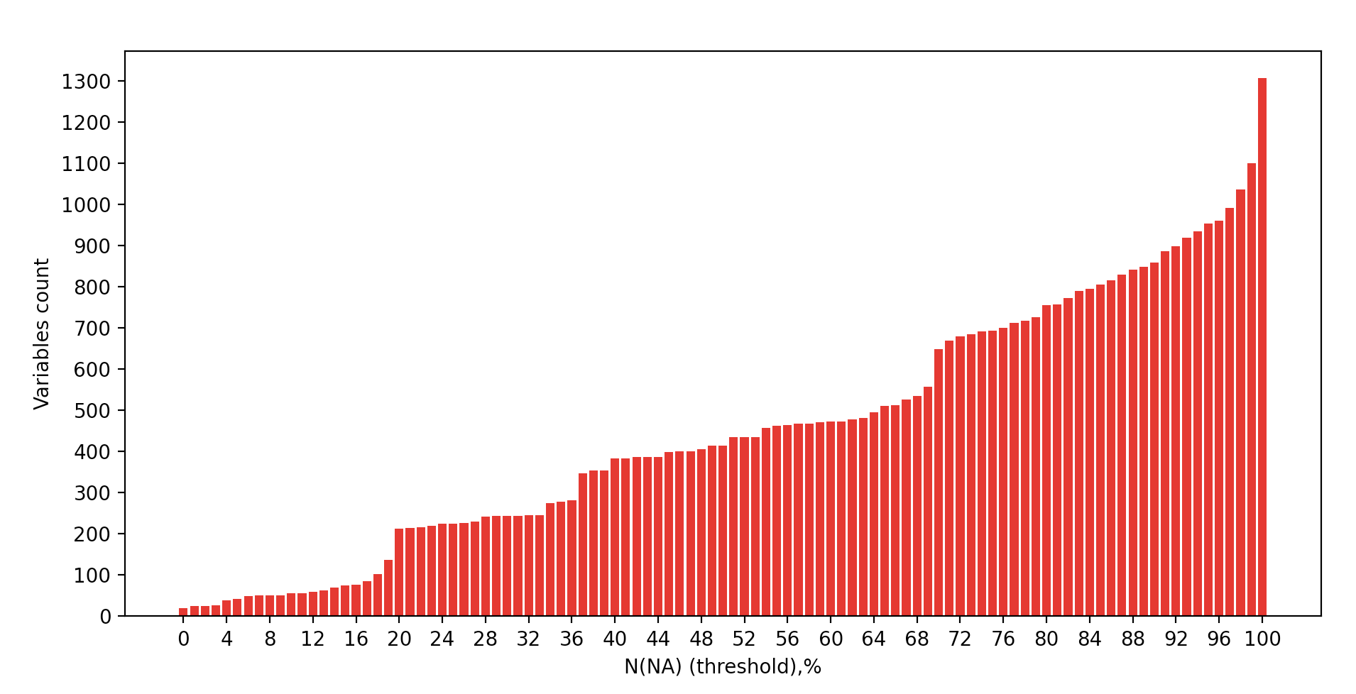

Figure S2. Examples of the STAR algorithm outlier detection for NHANES variables
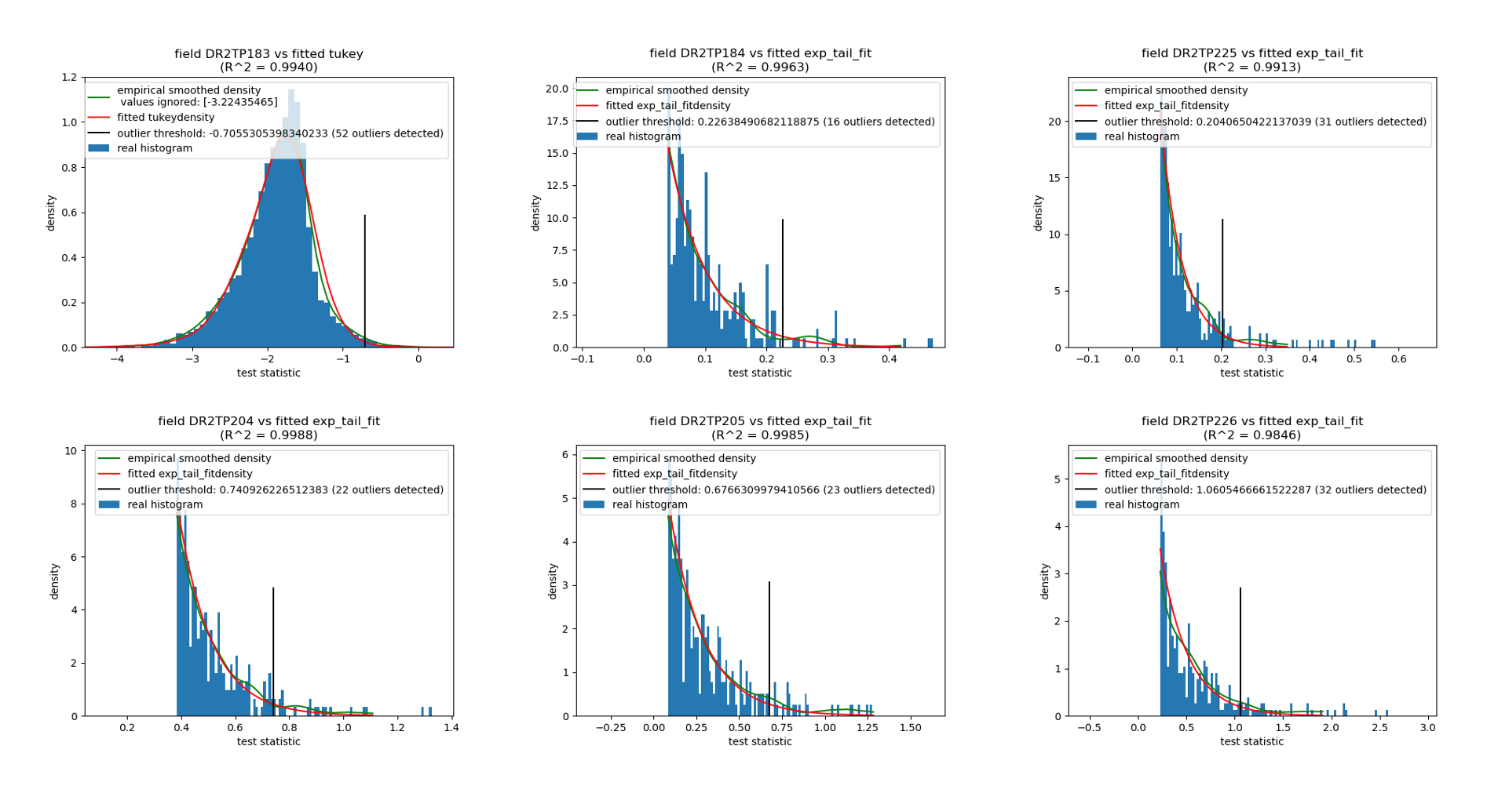

Figure S3 Hierarchical relationships between NHANES variables for caries severity-stratified subpopulations with caries identified by pvclust clustering method. Clusters with the significant approximately unbiased (AU) bootstrap probability estimate are shown for severe (A), mild (B) active caries, and no caries (C). Cluster size (number of variables in AU significant cluster) distributions are shown for each age subpopulation. Large AU significant cluster (>75 variables) is indicated for active caries group (S1).
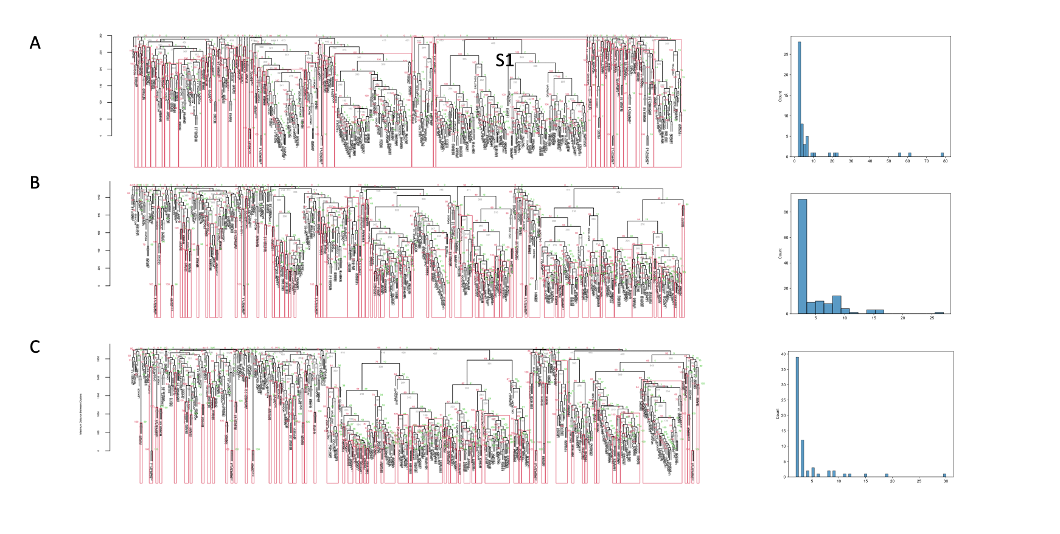

Figure S4. Variables subset S1 (largest AU significant cluster) for severe, mild active caries, and no caries subpopulations(A). Variables were normalized with ‘MinMax’ scaler to a range of 100. Functional categories distribution for all variables and cluster S1 (B). Lab – laboratory variables category, EXAM – physical examination variables category, DEMO- demographic variables category, QUEST – questionnaire variables category, NUTR- nutrition variables category.

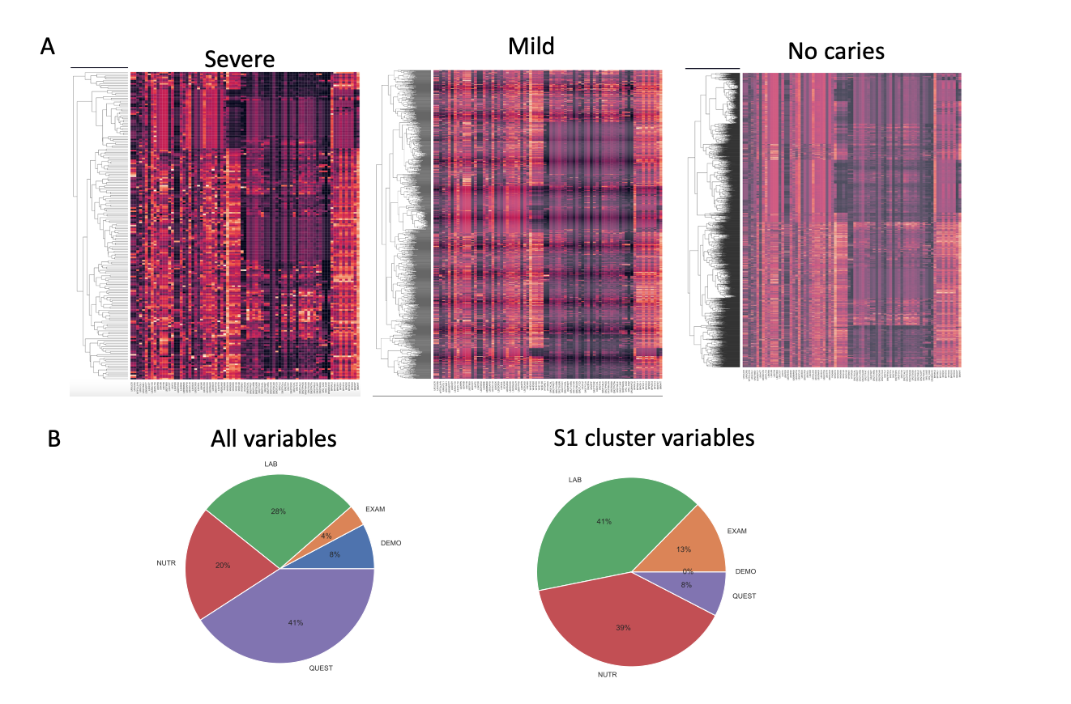
Figure S5. Spectral hierarchical clustering analysis of the caries subpopulation with the age group annotation for nutrition variables only subset. Top right: diversity distributions for nutrition and laboratory only variables subsets, K-S p - Kolmogorov-Smirnov test p-value. Top left: diversity summary statistics distributions for nutrition variables only subsets.

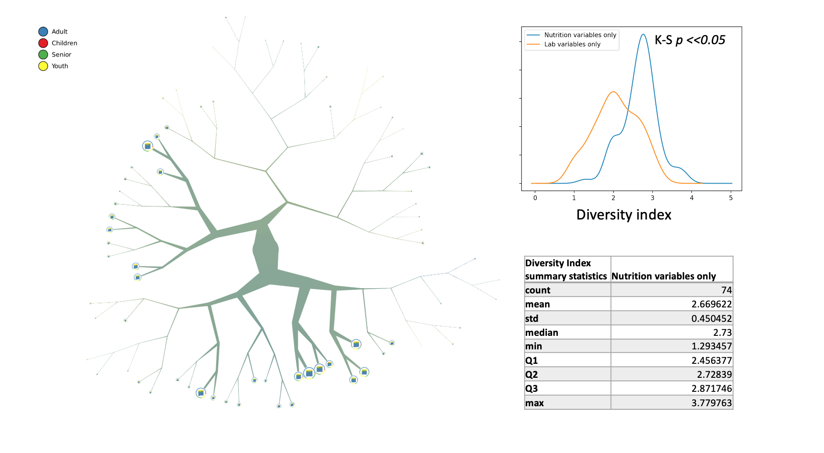

Figure S6. Blood lead levels for caries and no caries subpopulations.
