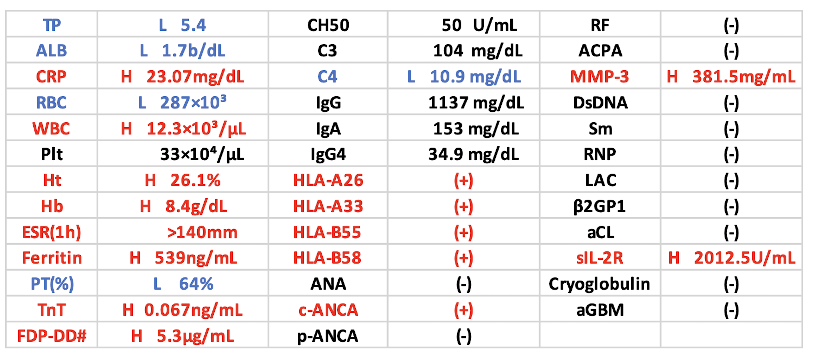

Table. Laboratory test results:
H: Higher than normal range (Red), L: Lower than normal range (Blue), TP: Total protein, ALB: Albumin, CRP: Creatin reactive protein, RBC: Red cell concentrate, WBC: White blood cell, Ht: Hematocrit, Hb: Hemoglobin, Plt: Platelet, ESR: Erythrocyte sedimentation rate, PT(%): Prothrombin time test, TnT: Troponin T, FDP-DD#: Fibrin degradation product-D-dimer, CH50: Hemolytic complement activity, ANA: Antinuclear antibody, c-ANCA: Anti-neutrophil cytoplasmic antibody, p-ANCA: Anti-neutrophil perinuclear antibody, RF: Rheumatoid factor, ACPA: Anti-cyclic citrullinate peptide antibody, MMP-3: Matrix metalloproteinase-3, DsDNA: Double-stranded deoxyribonucleic acid, Sm: Anti-Sm antibody, RNP: Anti-ribonucleoprotein antibody, LAC: Anti lupus anticoagulant antibody, β2GP1: Anti-β2-GlycoproteinⅠatidy, sIL-2R: Anti-soluble interleukin-2 receptor antibody, aGBM: Anti-GBM antibody

