Supplementary Information
for
Ubiquitous Organic Molecule-based Free-standing Nanowires with Ultra-High Aspect Ratios

Koshi Kamiya¹, Kazuto Kayama¹, Masaki Nobuoka¹, Shugo Sakaguchi¹,
Tsuneaki Sakurai¹*, Akira Idesaki², Hiroshi Koshikawa², Masaki Sugimoto²,
G.B.V.S. Lakshmi³, D.K. Avasthi⁴, Shu Seki¹*

¹ Department of Molecular Engineering, Graduate School of Engineering, Kyoto University, Nishikyo-ku, Kyoto 615-8510, Japan.
² Takasaki Advanced Radiation Research Institute, National Institutes for Quantum and Radiological Science and Technology, 1233 Watanuki-machi, Takasaki, Gunma 370-1292, Japan.
³ Special Center for Nanoscience, Jawaharlal Nehru University, New Mehrauli Road, New Delhi 110067, India.
⁴ Department of Physics, School of Engineering, University of Petroleum and Energy Studies, Dehradun 248007, India

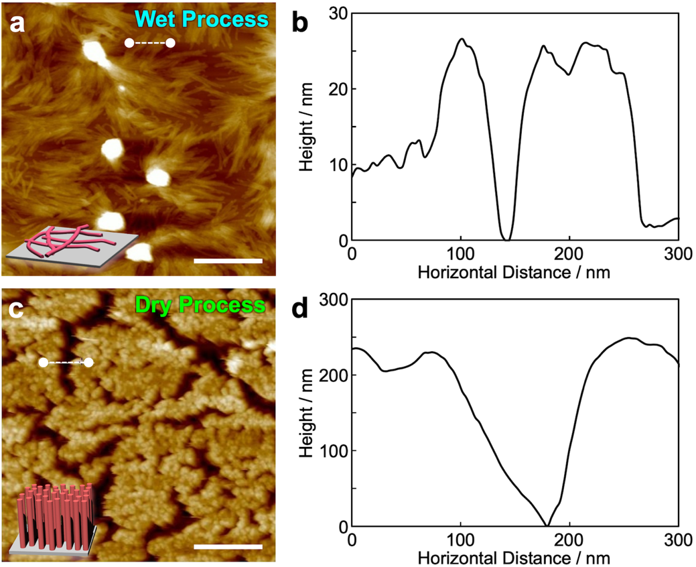
Fig. S1. Comparison of morphology of knocked-down and standing nanowires. (a,c) AFM topographic images of nanowires isolated by (a) wet process and (c) dry process. Nanowires were fabricated via irradiation of vapor-deposited 250 nm thickness of C₆₀ films with 490 MeV ¹⁹²Os³⁰⁺ at 1.0 × 10¹¹ cm^{–2}. (b,d) Height profiles along white dashed lines in (a) and (c), respectively. Scale bars in (a,c) represent 500 nm.

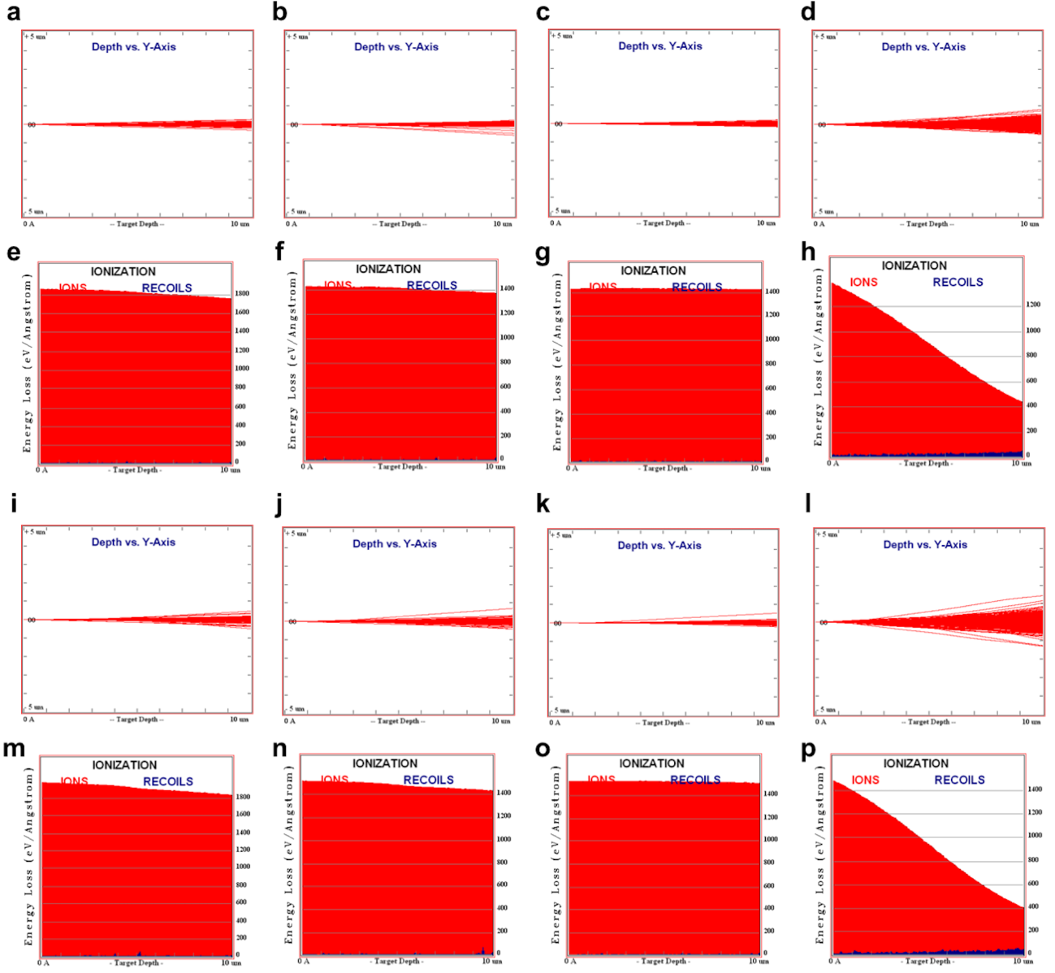
Fig. S2. Monte Carlo simulations of ion trajectories. Ion trajectories of (a,i) 490 MeV ¹⁹²Os³⁰⁺, (b,j) 350 MeV ¹²⁹Xe²⁶⁺, (c,k) 450 MeV ¹²⁹Xe²³⁺, and (d,l) 120 MeV ¹⁹⁷Au⁹⁺ for 10 µm film thickness of (a–d) C₆₀ and (i–l) PTCDA-Cl₄. LET vs. target depth profiles of (e,m) 490 MeV ¹⁹²Os³⁰⁺, (f,n) 350 MeV ¹²⁹Xe²⁶⁺, (g,o) 450 MeV ¹²⁹Xe²³⁺, and (h,p) 120 MeV ¹⁹⁷Au⁹⁺ for 10 µm film thickness of (e–h) C₆₀ and (m–p) PTCDA-Cl₄. LET over 12000 eV nm^{–1} is estimated for all the conditions until 3 µm depth.

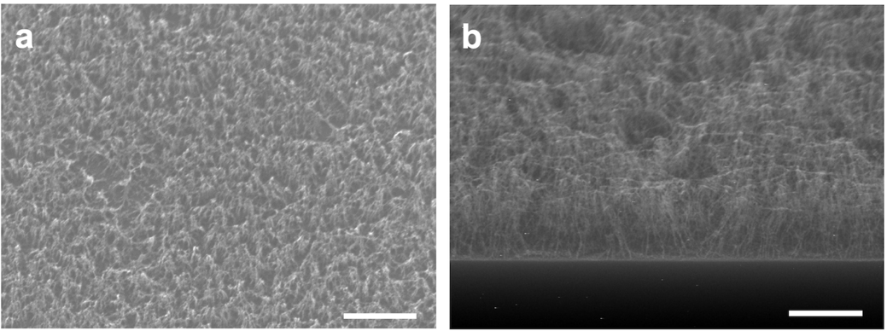
Fig. S3. Effect of irradiation fluence on vertical alignment of nanowires. SEM images of nanowires fabricated via charged particle irradiation and subsequent sublimation of C₆₀ films with (a) 200 nm and (b) 1000 nm thickness. Scale bars represent 1 µm. Irradiation condition: (a) 350 MeV ¹²⁹Xe²⁶⁺ at 5.0 × 10¹⁰ cm^{–2}; (b) 350 MeV ¹²⁹Xe²⁶⁺ at 1.0 × 10¹⁰ cm^{–2}.

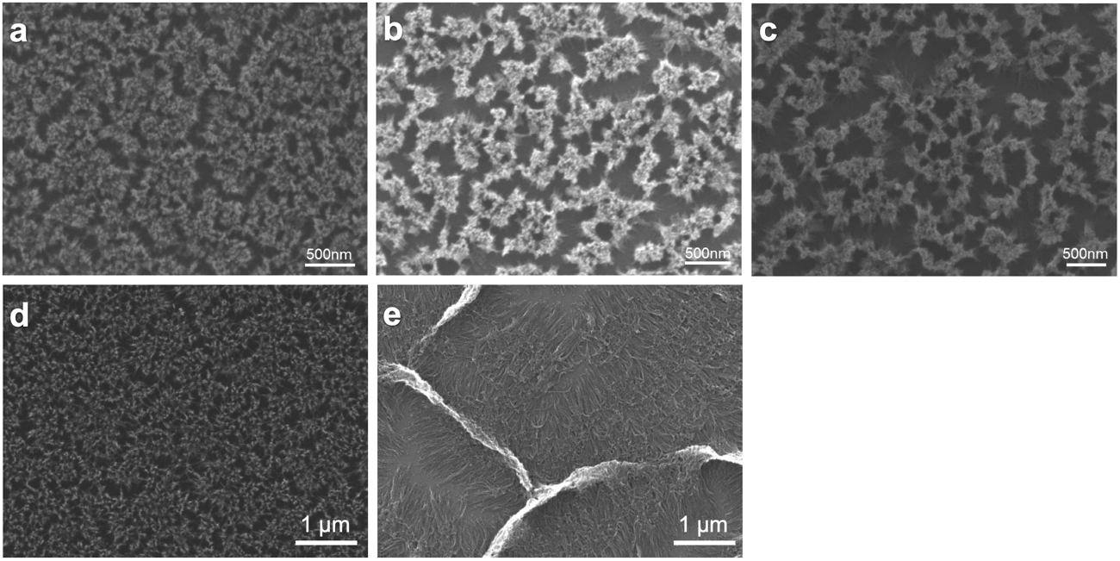
Fig. S4. Solvent treatment of isolated standing nanowires. SEM images of standing nanowires fabricated via irradiation of (a) 250 nm and (d) 500 nm C₆₀ film thickness and subsequent sublimation. Irradiation condition: (a) 490 MeV ¹⁹²Os³⁰⁺ at 1.0 × 10¹¹ cm^{–2}; (d) 350 MeV ¹²⁹Xe²⁶⁺ at 1.0 × 10¹¹ cm^{–2}. SEM images of C₆₀-based standing nanowires after immersed in 1,2-dichlorobenzene for (b) 5 sec and (c) 5 min. SEM images of C₆₀-based standing nanowires in (d) after immersed in 1,2-dichlorobenzene for (e) 5 min.

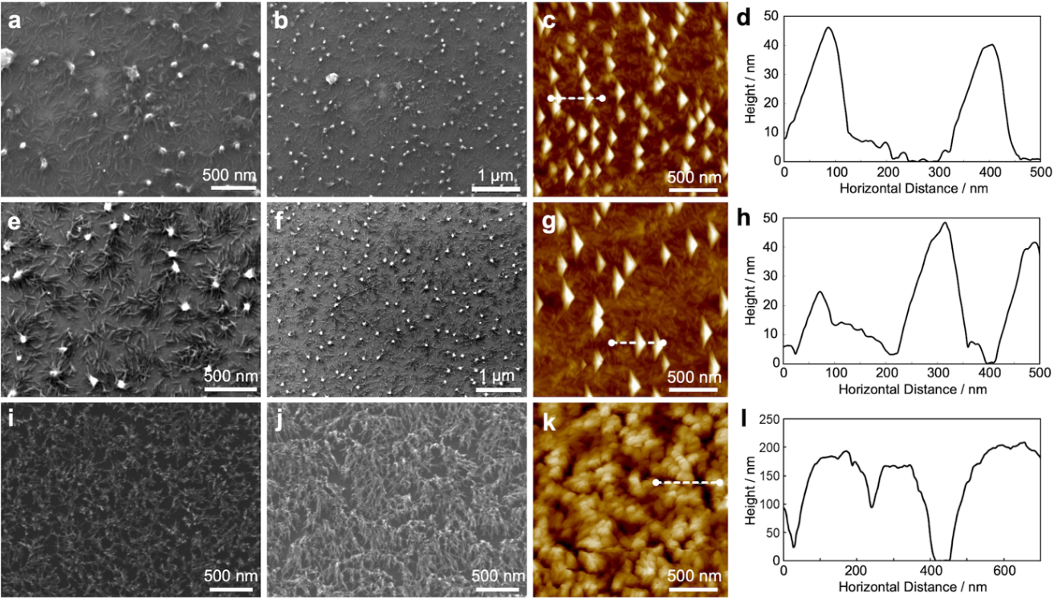
Fig. S5. Nanowires from other fullerene derivatives isolated by sublimation. (a,b) SEM images, (c) AFM images, and (d) height profile along white dashed line in (c) of nanowires fabricated via irradiation of PC₆₁BM ([6,6]-phenyl-C₆₁-butyric acid methyl ester) spin-coated film (100 nm thickness) with 350 MeV ¹²⁹Xe²⁶⁺ at 1.0 × 10¹¹ cm^{–2} and isolated by sublimation at ~300 ºC. (e,f) SEM images, (g) AFM images, and (h) height profile along white dashed line in (c) of nanowires fabricated via irradiation of 100 nm thickness PC₆₁BM spin-coated film with 350 MeV ¹²⁹Xe²⁶⁺ at 1.0 × 10¹¹ cm^{–2} and isolated by development with 1,2-dichlorobenzene at 25 ºC. (i,j) SEM images, (k) AFM images, and (l) height profile along white dashed line in (c) of nanowires fabricated via irradiation of 230 nm thickness vapor-deposited C₇₀ film with 350 MeV ¹²⁹Xe²⁶⁺ at 1.0 × 10¹¹ cm^{–2} and isolated by sublimation at ~300 ºC.

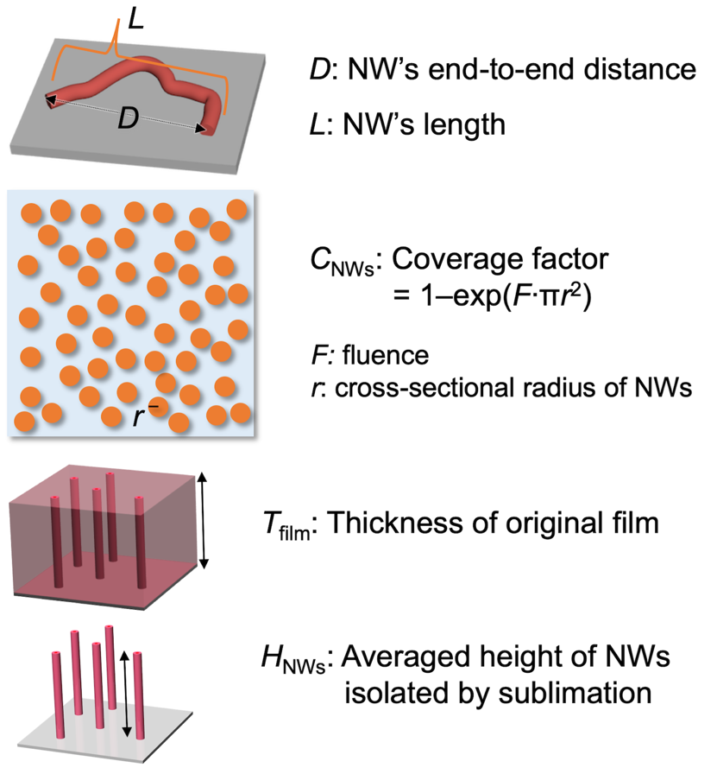
Fig. S6. Schematic illustrations explaining parameters used in Table 1.

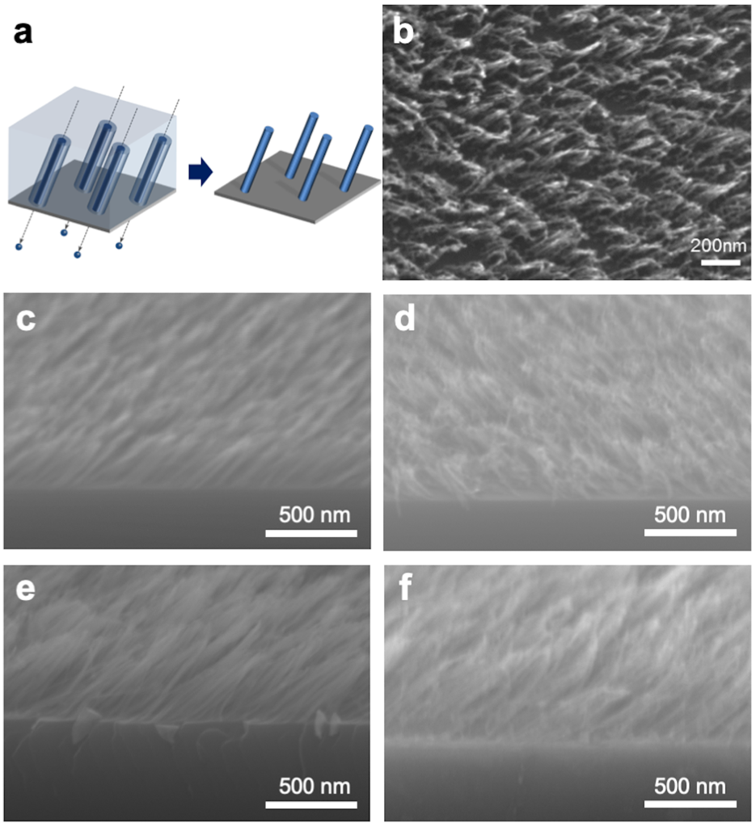
Fig. S7. Fabrication of tilted nanowires. (a) Schematic illustration and (b) top views in SEM for nanowires fabricated via irradiation of 200 nm thickness C₆₀ film with 350 MeV ¹²⁹Xe²⁶⁺ at 1.0 × 10¹¹ cm^{–2} in oblique direction and subsequent sublimation. Tilt view in SEM for nanowires fabricated via irradiation of (c) 200 nm thickness PTCDA-Cl₄, (d) 200 nm thickness TBP, (e) 450 nm thickness BPEA, and (f) 500 nm thickness DBBA films with 490 MeV ¹⁹²Os³⁰⁺ at 2.0 × 10¹¹ cm^{–2} in oblique direction and subsequent sublimation.

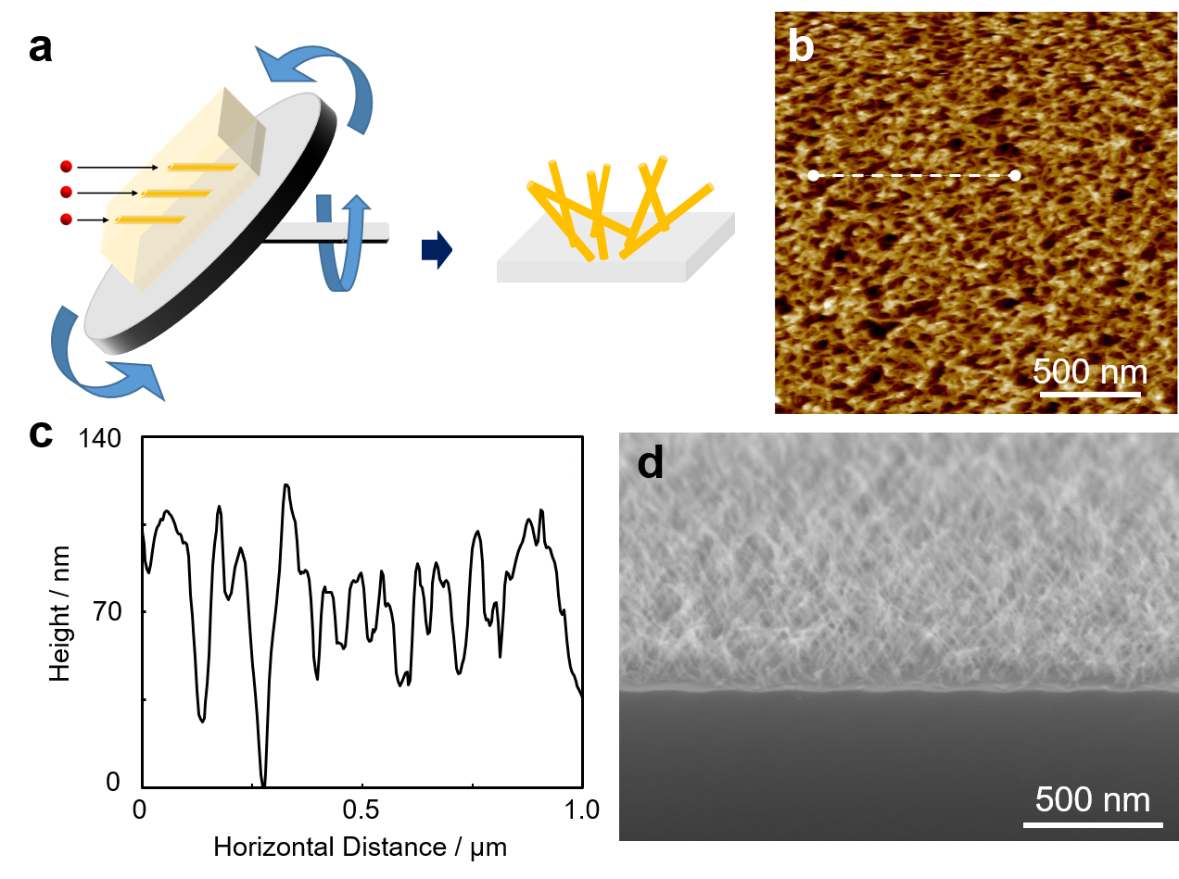
Fig. S8. Fabrication of cross-connected nanowires. (a) Schematic illustration of high-energy ion irradiation of thin films on automatically rotating disk. The incident angle between the ion vector and plane of disk was set at 45º. (b) AFM image and (c) height profile along white dashed line in (b), and (d) SEM image of crosslinked nanowires fabricated via irradiation of 200 nm thickness vapor-deposited PTCDA-Cl₄ film irradiated with 450 MeV ¹²⁹Xe²³⁺ at 4.0 × 10¹¹ cm^{–2} and isolated by sublimation.

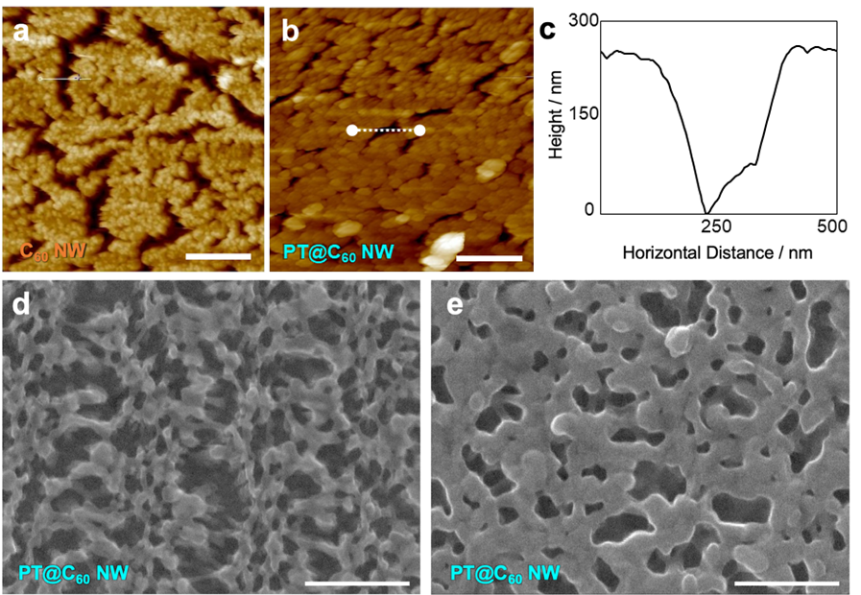
Fig. S9. Morphology of coaxial nanowires. AFM images of (a) C₆₀-based standing nanowires and (b) polythiophene-rapped C₆₀-based coaxial nanowires (PT@C₆₀). Height profile along white dashed line in (b). Top views of SEM images for PT@C₆₀ after (d) 1 min and (e) 3 min electropolymerization of 2,2’-bithiophene. Scale bars represent 500 nm. Irradiation condition: 450 MeV ¹²⁹Xe²³⁺ at 1.0 × 10¹¹ cm^{–2} for C₆₀ nanowires.

