Supplementary Information For
Structural insights into TSC complex assembly and GAP activity on Rheb
Huirong Yang^{1,2,3 #}, Zishuo Yu^{1#}, Xizi Chen^{1#}, Jiabei Li¹, Ningning Li⁴, Jiaxuan Cheng⁴, Ning Gao⁴, Hai-Xin Yuan⁵, Dan Ye⁵, Kun-liang Guan⁶, and Yanhui Xu^{1,2,3}*

¹Fudan University Shanghai Cancer Center, Institutes of Biomedical Sciences, State Key Laboratory of Genetic Engineering and Shanghai Key Laboratory of Medical Epigenetics, Shanghai Medical College of Fudan University, Shanghai 200032, China
²The International Co-laboratory of Medical Epigenetics and Metabolism, Ministry of Science and Technology, China, Department of Systems Biology for Medicine, School of Basic Medical Sciences, Shanghai Medical College of Fudan University, Shanghai 200032, China
³Human Phenome Institute, Collaborative Innovation Center of Genetics and Development, School of Life Sciences, Fudan University, Shanghai 200433, China
⁴State Key Laboratory of Membrane Biology, Peking-Tsinghua Joint Center for Life Sciences, School of Life Sciences, Peking University, Beijing 100871, China
⁵The Molecular and Cell Biology Research Lab, the Shanghai Key Laboratory of Medical Epigenetics, Institutes of Biomedical Sciences, Fudan University, Shanghai, 200032, China
⁶Department of Pharmacology and Moores Cancer Center, University of California San Diego, La Jolla, California, USA
# These authors contributed equally to this work.
* Corresponding author: xuyh@fudan.edu.cn

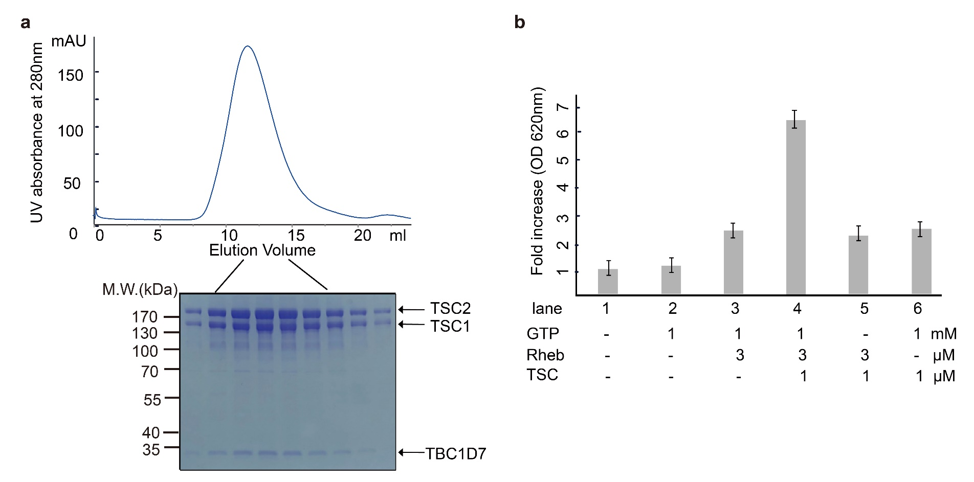Supplementary Figure 1 TSC complex purification and in vitro GAP activity.
(a) Gel filtration profile of the purified TSC complex on Superose 6 column. The peak fractions were subjected to SDS-PAGE followed by Coomassie blue staining. (b) In vitro GAP activity assay of TSC complex with purified Rheb as substrate. Malachite green/acid molybdate reagent was used to measure formation of inorganic phosphate. The concentrations of GTP and proteins are indicated. The experiments were performed in triplicates. Vertical axis indicates the fold increase of inorganic phosphate measured by OD 620nm.

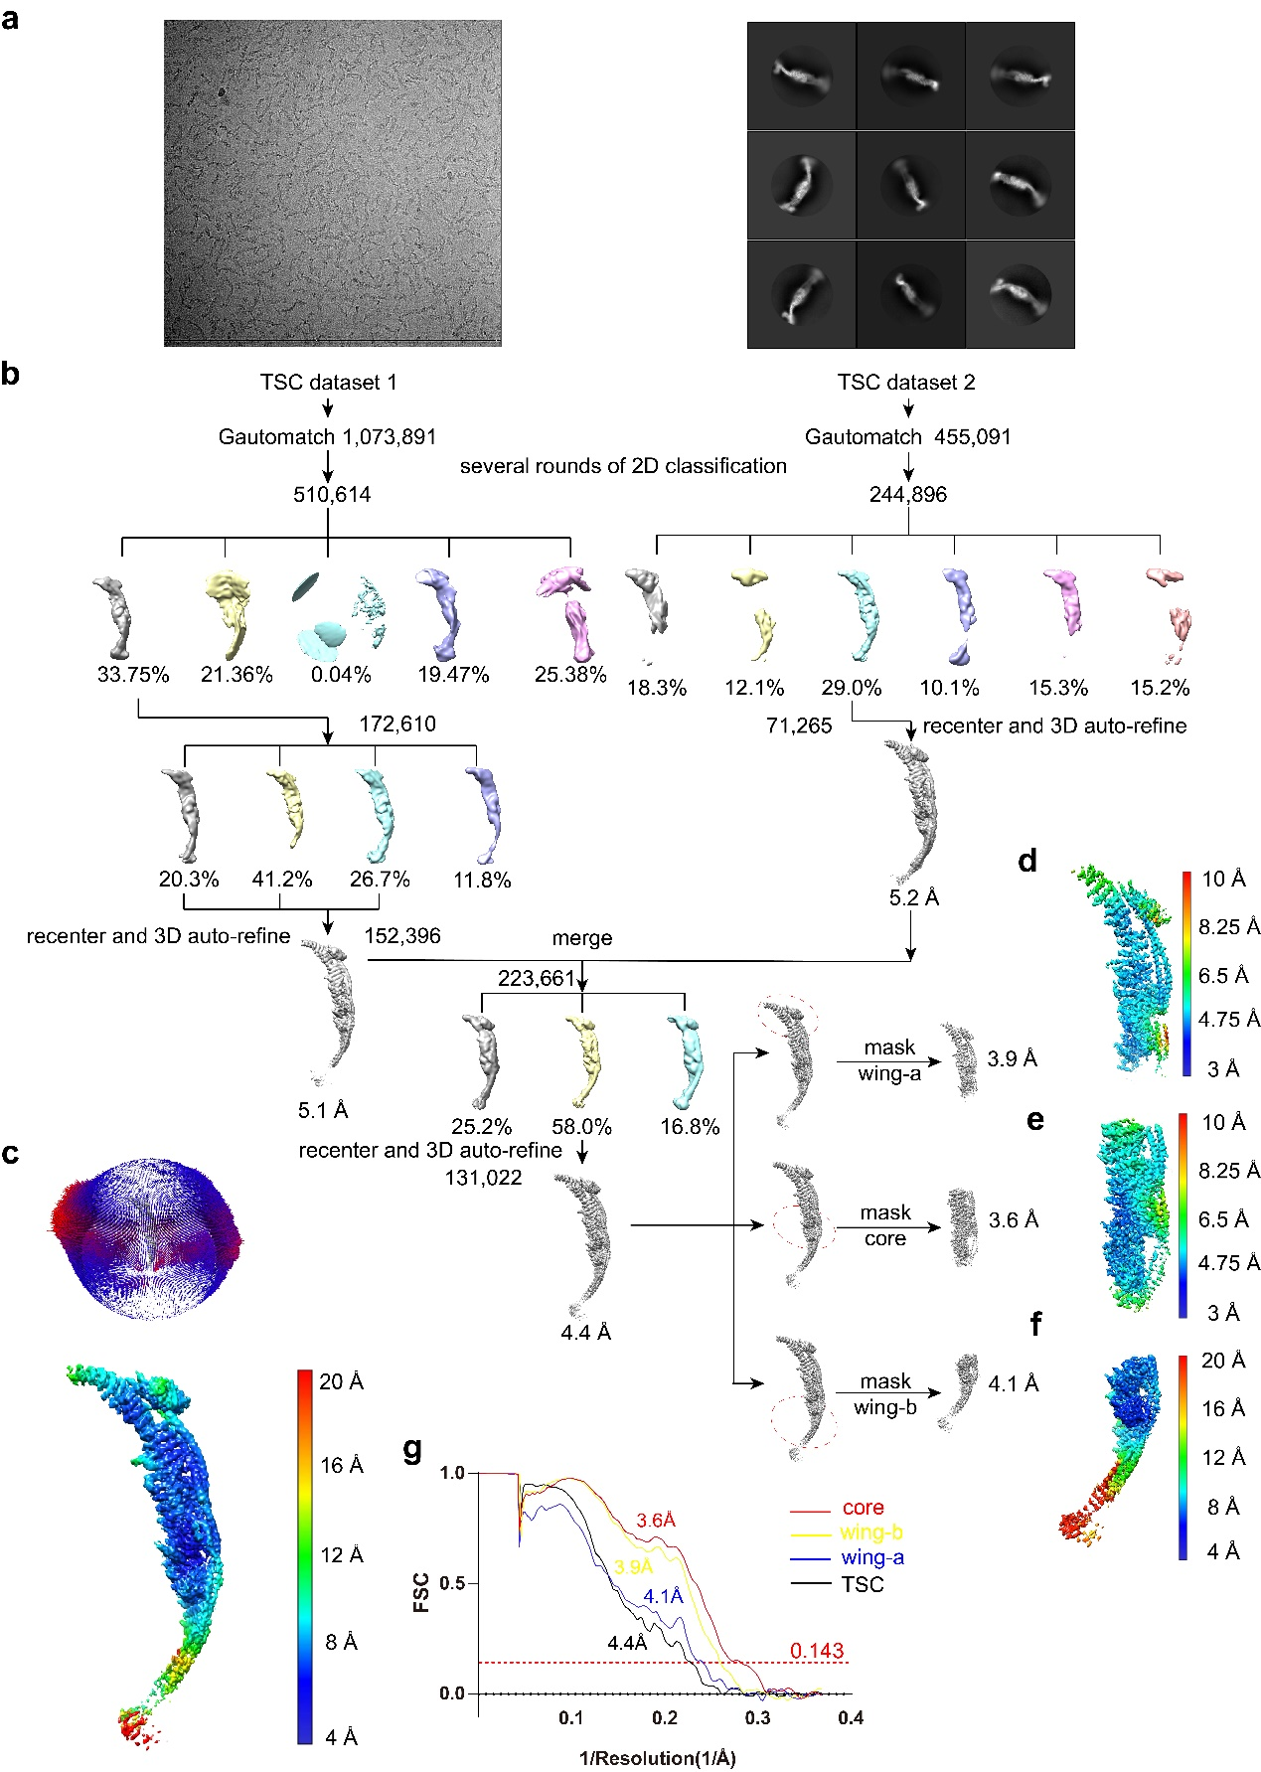
Supplementary Figure 2 Data collection and processing of TSC complex.
(a) Representative cryo-EM images (left) and 2D classification of TSC complex. (b) Flow-chart of the cryo-EM data processing and 3D reconstructions. (c) Local resolution estimation and orientation of the cryo-EM reconstructions of TSC overall complex at 4.4 Å resolution. Local resolution estimations of the wing-b module at 3.9 Å resolution (d), of the core module at 3.6 Å resolution (e), and of the wing-a module of TSC at 4.1 Å resolution (f), respectively. (g) FSC curves of the best resolved classes of the TSC (black), wing-a (blue), core (red) and wing-b (yellow) modules.

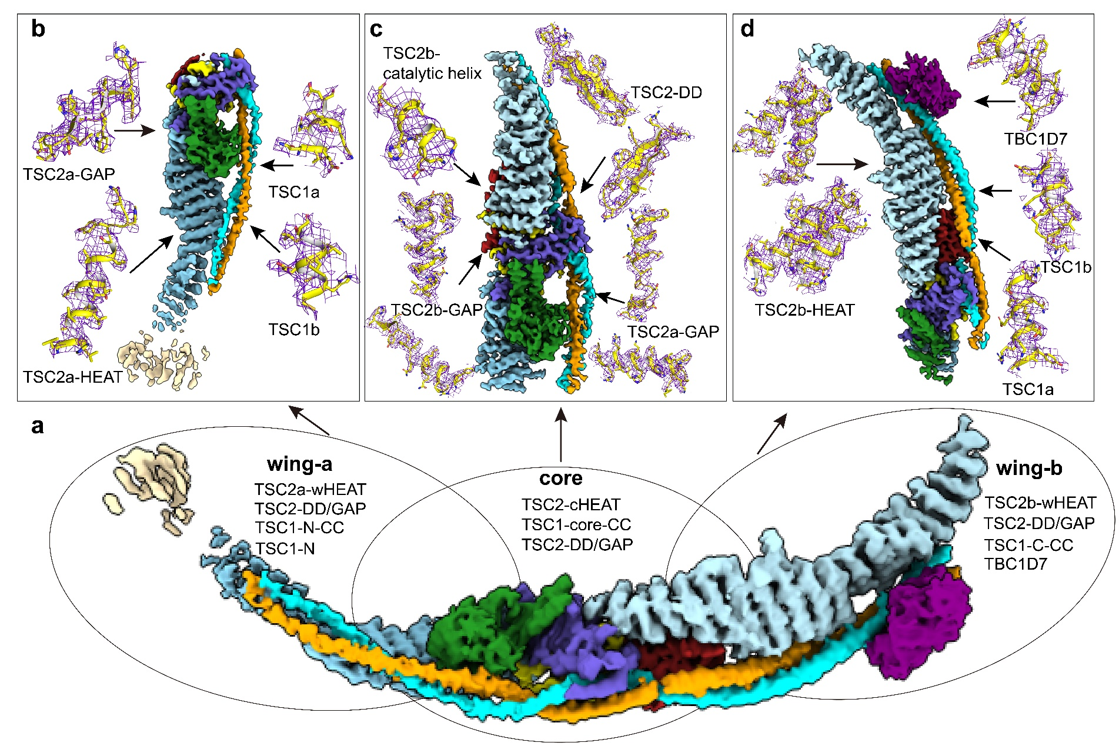
Supplementary Figure 3 Cryo-EM maps and structural model of the TSC complex. (a) The cryo-EM map of overall structure at 4.4 Å resolution with the map colored as in Fig. S 1b. b-d, Locally refined cryo-EM reconstructions of wing-a module at 4.1 Å resolution (b), core module at 3.6 Å resolution (c), and wing-b module at 3.9 Å resolution (d). Close-up views of the model are shown in sticks and the maps are shown in blue meshes.

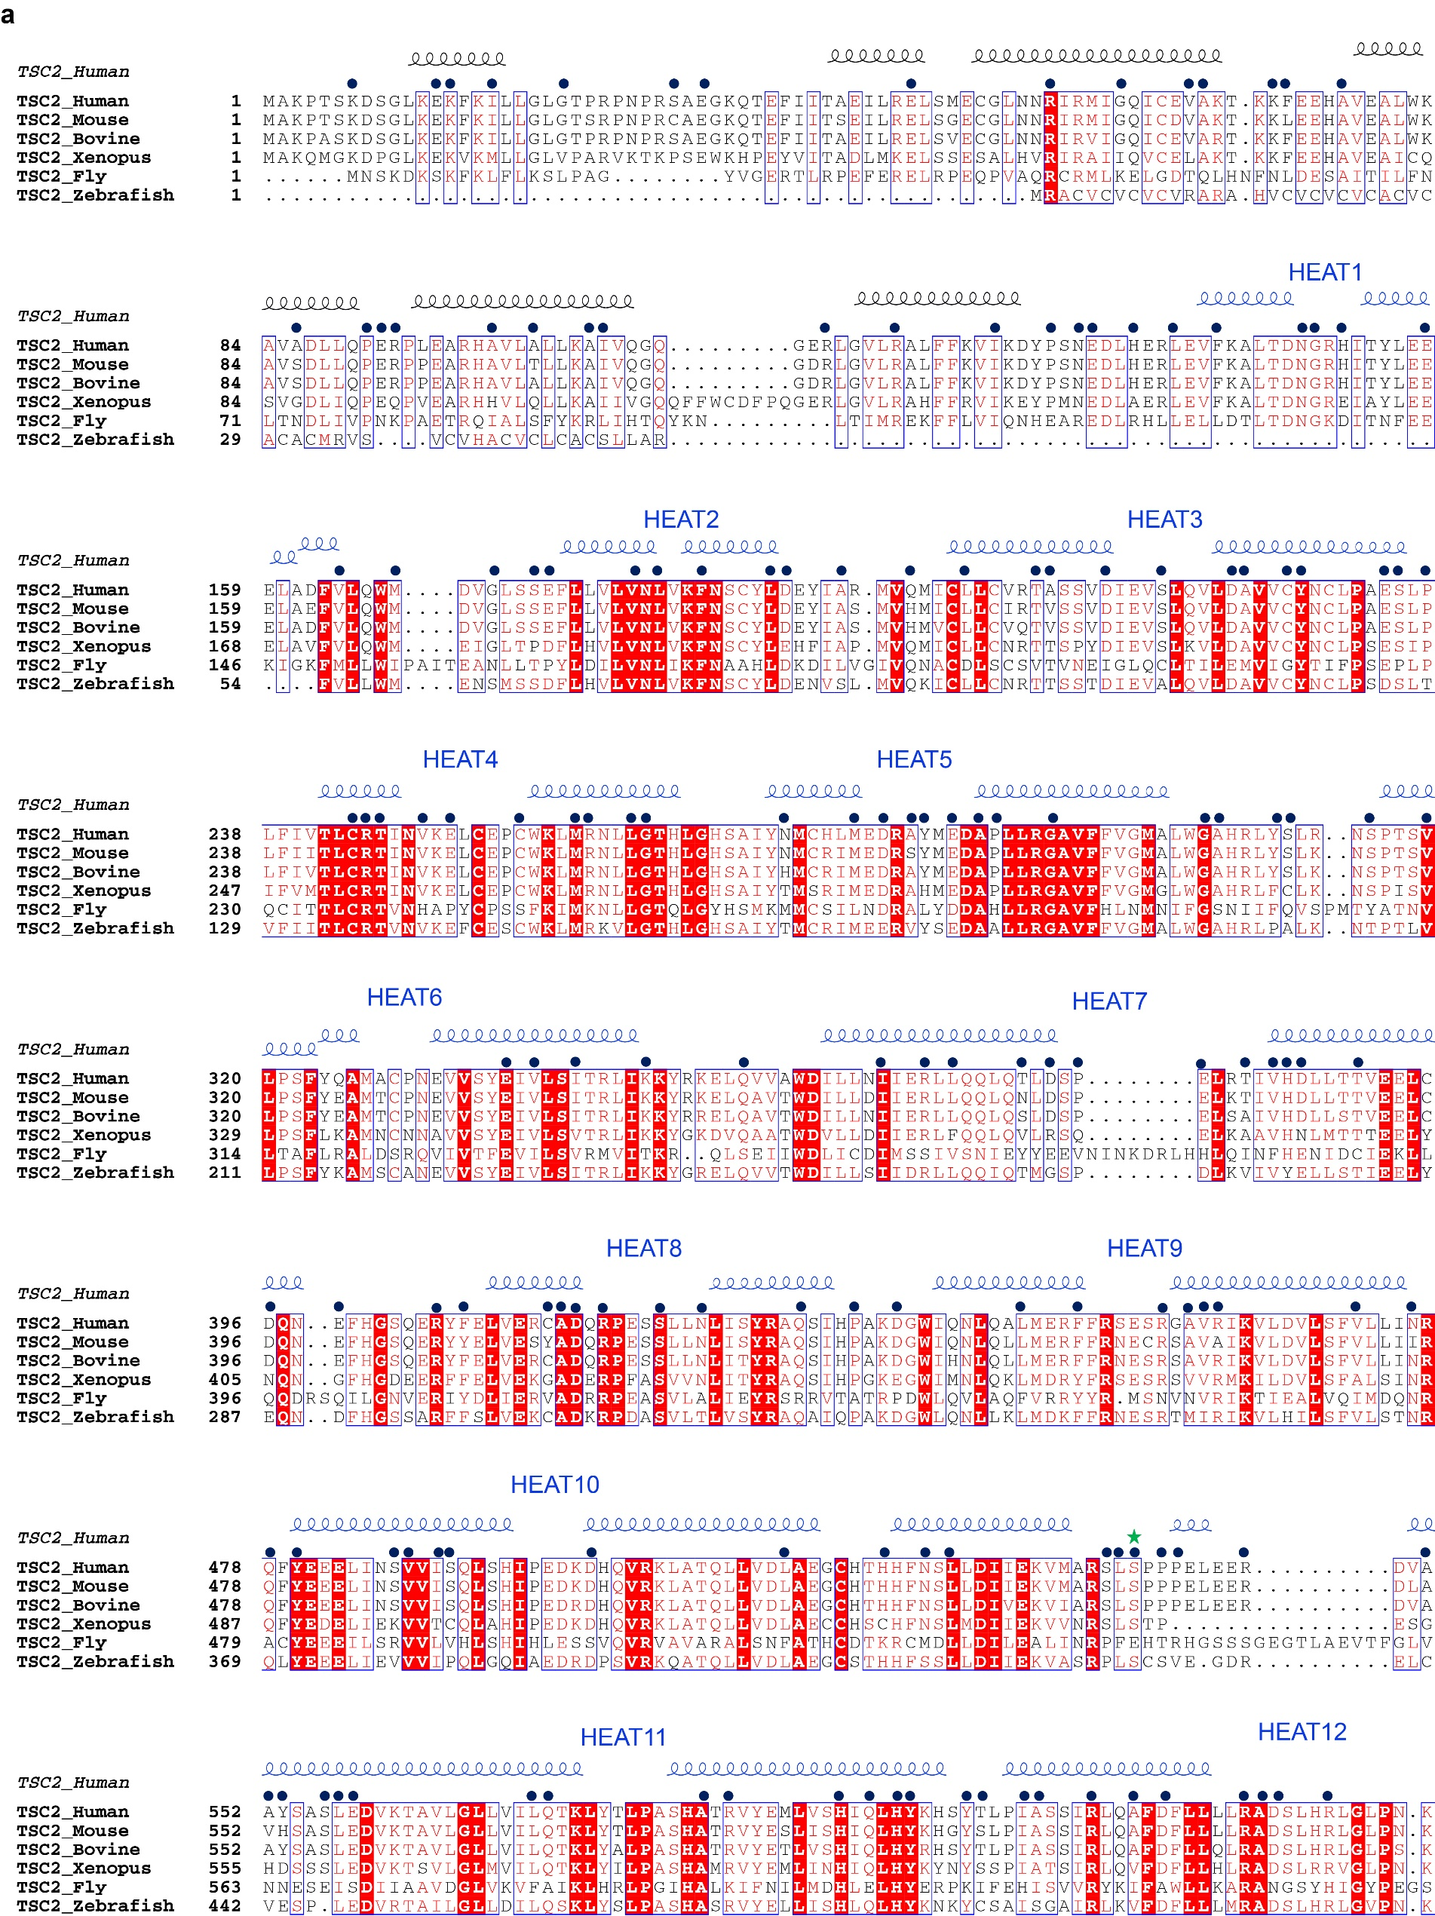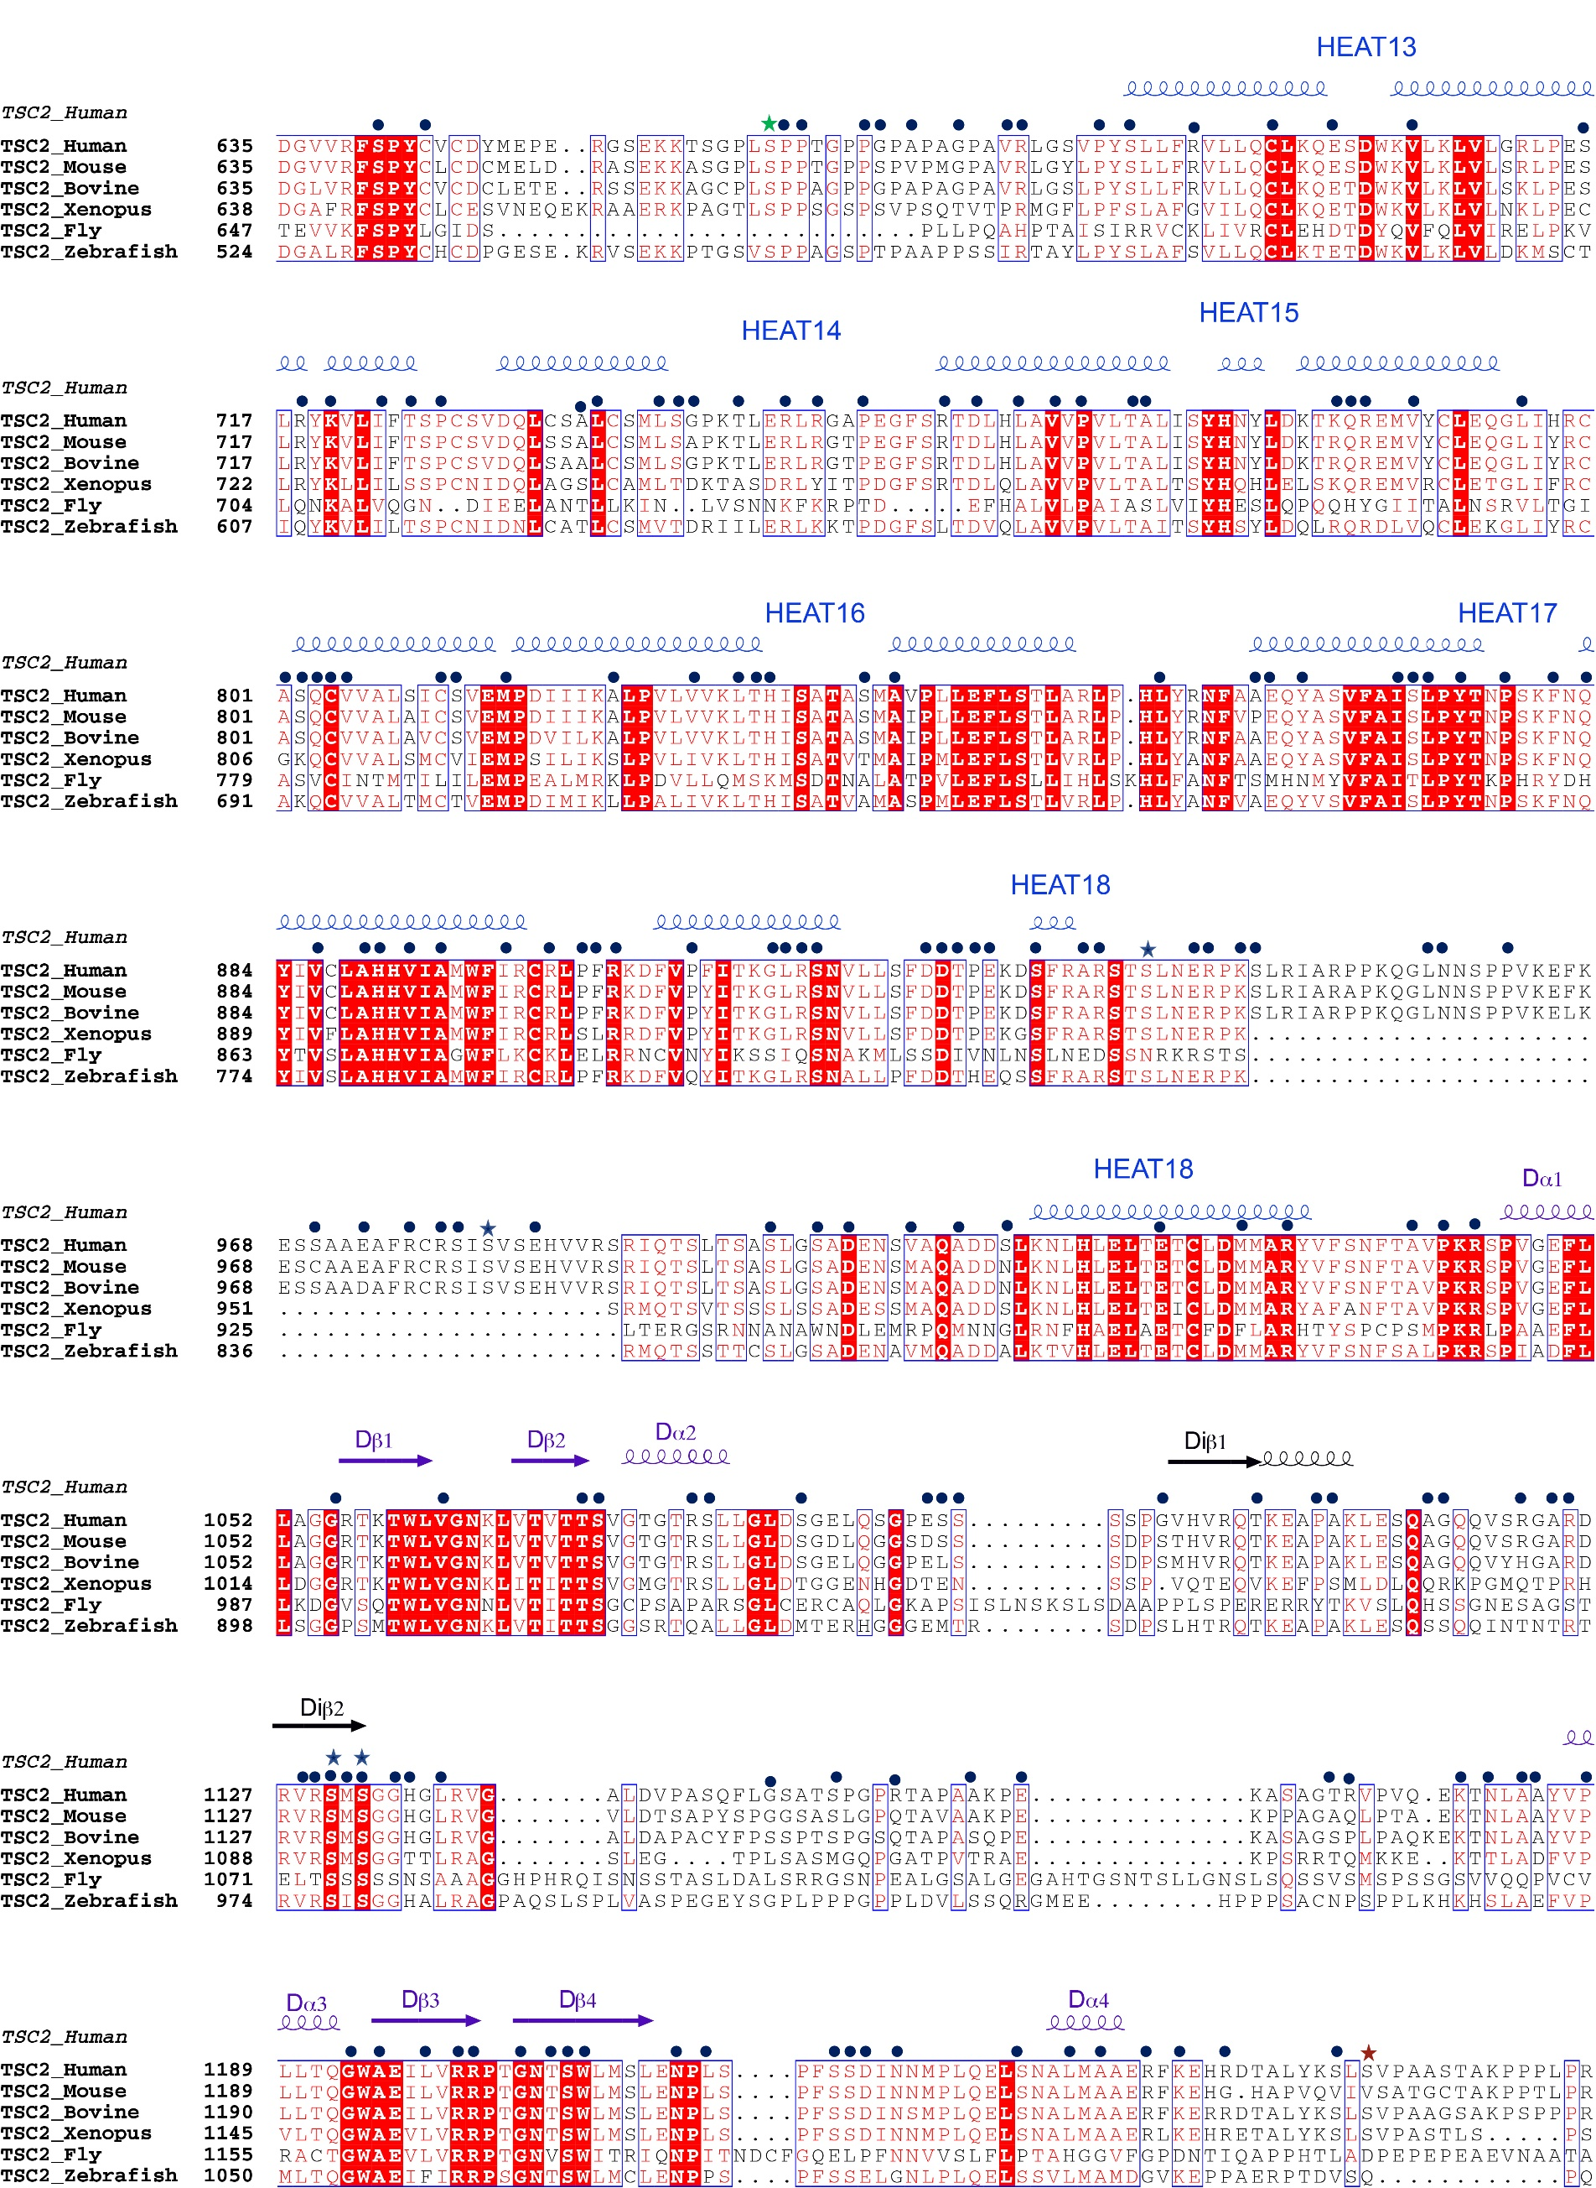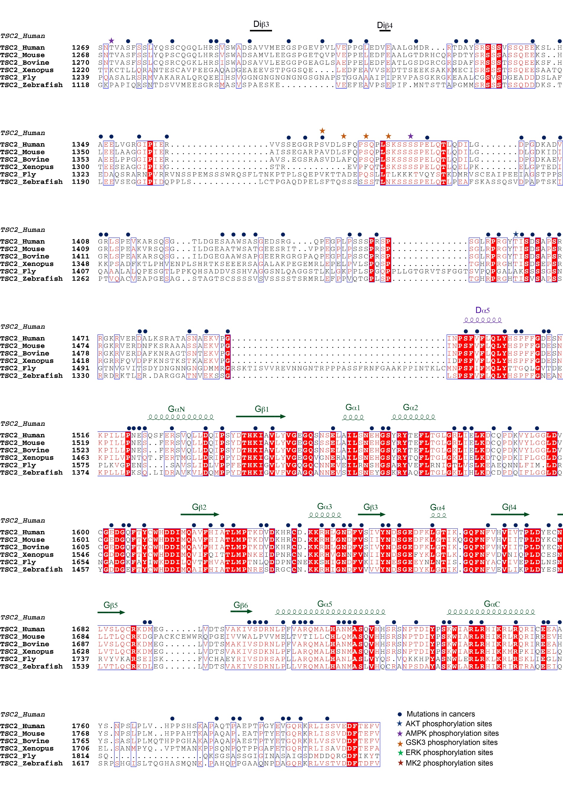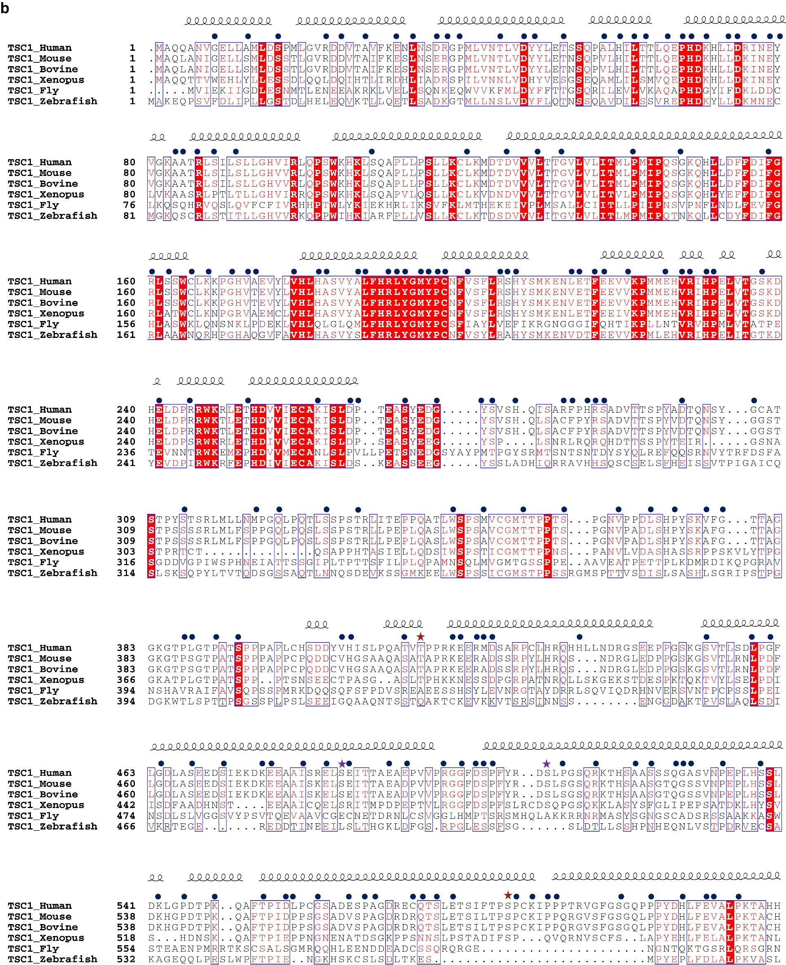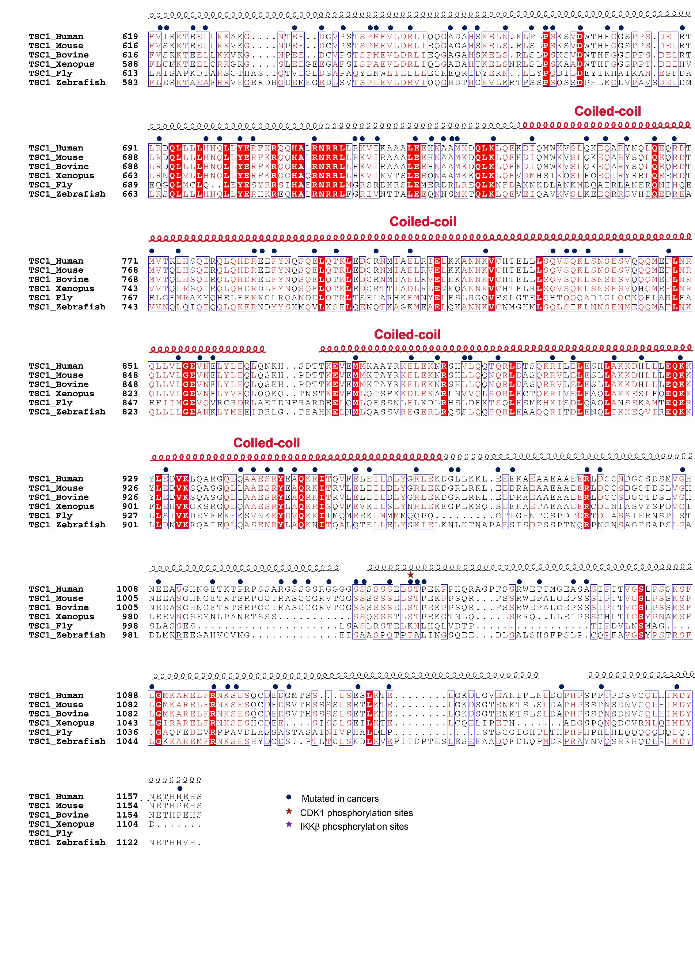
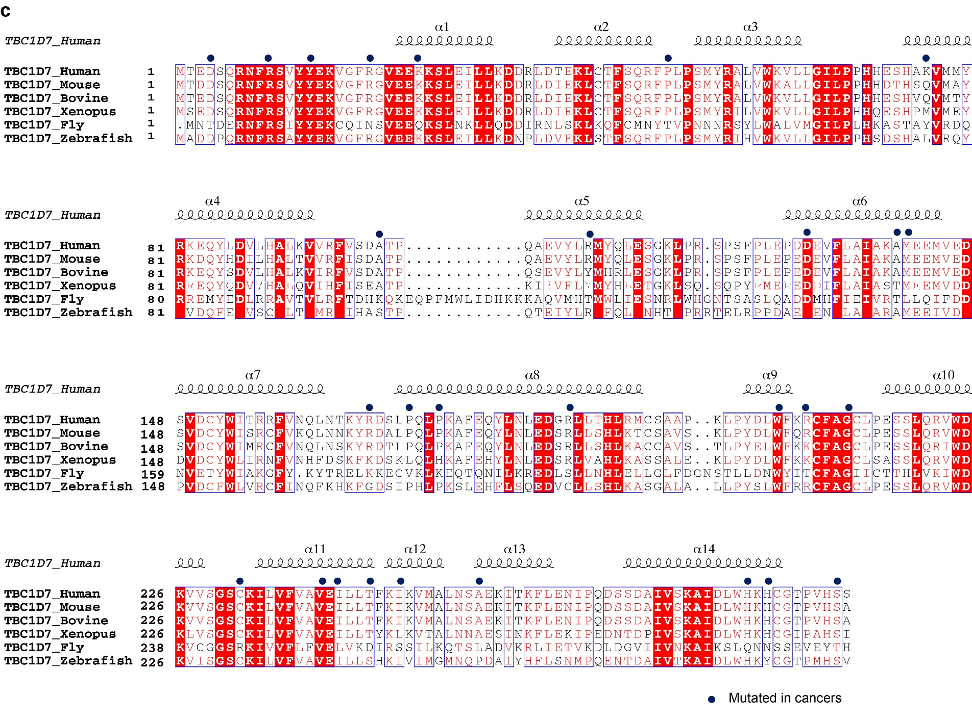
Supplementary Figure 4 Sequence alignment of TSC1, TSC2 and TBC1D7 across species.
Structure-based sequence alignment of TSC1 (a), TSC2 (b), and TBC1D7 (c) across species. Secondary structure (α helices and β strands) and domain annotations are indicated above the sequences. The secondary structures of unmodeled regions were obtained from secondary structure prediction¹. Phosphorylation sites and disease-associated mutations are marked in stars and circles, respectively. Alignments were generated by ESPript².

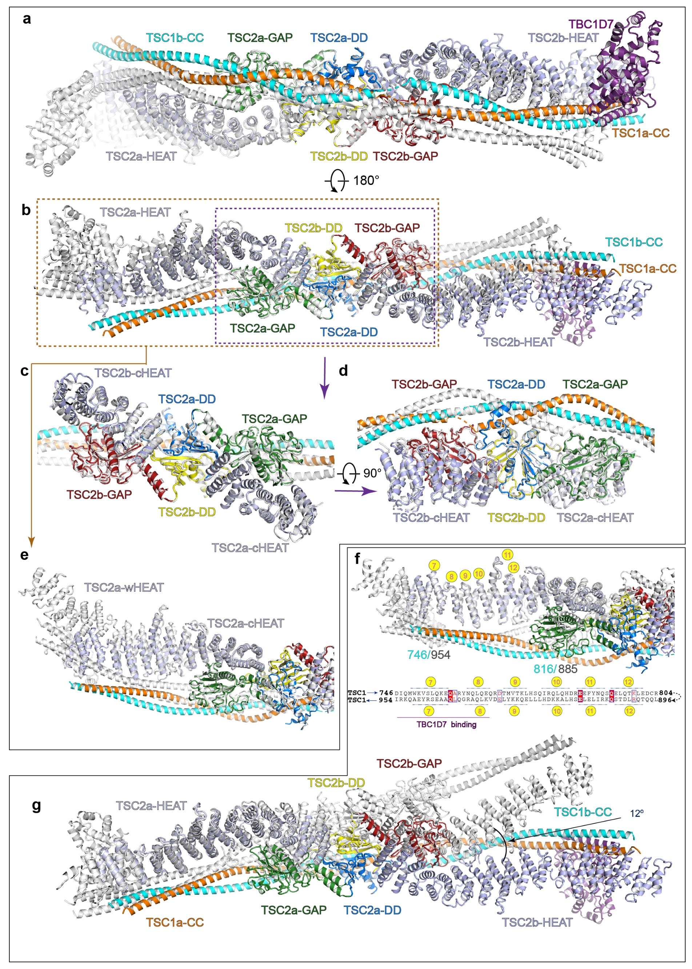Supplementary Figure 5 Asymmetric assembly of TSC complex.
(a-e) Reciprocal superimposition of two TSC complexes with one complex colored as in Fig. 1 and the other in grey (a-b). The central core module adopts almost symmetric fold (c-d) whereas the wing modules are asymmetrically arranged (e). (f-g) When two wHEAT modules are superimposed (f), the two TSC complexes show a ~12-degree deviation at the other end (g). The asymmetric assembly of TSC complex is resulted from directional binding of TSC1 dimer, as indicated by the schematic figure of TSC1-TSC2 and TSC1-TBC1D7 interactions (f).

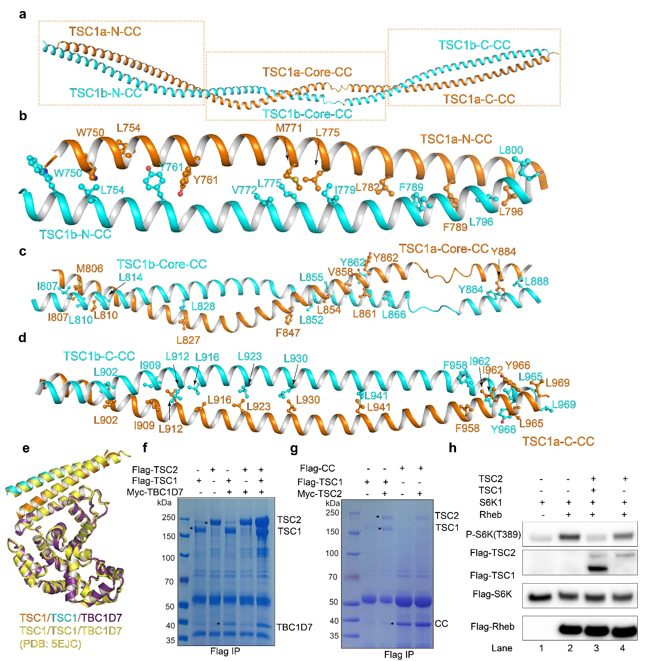
Supplementary Figure 6 TSC1 dimer interface and TSC1 CC binding with TSC2.
(a) The TSC1 coiled-coil dimer is shown as in Fig. 1c in a different view, as labeled by N-CC, Core-CC and C-CC three parts. The close-up views of the three interfaces around the N-terminal (b), central (c), and C-terminal (d) regions. Residues involved in dimerization are shown in stick representation. (e) Superimposition of TSC1-TBC1D7 subcomplex in our structure and the previously reported crystal structure (colored in yellow) (PDB:5EJC). (f) Flag immunoprecipitation assay. Flag-TSC1, Flag-TSC2, Myc-TBC1D7 were transfected alone or co-transfected to Expi 293F cells and purified on anti-Flag M2-beads. The bound proteins were subjected to SDS-PAGE followed by Coomassie blue staining. (g) Flag immunoprecipitation assay performed as in (f). Flag-TSC1 or Flag-TSC1 CC (725-988aa) were co-transfected with myc-TSC2 to 293F cells and purified on anti-Flag M2-beads. The bound proteins were subjected to SDS-PAGE followed by Coomassie blue staining. (h) Cell-base GAP activity assay of TSC2 with or without TSC1. The activities were detected by western blotting with antibody against phosphorylated S6K (T389).

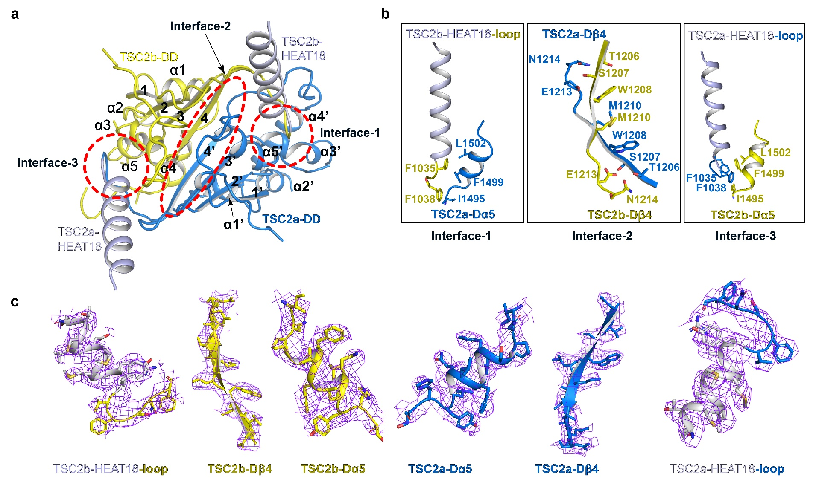
Supplementary Figure 7 Three detailed interfaces of TSC2 dimer.
Cartoon model of TSC2 dimerization domain (a) and close-up views of the three interfaces (b). Secondary structural elements are labeled with numbers with apostrophe in the TSC2a. Critical residues involved in dimerization are shown in sticks (b) and the corresponding cryo-EM maps are shown in blue meshes (c).

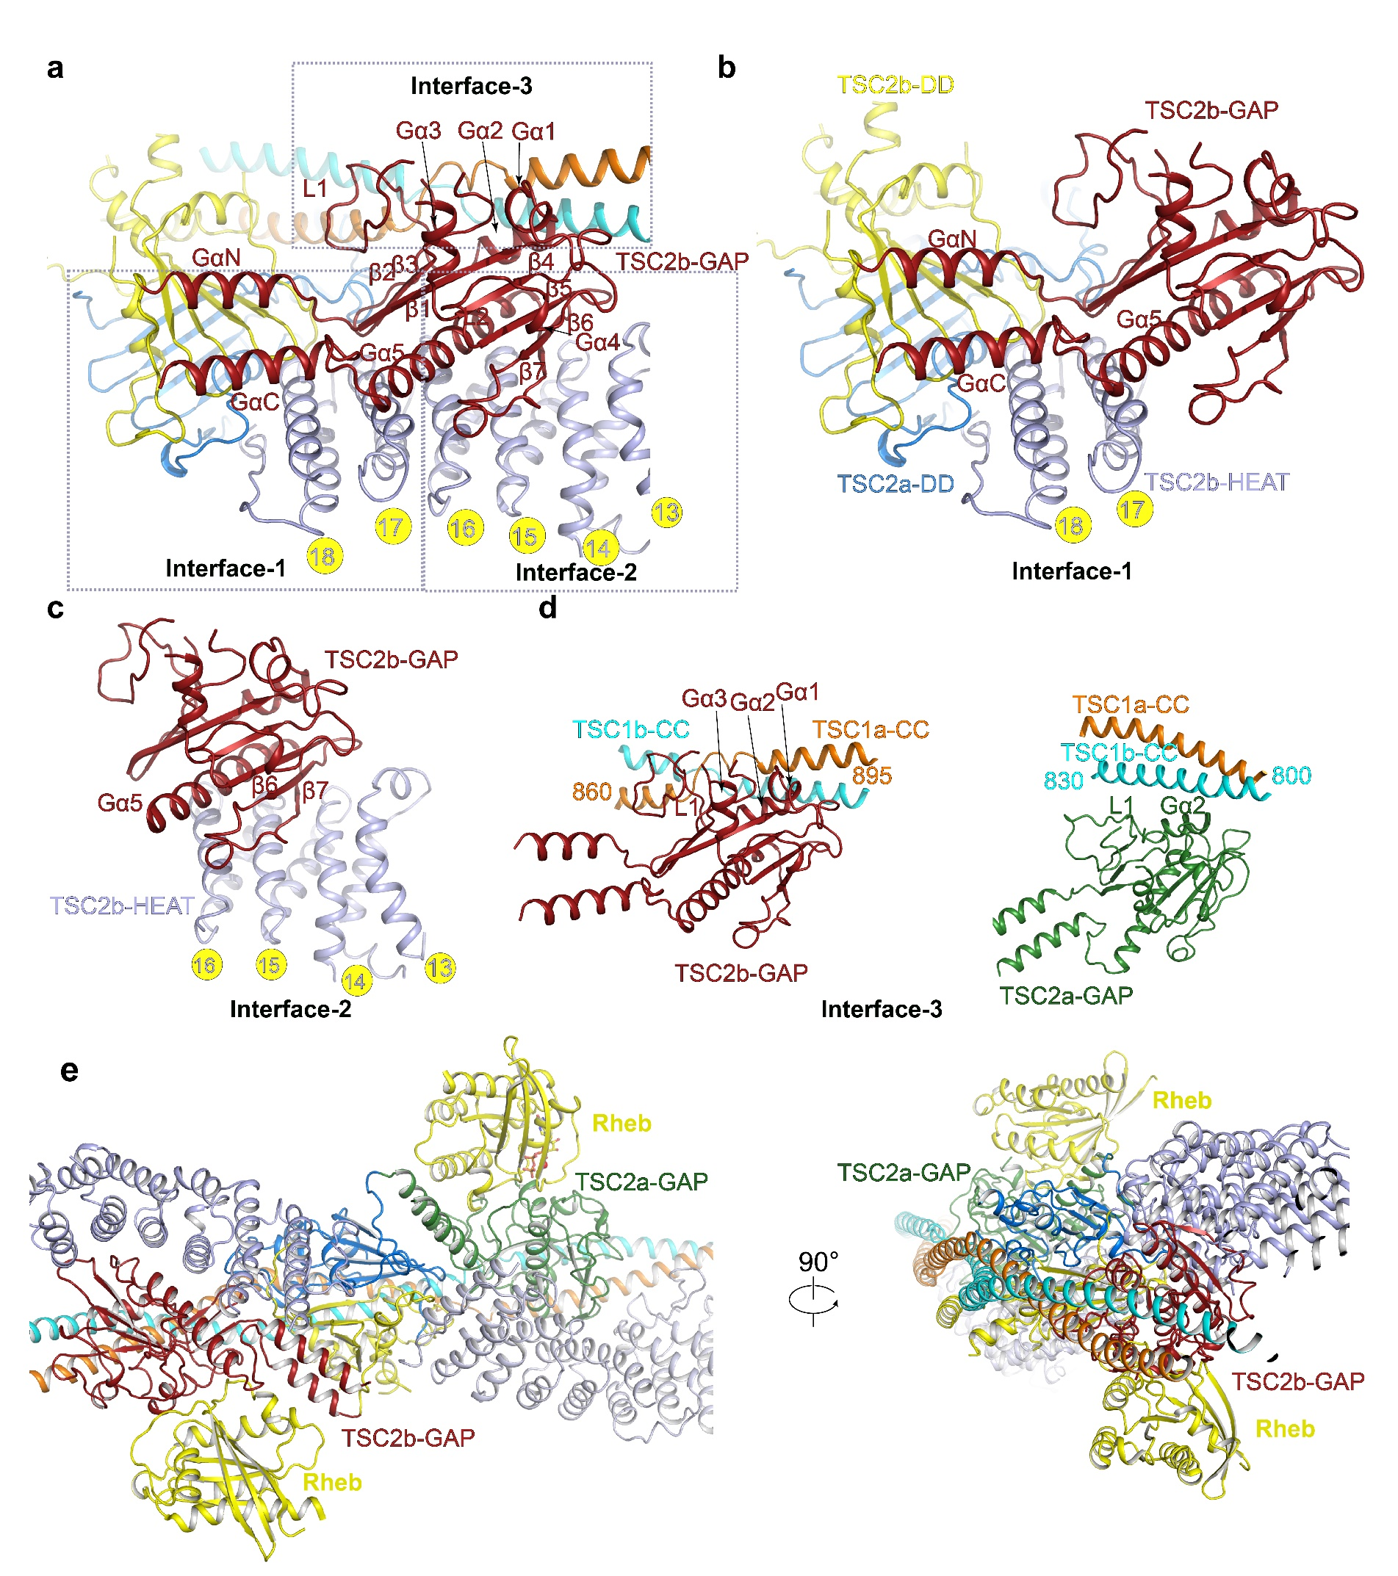
Supplementary Figure 8 Detailed interactions of TSC2 GAP domain within other modular of TSC complex.
(a) Interactions between TSC2 GAP domain and the rest of TSC complex. The interfaces shown in b-d are highlighted with dashed boxes. (b-d) Close-up views of the three interfaces as indicated in (a). Note that interface-1 and interface-2 are the same for two GAP domains, whereas interface-3 (d) is different in TSC2a and TSC2b. (e) Putative interactions between TSC2 and Rheb based on alignment with Rap1-Rap1GAP structure in two views.
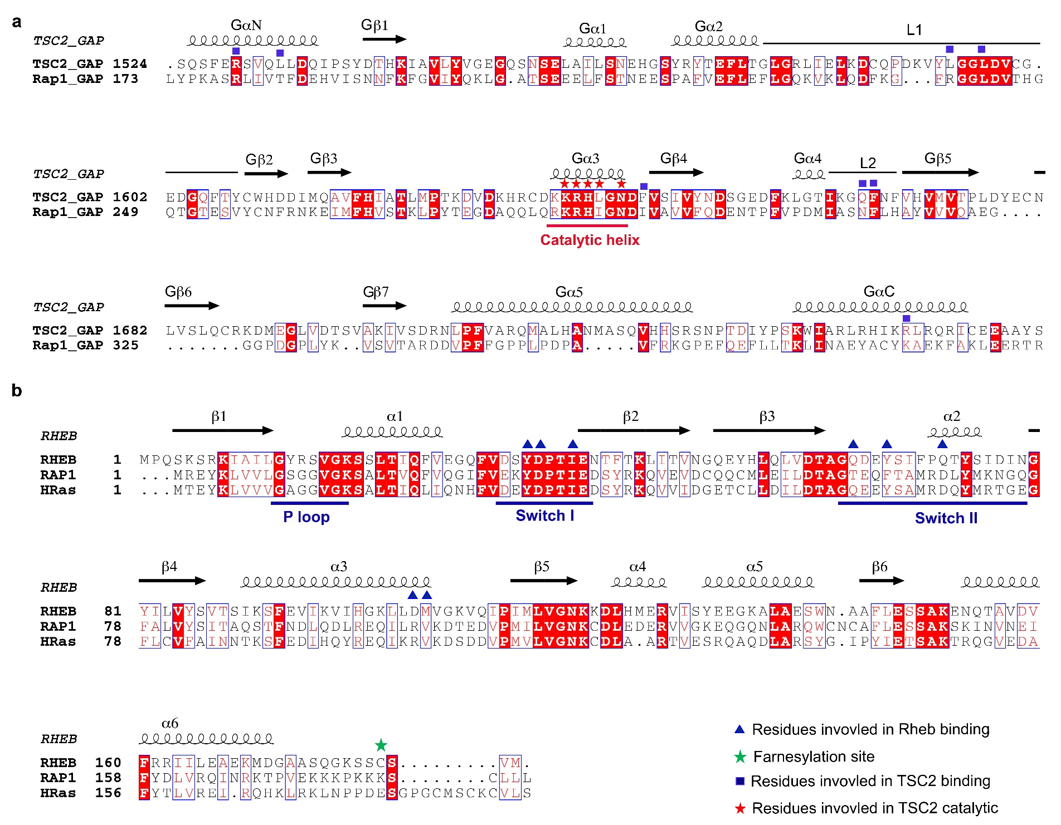
Supplementary Figure 9 Sequence alignments of TSC2 GAP domain and Rheb.
(a) Structure-based sequence alignment of human TSC2 GAP and Rap1 GAP. Secondary structures are indicated above the sequences. Residues involved in TSC2 GAP catalytic and binding of Rheb are indicated with red stars and blue squares, respectively. (b) Sequence alignment of human Rheb, Rap1 and H-Ras. The critical elements of GTPase including the P-loop, switch I, and switch II regions are indicated. Residue annotations are indicated below.

Supplementary References:
1 Yan, R., Xu, D., Yang, J., Walker, S. & Zhang, Y. A comparative assessment and analysis of 20 representative sequence alignment methods for protein structure prediction. Sci Rep 3, 2619, doi:10.1038/srep02619 (2013).
2 Robert, X. & Gouet, P. Deciphering key features in protein structures with the new ENDscript server. Nucleic Acids Res 42, W320-324, doi:10.1093/nar/gku316 (2014).

