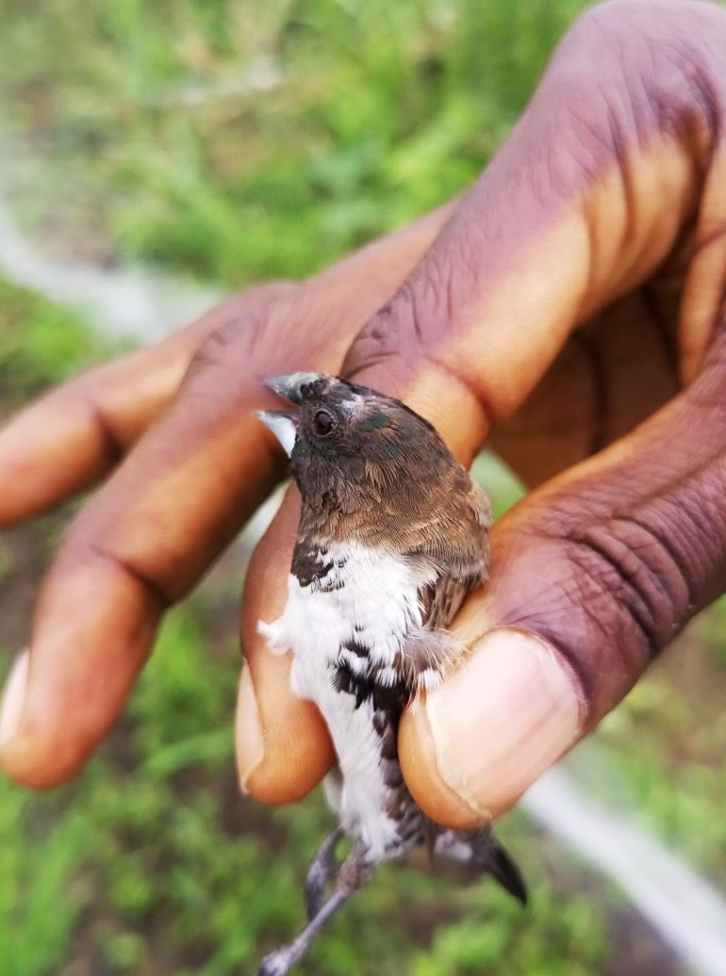
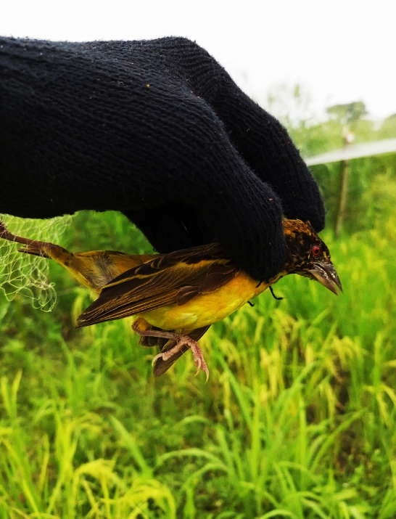

Plate 2: Bronze mannikin
(Spermestes cucullata)

Plate 1: Black-headed weaver
(Ploceus melanocephalus)

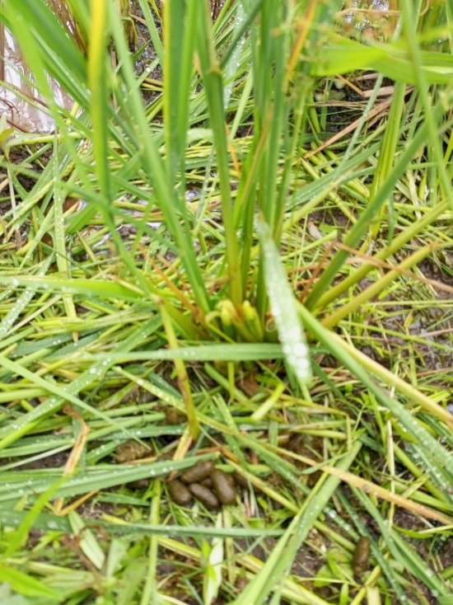
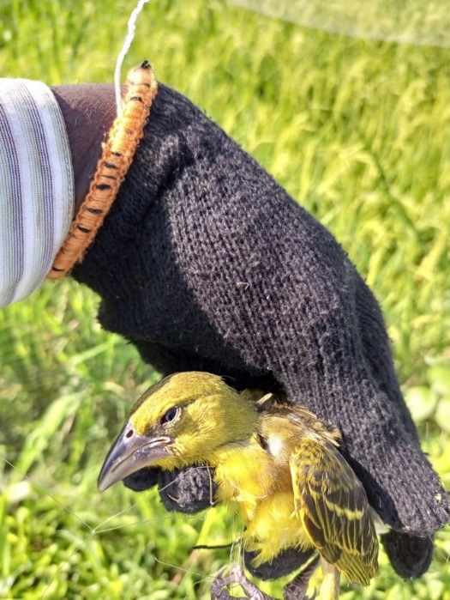

Plate 4: Village Weaver
(Ploceus cucullatus)
Plate 3: Rodent’s dropping next to damaged rice tillers

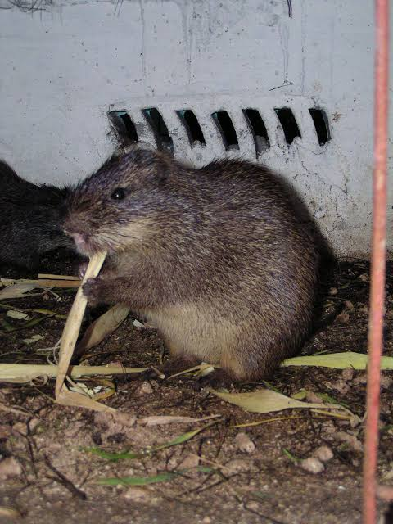

Plate 5: Suspected Rodent pest
(Thryonomys swinderialus)

