Supplementary Information

Optimized Spatial Configuration of Heterogeneous Biocatalysts Maximizes Cell-Free Biosynthesis of ω-Hydroxy and ω-Amino Acids

Javier Santiago-Arcos^{[a]}, Susana Velasco-Lozano^{[a,b,e]*}, Eleftheria Diamanti^{[a]}, Ana I. Benítez-Mateos^{[c,d]}, Daniel A. Grajales^{[a]}, Francesca Paradisi^{[c]}, and Fernando López-Gallego^{[a,f]*}

^{[a]} Heterogeneous Biocatalysis group, CIC biomaGUNE, Edificio Empresarial “C”, Paseo de Miramón 182, 20009, Donostia, Spain.
^{[b]} Instituto de Síntesis Química y Catálisis Homogénea (ISQCH), CSIC-Universidad de Zaragoza, C/ Pedro Cerbuna, 12, 50009, Zaragoza, Spain.
^{[c]} Department of Chemistry, Biochemistry and Pharmaceutical Sciences, University of Bern, Freiestrasse 3, 3012, Bern, Switzerland.
^{[d]} Current address: Department of Chemistry and Applied Sciences, ETH Zürich, Vladimir-Prelog-Weg 1, 8093, Zürich, Switzerland.
^{[e]} Aragonese Foundation for Research and Development (ARAID), Zaragoza (Spain)
^{[f]} IKERBASQUE, Basque Foundation for Science, Bilbao (Spain)
*Corresponding authors. (F. López-Gallego) and (S. Velasco-Lozano)
Phone: +34 943003500 Ext 309, Fax: +34 943003501
E-mail addresses: flopez@cicbiomagune.es and svelasco@unizar.es

Supplementary Figures
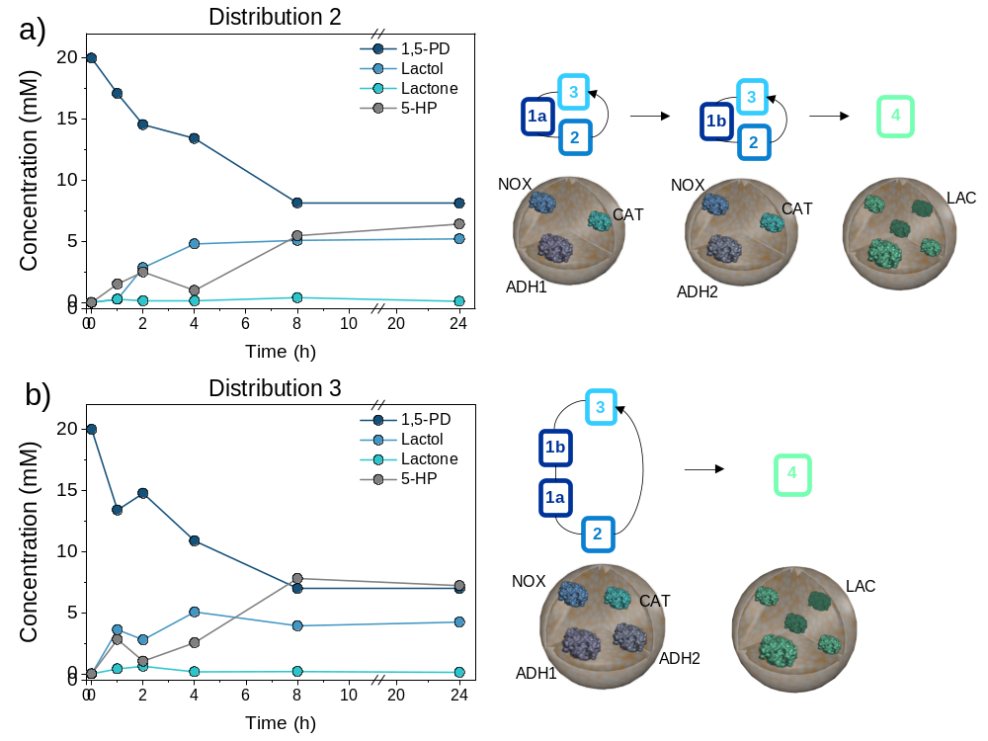

Figure S1. Different spatially organized multi-enzyme systems (distribution 2; D2 and distribution 3; D3) and their catalytic kinetic performance in the synthesis of 5-HP. In all cases reaction mixtures consisted in 20 mM 1,5-pentanediol, 1 mM NAD⁺, 0.15 mM FAD⁺ in 100 mM sodium phosphate buffer pH 8. Distribution 2 is the mixture of HB6, HB7 and HB5. Distribution 3 is the mixture of HB8 and HB5.

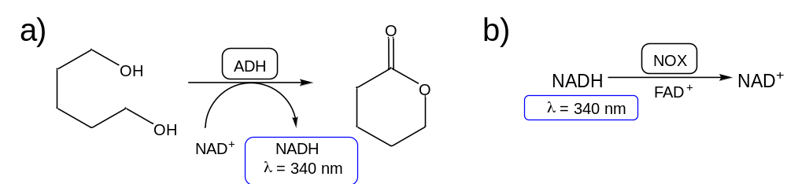
Figure S2. Colorimetric assays for biocatalysts kinetic characterization. a) Oxidative lactonization, recording increment in the absorbance at 340 nm. Reaction conditions: 10 mM 1,5-pentanediol and 1 mM of NAD⁺ in 100 mM sodium phosphate buffer pH 8 at 30 ºC. b) Cofactor regeneration, recording increment in the absorbance at 340 nm. Reaction conditions: 0.2 mM NADH, 0.15 mM FAD⁺ in 100 mM sodium phosphate buffer pH 8 at 30 ºC.

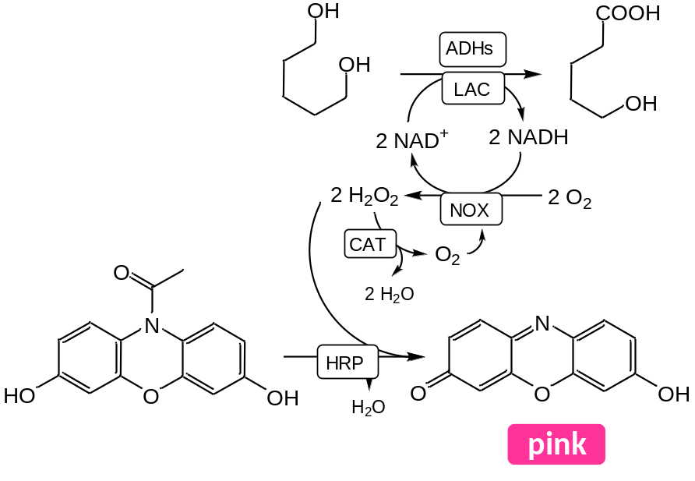
Figure S3. Colorimetric assay for measuring the hydrogen peroxide accumulation. Recording the absorbance increase at 560 nm due to the formation of resorufin. Reaction conditions consisted in 0.5 µg·mL⁻¹ HRP, 20 mM 1,5-pentanediol, 1 mM NAD⁺, 0.15 mM FAD⁺, 50 µM AmplifluRED in 100 mM sodium phosphate buffer pH 8.

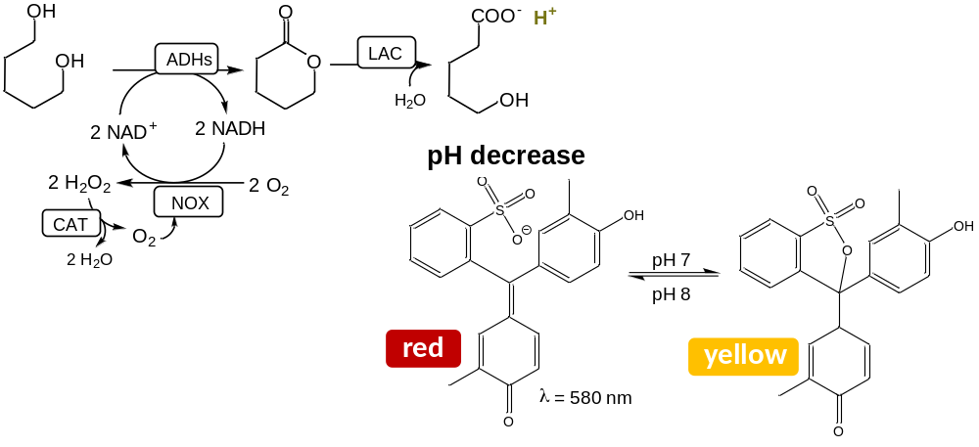
Figure S4. Colorimetric assay for measuring the ω-hydroxy acid production. Recording the decrease in the absorbance at 580 nm and at the same time recording the absorbance at 340 nm in order to guarantee that there is not NADH accumulation since it also decreases the pH. Reaction conditions consisted in 20 mM 1,5-pentanediol, 1 mM NAD⁺, 0.15 mM FAD⁺, 0.1 mM Cresol Red in sodium phosphate buffer 2.5 mM pH 8.

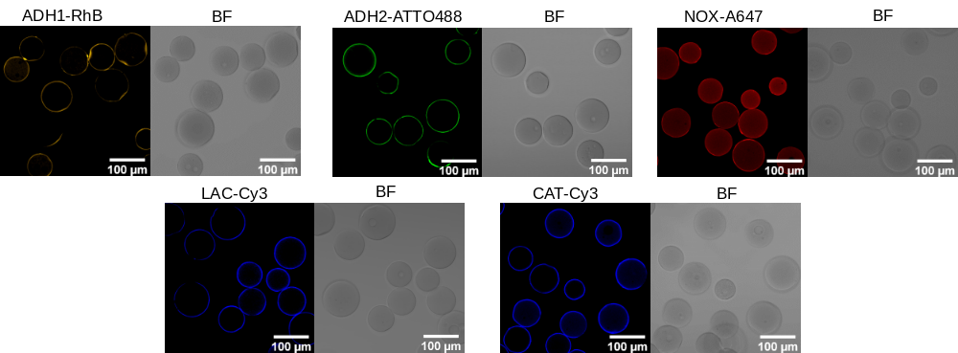
Figure S5. Spatial distribution of single immobilized enzymes (mixture of HB1:(ADH1-RhB), HB2 (ADH2-ATTO488), HB3 (NOX-A647), HB4 (LAC-Cy3) and HB5 (CAT-Cy3)).

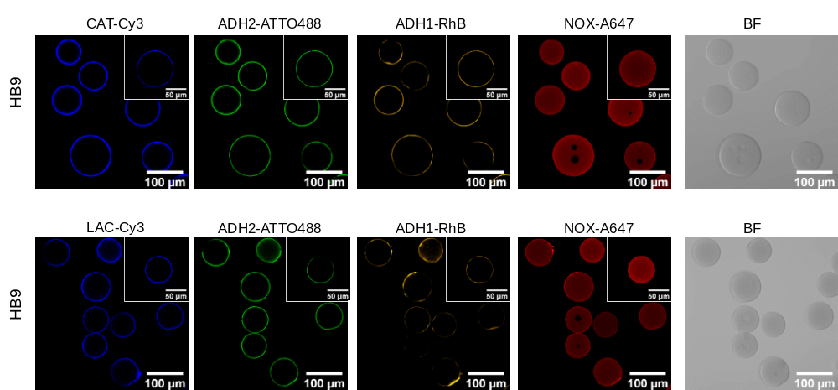
Figure S6. Uncontrolled spatial distribution of co-immobilized multi-enzyme system in HB9.

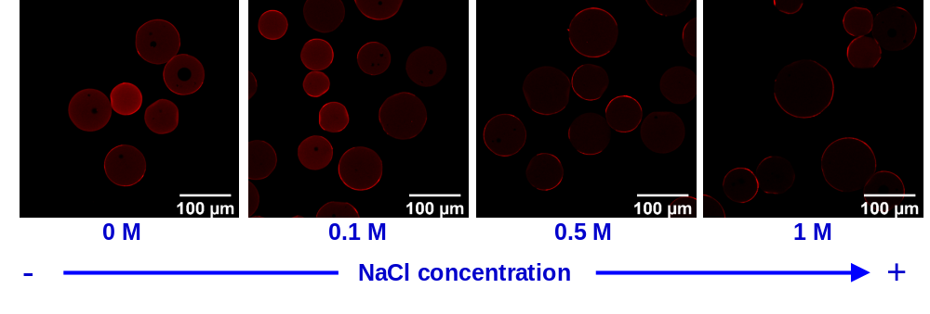
Figure S7. Control of the spatial distribution of NOX by ionic strength.

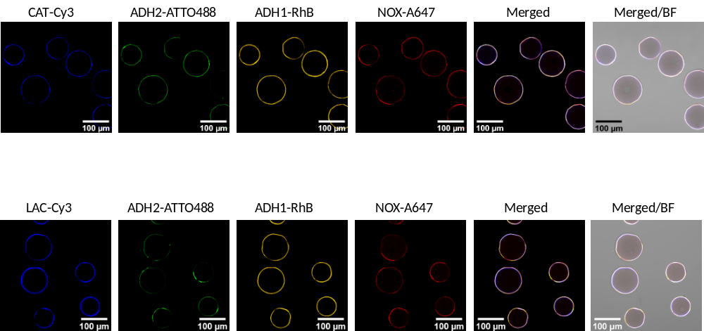
Figure S8. Controlled spatial distribution of co-immobilized multi-enzyme system in HB10 using 1M NaCl in the immobilization process.

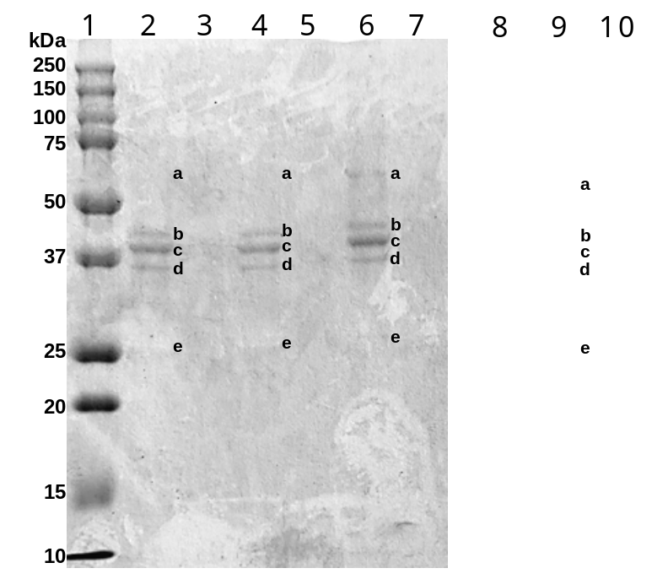
Figure S9. SDS-PAGE gels of HBs after five batch cycles. Lanes correspond to: 1, molecular weight marker; 2, Freshly prepared HB10; 3, HB10 after 5 batch reaction cycles; 4, Freshly prepared HB11; 5, HB11 after 5 batch reaction cycles; 6, Freshly prepared HB12; 7, HB12 after 5 batch reaction cycles; 8, molecular weight marker; 9, Freshly prepared HB13; 10, Freshly prepared HB12. a) CAT, 58 kDa, b) ADH2, 41 kDa, c) ADH1, 36 kDa, d) LAC, 35 kDa, and e) NOX, 23 kDa.

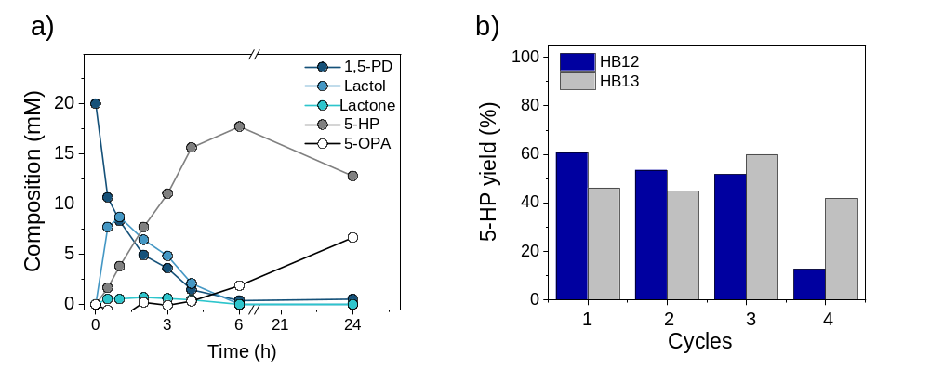
Figure S10: a, Reaction-time course of HB13 at 20 mM of 1,5-pentanediol, 1 mM NAD⁺, 0.15 mM FAD⁺ in 100 mM sodium phosphate buffer pH 8 at 30 ºC. b, Conversion yield of HB12 and HB13 after consecutive operational 4 h cycles at 10 mM 1,5-PD initial substrate concentration.

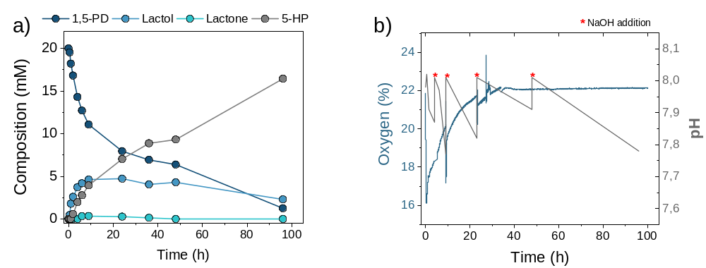
Figure S11. Scale-up batch reaction. a, Reaction time course, b, Oxygen and pH signal during the batch reaction. Reaction conditions consisted in 1.5 g of HB13 added to 30 mL of a reaction mixture composed by 20 mM 1,5-PD, 1 mM NAD⁺, and 0.15 mM FAD⁺ in 100 mM sodium phosphate buffer at pH 8 and 30 ºC.

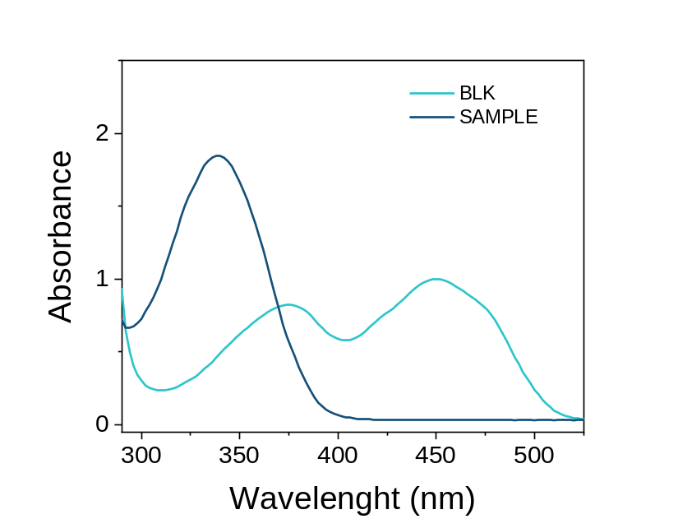
Figure S12. UV-Vis Spectra of the collected volume (sample) after the first test of the PBR flow reaction at 10 mM of substrate and 20 µL·min⁻¹ flow rate. Consumed diol: 12.3%. As control (blank) we measured the reaction mixture before passing through the PBR.

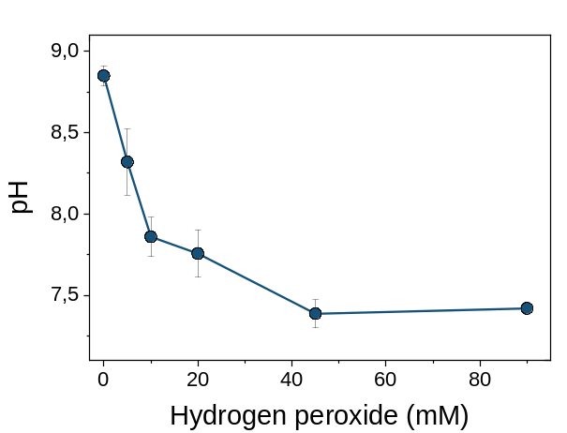
Figure S13. pH values of collected samples after PBR flow reaction at different hydrogen peroxide concentrations.

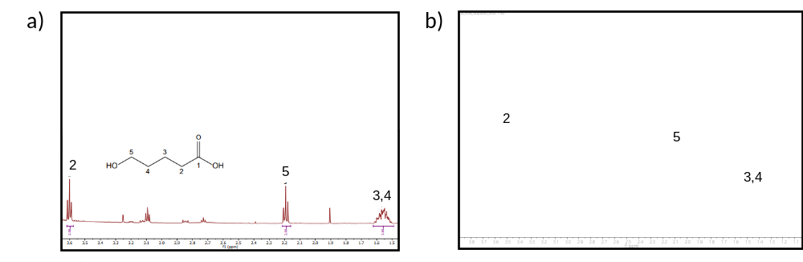
Figure S14. ¹H NMR of the reaction mixture of a, soluble system reported in Velasco-Lozano et al.¹ b, PBR flow reaction The assigned signals correspond to the produced ω-HA, 5-hydroxypentanoic acid. ¹H NMR (500 MHz, Deuterium Oxide) δ 3.60 (t, J = 6.3 Hz, 2H, H2), 2.19 (t, J = 7.1 Hz, 2H,H5), 1.56 (m, 4H,H3,H4).²

a)
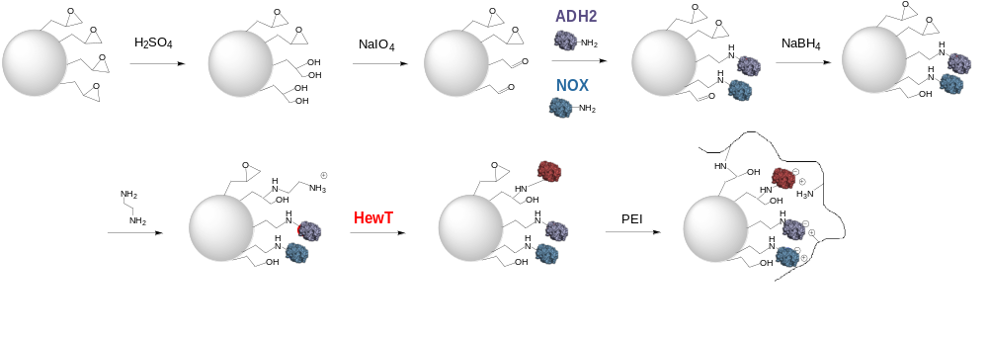
b)
Enzyme | Enzyme load (offered / final)  (mg·g⁻¹) | Ψ ª  (%) | Recovered activity ^{b}  (U·g⁻¹) / (%)
ADH2 | 4 / 4^{c} | >99 | 0.97 (65)
NOX | 5 / 4.65^{c} | 93 | 1.5 (3.5)
HewT | 5 / 3.85^{c} | 77 | 0.66 (19)

Figure S15. a, Scheme of the immobilization protocol for the preparation of HB14. b, Immobilization parameters of HB14. ª Immobilization yield, Ψ = (immobilized activity/offered activity) × 100. ^{b} (%) Recovered activity of the immobilized enzyme is defined as the coefficient between the specific activity of the immobilized enzymes and the specific activity of the soluble ones. ^{c} Total protein content.

Supplementary Tables
Table S1. JaCoP and Manders coefficients
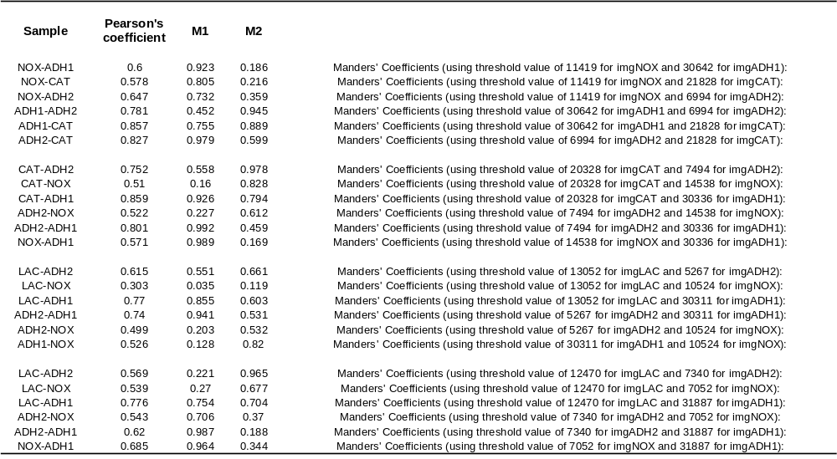

Table S2. Operational stability of ADH2, NOX and HewT after the telescoped flow reaction for the synthesis of 5-AP. ª Retained activity (%) refers to the enzyme activity detected on the HB after 72 h at 30 ºC in the flow reactor.
Enzyme | PBR | Activity before flow reaction (U·g⁻¹) |  | Activity after flow reaction (U·g⁻¹) | ª Retained activity  (%)
ADH2 | PBR1 (HB13) |  | 0.86 | 0.28 | 33
NOX |  |  | 0.68 | 0.51 | 75
ADH2 | PBR2 (HB14) |  | 0.97 | 0.13 | 14
NOX |  |  | 1.5 | 0.84 | 56
HewT |  |  | 0.66 | 0.42 | 64

Supplementary References
1 Velasco-Lozano, S., et al. Cell-Free Biosynthesis of ω-Hydroxy Acids Boosted by a Synergistic Combination of Alcohol Dehydrogenases. ChemSusChem 15, e202200397, (2022).
2 Zhou, Z.-z., et al. Silver(I)-Catalyzed Widely Applicable Aerobic 1,2-Diol Oxidative Cleavage. Angew. Chem. Int. Ed. 57, 2616-2620, (2018).

