Supporting information
Isometric strength of quadriceps as a best fall predictor among older adults: analysis by machine learning approach
Jagannathan Madhanagopal^{a*}, Fuad A Abdullaª, Faris Baniyasinª, Om Prakash Singh^{b}, Pandya Rutwa Kulinkumar^{c}, Murugananthan Balaganapathy^{c*}
ªDepartment of Physiotherapy, Faculty of Allied Medical Sciences, Philadelphia University, Amman, Jordan
^{b}Centre for Health Technology, School of Nursing and Midwifery, Faculty of Health, University of Plymouth, Plymouth, PL4 6DT, UK.
^{c}Ashok & Rita Patel Institute of Physiotherapy, Charotar University of Science and Technology, Gujarat, India

*Corresponding Author: Dr. J. Madhanagopal, PT, PhD., Department of Physiotherapy, Faculty of Allied Medical Sciences, Philadelphia University, Jordan. Email: mjagannathan@philadelphia.edu.jo. Phone: +962785302488. & Dr. M. Balaganapathy, PT, PhD., Ashok & Rita Patel Institute of Physiotherapy, Charotar University of Science and Technology, Gujarat, India. Email: principal.arip@charusat.ac.in. Phone: +917490053771.

SI table 1: Other machine learning model results of Sensitivity (Se), Specificity (Sp), Precision (Pr), Accuracy (Ac), and Area under the curve (AUC) for all index measures.
Index measures | ML models | Se | Sp | Pr | Ac | AUC
Functional Mobility (TUG) | KNN SVM  NB | 0.53  0.53  0.57 | 0.87  0.87  0.86 | 0.67  0.67  0.67 | 0.75  0.75  0.76 | 0.64  0.64  0.67
Fear of falling (MFES) | KNN SVM  NB | 0.48  0.59  0.36 | 0.80  0.82  0.89 | 0.56  0.63  0.62 | 0.70  0.75  0.71 | 0.61  0.69  0.51
Hip flexors | KNN SVM  NB | 0.72  0.72  0.74 | 0.96  0.96  0.91 | 0.91  0.91  0.81 | 0.88  0.88  0.85 | 0.79  0.79  0.80
Hip extensors | KNN SVM  NB | 0.76  0.76  0.76 | 0.90  0.92  0.92 | 0.80  0.83  0.83 | 0.85  0.87  0.87 | 0.82  0.82  0.82
Hip abductors | KNN SVM  NB | 0.74  0.70  0.73 | 0.90  0.93  0.90 | 0.79  0.84  0.80 | 0.85  0.85  0.84 | 0.80  0.77  0.79
Hip adductors | KNN SVM  NB | 0.70  0.68  0.73 | 0.86  0.92  0.92 | 0.71  0.82  0.83 | 0.80  0.84  0.85 | 0.77  0.75  0.79
Knee flexors | KNN SVM  NB | 0.72  0.76  0.76 | 0.90  0.93  0.89 | 0.79  0.85  0.78 | 0.84  0.87  0.85 | 0.79  0.82  0.82
Knee extensors | KNN SVM  NB | 0.80  0.80  0.87 | 0.91  0.94  0.88 | 0.82  0.88  0.78 | 0.87  0.90  0.87 | 0.85  0.85  0.90
Plantar flexors | KNN SVM  NB | 0.72  0.74  0.80 | 0.92  0.95  0.92 | 0.82  0.88  0.84 | 0.85  0.99  0.88 | 0.79  0.80  0.85
Dorsiflexors | KNN SVM  NB | 0.72  0.74  0.76 | 0.94  0.94  0.92 | 0.87  0.87  0.83 | 0.87  0.87  0.87 | 0.79  0.80  0.82
TUG: Timed up and go test, MFES: Modified fall efficacy scale, ML: machine learning, KNN: k-nearest neighbors, SVM: Kernel support vector machine, NB: Navies Bayes

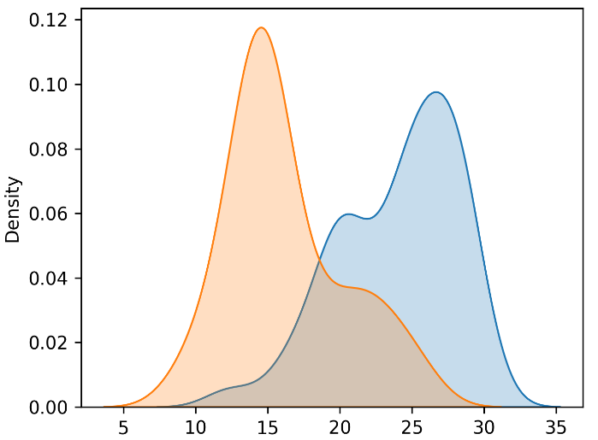
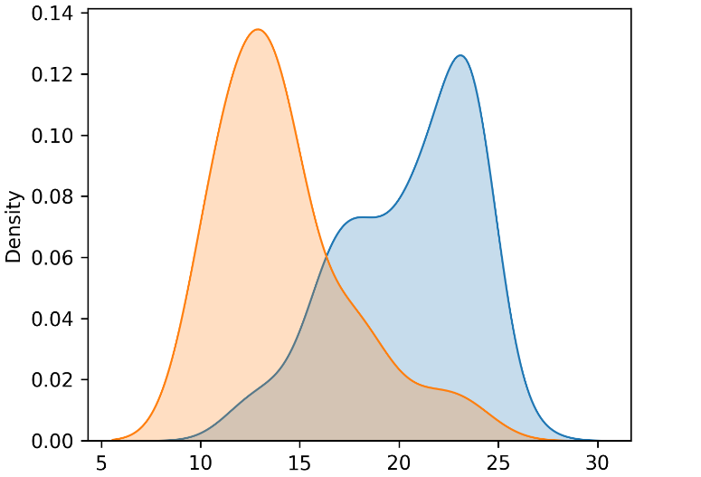
B
Hip abductors (kgf)
Knee flexors (kgf)
A

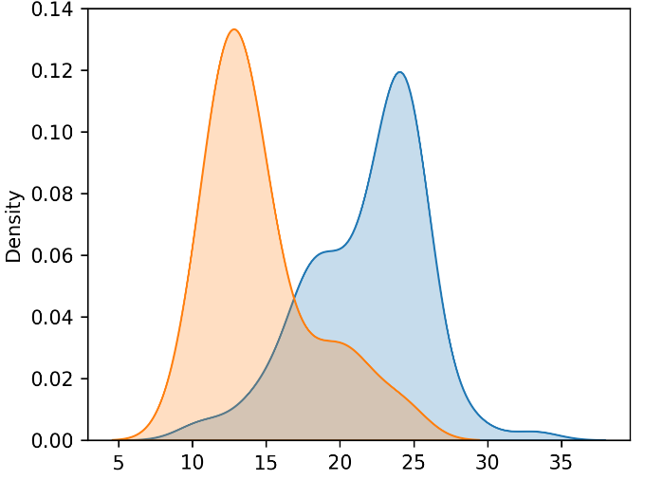
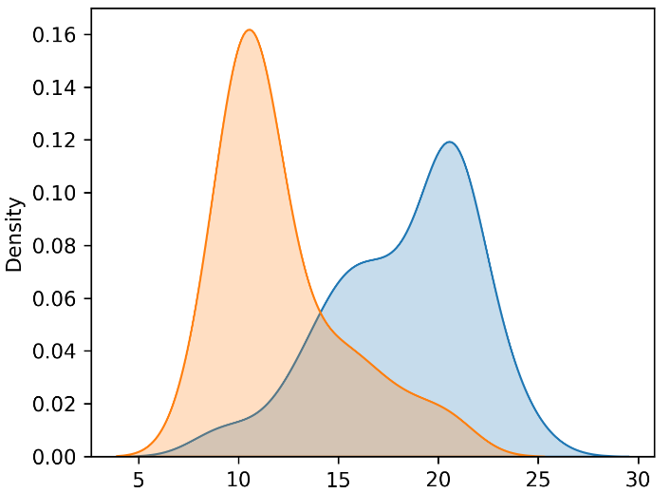
D
C

Hip extensor (kgf)
Hip adductors (kgf)

SI Figure 1: Probability density distribution of MVIS of knee flexors (A), hip abductors (B), hip adductors (C) and hip extensors (D) of fallers (orange color) and non-fallers (blue color) against history of fall.

