Supplementary Information
Forecasting the ecological footprint of G20 countries in the next 30 years

Rafael M. Eufrasio¹ and S.C. Lenny Koh¹
¹Advanced Resource Efficiency Centre, Management School, University of Sheffield

Figure SI 1 Historical Records G20 EF 2
Figure SI 2 Population ARIMA forecast 3
Figure SI 3 Population Auto-ARIMA forecast 4
Figure SI 4 Population Prophet forecast 5
Figure SI 5 GDP ARIMA forecast 6
Figure SI 6 GDP AUTO-ARIMA forecast 7
Figure SI 7 GDP Prophet forecast 8
Figure SI 8 Emissions ARIMA forecast 9
Figure SI 9 Emissions AUTO-ARIMA forecast 10
Figure SI 10 Emissions Prophet forecast 11
Figure SI 11 EF Consumption ARIMA forecast 12
Figure SI 12 EF Consumption AUTO-ARIMA forecast 13
Figure SI 13 EF Consumption Prophet forecast 14
Figure SI 14 Biocapacity ARIMA forecast 15
Figure SI 15 Biocapacity AUTO-ARIMA forecast 16
Figure SI 16 Biocapacity Prophet forecast 17
Figure SI 17 Forest ARIMA forecast 18
Figure SI 18 Forest AUTO-ARIMA forecast 19
Figure SI 19 Forest Prophet forecast 20
Figure SI 20 Crops ARIMA forecast 21
Figure SI 21 Crops AUTO-ARIMA forecast 22
Figure SI 22 Crops Prophet forecast 23
Figure SI 23 Human Development Index forecast (HDI) 24
Figure SI 24 countries current vs forecasted values in 2050 25

Table SI 1 Population forecast model evaluation (avg) 26
Table SI 2 GDP forecast model evaluation (avg) 26
Table SI 3 Emissions kt model evaluation (avg) 27
Table SI 4 Biocapacity forecast model evaluation (avg) 27
Table SI 5 Forest km2 forecast model evaluation (avg) 28
Table SI 6 Crops km2 forecast model evaluation (avg) 28
Table SI 7 kwh per capita forecast model evaluation (avg) 29
Table SI 8 kg oileq PerCapita mode forecast evaluation (avg) 29
Table SI 9 emissions Mt cap model forecast evaluation (avg) 30
Table SI 10 gdp PerCap model forecast evaluation (avg) 30
Table SI 11 Area PerCap model forecast evaluation (avg) 31
Table SI 11 Biocap PerCap model forecast evaluation (avg) 31
Table SI 13 EFConsPerCap model forecast evaluation (avg) 32

Figure SI 1 Historical Records G20 EF
This plot shows the historical footprint balance of the G20 countries, biocapacity per capita, consumption per capita and their corresponding deficit/balance, all units are in global hectares per capita. Source; based on Global Footprint Network

Population
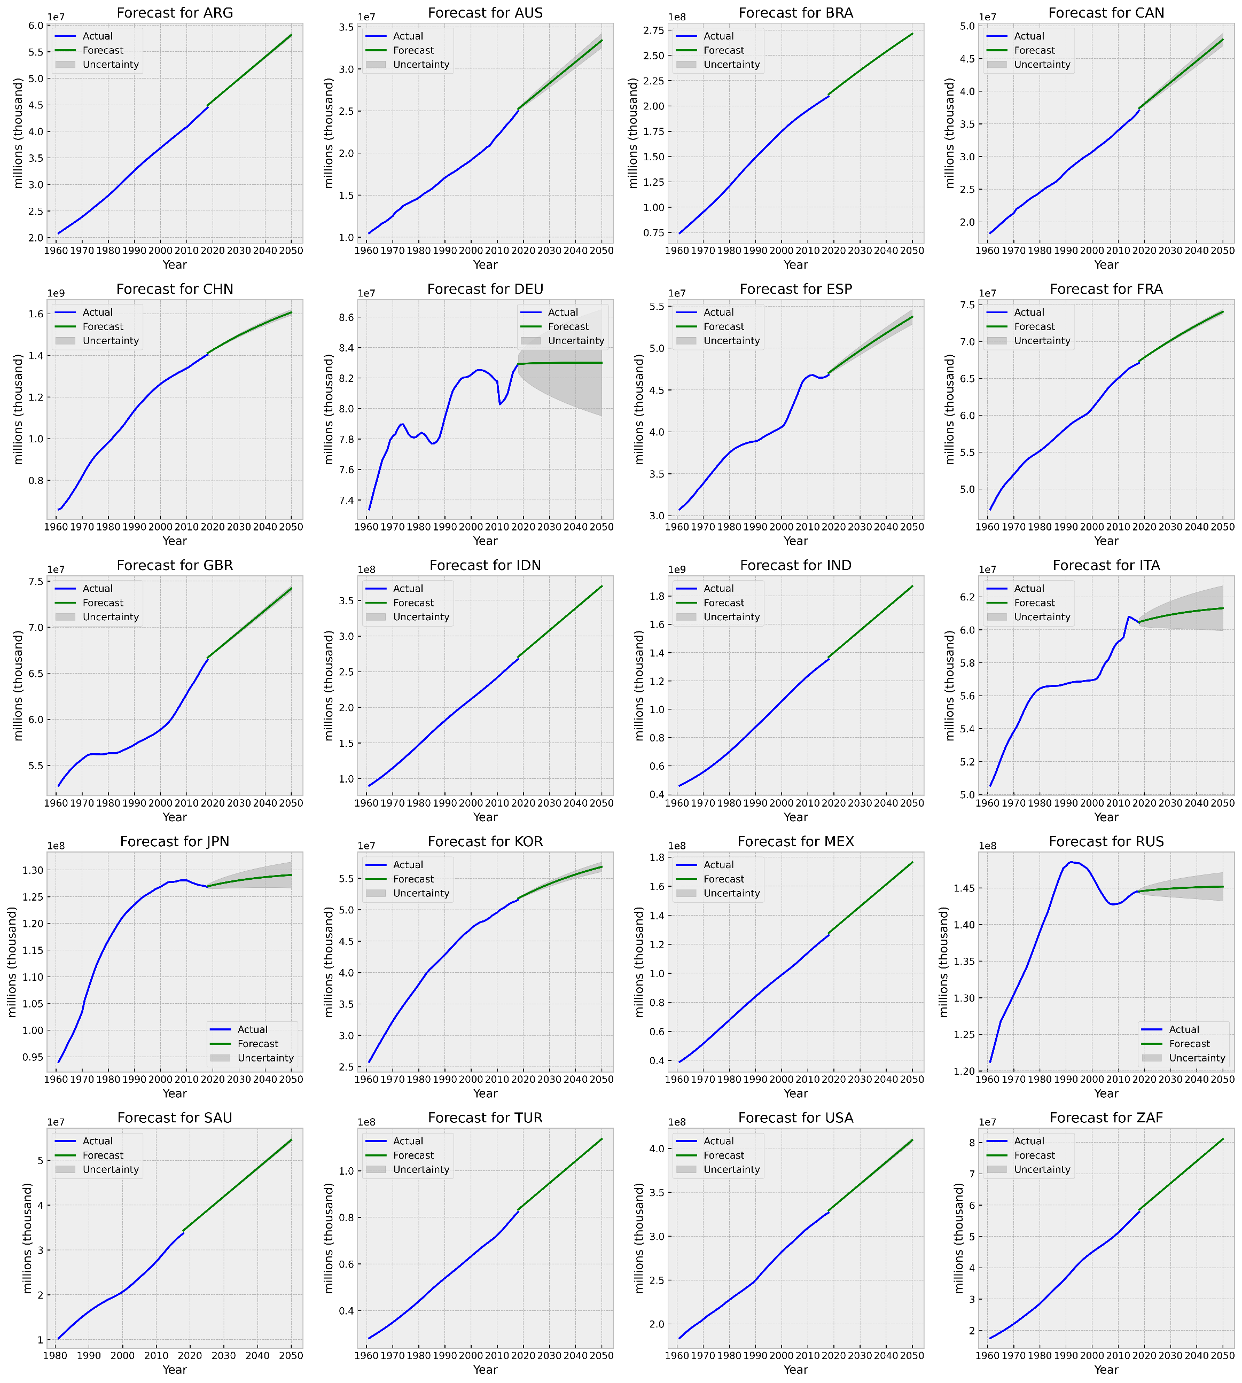
Figure SI 2 Population ARIMA forecast
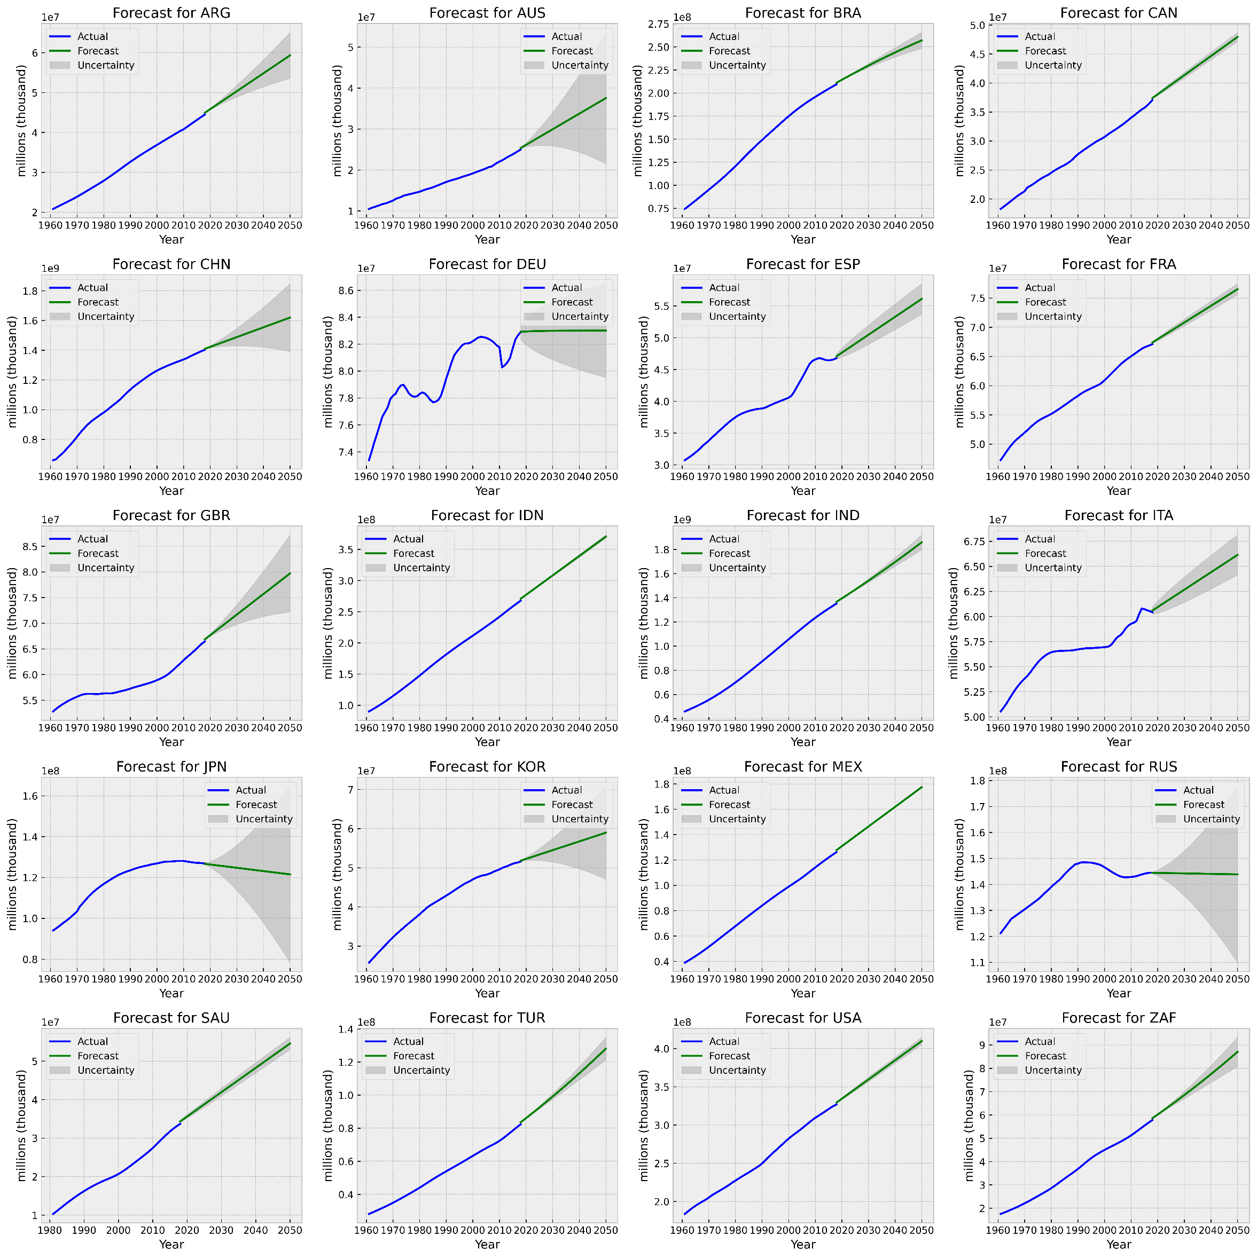
Figure SI 3 Population Auto-ARIMA forecast
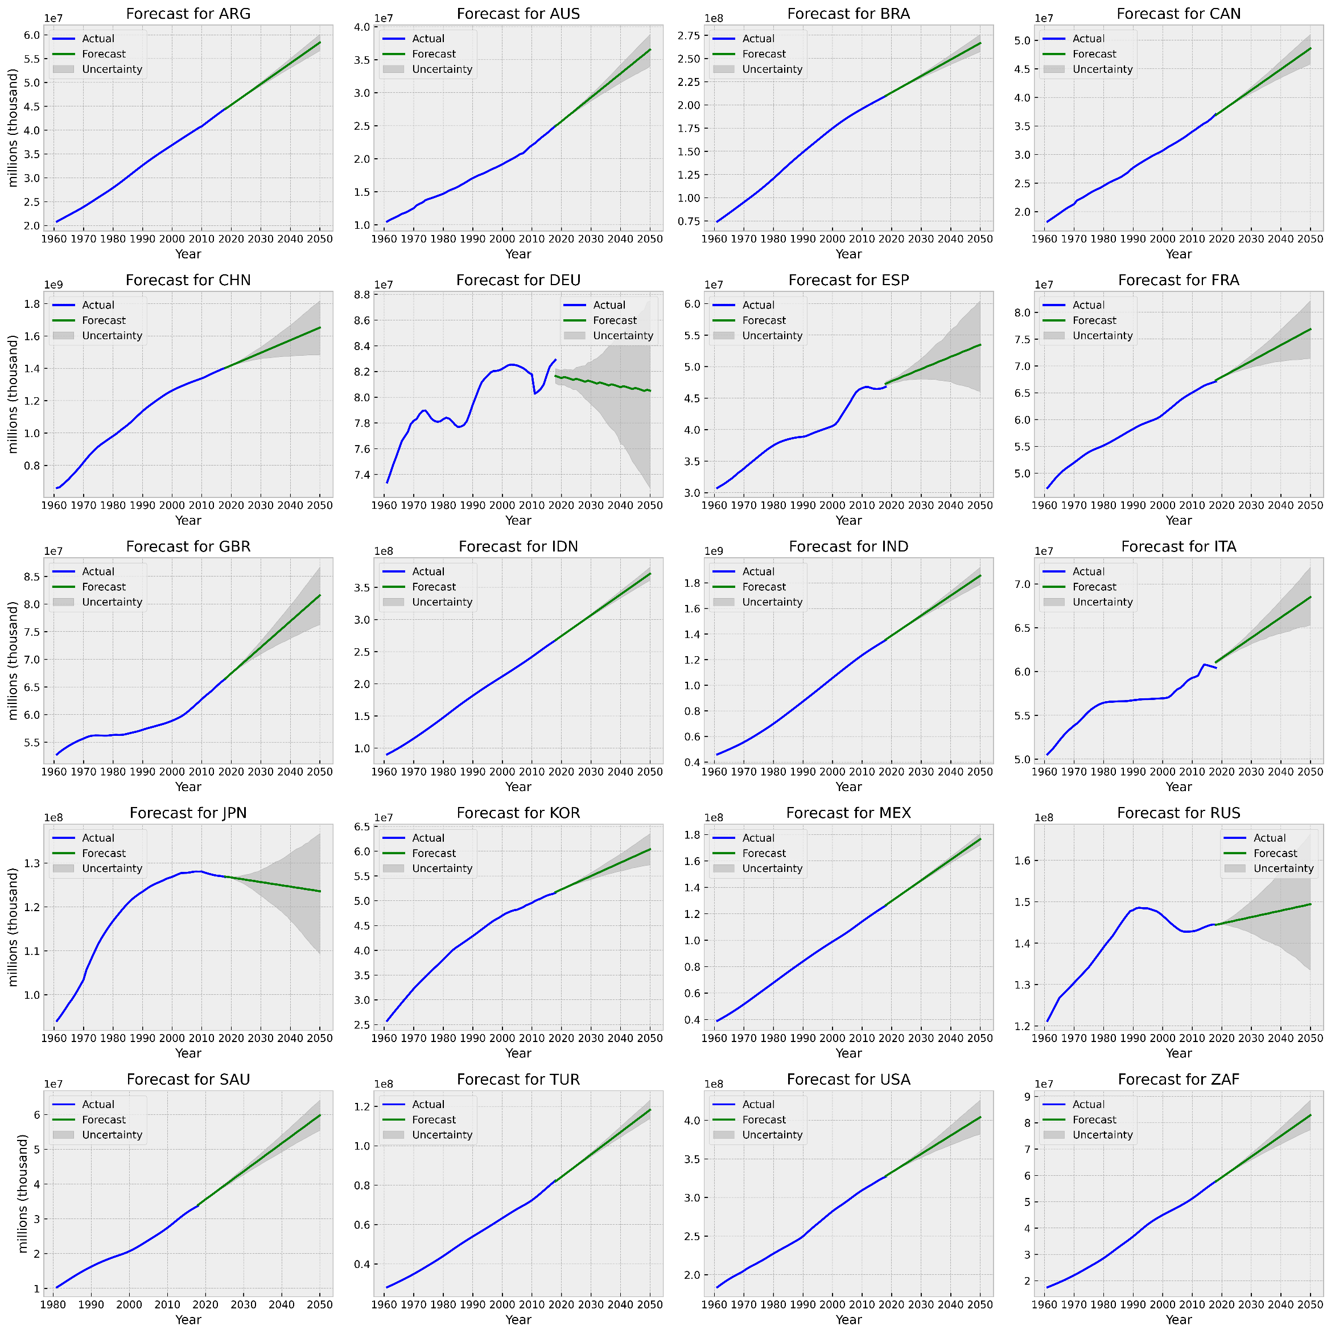
Figure SI 4 Population Prophet forecast

GDP
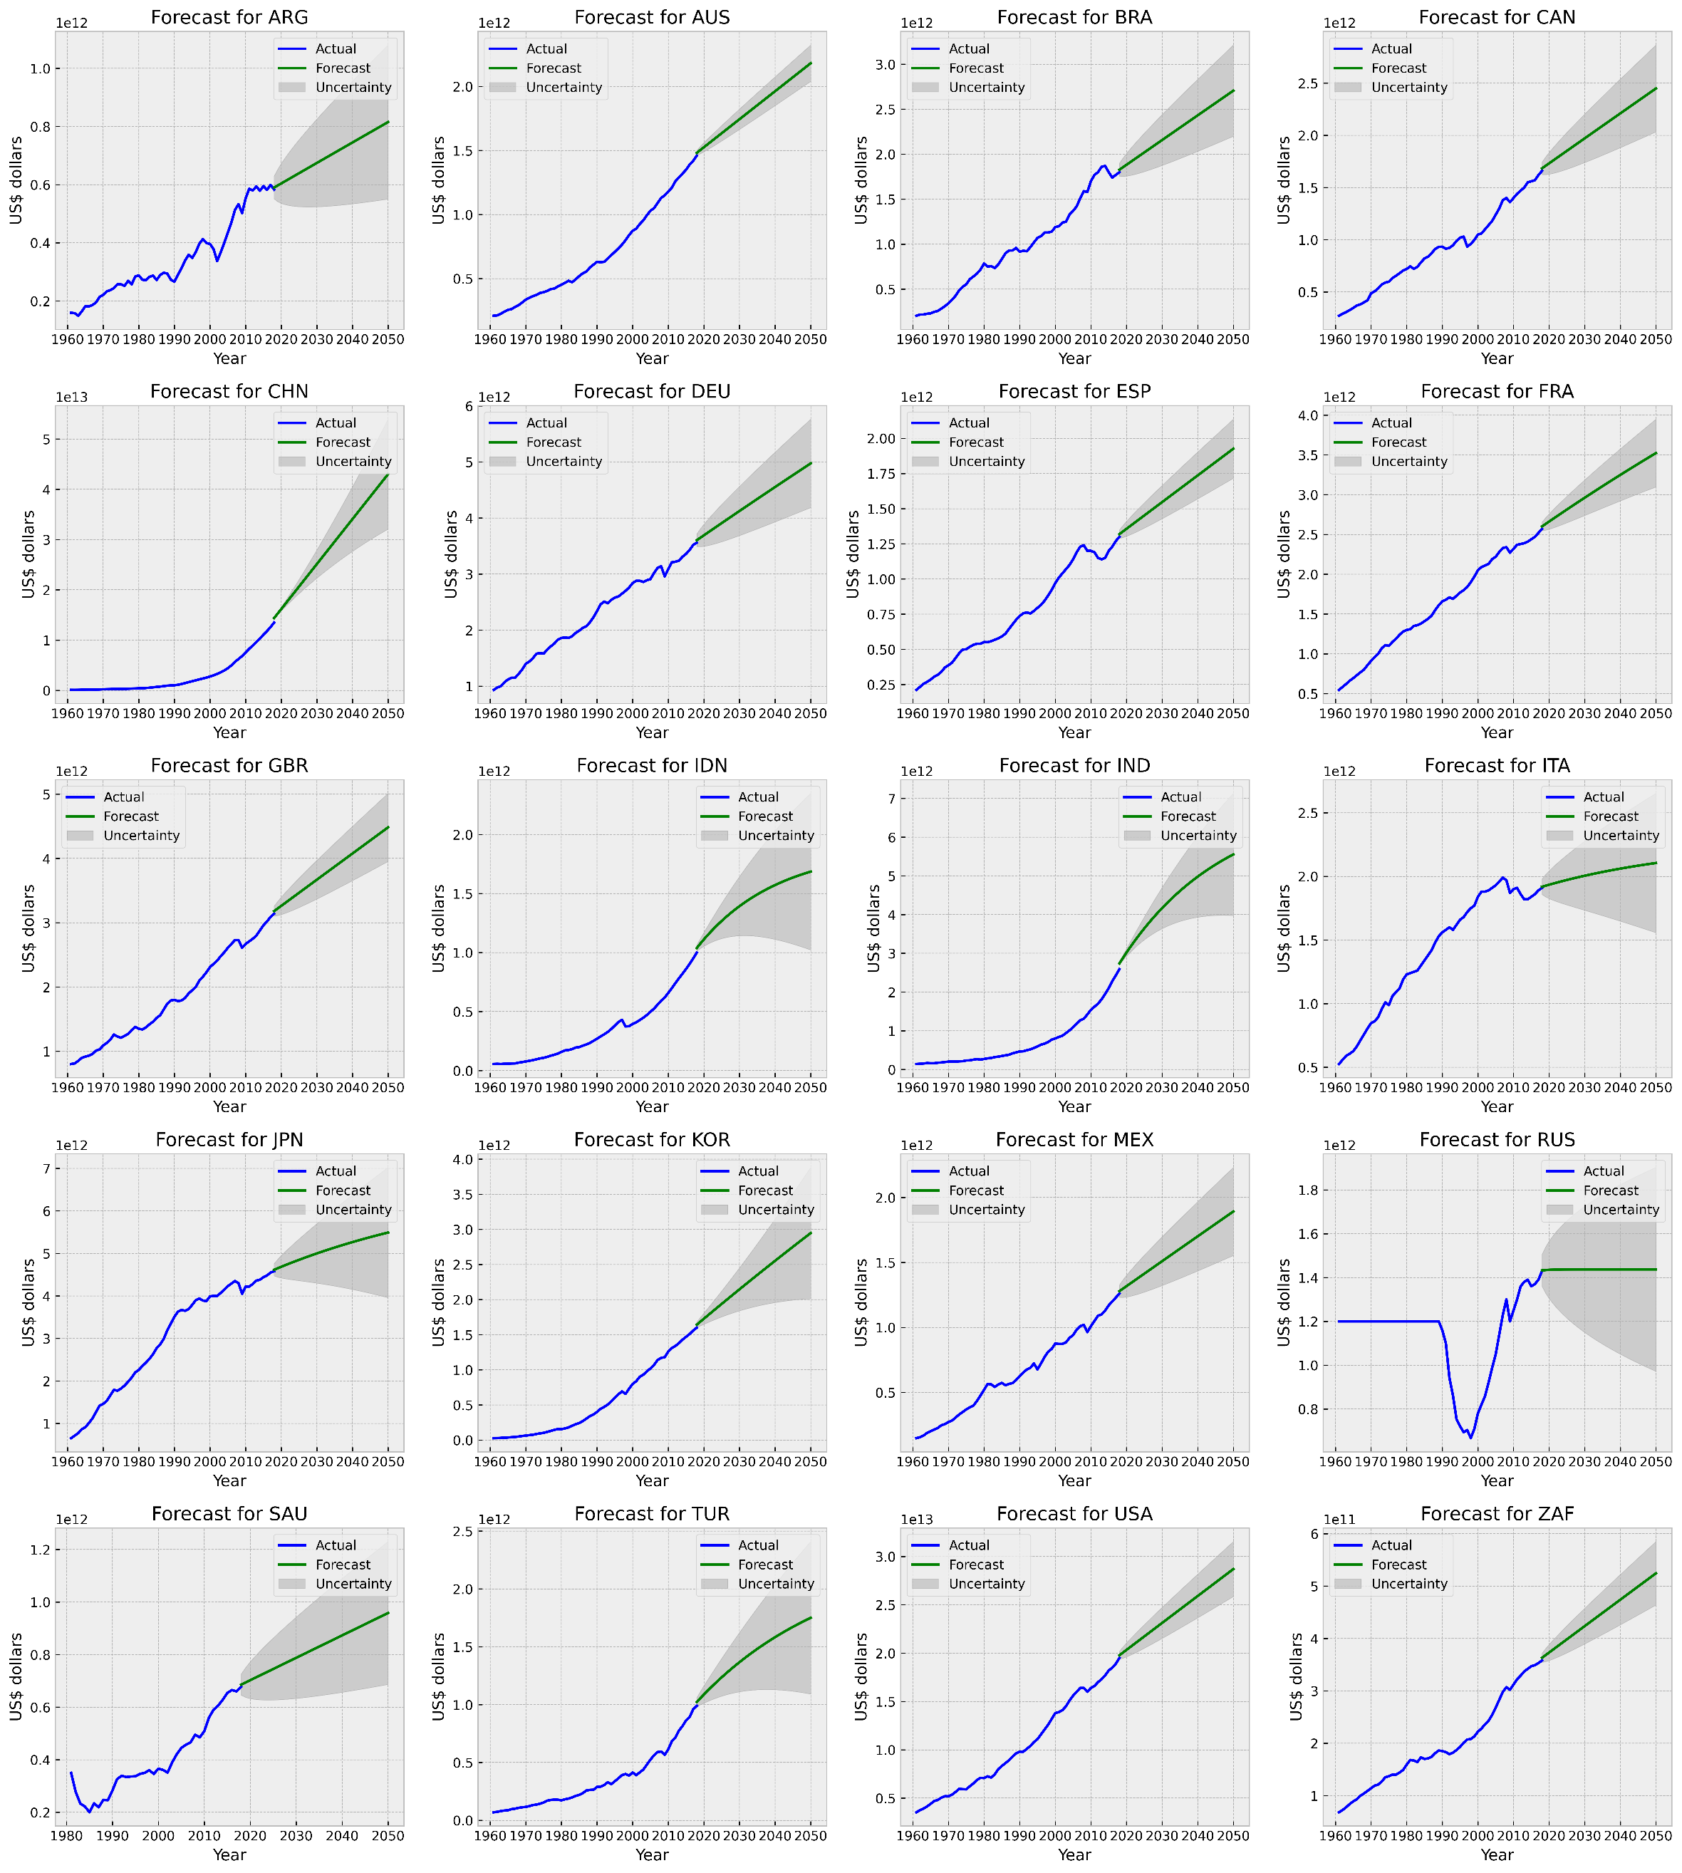
Figure SI 5 GDP ARIMA forecast

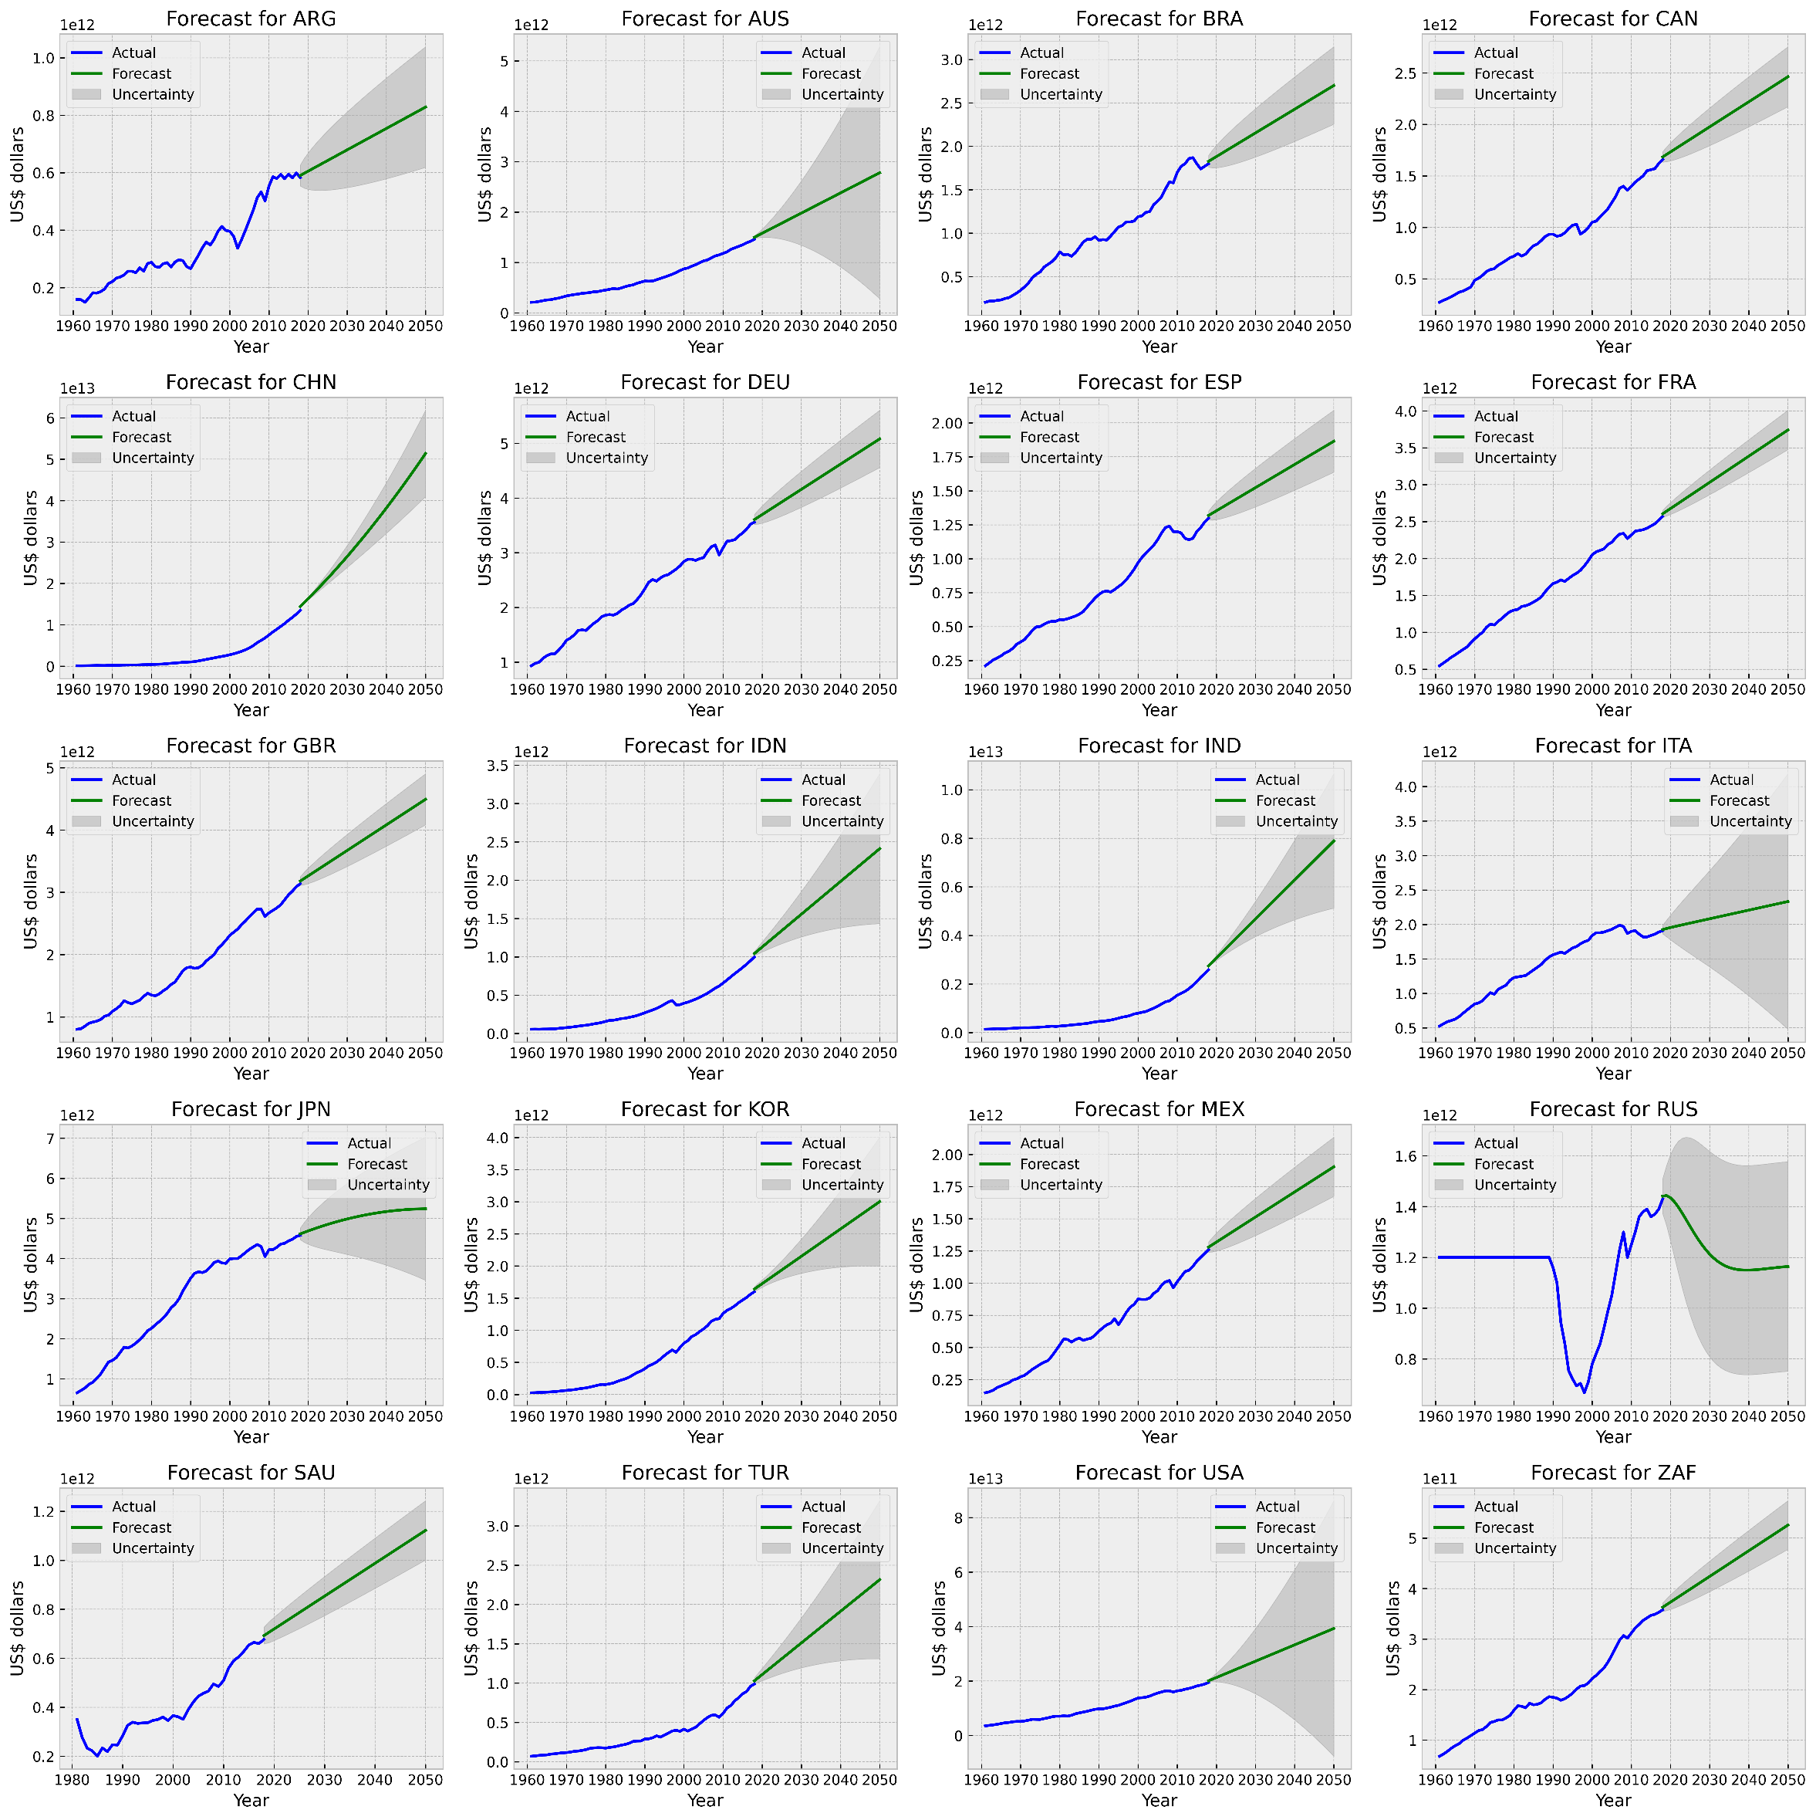
Figure SI 6 GDP AUTO-ARIMA forecast

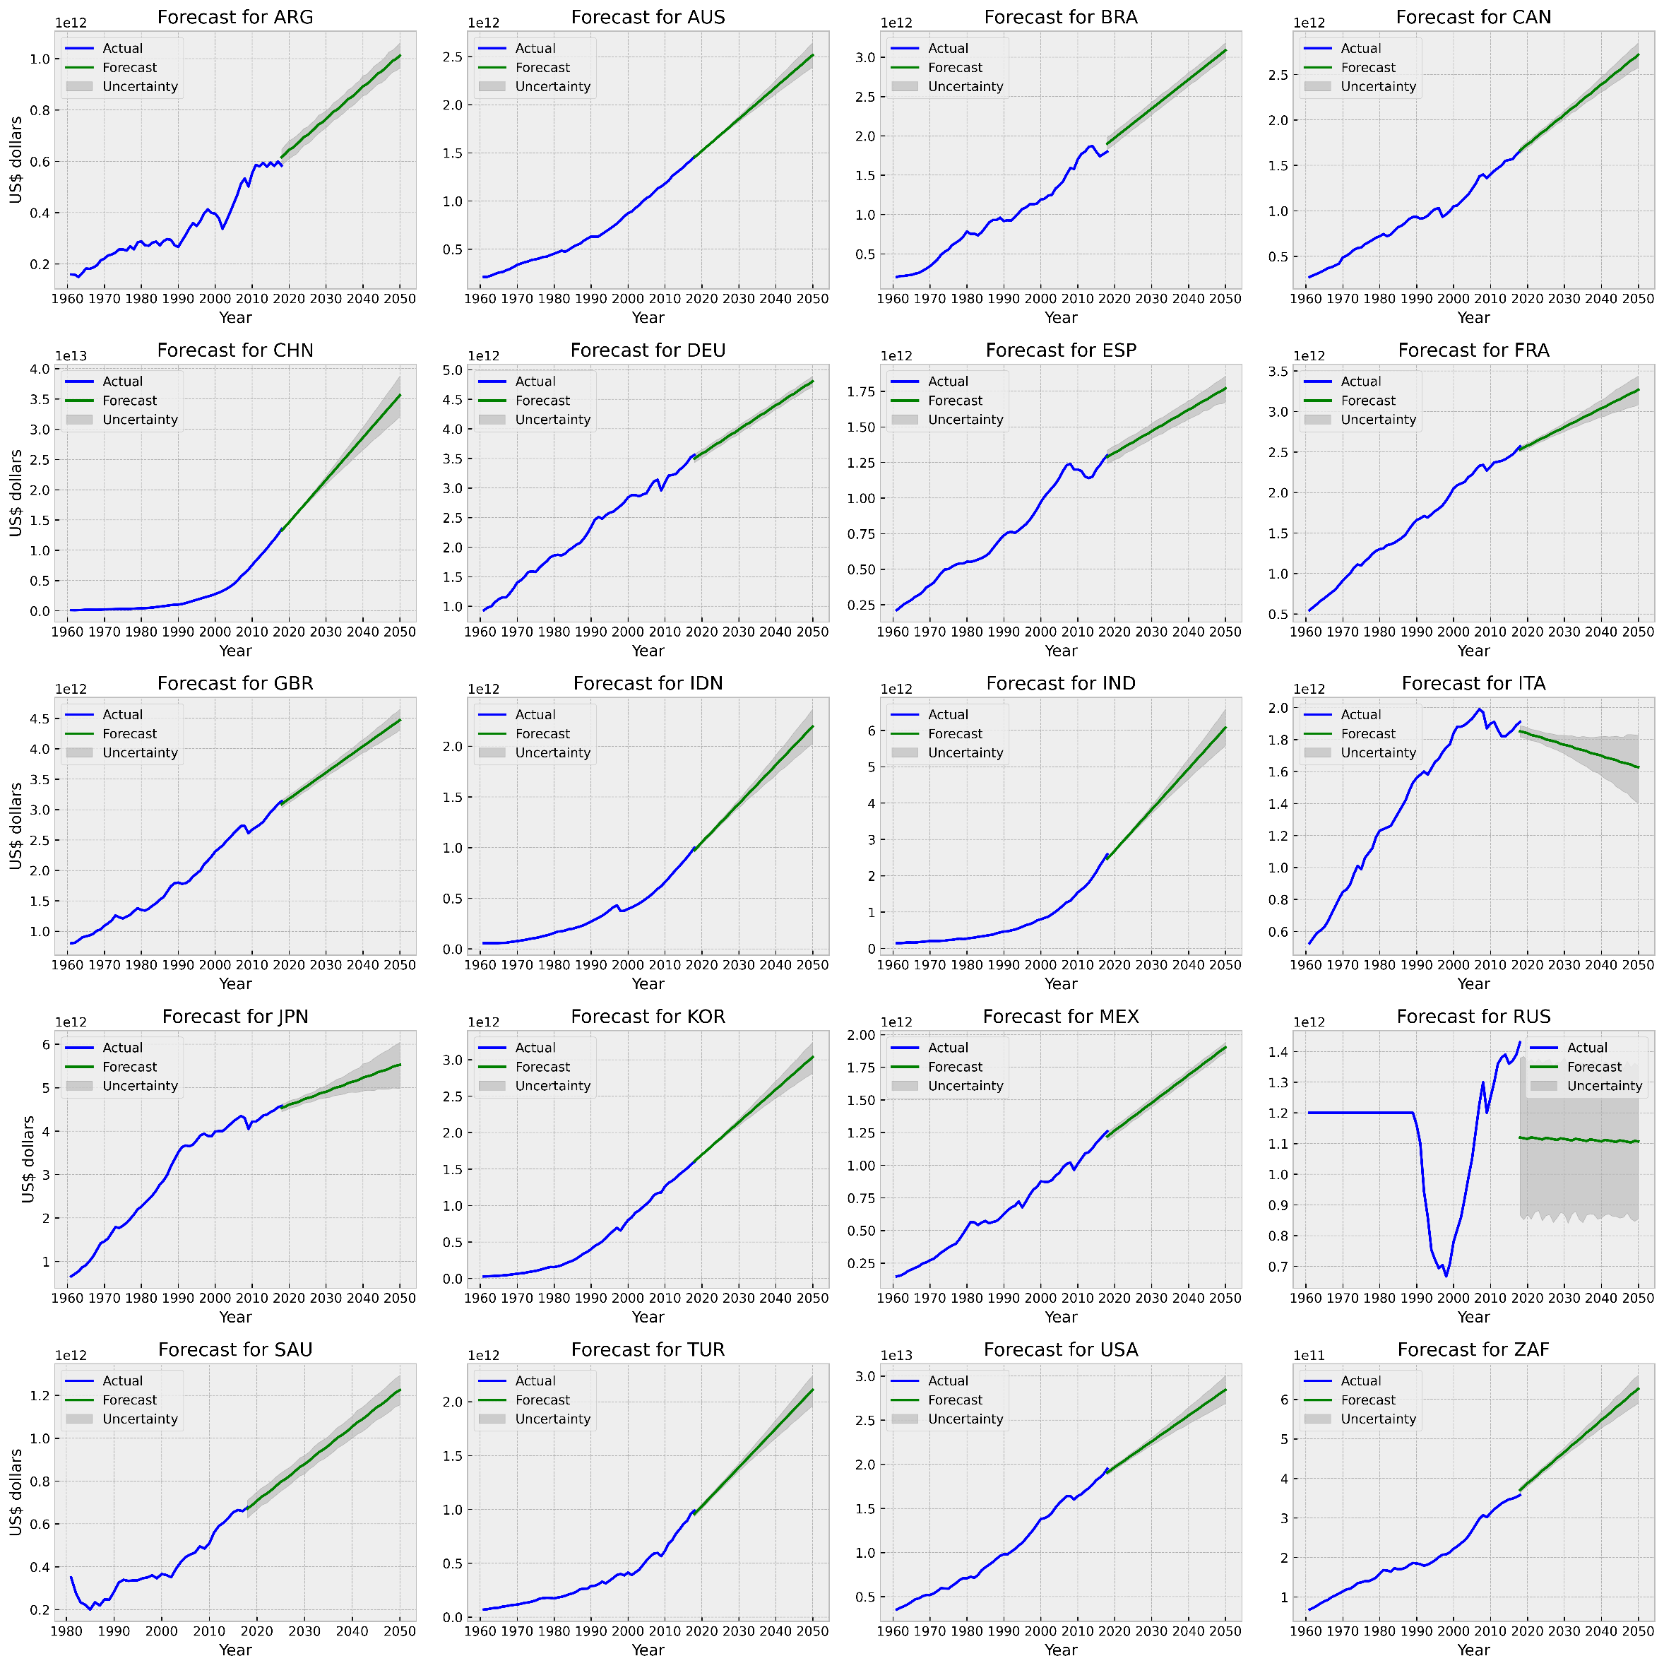
Figure SI 7 GDP Prophet forecast

Emissions
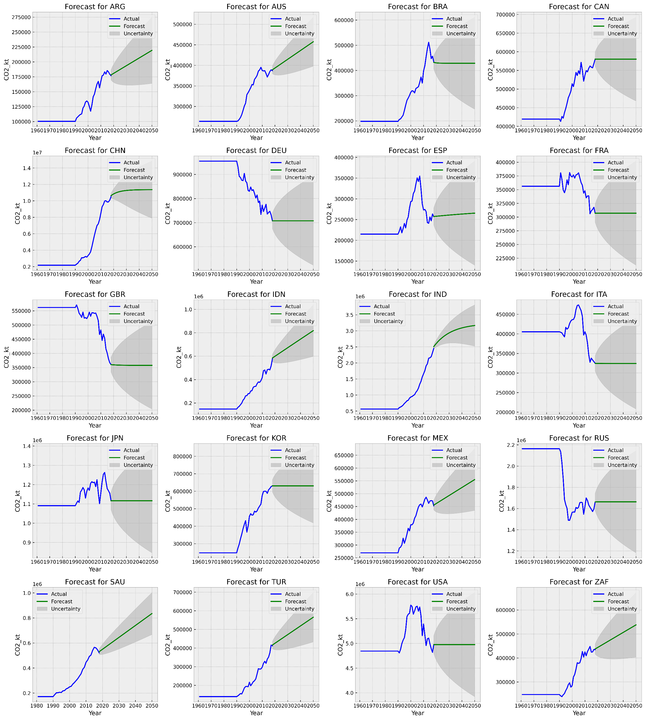
Figure SI 8 Emissions ARIMA forecast

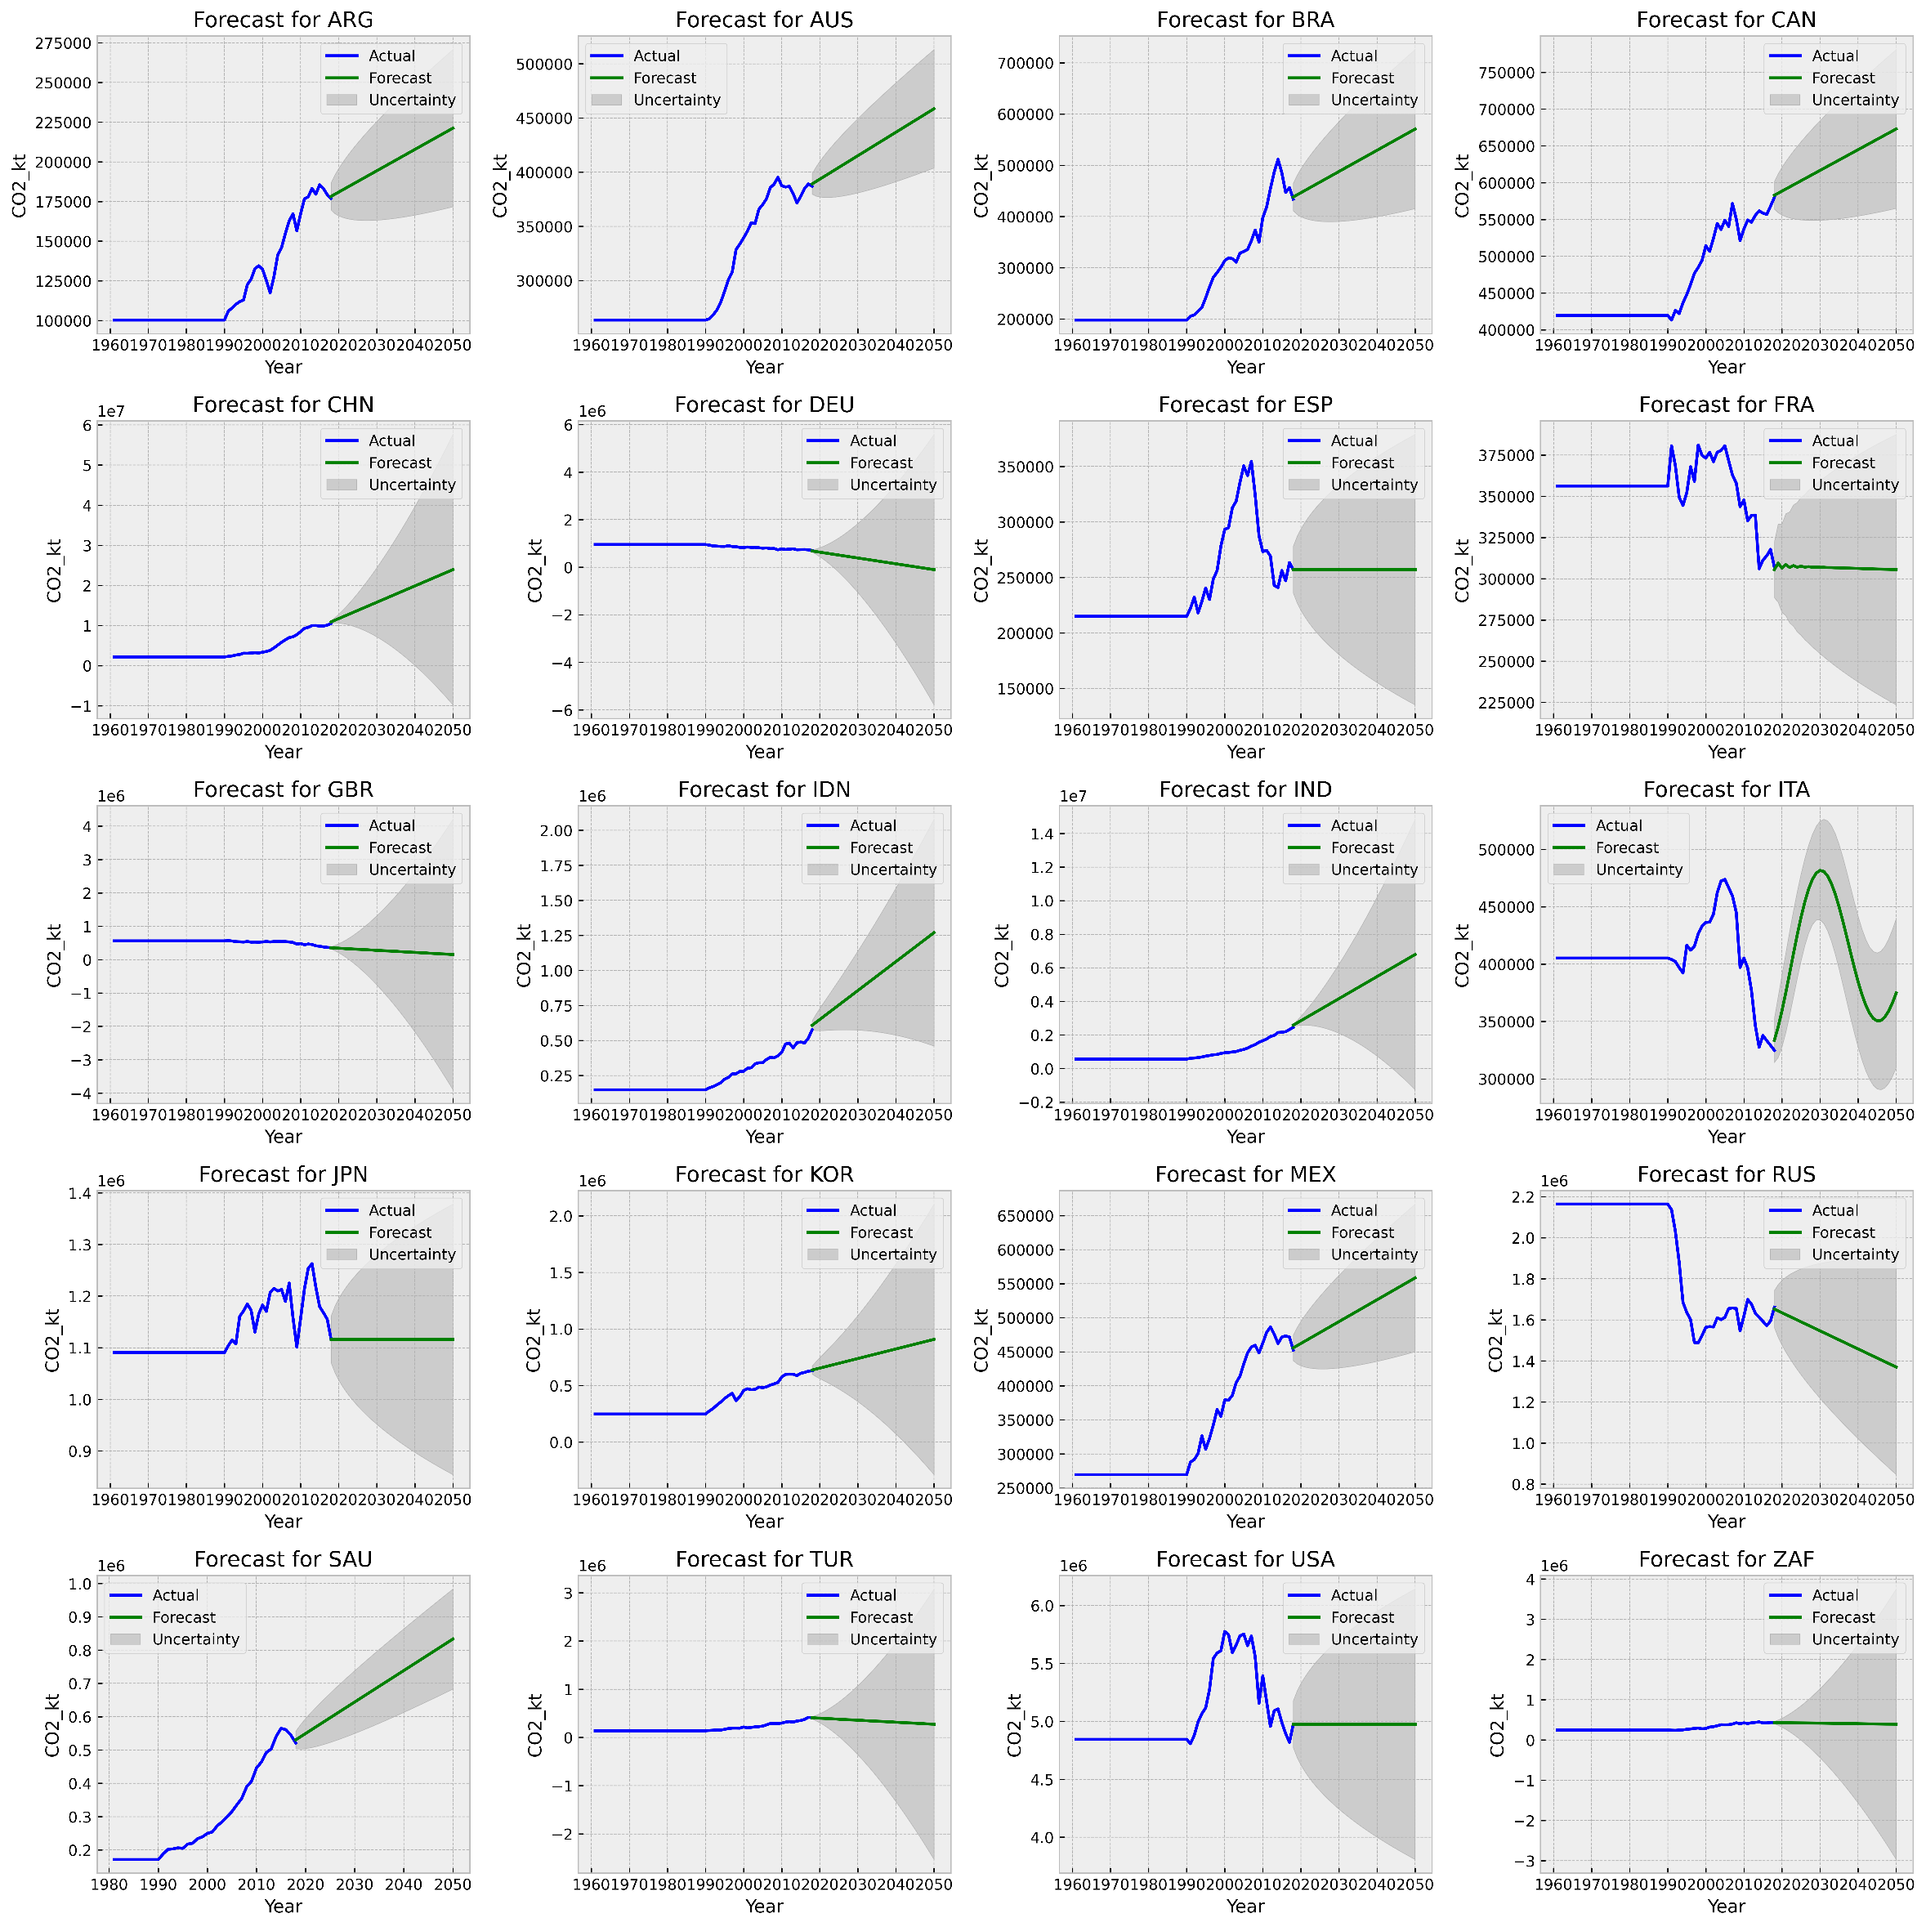
Figure SI 9 Emissions AUTO-ARIMA forecast

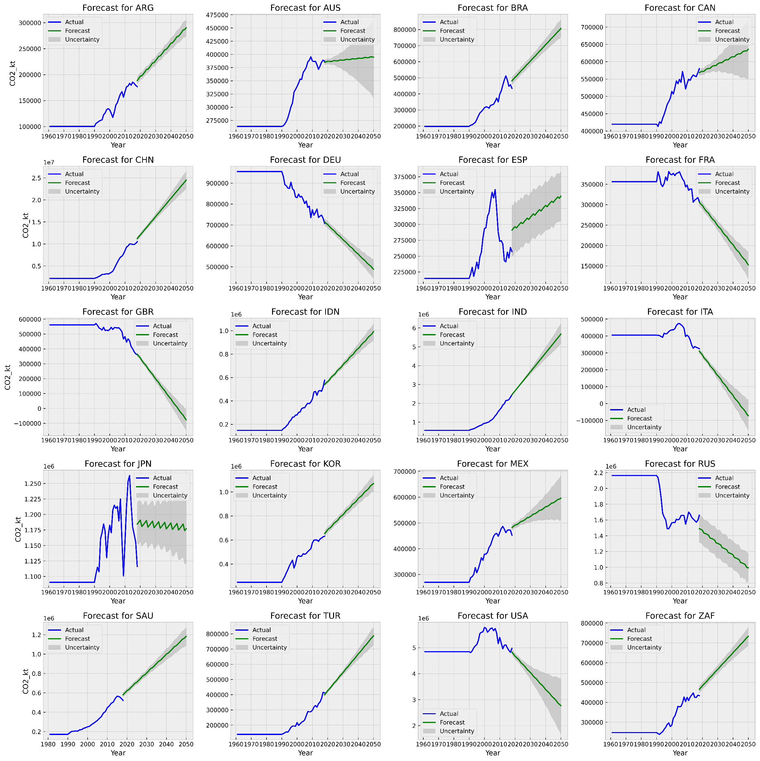
Figure SI 10 Emissions Prophet forecast

Consumption
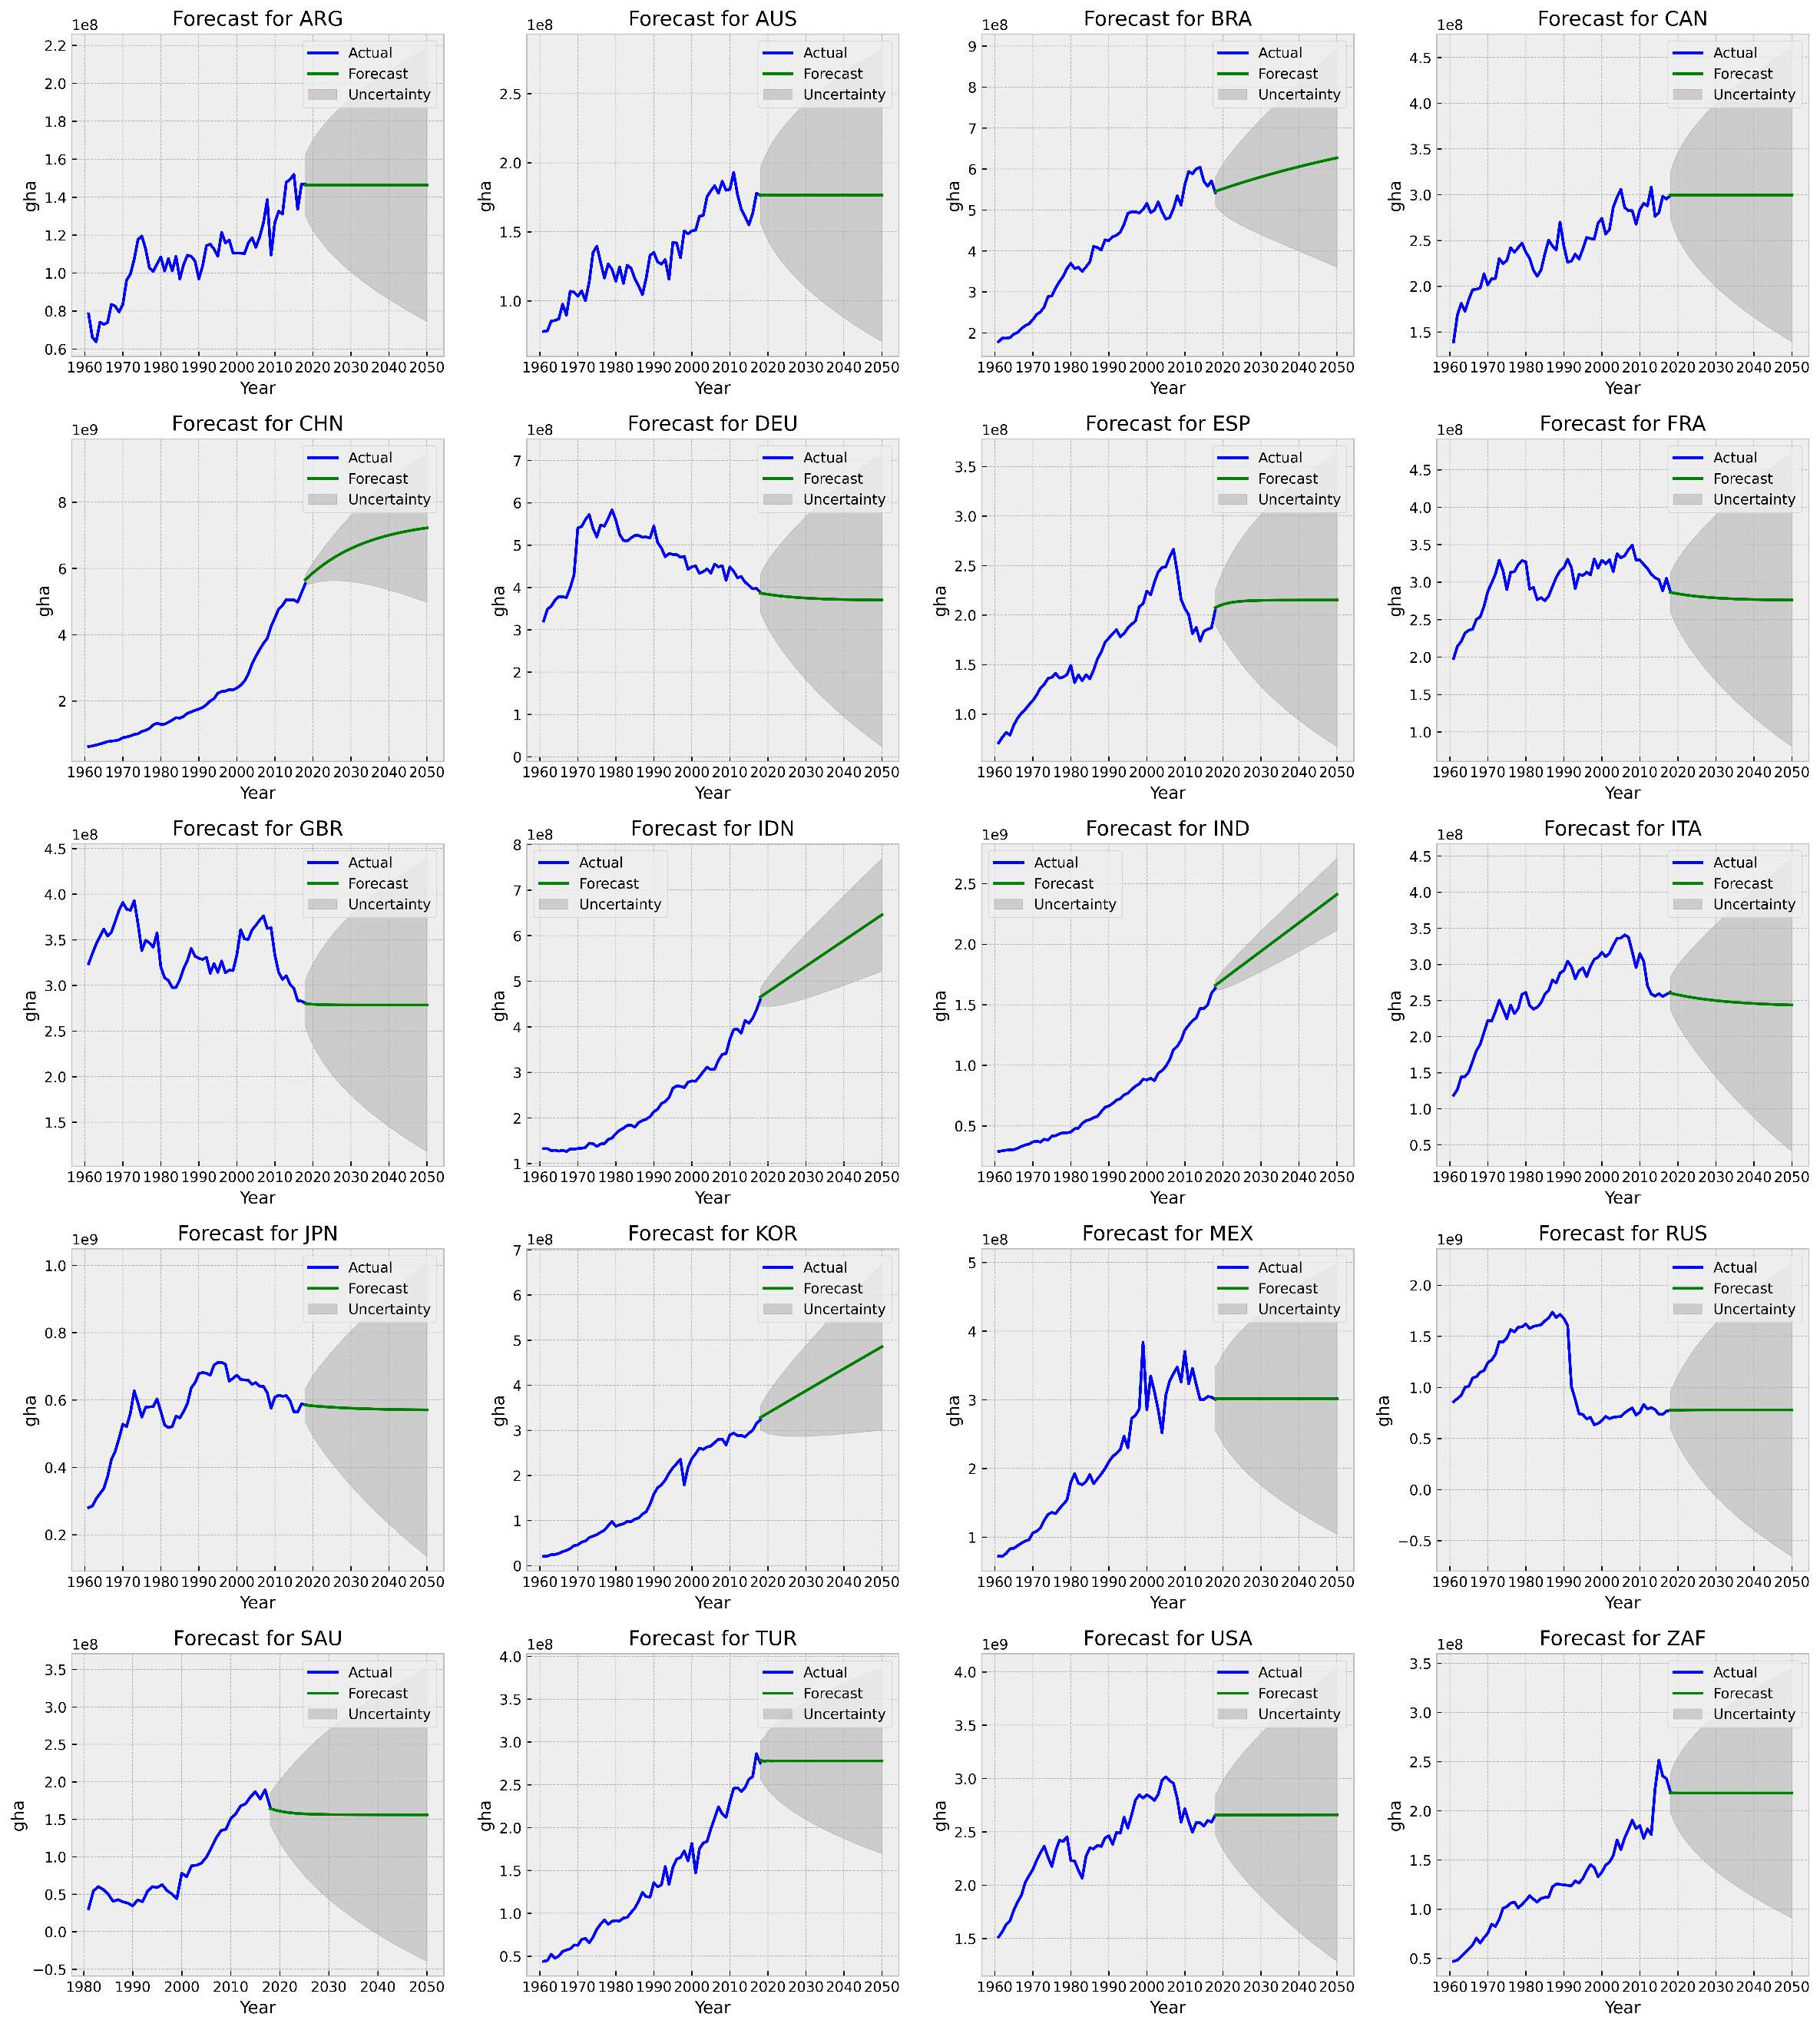
Figure SI 11 EF Consumption ARIMA forecast

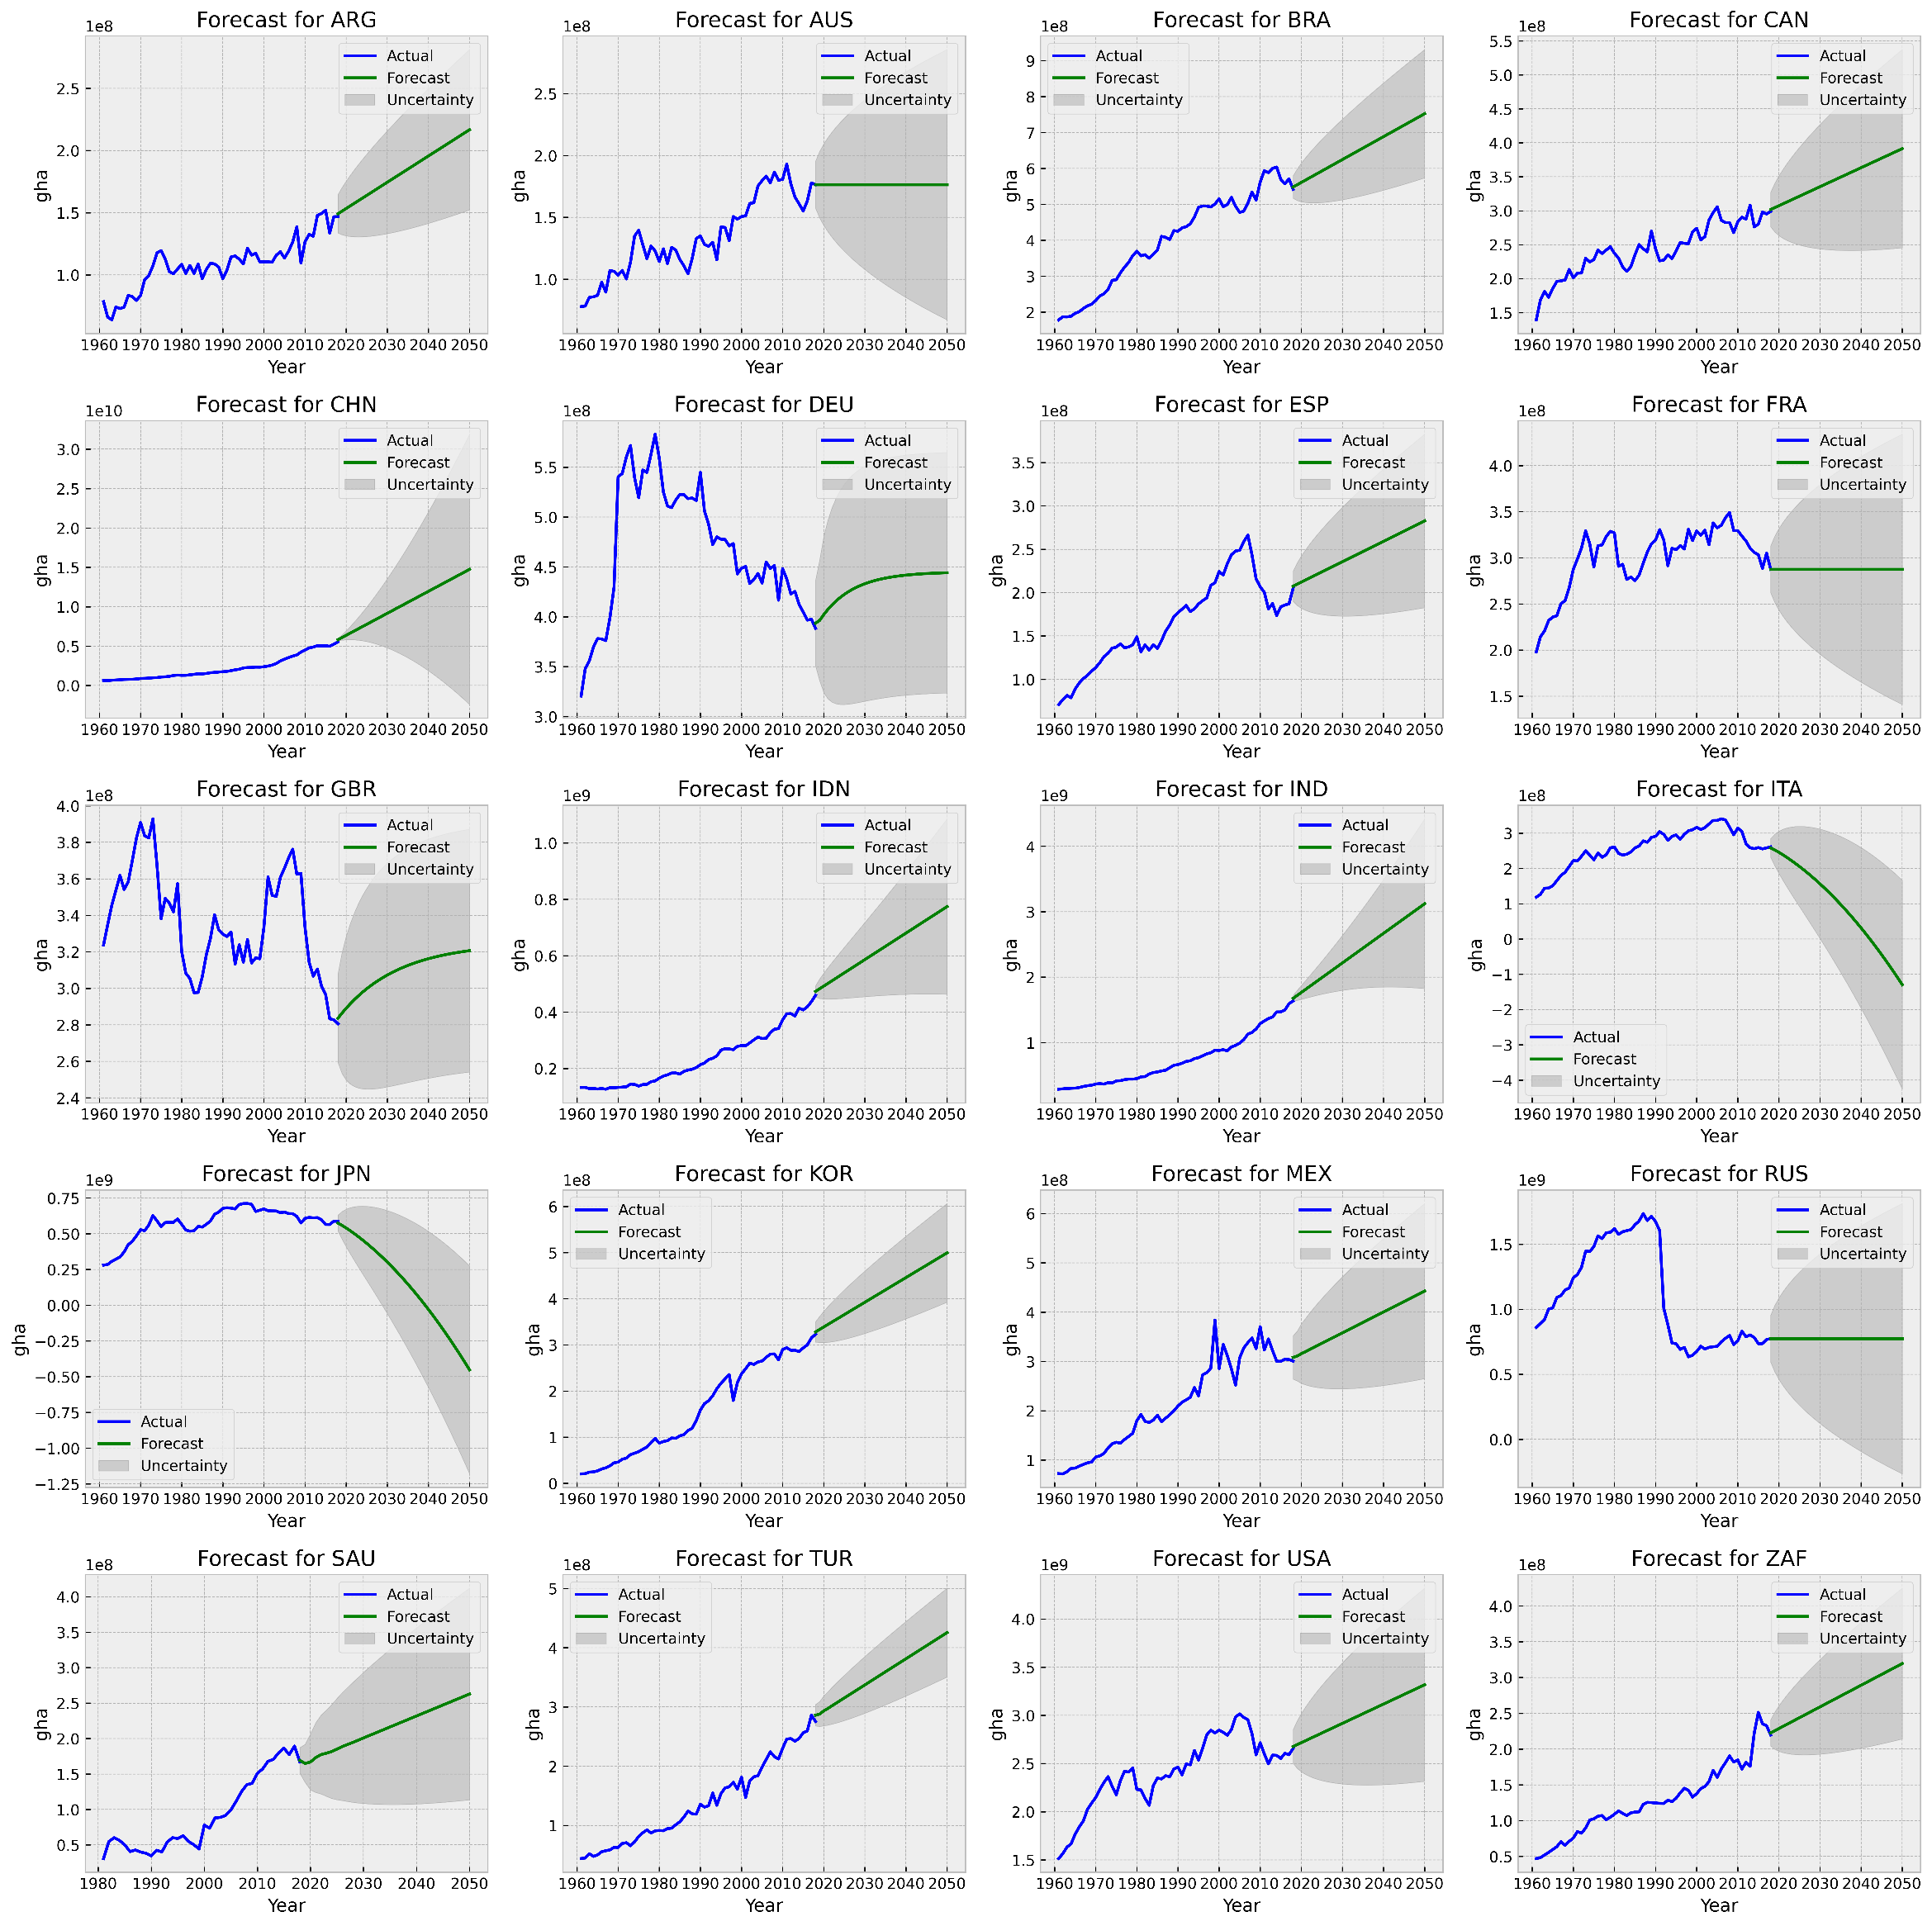
Figure SI 12 EF Consumption AUTO-ARIMA forecast
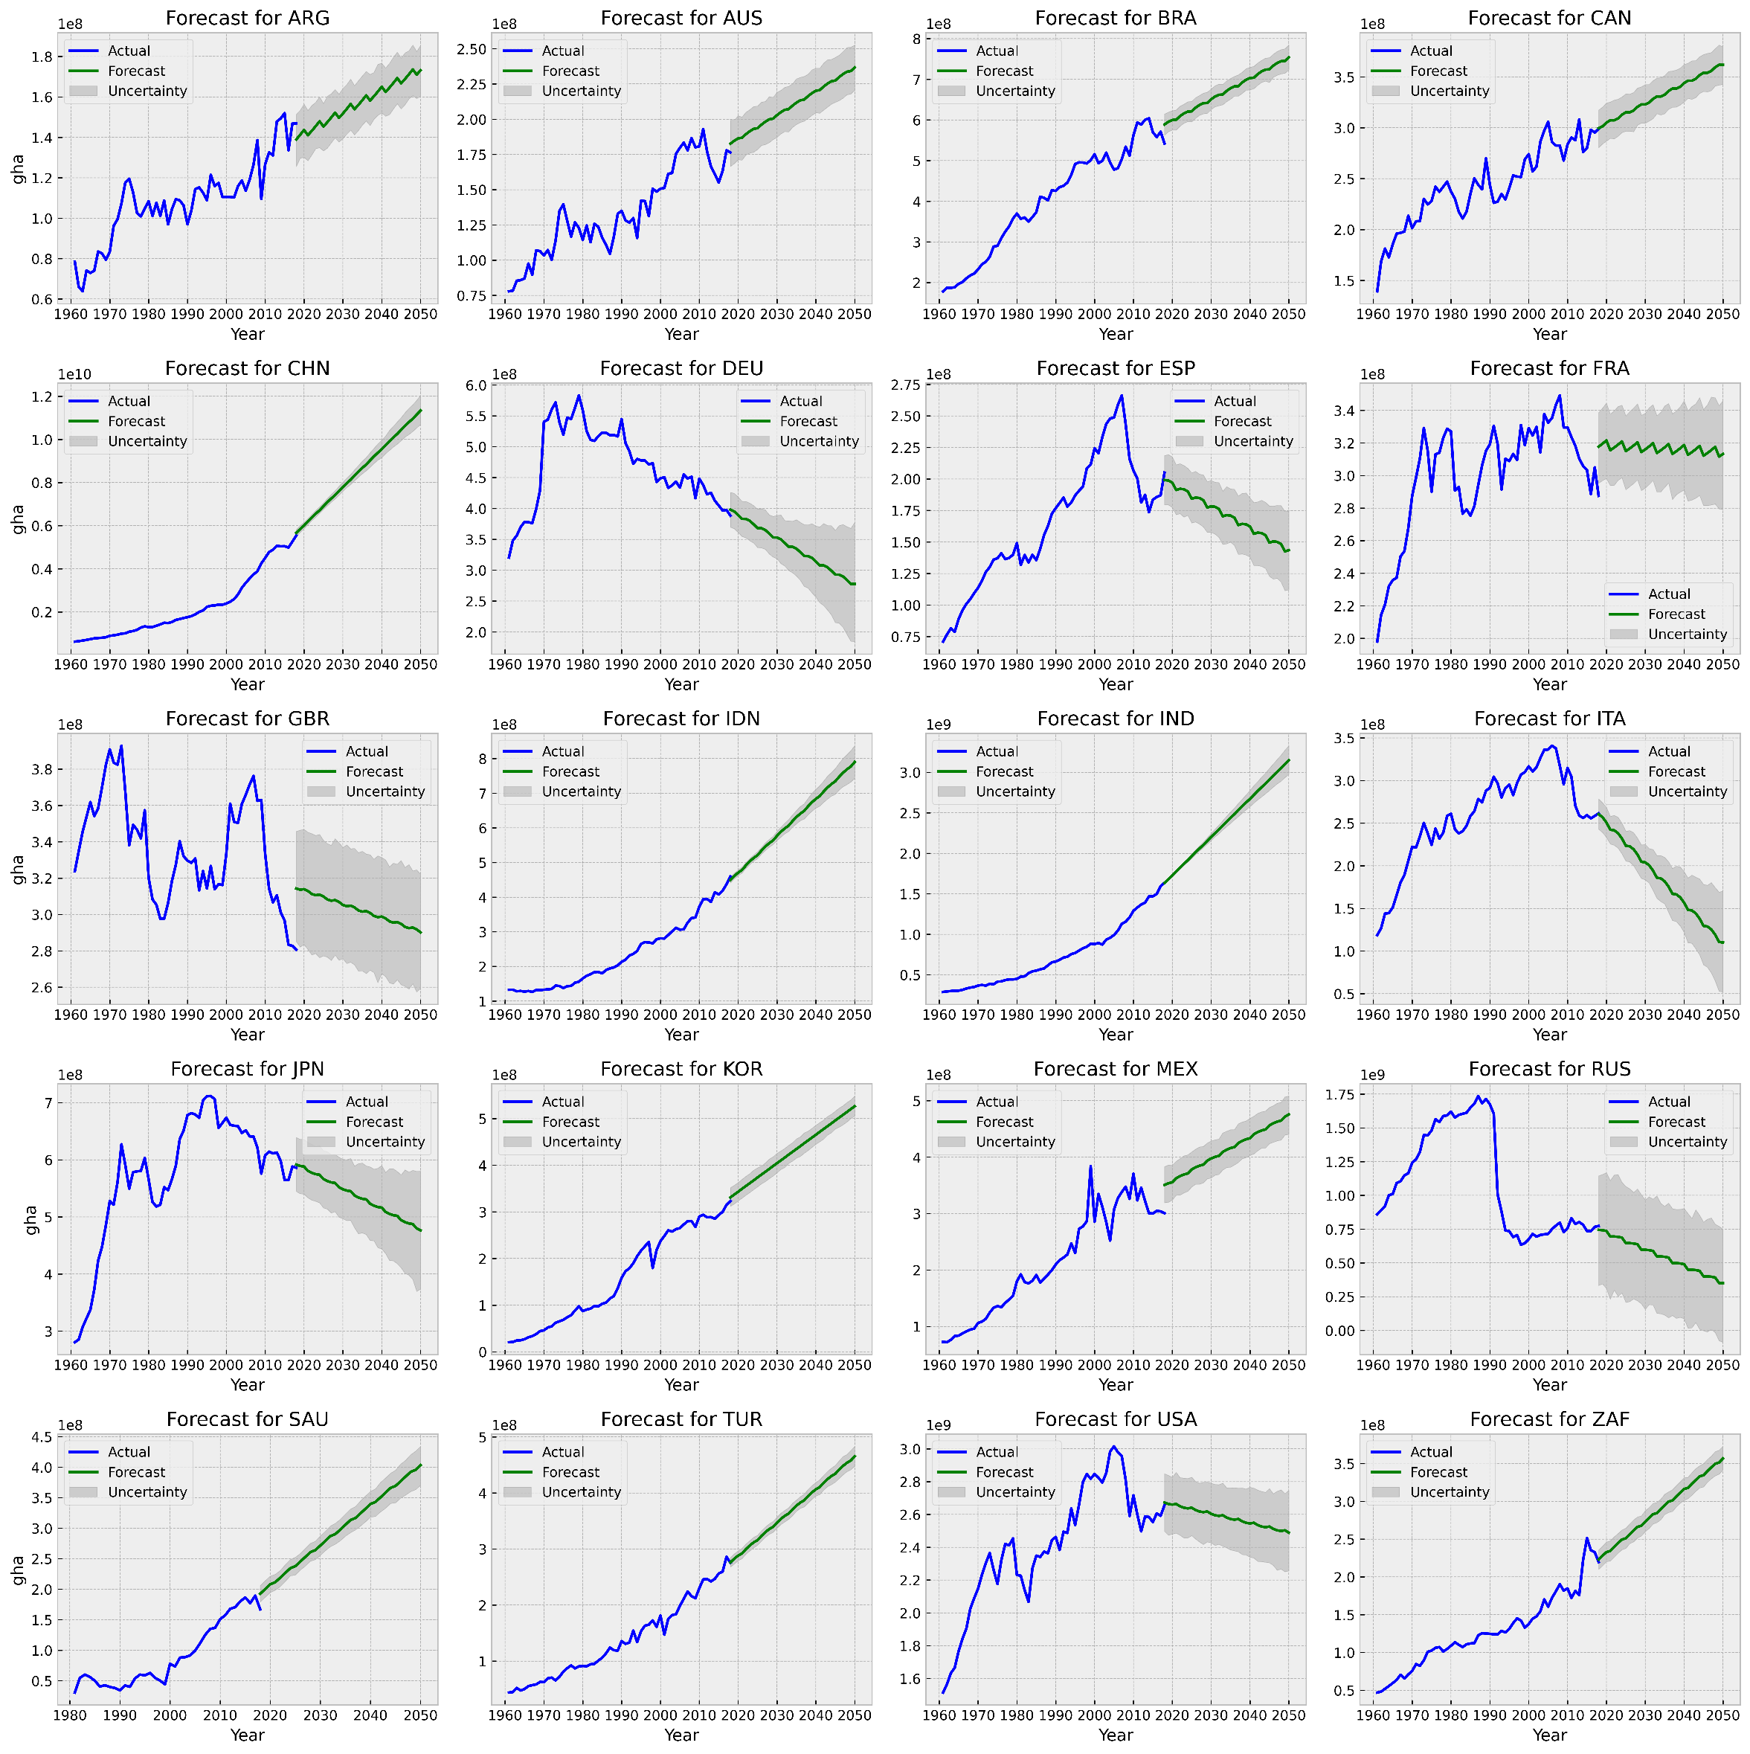
Figure SI 13 EF Consumption Prophet forecast

Biocapacity
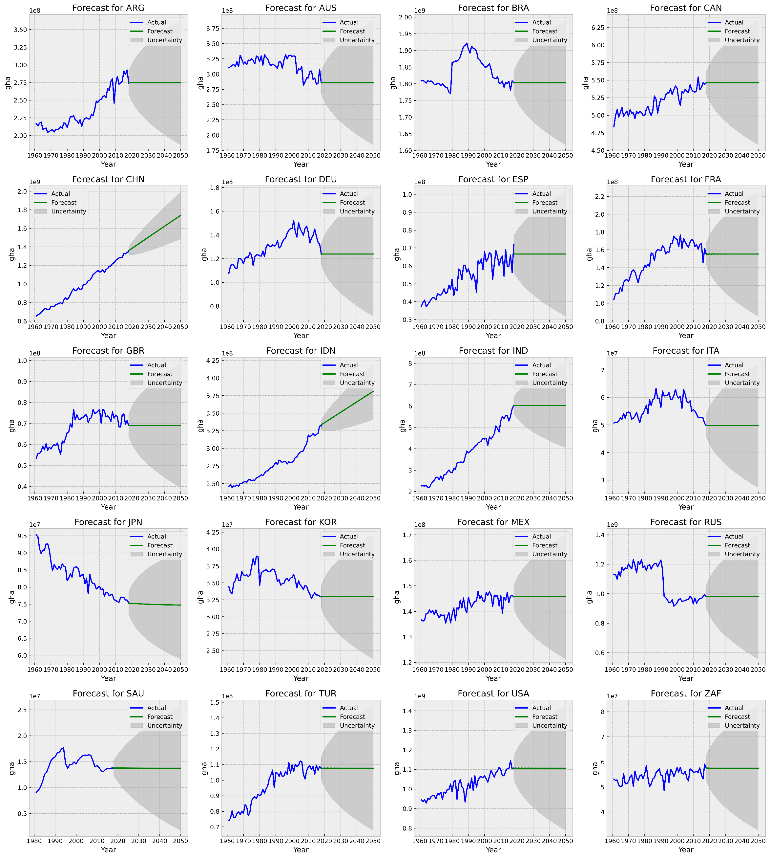
Figure SI 14 Biocapacity ARIMA forecast
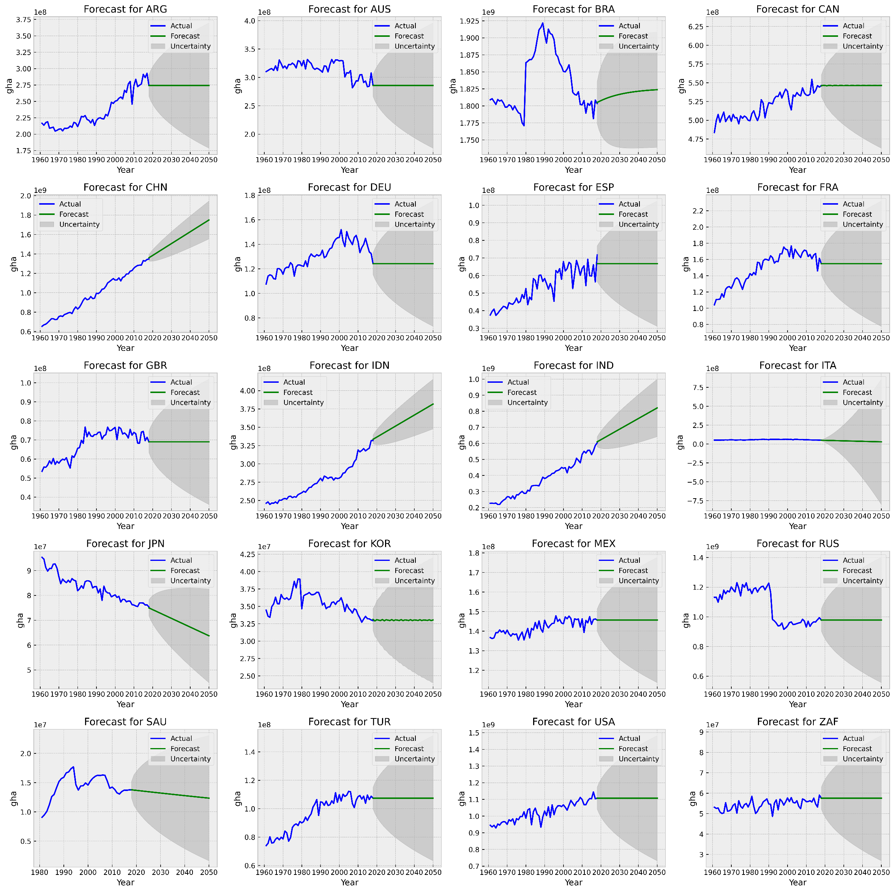
Figure SI 15 Biocapacity AUTO-ARIMA forecast
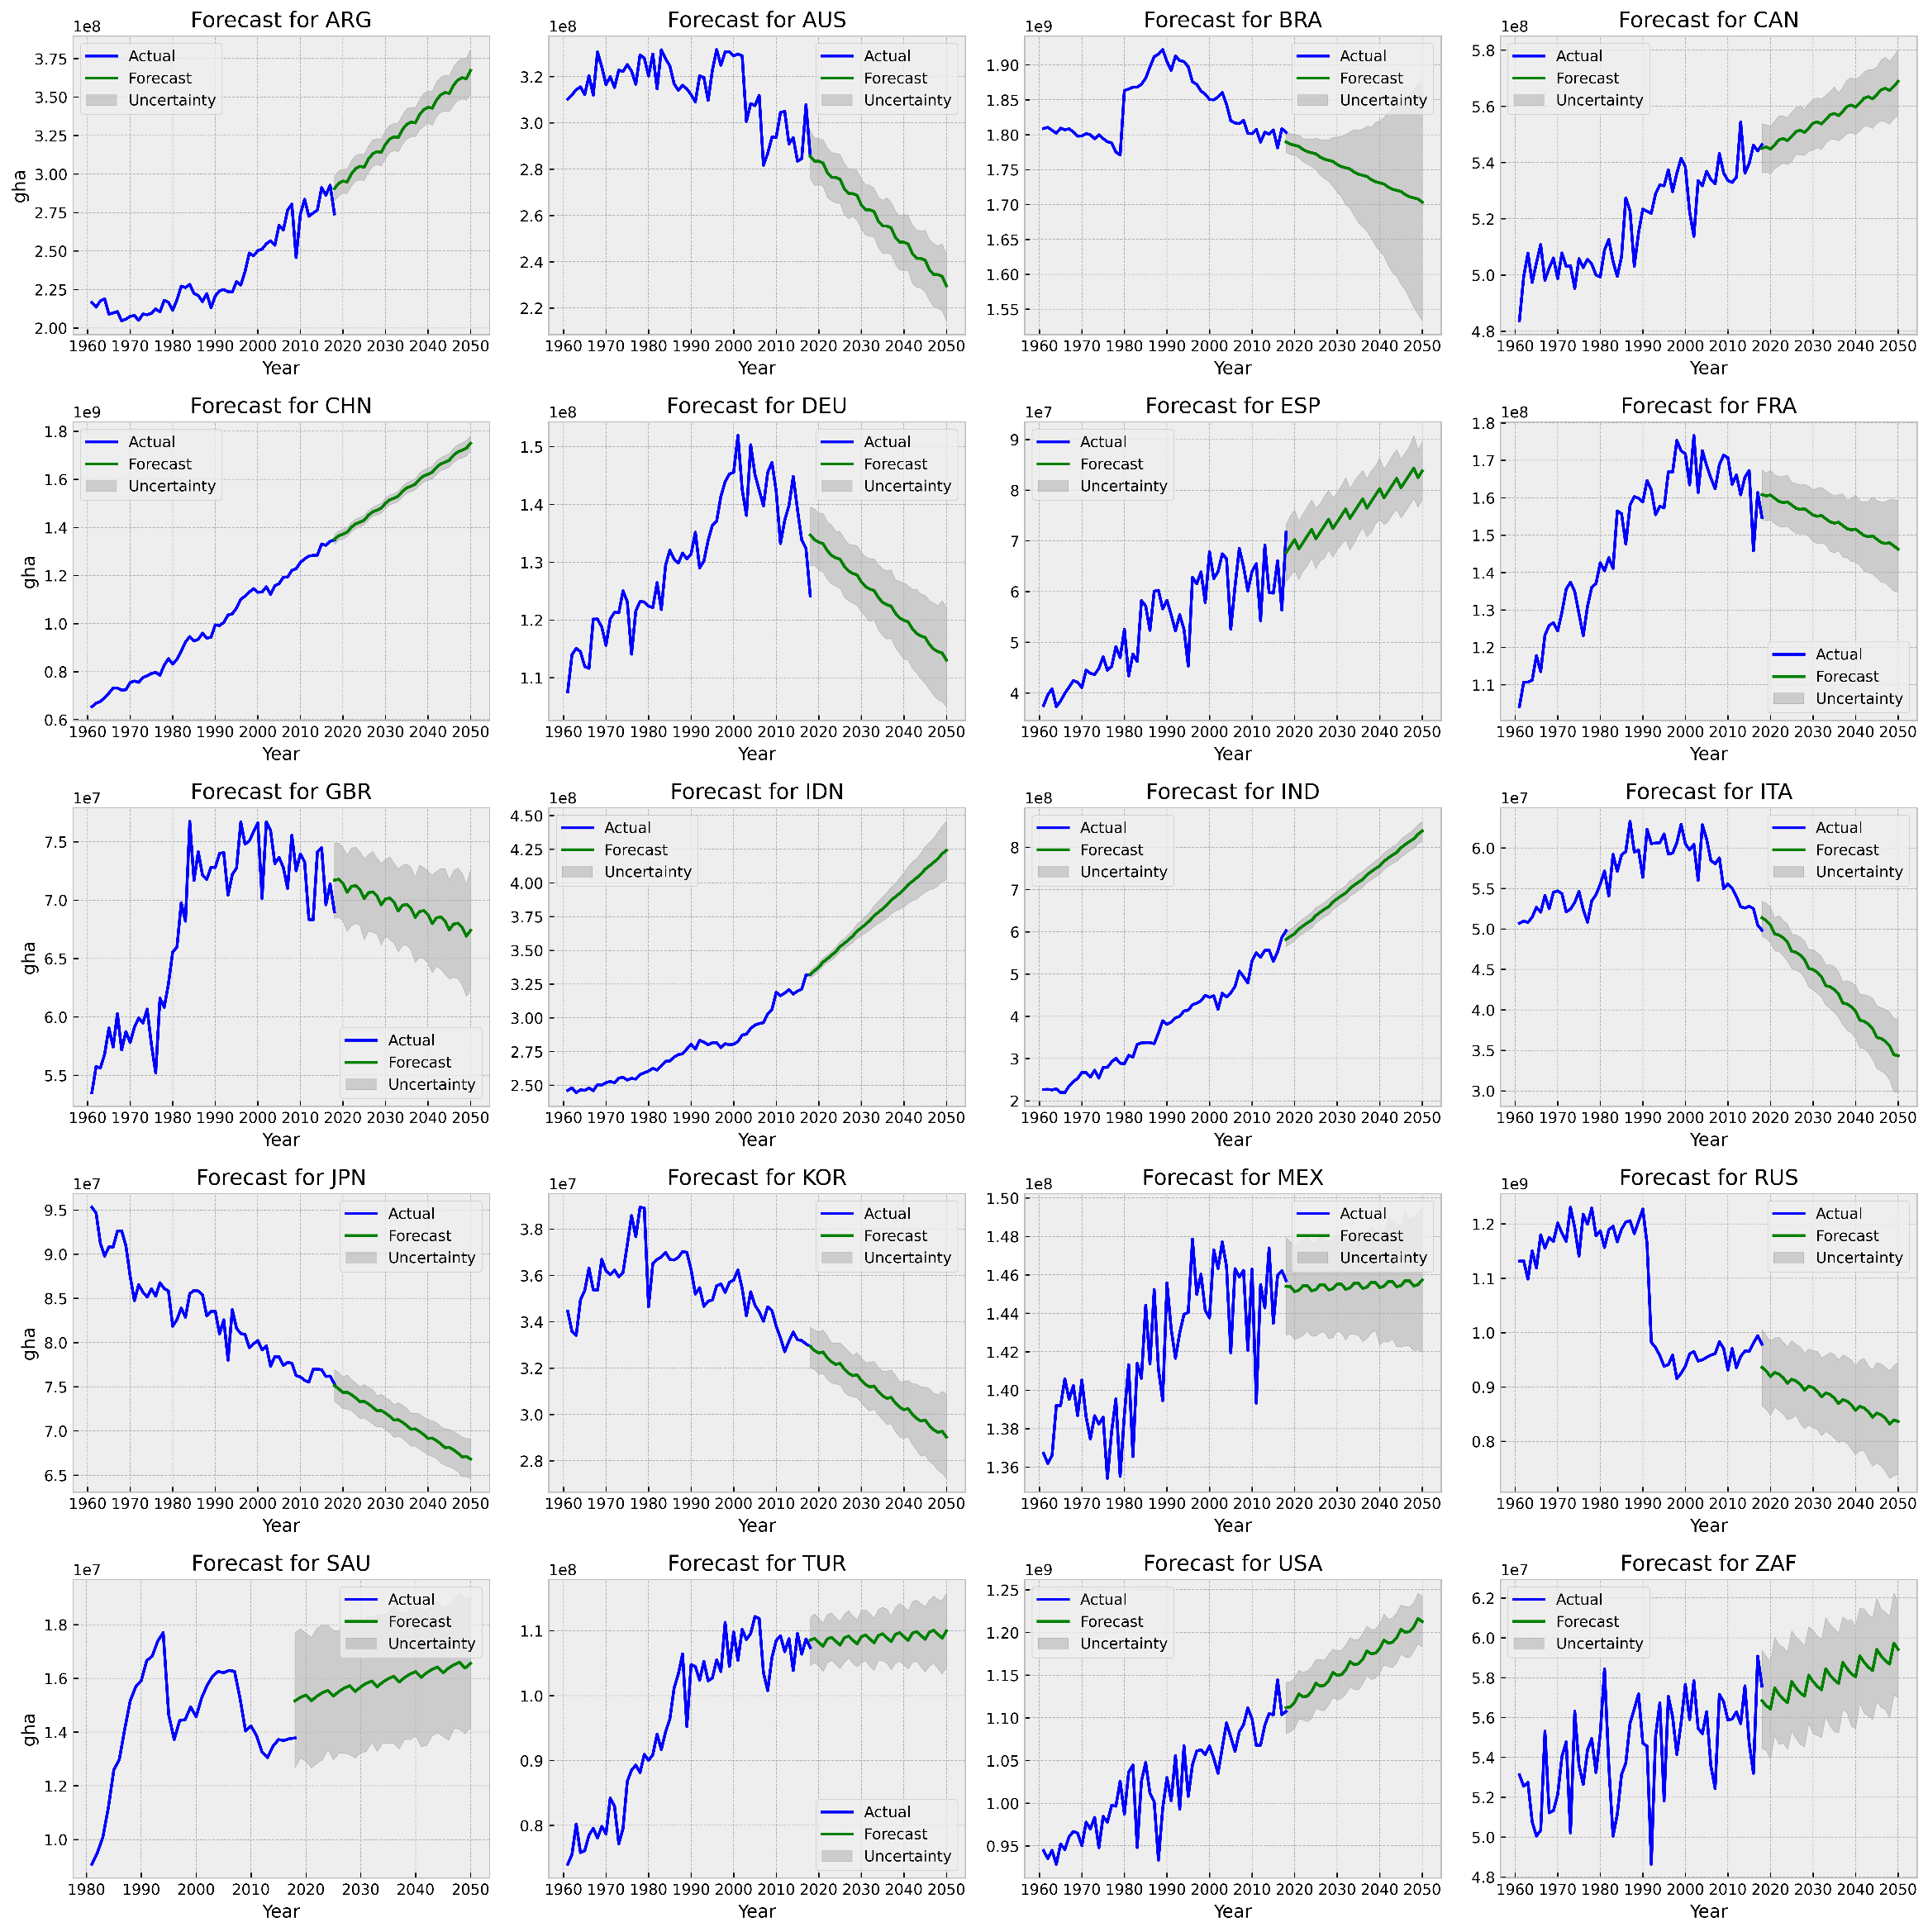
Figure SI 16 Biocapacity Prophet forecast

Forest
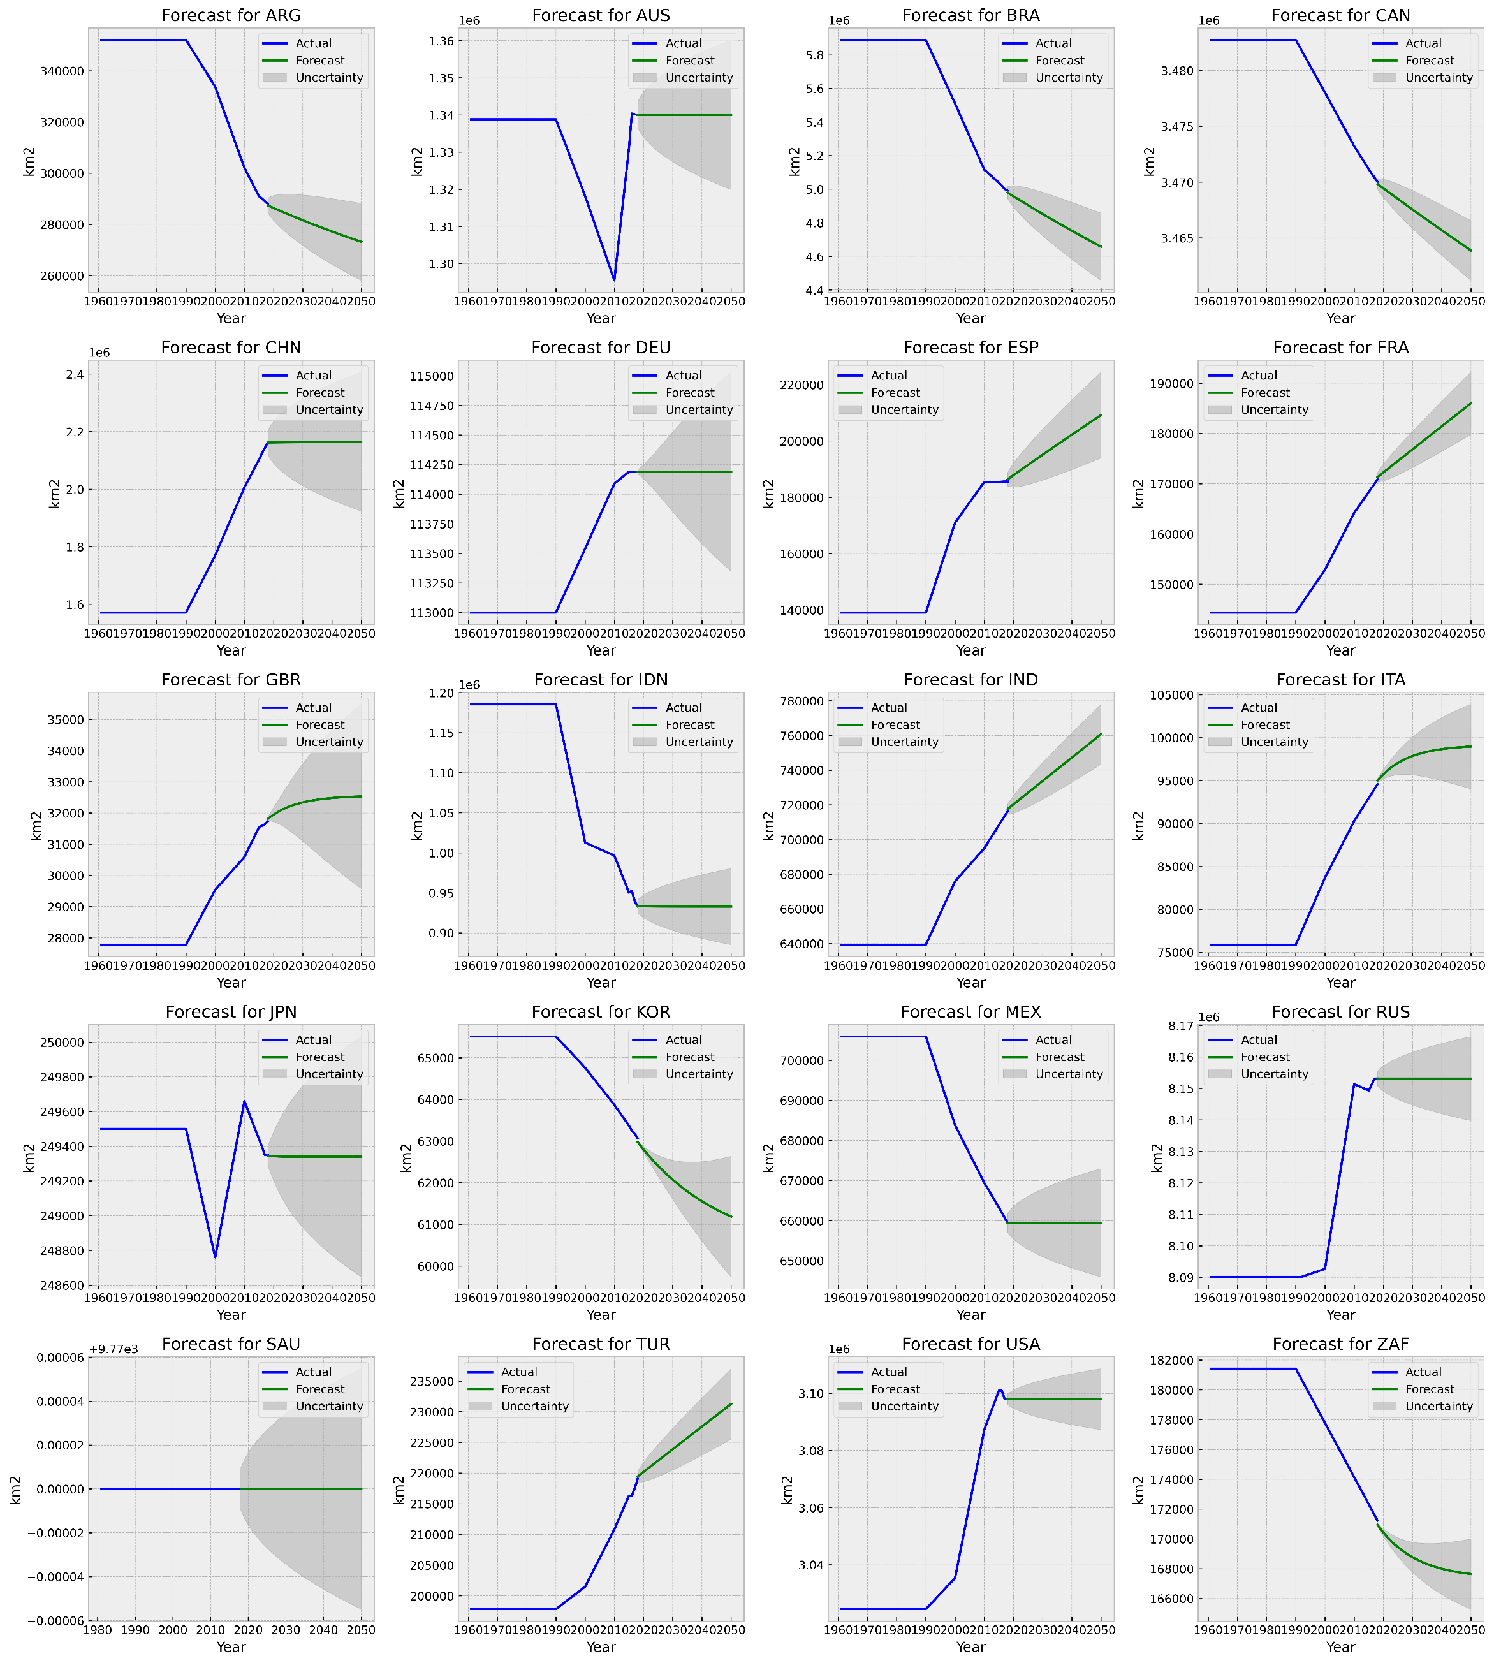
Figure SI 17 Forest ARIMA forecast

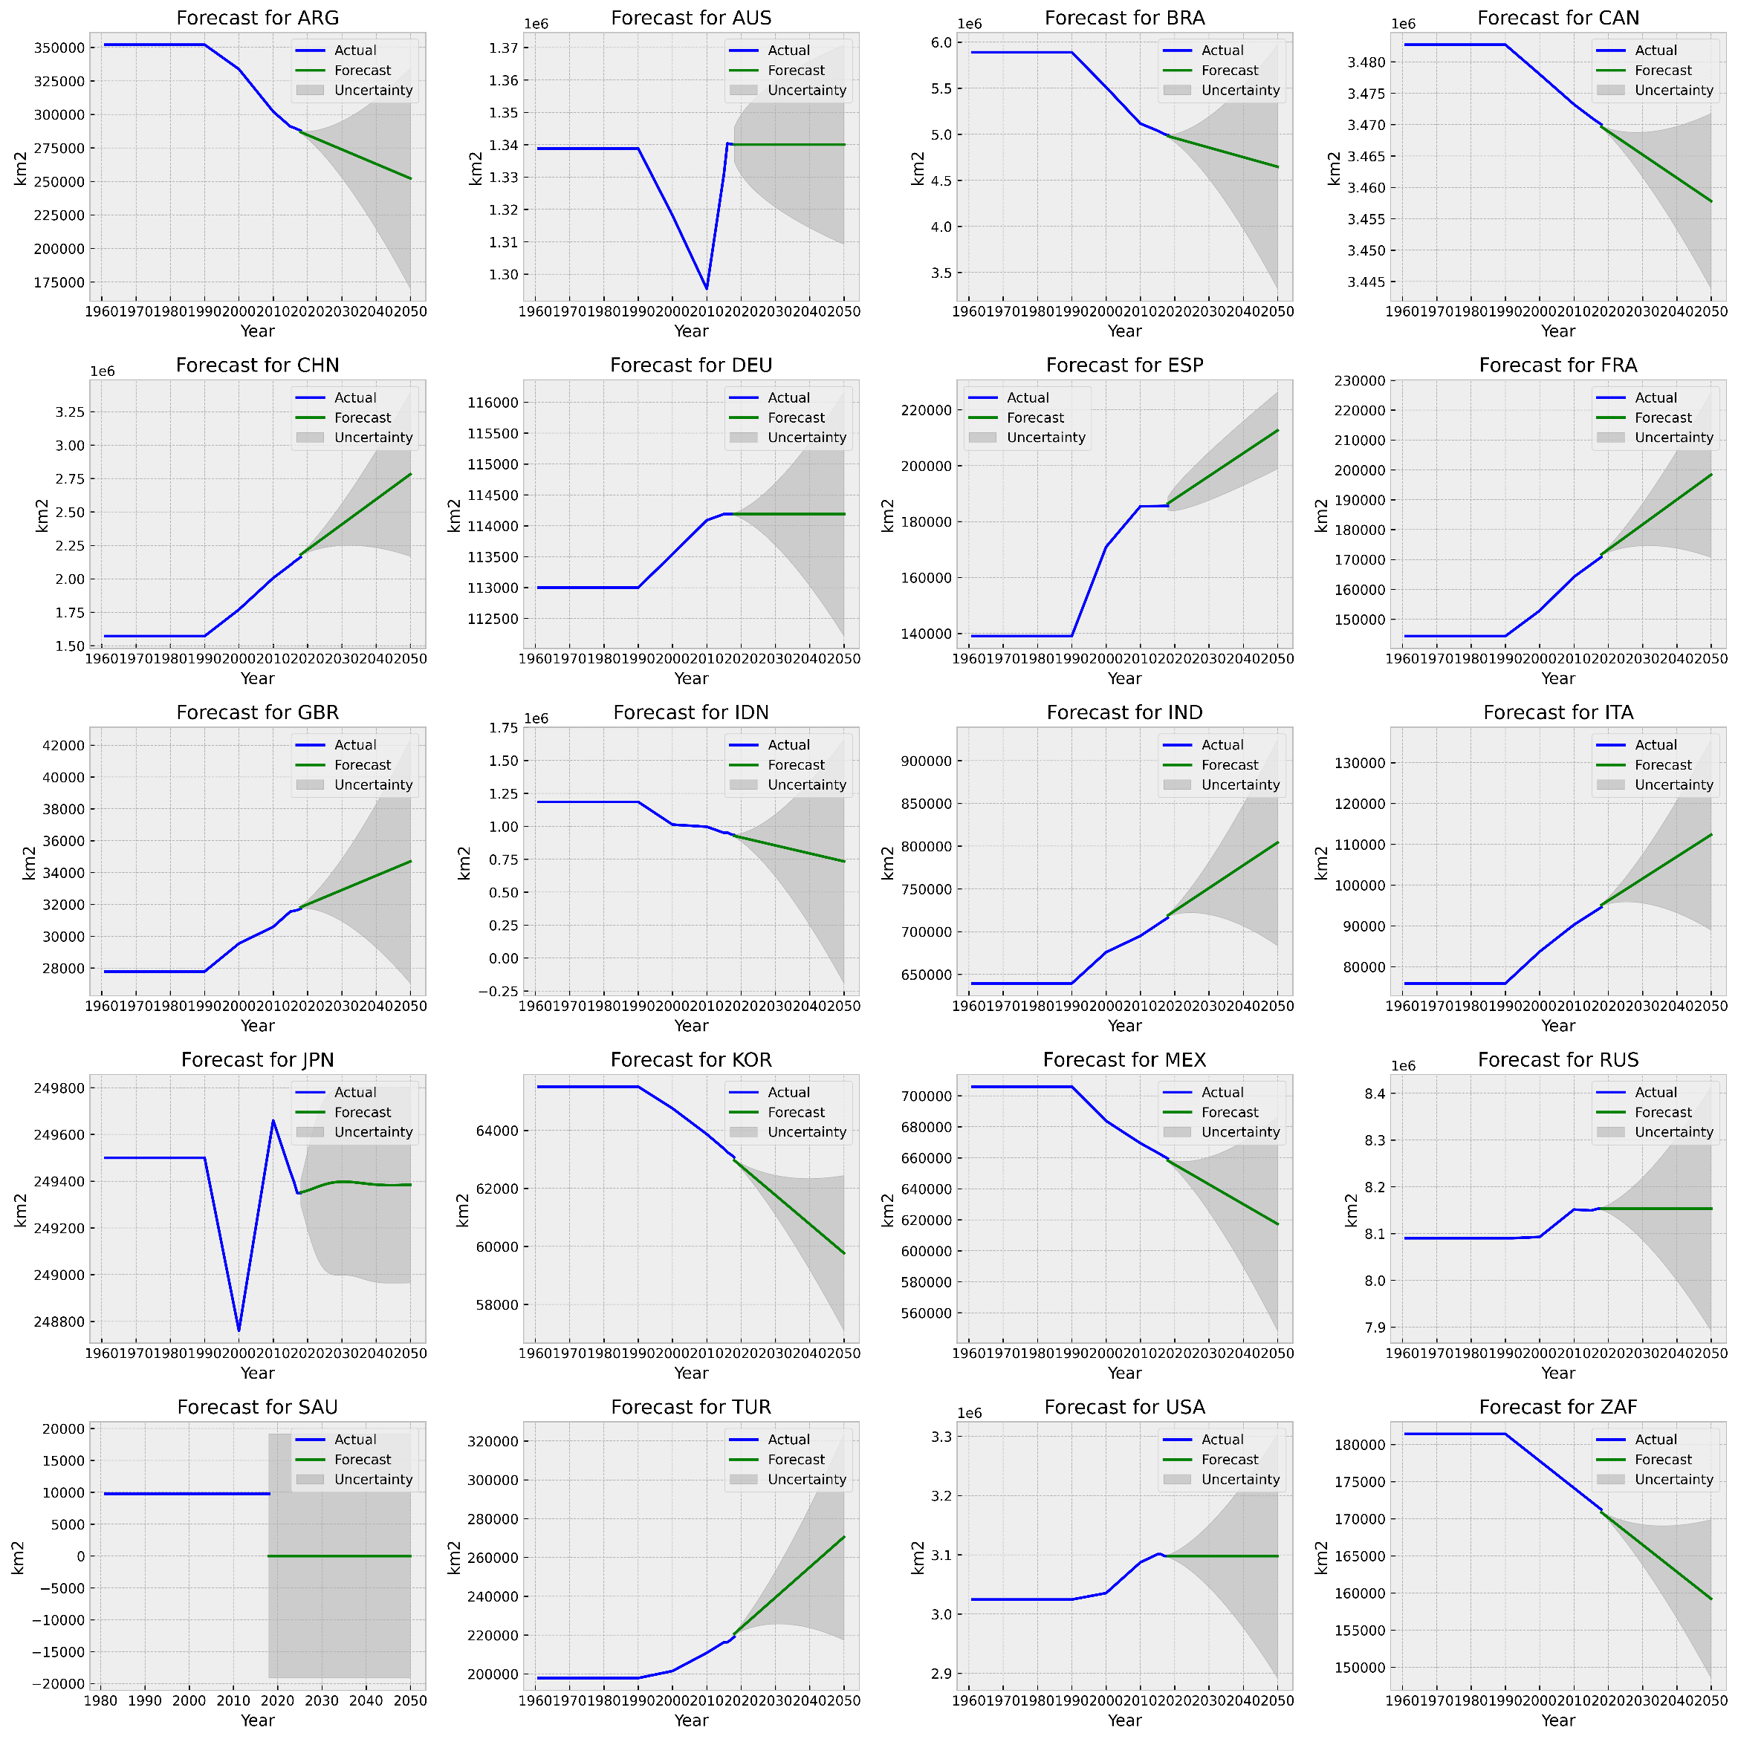
Figure SI 18 Forest AUTO-ARIMA forecast

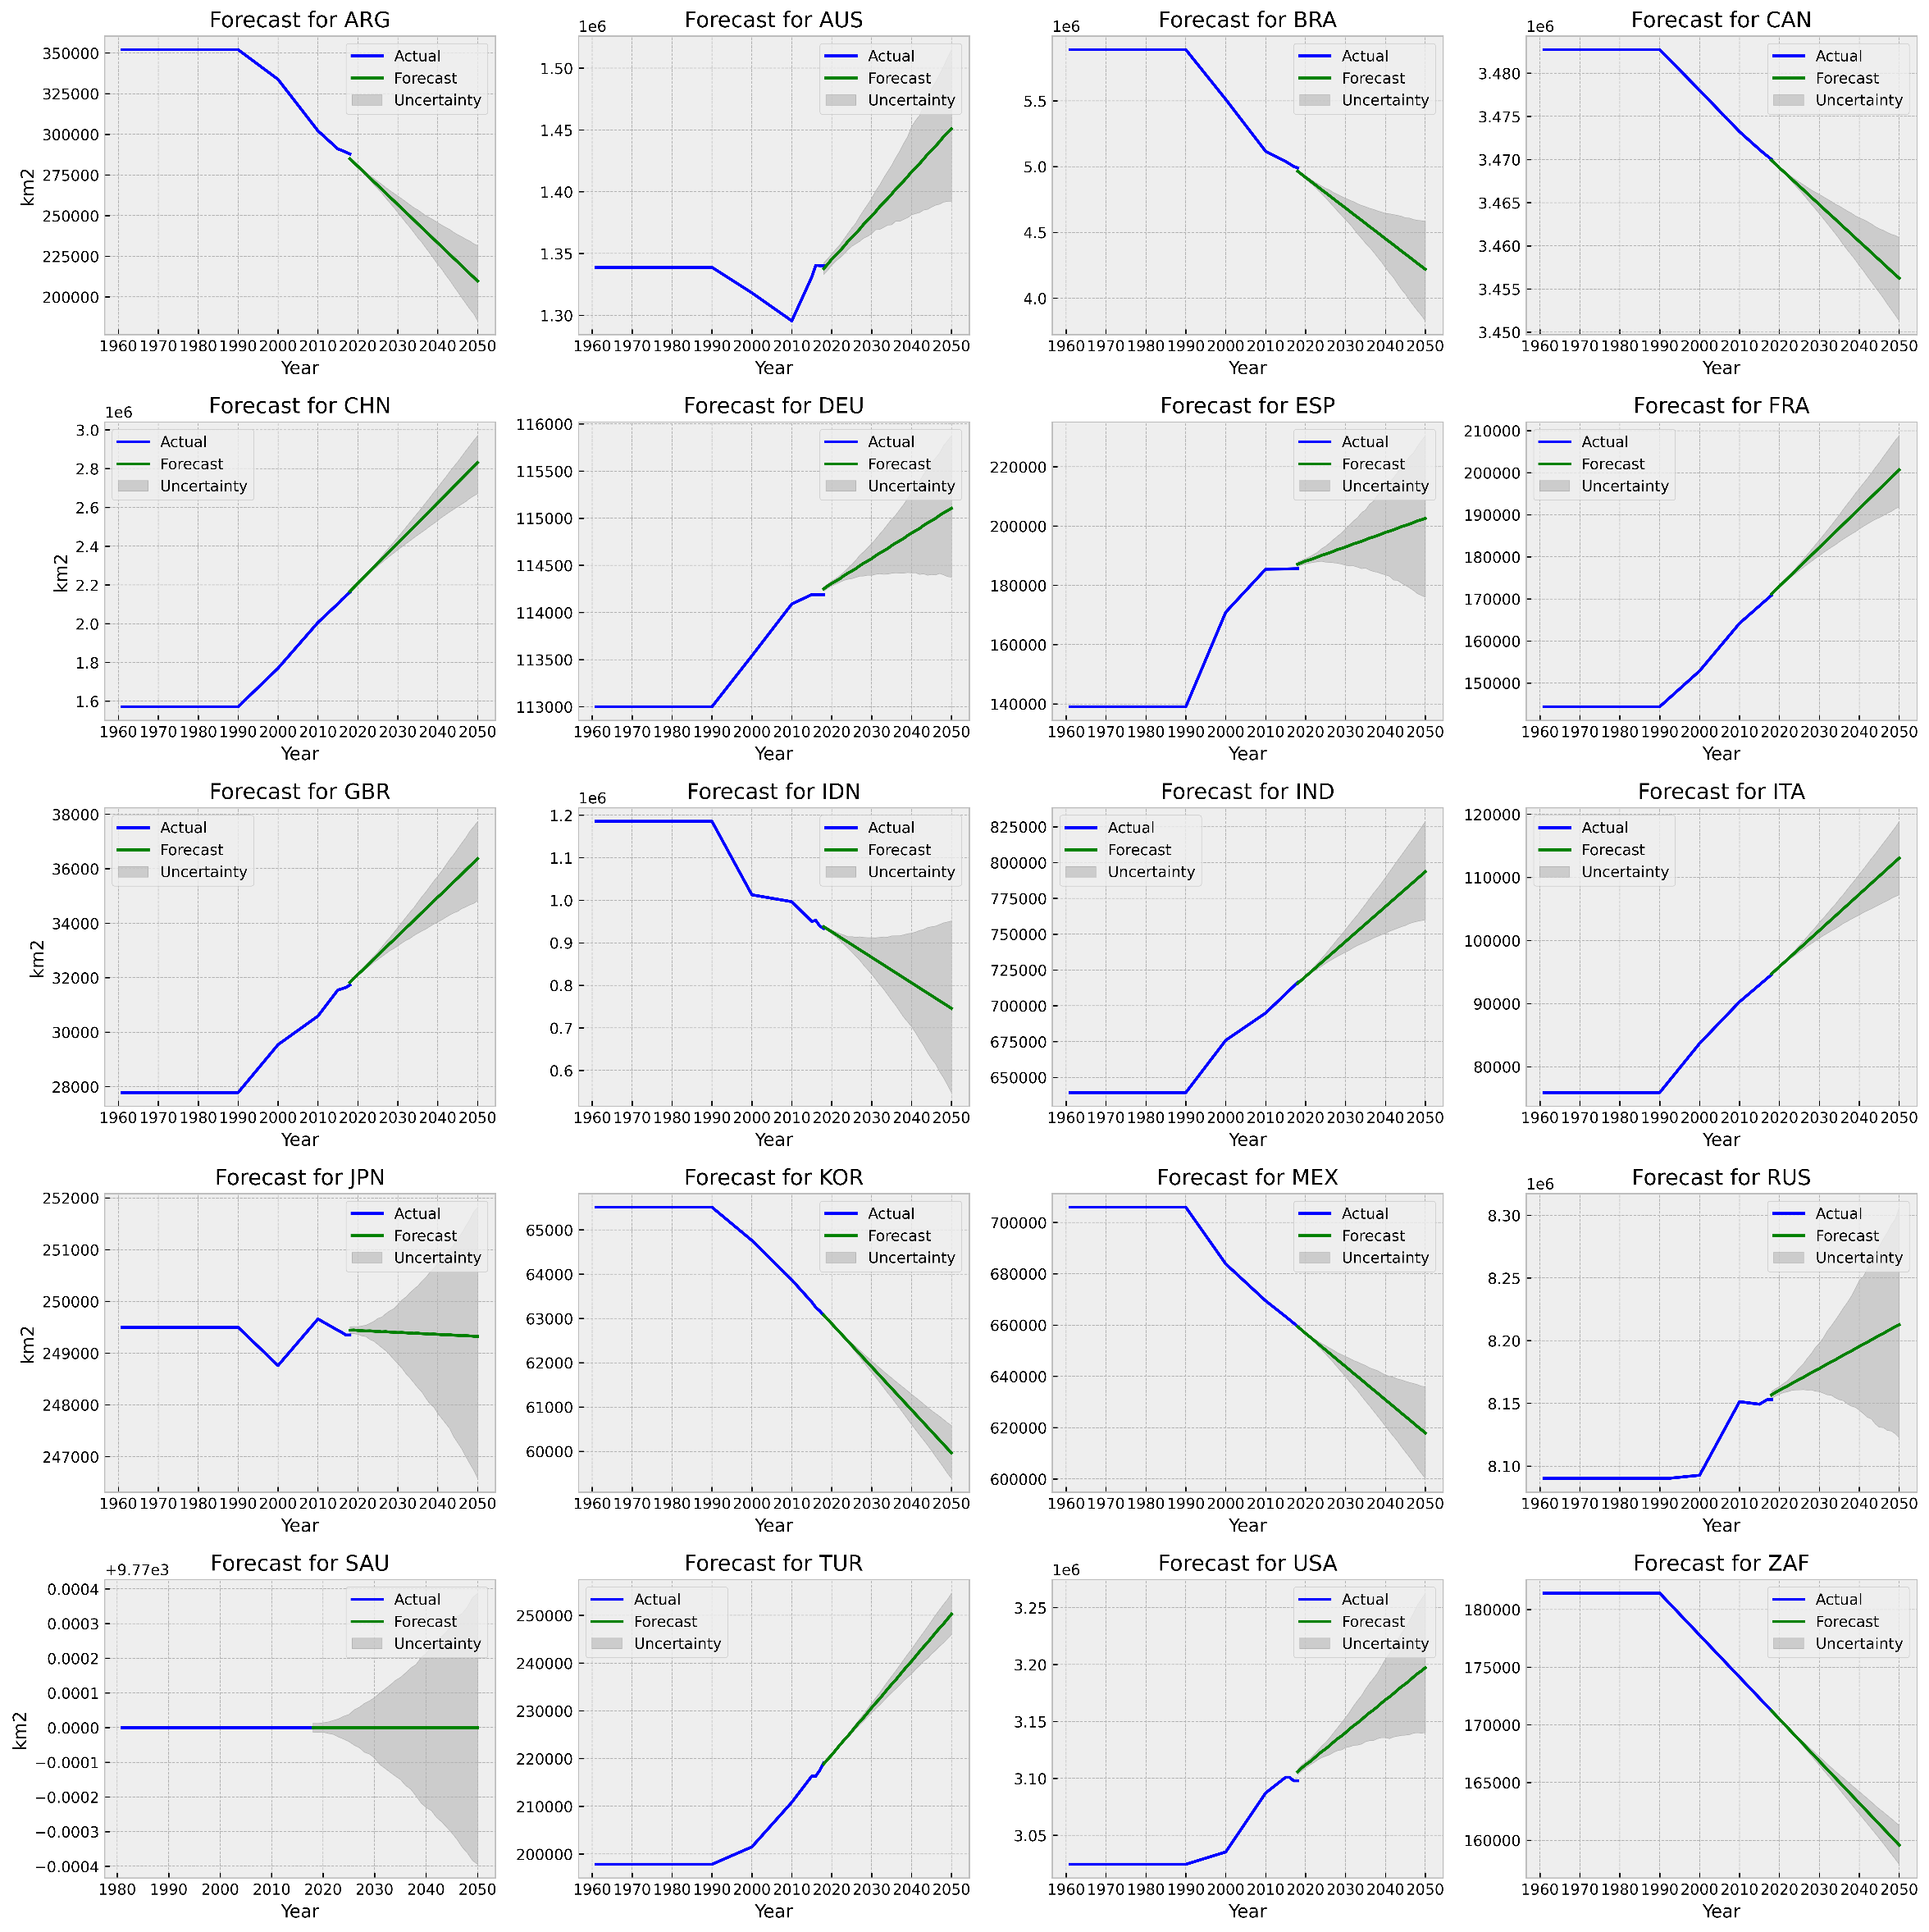
Figure SI 19 Forest Prophet forecast

Crops
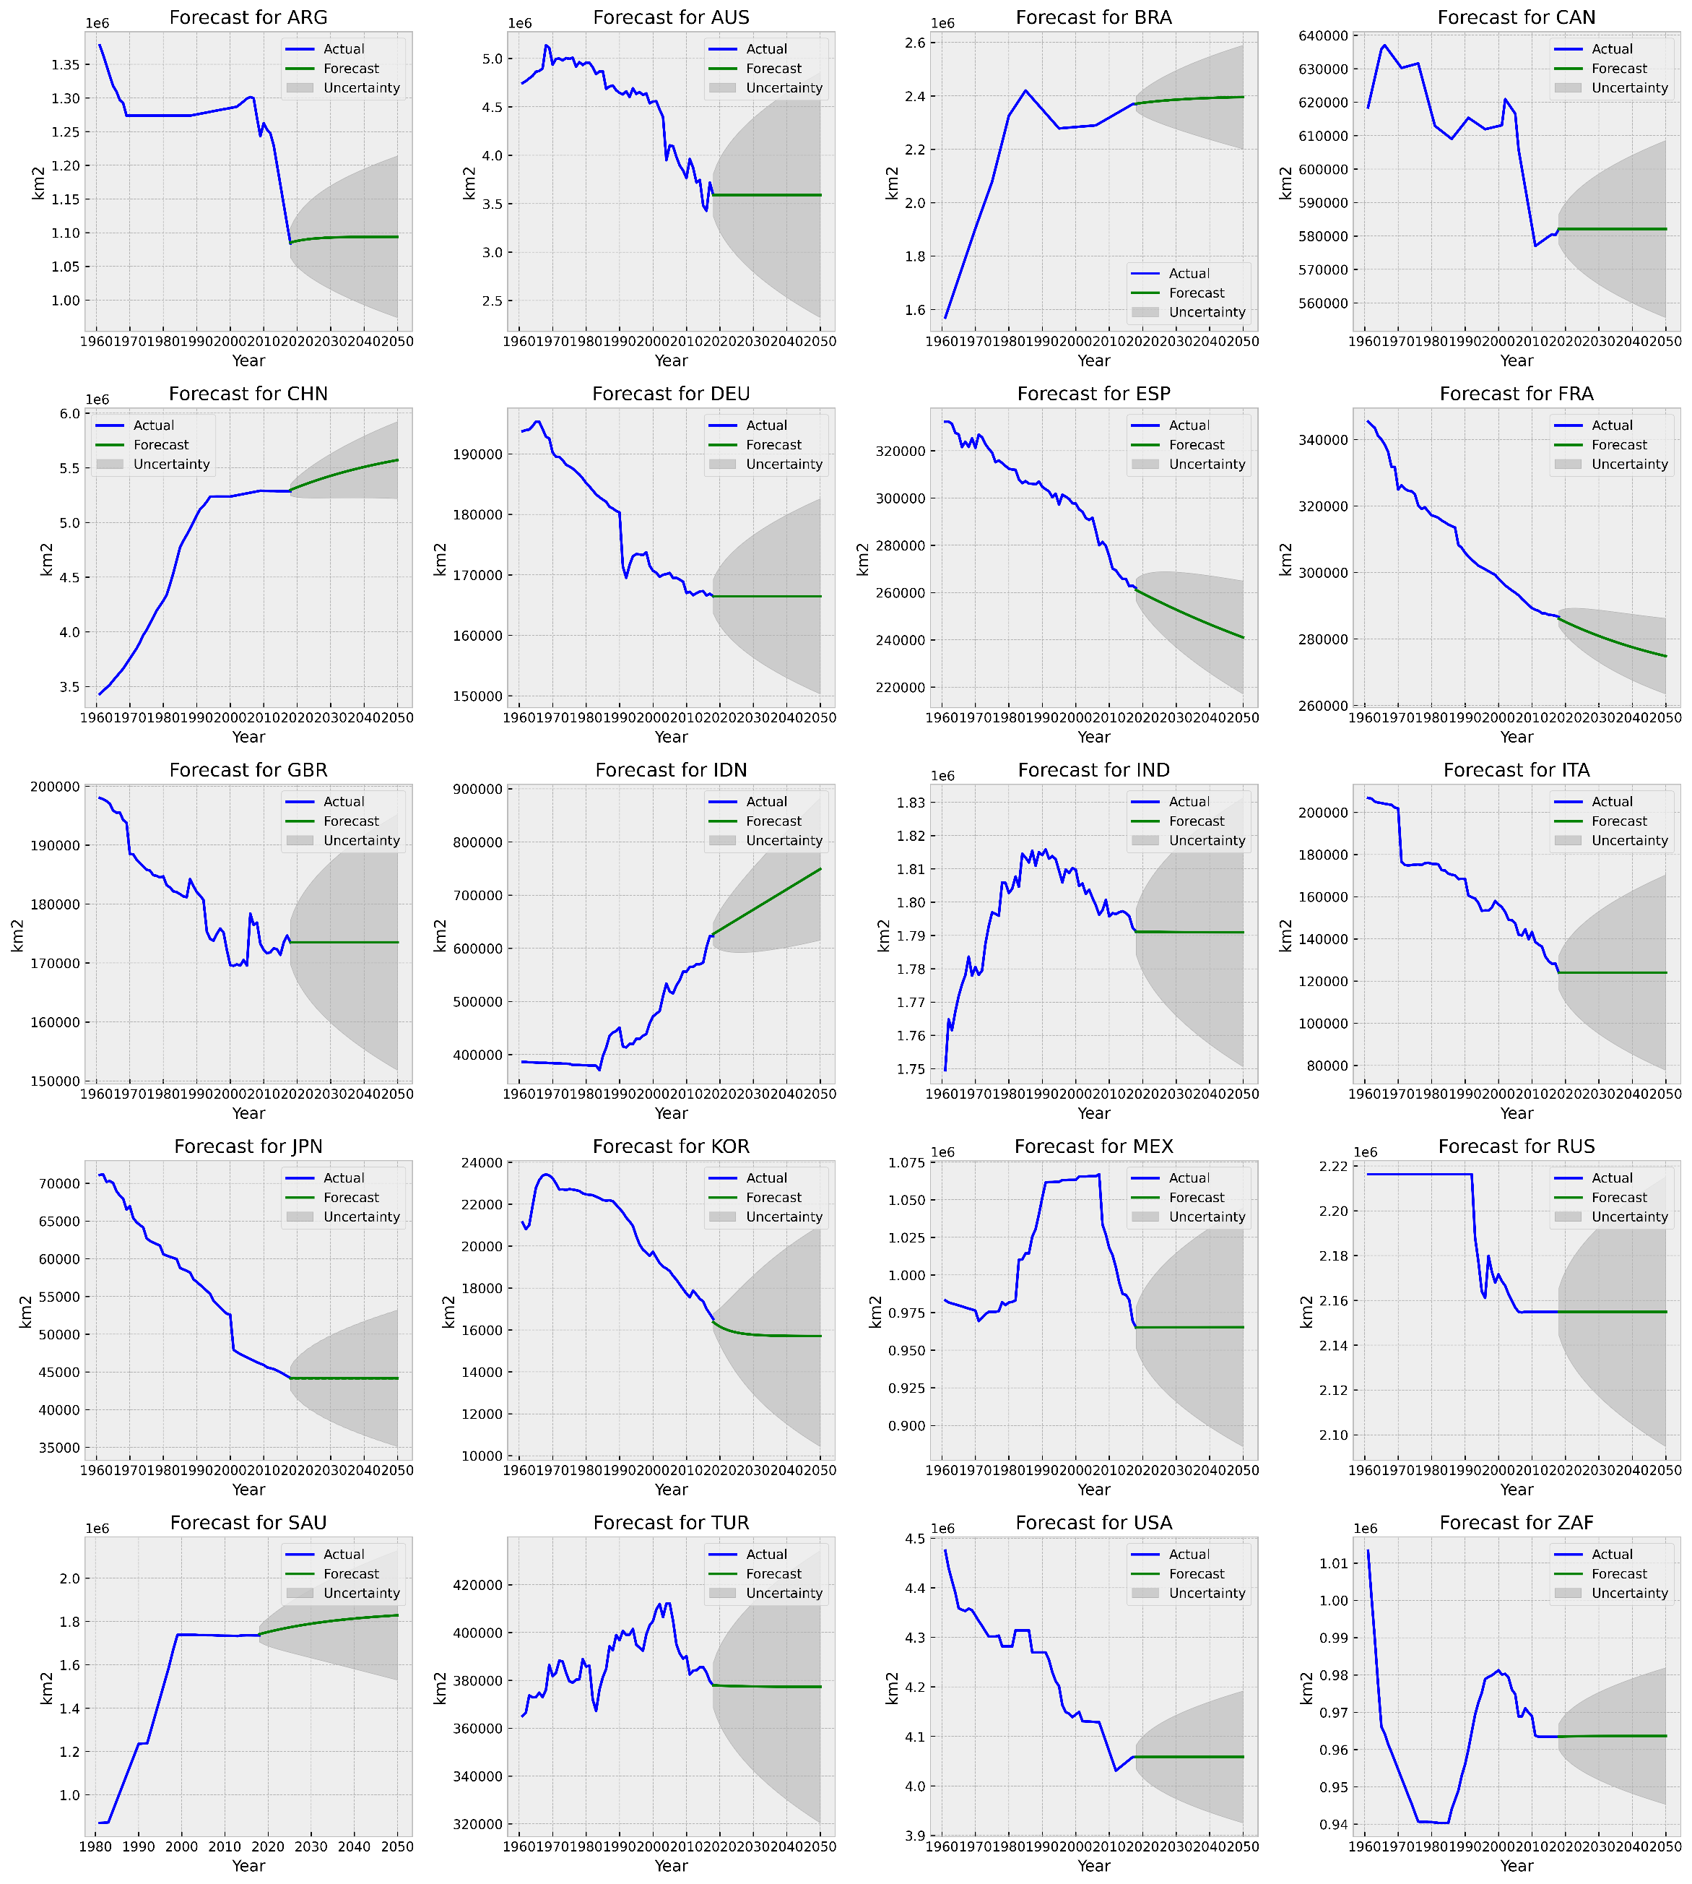
Figure SI 20 Crops ARIMA forecast

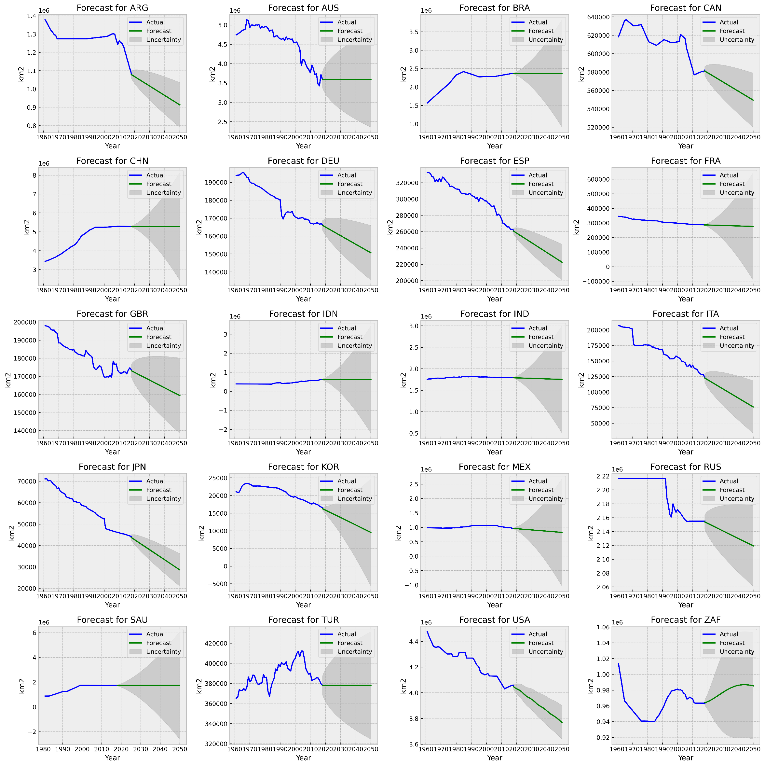
Figure SI 21 Crops AUTO-ARIMA forecast

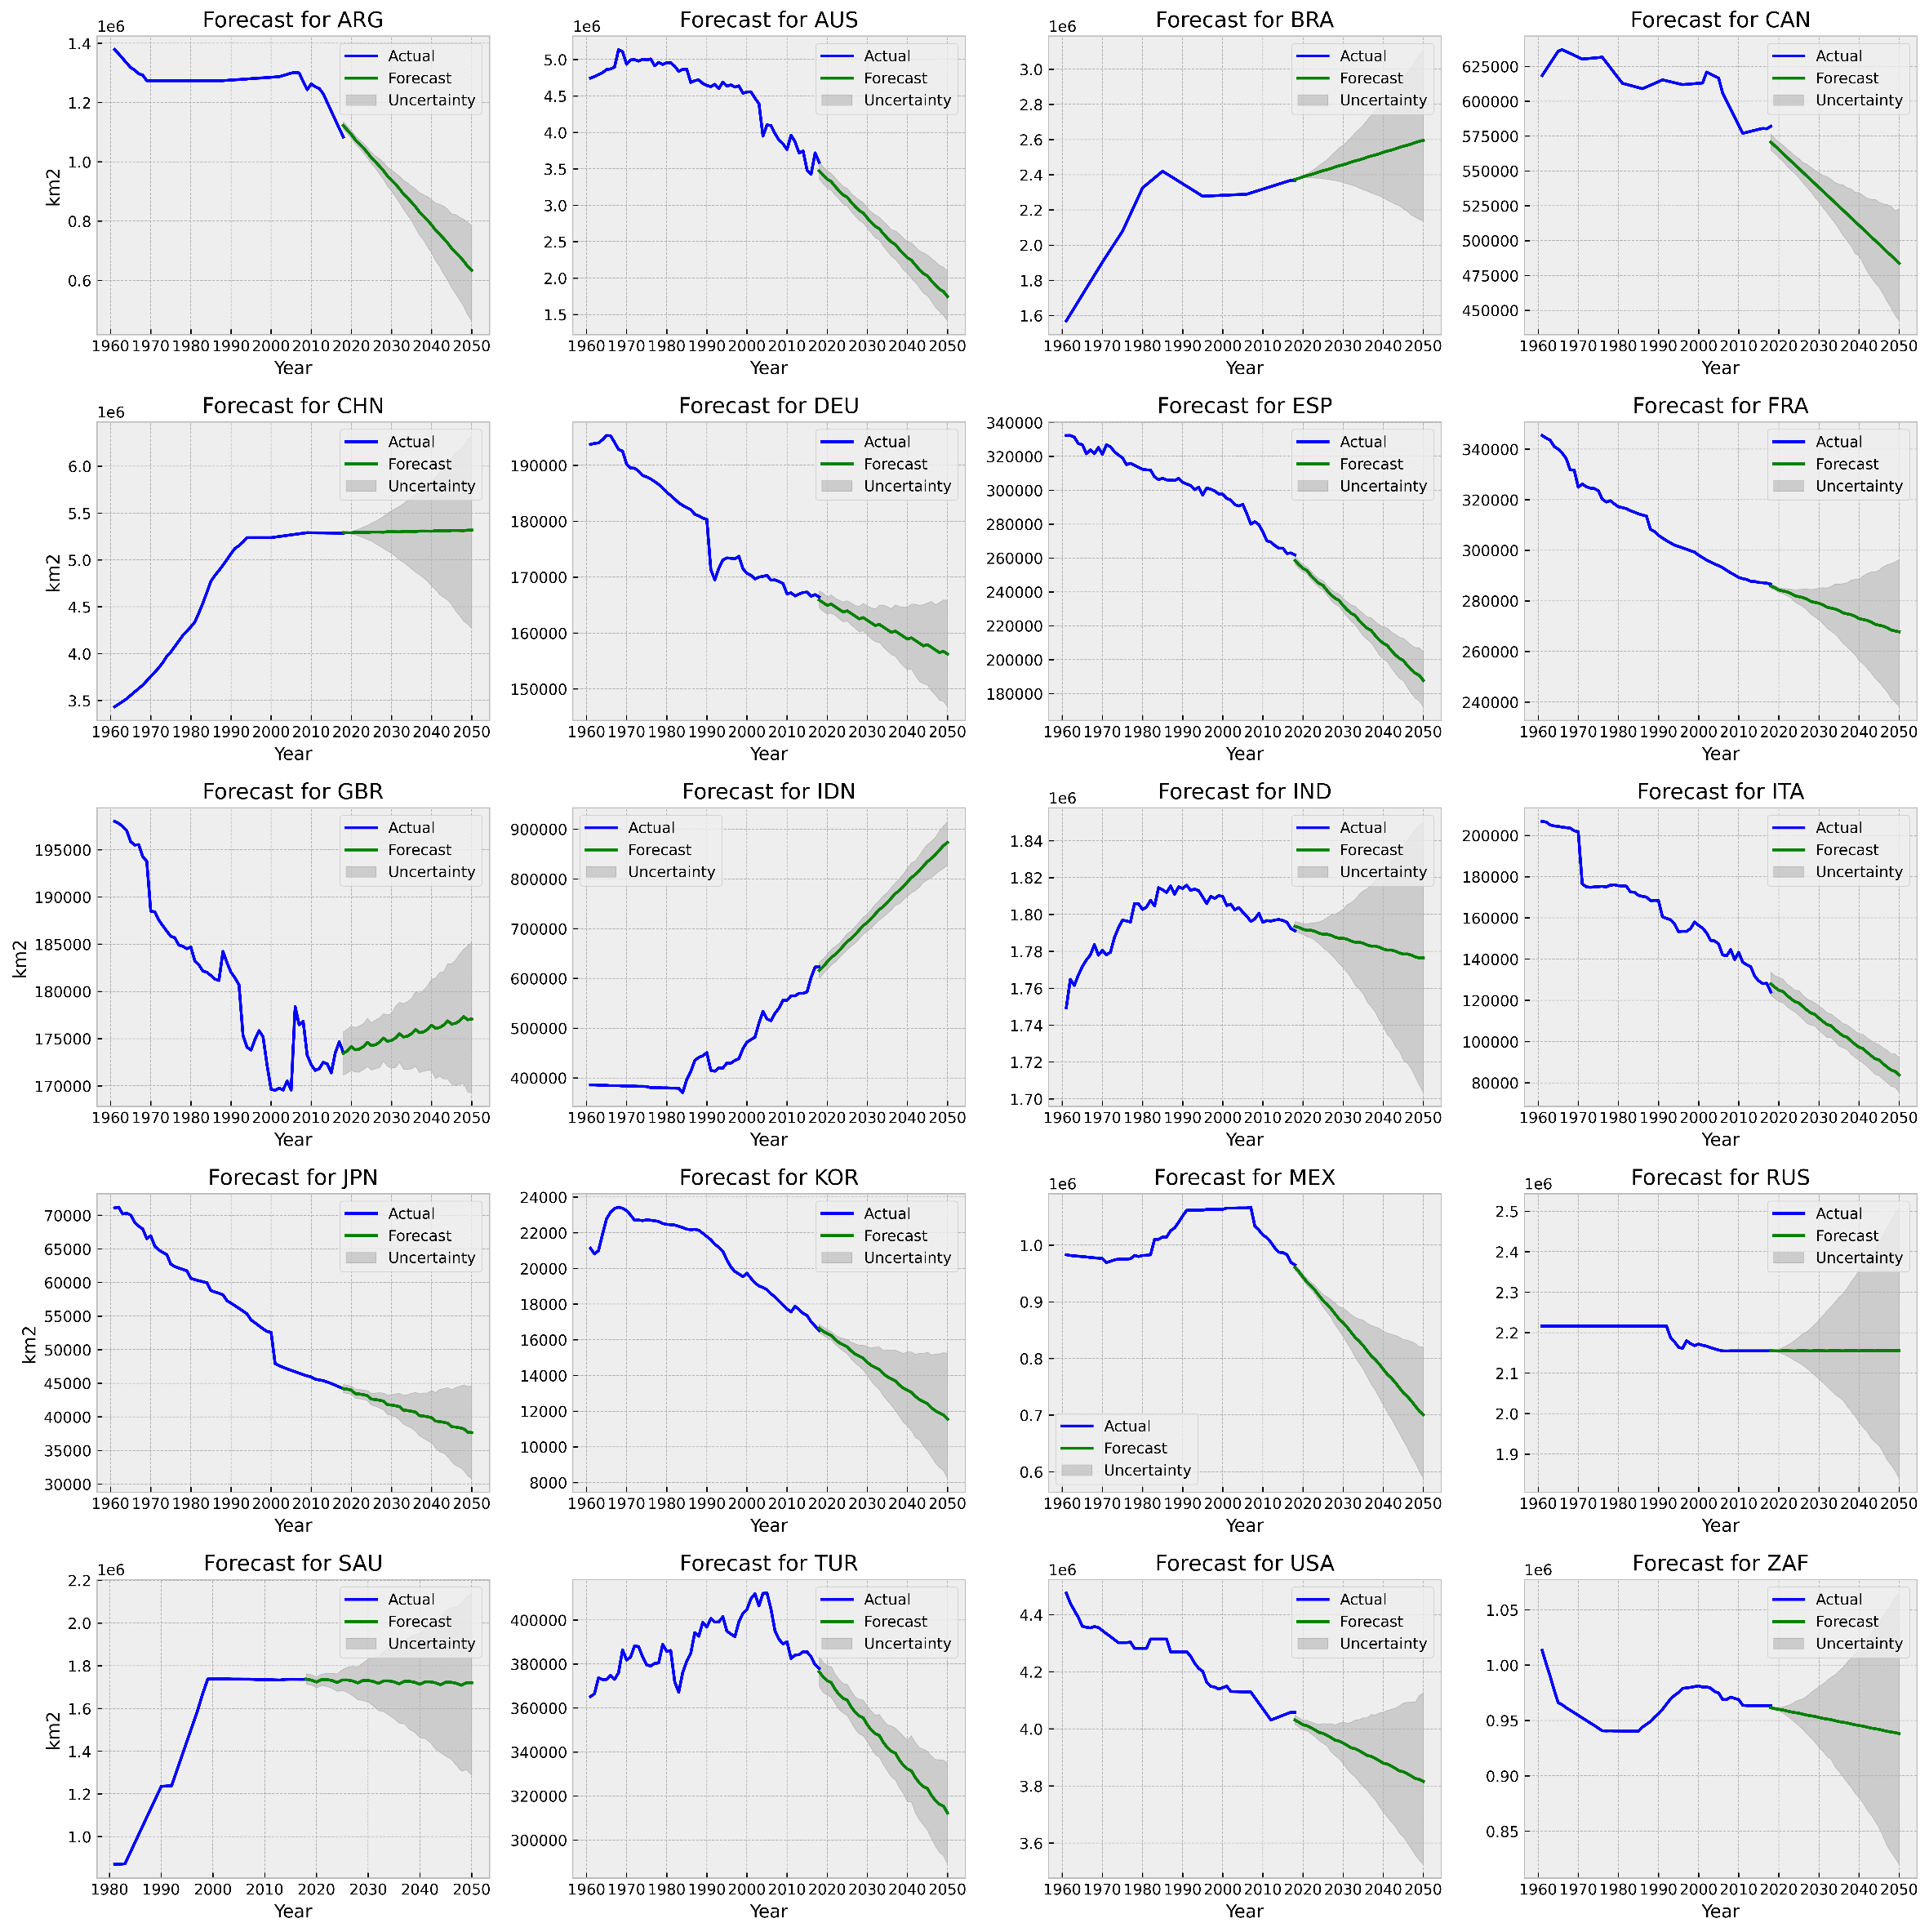
Figure SI 22 Crops Prophet forecast

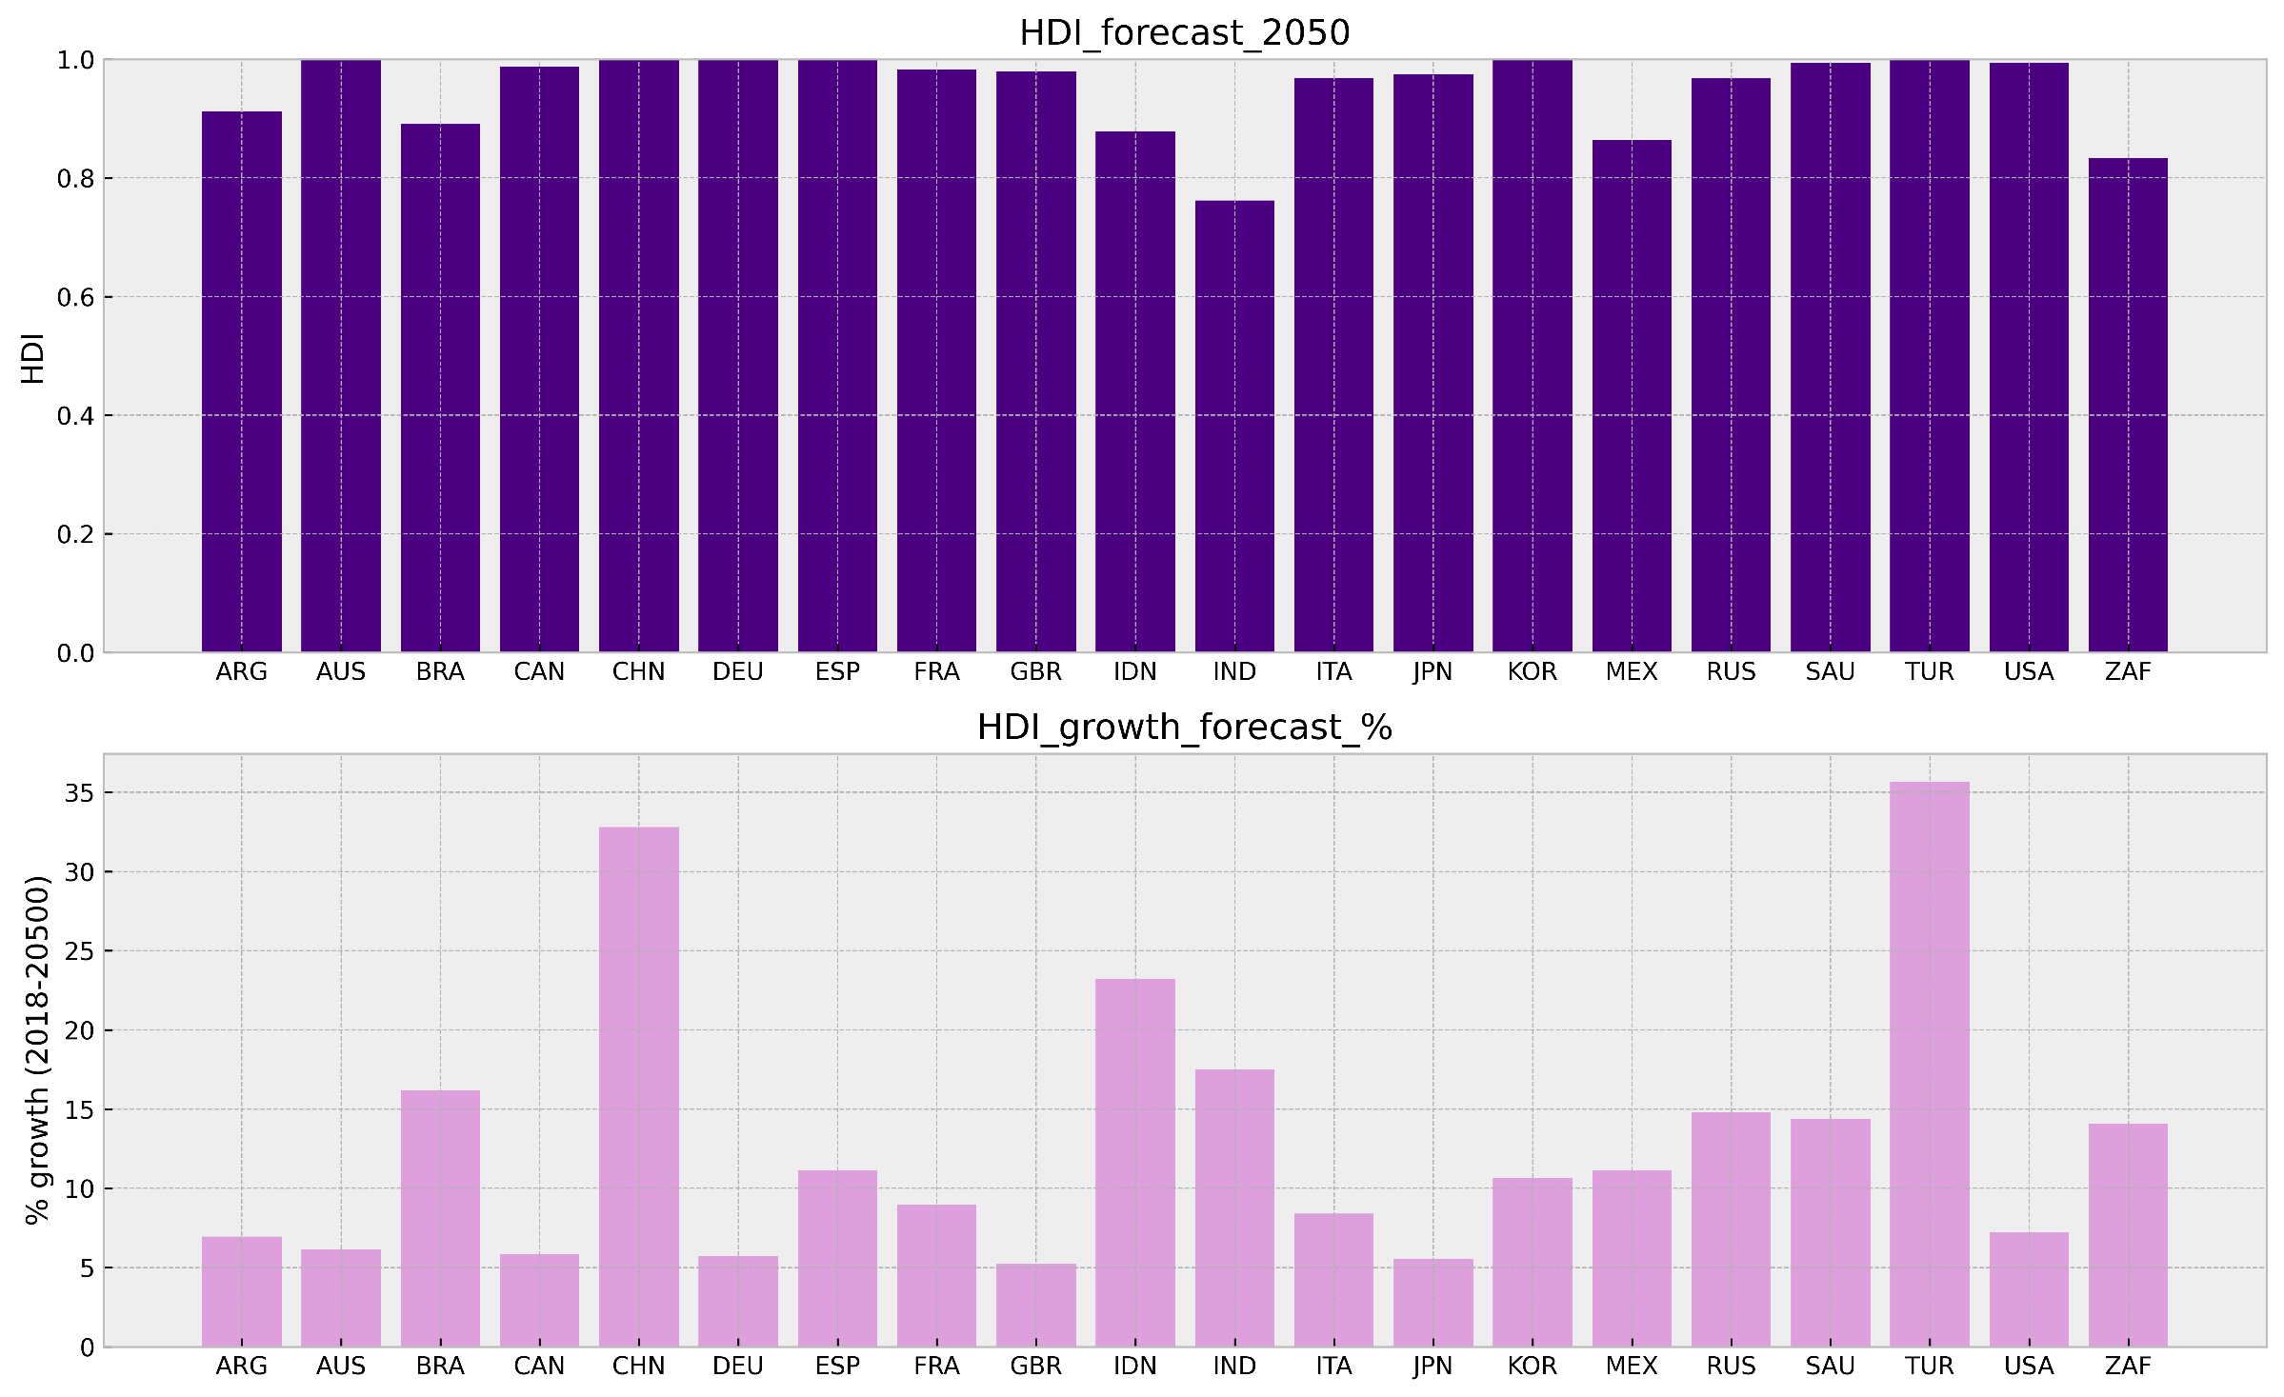
Figure SI 23 Human Development Index forecast (HDI)

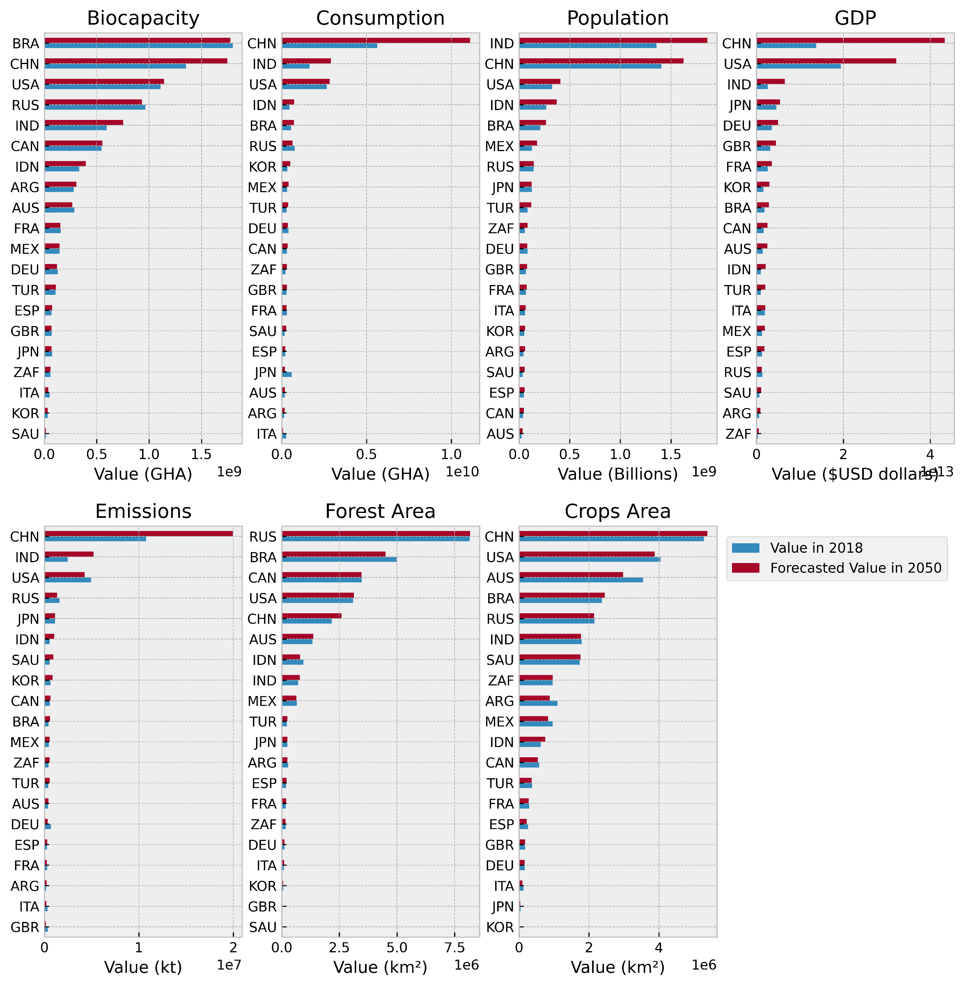
Figure SI 24 countries current vs forecasted values in 2050

Model Accuracy
Table SI 1 Population forecast model evaluation (avg)
Country | MAE | MSE | RMSE | MAPE
ARG | 97324.43 | 1.69E+10 | 129621.2 | 0.228094
AUS | 766263.8 | 9.2E+11 | 958986.5 | 3.259769
BRA | 5055074 | 3.59E+13 | 5988321 | 2.502804
CAN | 345244.7 | 2.08E+11 | 438744 | 0.9722
CHN | 21229454 | 7.16E+14 | 23263814 | 1.558945
DEU | 1639326 | 4.25E+12 | 1947192 | 2.014287
ESP | 1991704 | 4.62E+12 | 2125482 | 4.322238
FRA | 871777.7 | 1.06E+12 | 984851 | 1.326137
GBR | 2565836 | 8.96E+12 | 2955786 | 3.98809
IDN | 875696.4 | 1.68E+12 | 1093605 | 0.343983
IND | 14845307 | 3.99E+14 | 18855948 | 1.149645
ITA | 1412814 | 3.26E+12 | 1574434 | 2.358035
JPN | 2489616 | 8.79E+12 | 2957912 | 1.955083
KOR | 713660.1 | 7.38E+11 | 801389.3 | 1.417698
MEX | 511407.9 | 4.68E+11 | 596426.6 | 0.429988
RUS | 3484519 | 2.62E+13 | 4334657 | 2.422964
SAU | 1420783 | 3.12E+12 | 1610865 | 4.516905
TUR | 638075.3 | 8.81E+11 | 903968.3 | 0.817822
USA | 2029858 | 9.26E+12 | 2374536 | 0.644429
ZAF | 570777.8 | 6.84E+11 | 705645.5 | 1.061444

Table SI 2 GDP forecast model evaluation (avg)
Country | MAE | MSE | RMSE | MAPE
ARG | 1.37E+11 | 2.2E+22 | 1.46E+11 | 24.55575
AUS | 6.21E+10 | 7.53E+21 | 7.03E+10 | 4.8373
BRA | 2.15E+11 | 5.59E+22 | 2.36E+11 | 12.54724
CAN | 1.75E+11 | 3.61E+22 | 1.85E+11 | 11.83764
CHN | 2.44E+12 | 9.08E+24 | 2.93E+12 | 25.33121
DEU | 8.63E+10 | 1.25E+22 | 9.98E+10 | 2.715993
ESP | 8.69E+10 | 1.15E+22 | 1.03E+11 | 7.250385
FRA | 9.65E+10 | 1.37E+22 | 1.13E+11 | 3.996181
GBR | 9.11E+10 | 1.33E+22 | 1.03E+11 | 3.256057
IDN | 1.78E+11 | 4.62E+22 | 2.14E+11 | 22.40565
IND | 3.92E+11 | 2.68E+23 | 4.91E+11 | 20.20428
ITA | 2.38E+11 | 8.38E+22 | 2.89E+11 | 12.75623
JPN | 2.33E+11 | 9.52E+22 | 2.73E+11 | 5.349436
KOR | 3.99E+10 | 2.05E+21 | 4.38E+10 | 2.967281
MEX | 5.04E+10 | 3.47E+21 | 5.89E+10 | 4.517596
RUS | 4.14E+11 | 2E+23 | 4.38E+11 | 31.53654
SAU | 9.69E+10 | 1.22E+22 | 1.07E+11 | 15.40036
TUR | 1.92E+11 | 5.1E+22 | 2.26E+11 | 24.81534
USA | 7.46E+11 | 8.06E+23 | 8.67E+11 | 4.277468
ZAF | 3.96E+10 | 1.75E+21 | 4.16E+10 | 12.1879

Table SI 3 Emissions kt model evaluation (avg)
Country | MAE | MSE | RMSE | MAPE
ARG | 35014.82 | 1.45E+09 | 36856.74 | 20.2654
AUS | 32574.44 | 1.74E+09 | 37673.54 | 8.490102
BRA | 68896.83 | 7.8E+09 | 81082.18 | 15.71501
CAN | 83203.96 | 1.27E+10 | 93876.25 | 15.00415
CHN | 2668584 | 1.03E+13 | 2988651 | 29.91151
DEU | 46375.35 | 3.22E+09 | 51449.1 | 6.180919
ESP | 86445.7 | 1.13E+10 | 102832.7 | 33.07117
FRA | 41347.68 | 2.47E+09 | 49131.33 | 12.76817
GBR | 74832.03 | 9.02E+09 | 94011.32 | 18.32786
IDN | 73906.14 | 9.82E+09 | 86345.15 | 15.90889
IND | 541946.9 | 4.13E+11 | 634339.5 | 27.74095
ITA | 134197.9 | 3.09E+10 | 160664.2 | 38.07403
JPN | 53859.78 | 5.3E+09 | 68888.19 | 4.652432
KOR | 73013.85 | 7.52E+09 | 83275.59 | 12.4621
MEX | 58830.28 | 6.21E+09 | 71097.24 | 12.64898
RUS | 228570.1 | 1.12E+11 | 247783.1 | 14.03615
SAU | 61720.32 | 5.85E+09 | 72592.66 | 11.83987
TUR | 52260.67 | 5.29E+09 | 61373.01 | 15.37904
USA | 735085.2 | 8.8E+11 | 858891.2 | 14.51849
ZAF | 59775.44 | 7.04E+09 | 69075.82 | 14.13438

Table SI 4 Biocapacity forecast model evaluation (avg)
Country | MAE | MSE | RMSE | MAPE
ARG | 16781805 | 3.8E+14 | 19221914 | 6.056389
AUS | 20292373 | 5.47E+14 | 22072005 | 6.959919
BRA | 39053961 | 2.04E+15 | 41330164 | 2.164241
CAN | 5477361 | 5.59E+13 | 7445900 | 1.008191
CHN | 68246690 | 8.55E+15 | 74007951 | 5.341585
DEU | 8207774 | 1.18E+14 | 9929196 | 5.986129
ESP | 5983173 | 5.82E+13 | 7584039 | 10.22849
FRA | 11843427 | 2.53E+14 | 14785989 | 7.413067
GBR | 5615390 | 4.44E+13 | 6239404 | 7.911329
IDN | 18857311 | 4.57E+14 | 21118130 | 5.922857
IND | 40406597 | 2.92E+15 | 47242605 | 7.422962
ITA | 4368508 | 2.86E+13 | 5027551 | 8.056754
JPN | 1503896 | 3.99E+12 | 1688110 | 1.964215
KOR | 1098877 | 1.95E+12 | 1232968 | 3.287568
MEX | 3509170 | 1.84E+13 | 4197355 | 2.444831
RUS | 78095767 | 1.5E+16 | 85173979 | 8.06526
SAU | 2460888 | 8.25E+12 | 2501569 | 18.05744
TUR | 4464788 | 3.78E+13 | 5385549 | 4.211634
USA | 24954066 | 9.7E+14 | 30366220 | 2.25621
ZAF | 1408771 | 3.21E+12 | 1790875 | 2.545561

Table SI 5 Forest km2 forecast model evaluation (avg)
Country | MAE | MSE | RMSE | MAPE
ARG | 10778.71 | 1.93E+08 | 12421.47 | 3.638236
AUS | 18519.35 | 7.62E+08 | 26584.93 | 1.39289
BRA | 122441.3 | 3.09E+10 | 148466 | 2.416103
CAN | 974.4529 | 2881662 | 1135.514 | 0.028067
CHN | 68464.82 | 1.36E+10 | 77715.67 | 3.318626
DEU | 79.88221 | 14938.96 | 116.8389 | 0.069974
ESP | 7337.192 | 1.34E+08 | 8925.062 | 3.970132
FRA | 2693.721 | 16214798 | 3057.26 | 1.618021
GBR | 331.8324 | 196213.5 | 409.4255 | 1.062938
IDN | 44224.6 | 4.37E+09 | 50434.85 | 4.575942
IND | 7207.282 | 84782756 | 8331.893 | 1.023745
ITA | 1642.29 | 6114956 | 1943.94 | 1.781965
JPN | 528.8228 | 359139.4 | 558.1621 | 0.211974
KOR | 131.5325 | 40267.6 | 167.1052 | 0.207343
MEX | 5795.766 | 65634252 | 6573.126 | 0.870939
RUS | 23853.63 | 7.73E+08 | 27251.92 | 0.292777
SAU | 3256.667 | 31817633 | 3256.667 | 33.33333
TUR | 3677.229 | 25925450 | 4182.568 | 1.717122
USA | 21036.2 | 6.79E+08 | 23958.73 | 0.680509
ZAF | 829.7965 | 2750595 | 957.5667 | 0.480034

Table SI 6 Crops km2 forecast model evaluation (avg)
Country | MAE | MSE | RMSE | MAPE
ARG | 74272.92 | 1.03E+10 | 101409.4 | 6.399818
AUS | 431252.9 | 2.48E+11 | 460069.7 | 11.49832
BRA | 35368.94 | 1.96E+09 | 43736.47 | 1.507069
CAN | 30875 | 1.16E+09 | 34076.62 | 5.296801
CHN | 183281.4 | 6.45E+10 | 209891.6 | 3.467591
DEU | 1856.515 | 5093377 | 2135.767 | 1.108774
ESP | 14875.79 | 2.91E+08 | 16901.16 | 5.538999
FRA | 1720.949 | 7928938 | 2147.532 | 0.597292
GBR | 9462.482 | 1.07E+08 | 10165.57 | 5.445724
IDN | 44685.94 | 2.69E+09 | 50677.62 | 7.743302
IND | 9035.099 | 1.83E+08 | 10341.97 | 0.503079
ITA | 4037.566 | 28525900 | 4960.927 | 3.047331
JPN | 2962.939 | 13322325 | 3417.982 | 6.556688
KOR | 636.3225 | 749908.5 | 739.1109 | 3.650545
MEX | 55403.92 | 4.6E+09 | 67369.06 | 5.586144
RUS | 6216.273 | 44097379 | 6475.541 | 0.288428
SAU | 96498.65 | 1.66E+10 | 107345.4 | 5.560871
TUR | 23534.32 | 7.21E+08 | 26293.95 | 6.108484
USA | 37442.95 | 2.28E+09 | 44675.88 | 0.920985
ZAF | 11617.67 | 2.16E+08 | 12470.67 | 1.203058

Table SI 7 kwh per capita forecast model evaluation (avg)
Country | MAE | MSE | RMSE | MAPE
ARG | 270.0973 | 101414.5 | 300.4861 | 9.298558
AUS | 1713.389 | 4192279 | 2044.598 | 16.7191
BRA | 242.6138 | 78252.69 | 271.5918 | 9.804152
CAN | 1978.413 | 4871940 | 2193.778 | 12.6379
CHN | 611.0419 | 828363.5 | 700.4752 | 18.7057
DEU | 483.9238 | 461066.4 | 587.4315 | 6.819861
ESP | 1261.915 | 2522810 | 1538.477 | 23.11571
FRA | 1249.926 | 2281004 | 1502.375 | 17.55592
GBR | 1125.37 | 1795815 | 1326.832 | 21.1334
IDN | 150.3793 | 39117.32 | 193.5405 | 18.05032
IND | 145.1393 | 28273.56 | 167.2905 | 20.01761
ITA | 1176.491 | 2031239 | 1424.061 | 22.79825
JPN | 1188.452 | 2495636 | 1384.319 | 14.89794
KOR | 443.7615 | 426285.9 | 639.7247 | 4.39803
MEX | 394.4597 | 203358.4 | 450.3069 | 18.57843
RUS | 1095.526 | 2020134 | 1164.096 | 16.97254
SAU | 621.303 | 504060 | 709.103 | 6.963336
TUR | 269.9603 | 87078.79 | 293.1343 | 10.39802
USA | 918.8591 | 1575864 | 1075.627 | 7.017759
ZAF | 531.5347 | 464945.8 | 636.0471 | 12.35253

Table SI 8 kg oileq PerCapita mode forecast evaluation (avg)
Country | MAE | MSE | RMSE | MAPE
ARG | 292.5867 | 96635.41 | 305.5181 | 14.98337
AUS | 440.2707 | 320799.1 | 565.2536 | 7.994048
BRA | 211.1651 | 57286.31 | 236.2993 | 14.93941
CAN | 841.0628 | 1043916 | 952.1741 | 10.81457
CHN | 416.347 | 280951.1 | 471.7929 | 20.69262
DEU | 634.718 | 674179.5 | 684.6788 | 16.34578
ESP | 811.4754 | 922377.2 | 958.7331 | 30.95807
FRA | 739.3569 | 727020.8 | 848.998 | 19.47835
GBR | 639.5819 | 536602.6 | 730.0147 | 21.82935
IDN | 52.77493 | 5555.606 | 61.4759 | 6.162887
IND | 96.08415 | 12130.54 | 109.5353 | 16.13079
ITA | 727.0828 | 771409.1 | 876.1951 | 28.03629
JPN | 640.8865 | 664544.6 | 746.8917 | 18.06773
KOR | 385.3901 | 300775.9 | 435.2088 | 7.594349
MEX | 140.7941 | 30720.36 | 167.8523 | 9.000479
RUS | 702.283 | 1223053 | 761.4577 | 14.32328
SAU | 765.7296 | 650834.5 | 801.2073 | 11.30332
TUR | 154.7476 | 29238.84 | 170.0891 | 10.02815
USA | 608.7574 | 510632.1 | 710.9019 | 8.765712
ZAF | 227.9442 | 59804.02 | 243.6388 | 8.293209

Table SI 9 emissions Mt cap model forecast evaluation (avg)
Country | MAE | MSE | RMSE | MAPE
ARG | 0.56598 | 0.370016 | 0.595643 | 13.67669
AUS | 1.71564 | 5.909087 | 2.053161 | 10.45643
BRA | 0.365326 | 0.205026 | 0.417159 | 16.86498
CAN | 2.191616 | 6.946064 | 2.48673 | 13.88669
CHN | 1.390401 | 2.932903 | 1.500975 | 21.62438
DEU | 0.524461 | 0.363958 | 0.598965 | 5.721206
ESP | 2.700905 | 10.52071 | 3.195005 | 48.02727
FRA | 0.871181 | 0.999094 | 0.99951 | 17.66015
GBR | 1.532601 | 3.647797 | 1.880471 | 24.16474
IDN | 0.148249 | 0.03214 | 0.172089 | 8.29173
IND | 0.389481 | 0.21209 | 0.453339 | 25.51947
ITA | 1.929644 | 5.595166 | 2.334722 | 33.06779
JPN | 0.354508 | 0.22347 | 0.46114 | 3.906747
KOR | 1.172978 | 1.88885 | 1.334065 | 10.10056
MEX | 0.250608 | 0.118558 | 0.32764 | 6.462085
RUS | 1.263663 | 4.003984 | 1.349199 | 11.16243
SAU | 0.936857 | 1.898398 | 1.347011 | 5.756664
TUR | 0.750878 | 0.756945 | 0.840225 | 16.91881
USA | 2.88984 | 11.40402 | 3.347428 | 18.08659
ZAF | 0.650923 | 0.635764 | 0.728615 | 8.07946

Table SI 10 gdp PerCap model forecast evaluation (avg)
Country | MAE | MSE | RMSE | MAPE
ARG | 2983.318 | 10174182 | 3149.41 | 22.37996
AUS | 1578.737 | 4674409 | 1877.075 | 2.862667
BRA | 1112.46 | 1591876 | 1229.064 | 12.87501
CAN | 3946.266 | 20283376 | 4143.268 | 9.324776
CHN | 1702.085 | 4393298 | 2029.743 | 24.15372
DEU | 777.6934 | 936285.7 | 951.4828 | 1.999642
ESP | 2432.271 | 10948282 | 2958.83 | 9.450114
FRA | 2091.73 | 6493607 | 2499.576 | 5.712304
GBR | 3243.404 | 15782063 | 3833.878 | 7.304572
IDN | 594.3487 | 535029.3 | 710.7361 | 18.89679
IND | 284.4815 | 120164.7 | 346.5037 | 19.04857
ITA | 5298.011 | 39554899 | 6287.835 | 17.02252
JPN | 1371.252 | 3712221 | 1651.291 | 4.02378
KOR | 553.827 | 404844.9 | 608.045 | 2.153966
MEX | 419.9368 | 285220 | 481.2367 | 4.48157
RUS | 2330.61 | 7270922 | 2473.059 | 25.65392
SAU | 2187.131 | 6682118 | 2355.195 | 10.89333
TUR | 2130.458 | 5845411 | 2410.354 | 21.16713
USA | 2372.185 | 8144703 | 2660.958 | 4.302267
ZAF | 1076.295 | 1328664 | 1118.877 | 17.5626

Table SI 11 Area PerCap model forecast evaluation (avg)
Country | MAE | MSE | RMSE | MAPE
ARG | 0.266441 | 0.119093 | 0.312641 | 4.306824
AUS | 3.054803 | 10.94123 | 3.190699 | 9.690558
BRA | 0.232312 | 0.080843 | 0.278234 | 5.388217
CAN | 0.377031 | 0.414347 | 0.469666 | 1.7575
CHN | 0.01518 | 0.000399 | 0.018078 | 1.947324
DEU | 0.004787 | 3.76E-05 | 0.00584 | 0.596873
ESP | 0.049893 | 0.00409 | 0.060111 | 4.335641
FRA | 0.008564 | 0.000133 | 0.010718 | 0.73032
GBR | 0.038723 | 0.001943 | 0.043622 | 3.302896
IDN | 0.075827 | 0.01013 | 0.09004 | 5.542115
IND | 0.011874 | 0.000269 | 0.014347 | 2.770786
ITA | 0.029063 | 0.001216 | 0.034763 | 3.48724
JPN | 0.012868 | 0.000309 | 0.015239 | 1.66366
KOR | 0.024453 | 0.001212 | 0.030066 | 2.719471
MEX | 0.088577 | 0.019855 | 0.113174 | 4.863691
RUS | 0.70383 | 1.453852 | 0.775188 | 6.661927
SAU | 1.404476 | 2.779196 | 1.549833 | 23.55818
TUR | 0.032484 | 0.001883 | 0.040117 | 3.360805
USA | 0.082092 | 0.015379 | 0.093456 | 2.590896
ZAF | 0.108704 | 0.032751 | 0.135055 | 4.746578

Table SI 11 Biocap PerCap model forecast evaluation (avg)
Country | MAE | MSE | RMSE | MAPE
ARG | 0.336924 | 0.210302 | 0.421903 | 5.198063
AUS | 0.936154 | 1.396579 | 1.042241 | 7.250171
BRA | 0.548588 | 0.511047 | 0.644475 | 6.138892
CAN | 0.903006 | 1.29764 | 1.003209 | 5.873214
CHN | 0.052703 | 0.003657 | 0.056405 | 5.344412
DEU | 0.101649 | 0.018948 | 0.134224 | 6.189391
ESP | 0.21666 | 0.062846 | 0.25002 | 16.86271
FRA | 0.24612 | 0.094867 | 0.291286 | 9.822518
GBR | 0.171291 | 0.035418 | 0.185407 | 15.52927
IDN | 0.104292 | 0.016053 | 0.121726 | 8.262826
IND | 0.020049 | 0.000561 | 0.023681 | 2.932513
ITA | 0.122329 | 0.020642 | 0.139492 | 12.91344
JPN | 0.027759 | 0.00109 | 0.032269 | 3.388174
KOR | 0.054536 | 0.004165 | 0.059979 | 5.85061
MEX | 0.033849 | 0.001677 | 0.039544 | 2.741282
RUS | 0.407942 | 0.390947 | 0.461208 | 6.093234
SAU | 0.126754 | 0.017309 | 0.13138 | 17.80153
TUR | 0.095161 | 0.018813 | 0.11074 | 6.737472
USA | 0.112079 | 0.01877 | 0.134628 | 3.205854
ZAF | 0.164362 | 0.038273 | 0.185773 | 15.65808

Table SI 13 EFConsPerCap model forecast evaluation (avg)
Country | MAE | MSE | RMSE | MAPE
ARG | 0.27966 | 0.144799 | 0.343381 | 8.693426
AUS | 0.765605 | 0.722489 | 0.849859 | 9.95888
BRA | 0.169801 | 0.038797 | 0.195433 | 6.317036
CAN | 0.644657 | 0.547613 | 0.727508 | 7.768937
CHN | 0.814701 | 0.778624 | 0.881653 | 24.64615
DEU | 0.29005 | 0.121328 | 0.347802 | 5.692444
ESP | 1.66939 | 3.913805 | 1.974857 | 40.54746
FRA | 0.347097 | 0.175956 | 0.419292 | 7.177283
GBR | 0.742963 | 0.826709 | 0.888621 | 15.80516
IDN | 0.119983 | 0.025668 | 0.146097 | 7.55621
IND | 0.170878 | 0.038957 | 0.195077 | 15.52317
ITA | 1.087704 | 1.853602 | 1.33298 | 24.42007
JPN | 0.680521 | 0.701765 | 0.733131 | 14.61074
KOR | 0.538543 | 0.444279 | 0.635386 | 9.266168
MEX | 0.46274 | 0.340981 | 0.560571 | 18.04725
RUS | 0.691067 | 0.778604 | 0.760976 | 12.8545
SAU | 1.11585 | 1.635901 | 1.165349 | 19.92652
TUR | 0.332104 | 0.144421 | 0.359263 | 10.29118
USA | 1.122671 | 1.634329 | 1.276114 | 13.54853
ZAF | 0.583961 | 0.527069 | 0.69722 | 14.91111

