Supplementary Material

Table: 1: Safe Permissible Limit of Heavy Metals in Fruits, Vegetables, Water, and Soil as FAO /WHO standard 2001, 2007 and IS: 10500:1993
Metal | Fruits/Veg.  ( mg/kg) | Soil  ( mg/kg) | Water  (mg/l) | Papaya  (mg/kg) | Guava  (mg/kg) | Effluent  IS:10500  (mg/l)
Cu | 73 | 5-5.6 | 2 |  |  | 3.0
Pb | 0.30 | 2-13.4 | 0.01 | Nd | 0.58 | 0.10
Cd | 0.20 | 0.1 | 0.003 | Nd | Nd | 1.0
Cr | 0.1-1 | 10-80 | 0.05 |  |  | 2.0
Zn | 99.4 | 60-780 | 3 |  |  | 15
Ni | 1-10 | 10-50 | 0.02 | 0.26 | Nd | 3
Nd= not detectable, Source a=Adue et.al 2012

Table 2: Pb concentration in effluent, canal, pond, tube well water and soil
Sl. No | Sample  & year | Canal Water (mg/l) | Effluent (mg/l) | Pond water (mg/l) | Tube well water (mg/l) | Soil  (mg/kg)
1. | *S-12 | 0.05 | 0.07 | 0.01 | 0.007 | 1.16
2 | S-12 | 0.05 | 0.08 | 0.25 | ------ | 11.14
3. | S-12 | 0.104 | ----- | ------ | ------ | 17.32
4. | S-12 | 0.03 | ----- | ------ | ------ | 41.20
5. | S-13 | 0.014 | 0.25 | 0.016 | 0.058 | 90.80
6. | S-13 | 0.15 | 1.84 | 0.01 | ------ | ------
7. | S-13 | 0.10 | 0.10 | ------ | ------ | ------
8. | S-13 | 0.10 | 0.14 | ------ | ------ | ------
9. | S-13 | ---- | 0.17 | ------ | ------ | ------
 | Mean | 0..38 | 0.074 | 0.07 | 0.02 | 32.32
 | S.D | 0.27 | 0.67 | 0.10 | 0.02 | 32.07
*S-12, 13 indicates sample of the 1st year and 2nd year. As per WHO safe limits of Pb concentration in canal water, Effluent, Pond water, tube well water, and soil were very significantly higher (39-fold, 7-fold, 7-fold, 10-fold, ). Further, Mean Pb concentration was found in canal water > soil> effluent ˃ Pond ≥ tube well water. Again, Pb level increases from year 1st year to 2nd year in canal water (0.03 mg/l to 0.15 mg/l), effluent (0.07mg/l to 1.84 mg/l), and tube well water (0.007 mg/l to 0.058 mg/l), and soil (from 1.16mg/kg to 90.80 mg/kg).
Table 3: Content of Nickel in the effluent, canal water, pond, tube well water, and soil
Sample/  Year | Canal water (mg/l) | Effluent  (mg/l) | pond  (mg/l) | Tube well (mg/kg) | Soil(mg/kg)
S-12 | 0.05 | - | - | - | 0.34
S-12 | 0.05 | - | - | - | 14.93
S-12 | 0.07 | - | - | - | 34.77
S-12 | 0.05 | - | - | - | -
S-13 | 0.037 | 0.049 | 0.02 | 0.016 | -
S-13 | 0.037 | 0.093 | - | - | -
Mean | 0.05 | 0.07 | 0.02 | 0.016 | 16.68
SD | 0.01 | 0.02 | - | - | 14.11
---------------------------------------------------------------------------------------------------------------------------------

As per Sample in Year 2012,13, Mean Ni in Effluent, canal, pond water, and soil were significantly Higher (4- fold, 3-fold, normal, 2- fold) and lower in Tube well water.

Table 4: Content of Zinc in the effluent, canal water, pond, tube well water, and soil

Sample | Canal water | Effluent | Pond  water | Tube well  water | Soil
 | Mg/l | Mg/l | Mg/l | Mg/l | Mg/kg
*S-12 | 0.05 | 0.94 | 0.004 | 1.15 | 250.84
S-12 | 0.28 | 0.15 | ----- | ------ | 54.26
S-12 | 0.02 | ----- | ----- | ------ | 980.4
S-12 | 0.18 | ----- | ----- | ------ | -------
S-13 | 0.15 | 0.55 | 0.05 | 0 | ------
S-13 | ----- | 0.07 | ------ | ------ | ------
S-13 | ----- | 0.09 | ------ | ------ | ------
Mean | 0.14 | 0.36 | 0.027 | 1.15 | 428.50
S.D | 0.09 | 0.33 | 0.025 | ---- | 398.41
As per WHO limits mean Zn level in effluent, canal, pond, tube well water and soil
were very significantly lower (8- fold, 21-fold, 111- fold, 3- fold, 2- fold).

Table 5: Content of Cadmium (Cd) in Soil

Sample/ year | Soil  mg/kg
S -12 | 0.94
S-12 | 0.53
R-12 | 1.29
Mean | 0.92
S.D | 0.31
As per WHO standard, the Concentration of Cd in Soil was lower ( 9 fold)

Table 6: Metal concentration papaya and coconut water, guava, coix grass and water hyacinth
for the year 2013
Metal | Papaya  mg/kg | Coconut water  mg/l | Guava  mg/kg | Coix grass mg/kg | Water Hyacinth  mg/kg
Pb | 0.45 | 0.41 | 12.62 | 0.66 | 2.75
Cd | ---- | ---- | 1.47 | 0.10 | 0.15
Cr | ---- | ---- | 0.10 | 0.145 | 0.27
Zn | 1.96 | 0.39 | ---- | 13.15

Pb levels significantly higher (2-fold, 1.5-fold, 42-fold, 2- fold, 9- fold) , safe limits of Cd in Guava were
Significantly higher ( 7- fold, ), Safe limit of Cr in Guava was normal and Safe limit of Zn in Papaya
Coconut water and Coix grass was significantly Lower 50- fold, 8 –fold, 8 – fold.

Table 7: Concentrations of different metals in green papaya
Parameters | Na | Pb | Fe | Zn | Al
Samples | mg/kg | mg/kg | mg/kg | mg/kg | mg/kg
S1 | 65.88 | 0.51 | 7.06 | 1.64 | 5.1
S2 | 66.72 | 0.62 | 10.86 | 3.01 | 7.56
S3 | 64.13 | 0.27 | 9.75 | 2.46 | 3.85
S4 | 72.91 | 0.69 | 6.97 | 3.01 | 8.13
S5 | 65.86 | 0.3 | 7.59 | 1.66 | 7.84
S6 | 63.46 | 0.75 | 11.57 | 2.2 | 3.88
S7 | 62.11 | 0.45 | 3.25 | 1.96 | 7.56
Mean | 65.87 | 0.51 | 8.15 | 2.28 | 6.27
Maximum | 72.91 | 0.75 | 11.57 | 3.01 | 8.13
Minimum | 63.46 | 0.27 | 3.25 | 1.64 | 3.85
Std.Dev | 3.49 | 0.19 | 2.84 | 0.58 | 1.92
FAO/WHO  (2011) | --- | 0.10 | 5.0 | 3.0 | 6.00
Condition/  Fold higher | --- | 5 | 1.6 | low | 1.05

Table 8: Health risk (HRI) assessment due to metals in Papaya
 | Unit  mg/kg | HQ Adult | HQ Child | DDI | DIM | HRI
Mean Pb concentration | 0.51 | 8.70 | 7.28 | 0.0008 | 0. 003 | 0.86
Mean Al concentration | 5.1 | 4.60 | 3.21 | 0.0001 | 0.001 | 0.21
Total HRI |  |  |  |  |  | 1.07
HQ Standard |  | 1.00 | 1.00 |  |  | 1.00
DDI=Daily dietary Index, DIM=Daily intake of metal , HRI= Health risk index, Adult=55 year
Based on US EPA(2002) and Hakanson (1980) for HQ and US EPA (2012) for HRI

Table 9 : Concentrations (mg/L) of different metals in Guava
Samples | Unit | Cd | Pb | Zn
S1 | mg/L | 0.005 | 0.41 | 0.36
S2 | mg/L | 0.017 | 0.052 | 0.39
S3 | mg/L | 0.009 | 0.161 | 0.775
S4 | mg/L | 0.019 | 0.172 | 0.835
S5 | mg/L | 0.009 | 0.181 | 0.431
S6 | mg/L | 0.019 | 0.18 | 0.853
S7 | mg/L | 0.009 | 0.197 | 0.566
Mean |  | 0.01 | 0.19 | 0.6
Maximum |  | 0.02 | 0.41 | 0.85
Minimum |  | 0.01 | 0.52 | 0.85
Std. dev. |  | 0.01 | 0.11 | 0.22
FAO/WHO  (2011) |  | 0.003 | 0.01 | 5.0

Table 10: Concentrations (mg/L) of different metals in coconut
water collected from local area
Details (mg/L) | Cd(mg/L) | Pb(mg/L) | Zn(mg/L)
Mean | 0.01 | 0.19 | 0.60
Maximum | 0.019 | 0.41 | 0.85
Minimum | 0.009 | 0.052 | 0.36
Std. Dev. | 0.01 | 0.11 | 0.22
Permissible  Standard FAO,2002 | 0.01 | 0.05 | 5.00
Higher/Lower(Fold) | At par | 4 | (8.33)
Condition | Less nutrient |  | Less nutrient
Note : limits of permissible concentration as per FAO/WHO,2002

Table 11: Disease profile
Serial no | Waterborne diseases | Yes (%) | Remarks
1 | Digestive problem | 78.00% | Related to Gastroenterology
2 | Diarrhea | 12.32% | Related to Gastroenterology
3 | Dysentery | 35.61% | Related to Gastroenterology
4 | Typhoid | 8.00% | -----
5 | Cholera | 7.00% | Related to Gastroenterology
6 | Hepatitis/liver trouble | 6.84% | Related to Gastroenterology
7 | Vomiting | 53.42% | Related to Gastroenterology
8 | Discoloration of teeth | 63.01% | Related to Gastroenterology

Table 12: Socioeconomic profile based on survey
Sl No. | Particulars | Details | Other information
1 | Type of respondent | Male: 84.94% | Female: 15.06%
2 | Type of Respondent | Local: 41.09% | Migrated:58.91 %
3 | Age group | 21—40yrs: 78.08% | 50 -55 yr: 17.08%
4 | Literacy rate | Literate : 89.04% | Illiterate: 10.96%
5 | Type of Literacy | Class I—IV: 45.28% | Class V—X:25.00 %  Class X-XII: 12.00%  Higher Education: 6.85 %  Balance NA : 10.95%
6 | Type of Occupation | Textile Bleaching and dyeing: 56.00 % | Different small business : 32.00%, Automobile & 0thers : 12.00%
7 | Annual Income | ≤Rs. 36,000/- : 1.36 % | ≥ Rs.60,000/- : 86.32%  ≥1,20,000/- : 12.32%

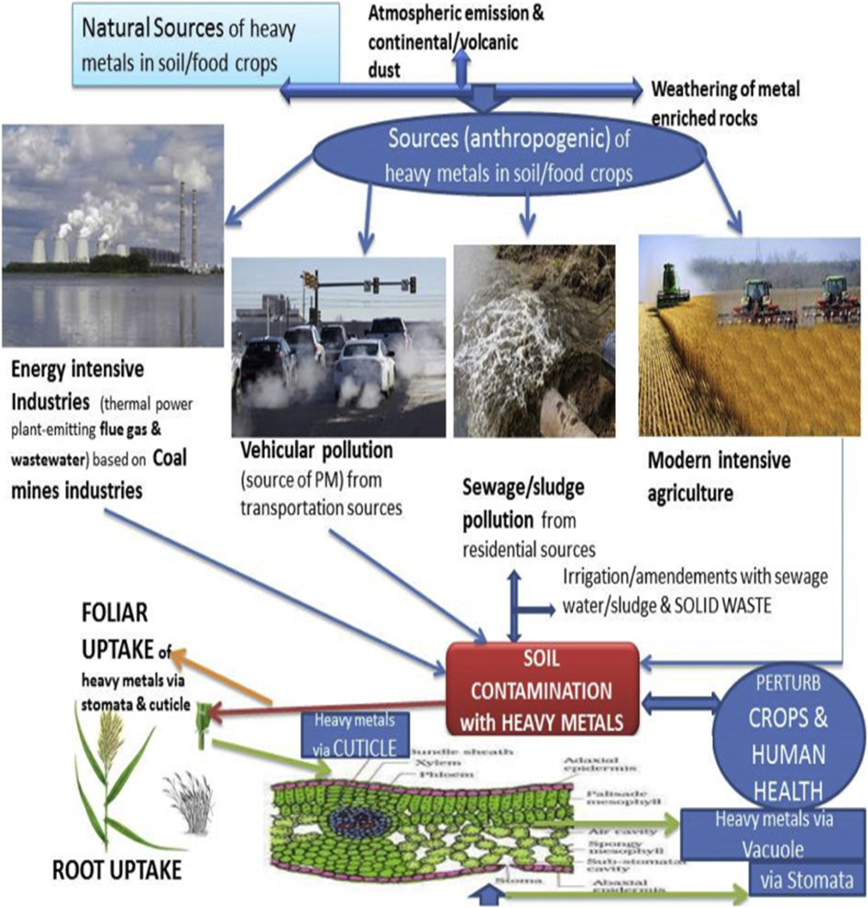

Fig. 1. The toxic metal contamination in food crops and the mechanisms of their entrance (through stomata/cuticle) with resulting effects on biota and humans.

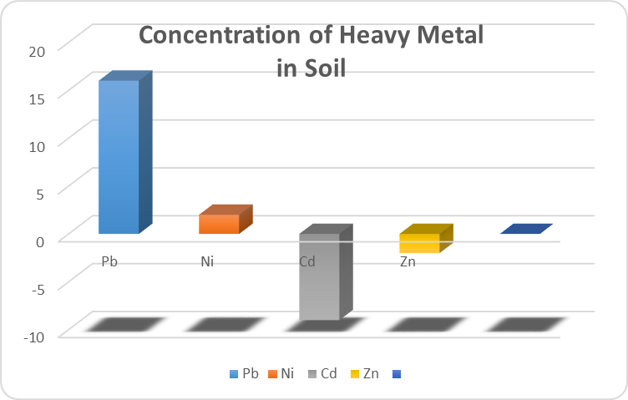

Figure 2:. The concentration of different heavy metals in soils collected from agricultural land in the vicinity of the bleaching and dyeing units. Respective concentrations have been represented in proportionate to increased or decreased levels expressed in folds.
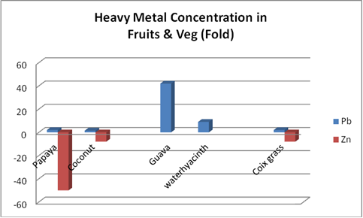

Fig 3: Pb and Zn concentrations in fruits , vegetables and plants are shown either in
higher or lower order (fold) respectively against WHO/FAO and IS:10500:1993
standards.

