Supplementary material for:
A Spatio-Temporal Assessment of Industrial Water Use in African Countries
Authors: Edwin Kipkirui ^{a,b} ; Sha Lu ^{a,b}; Jianfu Zhao ^{a,b **}; Tao Wang ^{a,b,c,d *}
- College of Environmental Science and Engineering, Tongji University, Shanghai 200092, China
- UNEP-Tongji Institute of Environment for Sustainable Development, Shanghai 200092, China
- Institute of Carbon Neutrality, Tongji University, Shanghai 200092, China
- Key Laboratory of Cities’ Mitigation and Adaptation to Climate Change in Shanghai, Shanghai, 200092, China

Table of Contents
TableS1: The description of the selected countries.
Table S2: The industrial water withdrawal in 20 selected countries. All units in (Km3/Year)
Table S3: The Gross Domestic product (GDP) (Constant 2010 US$)
Figure S1. The Gross Domestic Product of 20 countries in the periods 1988-1997. 1998- 1997, 2008-2017
Figure S2. The Industrial Water withdrawal in 20 countries in the periods 1988-1997. 1998- 2221997, 2008-2017
Figure S3. The industrial value-added change with respect to the GDP in 20 selected 122countries
Figure S4: The population of the 20 selected countries in the period 1987, 1997, 2007 and 1232017
Figure S5: The contribution of the factors influencing the industrial water withdrawal. (a) shows the contribution in the 1988-1997 period, (b) shows the contribution in the 1998-2007 period and (c) refers to the contribution in 2008-2017
Figure S6: The Spatio-temporal decomposition results of industrial water withdrawal during 1988-2017.

Table S1: The description of the selected countries. Source:(WorldOmeter, 2022). June 2022
Region | Population (Million) | Population growth (%) | Urbanization rate (%) | Area (Km²) | Selected Countries
Northern | 254.05 | 1.56 | 52.4 | 7.76 | Egypt, Tunisia, Morocco, Sudan, Algeria
Eastern | 467.44 | 2.71 | 47.7 | 6.67 | Kenya, Ethiopia, Uganda, Tanzania
Middle Africa | 189.56 | 3.1 | 50.5 | 6.5 | DR. Congo, Angola, Cameroon
Southern | 69.17 | 1.40 | 64.7 | 2.65 | South Africa, Botswana, Zambia
Western | 421.56 | 2.70 | 47.7 | 6.06 | Senegal, Mali, Ivory Coast, Nigeria, Ghana

Table S2: The industrial water withdrawal in 20 selected countries. All units in (Km³/Year)(2020, FAO)
Countries | 1988-1992 | 1993-1997 | 1998-2002 | 2003-2007 | 2008-2012 | 2013-2017
Tanzania | 0.025 | 0.025 | 0.025 | 0.025 | 0.025 | 0.025
Algeria | 0.644 | 0.554 | 0.486 | 0.450 | 0.415 | 0.191
Angola | 0.101 | 0.153 | 0.207 | 0.240 | 0.240 | 0.240
Botswana | 0.023 | 0.031 | 0.037 | 0.037 | 0.036 | 0.023
Cameroon | 0.076 | 0.071 | 0.083 | 0.105 | 0.105 | 0.105
Democratic Republic of the Congo | 0.071 | 0.103 | 0.132 | 0.147 | 0.147 | 0.147
Egypt | 4.200 | 4.257 | 3.600 | 2.600 | 1.200 | 5.400
Ethiopia | 0.021 | 0.020 | 0.021 | 0.051 | 0.051 | 0.051
Ghana | 0.080 | 0.089 | 0.095 | 0.095 | 0.095 | 0.095
Ivory coast | 0.196 | 0.270 | 0.289 | 0.301 | 0.259 | 0.242
Kenya | 0.083 | 0.091 | 0.098 | 0.114 | 0.125 | 0.303
Mali | 0.011 | 0.009 | 0.006 | 0.004 | 0.004 | 0.004
Morocco | 0.322 | 0.346 | 0.766 | 0.420 | 0.212 | 0.212
Nigeria | 0.933 | 1.321 | 1.718 | 1.965 | 1.965 | 1.965
Senegal | 0.048 | 0.056 | 0.058 | 0.058 | 0.058 | 0.058
South Africa | 1.310 | 1.082 | 1.140 | 1.361 | 1.581 | 4.100
Sudan | 0.050 | 0.051 | 0.050 | 0.050 | 0.075 | 0.075
Tunisia | 0.091 | 0.103 | 0.123 | 0.147 | 0.298 | 0.965
Uganda | 0.047 | 0.054 | 0.046 | 0.049 | 0.050 | 0.050
Zambia | 0.107 | 0.124 | 0.130 | 0.130 | 0.130 | 0.130

Table S3: The Gross Domestic product (GDP) (Constant 2010 US$) (World_Bank, 2019)
Country Name | 1987 [YR1987] | 1997 [YR1997] | 2007 [YR2007] | 2017 [YR2017]
Algeria | 8.83E+10 | 9.81E+10 | 1.5E+11 | 1.98E+11
Angola | 3.12E+10 | 3.28E+10 | 7.16E+10 | 1.02E+11
Botswana | 3.69E+09 | 7.62E+09 | 1.2E+10 | 1.73E+10
Cameroon | 1.86E+10 | 1.58E+10 | 2.39E+10 | 3.64E+10
Congo, Dem. Rep. | 2.62E+10 | 1.56E+10 | 1.84E+10 | 3.33E+10
Cote d'Ivoire | 1.73E+10 | 2.14E+10 | 2.31E+10 | 3.91E+10
Egypt, Arab Rep. | 7.48E+10 | 1.15E+11 | 1.86E+11 | 2.72E+11
Ethiopia | 9.69E+09 | 1.21E+10 | 2.21E+10 | 5.84E+10
Ghana | 1.05E+10 | 1.62E+10 | 2.61E+10 | 5.06E+10
Kenya | 1.88E+10 | 2.46E+10 | 3.56E+10 | 5.81E+10
Mali | 3.74E+09 | 5.35E+09 | 9.24E+09 | 1.42E+10
Morocco | 3.63E+10 | 5.21E+10 | 8.13E+10 | 1.19E+11
Nigeria | 1.17E+11 | 1.55E+11 | 2.9E+11 | 4.58E+11
Senegal | 8.27E+09 | 9.89E+09 | 1.46E+10 | 2.25E+10
South Africa | 2.1E+11 | 2.49E+11 | 3.59E+11 | 4.26E+11
Sudan | 1.93E+10 | 2.98E+10 | 5.7E+10 | 8.52E+10
Tanzania | 1.29E+10 | 1.49E+10 | 2.71E+10 | 4.97E+10
Tunisia | 1.67E+10 | 2.5E+10 | 3.96E+10 | 4.97E+10
Uganda | 5.65E+09 | 1.12E+10 | 2.17E+10 | 3.76E+10
Zambia | 8.01E+09 | 9.12E+09 | 1.56E+10 | 2.8E+10

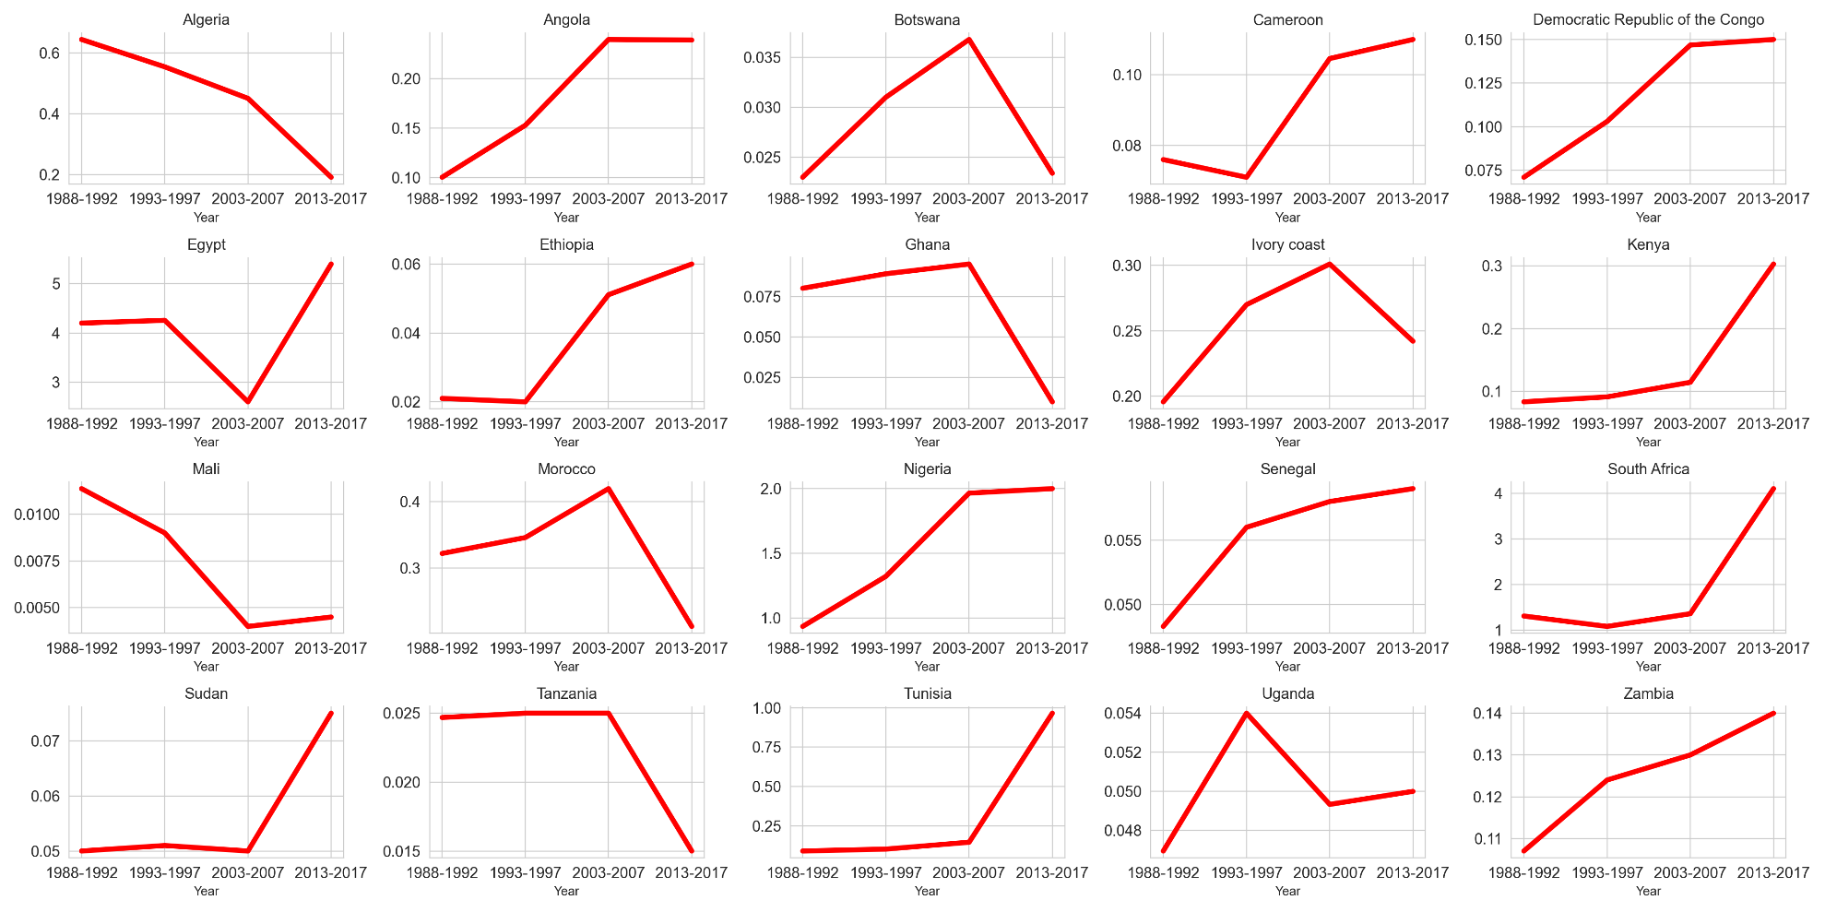
Figure S1. The Gross Domestic Product trends of 20 countries in the periods 1988-1997. 1998-2997, 2008-2017

Figure S2. The Industrial Water withdrawal trends in 20 countries in the periods 1988-1997. 1998-2997, 2008-2017

Figure S3. The industrial value-added change with respect to the GDP in 20 selected countries(Knoema, 2022)

Figure S4: The population of the 20 selected countries in the period 1987, 1997, 2007 and 2017(World_Bank, 2019)
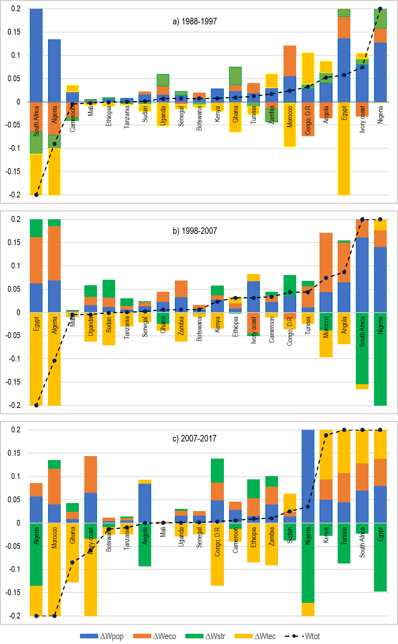
Figure S5: The contribution of the factors influencing the industrial water withdrawal. (a) shows the contribution in the 1988-1997 period, (b) shows the contribution in the 1998-2007 period and (c) refers to the contribution in 2008-2017
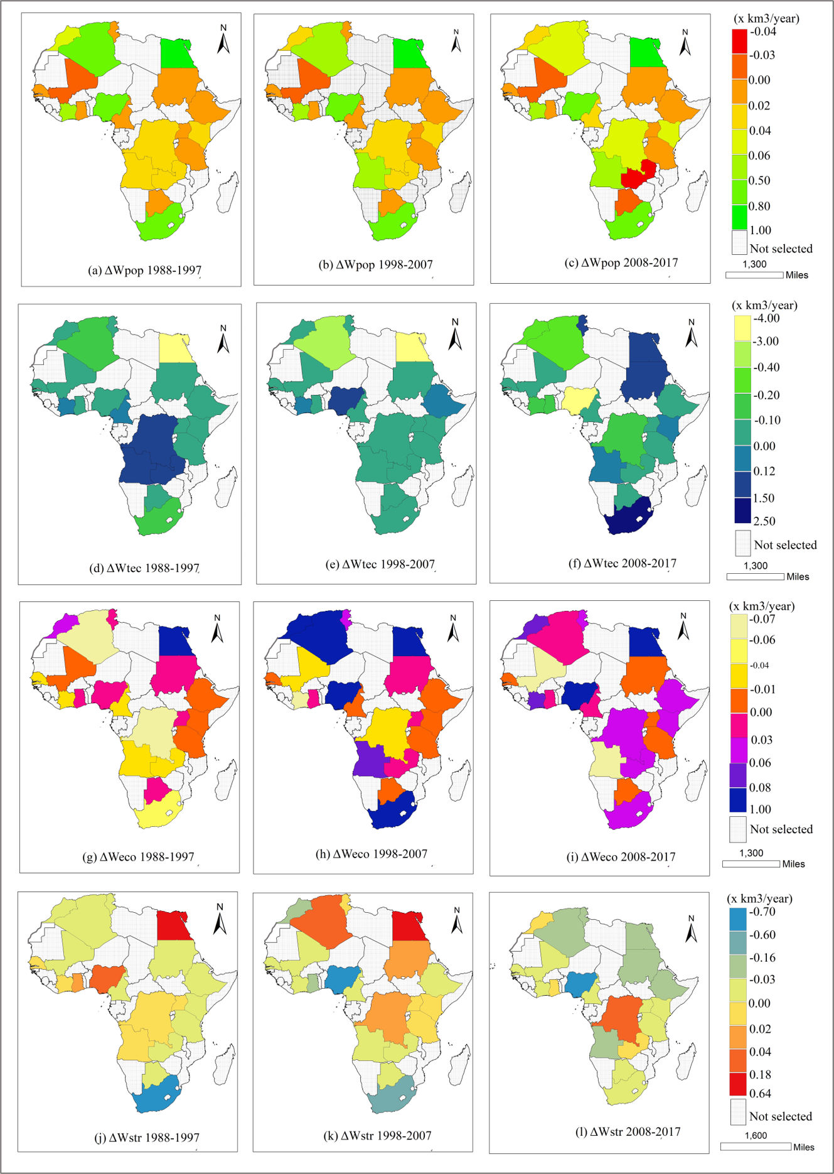
Figure S6: The Spatio-temporal decomposition results of industrial water withdrawal during 1988-2017.
References
2020, FAO. https://www.fao.org/aquastat/statistics/query/index.html. Accessed on 30/03/2023
Knoema, 2022. https://public.knoema.com/lftihvf/world-development-indicators-wdi. Accessed on 30/04/2023
World_Bank, 2019. https://data.worldbank.org/country/kenya. Accessed on 30/05/2023
WorldOmeter, 2022. https://www.worldometers.info/population/africa/. Accessed on 30/10/2022

