Large-area Printing of Ferroelectric Surface and Super-domains for Efficient Solar Water Splitting
Yu Tian^{1,2#}, Yaqing Wei^{3#}, Minghui Pei^{1#}, Rongrong Cao⁴, Zhenao Gu⁵, Jing Wang⁶, Kunhui Liu³, Dashan Shang⁴, Jiebin Niu⁴, Xiaoqiang An⁷, Run Long^{3*}and Jinxing Zhang^{1*}

¹Department of Physics, Beijing Normal University, Beijing 100875, China.
²School of Basic Medical Science, Air Force Medical University, Shaanxi Xi’an 710032, China.
³College of Chemistry, Key Laboratory of Theoretical & Computational Photochemistry of Ministry of Education, Beijing Normal University, Beijing 100875, China.
⁴Key Laboratory of Microelectronics Devices and Integrated Technology, Institute of Microelectronics, Chinese Academy of Sciences, Beijing 100029, China.
⁵Key Laboratory of Drinking Water Science and Technology, Research Center for Eco-Environmental Sciences, Chinese Academy of Sciences, Beijing 100085, China.
⁶Advanced Research Institute of Multidisciplinary Science, Beijing Institute of Technology, Beijing 100081, China.
⁷Center for Water and Ecology, State Key Joint Laboratory of Environment Simulation and Pollution Control, School of Environment, Tsinghua University, Beijing 100084, China.

#These authors contributed equally to this work.
*Corresponding authors email: runlong@bnu.edu.cn; jxzhang@bnu.edu.cn
Supporting Information

Experimental
Epitaxial growth of BiFeO₃ (BFO) thin films. Epitaxial BFO thin films were prepared on atomically smooth (001) SrTiO₃ (STO) substrates with (La, Sr)MnO₃ (LSMO) conductive buffer layers by pulsed laser deposition. LSMO and BFO layers were grown at 700 °C in an oxygen atmosphere of 20 Pa. The laser energy density was 1.2 J/cm² and the repetition rate was 5 Hz during the deposition.

Piezoresponse force microscopy (PFM) measurements. The PFM measurements were carried out on the nanoscope-V multimode atomic force microscope (AFM) equipped with external lock-in amplifiers (SRS 830, Stanford Research Instruments). The ferroelectric polarization directions were characterized by a commercially available Pt-coated Si tips under an AC voltage (1 Vpp, 22 kHz). In this work, all the PFM phase images are out-of-plane phase images.

Photoelectrochemical measurements. All the photoelectrochemical measurements were carried out on a Gamry Interface 1000 electrochemical workstation, equipped with a 500 W Xe lamp (CEL-S500) as simulate solar source (the light intensity was calibrated to 100 mW/cm²). We used a three-electrode configuration (saturated Ag/AgCl electrode and Pt-wire electrode were used as the reference and counter electrode, respectively) in 0.1 M Na₂SO₄ aqueous solution (pH = 7) during the measurements. The current density vs. voltage curves were measured at a scan rate of 10 mV·s⁻¹. Electrochemical impedance spectroscopy was carried out under an AC voltage, which amplitude and frequency range were controlled at 10 mV and from 10⁵ to 10⁻² Hz, respectively.

X-ray photoelectron spectroscopy (XPS) measurements. XPS measurements were carried out in an ultra-high vacuum system with the surface analysis system (ESCALAB 250Xi/Thermo Fisher). We used the monochromatic Al Kα beam as X-ray source (1486.7 eV), and the operating voltage is 15 kV (90 W). The surface chemical constructions of the samples were analyzed with a 90° take-off angle of the photoelectrons. All the spectra were calibrated according to the standard binding energy of C 1s with 284.8 eV.

Scanning tunneling spectroscopy (STS) measurements. STS measurements were carried out in Omicron ultra-high vacuum SPM system with a better than 3.0×10⁻¹¹ Torr base pressure. STS were recorded by the lock-in technique with a bias-voltage modulation of 5 mV and 983 Hz. Pt/Ir tips in constant-current mode were used for the measurement. We recorded the spectra as many points as possible on BFO and BFO-OH surface and performed the average values of the curves in the main text.

First-principles calculations. The first-principles calculations were carried out with Vienna Ab-initio Simulation Package (VASP) ¹. The electron-nuclei interactions were treated by the pseudo potential using the projector augmented wave (PAW) method ², and the electron exchange-correlation interactions were described by Pedrew-Burke-Ernzerhof (PBE) functional ³. The plane-wave basis energy cut-off was set to 400 eV. A 4×4×1 Γ-centered Monkhorst-Pack k-mesh ⁴ was used for geometry optimization and a much denser 8×8×1 Γ-centered k-mesh was adopted for electronic structure calculation with onsite U = 4 eV on the Fe 3d electrons ⁵. The BFO slab was represented by a trilayer (1×1) FeO₂-terminated BiFeO₃ (001) surface, which was used for calculation of the density of states. The free hydroxyl ions chemically bond to terminal Fe ions on the BFO surface and forms the BFO-OH system. In order to avoid the spurious interactions between periodic images, a 25 Å vacuum region was added along the surface normal. For modelling charge redistribution within the ferroelectric domains with opposite polarization, a larger (1×3) supercell was used for charge density calculations for both the BFO and BFO-OH systems.

Secondary ion mass spectroscopy (SIMS) measurement. TOF-SIMS 5-100 analyses were carried out with an ION-TOF GmbH spectrometer. Surface analysis was performed in a static mode. The samples were analyzed using a 30 kV Bi⁺ primary beam focused on a ∼200 μm spot. Depth profiling of the sample was carried out using a Cs+ ion-sputtering source operated at 500 eV with a 45º incident angle. The sputtering speed to reach the surface was 0.03 nm/s for SiO₂.

Supporting Figures

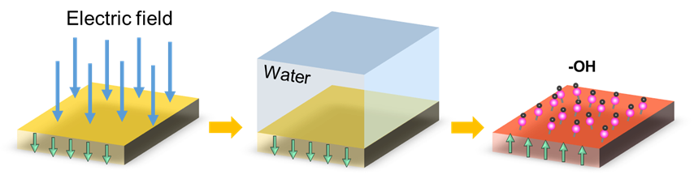
Supporting Figure 1. Hydroxyl modification process. Firstly, the initial upward-polarized BFO thin film was switched to downward by applying a 5 V DC voltage between the LSMO bottom electrode and the Pt reference electrode in aqueous solution. Secondly, exposing the film in water, in which the OH⁻ bonded with Fe at the surface layer of BFO induced the polarization switching and formed the BFO-OH structure. The green arrows describe the out-of-plane component of the polarization.

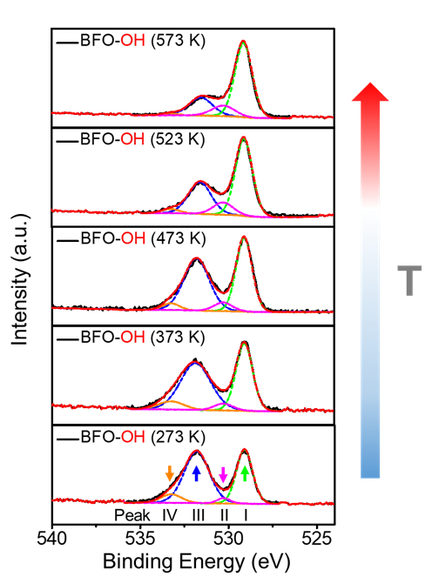
Supporting Figure 2.Temperature dependence of binding energy for the BFO-OH. The XPS spectra of O 1s of the BFO-OH. Peak I (~529.1 eV) belongs to oxygen in the perovskite structure. Annealing the BFO-OH in an O₂-rich environment for twenty minutes leads to the increase of peak II (~530.3eV) relative to lowly charge oxygen particles (O⁻) and the decrease of peak IV (~533.2eV) ascribed to absorbed water molecules. When the temperature increases to 523 K, peak III (∼531.7 eV), belonging to M-O-H bonds gradually disappears.

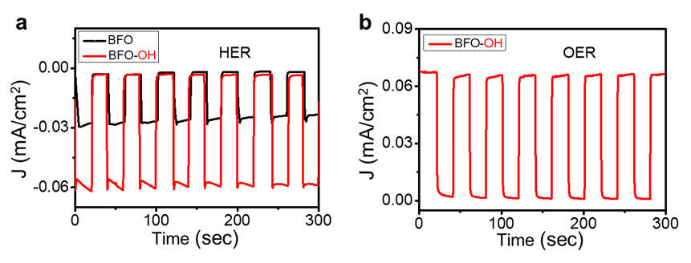
Supporting Figure 3. Chronoamperometry measurement of the upward-polarized BFO and BFO-OH. Transient photocurrent measurements of the BFO and BFO-OH for HER (a, voltage at 0 V vs. RHE) and OER (b, voltage at 1.23 V vs. RHE).

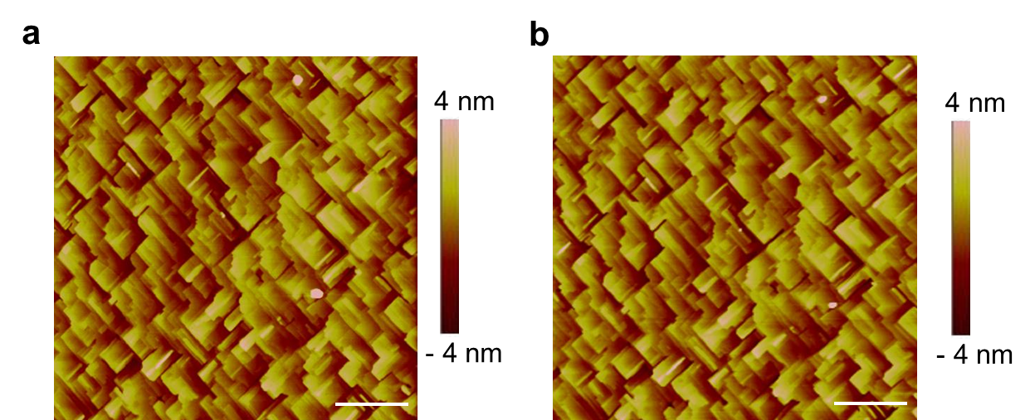
Supporting Figure 4. No change of BFO surface topography after hydroxyl modification. The topographies of BFO before (a) and after (b) hydroxyl modification demonstrate that the roughness of surface remains same. Scale bar 2 μm in (a, b).

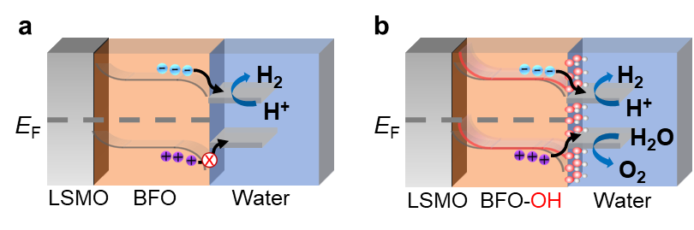
Supporting Figure 5. Energy band diagrams for the upward-polarized BFO and BFO-OH. (a) Downward bending of the surface conduction band and valence band of the upward-polarized BFO inhibits the holes migration across the BFO/water interface, and thus prevents the OER. (b) Hydroxylation modification of the BFO reduces the band bending of the conduction band and valence band, which decreases the energy barrier of the electrons and holes transfer, and thus enhances the efficiency of HER and OER simultaneously.

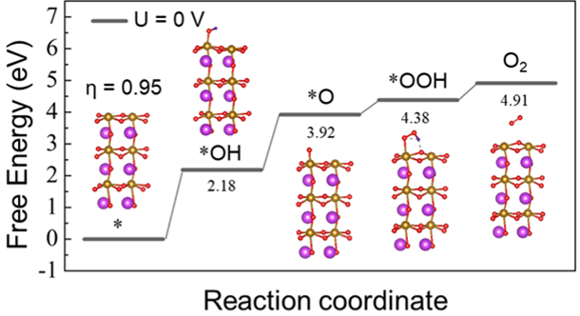
Supporting Figure 6. Free energy diagram of the OER processes on the downward-polarized BFO. The U = 0 V is the open circuit potential. The symbol “*” represents the active sites of catalysts. The OER starts with the dissociation of the adsorbed water molecule into *OH (energy barrier of 2.18 eV), and then dehydrogenating into *O (1.74 eV), reacting with another water molecule forming *OOH (0.46 eV) and dissociating to oxygen (0.53 eV).

The overpotential calculations for OER.
The overpotential η of OER can be computed as
$η=\frac{max⁡\{∆G_{1},∆G_{2},∆G_{3},∆G_{4}\}}{e}-1.23$
where, the Gibbs free energy G is obtained according to the equation G = ZPE + E –T*S. Here, ZPE is abbreviation of zero point energy, E stands for the single point energy, and T*S is the product of temperature and entropy of the system.

Table S1. The zero point energy (ZPE), single point energy (E), product of temperature and entropy (T*S), and the free energy (G) of the downward-polarized BFO adsorbed with various oxygen-related species during the processes of OER. The units are in eV. The symbol “*” means various oxygen-related absorbent interacting with the substrate.
Species | ZPE | E | T*S | G
* | -186.700 | 2.816 | 1.774 | -185.658
OH* | -195.958 | 3.519 | 1.913 | -194.352
O* | -190.151 | 2.853 | 1.878 | -189.176
OOH* | -200.900 | 3.777 | 2.470 | -199.593

Table S2. The zero point energy (ZPE), single point energy (E), product of temperature and entropy (T*S), and the free energy (G) of the BFO-OH adsorbed with various species during the processes of OER. The units are in eV. The symbol “*” denotes various oxygen-related absorbent interacting with the substrate.
Species | ZPE | E | T*S | G
* | -207.868 | 4.595 | 2.262 | -205.535
OH* | -217.5 | 5.122 | 2.438 | -214.816
O* | -212.252 | 4.472 | 2.446 | -210.226
OOH* | -222.021 | 5.13 | 2.455 | -219.346

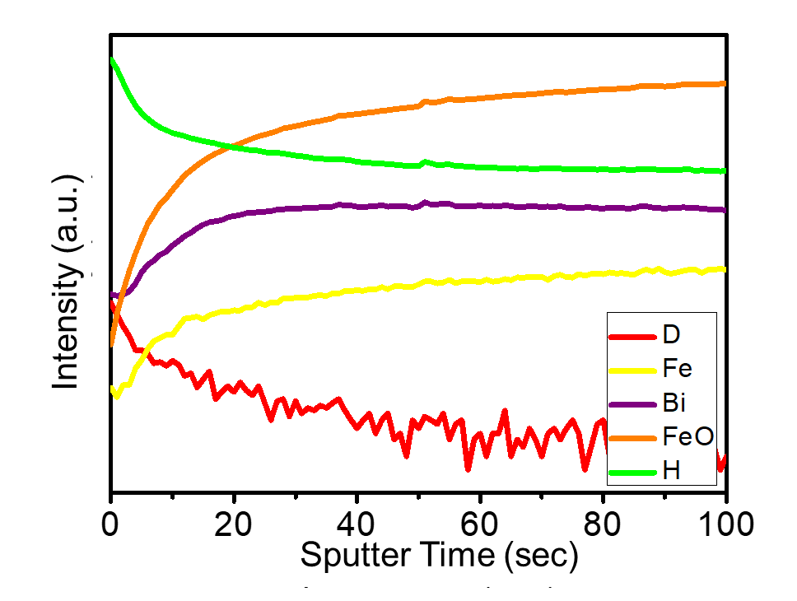
Supporting Figure 7. SIMS of the BFO-OD thin film. During the deuterium oxide treatment, water was replaced by deuterium oxide for OD modification, demonstrated by the depth profiles of secondary D⁺, Fe⁺, FeO⁺ and Bi⁺ in the BFO-OD film.

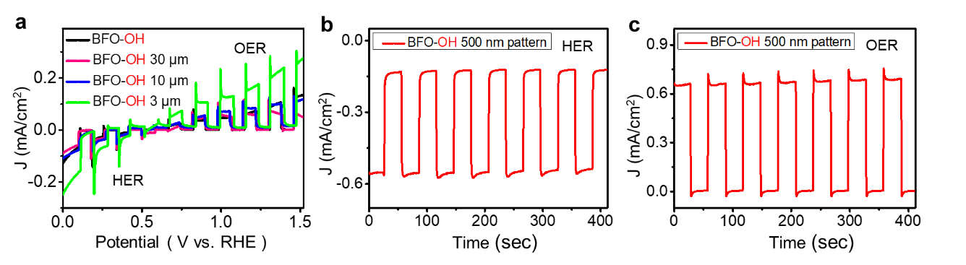
Supporting Figure 8. PEC activity of the BFO-OH photoelectrodes with super-domains. (a) As the domain size decreases, the current density increases. Transient photocurrent measurements of the BFO-OH with 500 nm periodic super-domains for HER (b, voltage at 0 V vs. RHE) and OER (c, voltage at 1.23 V vs. RHE).

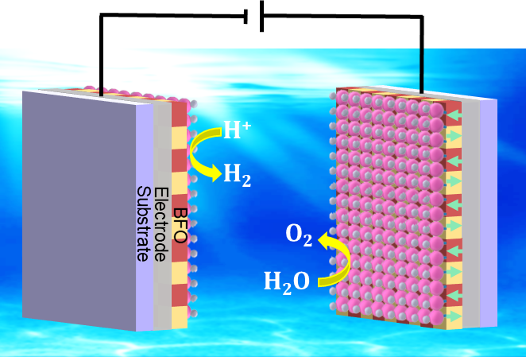
Supporting Figure 9. Schematics of the bifunctional BFO-OH photoelectrodes with super-domains. The BFO-OH films with periodic checkboard up/down electric fields can perform both photocathode and photoanode behaviors in integrated system with the same pH value.

Reference
- Kresse, G.; Furthmuller, J. Phys. Rev. B 1996, 54, 11169-11186.
- Blochl, P. E. Phys. Rev. B 1994, 50, 17953-17979.
- Perdew, J. P.; Burke, K.; Ernzerhof, M. Phys. Rev. Lett. 1996, 77, 3865-3868.
- Monkhorst, H. J.; Pack, J. D. Phys. Rev. B 1976, 13, 5188-5192.
- Neaton, J. B.; Ederer, C.; Waghmare, U. V.; Spaldin, N. A.; Rabe, K. M. Phys. Rev. B 2004, 71, 4113.

