Supplementary figures
Table S1 Characteristics of glioma patients in theTCGA and CGGA datasets
Variable | TGGA  (n = 611) | CCGA  (n =310)
Median age (range) | 47 (14-89) | 43 (8-81)
Gender
Male | 357 | 195
Female | 254 | 115
Grade
II | 214 | 105
III | 237 | 67
IV | 160 | 138
Subtype
Neural | 102 | 76
Proneural | 218 | 99
Classical | 84 | 70
Mesenchymal | 94 | 65
NA | 113 | 0
IDH mutation status
WT | 227 | 146
Mut | 376 | 164
NA | 8 | 0
1p/19q codeletion status
No | 455 | 218
Yes | 150 | 36
NA | 6 | 56
MGMT promoter status
Unmethylated | 151 | 110
Methylated | 426 | 134
NA | 34 | 66
Radiotherapy
Yes | NA | 207
No | NA | 80
NA | NA | 23
Chemotherapy
Yes | NA | 155
No | NA | 124
NA | NA | 31
TCGA: The Cancer Genome Atlas; CGGA: Chinese Glioma Genome Atlas; IDH: isocitrate dehydrogenase; MGMT: methylguanine methyltransferase; NA: not available

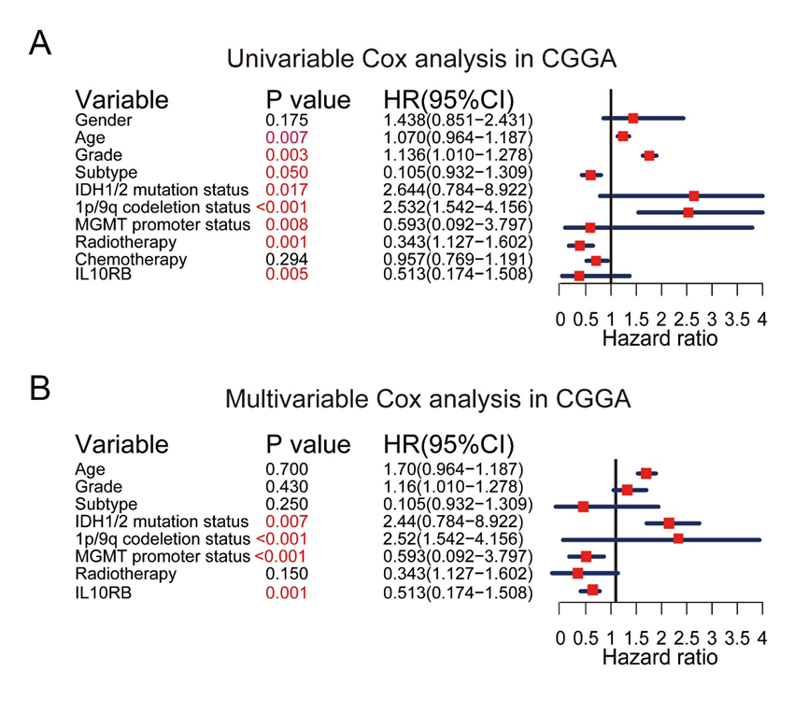
Figure S1: Univariable and multivariable Cox analysis of IL10RB expression, age, grade subtype, IDH1/2 mutation status, 1p/19q codeletion status, MGMT promoter status, radiotherapy in the CGGA dataset.

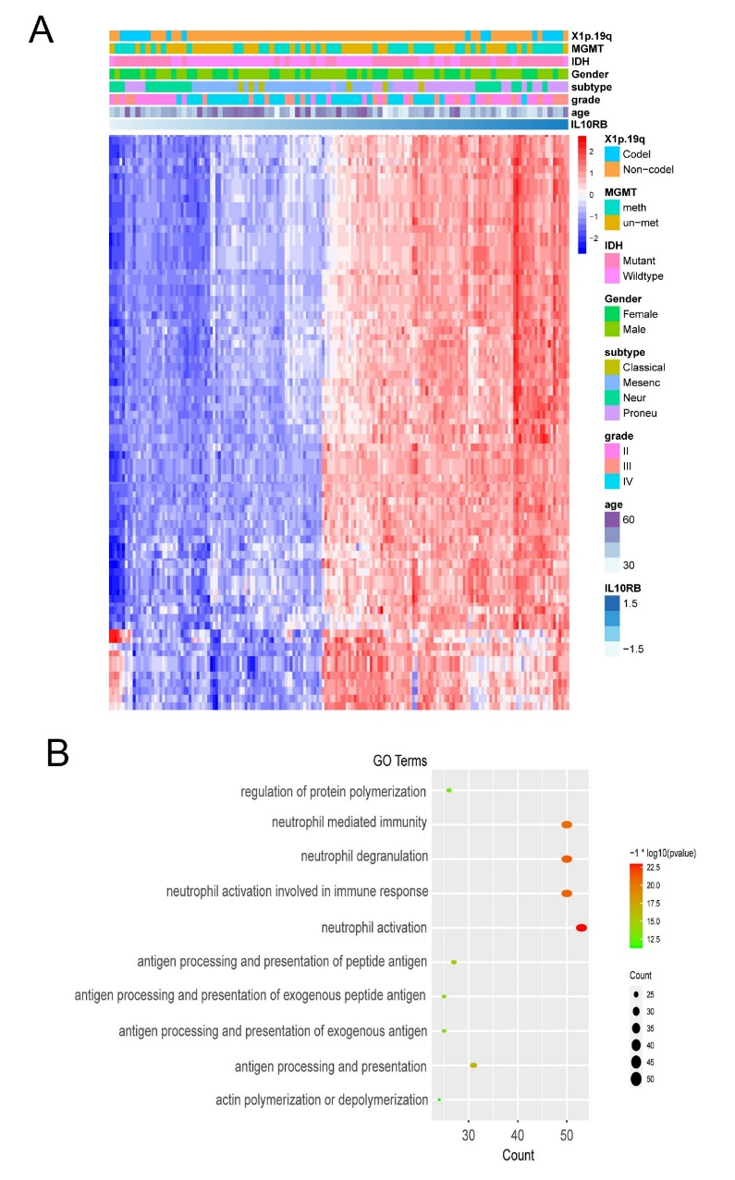
Figure S2: Genes positively related (R > 0.5) with IL10RB expression (A), and the BP analysis results show that IL10RB expression is related to immune function of gliomas (B) based on CGGA dataset.

