Supplementary Materials
1. State and error activity of the predictive coding model
2. Cross-trial similarity analysis on simulated activity produced within the lexical and semantic levels separately
3. Evoked and cross-trial similarity effects within left lateral temporal cortices

1. State and error activity of the predictive coding model
In the main manuscript, we report the summed activity of error units (summed across the lexical and semantic layers). Here we report the summed activity of state units in comparison to the error units.
As shown in Figure S1A, at all iterations of the algorithm, the total activity produced by error units (shown in red) was far greater than that produced by state units (shown in blue). Following the onset of the expected inputs, the magnitude of lexico-semantic prediction error was minimal because activity within these error units was immediately suppressed by the top-down lexical and semantic predictions. However, following the onset of the unexpected inputs, lexico-semantic prediction error rapidly rose, peaking at around iteration 4, and then fell again such that it was minimized by iteration 15. Prediction error rose because, as new lexico-semantic information was encoded, the prior top-down predictions were unable to explain/suppress activity within the error units. Prediction error fell again because, as error activity at each level was passed up to update state units at the level above, these state units produced increasingly more accurate top-down predictions that gradually suppressed the lexico-semantic prediction error.
Therefore, to better visualize the relative dynamics of activity produced by state and error units as the algorithm converged, we normalized both state and error values by dividing their respective maximum value across the expected and unexpected conditions over all iterations (see Supplementary Figure 1B). When expected inputs were presented, state activity rapidly rose, plateauing at around iteration 10 as the model converged on the state representations that matched the top-down predictions. However, when unexpected inputs were presented, state activity rose slightly later, reaching its maximum at around iteration 15 when lexico-semantic prediction error was minimized.

Figure S1. Outputs of the predictive coding model produced by lexico-semantic error and state units in response to expected and unexpected inputs.
A. Error activity (red) and state activity (blue) prior to data normalization. Note that activity produced by error units was far greater than that produced by state units on all iterations of the algorithm.
B. Normalize state and error activity was calculated by dividing their respective maximum value across the expected and unexpected conditions over all iterations.
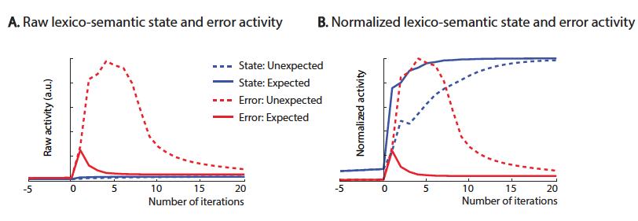

2. Cross-trial similarity analysis on simulated activity produced within the lexical and semantic levels separately
As shown in Figure 3 of the main manuscript, the duration of the MEG cross-trial similarity effect (within-expected > between-condition) within left anterior inferior and medial temporal regions, which are thought to map semantic features onto amodel conceptual representations¹, was slightly longer than that produced within the left anterior and mid-fusiform cortex, which is thought to encode lexical representations that function to map orthographic form onto semantic features². We hypothesized that this is because it took slightly longer for the predictive coding algorithm to converge on semantic than lexical representations. To test this hypothesis, we separately extracted activity from the lexical and semantic layers of the predictive coding model, and after projecting this activity into the sampling space, carried out cross-trial similarity analyses on the simulated data produced at the lexical level and the semantic level separately. For each time series, we identified the peak of the effect, and estimated its duration by calculating the Full Width Half Maximum (FWHM) — the range of iteration numbers over which the value of the spatial similarity effect reached half of its maximum value. This analysis indeed showed that the cross-trial similarity effect produced by semantic error and state units had a slightly longer duration (FWHM: 12 iterations; see Figure S2B) than that produced by lexical error and state units (FWHM: 11 iterations; see Figure S2A).

Figure S2. Time courses of cross-trial similarity effects (within-expected > between-condition) of simulated data. A. Effect at the lexical layer. B. Effect at the semantic layer. The Full Width Half Maximum (FWHM) is indicated by the box surrounding the region in which the cross-trial similarity effects reached half of its maximum value.
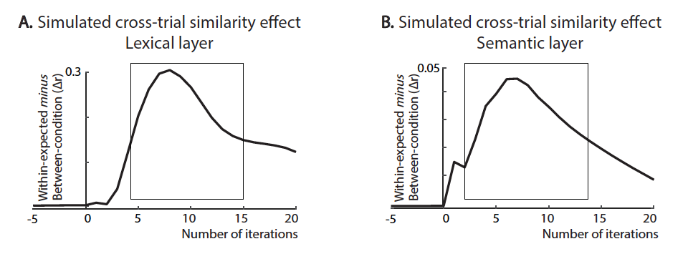

3. Evoked and cross-trial similarity effects within left lateral temporal cortices
3.1. Introduction
In the main manuscript, we reported the results of univariate and multivariate analyses within the left ventromedial temporal lobe, which is thought to support the mapping of orthographic form onto meaning — the process simulated by our computational model. In the MEG analyses, we also observed evoked and cross-trial similarity effects within lateral regions of the left temporal cortex, which are thought to support reading comprehension through another pathway that indirectly maps orthography to meaning via phonology^{3,4}. Below we report these findings. Although our predictive coding model did not include this indirect pathway, we speculate on how predictive coding could potentially explain these results.

3.2. Results
The cluster-based permutation test on the univariate response within the left fronto-temporal search volume revealed a significant evoked effect (unexpected > expected, Figure S3A) within the left mid-portion of the superior temporal region (p = 0.02). The cross-trial similarity analysis showed a significant spatial similarity effect (within-expected > between-condition, Figure S3B) within slightly more inferior regions — the mid-portions of the left middle temporal cortex (p = 0.04) and the left inferior temporal cortex (p = 0.02).

Figure S3. Evoked and cross-trial similarity effects within the left lateral temporal cortices.
A. Source-localized N400 effect. Left: A cluster within the mid-portion of the left superior temporal cortex showed a significantly larger evoked response to Unexpected than Expected words between 300-500ms following stimulus onset. Statistical t-values were interpolated onto the MNI template brain and are visualized using BrainNet Viewer⁵. Right: Full time course of the N400 evoked effect (Unexpected minus Expected), averaged across the voxels that showed a significant evoked effect between 300-500ms. Standard errors are indicated using gray shading.
B. Cross-trial similarity effects in the mid-portions of the left middle and inferior temporal cortices, which are visualized using Scalable Brain Atlas⁶. Right: For each subregion, we show the time course of the cross-trial similarity effect, with standard errors indicated with gray shading. A 10Hz low-pass filter was applied for visualization purposes.

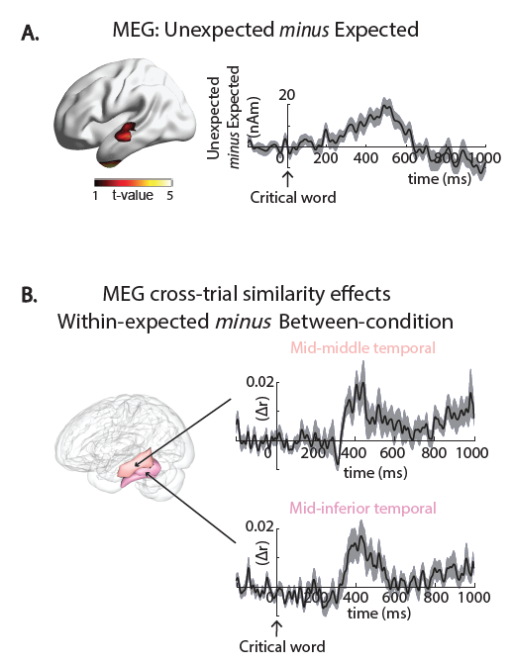

3.3. Discussion
The larger N400 response to unexpected versus expected inputs within the left superior temporal cortex is consistent with previous MEG findings^{7,8}. Within slightly more inferior regions of the lateral temporal cortex — the left mid-portions of the left middle and inferior temporal cortex, we saw a cross-trial similarity effect.
These findings can be explained within an extended predictive coding framework of reading comprehension that incorporates not only a direct mapping from orthography to meaning, as simulated by our model, but also indirect mappings from orthography to meaning via phonology^{3,4}. According to this extended framework, sublexical phonemic representations within the left superior temporal cortex^{9,10} receive input from sublexical orthographic representations within left posterior fusiform. In addition, lexical-phonological representations within mid-portions of the left middle and inferior temporal cortex¹¹⁻¹³ receive inputs from lexical-orthographic representations within left mid-fusiform. A rapid convergence on the semantic representations of unexpected inputs through orthographic-semantic mappings (particularly likely in Chinese, see Williams et al., 2010¹⁴) would result in the generation of accurate top-down predictions that would immediately suppress any lexical-phonological prediction error to unexpected inputs within left mid-portions of middle and inferior temporal cortices. However, it may take slightly longer for the indirect pathway to converge on unexpected lexical-phonological representations. This would result in a failure to immediately suppress sublexical phonemic prediction error within left superior temporal regions (see Blank et al. and Sohoglu et al.^{15,16} for work linking this region to sub-lexical prediction error in speech processing). Consistent with this hypothesis, the evoked effect within the left superior temporal cortex appeared to peak slightly later than the canonical N400 effect (at 500ms rather than 400ms). It will be important to test this idea in future versions of our predictive coding model that incorporate the indirect pathway.

References
1 Lambon-Ralph, M. A., Jefferies, E., Patterson, K. & Rogers, T. T. The neural and computational bases of semantic cognition. Nat Rev Neurosci 18, 42-55, doi:10.1038/nrn.2016.150 (2017).
2 Woolnough, O. et al. Spatiotemporal dynamics of orthographic and lexical processing in the ventral visual pathway. Nat Hum Behav 5, 389–398, doi:10.1038/s41562-020-00982-w (2021).
3 Harm, M. W. & Seidenberg, M. S. Computing the meanings of words in reading: Cooperative division of labor between visual and phonological processes. Psychological Review 111, 662-720, doi:10.1037/0033-295X.111.3.662 (2004).
4 Grainger, J. & Holcomb, P. J. Watching the word go by: On the time-course of component processes in visual word recognition. Lang Linguist Compass 3, 128-156 (2009).
5 Xia, M., Wang, J. & He, Y. BrainNet Viewer: a network visualization tool for human brain connectomics. PLoS One 8, e68910, doi:10.1371/journal.pone.0068910 (2013).
6 Bakker, R., Tiesinga, P. & Kotter, R. The scalable brain atlas: Instant web-based access to public brain atlases and related content. Neuroinformatics 13, 353-366, doi:10.1007/s12021-014-9258-x (2015).
7 Service, E., Helenius, P., Maury, S. & Salmelin, R. Localization of syntactic and semantic brain responses using magnetoencephalography. J Cogn Neurosci 19, 1193-1205, doi:10.1162/jocn.2007.19.7.1193 (2007).
8 Wang, L. et al. Beta oscillations relate to the N400m during language comprehension. Hum. Brain Mapp. 33, 2898-2912, doi:10.1002/hbm.21410 (2012).
9 Vartiainen, J., Parviainen, T. & Salmelin, R. Spatiotemporal convergence of semantic processing in reading and speech perception. J. Neurosci. 29, 9271-9280, doi:10.1523/Jneurosci.5860-08.2009 (2009).
10 Solomyak, O. & Marantz, A. Lexical access in early stages of visual word processing: A single-trial correlational MEG study of heteronym recognition. Brain Lang. 108, 191-196, doi:10.1016/j.bandl.2008.09.004 (2009).
11 Booth, J. R. et al. Specialization of phonological and semantic processing in Chinese word reading. Brain Res. 1071, 197-207, doi:10.1016/j.brainres.2005.11.097 (2006).
12 Yang, J., Wang, X., Shu, H. & Zevin, J. D. Brain networks associated with sublexical properties of Chinese characters. Brain Lang 119, 68-79, doi:10.1016/j.bandl.2011.03.004 (2011).
13 Wu, C. Y., Ho, M. H. & Chen, S. H. A meta-analysis of fMRI studies on Chinese orthographic, phonological, and semantic processing. Neuroimage 63, 381-391, doi:10.1016/j.neuroimage.2012.06.047 (2012).
14 Williams, C. & Bever, T. Chinese character decoding: a semantic bias? Reading and Writing 23, 589-605, doi:10.1007/s11145-010-9228-0 (2010).
15 Blank, H. & Davis, M. H. Prediction errors but not sharpened signals simulate multivoxel fMRI patterns during speech perception. PLoS Biology 14, e1002577 (2016).
16 Sohoglu, E. & Davis, M. H. Rapid computations of spectrotemporal prediction error support perception of degraded speech. Elife 9, doi:10.7554/eLife.58077 (2020).

